VMware Pro Cloud Services for Private Cloud - Design Library

You can find the most up-to-date technical documentation on the VMware website at:
https://docs.vmware.com/
Broadcom®
3421 Hillview Ave.
Palo Alto, CA 94304
www.vmware.com
Copyright© 2026 Broadcom® All rights reserved. Copyright and trademark information.
Contents
1. Design Library for VMware Cloud Foundation 5
VCF Operations Detailed Design 5
Simple VCF Operations Model 9
High Availability VCF Operations Model 18
Continuous Availability VCF Operations Model 30
VCF Configuration Drift Design 41
SDDC Manager Detailed Design 46
VCF Operations for Logs Detailed Design 48
VCF Operations for Networks Detailed Design 56
VCF Automation Detailed Design 67
Simple VCF Automation Model 69
High Availability VCF Automation Model 72
Network Design Options for VCF Automation Instance Deployment 74
VCF Automation Deployment Patterns 75
Tenancy Deployment Models in VCF 79
Organization Consumption Model 88
Multi Tenancy Consumption Patterns 102
VCF Automation Identity and Access Management Design 112
VCF Automation Load Balancing Design 121
VCF Operations Orchestrator Design 122
Chargeback and Billing 124
Workload Domain Detailed Design 126
Management Domain Model 126
Workload Domain Model 130
vSphere Cluster Detailed Design 131
vSphere Single-Rack Cluster Model 131
vSphere Multi-Rack Cluster Model 140
vSphere Multi-Rack Cluster Detailed Design 144
vSphere Stretched Cluster Model 160
VCF Edge Detailed Design 170
VCF Edge Pattern 1: Centrally Managed Edge Compute Clusters in a Workload Domain 171
VCF Edge Pattern 2: Segregated Edge deployment across Multi-Region Workload Domains 172
VCF Edge Pattern 3: Locally Managed Edge 173
VCF Edge Pattern 4: VCF Fleet with Multi Region, Distributed Edge 175
VCF Edge Pattern 5: Dark Site Edge 177
VCF Edge Pattern 6: vSphere Supervisor at the Edge in a VCF Instance with Multiple Domains 179
VCF Edge Pattern 7: Supervisor Zonal separation at the Edge 180
VCF Edge Pattern 8: Single Host vSphere Supervisor at the Edge in a VCF Instance 181
VCF Edge Pattern 9: Leveraging Existing VCF Operations for Far Edge Expansion 183
Other flexible design options with VCF Edge 184
VCF Network Detailed Design 189
Distributed Switch Detailed Design 189
VMkernel Detailed Design 225
Network I/O Control Detailed Design 226
Fleet Level Components Networking Detailed Design 227
Storage Detailed Design 241
vSAN Detailed Designs 241
NFS Storage Model 385
Fibre Channel Storage Model 389
vCenter Detailed Design 394
ESX Detailed Design 400
External Services Detailed Design 406
Data Center Network Requirements 406
Information Security Detailed Design 439
Access Management Design 439
Account Management Design 441
Certificate Management Design 450
VCF Identity Broker Detailed Design 452
Embedded VCF Identity Broker Model 452
Appliance VCF Identity Broker Model 454
VCF Single Sign-On Detailed Design 456
VCF Fleet-Wide Single Sign-On Model 456
Cross VCF Instance Single Sign-On Model 458
Single VCF Instance Single Sign-On Model 460
NSX Management and Control Plane Detailed Design 462
Simple NSX Manager Model 462
High Availability NSX Manager Model 465
High Availability NSX Manager With External Load Balancer Model 468
High Availability NSX Global Manager Model 471
High Availability with Standby NSX Global Manager Cluster Model 474
Network Consumption Models 477
Workload Networking Detailed Designs 484
VPC with Full Services Workload Networking Model 485
VPC Scalable Workload Networking Model 509
VPC Getting Started Workload Networking Model 521
NSX Segment Network Virtualization Scalable Workload Networking Model 524
Large Scale Topology Workload Networking Model 535
NSX Edge Cluster Detailed Design 537
NSX Edge Cluster Models for Single Availability Zone 537
NSX Edge Cluster Models for Dual Availability Zones 582
vSphere Supervisor Detailed Design 611
Simplified Supervisor Model 612
vSphere Supervisor Zone Models 613
vSphere Supervisor Control Plane Availability Models 628
vSphere Supervisor Load Balancer Models 632
Modern Applications Consumption Models 635
Continuous Integration and Delivery with Harness Architecture 636

Design Library for VMware Cloud Foundation
The design library section contains detailed designs for each component of the VCF private cloud.

VCF Operations Detailed Design
VCF Operations is a mandatory component for each VCF fleet and is the central console for operating your VCF fleet, providing dashboards for monitoring, log analysis, reporting, and licensing. With VCF Operations offers fleet management capabilities such as life cycle management, certificate and password management. This section describes the options, requirements and recommendations for each VCF Operations Model.
The initial management domain hosts essential components, including SDDC Manager, vCenter, NSX Manager, VCF Operations , and VCF Automation. These components work together to ensure smooth operations and orchestration across the VCF fleet.
This streamlined and scalable approach provides centralized management, allowing a unified framework to oversee VCF Instances through a single VCF Operations instance delivering a strong foundation to expand to multiple VCF Instances while maintaining centralized operations and automation.
To enable additional capabilities, VCF Operations can be further extended through the deployment of VMware Cloud Foundation Operations for logs and VMware Cloud Foundation Operations for networks. These components support their own deployment models, this section describes the options, requirements and recommendations for each.
- Simple VCF Operations Model
- High Availability VCF Operations Model
- Continuous Availability VCF Operations Model

VCF Operations Placement
VCF Operations placement for an entire VCF fleet plays a critical role in monitoring, analyzing, licensing, life cycle management, optimizing the performance and capacity of the VMware Cloud Foundation platform. Proper placement of the VCF Operations components is essential to ensure high availability, scalability, and efficient resource utilization.
Attribute | Details
Resource Allocation | Ensure that sufficient compute, memory, and storage resources are allocated to the VCF Operations appliances to handle the expected workload. This is particularly important in environments with large-scale deployments or high data ingestion rates.
Network Connectivity | VCF Operations should be placed in a network segment with low latency and high bandwidth to ensure efficient communication with vCenter, NSX, and other monitored components.
Scalability | Plan for future growth by deploying Aria Operations in a manner that allows for easy scaling as the VCF environment expands. This includes considering the placement of additional nodes if required. By carefully planning the placement of Aria Operations, organizations can ensure optimal performance, reliability, and scalability of their VCF environment while gaining actionable insights to improve operations.

VCF Operations Network Placement
Model | Details | Benefits | Implications
Default VM management distributed port group | VCF Operations components are deployed on the same network as the default VM management network or the ESX management network if configured with the same VLAN. | - Simplified deployment with no additional network configuration required.  - Immediate integration with the existing management infrastructure.  - Suitable for smaller environments or those with limited network segmentation requirements. | - Shared traffic between management and VCF Operations components, potentially impacting performance in larger environments.  - Limited isolation for VCF Operations traffic, which may not meet security or compliance requirements in some organizations.
Dedicated distributed port group | VCF Operations components are deployed on a dedicated distributed port group. | - Enhanced security and traffic isolation for VCF Operations components  - Improved performance by separating VCF Operations traffic from other management traffic.  - Greater flexibility for scaling and integrating with advanced network architectures. | - Requires additional planning and configuration during deployment.  - VCF Operations deployment must be skipped during the initial deployment (Day 0) and configured as a Day 2 activity after the network is set up.
NSX segment (overlay or VLAN backed) | VCF Operations components are deployed to an NSX segment. | - Enhanced security and traffic isolation for VCF Operations components  - Improved performance by separating VCF Operations traffic from other management traffic.  - Greater flexibility for scaling and integrating with advanced network architectures. | - Requires additional planning and configuration during deployment.  - VCF Operations deployment must be skipped during the initial deployment (Day 0) and configured as a Day 2 activity after the network is set up.

VCF Operations Licensing Modes
VCF Operations uses the VMware Cloud Foundation Business Services console to license VCF Instances and report license usage. It is recommended that you use the Connected Mode whenever possible to simplify license management.
Mode | Details | Benefits | Implications
Connected Mode | VCF Operations maintain a live connection to the VCF Business Services console via the internet and regularly reports license usage. | Reduced operational overhead of manual license management operations. | An outbound internet connection to VCF Business Services console is required for Connected Mode.
Disconnected Mode | Offline registration of VCF Operations with the VCF Business Services console and license usage reporting. | Internet connection is not required for VCF Operations instances. | Operational overhead of manual license management tasks, such as license usage reporting.
Table 3-464. Deployment Path
Component Name | Deployment Path
VCF Operation | Must be deployed either:  - During the installation of the management domain with VCF Installer.  Important All components will be deployed with the management domain.  - After the installation of the management domain as a separate workflow.  Important All components must be deployed using the API.
VCF Operations collector | Mandatory component:  - During the installation of the management domain with VCF Installer.  Important Will be deployed with the management domain.  - After the installation of the management domain as a separate workflow.  Important Must be deployed using the API.  - With each new VCF Instance that will be part of existing VCF fleet.  Important Will be deployed with the management domain of the new VCF Instance.
VCF Operations fleet management | Must be deployed either:  - During the installation of the management domain with VCF Installer.  Important Will be deployed with the management domain.  - After the installation of the management domain as a separate workflow.  Important Must be deployed using the API.

Configuration Drift
Using a desired state approach, fleet management can be managed through a configuration drift capability for vCenter and vSphere Clusters. This approach is based on a template style management. A single template can be applied against each component, or multiple templates without overlapping configuration values can be applied to each component. Due to the range of possible configuration drift values and their impact on security, operations should invite security and compliance teams to participate in the process. Balancing the need to manage operations with the need for appropriate security can alter the approach taken. For more detailed design recommendations for security and compliance, see the section on
Figure 3-26. Configuration Drift
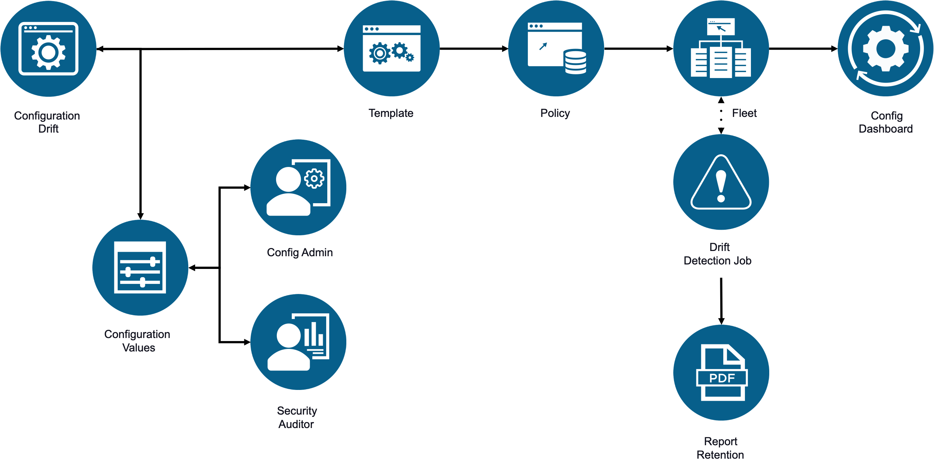
The process for evaluating and confirming values should be balanced with the use of one, or more templates. There are some uses cases were global values and a single template to enforce them is possible, while in other use cases this requires a different approach. The range of configuration drift values and how the VCF instance is used should select the best approach to fleet management.
Figure 3-27. Configuration Drift Values and Templates
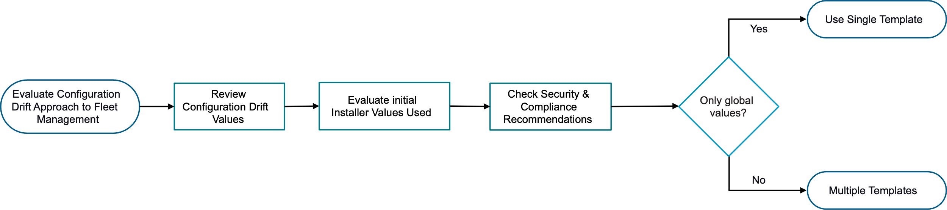

Simple VCF Operations Model
The Simple VCF Operations Model deploys a single node of all the VCF Operations components and uses vSphere HA as an availability mechanism.
The Simple VCF Operations Model includes three single-node components.
Figure 3-28. Simple VCF Operations Model
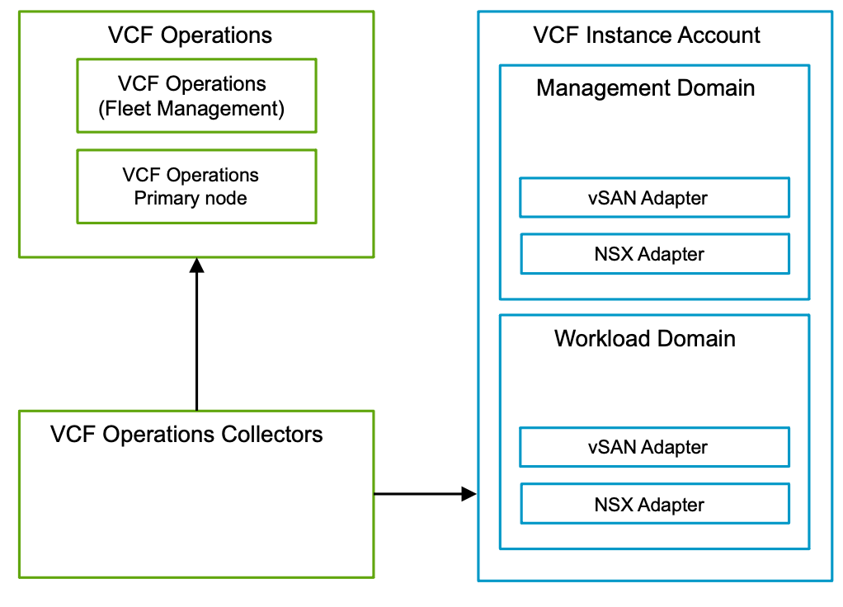

Simple VCF Operations Model Attributes
A Simple VCF Operations Model has the following attributes.
Attribute | Detail
Availability | Relies on vSphere HA to restart the nodes in the event of an ESX host failure.
Scalability | Supports scale-up and scale-out.  Note Scale-out is supported for the VCF Operations data nodes and VCF Operations collector nodes.
Recoverability | Restore through a backup.

Simple VCF Operations Model Options
A Simple VCF Operations Model can leverage options from the design areas listed below, depending on objectives.
Design Area | Options
Networking | - Default VM management distributed port group  - Dedicated distributed port group  - NSX segment (overlay or VLAN backed)
Licensing | - Connected Mode  - Disconnected Mode

Simple VCF Operations Model Design Requirements
Table 3-465. Simple VCF Operations Model Design Requirements
Design Requirement ID | Design Requirement | Justification | Implication
VCF-OPS-REQD-SIM-001 | Deploy VCF Operations as a single node in the default management vSphere cluster. | - Supports the simple deployment objective.  - Provides the capacity required for monitoring virtual machines or objects within the monitoring scale limits.  - Supports scale-out to a high availability model. | - You must select a size for the VCF Operations cluster nodes based on the known or forecasted virtual machine and object count across each connected VCF Instance to adhere to the scale limits.  - No application level high availability.
Table 3-466. Common VCF Operations Design Requirements for All Models
Design Requirement ID | Design Requirement | Justification | Implication
VCF-OPS-REQD-COM-001 | Deploy a single VCF Operations fleet management appliance in the default management vSphere cluster. | Provides life cycle management operations for VCF Operations fleet management components. | None.
VCF-OPS-REQD-COM-002 | Protect VCF Operations fleet management appliance by using vSphere HA. | Ensures availability of VCF Operations fleet management appliance without requiring manual intervention during an ESX host failure event. | None.
VCF-OPS-REQD-COM-003 | Deploy a single VCF Operations collector appliance in the default management vSphere cluster. | - Removes the load from the VCF Operations analytic node(s) from collecting metrics from local-instance applications.  - Reuse VCF Operations collectors to gather both logs and metrics across the VCF environment.  - Centralized management of logs and metrics, reducing administrative overhead. | You may need to scale-up the VCF Operations collector nodes to a greater size based on the known or forecast virtual machine and object count across each connected VCF Instance to adhere to the scale limits.
VCF-OPS-REQD-COM-004 | Protect VCF Operations collector appliance by using vSphere HA. | Ensures availability of VCF Operations collector appliance without requiring manual intervention during an ESX host failure event. | None.

Simple VCF Operations Model Design Recommendations
Table 3-467. Common VCF Operations Design Recommendations for All Models
Design Recommendation ID | Design Recommendation | Justification | Implication
VCF-OPS-RECD-COM-001 | Enable data persistence on each VCF Operations collector appliance. | Provides the ability to store data in case of connectivity issues. | Storage availability on each VCF Operations collector must be monitored.
VCF-OPS-RECD-COM-002 | Configure VCF Operations to use a notifications configuration to route notifications for system events. | Integrates VCF Operations system events notifications to platform engineers, providing an enhanced user experience. | You must configure and maintain the notification integration.
VCF-OPS-RECD-COM-003 | Add a physical data center object to the VCF Operations configuration for the geographic location of each VCF Instance. | Provides organization of the VCF Operations collector nodes in VCF Operations inventory. | VCF Operations must have connection to the Internet to view and set the precise geographic coordinates in the UI.
VCF-OPS-RECD-COM-004 | Activate the Ping integration in VCF Operations. | Provides metrics on the availability of endpoints. | You must activate the integration manually.
VCF-OPS-RECD-COM-005 | Configure the currency in the VCF Operations global options based on your organization requirements. | To receive benefits of the VCF Operations cost engine, you must select a currency. | None.

VCF Operations - Networking and Internet Access Design Choices
There are several options regarding connectivity to the external resources and network placement for the VCF Operations components. You should choose one option from each of the tables below.
Table 3-468. Network Placement for VCF Operations Design Recommendations Default Distributed Port Group
Design Recommendation ID | Design Recommendation | Justification | Implications
VCF-OPS-RECD-NET-001 | Deploy the VCF Operations nodes on the distributed port group created by VCF Installer and reserved for management components. | Ensures that the VCF Operations nodes are deployed adjacent to the other components on the same Layer-2 network. | None.
Table 3-469. Network Placement for VCF Operations Design Recommendations Dedicated Distributed Port Group
Design Recommendation ID | Design Recommendation | Justification | Implications
VCF-OPS-RECD-NET-001 | Deploy the VCF Operations nodes on a dedicated distributed port group other than default port group reserved for management components by VCF Installer. | Ensures that the VCF Operations nodes are deployed in a dedicated Layer-2 network. | - You must skip the deployment of the VCF Operation (and VCF Operations fleet management) when using the VMware Cloud Foundation Installer.  - You must perform configuration to support the networking configuration as a post-deployment task before manually deploying the VCF Operations and its prerequisites.  - You must perform deployment using the SDDC Manager API with JSON file as input.  - You must ensure that VLAN is provisioned in each availability zone if stretched clusters are used.
Table 3-470. Network Placement for VCF Operations Design Recommendations VLAN-backed NSX Segment
Design Recommendation ID | Design Recommendation | Justification | Implications
VCF-OPS-RECD-NET-001 | Deploy the VCF Operations nodes on a VLAN-backed NSX segment. | Ensures that the VCF Operations nodes are deployed in a dedicated Layer-2 network. | - You must skip the deployment of the VCF Operations (and VCF Operations fleet management) when using the VCF Installer.  - You must perform configuration to support the networking configuration as a post-deployment task before manually deploying the VCF Operations and its prerequisites.  - You must perform deployment using the SDDC Manager API with JSON file as input.  - You must ensure that VLAN is provisioned in each availability zone if stretched clusters are used.
Table 3-471. Network Placement for VCF Operations Design Recommendations Ovelay-backed NSX Segment
Design Recommendation ID | Design Recommendation | Justification | Implications
VCF-OPS-RECD-NET-001 | Deploy the VCF Operations nodes on an overlay NSX segment. | Allow portability of the VCF Operations nodes to another VCF Instance in the VCF fleet without the need for reconfiguration of the IP addressing. | - You must skip the deployment of the VCF Operations (aVCF Operations fleet management) when using the VCF Installer.  - You must perform configuration to support the networking configuration as a post-deployment task before manually deploying the VCF Operations and its prerequisites.  - You must perform deployment using the SDDC Manager API with JSON file as input.
Table 3-472. Licensing for VCF Operations Design Recommendations Connected Mode
Design Recommendation ID | Design Recommendation | Justification | Implications
VCF-OPS-RECD-LIC-001 | Use VCF Operations in "Connected licensing mode". | - Provides easy license management and up to date states in overall licensing portal.  - No manual interaction required. | VCF Operations will require outbound connection to internet directly or through a proxy server.
Table 3-473. Licensing for VCF Operations Design Recommendations Disconnected Mode
Design Recommendation ID | Design Recommendation | Justification | Implications
VCF-OPS-RECD-LIC-001 | Use VCF Operations in "Disconnected licensing mode". | If your policy does not permit access to internet for management components. | - You need to upload usage statistics from VCF Operations to Broadcom's licensing portal and then download and apply entitlements to all VCF Operations.  - Usage statistics has be uploaded to the licensing portal every 180 days.
Table 3-474. VCF Operations Diagnostics Design Recommendations Manual Upload
Design Recommendation ID | Design Recommendation | Justification | Implications
VCF-OPS-RECD-DIAG-001 | Manually upload Skyline Health Diagnostics and Advisory signatures. | If your policy does not permit access to internet for management components. | Signatures should be downloaded manually and then uploaded into VCF Operations.
Table 3-475. VCF Operations Diagnostics Design Recommendations Online
Design Recommendation ID | Design Recommendation | Justification | Implications
VCF-OPS-RECD-DIAG-001 | Download Skyline Health Diagnostics and Advisory signatures directly from Broadcom's repository. | Ensures always up to date information about potential issues and mitigation steps in your environment. | VCF Operations will require outbound connection to internet directly or through a proxy server.
Table 3-476. Binary Management for VCF Operations Design Recommendations Online
Design Recommendation ID | Design Recommendation | Justification | Implications
VCF-OPS-RECD-BIN-001 | Connect to the online depot. | Ensures always up to date information about bundles for Install, Update, Patch and compatibility information. | VCF Operations will require outbound connection to internet directly or through a proxy server.
Table 3-477. Binary Management for VCF Operations Design Recommendations Offline
Design Recommendation ID | Design Recommendation | Justification | Implications
VCF-OPS-RECD-BIN-001 | Connect to an offline depot. | If your policy does not permit access to internet for management components you may configure an internal depot. | The bundles should be downloaded to a system with access to the Broadcom's depot and then uploaded to the internal depot by following your internal procedures.
Table 3-478. Binary Management for VCF Operations Design Recommendations Manual
Design Recommendation ID | Design Recommendation | Justification | Implications
VCF-OPS-RECD-BIN-001 | Upload files manually. | Removes the overhead of installing and managing an additional appliance for internal depot. | You should download and upload all the files to the respective directories and set the right permissions. A lot of manual labor and error prone process.

High Availability VCF Operations Model
The High Availability VCF Operations Model deploys a three node cluster for the analytic engine, and single node VCF Operations fleet management and VCF Operations collector appliances. To achieve high availability after the initial deployment, additional VCF Operations collector nodes can be deployed and then combined in collector groups.
Figure 3-29. High Availability VCF Operations Model
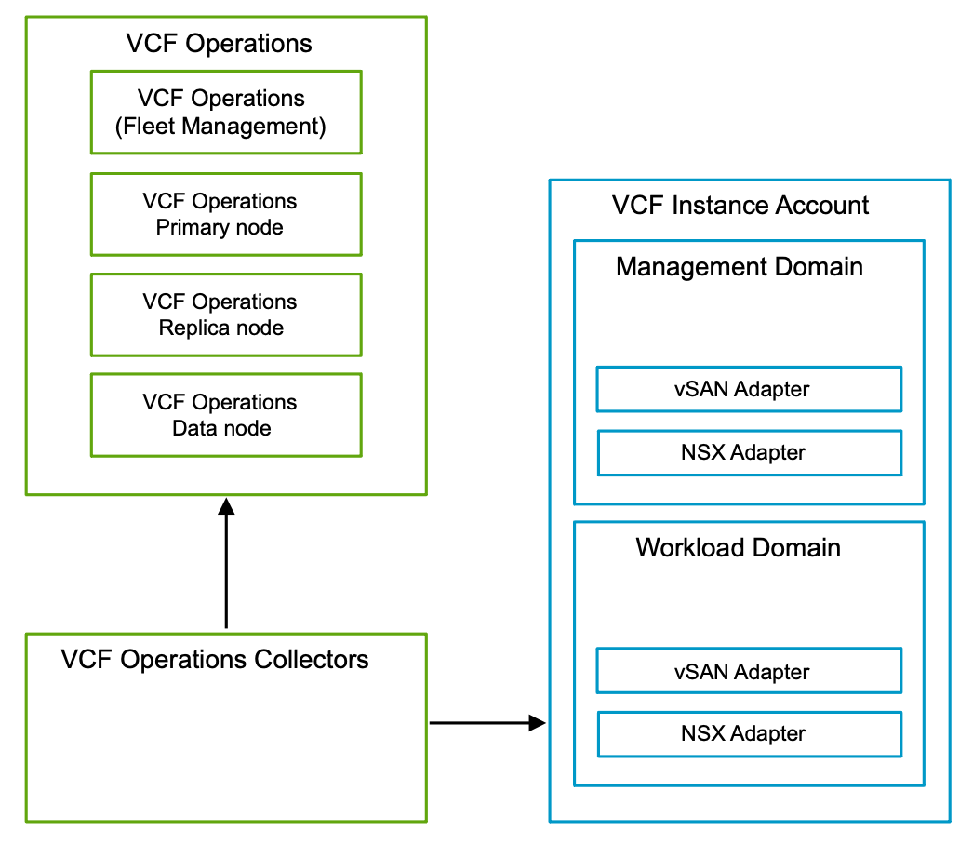

High Availability VCF Operations Model Attributes
A High Availability VCF Operations Model has the following attributes.
Attribute | Detail
Availability | Relies on vSphere HA to restart the nodes in the event of an ESX host failure. Additional level of availability for the components in:  - VCF Operations cluster  - VCF Operations collector groups
Scalability | Supports scale-up and scale-out.  Note Scale-out is supported for the VCF Operations data nodes and VCF Operations collector nodes.
Recovery | Restore through a backup.
Load balancing | Optional external load balancer for the VCF Operations cluster UI.

High Availability VCF Operations Model Sizing Considerations
Important Choose your initial sizing of the deployment based on known or forecasted objects. The object count will influence future scale-up and scale-out. Please refer to the VCF Operations sizing and scale documentation

High Availability VCF Operations Model Options
A High Availability VCF Operations Model can leverage options from the design areas listed below, depending on objectives.
Design Area | Options
Networking | - Default VM management distributed port group  - Dedicated distributed port group  - NSX segment (overlay or VLAN backed)
Licensing | - Connected Mode  - Disconnected Mode

High Availability VCF Operations Model Design Requirements
Table 3-479. Common VCF Operations Design Requirements for All Models
Design Requirement ID | Design Requirement | Justification | Implication
VCF-OPS-REQD-COM-001 | Deploy a single VCF Operations fleet management appliance in the default management vSphere cluster. | Provides life cycle management operations for VCF Operations fleet management components. | None.
VCF-OPS-REQD-COM-002 | Protect VCF Operations fleet management appliance by using vSphere HA. | Ensures availability of VCF Operations fleet management appliance without requiring manual intervention during an ESX host failure event. | None.
VCF-OPS-REQD-COM-003 | Deploy a single VCF Operations collector appliance in the default management vSphere cluster. | - Removes the load from the VCF Operations analytic node(s) from collecting metrics from local-instance applications.  - Reuse VCF Operations collectors to gather both logs and metrics across the VCF environment.  - Centralized management of logs and metrics, reducing administrative overhead. | You may need to scale-up the VCF Operations collector nodes to a greater size based on the known or forecast virtual machine and object count across each connected VCF Instance to adhere to the scale limits.
VCF-OPS-REQD-COM-004 | Protect VCF Operations collector appliance by using vSphere HA. | Ensures availability of VCF Operations collector appliance without requiring manual intervention during an ESX host failure event. | None.
Table 3-480. High Availability VCF Operations Model Design Requirements
Design Requirement ID | Design Requirement | Justification | Implication
VCF-OPS-REQD-HA-001 | Deploy VCF Operations as a cluster of three nodes in the default management vSphere cluster. | - Supports the high availability objectives by deploying VCF Operations as a cluster.  - Provides the capacity required for monitoring virtual machines or objects within the monitoring scale limits.  - Supports scale-out with additional data nodes. | - You must select a size for the VCF Operations cluster nodes based on the known or forecasted virtual machine and object count across each connected VCF Instance to adhere to the scale limits.  - Create an anti affinity rule (Separate Virtual Machines) for the VMs in the cluster after the deployment.
VCF-OPS-REQD-HA-002 | Deploy a single Unified VCF Operations collector node in the default management vSphere cluster. | Removes the load from the VCF Operations cluster from collecting metrics from local-instance applications. | You may need to scale-up the VCF Operations collector nodes to a greater size based on the known or forecasted virtual machine and object count across each connected VCF Instance to adhere to the scale limits.
VCF-OPS-REQD-HA-004 | Apply a vSphere Distributed Resource Scheduler (DRS) anti-affinity rule to the VCF Operations cluster nodes. | Using vSphere DRS prevents the VCF Operations cluster nodes from running on the same ESX host and risking the high availability of the cluster. | - You must perform additional configuration to set up an anti-affinity rule.  - You must have a minimum of four ESX hosts in the default management vSphere cluster to ensure you can put an ESX host in maintenance mode.  - If additional data nodes are added, you must update the anti-affinity rule and ensure there are enough ESX hosts in the default management vSphere cluster to ensure you can put an ESX host in maintenance mode.
VCF-OPS-REQD-HA-007 | The certificate for VCF Operations must include the FQDNs for all cluster nodes in the SAN (subject alternative name) attribute.  Note The SAN does not need to include the FQDN of VCF Operations collector nodes. | Ensures that the communication to the VCF Operations UI and API, and cross-component, is encrypted. | Prior to scale-out, the certificate for VCF Operations must be changed to also include the FQDN of the additional node in the SAN (subject alternative name) attribute.
VCF-OPS-REQD-HA-001 | If using an optional external load balancer in the high availability deployment model, the certificate for VCF Operations must also include the FQDN of the load balancer in the SAN (subject alternative name) attribute. | Ensures that the communication to the VCF Operations UI and API, and cross-component, is encrypted when using an external load balancer with the high availability model. | None.
Table 3-481. Common VCF Operations Design Recommendations for All Models
Design Recommendation ID | Design Recommendation | Justification | Implication
VCF-OPS-RECD-COM-001 | Enable data persistence on each VCF Operations collector appliance. | Provides the ability to store data in case of connectivity issues. | Storage availability on each VCF Operations collector must be monitored.
VCF-OPS-RECD-COM-002 | Configure VCF Operations to use a notifications configuration to route notifications for system events. | Integrates VCF Operations system events notifications to platform engineers, providing an enhanced user experience. | You must configure and maintain the notification integration.
VCF-OPS-RECD-COM-003 | Add a physical data center object to the VCF Operations configuration for the geographic location of each VCF Instance. | Provides organization of the VCF Operations collector nodes in VCF Operations inventory. | VCF Operations must have connection to the Internet to view and set the precise geographic coordinates in the UI.
VCF-OPS-RECD-COM-004 | Activate the Ping integration in VCF Operations. | Provides metrics on the availability of endpoints. | You must activate the integration manually.
VCF-OPS-RECD-COM-005 | Configure the currency in the VCF Operations global options based on your organization requirements. | To receive benefits of the VCF Operations cost engine, you must select a currency. | None.

VCF Operations - Networking and Internet Access Design Choices
There are several options regarding connectivity to the external resources and network placement for the VCF Operations components. You should choose one option from each of the tables below.
Table 3-482. Network Placement for VCF Operations Design Recommendations Default Distributed Port Group
Design Recommendation ID | Design Recommendation | Justification | Implications
VCF-OPS-RECD-NET-001 | Deploy the VCF Operations nodes on the distributed port group created by VCF Installer and reserved for management components. | Ensures that the VCF Operations nodes are deployed adjacent to the other components on the same Layer-2 network. | None.
Table 3-483. Network Placement for VCF Operations Design Recommendations Dedicated Distributed Port Group
Design Recommendation ID | Design Recommendation | Justification | Implications
VCF-OPS-RECD-NET-001 | Deploy the VCF Operations nodes on a dedicated distributed port group other than default port group reserved for management components by VCF Installer. | Ensures that the VCF Operations nodes are deployed in a dedicated Layer-2 network. | - You must skip the deployment of the VCF Operation (and VCF Operations fleet management) when using the VMware Cloud Foundation Installer.  - You must perform configuration to support the networking configuration as a post-deployment task before manually deploying the VCF Operations and its prerequisites.  - You must perform deployment using the SDDC Manager API with JSON file as input.  - You must ensure that VLAN is provisioned in each availability zone if stretched clusters are used.
Table 3-484. Network Placement for VCF Operations Design Recommendations VLAN-backed NSX Segment
Design Recommendation ID | Design Recommendation | Justification | Implications
VCF-OPS-RECD-NET-001 | Deploy the VCF Operations nodes on a VLAN-backed NSX segment. | Ensures that the VCF Operations nodes are deployed in a dedicated Layer-2 network. | - You must skip the deployment of the VCF Operations (and VCF Operations fleet management) when using the VCF Installer.  - You must perform configuration to support the networking configuration as a post-deployment task before manually deploying the VCF Operations and its prerequisites.  - You must perform deployment using the SDDC Manager API with JSON file as input.  - You must ensure that VLAN is provisioned in each availability zone if stretched clusters are used.
Table 3-485. Network Placement for VCF Operations Design Recommendations Ovelay-backed NSX Segment
Design Recommendation ID | Design Recommendation | Justification | Implications
VCF-OPS-RECD-NET-001 | Deploy the VCF Operations nodes on an overlay NSX segment. | Allow portability of the VCF Operations nodes to another VCF Instance in the VCF fleet without the need for reconfiguration of the IP addressing. | - You must skip the deployment of the VCF Operations (aVCF Operations fleet management) when using the VCF Installer.  - You must perform configuration to support the networking configuration as a post-deployment task before manually deploying the VCF Operations and its prerequisites.  - You must perform deployment using the SDDC Manager API with JSON file as input.
Table 3-486. Licensing for VCF Operations Design Recommendations Connected Mode
Design Recommendation ID | Design Recommendation | Justification | Implications
VCF-OPS-RECD-LIC-001 | Use VCF Operations in "Connected licensing mode". | - Provides easy license management and up to date states in overall licensing portal.  - No manual interaction required. | VCF Operations will require outbound connection to internet directly or through a proxy server.
Table 3-487. Licensing for VCF Operations Design Recommendations Disconnected Mode
Design Recommendation ID | Design Recommendation | Justification | Implications
VCF-OPS-RECD-LIC-001 | Use VCF Operations in "Disconnected licensing mode". | If your policy does not permit access to internet for management components. | - You need to upload usage statistics from VCF Operations to Broadcom's licensing portal and then download and apply entitlements to all VCF Operations.  - Usage statistics has be uploaded to the licensing portal every 180 days.
Table 3-488. VCF Operations Diagnostics Design Recommendations Manual Upload
Design Recommendation ID | Design Recommendation | Justification | Implications
VCF-OPS-RECD-DIAG-001 | Manually upload Skyline Health Diagnostics and Advisory signatures. | If your policy does not permit access to internet for management components. | Signatures should be downloaded manually and then uploaded into VCF Operations.
Table 3-489. VCF Operations Diagnostics Design Recommendations Online
Design Recommendation ID | Design Recommendation | Justification | Implications
VCF-OPS-RECD-DIAG-001 | Download Skyline Health Diagnostics and Advisory signatures directly from Broadcom's repository. | Ensures always up to date information about potential issues and mitigation steps in your environment. | VCF Operations will require outbound connection to internet directly or through a proxy server.
Table 3-490. Binary Management for VCF Operations Design Recommendations Online
Design Recommendation ID | Design Recommendation | Justification | Implications
VCF-OPS-RECD-BIN-001 | Connect to the online depot. | Ensures always up to date information about bundles for Install, Update, Patch and compatibility information. | VCF Operations will require outbound connection to internet directly or through a proxy server.
Table 3-491. Binary Management for VCF Operations Design Recommendations Offline
Design Recommendation ID | Design Recommendation | Justification | Implications
VCF-OPS-RECD-BIN-001 | Connect to an offline depot. | If your policy does not permit access to internet for management components you may configure an internal depot. | The bundles should be downloaded to a system with access to the Broadcom's depot and then uploaded to the internal depot by following your internal procedures.
Table 3-492. Binary Management for VCF Operations Design Recommendations Manual
Design Recommendation ID | Design Recommendation | Justification | Implications
VCF-OPS-RECD-BIN-001 | Upload files manually. | Removes the overhead of installing and managing an additional appliance for internal depot. | You should download and upload all the files to the respective directories and set the right permissions. A lot of manual labor and error prone process.

VCF Operations High Availability Deployment Model Design Recommendations
In your VCF Operations design, you can apply certain best practices as part of post deployment workflows.
Table 3-493. High Availability VCF Operations Model Design Recommendations
Design Recommendation ID | Design Recommendation | Justification | Implication
VCF-OPS-RCMD-HA-001 | Deploy VCF Operations with an external load balancer to load balance the connections across the VCF Operations cluster nodes. | Required to deploy a VCF Operations cluster deployment with distributed user interface access across members. | You must configure the external load balancer configuration to support this VCF Operations configuration.
VCF-OPS-RCMD-HA-002 | Create a collector group in VCF Operations for each VCF Instance and assign the default VCF Operations collector appliance. | Provides increased availability to metric collection across the VCF Operations collector appliances asigned to the collector group. | Manual reconfiguration of the VMware Cloud Foundation adapter required to utilze multiple VCF Operations collector appliances with the group.
VCF-OPS-RCMD-HA-003 | Deploy an additional VCF Operations collector node in the default management vSphere cluster. | Extends the availability of the VCF Operations collectors by balancing the load across the collectors when added to a collector group. | - You must deploy the collector node after the deployment of the VCF Operations.  - Additional collector node should be deployed for all VCF Instances that requires a collector group.
VCF-OPS-RCMD-HA-004 | Apply a vSphere Distributed Resource Scheduler (DRS) anti-affinity rule to the VCF Operations collector nodes. | Using vSphere DRS prevents the VCF Operations collectors from running on the same ESX host and risking the high availability of the collectors. | You must perform manual configuration to set up an anti-affinity rule.
VCF-OPS-RCMD-HA-005 | Reconfigure the default VMware Cloud Foundation Adapter in VCF Operations to use a local-instance collector group for a VCF Instance. | Increases the availability of metric collection. | This must be reconfigured post-deployment.

Continuous Availability VCF Operations Model
The Continuous Availability VCF Operations Model separates the VCF Operations cluster into two fault domains, stretching across two vSphere instances in two separate availability zones, and protects the analytics cluster against the loss of an entire fault domain.
VCF Operations uses a robust architecture to ensure data availability and fault tolerance across analytics nodes. Data is stored in pairs of analytics nodes, distributed across two fault domains, ensuring continuous availability and synchronization. Each object is stored in two nodes (primary and replica) across fault domains, providing redundancy and resilience in case of failures.
A fault domain consists of one or more analytics nodes, grouped according to their physical location in the data center. The two fault domains enables VCF Operations to tolerate failure of an entire physical location and failures from resources dedicated to a single fault domain. This design requires a VCF Operations witness in a third site.
To deploy the VCF Operations with continuous availability, you first deploy the initial VCF Operations instance by using the Simple VCF Operations Model or the High Availability VCF Operations Model. You then create a second VCF Instance in a separate site/availability zone where you deploy the VCF Operations witness.

Continuous Availability VCF Operations Model Attributes
A Continuous Availability VCF Operations Model has the following attributes.
Attribute | Detail
Availability | Implements design with two VCF instances, across two availability zones to protect data from an availability zone failure.  Inside the availability zone, relies on vSphere HA to restart the nodes in the event of an ESX host failure.
Scalability | Supports scale-up and scale-out.  Note Scale-out is supported for the VCF Operations data nodes and VCF Operations collector nodes.
Recovery | Redeploy of a components in one of the availability zones in case of availability zone failure.  Restore through a backup for the whole deployment, in case of both availability zones failure.
Load balancing | Optional external load balancer for the VCF Operations cluster UI.

Continuous Availability VCF Operations Model Sizing Considerations
Important Choose your initial sizing of the deployment based on known or forecasted objects. The object count will influence future scale-up and scale-out. Please refer to the VCF Operations sizing and scale documentation

Continuous Availability VCF Operations Model Options
A Continuous Availability VCF Operations Model can leverage options from the design areas listed below, depending on objectives.
Design Area | Options
Networking | - Default VM management distributed port group  - Dedicated distributed port group  - NSX segment (overlay or VLAN backed)
Licensing | - Connected Mode  - Disconnected Mode

Continuous Availability VCF Operations Model Design Requirements
Table 3-494. Common VCF Operations Design Requirements for All Models
Design Requirement ID | Design Requirement | Justification | Implication
VCF-OPS-REQD-COM-001 | Deploy a single VCF Operations fleet management appliance in the default management vSphere cluster. | Provides life cycle management operations for VCF Operations fleet management components. | None.
VCF-OPS-REQD-COM-002 | Protect VCF Operations fleet management appliance by using vSphere HA. | Ensures availability of VCF Operations fleet management appliance without requiring manual intervention during an ESX host failure event. | None.
VCF-OPS-REQD-COM-003 | Deploy a single VCF Operations collector appliance in the default management vSphere cluster. | - Removes the load from the VCF Operations analytic node(s) from collecting metrics from local-instance applications.  - Reuse VCF Operations collectors to gather both logs and metrics across the VCF environment.  - Centralized management of logs and metrics, reducing administrative overhead. | You may need to scale-up the VCF Operations collector nodes to a greater size based on the known or forecast virtual machine and object count across each connected VCF Instance to adhere to the scale limits.
VCF-OPS-REQD-COM-004 | Protect VCF Operations collector appliance by using vSphere HA. | Ensures availability of VCF Operations collector appliance without requiring manual intervention during an ESX host failure event. | None.
Table 3-495. Continuous Availability VCF Operations Model Design Requirements
Design Requirement ID | Design Requirement | Justification | Implication
VCF-OPS-REQD-CA-001 | Deploy VCF Operations in the default management vSphere cluster. | - Supports the high availability objectives by deploying VCF Operations as a cluster.  - Provides the capacity required for monitoring virtual machines or objects within the monitoring scale limits.  - Supports scale-out with additional data nodes. | - You must select a size for the VCF Operations cluster nodes based on the known or forecasted virtual machine and object count across each connected VCF Instance to adhere to the scale limits.  - Create an anti affinity rule (Separate Virtual Machines) for the VMs in the cluster after the deployment.
VCF-OPS-REQD-CA-002 | Deploy a single Unified VCF Operations collector node in the default management vSphere cluster. | Removes the load from the VCF Operations cluster from collecting metrics from local-instance applications. | You may need to scale-up the VCF Operations collector nodes to a greater size based on the known or forecasted virtual machine and object count across each connected VCF Instance to adhere to the scale limits.
VCF-OPS-REQD-CA-003 | The certificate for VCF Operations must include the FQDNs for all cluster nodes in the SAN (subject alternative name) attribute.  Note The SAN does not need to include the FQDN of VCF Operations collector nodes. | Ensures that the communication to the VCF Operations UI and API, and cross-component, is encrypted. | Prior to scale-out, the certificate for VCF Operations must be changed to also include the FQDN of the additional node in the SAN (subject alternative name) attribute.
VCF-OPS-REQD-CA-004 | Deploy a second VCF instance in a separate availability zone. | A second instance is needed to provide a separate SDDC Manager and fully independent infrastructure.
VCF-OPS-REQD-CA-005 | Satisfy latency requirements for different components. | VCF Operations Continuous Availability requires:  - 10ms with peaks up to 20 ms during 20 sec intervals between the cluster nodes.  - 30ms between the witness and the cluster nodes. | Availability zones should be in close proximity and connected with enterprise grade connection.
VCF-OPS-REQD-CA-006 | 3rd location (Separate Availability zone) for witness node deployment. | The witness node ensures cluster health and determines which fault domain remains online during communication failures.
VCF-OPS-REQD-CA-007 | Reconfigure primary replica cluster node to a data node if VCF Operations was deployed with High Availability. | During the configuration of VCF Operations Continuous Availability we will deploy replication partner of the primary node in the second availability zone.
VCF-OPS-REQD-CA-008 | Deploy through vSphere:  - Replication partners to the nodes in the primary AZ in the secondary AZ.  - Witness node in the designated 3rd location. | Replica nodes for all components, should be deployed from a template and later configured in VCF Operations. | Manual workflow spanning across vSphere and VCF Operations.
VCF-OPS-REQD-CA-009 | If using an optional external load balancer, the certificate for VCF Operations must also include the FQDN of the load balancer in the SAN (subject alternative name) attribute. | Ensures that the communication to the VCF Operations UI and API, and cross-component, is encrypted when using an external load balancer with the high availability model. | None.

VCF Operations - Networking and Internet Access Design Choices
There are several options regarding connectivity to the external resources and network placement for the VCF Operations components. You should choose one option from each of the tables below.
Table 3-496. Network Placement for VCF Operations Design Recommendations Default Distributed Port Group
Design Recommendation ID | Design Recommendation | Justification | Implications
VCF-OPS-RECD-NET-001 | Deploy the VCF Operations nodes on the distributed port group created by VCF Installer and reserved for management components. | Ensures that the VCF Operations nodes are deployed adjacent to the other components on the same Layer-2 network. | None.
Table 3-497. Network Placement for VCF Operations Design Recommendations Dedicated Distributed Port Group
Design Recommendation ID | Design Recommendation | Justification | Implications
VCF-OPS-RECD-NET-001 | Deploy the VCF Operations nodes on a dedicated distributed port group other than default port group reserved for management components by VCF Installer. | Ensures that the VCF Operations nodes are deployed in a dedicated Layer-2 network. | - You must skip the deployment of the VCF Operation (and VCF Operations fleet management) when using the VMware Cloud Foundation Installer.  - You must perform configuration to support the networking configuration as a post-deployment task before manually deploying the VCF Operations and its prerequisites.  - You must perform deployment using the SDDC Manager API with JSON file as input.  - You must ensure that VLAN is provisioned in each availability zone if stretched clusters are used.
Table 3-498. Network Placement for VCF Operations Design Recommendations VLAN-backed NSX Segment
Design Recommendation ID | Design Recommendation | Justification | Implications
VCF-OPS-RECD-NET-001 | Deploy the VCF Operations nodes on a VLAN-backed NSX segment. | Ensures that the VCF Operations nodes are deployed in a dedicated Layer-2 network. | - You must skip the deployment of the VCF Operations (and VCF Operations fleet management) when using the VCF Installer.  - You must perform configuration to support the networking configuration as a post-deployment task before manually deploying the VCF Operations and its prerequisites.  - You must perform deployment using the SDDC Manager API with JSON file as input.  - You must ensure that VLAN is provisioned in each availability zone if stretched clusters are used.
Table 3-499. Network Placement for VCF Operations Design Recommendations Ovelay-backed NSX Segment
Design Recommendation ID | Design Recommendation | Justification | Implications
VCF-OPS-RECD-NET-001 | Deploy the VCF Operations nodes on an overlay NSX segment. | Allow portability of the VCF Operations nodes to another VCF Instance in the VCF fleet without the need for reconfiguration of the IP addressing. | - You must skip the deployment of the VCF Operations (aVCF Operations fleet management) when using the VCF Installer.  - You must perform configuration to support the networking configuration as a post-deployment task before manually deploying the VCF Operations and its prerequisites.  - You must perform deployment using the SDDC Manager API with JSON file as input.
Table 3-500. Licensing for VCF Operations Design Recommendations Connected Mode
Design Recommendation ID | Design Recommendation | Justification | Implications
VCF-OPS-RECD-LIC-001 | Use VCF Operations in "Connected licensing mode". | - Provides easy license management and up to date states in overall licensing portal.  - No manual interaction required. | VCF Operations will require outbound connection to internet directly or through a proxy server.
Table 3-501. Licensing for VCF Operations Design Recommendations Disconnected Mode
Design Recommendation ID | Design Recommendation | Justification | Implications
VCF-OPS-RECD-LIC-001 | Use VCF Operations in "Disconnected licensing mode". | If your policy does not permit access to internet for management components. | - You need to upload usage statistics from VCF Operations to Broadcom's licensing portal and then download and apply entitlements to all VCF Operations.  - Usage statistics has be uploaded to the licensing portal every 180 days.
Table 3-502. VCF Operations Diagnostics Design Recommendations Manual Upload
Design Recommendation ID | Design Recommendation | Justification | Implications
VCF-OPS-RECD-DIAG-001 | Manually upload Skyline Health Diagnostics and Advisory signatures. | If your policy does not permit access to internet for management components. | Signatures should be downloaded manually and then uploaded into VCF Operations.
Table 3-503. VCF Operations Diagnostics Design Recommendations Online
Design Recommendation ID | Design Recommendation | Justification | Implications
VCF-OPS-RECD-DIAG-001 | Download Skyline Health Diagnostics and Advisory signatures directly from Broadcom's repository. | Ensures always up to date information about potential issues and mitigation steps in your environment. | VCF Operations will require outbound connection to internet directly or through a proxy server.
Table 3-504. Binary Management for VCF Operations Design Recommendations Online
Design Recommendation ID | Design Recommendation | Justification | Implications
VCF-OPS-RECD-BIN-001 | Connect to the online depot. | Ensures always up to date information about bundles for Install, Update, Patch and compatibility information. | VCF Operations will require outbound connection to internet directly or through a proxy server.
Table 3-505. Binary Management for VCF Operations Design Recommendations Offline
Design Recommendation ID | Design Recommendation | Justification | Implications
VCF-OPS-RECD-BIN-001 | Connect to an offline depot. | If your policy does not permit access to internet for management components you may configure an internal depot. | The bundles should be downloaded to a system with access to the Broadcom's depot and then uploaded to the internal depot by following your internal procedures.
Table 3-506. Binary Management for VCF Operations Design Recommendations Manual
Design Recommendation ID | Design Recommendation | Justification | Implications
VCF-OPS-RECD-BIN-001 | Upload files manually. | Removes the overhead of installing and managing an additional appliance for internal depot. | You should download and upload all the files to the respective directories and set the right permissions. A lot of manual labor and error prone process.

Continuous Availability VCF Operations Model Design Recommendations
Table 3-507. Common VCF Operations Design Recommendations for All Models
Design Recommendation ID | Design Recommendation | Justification | Implication
VCF-OPS-RECD-COM-001 | Enable data persistence on each VCF Operations collector appliance. | Provides the ability to store data in case of connectivity issues. | Storage availability on each VCF Operations collector must be monitored.
VCF-OPS-RECD-COM-002 | Configure VCF Operations to use a notifications configuration to route notifications for system events. | Integrates VCF Operations system events notifications to platform engineers, providing an enhanced user experience. | You must configure and maintain the notification integration.
VCF-OPS-RECD-COM-003 | Add a physical data center object to the VCF Operations configuration for the geographic location of each VCF Instance. | Provides organization of the VCF Operations collector nodes in VCF Operations inventory. | VCF Operations must have connection to the Internet to view and set the precise geographic coordinates in the UI.
VCF-OPS-RECD-COM-004 | Activate the Ping integration in VCF Operations. | Provides metrics on the availability of endpoints. | You must activate the integration manually.
VCF-OPS-RECD-COM-005 | Configure the currency in the VCF Operations global options based on your organization requirements. | To receive benefits of the VCF Operations cost engine, you must select a currency. | None.
Table 3-508. Continuous Availability VCF Operations Model Recommendations
Design Recommendation ID | Design Recommendation | Justification | Implication
VCF-OPS-RCMD-CA-001 | Deploy VCF Operations with an external load balancer to load balance the connections across the VCF Operations cluster nodes. | Required to deploy a VCF Operations cluster deployment with distributed user interface access across members. | You must configure the external load balancer configuration to support this VCF Operations configuration.
VCF-OPS-RCMD-CA-002 | Create a collector group in VCF Operations for each VCF Instance and assign the default VCF Operations collector appliance. | Provides increased availability to metric collection across the VCF Operations collector appliances asigned to the collector group. | Manual reconfiguration of the VMware Cloud Foundation adapter required to utilze multiple VCF Operations collector appliances with the group.
VCF-OPS-RCMD-CA-003 | Reconfigure the default VMware Cloud Foundation Adapter in VCF Operations to use a local-instance collector group for a VCF Instance. | Increases the availability of metric collection. | This must be reconfigured post-deployment.
VCF-OPS-RCMD-CA-004 | Deploy a second VCF Operations collector appliance in the default management vSphere cluster and assign it to the collector group. | Increases the availability of metric collection. | None.
VCF-OPS-RCMD-CA-005 | Apply a vSphere Distributed Resource Scheduler (DRS) anti-affinity rule to the VCF Operations collector nodes in the same group. | Using vSphere DRS prevents the VCF Operations collectors from running on the same ESX host and risking the high availability of the collectors. | You must perform manual configuration to set up an anti-affinity rule.

VCF Configuration Drift Design
Configuration drift supports a desired state approach to managing a VCF fleet based on security and compliance best practices.
To track configuration drift, VCF Operations uses a VCF Collector to retrieve configuration values from vCenters and vSphere clusters. The gathered configuration data is compared to the desired state values in the configuration template. The detection process is applied through a policy. Policies can be configured based on the global or regional desired state values. Each policy runs on a defined schedule. To ensure the desired state values are vetted before publishing them as a policy and enforced, configuration template source control can be managed externally through GitHub or GitLab and imported through a job.
Figure 3-30. Configuration Drift Design
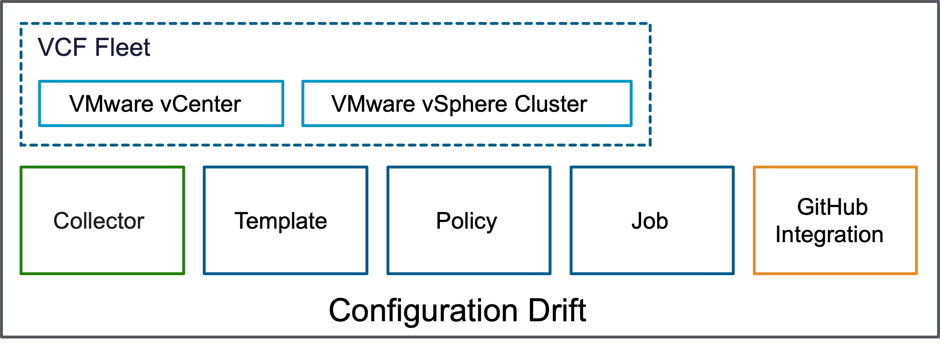

Design Choices
Determine if there will be a single configuration template or if multiple configuration templates are needed. Configuration values are specific to each deployment and should be adjusted. Factors such as 'geographic location, environment sensitivity, or variances in environments requiring more than one template should be considered. It is possible to break configuration drift into separate configuration templates. Some configuration templates may hold global configuration values while others may be more focused on localized configuration values.
- Evaluate configurations to determine if there are regional, geographical, or other criterion that require the use of multiple configuration templates.
- For greenfield deployments, the configurations identified during installation may also need to be considered against the desired state configuration template values.
- Evaluate if a different configuration template is necessary for the management domain instead of the workload domain.
- Consider that in some deployments a single configuration template can be used.
If two or more policies are applied using different configuration templates and there are conflicting configuration overlaps, the Configuration Drifts will trigger the job to show alerts for all policies with conflicting configuration values. It is important to avoid configuration template overlap and to apply policies in such a way that there are no conflicting configuration overlaps.
Design Choice | Justification | Implication
Global desired state values are assigned their own configuration template. | Consistent desired value across all instances usually enforced based on company policies. | A single configuration template using a single policy is applied to all instances to track universal configuration values for possible drift.
Regional or data center specific desired state values are assigned their own configuration template. | Configurations that are common based on the deployment context can shared a configuration template based on those common configurations. | Reduces the number of configuration templates that must be applied and maximizes the configuration drift capability.
Consider vCenter and/or vSphere Clusters values before establishing them as desired values in configuration drift templates. | Any values already in use should be examined and confirmed to be accurate going forward. | Avoid creating a new set of configuration templates by capturing values against a known, target instance.
Evaluate vCenter and/or vSphere Clusters for any variation against VCF installer values. | Values selected during installation should be evaluated to minimize the need to revisit the values for those configurations that were already set based on valid use cases. | Capture values against a known, target instance.

Design Requirements
Evaluate configurations with all relevant stakeholders to create an understanding and context for each desired state value to be assigned one or more configuration templates. Ensure a clear understanding and inventory of vCenter and vSphere Cluster fleet to apply a policy that enforces one configuration template.
This solution is relevant for all designs because the policy can be enforced without altering the configuration drift solution. In the event of a disaster recovery event, the configuration template and policy should not have any changes. The Job tracking the configuration drift should already include the primary vCenter and any vCenters located within the disaster recovery environment.

Security and Compliance using Configuration Drift Design Requirements
Design Requirement ID | Design Requirement | Justification | Implication
VCF-OPS-REQD-CD-001 | Determine if more than one configuration template will be necessary for detecting desired state configuration drift. | Size of deployment and homogeneity of configuration values may be optimized through a single configuration template. | Maximize monitoring of configuration drift by using only the appropriate number of configuration templates.
VCF-OPS-REQD-CD-002 | Assign global variables as a separate configuration template that is applied to all in-scope vCenters and vSphere Clusters. | Set of configuration values are consistent across all instances. | Templates with global configuration values can be applied and monitored in a single report.
VCF-OPS-REQD-CD-003 | Structure multiple configuration templates according to geography, data center, or other hierarchy that allows for policy enforcement at a grouping level. | Monitoring configurations requires the requisite grouping to maximize the monitoring to group configurations that share desired values in common. | Monitoring of configuration drift is enabled at the appropriate level.
VCF-OPS-REQD-CD-004 | Apply one configuration template with just one policy per each vCenter or vSphere Cluster. | Deployment size is sufficiently practical to be managed with minimal configuration drift value variation between instances. | Monitoring is simplified through the use of a single report.

Design Recommendations
Evaluating the configuration drift solution has several aspects that need to be carefully evaluated. These recommendations should be considered.

Security and Compliance using Configuration Drift Design Recommendations
Design Requirement ID | Design Requirement | Justification | Implication
VCF-OPS-RCMD-CD-001 | Create a job to run each configuration template. | Produce audit evidence to support security and compliance documentation requirements. | Enables additional layers of documentation to support monitoring of control such as email confirmation the job was run successfully and creates a PDF report that can be stored as audit records.
VCF-OPS-RCMD-CD-002 | Enable job updates via email to capture documentation for each job, which can also be used as documentation of the outcome of the job. | Capture evidence that the job was run successfully to support security and compliance control evidence. | Allows auditor to compare multiple monitoring controls to correlate configuration drift is being used and monitoring is active as an operating control.
VCF-OPS-RCMD-CD-003 | Consult both the Administrator and the Security Auditor to evaluate all configuration values use in configuration templates. | Security team participation includes an important perspective to ensure configuration drift capabilities are designed and deployed according to security and compliance best practices. | Involving the appropriate stakeholders and obtaining sign-off will minimize the risk of mis-configuration and audit findings gaps.
VCF-OPS-RCMD-CD-004 | Run daily jobs can to monitor configuration drift and separately run a weekly job to track configuration drift over time. | There will be smaller sample sizes in weekly (52) than daily (365) to store and present as audit evidence providing less risk of missing documentation records. | Treating control as weekly will result in fewer samples (typically 5-9 for weekly while daily can be 25+) making the control more manageable for auditing.
VCF-OPS-RCMD-CD-005 | Create and retain a weekly job to be used as audit documentation of the configuration drift control. | Weekly configuration drift monitoring in the form of a report provides audit evidence of the control operating effectively. | Auditor subjectivity may shift to the configuration template design and trust in the reports instead of sampling larger data sets, thus reducing the scope and level of effort for the audit.
VCF-OPS-RCMD-CD-006 | Increase the retention period of configuration drift reporting to 30 days (maximum parameter allowed). | Default retention period of 7 days covers too small a time period for audit evidence. | Audit evidence is retained for 30 days to facilitate subsequent storage in an external system.
VCF-OPS-RCMD-CD-007 | Store weekly reports in an alternative location in order to ensure the audit evidence captures a suggested 18 month rolling period. | Audit evidence is typically required for a 12 month period, yet audits may not complete nearly 6 months after the target audit period has ended. | Ensure audit evidence is available for audits and their target audit timeline.
VCF-OPS-RCMD-CD-008 | Enable job updates via email and retain email records for 18 months. | Successful execution of the job shows the health of configuration drift monitoring. | Audit evidence supports operational success to monitor configuration drift through system jobs.
VCF-OPS-RCMD-CD-009 | Manually store PDF configuration drift reports in a separate repository and retain records for 18 months. | Audit evidence for a typical year-long audit that may occur several months after the audit period ends, typically 18 months is sufficient. | Audit evidence is made available to auditors for the target audit period in scope.
VCF-OPS-RCMD-CD-010 | If source control (GitHub/Gitlab for example) is used, ensure tokens are assigned at the appropriate level. | Tokens should be assigned at the organizational level to facilitate continuity, instead of assigning them at an individual level. | Tokens grant access to the source control repository and these need to be managed by the organization.
VCF-OPS-RCMD-CD-011 | If source control (GitHub/Gitlab for example) is used, ensure appropriate access to is granted to the individuals able to alter the template source control values. | Access to the underlying source control and template values can alter the process of evaluating and confirming values that could lead to unauthorized configuration values. | Configuration drift shifts the risk from ad hoc process and people based into a desired state configuration value that undergoes proper governance controls to ensure its value is correctly identified and assigned, which then creates trust in the system making source control and access to it an elevated risk that needs to be properly manged.

SDDC Manager Detailed Design
SDDC Manager provides fleet management capabilities for the underlying virtual infrastructure and uses binaries to deploy new workload domains, and to patch and upgrade existing ones.
Fleet management capabilities provided by the SDDC Manager appliance include the following, the main difference in VMware Cloud Foundation 9.0 is the process for performing these operations is performed with either the VCF Operations UI or vCenter UI.
- Commissioning or decommissioning ESX hosts.
- Deployment of workload domains.
- Adding and extending clusters in workload domains.
- Life cycle management of the virtual infrastructure components in all workload domains.
- Creation of network pools for ESX host configuration workload domains.
- Certificate management of underlying virtual infrastructure.
- Password management and rotation of underlying virtual infrastructure.
- Backup configuration of underlying virtual infrastructure.

SDDC Manager Binary Management
SDDC Manager uses binaries to deploy, patch or upgrade the underlying virtual infrastructure and provides users with flexibility in how they obtain and consume the binaries.
Mode | Details | Benefits | Implications
Connected Mode | SDDC Manager maintains a live connection to Broadcom depot via the internet and regularly updates the unified manifest. | Reduced operational overhead. | An outbound internet connection to the Broadcom depot is required for Connected Mode.
Disconnected Mode | Offline registration of SDDC Manager with an internal depot. | - Internet connection is not required for SDDC Manager instances.  - Internal centrally managed depot.  - Increased security posture. | Operational overhead of manual binary download management to populate the offline depot.
Manual | Manual download of binaries and upload to an SDDC Manager instance. | Increased security posture. | Operational overhead of manual binary download management.
Table 3-509. SDDC Manager Design Requirements
Design Requirement ID | Design Requirement | Justification | Implication
VCF-SDDCM-REQD-CFG-001 | Deploy a new SDDC Manager with each new VCF Instance. | The VCF Installer will automatically install new SDDC Manager with each new management domain. | None.
VCF-SDDCM-REQD-CFG-002 | Deploy an SDDC Manager system in the first availability zone of the management domain. | SDDC Manager is required to perform VMware Cloud Foundation capabilities, such as provisioning workload domains, deploying solutions, patching, upgrading, and others. | None.
VCF-SDDCM-REQD-CFG-003 | Place the SDDC Manager appliance on the VM management network. | - Simplifies IP addressing for management VMs by using the same VLAN and subnet.  - Provides simplified secure access to management VMs in the same VLAN network. | None.

VCF Operations for Logs Detailed Design
A VCF fleet can include one or more of the supported for VCF Operations for logs Models. This section describes the options, requirements and recommendations for each VCF Operations for logs Model.
- Simple VCF Operations for Logs Model
- High Availability VCF Operations for Logs Model

VCF Operations for Logs Deployment Models
Table 3-510. Common Design Attributes for the VCF Operations for Logs Deployment Models
Attribute | Details
Centralized management | Provides a centralized log management framework for vCenter, ESX, VCF Automation, NSX, and VCF Identity Broker.  The use cases listed are an example, but they are not limited to this subset, for a High Availability / Cluster VCF Operations for logs instance to manage:  - Fleet level deployments  - Default deployment model for all management and workload environments  - High availability environments  The use cases listed are an example, but they are not limited to this subset, for a Simple / Standard VCF Operations for logs instance to manage:  - Test/Dev Environments Only
Initial deployment | Deployed after initial deployment of infrastructure and Ops. It is deployed within the Fleet Management component of VCF Ops.
Architecture flexibility | Can be deployed in a Simple or Highly Available Cluster deployment.  Recommended deployment is a HA Cluster deployment and it satisfies most use cases.  Simple deployment is for test/dev environments, it is not for production use cases.

Figure 3-31. VCF Fleet Single Site Deployment Design
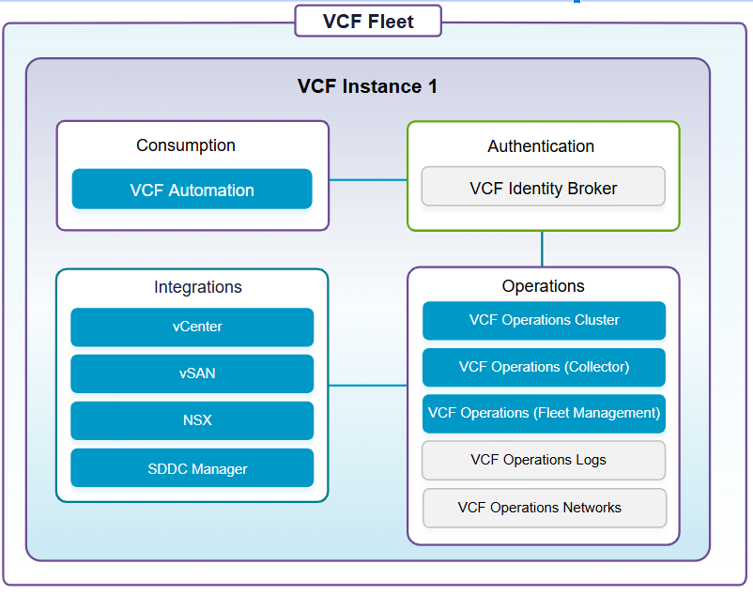

VCF Operations for logs Sizing Considerations
Log ingestion rates for the Simple / Standard deployment is as follows the storage requirement is 530 GB per node but can support up to 6 TB per volume.
The table below shows examples for simple deployments, to understand the numbers for a clustered deployment simply multiply by 3.
Ex: Medium Node supports 1000 IOPs, a medium cluster deployment has 3 medium sized nodes so it supports 3 x 1000 = 3000 IOPs.
Node Size | Log Ingest Rate | Virtual CPUs | Memory | IOPs | Syslog Connections (Active TCP Connections) | Events Per Second
Small | 30 GB/Day | 4 | 8 GB | 500 | 100 | 2000
Medium | 75 GB/Day | 8 | 16 GB | 1000 | 250 | 5000
Large | 225GB/Day | 16 | 32 GB | 1500 | 750 | 15000

Log Retention and Archive Design for VCF Operations for logs
VCF Operations for Logs can allow for archival and retention based upon your organizations requirements. Your organization might require log retention and/or archiving due to compliance, auditing or for troubleshooting purposes and in doing so you will need to configure Operations for Logs to do this. You will need to calculate the sizing by using the VRLI Sizer. By default the virtual disk configuration within Operations for Logs is as shown in the table below.
Table 3-511. Virtual Disk Configuration on the VCF Operations for logs Appliance
Hard disk | Size | Usage
Hard disk 1 | 20 GB | Root file system
Hard disk 2 | 510 GB for a medium-size deployment | Contains two partitions:  - /storage/var for system logs  - /storage/core for collected logs
Table 3-512. Log Archiving Attributes
Attribute | Description
Archiving period | VCF Operations for logs archives log messages as soon as possible. At the same time, the logs are retained on the virtual appliance until the free local space is almost filled. Data exists on both theVMware Aria Operations for Logsappliance and the archive location for most of the retention period. The archiving period must be longer than the retention period.
Archive location | The archive location must be on an NFS version 3 (NFSv3) shared storage. The archive location must be available and must have enough capacity to accommodate the archives.

Simple VCF Operations for Logs Model
A single VCF Operations for logs node deployed in a vSphere cluster. Availability is provided by the native vSphere HA functionality within the vSphere cluster.
Figure 3-32. Simple VCF Operations for Logs Model
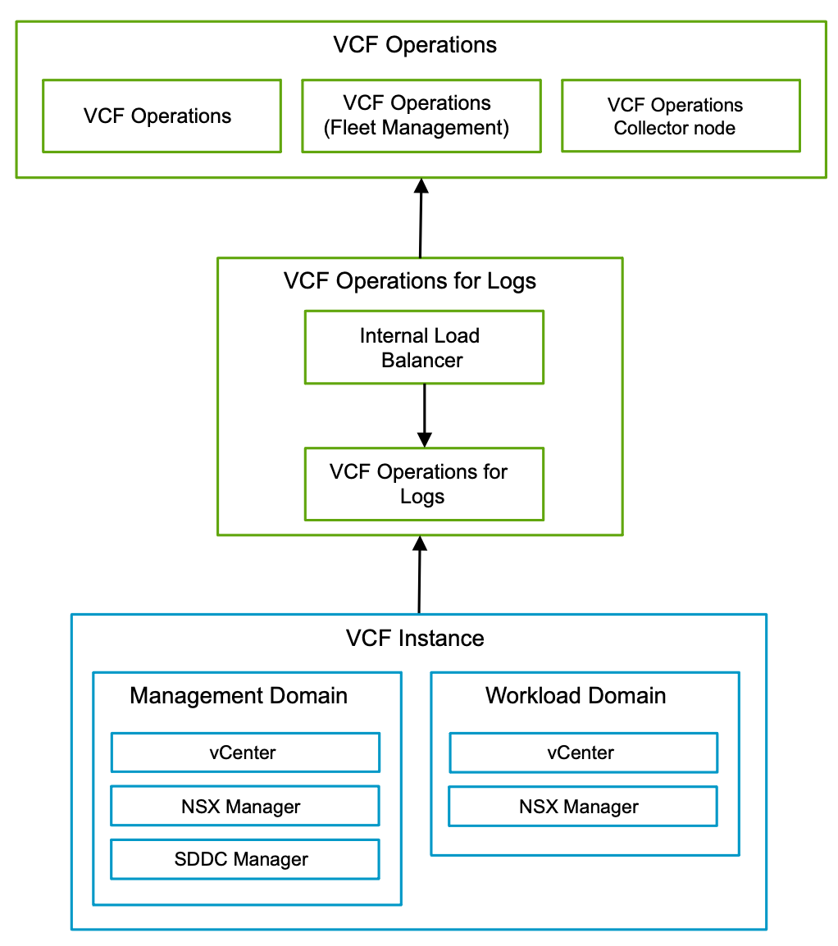

Simple VCF Operations for Logs Model Attributes
A Simple VCF Operations for Logs Model has the following attributes.
Attribute | Detail
Centralized management | Provides a centralized log management framework for vCenter, ESX, NSX, VCF Operations, VCF Automation, and VCF Identity Broker.
Availability | Relies on vSphere HA to restart the nodes in the event of an ESX host failure.
Scalability | Supports scale-up and scale-out.
Recoverability | Restore through a backup.

Simple VCF Operations for Logs Model Options
A Simple VCF Operations for Logs Model can leverage options from the design areas listed below, depending on objectives.
Design Area | Options
Appliance Size | - Small  - Medium  - Large

Simple VCF Operations for Logs Model Design Requirements
Table 3-513. Simple VCF Operations for Logs Model Design Requirements
Design Requirement ID | Design Requirement | Justification | Implication
VCF-LOGS-REQD-SIM-001 | Deploy VCF Operations for logs as a single node - one primary node with an integrated load balancer, in the default management vSphere cluster. | - Supports the simple deployment objective.  - Supports scale-out to a high availability model. | None.

Simple VCF Operations for Logs Model Design Recommendations
Table 3-514. Common VCF Operations for Logs Design Recommendations for All Models
Design Recommendation ID | Design Recommendation | Justification | Implication
VCF-LOGS-RCMD-COM-001 | Install the content pack for NSX from the Marketplace. | Enables log analysis of NSX based logs. | Internet access is required to access the Marketplace.
VCF-LOGS-RCMD-COM-002 | Configure a retention period for VCF Operations for logs  according to your design objectives. | Accommodates logs from the expected number of logging sources in VMware Cloud Foundation platform. | None.
VCF-LOGS-RCMD-COM-003 | Configure alert notifications. | Activates alerts from VCF Operations for logs sent to administrators and operators. | If using email for notifications, you must configure the SMTP server settings in VCF Operations for logs.
VCF-LOGS-RCMD-COM-004 | Enable vCenter adapter for VCF Operations for Logs | To gather logs from vCenter the Logs adapter needs to be manually enabled. It is not enabled by default. | Requires manually enabling per adapter.

High Availability VCF Operations for Logs Model
The High Availability VCF Operations for logs model consists of a three-node deployment behind and internal load balancer. This model provides resiliency at both the application level through the clustered deployment as well as the vSphere cluster level through vSphere HA and vSphere DRS functionality.
Figure 3-33. High Availability VCF Operations for Logs Model
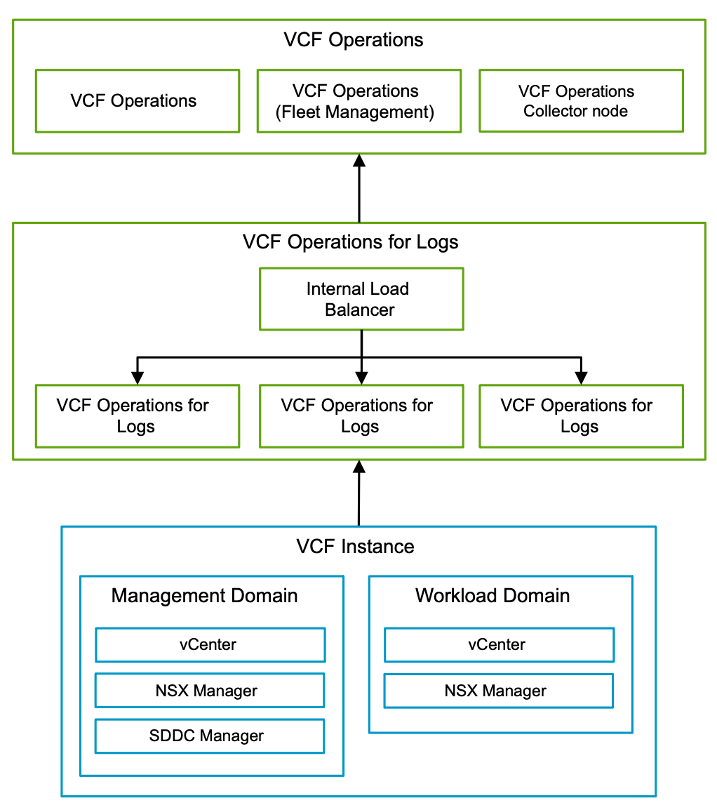

High Availability VCF Operations for Logs Model Attributes
A High Availability VCF Operations for Logs has the following attributes.
Attribute | Detail
Centralized management | Provides a centralized log management framework for vCenter, ESX, NSX, VCF Operations, VCF Automation, and VCF Identity Broker.
Availability | Relies on cluster technology in the event of an outage or ESX HA technology in the case of a host failure.
Scalability | Supports scale-up and scale-out.
Recoverability | Restore through a backup.

High Availability VCF Operations for Logs Model Options
A High Availability VCF Operations for Logs Model can leverage options from the design areas listed below, depending on objectives.
Design Area | Options
Appliance Size | - Small  - Medium  - Large

High Availability VCF Operations for Logs Model Design Requirements
Table 3-515. High Availability VCF Operations for Logs Model Design Requirements
Design Requirement ID | Design Requirement | Justification | Implication
VCF-LOGS-REQD-HA-001 | Deploy VCF Operations for logs as a three node cluster - one primary and two worker nodes with an integrated load balancer, in the default management vSphere cluster. | - Provides high availability.  - Using the integrated load balancer prevents a single point of failure.  - Using the integrated load balancer simplifies the VCF Operations for logs deployment and subsequent integration. | - You must deploy a minimum of three appropriately sized nodes.  - You must size all nodes identically.  - If the capacity of your VCF Operations for logscluster must expand, identical capacity must be added to each node.
VCF-LOGS-REQD-HA-002 | Protect all VCF Operations for logs cluster nodes by using vSphere High Availability. | Supports the availability objectives for VCF Operations for logs without requiring manual intervention during an ESX host failure event. | None.
VCF-LOGS-REQD-HA-003 | Apply a vSphere Distributed Resource Scheduler (DRS) anti-affinity rule to the VCF Operations for logs cluster nodes. | Using vSphere DRS prevents the VCF Operations for logs cluster nodes from running on the same ESXhost and risking the high availability of the cluster. | None.

High Availability VCF Operations for Logs Model Design Recommendations
Table 3-516. Common VCF Operations for Logs Design Recommendations for All Models
Design Recommendation ID | Design Recommendation | Justification | Implication
VCF-LOGS-RCMD-COM-001 | Install the content pack for NSX from the Marketplace. | Enables log analysis of NSX based logs. | Internet access is required to access the Marketplace.
VCF-LOGS-RCMD-COM-002 | Configure a retention period for VCF Operations for logs  according to your design objectives. | Accommodates logs from the expected number of logging sources in VMware Cloud Foundation platform. | None.
VCF-LOGS-RCMD-COM-003 | Configure alert notifications. | Activates alerts from VCF Operations for logs sent to administrators and operators. | If using email for notifications, you must configure the SMTP server settings in VCF Operations for logs.
VCF-LOGS-RCMD-COM-004 | Enable vCenter adapter for VCF Operations for Logs | To gather logs from vCenter the Logs adapter needs to be manually enabled. It is not enabled by default. | Requires manually enabling per adapter.

VCF Operations for Networks Detailed Design
A VCF fleet can include one of the supported VCF Operations for Networks Models. This section describes the options, requirements and recommendations for each VCF Operations for Networks Model.
- Simple VCF Operations for Networks Model
- High Availability VCF Operations for Networks Model

VCF Operations for Networks - Logical Design
Note VCF Operations for networks can be deployed as a cluster or a single node. This cluster processes the collected data and presents it using a dashboard. VCF Operations for Networks also uses collector nodes to collect data from the data sources, such as vCenter server and NSX Manager which then sends the data to the platform cluster for processing.
The platform cluster capacity is based on the deployment size of each node and the number of nodes composing the cluster. For more information about how to decide the platform brick (node) size and number of platform bricks (nodes), see the VCF Operations for Networks documentation.
The collector capacity is based on the deployment size. The amount of data sources that you can add to a specific collector is based on the documented capacity of the collector size (accounting for the number of VMs and the number of flows).

VCF Operations for Networks - Scaling
VCF Operations for networks scales in two dimensions: the platform and the collectors. The platform can only be clustered if using appliances of at least a large size. Medium deployments cannot be scaled into a cluster without first scaling up to large.
The scaling of a platform to a cluster model does not provide additional availability to the platform. Scaling must be used when maximums for a single node exceed.
The overall dimensioning for collector scaling is based on various factors including:
- Number of vCenter instances
- Number of VMs
- Number of flows to track
To determine when to scale the platform and collector nodes, see the VCF Operations for networks sizing below.. When collecting over 10,000 VMs and 4 million active flows, the platform must be upgraded from a single node to a clustered deployment. Similar scale-up and scale-out requirements exist for the Collectors.
Design Recommendations IDs | Design Recommendation | Justifications | Implications
VCF-NECE-RCMD-01 | Single Platform Node  Size based upon sizing document and best practices. | - Smallest footprint.  - Can be scaled-out to a platform cluster.  - Supports 10,000 virtual machines or objects. | - Requires a CPU and RAM reservation of 100% of the CPU and RAM assigned.  - No, high availability  - Requires the single node be deployed as an Extra Large size
VCF-NECE-RCMD-02 | Platform Cluster  - Three node clusters. Consisting of 3 platform instances. Can scale up to 15 XL nodes.  - Cluster node sizing starts at a Large Platform Node Size and go up to Extra Large. | - Highly Performant.  - Highly scalable. | - Cluster does not provide high availability. It is for performance.  - Requires higher CPU and memory reservations to support additional nodes.
VCF-NECE-RCMD-03 | Collector  Single VM used to monitor remote VCF deployments and to send data back to the primary cluster. | - Highly Performant.  - Highly scalable. | - Limitation of total flows is based on the capacity of the platform.  - Requires understanding the amount of VMs, Flows, and Edges will be sending data to the collector.

Understanding how to size VCF Operations for Networks
VCF Operations for Networks provides network visibility across virtual and physical devices. The key considerations are:
- Number of VMs monitored
- Flows Per Day
- Total Flows
- Flowing Planning
- Number of Edges
To understand how to properly size the environment see the Capacity for Non-Cluster and Clustered environments below.
- The reservation for the CPU speed and RAM for each node must be 100% of the value specified above.
- If the disk in any of the platform nodes exceeds 95% of the capacity, VCF Operations for Networks UI will not be accessible.
To match your setup to all the specifications, you might have to add the resources (RAM, Disk, CPU). See https://kb.vmware.com/s/article/53550and Increase the Brick Size of Your Setup

Non-Cluster Sizing
Table 3-517. Single Node Sizing
Brick Size | Cores required  for 2.1 GHz CPU | Cores required  for 2.3 GHz CPU | Cores required  for 2.6 GHz CPU | RAM | Disk
Medium | 10 | 9 | 8 | 32 GB | 1 TB
Large | 15 | 14 | 12 | 48 GB | 1 TB
Extra Large | 20 | 18 | 16 | 64 GB | 2 TB
Table 3-518. Flow and Network Rule Sizing
Brick Size | Number of VMs  (K = Thousand) | Flows per Day  (M = Million) | Total Flows  (M = Million) | Flow Planning  (M = Million) | Number of Network Rules for Network Map and Intents  (K = Thousand) | Number of Edges for VeloCloud  (K = Thousand) | Number of VMs for Flow Based Application Discovery | Number of UI Entities in the Network Map Topology
Medium | 4K | 1M | 4M | 2M | Not Applicable | 2K | Not Supported | Not Supported
Large | 6K | 2M | 8M | 4M | Not Applicable | 2K | Not Supported | Not Supported
Extra Large | 10K | 2M | 8M | 4M | 170K | 4K | 3K | 5K

Cluster Sizing
Brick Size | Cluster Size | Number of VMs  (K = Thousand) | Flows per Day  (M = Million) | Total Flows  (M = Million) | Flow Planning  (M = Million) | Number of Network Rules for Network Map and Intents  (K = Thousand) | Number of Edges for VeloCloud  (K = Thousand) | Number of VMs for Flow Based Application Discovery | Number of UI Entities in the Network Map Topology
Large | 3 | 10K | 2M | 8M | 4M | Not Applicable | 4K | Not Supported | 5K
Extra Large | 3 | 18K | 6M | 24M | 6M | 170K | 6K | 3K | 5K
Extra Large | 5 | 30K | 10M | 40M | 10M | 170K | 10K | 3K | 5K
Extra Large | 7 | 58K | 12M | 48M | 10M | 170K | 10K | 3K | 5K
Extra Large | 10 | 100K | 15M | 60M | 10M | 170K | 10K | 3K | 5K
Extra Large | 15 | 150K | 20M | 80M | 10M | 170K | 10K | 3K | 5K

Recommendation for the Collector Deployment
Collector Size | Number of VMs  (K = Thousand) | Flows per Day  (M = Million) | Flow count in 4 days  (M = Million) | Number of Edges for VeloCloud  (K = Thousand)
Medium | 4K | 2.5M | 3.25M | 4K
Large | 10K | 5M | 6.5M | 6K
Extra Large | 35K | 10M | 13M | 10K
2X Large | 45K | 17M | 22M | 10K

Simple VCF Operations for Networks Model
A single VCF Operations for networks node deployed in a vSphere cluster. Availability is provided by the native vSphere HA functionality within the vSphere cluster.
Figure 3-34. Simple VCF Operations for Networks Model
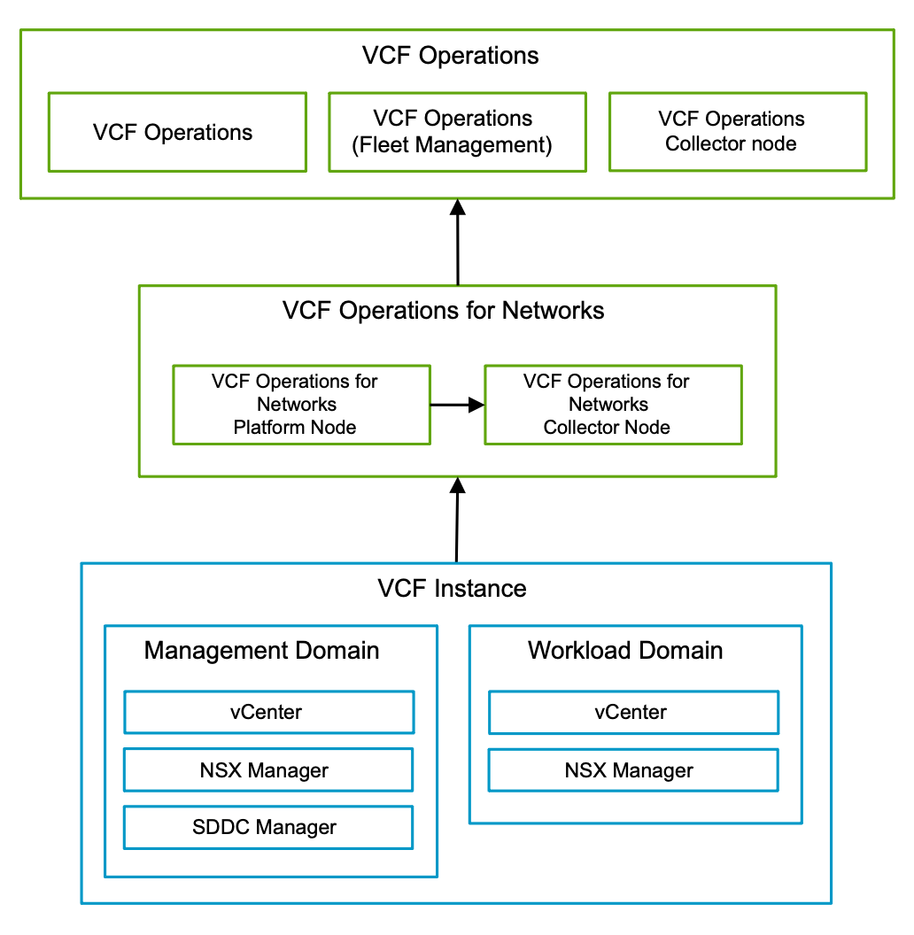

Simple VCF Operations for Networks Model Attributes
A Simple VCF Operations for Networks Model has the following attributes.
Attribute | Detail
Availability | Relies on vSphere HA to restart the nodes in the event of an ESXX host failure.
Scalability | Supports scale-up and scale-out.
Recoverability | Restore through a backup.

Simple VCF Operations for Networks Model Options
A Simple VCF Operations for Networks Model can leverage options from the design areas listed below, depending on objectives.
Design Area | Options
Appliance Size | - Medium  - Large  - Extra Large

Simple VCF Operations for Networks Model Design Requirements
Table 3-519. Simple VCF Operations for Networks Model Design Requirements
Design Requirement ID | Design Requirement | Justification | Implication
VCF-NET-REQD-SIM-001 | Deploy VCF Operations for networks as a non-clustered, single platform node in the default management vSphere cluster. | - Provides capacity for monitoring of up to 10,000 virtual machine or objects.  - Supports scale-out with additional VCF Operations for networks platform nodes to a platform cluster. | A 100% reservation for CPU and RAM for the deployed VCF Operations for networks platform node will be applied.
VCF-NET-REQD-SIM-002 | Deploy a single VCF Operations for networks collector node in the default management vSphere cluster. | A minimum of one VCF Operations for networks collector node is required to provide the VCF Operations for networks platform node with network monitoring data. | A 100% reservation for CPU and RAM for the deployed VCF Operations for networks collector node will be applied.

Simple VCF Operations for Networks Model Design Recommendations
Table 3-520. Simple VCF Operations for Networks Model Design Recommendations
Design Recommendation ID | Design Recommendation | Justification | Implication
VCF-NET-RCMD-SIM-001 | Deploy an appropriately sized VCF Operations for networksplatform node for your needs. | Ensures resource availability and usage efficiency. | None.
VCF-NET-RCMD-SIM-002 | Protect all VCF Operations for networks nodes by using vSphere High Availability. | Supports the availability objective for VCF Operations for networks without requiring manual intervention during an ESX host failure event. | You must ensure sufficient spare capacity for vSphere High Availability failover operations.
VCF-NET-RCMD-SIM-003 | In an environment with multiple VCF Instances, deploy the VCF Operations for networkscollector node(s) in the default management vSphere cluster in each VCF Instance by usingVCF Operations fleet management. | - Ensures a consistent deployment in each VCF Instances regarding network data collection.  - It is assumed that each VCF Instances introduces a sufficiently high number of virtual machines, so that the deployment of dedicated VCF Operations for networks collector nodes is justified. | Each VCF Operations for networks collector node must be registered with a VCF Operations for networks platform node.
VCF-NET-RCMD-SIM-004 | If the number of virtual machines exceeds 10,000 or if any other object scale limitations are reached, scale out to a VCF Operations for networks platform cluster deployment by adding additional platform nodes by usingVCF Operations fleet management. | Ensures that the VCF Operations for networks platform cluster has enough capacity to meet the SDDC object growth. | You must consider the additional resources required by VCF Operations for networks platform nodes in the management vSphere cluster when scaling out to a platform cluster.
VCF-NET-RCMD-SIM-005 | For each vCenter data source, enable NetFlow on each vSphere Distributed Switch within the workload domain. | Provides the collection of network flows via the IPFIX protocol. | For the VCF domains, VCF Operations for networks will automatically update the NetFlow settings for each cluster's vSphere Distributed Switch.
VCF-NET-RCMD-SIM-006 | For each NSX data source, enable IPFIX for the distributed firewall. | Provides the collection of network flows via the IPFIX protocol. | The distributed firewall service must be enabled on the NSX Local Manager for the VCF workload domain.
VCF-NET-RCMD-SIM-007 | For each NSX Manager data source, enable latency metric collection. | Provides the collection of latency metrics from NSX Transport Nodes. | Any firewall rule sets from all ESX hosts to the VCF Operations for networks collector must allow traffic on TCP 1991.
VCF-NET-RCMD-SIM-008 | Use the default retention period of one month for the VCF Operations for networks platform node. | Keeping the default value for retention minimizes required storage resources administrative efforts. | None.
VCF-NET-RCMD-SIM-009 | Use a CA-Signed certificate containing the fully qualified domain names (FQDNs) of each VCF Operations for networks platform and collector node in the SAN attributes, when deploying VCF Operations for networks. | Configuring a CA-Signed certificate ensures that the communication to the externally facing Web UI and API VCF Operations for networks for is encrypted. | - Using CA-signed certificates from a certificate authority might increase the deployment preparation time as certificate requests are generated and delivered.  - Each time a node is added the certificate must be replaced to include the fully qualified domain name of the additional node.
VCF-NET-RCMD-SIM-010 | Use a SHA-2 or higher algorithm when signing certificates. | The SHA-1 algorithm is considered less secure and has been deprecated. | Not all certificate authorities support SHA-2.

High Availability VCF Operations for Networks Model
The High Availability VCF Operations for Networks model consists of a three-node deployment. This model provides increased performance and scalability. Availability is provided by the native vSphere HA functionality within the vSphere cluster.
Figure 3-35. High Availability VCF Operations for Network Model
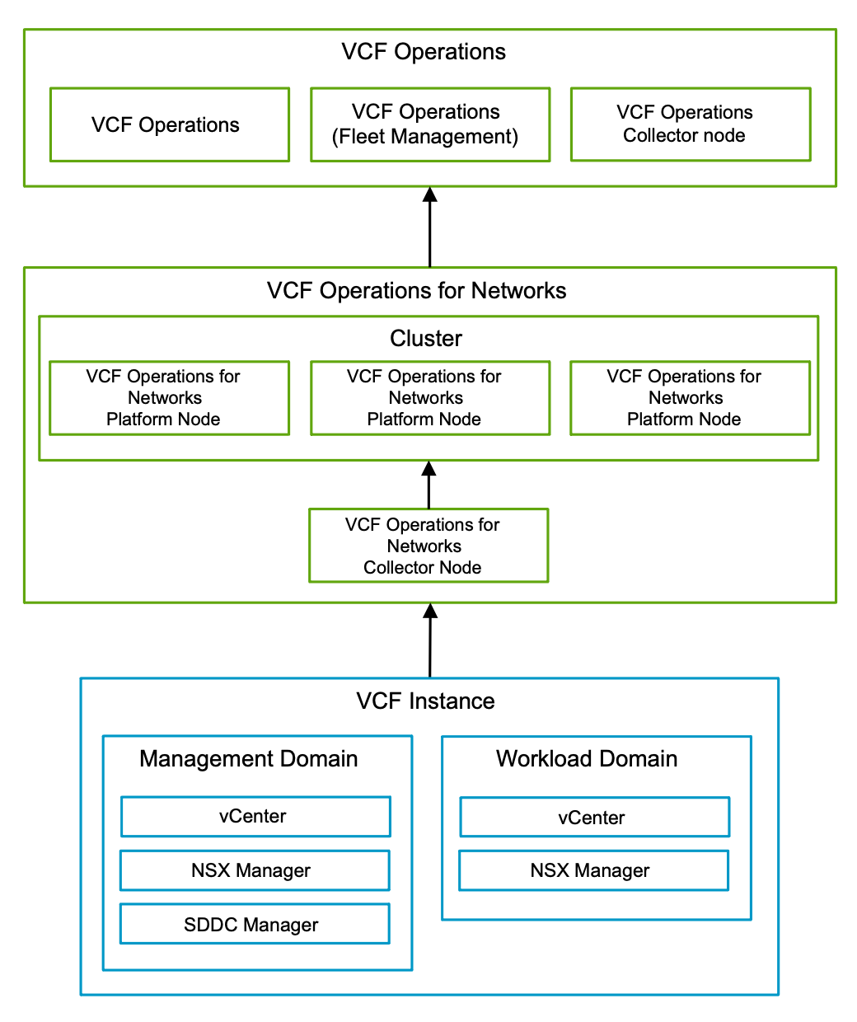

High Availability VCF Operations for Networks Model Attributes
A High Availability VCF Operations for Networks Model has the following attributes.
Attribute | Detail
Availability | Relies on vSphere HA to restart the nodes in the event of an ESX host failure.
Scalability | Supports scale-up and scale-out.
Recoverability | Restore through a backup.

High Availability VCF Operations for Networks Model Options
A High Availability VCF Operations for Networks Model can leverage options from the design areas listed below, depending on objectives.
Design Area | Options
Appliance Size | - Large  - Extra Large

High Availability VCF Operations for Networks Model Design Requirements
Table 3-521. High Availability VCF Operations for Networks Model Design Requirements
Design Requirement ID | Design Requirement | Justification | Implication
VCF-NET-REQD-HA-001 | Deploy threeVCF Operations for networksplatform nodes in a cluster. | - Highly Performant.  - Highly scalable, can scale up to 15 Extra Large nodes. | - Cluster does not provide high availability. It is for performance.  - Requires higher CPU and memory reservations to support additional nodes.
VCF-NET-REQD-HA-002 | Deploy a single VCF Operations for networks collector node in the default management vSphere cluster. | A minimum of one VCF Operations for networks collector node is required to provide the VCF Operations for networks platform node with network monitoring data. | A 100% reservation for CPU and RAM for the deployed VCF Operations for networks collector node will be applied.

High Availability VCF Operations for Networks Model Design Recommendations
Table 3-522. High Availability VCF Operations for Networks Model Design Recommendations
Design Recommendation ID | Design Recommendation | Justification | Implication
VCF-NET-RCMD-HA-001 | Deploy appropriately sized VCF Operations for networksplatform nodes for your needs. | Ensures resource availability and usage efficiency. | None.
VCF-NET-RCMD-HA-002 | Protect all VCF Operations for networks nodes by using vSphere High Availability. | Supports the availability objective for VCF Operations for networks without requiring manual intervention during an ESX host failure event. | You must ensure sufficient spare capacity for vSphere High Availability failover operations.
VCF-NET-RCMD-HA-003 | In an environment with multiple VCF Instances, deploy the VCF Operations for networkscollector node(s) in the default management vSphere cluster in each VCF Instance by using VCF Operations fleet management. | - Ensures a consistent deployment in each VCF Instances regarding network data collection.  - It is assumed that each VCF Instances introduces a sufficiently high number of virtual machines, so that the deployment of dedicated VCF Operations for networks collector nodes is justified. | Each VCF Operations for networks collector node must be registered with a VCF Operations for networks platform node.
VCF-NET-RCMD-HA-004 | For each vCenter data source, enable NetFlow on each vSphere Distributed Switch within the workload domain. | Provides the collection of network flows via the IPFIX protocol. | For the VCF domains, VCF Operations for networks will automatically update the NetFlow settings for each cluster's vSphere Distributed Switch.
VCF-NET-RCMD-HA-005 | For each NSX data source, enable IPFIX for the distributed firewall. | Provides the collection of network flows via the IPFIX protocol. | The distributed firewall service must be enabled on the NSX Local Manager for the VCF workload domain.
VCF-NET-RCMD-HA-006 | For each NSX Manager data source, enable latency metric collection. | Provides the collection of latency metrics from NSX Transport Nodes. | Any firewall rule sets from all ESX hosts to the VCF Operations for networks collector must allow traffic on TCP 1991.
VCF-NET-RCMD-HA-007 | Use the default retention period of one month for the VCF Operations for networks platform node. | Keeping the default value for retention minimizes required storage resources administrative efforts. | None.
VCF-NET-RCMD-HA-008 | Use a CA-Signed certificate containing the fully qualified domain names (FQDNs) of each VCF Operations for networks platform and collector node in the SAN attributes, when deploying VCF Operations for networks. | Configuring a CA-Signed certificate ensures that the communication to the externally facing Web UI and API VCF Operations for networks for is encrypted. | - Using CA-signed certificates from a certificate authority might increase the deployment preparation time as certificate requests are generated and delivered.  - Each time a node is added the certificate must be replaced to include the fully qualified domain name of the additional node.
VCF-NET-RCMD-HA-009 | Use a SHA-2 or higher algorithm when signing certificates. | The SHA-1 algorithm is considered less secure and has been deprecated. | Not all certificate authorities support SHA-2.

VCF Automation Detailed Design
This section describes the options, requirements, and recommendations for each VCF Automation deployment model.
VCF Automation can be deployed during initial deployment of your VMware Cloud Foundation platform by using VCF Installer, or at a later stage by using VCF Operations to use a custom network configuration.
Table 3-523. VCF Automation Deployment Paths
Deployment Path | Implications
Deployment by using VCF Installer, see Start a New VCF Fleet or a New VCF Instance Deployment by Using the VCF Installer Deployment Wizard | - Part of an initial net new VCF deployment along with other core management domain components (for example, vCenter, NSX, VCF Operations, SDDC Manager, etc.)  - Uses VCF Management DVPG network by default
Deployment by using VCF Operations fleet management for custom networking configuration. | - Post VCF core management components deployment  - Allows for custom network configurations
VCF Automation enables building a modern private cloud and plays a crucial role in both single-tenancy and multi-tenancy scenarios by providing a unified platform for designing a modern private cloud platform with VMware Cloud Foundation.
Modern private cloud platform from the service provider perspective:
- Single tenancy: service providers offer dedicated private cloud environments to customers who require strong isolation, compliance, or specific performance guarantees.
- Multi-tenancy: service providers use multi-tenancy to deliver cost-effective, shared cloud services to a broader customer base.
Modern private cloud platform from the Enterprise perspective:
- Single tenancy: enterprises use single tenancy to isolate sensitive workloads, critical applications, or different business units with specific requirements.
- Multi-tenancy: enterprises use multi-tenancy for internal IT infrastructure to improve efficiency, reduce costs, and simplify management of less critical applications.
This design section is intended to guide both enterprise and service providers in designing and deploying a modern private cloud with VCF Automation tailored to their organizational needs.
Throughout this VCF Automation design, the terms Organization, Tenant, Organization Admin, and Tenant Admin may be used interchangeably depending on the reader’s operational context — whether an enterprise IT team or a service provider.
Table 3-524. VCF Automation Terminology
Term | Description | Context Example
Organization | - It can be a department or a line of business for an enterprise Or  - It can be Tenant for a service providers | - Finance department in a large enterprise  - It can be Tenant for a service providers
Provider Admin | User role responsible for managing the overall infrastructure, services, and tenancy model across multiple organizations or tenants. | Administrator managing multi-tenant VCF Automation environment.  This role can either be an Enterprise IT Admin in an enterprise environment or a Provider Admin in a service provider context.
Organization Admin / Tenant Admin | User role responsible for managing resources, workloads, and permissions within their own organization/tenant. | Both refer to roles managing resources within their respective organizations/tenants.
VCF Automation Portals
Name | Location | Description
Provider Portal | https://<VCF Automation Appliance FQDN>/automation; Organization: system | Infrastructure and Resource defintions, Organization creation and networking + resource allocation
Organization Portal | https://<VCF Automation Appliance FQDN>/automation; Organization: <Customer Organization> | Configuration of Organization's allocated resources, projects, blueprints and self-service workload deployments.
In addition, the Provider will also rely direct access to vCenter and NSX Manager for some infrastructure configurations. For example, NSX Edge Cluster creation and Supervisor Cluster activation.

Simple VCF Automation Model
The Simple VCF Automation Model consists of a single node deployed in a vSphere cluster. Availability is provided by the native vSphere HA functionality within the vSphere cluster.
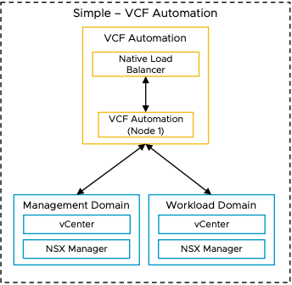

Simple VCF Automation Model Attributes
A Simple VCF Automation Model has the following attributes.
Attribute | Detail
Availability | Relies on vSphere HA to restart the nodes in the event of an ESX host failure.
Scalability | Supports scale-up and scale-out to high the availability model.  Note Scale-up to a larger node size and scale-out to three nodes at the same time.
Recoverability | Restore through a backup.

Simple VCF Automation Model Options
A Simple VCF Automation Model can leverage options from the design areas listed below, depending on objectives.
Design Area | Options
Network Placement | Deploy on the default VCF Management DVPG network
 | Deploy on a separate dedicated DVPG network
 | Deploy on a separate NSX overlay network

Simple VCF Automation Model Design Requirements
Table 3-525. Simple VCF Automation Model Design Requirements
Design Requirement ID | Design Requirement | Justification | Implication
VCF-AUTO-REQD-SIM-001 | Deploy VCF Automation as a single node in the default management vSphere cluster. | - Supports the simple deployment objective.  - VCF Automation supports scale out and up to a high availability model. | - The simple deployment model defaults to the small appliance size.  - Administrators will need to be aware of the scale and performance implications of the small size node to their design.  - If deployed VCF Automation through VCF Installer, the installer will deploy the small appliance by default.  - If deployed via VCF Operations fleet management, you will have to select the small appliance size to deploy the simple model.
VCF-AUTO-REQD-SIM-002 | Deploy VCF Automation in separate DVPG or NSX Overlay through VCF Operations fleet management Or SDDC Manager API | Supports different network other than default management network for security requirements. | If deployed via VCF Operations fleet management, all the VCF Operations components (to include fleet manager) will need to be fully up and functional prior to starting the VCF Automation deployment.
VCF-AUTO-REQD-SIM-003 | Protect the VCF Automation nodes by using vSphere HA. | Ensures availability of VCF Automation without requiring manual intervention during an ESX host failure event. | None.

Simple VCF Automation Model Design Recommendations
Table 3-526. Simple VCF Automation Model Design Recommendations
Design Recommendation ID | Design Recommendation | Justification | Implication

High Availability VCF Automation Model
The High Availability VCF Automation Model consists of a three-node deployment. This model provides resiliency at both the application level through the clustered deployment as well as the vSphere cluster level through vSphere HA and vSphere DRS functionality.
The high availability discussion in this section focuses on the VCF Automation appliance level. For discussions on high availability design for components supporting VCF Automation, see the following:
- vSphere Clusters - See vSphere Cluster Detailed Design for more details.
- vSphere Supervisor deployments - See vSphere Supervisor Detailed Design for more details.
- NSX Edges - See NSX Edge Cluster Detailed Design for more details.
For a discussion on high availability as it pertains to tenant design, please review the "Enable Modern Private Cloud with VCF Automation" Guide.
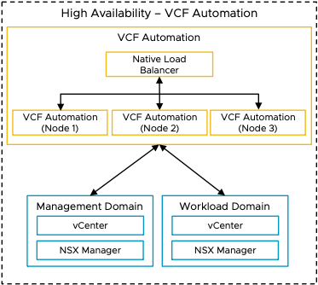

High Availability VCF Automation Model Attributes
A High Availability VCF Automation Model has the following attributes.
Attribute | Detail
Availability | - Application level availability provided by the three node cluster  - Appliance level level availability provided by vSphere HA
Scalability | Supports scale-up and scale-down of node sizes.
Recoverability | Restore through a backup.

High Availability VCF Automation Model Options
A High Availability VCF Automation Model can leverage options from the design areas listed below, depending on objectives.
Design Area | Option
Network Placement | - Deploy on the default VCF Management DVPG network  - Deploy on a separate dedicated DVPG network  - Deploy on a separate NSX overlay network
External Load Balancing | - External load balancer configuration is a post deployment configuration.  - The native Kubernetes load balancer is configured automatically during deployment of VCF Automation and cannot be removed.  - The external load balancer must be configured to send traffic to the native Kubernetes load balancer configured at deployment.  - The external load balancer requires VIP addressing, FQDN, as well as a certificate in addition to those assigned at deployment.

High Availability VCF Automation Model Design Requirements
Table 3-527. High Availability VCF Automation Model Design Requirements
Design Requirement ID | Design Requirement | Justification | Implication
VCF-AUTO-REQD-HA-001 | Deploy VCF Automation as a three node cluster in the default management vSphere cluster. | Supports high availability objectives. | - Analysis will be required to determine which node size is appropriate for your deployment.  - Node can be resized after deployment as necessary.
VCF-AUTO-REQD-HA-002 | Deploy VCF Automation in separate DVPG or NSX Overlay as a three node cluster through VCF VCF Operations fleet management. | Supports different network other than default management network for security requirements. | If deployed via VCF Operations fleet management, all the VCF Operations components (to include fleet manager) will need to be fully up and functional prior to starting the VCF Automation deployment.
VCF-AUTO-REQD-HA-003 | If VCF Automation is deployed as high availability deployment will default to the medium node size. Review the configuration maximums for the medium node size to determine if it will be sufficient for your use cases | Ensures that the VCF Automation node sizing is appropriate for your use cases. | If your use cases require the large size nodes you will need to perform a scale up action through VCF Operations fleet management post deployment.
VCF-AUTO-REQD-HA-004 | Protect all VCF Automation nodes by using vSphere HA. | Supports the high availability objective without requiring manual intervention during an ESX host failure. | None

Network Design Options for VCF Automation Instance Deployment
Each customer has different use cases and network requirements to place VCF Automation on VMware Cloud Foundation management domain. VMware Cloud Foundation provides flexibility of network segment options for our customers to design their private cloud. Below are the design options to choose which best fits your requirements.
Network Design Options | Justification | Implication
Deploy on the default VCF Management DVPG network | - Default deployment through VCF Installer  - Quick and easy deployment as it uses the default management network  - Does not require separate network or VLAN. | - Management network will need to have enough available IP addresses to support the VCF Automation deployment.  - Moving to a separate network from the default management network may require a redeployment of VCF Automation.
Deploy on a dedicated DVPG network | - Would like to separate user facing networks from management networks to meet regulatory and security requirements.  - Additional VLAN required. | - If this option is chosen, VCF Automation deployment cannot happen through VCF Installer.  - VCF Automation installation must be deployed through VCF Operations fleet management.  - VLAN will need to be created prior to VCF Automation deployment
Deploy on a separate NSX overlay network | - Would like to separate user facing networks from management networks to meet regulatory and security requirements.  - Future DR Ready.  - Additional Segment needed in NSX VPC | - If this option is chosen, VCF Automation deployment cannot happen through VCF Installer.  - VCF Automation installation must be deployed through VCF Operations fleet management  - Overlay network will need to be created prior to VCF Automation deployment  - VCF automation can be deployed via API call.

VCF Automation Deployment Patterns
This section explains different deployment patterns of VCF Automation within VMware Cloud Foundation single and multi-domain architectures.

Deployment Pattern 1: VCF Automation in a VCF Instance with Single Domain and Multiple Clusters
VCF Automation is deployed in a management domain and organization workloads are placed in a different vSphere cluster of the same management domain.
Figure 3-36. VCF Automation in a VCF Instance with single domain and multiple clusters
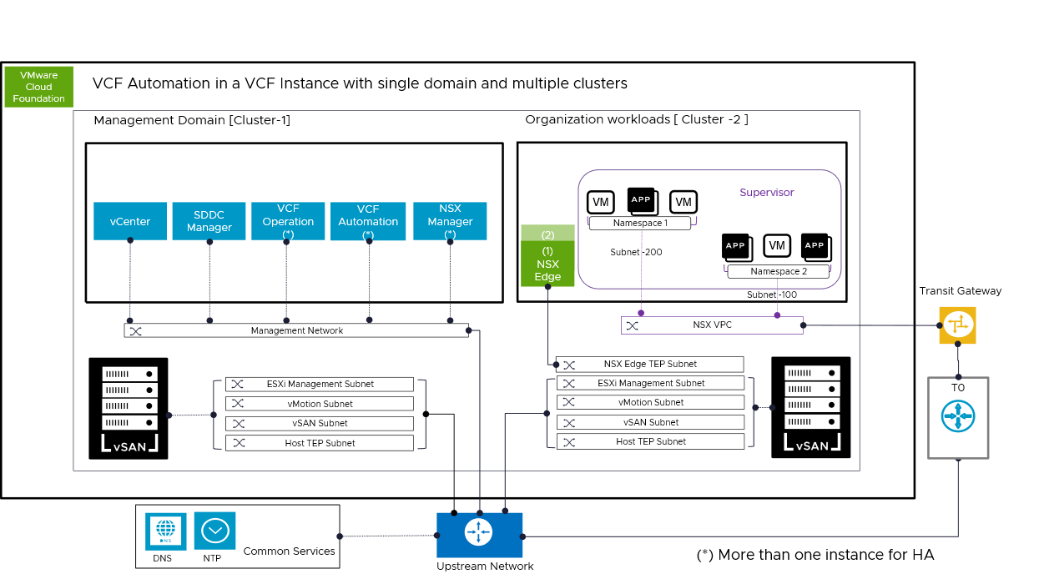
This deployment pattern separates the management and compute resources into two vSphere clusters in a single domain. The management domain hosts the core management components of VCF. In this deployment pattern, different subnets are used for various traffic types, ensuring security and performance. A Transit Gateway is used to connect upstream network and it serves as a high-level network routing hub, linking multiple subnets, and networks across the architecture.
The vSphere cluster that hosts the organization workloads has NSX VPC configured and vSphere Supervisor enabled to consume a modern private cloud with VCF Automation.
This deployment pattern enables High Availability through the deployment of multiple instances of components to provide redundancy and ensure reliability.
1. This architecture consolidates the management and compute resources into two primary clusters in a single domain: Cluster-1 (management) and Cluster-2 (workload).
2. [Cluster-1]: This hosts the core management components of VCF such as vCenter, NSX, SDDC Manager, VCF Operation and VCF Automation.
3. [Cluster-2] : It has multiple VMs and App instances, indicating that it is primarily focused on hosting applications and workloads for Tenants.
5. It shows clear separation between the Management and the Workload cluster.
6. As per VCF deployment guidelines, different subnets are used for various traffic types, ensuring security and performance.
7. NSX VPC and Supervisor Cluster is enabled in Cluster 2 to consume a modern private cloud with VCF Automation.
8. Transit Gateway (TGW) is used to connect upstream network and it serves as a high-level network routing hub, linking multiple subnets, and networks across the architecture.
9. Ensures that common services such as DNS and NTP is configured appropriately for VCF Automation to work properly.
10. This setup allows High Availability (HA), with an asterisk (*) indicating that multiple instances of components can be deployed to provide redundancy and ensure reliability.
Benefits | Drawbacks
- Fast deployment  - Simplified integrated management  - Dedicated VCF Instance for a Tenant or a Line of Business  - Near Edge Deployments Smaller Environments and no plan of growth  - Smaller hardware footprint  - VCF Automation HA is an option | - Limited scalability than VCF standard architecture  - Management Overhead to manage each VCF Instance for dedicated Tenant  - VCF Automation HA deployment will consume more infrastructure resources

Deployment Pattern 2: VCF Automation in a VCF Instance with multiple domains
VCF Automation is deployed in a management domain and organization workloads are placed in a workload domain.
Figure 3-37. VCF Automation in a VCF instance with multiple domains for workloads
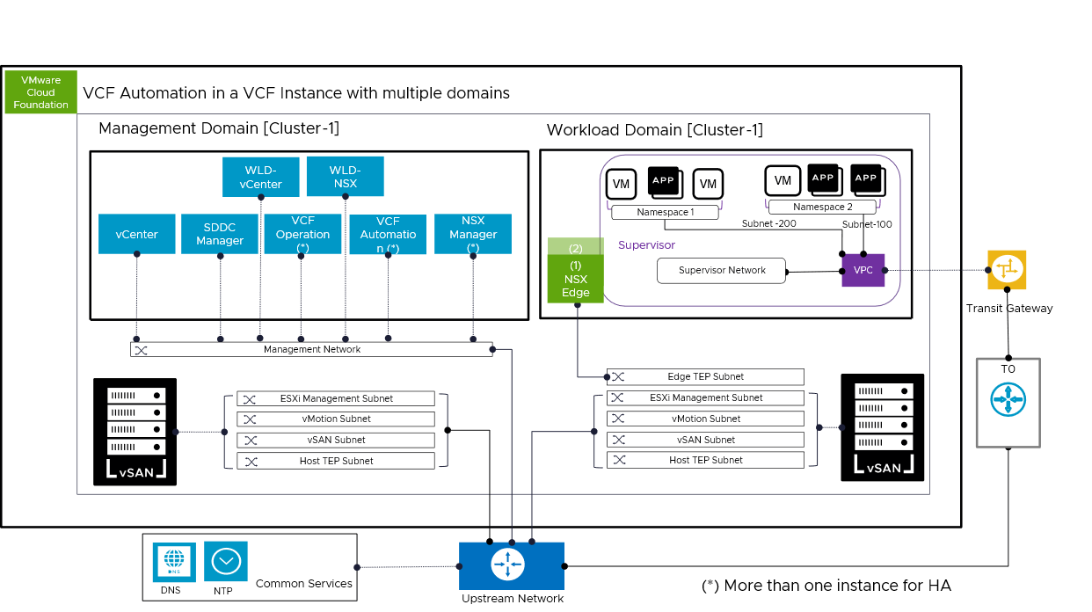
The Management domain hosts the core management components of VCF. The workload domain hosts the tenant virtual machines. different subnets are used for various traffic types, ensuring security and performance. In this deployment pattern, different subnets are used for various traffic types, ensuring security and performance. A Transit Gateway is used to connect upstream network and it serves as a high-level network routing hub, linking multiple subnets, and networks across the architecture.
The vSphere cluster that hosts the organization workloads has NSX VPC configured and vSphere Supervisor emabled to consume a modern private cloud with VCF Automation.
This deployment pattern enables High Availability through the deployment of multiple instances of components to provide redundancy and ensure reliability.
1. A Management Domain [Cluster-1]: This domain hosts the core management components of VCF such as vCenter, NSX, SDDC Manager, VCF Operation and VCF Automation.
2. A Workload Domain [Cluster-1]: This workload domain is where the actual Tenant virtual machines (VMs) and applications run.
3. Clear separation between the Management Domain and the Workload Domain.
4. As per VCF deployment guidelines, different subnets are used for various traffic types, ensuring security and performance.
5. NSX VPC and Supervisor Cluster is enabled in workload domain to consume a modern private cloud with VCF Automation.
6. Transit Gateway (TGW) is used to connect upstream network and it serves as a high-level network routing hub, linking multiple subnets, and networks across the architecture.
7. Ensures that common services such as DNS and NTP is configured appropriately for VCF Automation to work properly.
8. This setup allows High Availability (HA), with an asterisk (*) indicating that multiple instances of components can be deployed to provide redundancy and ensure reliability.
Benefits | Drawbacks
- Simplified integrated management  - Highly scalable through independent scaling of compute, storage, and networking components  - Distributed architecture  - Greater long-term flexibility to adapt to changing needs or growth  - Highly Available | - Larger hardware footprint  - Larger cost footprint

Deployment Pattern 3: External-Facing deployment of VCF Automation
External-Facing Deployment of VCF Automation refers to implementing VCF Automation to seamlessly interact with external networks or services in a secure manner.
Figure 3-38. External Facing deployment of VCF Automation
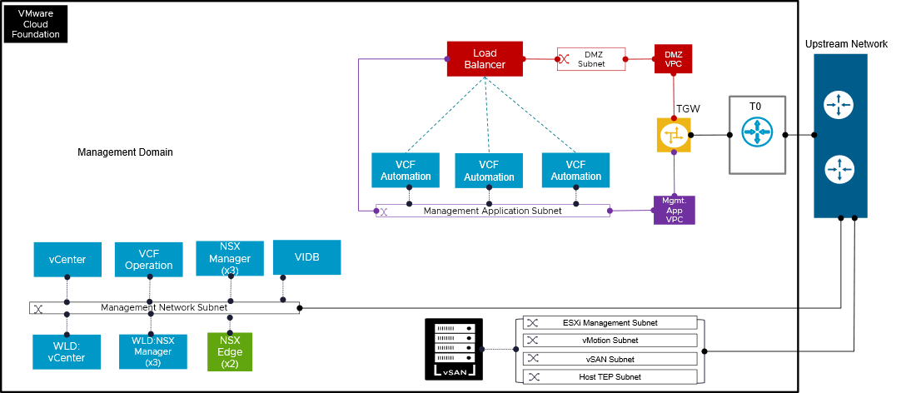
This deployment pattern helps to minimize the attack surface, contain potential security breaches, and provides the necessary controls for meeting various security and compliance standards for VCF Automation.
The DMZ VPC accommodates external facing services (like load balancers) and serve as a security barrier between the internet and the internal application network. To provide an additional layer of network isolation, this deployment pattern also uses a second VPC for the VCF Automation instances. The Transit Gateway routes traffic between the two VPCs and to the upstream network, enabling safe channels of communication.
The Tier-0 Gateway provides north and south routing as well as stateful firewall features. This offers a reliable and secure design for hosting VCF Automation that is accessible over the internet. Provider Admin can apply East - West firewall on the Mgmt App VPC to protect access to VCF Automation appliances and limit lateral movement.
Traffic Flow (Simplified for External Access):
- Web traffic enters the upstream network
- then It is sent to the load balancer in the DMZ Subnet
- Traffic is distributed among the VCF Automation instances in the Managment Application subnet by the load balancer.. .
- The TGW controls communication between the DMZ VPC and the Mgmt App VPC, and security rules are implemented both at the T0 and at this TGW level.
- The VCF Automation instances process the requests and send responses back through the same path.
Benefits | Drawbacks
- Easier to manage and update one set of VCF Automation appliances. Reduces operational overhead.  - Limits lateral movement and isolates external-facing services from core management and workloads.  - Micro-segmentation approach securely exposes services through DMZ VPC, Load Balancer, and T0 Gateway for strong protection  - Distributes traffic efficiently across multiple automation appliance instances for scale and availability. | - Needs robust security (firewalls, WAF, and API security in place).  - Load balancer misconfigurations could cause downtime or abnormal traffic routing.  - Adds network complexity; managing routing, firewall rules, and subnet allocations needs careful planning for each orgnizations or tenants.

Tenancy Deployment Models in VCF
This section describes how different tenancy models relate to the VCF fleet and VCF domain concepts, which impacts how tenants are provisioned and managed within a private cloud environment. Businesses can select a deployment model (or models) based on operational flexibility, compliance needs, and scalability requirements.
- Tenancy Deployment Model 1: Consolidated Management and Organization Workloads in a VCF Instance
- Tenancy Deployment Model 2: Shared Workload Domain for Multiple Organizations in a VCF Instance
- Tenancy Deployment Model 3: Centralized Management with Dedicated Workload Domains per Organization in a VCF Instance
- Tenancy Deployment Model 4: Centralized VCF Automation Managing Dedicated VCF Instances per Organization
- Tenancy Deployment Model 5: Dedicated VCF Fleet with Independent VCF Automation Supporting Single or Multiple Domains per Tenant

Tenancy Deployment Model 1: Consolidated Management and Organization Workloads in a VCF Instance
This tenancy deployment model consists of one VCF workload domain that hosts the management components and organization workloads.
Management components and workloads can share one vSphere cluster, or can be deployed on different vSphere clusters.
When adopting this model, carefully evaluate the potential implications, including resource contention, performance impact, security risks, and reduced availability that may arise from hosting organization workloads within the same cluster as management components.
Figure 3-39. Management and Organization Workload sharing one vSphere cluster within a vCenter
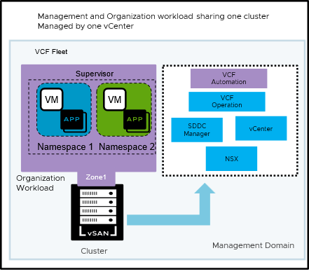
Figure 3-40. Management and organization workload on different vSphere clusters within in a vCenter
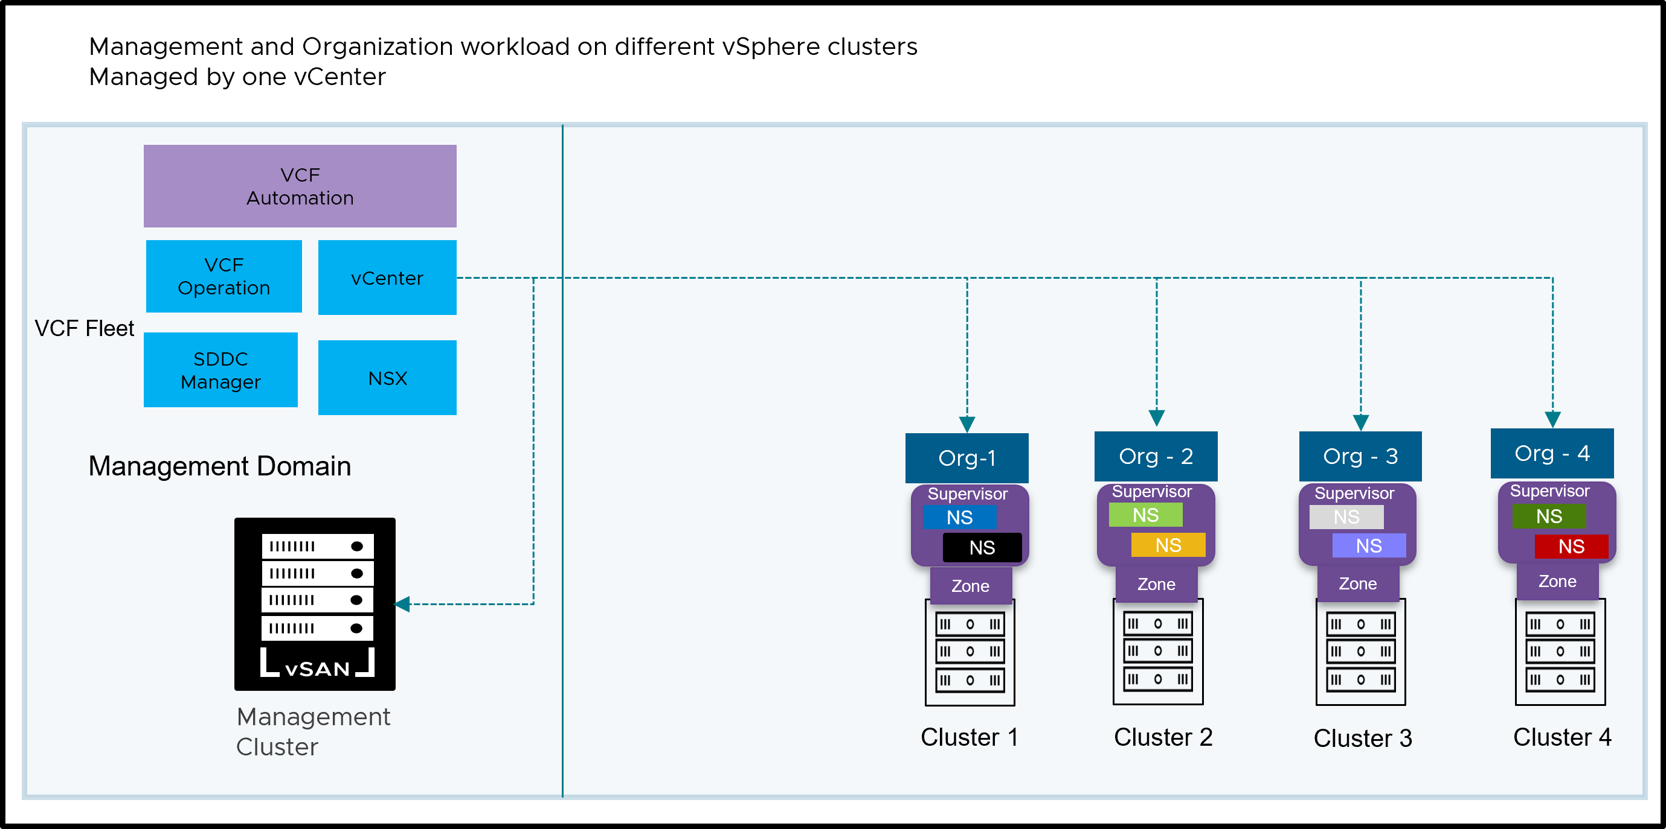
Benefits | Best Fit Scenarios
- Consolidating workloads can streamline the initial setup of a VCF Instance. There are fewer physical hosts and clusters to configure, which speeds up the deployment process.  - Using a single cluster lowers the overall hardware requirements. This can lead to cost savings in terms of server hardware, networking equipment, and data center space. | - For organizations with smaller environments and limited resource requirements, consolidating workloads can provide a cost-effective and manageable solution.

Tenancy Deployment Model 2: Shared Workload Domain for Multiple Organizations in a VCF Instance
This model offers a multi-tenant VMware Cloud Foundation platform where multiple organizations share a single workload domain. Isolation is achieved through vSphere Namespaces and network segmentation.
Figure 3-41. Shared Workload Domain for multiple organizations in a VCF Instance
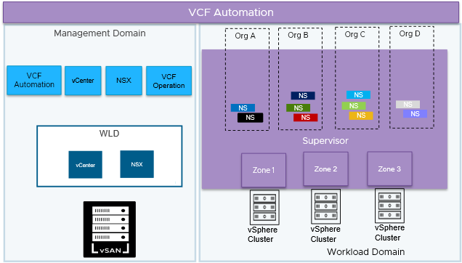
Benefits | Best fit scenarios
- Resource Sharing:  Tenants share the underlying infrastructure (workload domain, vCenter, NSX), leading to cost savings and efficient resource utilization.  - Simplified Management and Operational Consistency:  While providing tenant isolation, the centralized management of the VCF Management Domain simplifies overall infrastructure operations, including patching, upgrades, monitoring, and capacity planning. Consistent policies can be applied across all tenants.  - Scalability and Flexibility:  The model is highly scalable. As the number of tenants or their resource demands grow, the underlying workload domain can be scaled up by adding more hosts. Resource allocations within Namespaces can also be adjusted dynamically. If requirement comes, service provider can add more workload domains for multiple other organizations to share or can dedicate a workload domain per tenant like explained in Model 2.  - vSphere Namespace Isolation:  vSphere Namespaces provide logical resource isolation for tenants' workloads, preventing interference.  - Network Segmentation:  Network policies and security groups can be used to further segment tenant traffic and enhance security. | - Cloud Service Providers (CSPs) Offering Multi-Tenant Cloud Services:  This model allows the CSP to host multiple customers within a single VCF instance, maximizing resource utilization across their infrastructure. The Supervisor Cluster ensures strong isolation between each customer's workloads and data. Each customer gets their own vSphere Namespace, providing them with a secure and logically separated environment for deploying VMs and containers. Network segmentation (via NSX) further guarantees that customer traffic remains isolated.  - Large Enterprises with Multiple Business Units or Departments:  A large corporation has several independent business units (e.g., Finance, Marketing, R&D) that require their own isolated IT environments but can share underlying infrastructure.  - Organizations Offering Internal PaaS or Developer Platforms:  An organization wants to provide a self-service platform for its internal development teams to deploy and manage their applications (including containerized microservices) in an isolated and governed manner.  - Educational Institutions or Research Organizations with Multiple Projects or Teams:  A university hosts various research projects or has different departments with distinct IT requirements and security needs.

Tenancy Deployment Model 3: Centralized Management with Dedicated Workload Domains per Organization in a VCF Instance
This model provides a robust and secure multi-tenant environment by leveraging VCF Automation and dedicated workload domains. Each organization gets a dedicated environment, ensuring security, performance, and independent management. The central and shared management domain provides centralized control, while oranization-specific components offer flexibility and autonomy.
Figure 3-42. Centralized Management with Dedicated Workload Domains per Organization in a VCF Instance
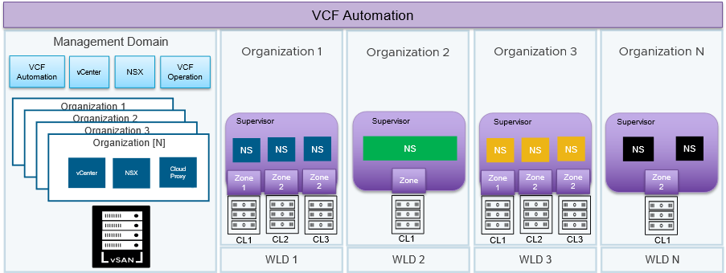
Benefits | Best fit scenarios
- Centralized Management:  Offers one control point for overseeing the entire VCF environment for service providers handling several tenants.  - Simplified Life Cycle Management:  Optimizes the updating and patching of essential VCF elements.  - Providers of multi-tenant services:  Provide safe and separate environments for various clients.  - Major corporations with separate business divisions:  Grant independence and seclusion to various departments.  - Industries with extensive regulations:  Adhere to rigorous compliance standards for data protection and confidentiality (such as healthcare, finance, public sector).  - Organizations handling sensitive information:  Provide increased security against unauthorized access and data leaks. | - Performance-Sensitive Workloads:  Applications with demanding performance needs (e.g., high-throughput databases, real-time processing) require consistent and predictable resource availability. Dedicated hardware eliminates the "noisy neighbor" effect, where the activity of other tenants can negatively impact performance.  - Specialized Hardware or Dedicated Hardware:  Some organizations may require specific hardware configurations (e.g., GPUs, specialized processors, high-performance networking) that differ from the standard infrastructure. In certain cases different organization may have a different licensing requirement depending on their hardware configurations such as different CPU cores. Dedicated workload domains allow them to use their required hardware without imposing it on other tenants.  - Data Sovereignty and Geographic Restrictions:  Some countries have data sovereignty laws that require data to be stored and processed within their borders. Dedicated workload domain can be used to create isolated environments within specific geographic locations to comply with these regulations.  - Mergers and Acquisitions:  Maintaining separation, When two organizations merge or one acquires another, they may need to maintain separate IT environments for a period (or even permanently) due to: Security policies, Compliance requirements, different IT processes, phased integration plans. Dedicated workload domains allow them to keep their infrastructure separate while still benefiting from a centralized private cloud platform.

Tenancy Deployment Model 4: Centralized VCF Automation Managing Dedicated VCF Instances per Organization
This model offers a dedicated VCF Instance (consisting of a management domain and a workload domains) for every tenant. Each tenant receives dedicated resources, in addition to common management components such as VCF Operations and VCF Automation managing both instances.
For multi-location deployments, a minimum of 10Mb/s with 100ms latency for management operations such as upgrades, patching, and cluster management is required. However, the bandwidth and latency requirements for day-to-day user operations in VCF Automation can vary significantly. These requirements depend on several factors, including:
- The number of users accessing VCF Automation.
- The geographical distribution of users and resources.
- The volume and nature of user transactions.
Figure 3-43. Centralized VCF Automation managing dedicated VCF Instances per Organization
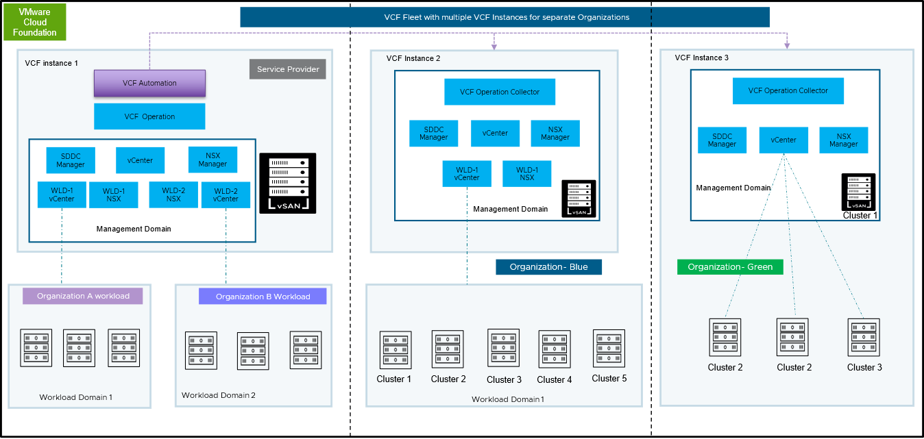
Benefits | Best fit scenarios
- This model offers a dedicated VCF Instance (comprising a Management Domain and Workload Domains) for every tenant. However, every VCF instances are consumed through one shared VCF Automation. This signifies that every tenant receives fully separate resources, encompassing compute, storage, and networking, in addition to their specific management components such as vCenter and NSX.  - Improved Security: Robust isolation stops the actions of one tenant from impacting others, reducing security threats and supporting adherence to data privacy and compliance.  - Committed Resources: Every tenant has assured access to their designated resources, guaranteeing stable performance and preventing resource conflict problems.  - Autonomous Management: Tenants possess complete authority over their environment, enabling them to oversee their resources and implement applications based on their individual requirements and regulations. Streamlined Operations: Dedicated instances reduce complexity and simplify management tasks, as each tenant's environment is self-contained. | - Large enterprises with autonomous business units: Corporations with distinct business units that have their own IT teams, budgets, and operational processes are ideal candidates for a VCF Fleet. Each business unit can have its own VCF instance tailored to its specific needs.  - Service Providers offering highly isolated environments:  Cloud Services Platforms that must provide isolated and secure environments for different enterprise customers benefit from a VCF Fleet. Each customer gets a dedicated VCF instance, ensuring maximum security and control.  - Government agencies with separate departments: Government entities with different departments that have strict security and operational autonomy requirements can deploy a VCF Fleet to ensure the necessary isolation and control for each department's workloads.  - Global organizations with regional data sovereignty needs: Multinational corporations with requirements for data to reside within specific geographic regions can deploy VCF instances in different locations, adhering to data sovereignty laws while maintaining a consistent VCF architecture.  - Organizations Undergoing Mergers and Acquisitions:  During the integration of two or more organizations, a VCF Fleet can provide a way to maintain separate environments initially and gradually consolidate or migrate workloads as needed, while ensuring isolation during the transition.

Tenancy Deployment Model 5: Dedicated VCF Fleet with Independent VCF Automation Supporting Single or Multiple Domains per Tenant
This model illustrates dedicated tenant approach where each tenant has its own isolated environment within a VCF Instance single domain or multiple domain construct. This means each tenant gets their own VCF Automation and dedicated compute and storage infrastructure such as vSphere cluster with higher level resource isolation with vSphere Automation along with vSphere Supervisor and NSX.
You can utilize the same vCenter for managing both management and compute workloads for Tenants.
Figure 3-44. Dedicated VCF Fleet with independent VCF Automation supporting single or multiple domains per tenant
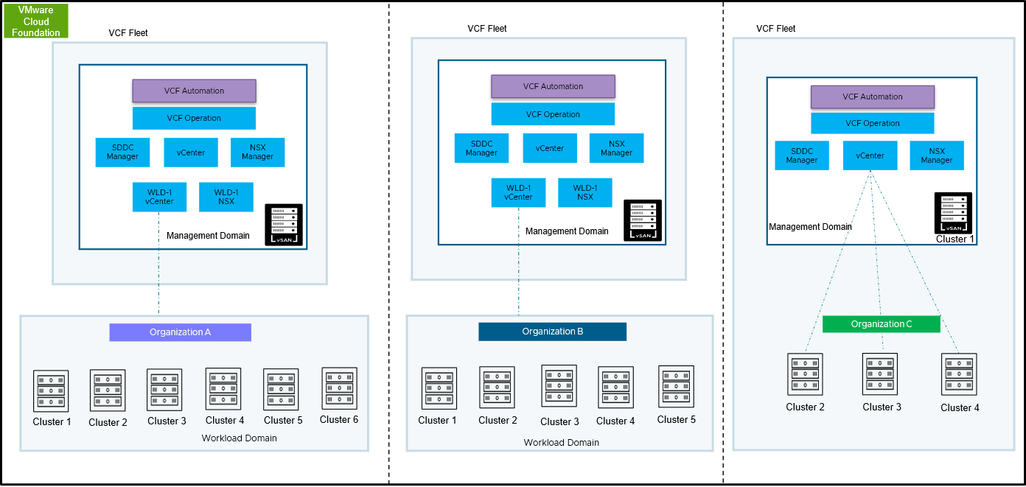
Benefits | Best fit scenarios
- Provides a dedicated VCF Fleet to each tenant. Each fleet operates with its own VCF Automation and VCF Operations instances, ensuring complete operational isolation. Within each VCF Fleet, service providers or enterprises have the flexibility to either deploy a single workload domain with multiple clusters or multiple workload domains, each containing multiple clusters. This model offers full design freedom to allocate and dedicate resources based on specific tenant or organizational needs.  - Resource Isolation and Efficiency:  This model strikes a balance between providing dedicated resources for isolation and consolidating infrastructure for efficiency. | - Organizations with strict isolation requirements but also wanting to optimize resource usage.  - Multi Geo - Complying with data sovereignty regulations  - Service Provider - Offering hosted private clouds with dedicated infrastructure.  - Supporting regulated industries with specific compliance needs.  - Providing high-value services with strict SLAs. Facilitating M&A scenarios with isolated environments.

Organization Consumption Model
This section focuses the organizational (tenant) layer within VCF Automation. How resources are consumed by administrators and end users through an Organization.

Understanding VCF Automation All Apps Organization Multi Tenancy Model
The All Apps Organizations are the primary multi-tenancy model within VCF Automation. All Apps Organizations uses vSphere Namespaces within vSphere Supervisor (Supervisors) to abstract tenant users and groups from the underlying vSphere and NSX infrastructure. This Supervisor-based model:
- Completely isolates resources between All Apps Organizations
- Within an All Apps Organization, allows for further isolation at the Project and vSphere Namespace levels
- Controls user access to the resources
The resulting Supervisor-based command and control model
- Completely removes the need for direct infrastructure access via individual tenant or service accounts
- Removes potential security concerns created by the service account access models
Remember The resources defined by a vSphere Namespace includes: compute, memory, storage and network resources (network redefined through VPCs).
The new structure guarantees tenant visibility to assigned infrastructure (vSphere Namespace) while protecting tenant A from impacting tenant B. Total isolation is assured by the vSphere Namespace boundary between tenants working in concert with the NSX Project boundary (for networking). Thus providing a modern, true cloud experience with secure multi-tenancy for VCF Automation customers.
Implementing the All Apps Organization model within VCF Automation requires a few underlying components:
VCF Automation Structure | Details
Organization | - It can be a department or a line of business for an enterprise Or  - It can be Tenant for a service providers  - An organization is a top-level entity used to group and manage resources, users, policies, IaaS services, and catalog entities, while maintaining a secure boundary from other organizations.  - It offers a centralized structure for billing, access control, and resource sharing, facilitating collaboration and governance across teams, departments.  - Maps to one or more Supervisor Cluster(s) through Regions to provide the resources (compute, memory, storage and networking) available for assignment within vSphere Namespaces.
vSphere Supervisor | - A supervisor is a capability that turns vSphere into a platform that can host multiple IaaS services.  - Supervisor defines the scope of vSphere IaaS control plane on vCenter.  - A supervisor is a collection of one or more clusters on a vCenter instance and can span across multiple zones for fault tolerance.vSphere Supervisor is a management plane for Infrastructure-as-a-Service.  - Provides compute, memory and storage resources to an Organization.  - Provides the structure on which vSphere Namespaces are deployed.  - A single Supervisor Clusters can be mapped to multiple Organizations
Region | - A region consists of one or more Supervisor enabled Clusters.  - A region is a collection of compute, memory, storage, and networking resources that can span across vCenter instances.
Project | - Resides within an Organization  - There can be many projects within a single Organization  - Manage users & resources at scale using projects  - Add users or groups to projects to give them access to IaaS services,  - Add catalog items to be shared with the project.  - Provide approvals and automate resource reclamation using project policies.  - Govern total allocated resources and access to VM and storage classes using vSphere Namespaces in projects.
vSphere Namespace | - Resides within a Project.  - There can be many vSphere Namespaces within a single Project.  - Defines resource limits for CPU, memory, and storage for workloads.  - Assigns available networks to workloads  - vSphere Namespaces are bound to the scope of the project with which they are associated.
VPC | - Set of networking resources that provide a public-cloud experience to VCF customers.  - Can be assigned to one or many vSphere Namespaces within an Organization.
Workload | - Virtual machine or containers deployed within a vSphere Namespace.  - Number of workloads only limited by the amount of resources allocated to the vSphere Namespace.
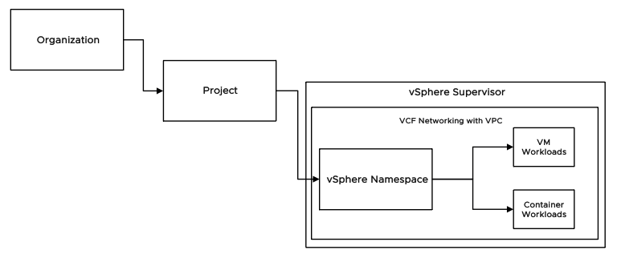
During All Apps Organization creation every All Apps Organization is mapped to one or more vSphere Supervisor via Regions. Each organization can then hold one or more projects. Each project then holds one or more vSphere Namespaces. vSphere Namespaces are instantiated within vSphere Supervisors mapped to the Organization. Traditional virtual machine or VMware Kubernetes Service-based container workloads are then deployed utilizing the Supervisor Cluster resources defined within vSphere Namespaces.
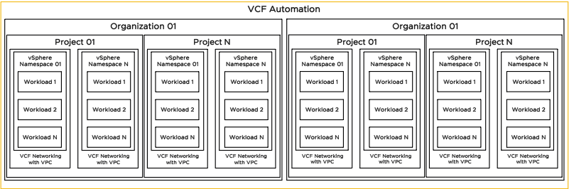

Provider Consumption Organization
The Provider Consumption Organization (PCO) is a special purpose All Apps Organization that is used by the provider persona (the Provider or Enterprise-level admin) to:
- Consume their own resources
- Publish blueprints and catalog items to other Organizations
- Run published workflows from embedded VCF Operations Orchestrator
Important The PCO is largely identical to all other All Apps Organizations. The primary difference is a special privilege allowing the PCO to publish catalog items to other Organizations.
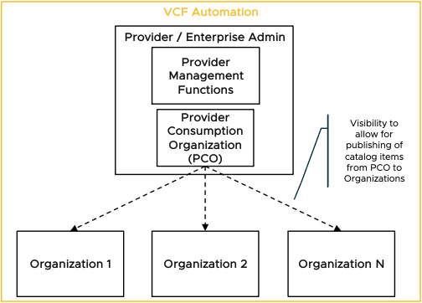
The publishing permissions does not change the management structure of the other Organization. This means that the PCO cannot perform any resource management for other Organizations.
Table 3-528. PCO Functionality Breakdown
Functions the PCO can perform | Functions the PCO cannot perform
See all other Organizations in the system in order to publish catalog items | Context switch into any other tenants
Publish catalog items to those Organizations | Use an identity provider different than the provider org
Login with the same credentials as they log in to the system level | Manage other Organizations (AKA: be a sub-provider)
Manage user/group importing and role assignment within the PCO separately from the system level | Perform resource management for other Organizations
Provide isolated resources for use by the Provider Organization

Provider Admin vs Organization Admin
Providers vs Organization
VCF Automation introduces multi-tenancy model based on a vSphere Supervisor running as a management plane for all IaaS services including both VMs and containers.
- Controls access via vSphere Namespaces within the Supervisor Cluster
- Completely removes the need for direct infrastructure access by tenants
- Provides complete isolation between tenants and limits each tenant to only view their own environment
The organizational model is separated into 2 primary levels - Provider and Organization or Tenant. There is also an additional layer of separation within a tenant: Projects (which are covered in the Understanding VCF Automation All Apps Organization Multi Tenancy Model section).
- Provider Administrators are responsible for
  - The underlying infrastructure
  - Assigning its resources to tenants.
- Organization Administrators
  - Consume from their assigned resources and allocate them to different projects within their organization through vSphere Namespaces
  - Have control over cross-project networking by managing Transit Gateways that can interconnect multiple VPCs, as well as their upstream connectivity
  - Also manages identity and access for the tenant
Figure 3-45. VCF Automation Organizational model
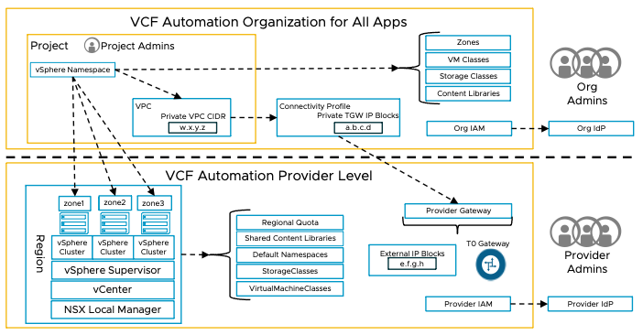

Understanding Supervisors, Regions, Zones & vSphere Namespaces
The Supervisor is the component that owns the physical infrastructure resources and runs organization workloads on those resources. A region is a collection of one or more Supervisors that share a common NSX Local Manager. Zones represent vSphere clusters that provide compute resources for a supervisor to run on. A supervisor can have multiple Zones. Supervisors and Zones are defined in vCenter.
Supervisors can run various services, which can be registered to the supervisor cluster through vCenter. As part of the activation process, the Kubernetes, Velero, and VM service are enabled, which supports running container-based workloads (Kubernetes), backing up the management components (Velero) and running VM workloads (VM Service).
A vSphere Namespace represents a logical pool of resources that consumes CPU, memory and storage from one to three Zones and runs a project’s workloads on those resources. Supervisors and their Zones are assigned into Regions by the Provider. vSphere Namespaces are created within a Project by the Org Admin using the resources allocated to the Org through Region Quotas. vSphere Namespaces are defined using a vSphere Namespace class. There are 3 default system vSphere Namespace classes (small, medium and large) which can be customized by the Org Admin, or new ones defined. The vSphere Namespace classes defines default resource limits and reservations (which can be overridden), in addition to storage classes (and capacity limits for each class), VM classes (the size of VMs that can be created), and Content Libraries.
Table 3-529. Provider and Organization Administrator Roles for Supervisor and Namespace objects
Object | Provider | Organization
Supervisor | Activates and configures in vCenter.  Assigns Supervisor resources to Organizations through Region Quotas. | Consumes indirectly (through vSphere Namespaces)
vSphere Zone | Creates vSphere Zone and adds a vSphere cluster  Assigns resources in vSphere Zones to Organizations through Region Quotas. | Consumes indirectly (through vSphere Namespaces)
Region Quota | Defines Region Quota allocating Region, Supervisor, Zones (with CPU and Memory limits & reservations per Zone), VM Classes, Storage Classes (with Storage Limit per Storage Class) | Assigns resources to vSphere Namespaces from the assigned Region Quota.
vSphere Namespace | Does not manage | Creates vSphere Namespaces and allocates resources in 1 to 3 vSphere Zones from assigned Region Quotas using a defined vSphere Namespace class. Has the ability to override the default class limits (within the available assigned Region quota).
vSphere Namespace Class - Limits | Defines CPU and Memory limits within assigned Zones to the Organization through Region Quota | Assigns CPU and Memory resources within Zones to vSphere Namespaces from the assigned Region Quota.
vSphere Namespace Class - VM Class | Assigns the list of VM Classes available to the Organization through Region Quota. | Assigns the list of VM Classes available to a vSphere Namespace from the list of VM Classes assigned in the Region Quota.
vSphere Namespace Class - Storage Class | Defines Storage Policies and maps physical storage to the Class (policy).  Assigns Storage Classes and capacity limits to Organizations through Region Quotas | Assigns Storage classes and capacity limit to vSphere Namespace Class.  Consumes Storage Classes within vSphere Namespaces
vSphere Namespace Class - Content Library | Provider Created Content Libraries cannot be added to vSphere Namespace Classes. | Assigns Content Libraries to vSphere Namespaces using vSphere Namespace Classes. Content Libraries can also be auto-assigned to all new vSphere Namespaces as an option when creating the Content Library. When that option is enabled, Content Libraries are not available to manually add to a vSphere Namespace Class.
Figure 3-46. VCF Automation Supervisor relationships
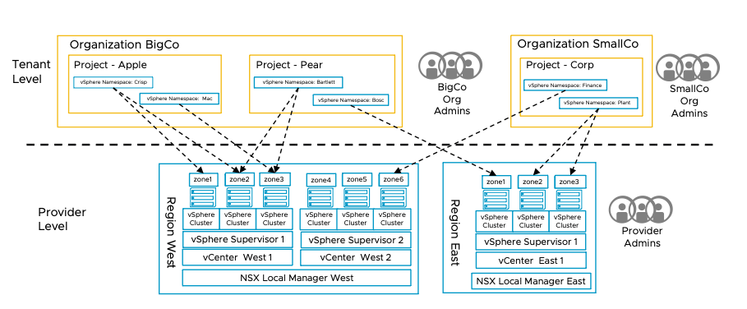
Designing the environment layout
A single VCF Automation instance can be fully integrated with a VCF fleet, and used to manage and deploy workloads across multiple vCenters and NSX Managers. When deploying across multiple workload domains in a region, the same NSX Local Manager should be shared across all the workload domains to allow for VPCs to be available throughout the entire region. When greater scale or physical separation is required, using a separate region for different sites will allow control over where the workloads run through the vSphere Namespace configuration. vSphere Namespaces are scoped to a single region.
A supervisor either has a 1-node control plane, that runs on a single vSphere cluster (or vSphere Zone), or for production/HA it can be a 3-node control plane running on either a single zone or 3 different zones (e.g. 3 vSphere clusters).
Note Please refer vSphere Supervisor Detailed Design to understand supervisor availability models.
Supervisor Design
A single Supervisor per vCenter will meet most requirements, with vSphere clusters representing a separate Zone in the Supervisor. It is possible to create multiple Supervisors in a single vCenter, each with its own management plane.
The supervisor control plane is associated with an NSX Project and VPC, and these NSX Networking constructs are also used for Namespaces running workloads, which depend upon having an Edge Cluster deployed, with a T0 router. The Gateway should be configured for Centralized Connectivity and in Active-Standby mode to support the stateful VPC services (NAT) required for VCF Automation’s use of NSX Networking. The Edge form factor, and number of Edges in the cluster depends primarily upon the number of VPCs created in VCF Automation within the Region. Each VPC requires a Small Load Balancer instance, and the Supervisor consumes 2 VPCs for its control plane. To avoid high CPU utilization on the Edge nodes, deploying a large Edge pair is sufficient for up to 48 VPCs. Additional capacity can be realized by adding more Edge VMs to the Edge Cluster, or scaling up the Edge VMs already present.
When deploying the Edge Cluster, the vCenter Networking workflow will require VPC network CIDRs for Private Transit Gateway IP Blocks and VPC External IP Blocks. These IP ranges will be assigned to the default NSX Project, which should be used for the Supervisor control plane. Workload networks will be deployed in an Organization (Org), and each Org in VCF Automation will have a dedicated NSX Project and therefore require different private IP ranges, although the External IP Blocks can be used across multiple Organizations and the control plane. To support the Supervisor, the Private Transit Gateway network should be at least a /26. The VPC External IP block should have enough capacity for any non-VCF Automation vSphere Namespaces, NAT, or Load Balancer VIPs being deployed in the default project, as well as at least 7 IPs per Supervisor (additional services will consume more IPs).
Table 3-530. Required Inputs
Description | Explanation
Clusters / Zones that will be used to run workloads managed by VCF Automation. | Supervisor must be activated on clusters or vSphere Zones to provision/manage workloads on vSphere infrastructure  Zone names must:  - Have 63 or fewer characters  - Begin and end with a lowercase alpha-numeric character (a-z and 0-9)  - Only contain dashes in addition to lowercase alpha & numeric characters.  Must be unique in the vCenter.
Assignment of clusters/Zones to Supervisors, and Supervisors to Regions | Define geographical alignment and boundaries for allocating infrastructure to tenants & users.  All Clusters/Zones in a supervisor must be managed by the same vCenter.  All Supervisors in a Region should have their networking provided by the same NSX Local Manager.
Service CIDR | A CIDR block used for services within the supervisor cluster. This network should not overlap with the supervisor management network or any networks used in VPCs within the supervisor, or any external networks that require reachability from workloads running in the supervisor. 100.96.0.0/23 is recommended. Must be between /24 and /12 in size. Must specify with the network IP, not an IP in the range.
Control Plane IP Range  Network port group for supervisor control plane with 5 or more available IPs | Where possible, this should be the same management network as ESXi management, and leverage the vmk0 VLAN & IP Space. A block of 5 contiguous IPs is required.  A separate VLAN and network can also be used when the ESXi management network is not suitable. Connectivity between supervisors is not required, but they must reach vCenter, NSX Manager, ESXi hosts, VCF Automation, and AVI Controllers if used. Used for management plane and basic metrics (low bandwidth).
Supervisor VPC networking:  NSX Project (default project)  Connectivity Profile (default profile)  External IP Blocks  Project Transit Gateway IP Blocks, Private VPC CIDRs, DNS, NTP | The Supervisor API and other services will reside on this VPC, created in the specified project with the specified connectivity profile and IPs. It is recommended to use the Default Project and Default VPC Connectivity Profile, but custom ones can be used if pre-created on NSX Manager, along with External and TGW IP space.  If the default project is used, the IP space assigned during the Edge Cluster deployment workflow, will be displayed. The Private VPC CIDR cannot conflict with any other IP ranges that need to be routable from the Supervisor.  Private TGW Blocks: /26 min.  The Private VPC CIDR: /25 min.
Supervisor Control Plane Size | Small by default. If there will be a large number of workloads running on the supervisor, you can increase this to Medium or Large.

Understanding Content Libraries
Content Libraries contain the templates and images used to deploy workloads. They are stored in vCenter using vCenter Content Libraries, but VCF Automation takes care of replicating the libraries across multiple regions to keep the content in sync. Content libraries can be created by the provider which are classified as shared, and are then available for all tenants within the region(s) selected for the library. They can also be created by the tenant which are classified as not shared, and only accessible to the tenant that created them. Tenants can only upload items to non-shared libraries that they created.
Design Objectives | Design Decisions
Define a collection of templates and objects (such as ISO images, OVA/OVF templates, vm disk files) which are replicated to all the regions where workloads are being deployed, so that end users can attach them to vSphere Namespaces where they are used to deploy workloads from the images stored in the Content Library. | There are 2 primary types of Content Library:  - Provider-managed Content Libraries, where the Provider can define and share images or files with multiple Tenants. Tenants cannot add to or modify the images in the library. Provider-managed Content Libraries will automatically be attached to any vSphere Namespaces in the region(s) the Content Library is configured for.  - Tenant-managed Content Libraries, which are created by the Tenant to upload their own images and files. Tenants have the option of manually assigning Content Libraries to vSphere Namespace Classes, or having them auto-attached to all vSphere Namespaces in the region(s) the Content Library is configured for. This setting cannot be modified once the Content Library has been created. When using the manual assignment method via vSphere Namespace Classes, only vSphere Namespaces created after the Content Library has been assigned in the vSphere Namespace Class will have access to it.  Content Libraries must be assigned to one or more Regions. When multiple regions are selected, the content libraries will be replicated with local copies stored in each region.  In most cases, a combination of a Provider Content Library and Tenant Content Library will be required.

Understanding Organization & Projects
Organization and projects are the top-level grouping objects used to define isolated sets of users and resources. A tenant is fully isolated from other tenants, with separation at the resource, network and identity layers. One tenant has no knowledge of any other tenants. This is typically used when multiple separate entities share a common infrastructure – either with a service provider model, or a centralized corporate IT department providing resources with self-service workload deployment and billing to different business units within the broader organization.
Within a tenant, there is further grouping possible, as vSphere Namespaces are created within the scope of a project. This allows compute and network resources to be defined independently for each vSphere Namespace. VPCs can be shared or dedicated as needed (to any projects or vSphere Namespace within the Organization, but not outside of the Organization). Access definitions can be managed at the project level, allocated by the Tenant Manager. These separations help reduce the need for requests to central infrastructure teams (Provider and Infrastructure Managers) and moving the operations closer to the consumers of the service.
Each Organization has a dedicated NSX project created when the provider creates the Region Network Configuration. This gives each Organization their own Transit Gateway and IP block allocation which they can carve up into VPCs and subnets to deploy different workloads.
Design Objectives | Design Decisions
Define groups based on the business structure to maintain required isolation and access management.  Assign administrators for each of these groups, allocating them appropriate resources for their areas, which they can re-allocate as needed.  Provide each development or application team with compute and networking resources. | For Enterprise use cases without the need for full isolation between tenants, such as when a shared IT team manages all infrastructure, a single Tenant can be used, while still providing a degree of isolation and self-service using Projects. This can simplify the networking as the same External and Private TGW networks can be used.  Each Tenant will have its own Private TGW network space, used when workloads require communication between projects. Private VPC network space is defined at the project level and cannot communicate with other projects without using NAT. The External network space is generally used for defining NAT rules to allow inbound access while the default SNAT enables outbound connectivity.  Tenants each have a separate directory to define their users. When multiple Tenants use the same directory it may be preferable to use the same Tenant with project-level separation. Because the Provider infrastructure needs access to the directory, in most Service-Provider models public Identity Providers (IdPs) or browser-based SAML IdPs will be necessary for authentication, using Just-in-Time user & group provisioning that sends group membership with the authentication token.
Note Please refer VCF Automation Role Base Access Control section for more information.

Understanding Workload Networking

Understanding Workload Networking
Each VPC is a separate, standalone network with 3 different types of IP addresses that each have different levels of reachability:
- VPC Private CIDRs are only advertised within the confines of the VPC and require NAT to connect to any resources outside of the VPC. These CIDRs are managed by the VPC (Project) Administrator and do not need to be unique across multiple VPCs.
- TGW Private IP blocks are only advertised within the confines of the NSX Project or VCF Automation Organization (and its TGW, which also is scoped to the NSX Project). The available IP blocks are defined by the Tenant Administrator. Multiple tenants can re-use the same IP space, however, as the traffic will be SNATed to an external IP before leaving the VPC, but must remain distinct from other IP space on the Tenant's enterprise network to ensure routability. Project administrators can allocate subnets from within the defined IP Blocks for use in their VPCs. These IPs have direct reachability to other VPCs within the Tenant using the TGW Private IP space.
- External IP Blocks are unique across the Enterprise network and are generally advertised upstream to the network infrastructure. These IPs are managed by the Provider and subnets within them can be assigned by the Tenant Admin from allocations defined by the Provider. IPs in this space are used for outbound Source NAT to enable external reachability for workings using Private IPs. The are also assigned to Load Balancer Virtual IPs (VIPs) for inbound application reachability.
Routing within the NSX Project is performed by the Transit Gateway (TGW), which has an external connection to upstream networks defined by the Provider.
Figure 3-47. Workload VPC Model
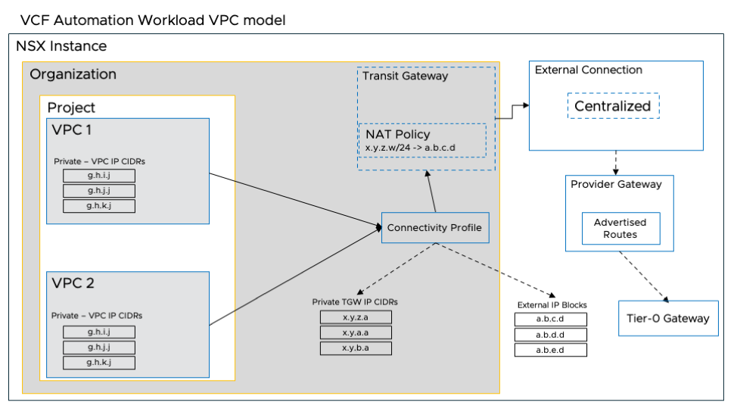
Design Objectives | Design Decisions
Define a networking model providing the appropriate level of isolation, scale and connectivity for each organization's workloads. Every organization should have sufficient external IP address allocations and guidance on reachability for external services to self-manage connectivity for their workloads. | - VPC Mapping:  vSphere Namespaces are managed by tenants, which includes mapping a vSphere Namespace to a VPC. Tenants can create a new VPC for each vSphere Namespace, or re-use the same VPC for multiple vSphere Namespaces.  Different VPCs should be used for workloads that require some level of network segregation (when on private VPC subnets) but also support communication between other workloads (on private TGW subnets). When no network separation is required, the same VPC can be used across the region.  VPCs only span a single region, so Namespaces in different regions will always be mapped to different VPCs.  - Network Selection:  Each tenant manages 2 pools of addresses: Private VPC and Private TGW. These can be allocated independently of other tenants but it’s a good idea for tenant managers to keep addressing consistent within an enterprise. Service Providers may only publish a list of reserved address ranges used for external and management to avoid conflicts.  In addition, the Provider manages the External IP address blocks which are assigned to tenants. One of the public IPs is automatically assigned as a default SNAT IP for the VPC. This IP is used as the source for any traffic from a TGW Private IP when communicating with a resource outside of the Project. NAT rules can also be defined for Inbound traffic when required, or for Inbound or Outbound communication from a VPC Private IP address. Since these IPs are more limited, they should only be used where necessary, and not assigned directly to VM workloads, but to Load balancer VIPs or NAT rules, leveraging the default SNAT rule when possible.

Understanding Classes, Catalogs & Blueprints
These are the constructs that define the types and details of the workloads that customers of the self-service portal can deploy, and the resources they are able to consume.
Tenant administrators manage the vSphere Namespaces and which projects can access them.
Design Objectives | Design Decisions
Define the parameters for which resources and how much resource is able to be consumed by tenants and end customers for their workloads. | vSphere Namespace Class:  vSphere Namespace classes are templates for the resources assigned to a vSphere Namespace. When a vSphere Namespace is created by the tenant manager, vSphere Namespace class is assigned, which determines the CPU, memory and storage available to that vSphere Namespace.  Default vSphere Namespace classes are defined by the Provider, and can be used as is, but the tenant manager can also define their own classes or edit the default ones.  VM Class:  VM Classes define the CPU & Memory properties for individual workloads that can be created. The class includes the number of CPUs as well as how much of the CPU is reserved capacity (vs. best effort), and how much memory is allocated, along with how much of that memory is reserved or allocated through best effort.  The Provider selects which VM Classes are available for the tenant organization.  Storage Class  Storage Classes define the storage policy (e.g. RAID5 on cluster 1) and the capacity of that policy. Storage classes are defined by the Provider and assigned to Tenants. The Tenant manager can select which of the policies available to them are assigned to a vSphere Namespace.

Multi Tenancy Consumption Patterns
This section describes the multi-tenancy consumption patterns aligned with the tenancy deployment models described in the 'Tenancy Deployment Models" section. It explains the different ways multiple organizations or tenants can consume shared compute, memory, storage, and networking resources, depending on the chosen tenancy deployment model.
Before diving into design and resource isolation scenarios, let's first understand the relationship between VCF Automation, vSphere Supervisor, and NSX objects, which you will see in various patterns below.
Object Relationship | Characteristics
Tier 0 router (T0) <> Organization | A single T0 can share multiple organizations  One Organization can have multiple T0s
Organization <> Project | One Organization can have one or multiple projects.
Organization <> TGW | One Organization can have only one TGW
Project <> vSphere Namespace | One Project can have multiple vSphere Namespaces
VPC <> vSphere Namespace | One VPC can have one or more vSphere Namespaces

Multi-Tenancy Consumption Pattern 1: Resource Isolation with Single VPC for Multiple Businesses in One Supervisor Zone
This design follows a multi-tenancy consumption pattern where resources are shared among multiple tenants, but logical isolation is provided through multiple levels within the private cloud stack.
This consumption pattern prioritizes cost optimization and simplified management over strict tenant isolation.
Figure 3-48. Multi Tenancy Consumption Pattern 1: Resource Isolation with Single VPC for Multiple Businesses in One Supervisor Zone
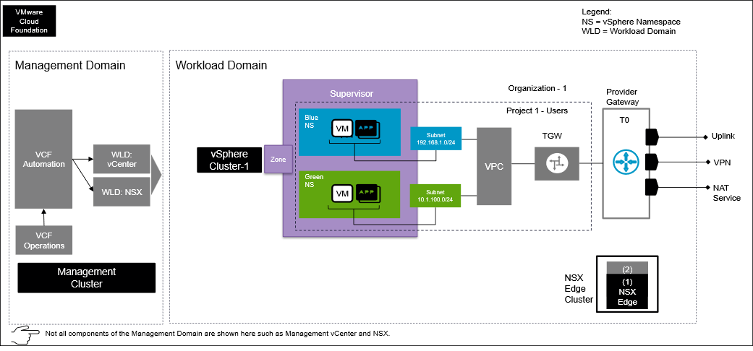
Design Attributes | Details | Diagram Representation
Organization | One | Represents as one Organization
Line of Business | Two | Describes Blue and Green as separate lines of business.
Number of vSphere Clusters | One | A compute and vSAN storage cluster used in a workload domain.
Number of vSphere Supervisors | One | vSphere Supervisor defines the scope of vSphere IaaS control plane on vCenter.
Number of vSphere Supervisor Zones | One | Zones are logical constructs within a vSphere Supervisor that represent failure domains or availability zones. Each zone is mapped to a specific vSphere cluster, ensuring that workloads deployed in a particular zone are physically located on separate hardware for high availability.
VCF Automation Project | One | Represented by "Project 1 - Users". This represents a logical project or user ownership within the environment.
Provider Gateway (T0) | One | The Tier-0 Gateway provides external connectivity. This is where NAT and VPN services are configured.
vSphere Namespaces | Two | Blue and Green line of businesses have dedicated vSphere Namespaces for workload isolation.
VPC | One | All lines of businesses / tenants share a single VPC.
Transit Gateway | One | A single Transit Gateway connects all the VPCs to the Provider Gateway.
Tenant Networks | Two | Distinct subnets are used for each vSphere Namespace, providing network segmentation.

Multi-Tenancy Consumption Pattern 2: Resource Isolation with Multiple VPCs for Multiple Lines of Business in One Supervisor Zone
This approach provides robust resource isolation for different lines of business (LOBs) within a single vSphere Supervisor Zone.
Figure 3-49. Pattern 2 : Resource Isolation with multiple VPCs for multiple line of business in one Supervisor zone
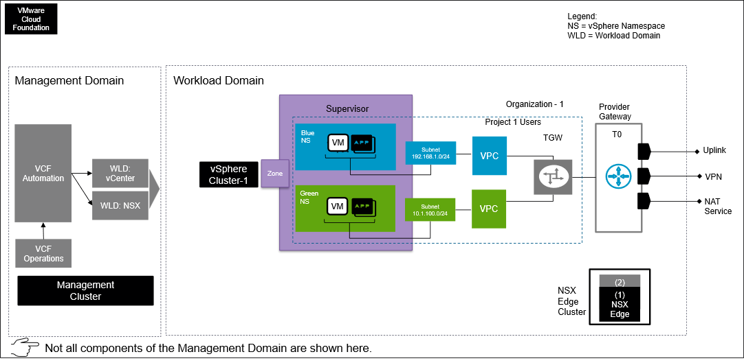
Design Attributes | Details | Diagram Representation
Organization | One | Represents as one Organization
Line of Business | Two | Describes Blue and Green as separate LOB
Number of vSphere Clusters | One | A compute and vSAN storage cluster used in a workload domain construct
Number of vSphere Supervisors | One | vSphere Supervisor defines the scope of vSphere IaaS control plane on vCenter.
Number of vSphere Supervisor Zones | One | Zones are logical constructs within a vSphere Supervisor that represent failure domains or availability zones. Each zone is mapped to a specific vSphere cluster, ensuring that workloads deployed in a particular zone are physically located on separate hardware for high availability.
VCF Automation Projects | One | Represented by "Project 1 - Users". This represents a logical project or user ownership within the environment.
Provider Gateways (T0) | One | The T0 gateway provides external connectivity. This is where NAT and VPN services are configured.
vSphere Namespaces | Two | Blue and Green LOB has dedicated vSphere Namespace for workload isolation.
VPCs | Two | Each LOB/ tenant has their own dedicated VPC for network isolation.
TGWs (Transit Gateway) | One | A single TGW connects all the VPCs to the Provider Gateway.
Tenant Networks | Two | Distinct subnets are used for each vSphere Namespace, providing network segmentation.

Multi-Tenancy Consumption Pattern 3: Resource Isolation with single VPC for multiple line of business in three Supervisor zone
This architecture provides resource isolation for multiple lines of business (LOBs) by consolidating them within a single Virtual Private Cloud (VPC) that spans three vSphere Supervisor Zones.
Figure 3-50. Pattern 3 : Resource Isolation with single VPC for multiple line of business in three Supervisor zone
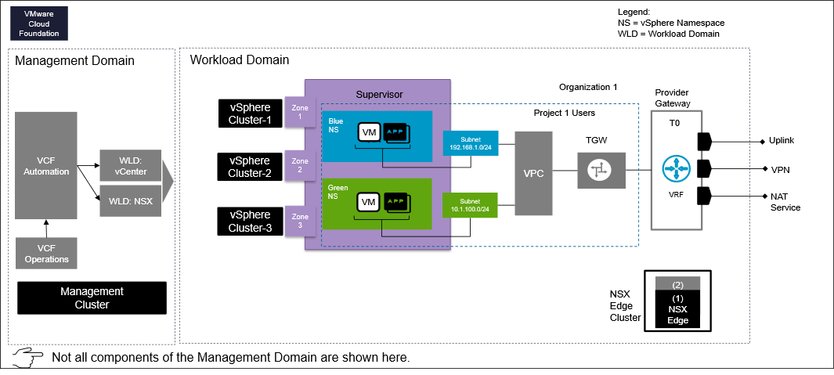
Design Attributes | Details | Diagram Representation
Organization | One | Represents as one Organization
Line of Business | Two | Describes Blue and Green as separate LOB
Number of vSphere Clusters | Three | Three compute and vSAN storage cluster used in a workload domain construct
Number of vSphere Supervisors | One | vSphere Supervisor defines the scope of vSphere IaaS control plane on vCenter.
Number of vSphere Supervisor Zones | Three | Zones are logical constructs within a vSphere Supervisor that represent failure domains or availability zones. Each zone is mapped to a specific vSphere cluster, ensuring that workloads deployed in a particular zone are physically located on separate hardware for high availability.
VCF Automation Projects | One | Represented by "Project 1 - User". This represents a logical project or user ownership within the environment.
Provider Gateways (T0) | One | The T0 gateway provides external connectivity. This is where NAT and VPN services are configured.
vSphere Namespaces | Two | Blue and Green LOB has dedicated vSphere Namespace for workload isolation.
VPCs | One | All LOB/ tenant sharing a single VPC
TGWs (Transit Gateway) | One | A single TGW connects all the VPCs to the Provider Gateway.
Organization Networks | Two | Distinct subnets are used for each vSphere Namespace, providing network segmentation.

Multi-Tenancy Consumption Pattern 4: Resource Isolation for multiple organization with dedicated VRFs
This design achieves strong resource isolation for multiple organizations by providing each with a dedicated Virtual Routing and Forwarding (VRF) instance, ensuring completely separate network routing and forwarding domains.
Figure 3-51. Pattern 4: Resource Isolation for multiple organization with dedicated VRFs
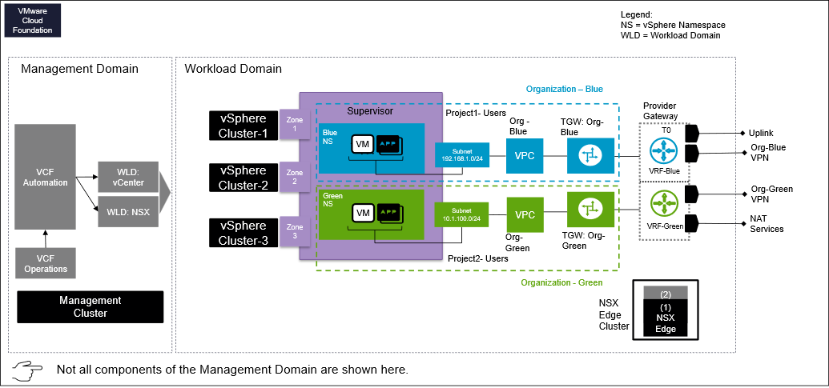
Design Attributes | Details | Diagram Representation
Management Domain | One | Centralized Management: Includes VCF Automation, workload domain vCenter, NSX, and VCF Operations. Consist of a vSphere Cluster -the underlying hardware for the management domain.
Workload Domain | One | A workload domain with three compute vSphere clusters for tenant workloads.
NSX Local Manager | One | Dedicated one NSX Local Manager per region
Organization | Two | Represents two separate Organizations. Such as Blue and Green
Number of vSphere Cluster | Three | Three compute and vSAN storage cluster used in a workload domain construct. Shared by both the organizations.
Number of vSphere Supervisor | Three | vSphere Supervisor defines the scope of vSphere IaaS control plane on vCenter.
Number of vSphere Supervisor Zone | Three | Zones are logical constructs within a vSphere Supervisor that represent failure domains or availability zones. Each zone is mapped to a specific vSphere cluster, ensuring that workloads deployed in a particular zone are physically located on separate hardware for high availability.
VCF Automation Project | Two | Represented by "Project 1 - Users" and "Project 2- Users". This represents a logical project or user ownership within the environment.
Provider Gateway (T0) | One | A single T0 gateway provides external connectivity, including Uplink, VPN, VRF (Virtual Routing and Forwarding), and NAT services.
VRF | Two | Each tenant has a dedicated VRF instance ("VRF: Tenant Blue" and "VRF: Tenant Green") for enhanced network segmentation and isolation. VRF resides in the T0 construct.
vSphere Namespace | Two | Blue and Green tenant has dedicated vSphere Namespace for workload isolation.
VPC | One | All LOB/ tenant sharing one VPC
TGW (Transit Gateway) | Two | Each tenant has a dedicated TGW, "TGW: Tenant Blue" and "TGW: Tenant Green", for connecting their respective VPCs.
Organization Networks | Two | Distinct subnets are used for each vSphere Namespace, providing network segmentation.

Multi-Tenancy Consumption Pattern 5: Multi-Region, Multi-Tenant Resource Isolation with Dedicated and Shared Gateways
This design provides multi-tenant resource isolation across multiple regions by combining dedicated gateways for strict tenant separation with shared gateways for efficient common services.
Figure 3-52. Pattern 5: Multi-Region, Multi-Tenant Resource Isolation with Dedicated and Shared Gateways
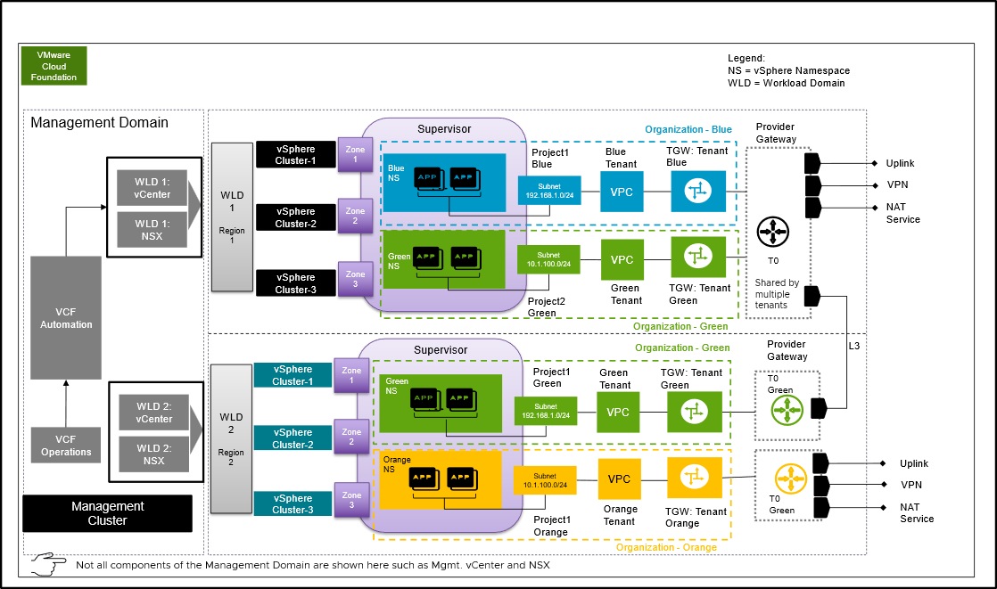
Important In the context of VCF Automation Region
- A region consists of one or more vSphere Supervisor.
- A region is a collection of compute, memory, storage, and networking resources that can span across vCenter instances.
Design Attributes | Details | Diagram Representation
Management Domain | One | Centralized Management: Includes VCF Automation, workload domain vCenter, NSX, and VCF Operations. Consist of a vSphere Cluster -the underlying hardware for the management domain.
Workload Domains | Two | A workload domain with three compute vSphere clusters for tenant workloads.
NSX Local Managers | Two | Each workload domain has one NSX local manager
Organizations | Three | Represents three separate Organizations. Such as Blue, Green and Orange
Number of vSphere Clusters | Six | Six compute and vSAN storage cluster used in two workload domain construct.
Number of vSphere Supervisors | Six | vSphere Supervisor defines the scope of vSphere IaaS control plane on vCenter.
Number of vSphere Supervisor Zones | Six | Zones are logical constructs within a vSphere Supervisor that represent failure domains or availability zones. Each zone is mapped to a specific vSphere cluster, ensuring that workloads deployed in a particular zone are physically located on separate hardware for high availability.
VCF Automation Projects | Three | Represented by "Project 1 - User" and "Project 2- User". This represents a logical project or user ownership within the environment.
Provider Gateways (T0) | One in each region | A single T0 gateway provides external connectivity, including Uplink, VPN, VRF (Virtual Routing and Forwarding), and NAT services.
VRFs | Two | Tenant "Green" and "Orange" has a dedicated VRF instance in a T0. Both tenant sharing a T0 but still they have network isolation.
vSphere Namespaces | Two | Blue and Green tenant has dedicated vSphere Namespace for workload isolation.
VPCs | One | Each LOB/ tenant sharing a single VPC
TGWs (Transit Gateway) | Two | Each tenant has a dedicated TGW, "TGW: Tenant Blue" and "TGW: Tenant Green", for connecting their respective VPCs.
Tenant Networks | Four | Distinct subnets are used for each vSphere Namespace, providing network segmentation.

Multi-Tenancy Consumption Pattern 6: Multi-Organization resource isolation with shared NSX across workload domains
This design provides multi-organization resource isolation across distinct workload domains by leveraging a shared NSX platform to centrally manage and logically segment network and security services for each tenant.
Figure 3-53. Pattern 6: Multi-Organization resource isolation with shared NSX across workload domains
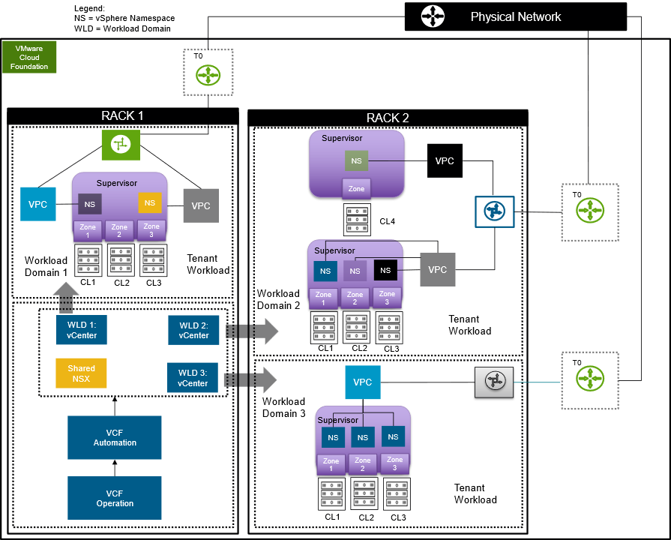
Please refer workload networking section for mode detailed information around workload networking. Workload Networking Detailed Designs
Design Attributes | Details | Diagram Representation
Management Domain | One | Centralized Management: Includes VCF Automation, workload domain vCenter, NSX, and VCF Operations. Consist of a vSphere Cluster -the underlying hardware for the management domain.
Workload Domains | Three | A workload domains with three compute vSphere clusters for tenant workloads.
Shared NSX Local Managers | One | Workload domains share a NSX local manager deployment.
Organizations | Three | Each workload domain represents as one organization workload.
Number of vSphere Clusters | Ten | Ten compute and vSAN storage clusters used in a three workload domain construct.
Number of vSphere Supervisors | Ten | vSphere Supervisor defines the scope of vSphere IaaS control plane on vCenter.  In this design Workload Domains 1 and 3 each have a 3 zone vSphere Supervisor. Workload Domain has a 3 zone vSphere Supervisor as well as a sepeate 1 zone vSphere Supervisor for a total of 10 zones.
Number of vSphere Supervisor Zones | Ten | Zones are logical constructs within a vSphere Supervisor that represent failure domains or availability zones. Each zone is mapped to a specific vSphere cluster, ensuring that workloads deployed in a particular zone are physically located on separate hardware for high availability.  In this design Workload Domains 1 and 3 each have a 3 zone vSphere Supervisor. Workload Domain has a 3 zone vSphere Supervisor as well as a sepeate 1 zone vSphere Supervisor for a total of 10 zones.
VCF Automation Projects | Three | Represented by "Project 1 - User" and "Project 2- User". This represents a logical project or user ownership within the environment.
Provider Gateways (T0) | One in each region | A single T0 gateway provides external connectivity, including Uplink, VPN, VRF (Virtual Routing and Forwarding), and NAT services.
vSphere Namespaces | Nine | Various vSphere Namespaces across the vSphere Supervisors.
VPCs | Five | Various VPCs assigned across the vSphere Namespaces
TGWs (Transit Gateway) | Three | Each Workload Domain has a dedicated TGW.
Tenant Networks | Multiple | Distinct subnets are used for each vSphere Namespace, providing network segmentation.

VCF Automation Identity and Access Management Design
As part of the VCF Automation, you configure authentication to grant user access and provide granular control of resources.
VCF Automation contains two persona levels. The provider persona manages the core infrastructure and the tenant / line-of-business (LOB) persona manages the individual tenants within that infrastructure. Each of these personas have different authentication options.
VCF Automation Personas | Capabilities
Provider | - Installs and manages core VCF Automation infrastructure  - Provider / Enterprise level administrative functions  - Manages shared content libraries published to organizations  - Creates organizations, assigns resource quotas, regional networking and first tenant user
Tenant / LOB | - Manages organizations  - Creates and manages projects  - Creates and manages vSphere Namespaces  - Configures Content Hub  - Creates blueprints  - Provides organization level user management

Provider Persona Attributes
The provider level supports three primary identity providers along with the default local admin account.
Attribute | Details
VCF SSO | - Embedded or appliance VCF Identity Broker  - Provides consistent SSO across the VMware Cloud Foundation platform  - VCF Identity Broker supports multiple different simultaneous LDAP and / or Active Directory connections
LDAP | - Allows for the configuration of a single Active Directory or OpenLDAP connection
SAML | - Assumes upstream SAML identity provider
Default Local Admin Account | - Local admin account created during initial install of VCF Automation  - Full admin rights  - Only one local admin account allowed
Table 3-531. VCF Automation Provider Authentication Requirements
Design Requirement ID | Design Requirement | Justification | Implications
VCF-AUTO-REQD-PROV-001 | Configure an identity provider for the VCF Automation Provider. | - Allows provider to leverage an enterprise directory.  - Enables named access control to Infrastructure level constructs.  - Required to provision administrative access to the Provider Administrator Portal for any account other than the default local admin account. | If not configured, the only access to the Provider Administrator Portal will be through the default local admin account created during installation.
VCF-AUTO-REQD-PROV-002 | Leverage the VCF Identity Broker identity provider. | - Provides Single Sign-On with the rest of the VMware Cloud Foundation components.  - Leverages the authentication direction for VMware allowing support for future enhancements. | None.

Tenant Persona Attributes
The tenant level accepts three primary identity providers along with the default local admin account.
Attribute | Details
OpenID Connect (OIDC) | - Allows for configuration of a OIDC identity provider
LDAP | - Allows for the configuration of a single Active Directory or OpenLDAP connection
SAML | - Assumes upstream SAML identity provider
First user | - Created during initial deployment of a tenant  - Organizational administrator role  - Is a local account
Table 3-532. VCF Automation Tenant Authentication Requirements
Design Requirement ID | Design Requirement | Justification | Implications
VCF-AUTO-REQD-TEN-001 | Configure an identity provider for VCF Automation Tenants. | - Allows tenant to leverage enterprise directory.  - Enables named access control to tenant level constructs.  - Required to provision administrative or user access to the Organization portal for any account other than the first user account established during Organization creation. | If not configured, the only access to the Organization Portal will be through the first user account established during Organization creation.

VCF Automation Authentication Models
Since VCF Automation deployments consist of a Provider and a Tenant persona. This section describes the design requirements, recommendations, and choices for each VCF Automation authentication model.
Table 3-533. Provider / Tenant Models
Attributes | Details
Enterprise Model | In this model, both the provider and tenant authenticate to the same identity provider.
Service Provider Model | In this model, the provider and tenant authenticate to different identity providers.

VCF Automation Enterprise Authentication Design
The VCF Automation Enterprise Authentication Model configures both the provider and tenant to authenticate to the same identity provider.
Figure 3-54. VCF Automation Enterprise Authentication Model
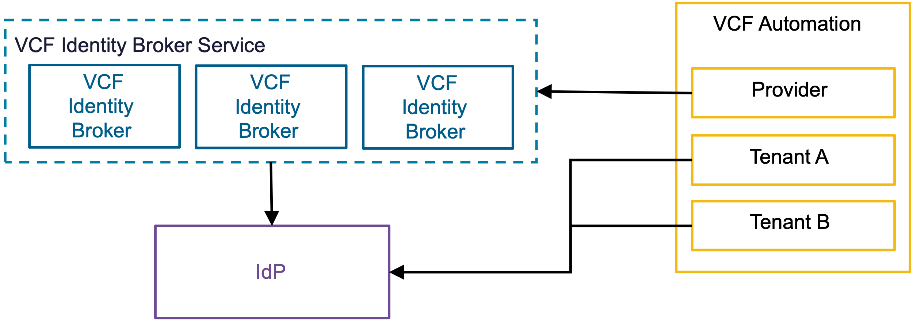

VCF Automation Enterprise Authentication Design Attributes
A VCF Automation enterprise authentication model has the following attributes.
Attribute | Detail
Provider | - The provider organization connects to the VCF Identity Broker service.  - VCF Identity Broker sources the users and groups from the identity provider.  - The provider uses the same identity provider as the tenant.
Tenant | - The tenant organization connects directly to the identity provider through either OIDC or SAML.  - The tenant uses the same identity provider as the provider.
Single Sign-On scope | - The provider log-ins have Single Sign-On with the rest of VCF components.  - The tenant log-ins do not have Single Sign-On with the rest of VCF components.

VCF Automation Enterprise Authentication Model Options
A VCF Automation Enterprise Authentication Model can leverage options from the design areas listed below, depending on objectives.
Design Area | Options
VCF Identity Broker models | - Embedded VCF Identity Broker Model  - Appliance VCF Identity Broker Model
Table 3-534. VCF Automation Enterprise Authentication Design Requirements
Design Requirement ID | Design Requirement | Justification | Implications
VCF-AUTO-REQD-IDP-001 | The provider uses the same IdP as the tenant. | - Allows consistent authentication across provider and tenant | None

VCF Automation Service Provider Authentication Design
The VCF Automation Service Provider Authentication Model configures the provider and tenant to authenticate to different identity providers.
Figure 3-55. VCF Automation Service Provider Authentication Model
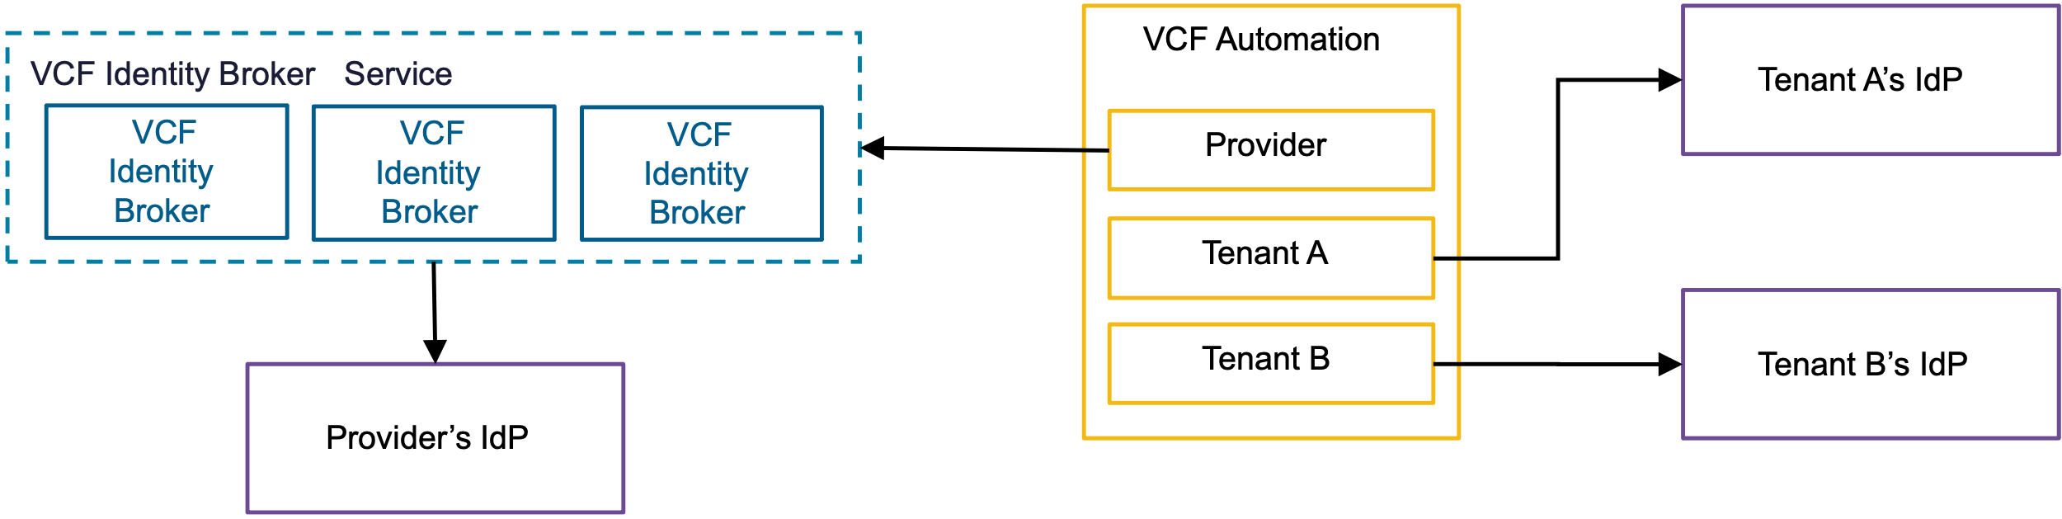

VCF Automation Service Provider Authentication Design Attributes
Attribute | Detail
Provider | - The provider organization connects to the VCF Identity Broker service.  - The VCF Identity Broker sources the users and group from the identity provider.  - The provider uses a different identity provider than the tenant.
Tenant | - The tenant organization connects directly to the identity provider through OIDC or SAML.  - The tenant uses a different identity provider than the provider.
Single Sign-On scope | - The provider log-ins have Single Sign-On with the rest of VCF components.  - The tenant log-ins do not have Single Sign-On with the rest of VCF components.

VCF Automation Service Provider Authentication Model Options
A VCF Automation Service Provider Authentication Modelcan leverage options from the design areas listed below, depending on objectives.
Design Area | Options
VCF Identity Broker models | - Embedded VCF Identity Broker Model  - Appliance VCF Identity Broker Model

VCF Automation Service Provider Authentication Design Requirements
Table 3-535. VCF Automation Service Provider Authentication Design Requirements
Design Requirement ID | Design Requirement | Justification | Implications
VCF-AUTO-REQD-IDP-002 | The provider uses a different IdP than the tenant. | - Supports separate authentication mechanisms for provider and tenant. | None

VCF Automation Role Base Access Control
Managing multi-tenant cloud environments demands a clearly established role-based access control (RBAC) strategy to guarantee restricted access, tenant separation, and secure operations.
Table 3-536. Best Practices for Efficient Role-Based Access Control
Best Practice | Recommendation
Principle of Least Privilege | Ensure users are granted only the permissions absolutely necessary for their specific roles, minimizing security risks.
Regular Review & Updates | Continuously review and update RBAC assignments to ensure they align with any changes in user roles and responsibilities.
Logging & Auditing | Implement logging and auditing to track user access and actions, providing transparency and accountability.
User Education | Provide ongoing training on the importance of role-based access and secure credential handling to prevent security breaches.
Integrate Third-Party Solutions for RBAC Optimization | Consider using external tools for more streamlined RBAC management, detailed reporting, and enhanced control.
VCF provides a platform to create and manage secure and multi-tenant environments. Implementing role-based access control for the management components offers the following benefits.
Table 3-537. Role-Based Access Control Design for Service Providers
Attribute | Detail
Separate Administrator roles | Establish distinct roles for service provider admins, such as managing infrastructure, provisioning resources, and troubleshooting tenant issues.
Provider Admin levels | To control access to sensitive areas, differentiate roles for basic resource management, advanced configuration, and network administration .
Multi-Factor Authentication for all privileged accounts | Implement Multi-Factor Authentication (MFA) for all privileged accounts, including both tenant and service provider administrators.
Table 3-538. RBAC Design for Tenants
Attribute | Detail
Predefined Tenant roles | Create predefined roles such as tenant user, tenant operator, and tenant administrator with permissions based on specific needs.
Custom roles for granularity | Implement custom roles for specific workflows, such as a deployment engineer, with permissions to deploy templates without managing infrastructure.
Least privilege | Apply the principle of least privilege to grant only the minimum permissions needed for each role to perform their tasks effectively.

VCF Automation Default Provider Level Global Roles
These are the default system level roles found in the Provider Admin Portal.
- They are automatically published to all Organizations
- Custom roles can be created at Provider Admin level and then published to one, many, or all Organizations as necessary
Table 3-539. VCF Automation Default Provider Level Global Roles
Role | Description | Published to other Organizations
Defer to Identity Provider | Rights will be determined based on information received from IdP | Yes, Default - All Organizations
Organization Administrator | Owns an Organization and can add users/groups to the organization | Yes, Default - All Organizations
Organization Auditor | Audit an Organization | Yes, Default - All Organizations
Organization User | Rights given to an organization user | Yes, Default - All Organizations
Custom role | Use "new" role button in the Access Control screen to create a custom role as necessary | Can be granularly published to one, many or all Organizations as necessary

VCF Automation Default Organization Level Roles
These are the default Organization level roles.
- Organization level roles govern who can log into the Organizational level portal and with what rights
- Organizations can also inherit custom roles created and subsequently published from the Provider Admin level
- Organizations Administrators can also create custom roles at the Organization level
Table 3-540. VCF Automation Default Organization Level Roles
Role | Description | Considerations
Defer to Identity Provider | Rights will be determined based on information received from IdP | - Inherited from Provider Level Global Roles  - Cannot be edited at Organization level
Organization Administrator | Owns an Organization and can add users/groups to the organization | - Inherited from Provider Level Global Roles  - Cannot be edited at Organization level
Organization Auditor | Audit an Organization | - Inherited from Provider Level Global Roles  - Cannot be edited at Organization level
Organization User | Rights given to an organization user | - Inherited from Provider Level Global Roles  - Cannot be edited at Organization level
Custom role | Use "new" role button in the Access Control screen to create a custom role as necessary | - Created specifically for the Organization  - Cannot be published to other Organizations

VCF Automation Default Organization Project Level Roles
Even if a user has access to the Organization portal, they still need to be assigned specific rights at the Project level to access and manage resources.
- Once a Project is created, the administrator must assign users to the a specific role
- The role assigned to the user applies to all Namespaces created within the Project
Table 3-541. VCF Automation Default Organization Project Level Roles
Role | Description
Project Administrator | Can manage members and catalog content
Project Advanced User | Can request catalog items and use IaaS services
Project User | Can request catalog items
Project Auditor | Can view all project content but cannot request

VCF Automation Load Balancing Design
VCF Automation runs within a Kubernetes-based container environment. The native load balancer is the default automatically configured load balancer for both the simple and highly available deployment models.
Important Note: This section does not cover load balancing for subsidiary functions, such as:
- Workload load balancing
- Load balancing of single sign-on solutions such as VMware Identity Broker
- vSphere Supervisors
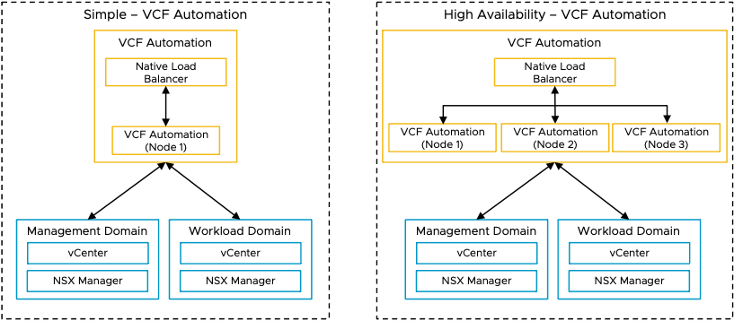
If an external load balancer is used, it is an optional post-deployment manual configuration. The external load balancer points to the native load balancer as the ingress point for VCF Automation.
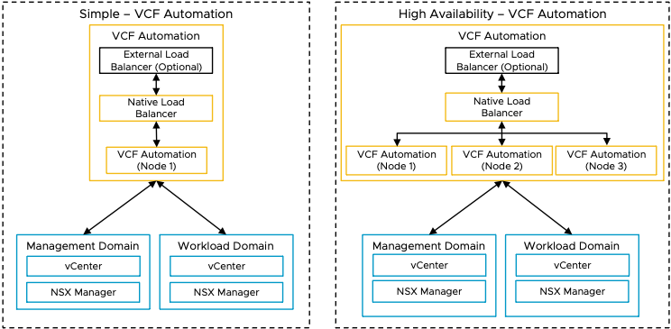
Default Load Balancer | Additional Load Balancer Options
Native Load Balancer | Can add external, 3rd-party load balancer in front of native load balancer  External, 3rd-party load balancers include VMware Avi Load Balancer

VCF Operations Orchestrator Design
VCF Operations orchestrator is a workflow automation solution designed to simplify the automation of complex IT tasks.
VCF Operations orchestrator helps improve service delivery efficiency, operational management, and IT agility. VCF Operations orchestrator is built with an open and flexible architecture that system administrators and IT operations staff can use to streamline tasks and integrate functions with third-party software through workflows.
VCF Operations Orchestrator Deployent Options
Orchestrator Deployment Options | Remarks | Recommended Scenario
Embedded | By default it will be installed as part of VCF Automation deployment | - Used by the Provider Consumption Organization  - Used by Provider Admin to create workflows that can be published to Organizations
External | It can be installed manually | - External VCF Operations orchestrator should be used by Organizations that want to create and publish their own workflows.  - Each Organization can have only one VCF Operations orchestrator instance.  - The Provider Admin deploys, manages and provides access to the external VCF Operations orchestrator used by Organizations
Figure 3-56. VCF Operation Orchestrator Deployment Design for Multiple Organizations
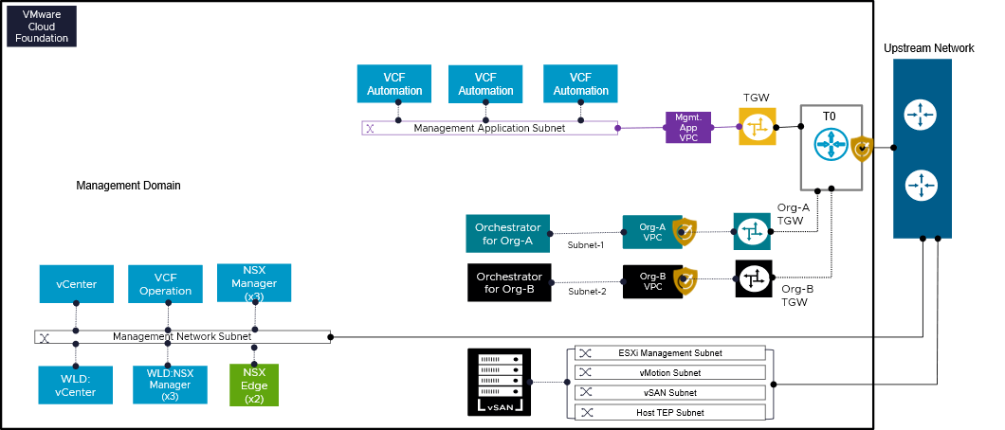
The architecture introduces separate, isolated VCF Operations orchestrator instances for every organization in a CSP environment (e.g., "Orchestrator for Org-A", "Orchestrator for Org-B"). These organizational VCF Operations orchestrator instances are each hosted in a logically distinct network segment or Virtual Private Cloud (VPC). These dedicated VCF Operations orchestrator instances ensure controlled and safe communication by establishing a secure connection to the centralized VCF management components. This architectural pattern enables any organization to take advantage of economies of scale provided by the shared underlying VCF infrastructure while managing and carrying out its unique automation workflows and operational tasks with logical separation and autonomy.
Design Attributes | Details
VCF Operations orchestrator Deployment Model | A dedicated VCF Operations orchestrator instance is deployed for each organization (e.g., "Orchestrator for Org-A," "Orchestrator for Org-B").
Network Isolation and Segmentation | - Each organization's VCF Operations orchestrator instance resides within its own distinct Virtual Private Cloud (VPC), providing inherent network isolation (e.g., "Org-A VPC," "Org-B VPC").  - Specific subnets are allocated within each organizational VPC for the VCF Operations orchestrator instances (e.g., "Subnet-1" for Org-A, "Subnet-2" for Org-B).
Firewall and Security Enforcement | Add on services such as vDefend can be used to create east -west and north south firewall policies to further protect traffic patterns. These policies will control and secure traffic flow to and from each organization's Orchestrator and its associated workloads, ensuring proper access control and segmentation.  Provider Admin can apply DFW policies on the NSX Project level in the case of individual NSX Projects.

VCF Operations Orchestrator for the Provider Consumption Organization
The VCF Automation deployment includes the embedded VCF Operations orchestrator by default.
After the provider admin creates a workflow in the embedded VCF Operations orchestrator, the workflow can be published to the catalog, either:
- As a catalog item for sole use by the provider admin
- As as catalog item that is available to all Organizations
Any workflow built in the PCO then published to all Organizations runs on the embedded VCF Operations orchestrator, even when run by a user in a non-PCO Organization.
If an Organization wishes to create and publish their own workflows within their Organization, they cannot use the PCO's embedded VCF Operations orchestrator. The Organization must use an external, dedicated VCF Operations orchestrator instance.

Chargeback and Billing
Chargeback is a cost management solution designed to help service providers accurately track and distribute expenses within a private cloud environment. It enables both providers and tenants to gain insights into resource usage and ensures fair cost allocation based on consumption. As a plug-in for tenants, Chargeback provides a metering and billing interface that simplifies usage tracking, measurement, and invoicing for services delivered through VCF Automation and VCF Operation.
Chargeback is an essential component of cloud services, particularly for service providers using VMware Cloud Foundation. It involves assigning the costs of cloud resources and services to the users or departments that actually use them. This practice is critical for both service providers and tenants, as it creates a transparent and clear method for billing and payment.
In older versions of VCF, service providers used VMware Cloud Director (VCD) to handle things like pricing, billing, and dashboards. But in VCF 9.0, these tasks will be managed directly through VCF Automation. This change likely aims to streamline operations, reduce dependencies on external systems, and provide a more integrated experience for providers within the VCF platform.
Figure below describes a high level overview how Chargeback and Billing is integrated part of VCF Operation. VCF Operations acts as the central management hub. It's the starting point for data collection and integration.
Management Packs (MPs):
VCF Operations utilizes Management Packs (MPs) to collect data from specific components. These MPs are like plugins or modules that enable integration. Management pack shown here are i) VCF Automation MP, vCenter MP and NSX MP. It shows a one-to-one relationship between each Management Pack and its corresponding component. This suggests a direct integration between each MP and its respective data source.
Figure 3-57. Chargeback Integration with VCF Operation
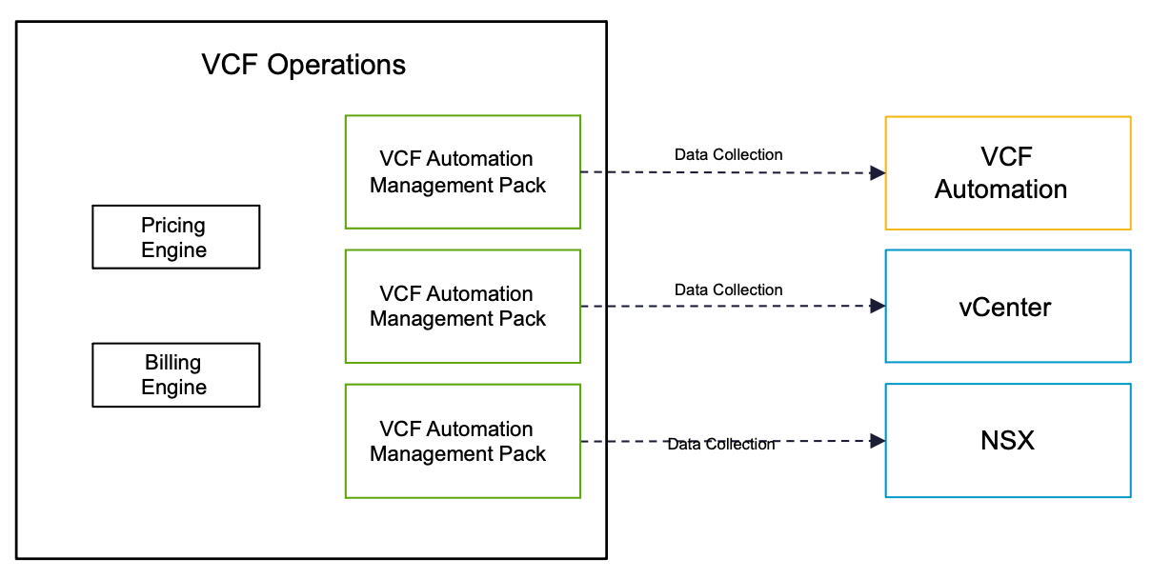
Key Use Cases:
Flexible Pricing (Rate Cards):
- Service providers need the ability to set their own prices for different resources (like storage, compute, network) based on regions or quotas. This allows them to offer tailored pricing plans to their customers.
Accurate Billing (Bills):
- Providers must be able to generate and provide detailed bills to their customers, showing usage and charges for organizations or specific resource allocations (quotas) in different regions.
Usage Monitoring (Dashboards):
- Providers need ready-to-use dashboards that give them a clear view of how their resources are being used by customers.
Customized Provider Interface (Control Panel and Launchpad):
- Providers need a customized interface (control panel and launchpad) that allows them to manage and configure their services and resources in a way that suits their specific needs.
High-level Steps to Initiate Billing
1. VCF Fleet is deployed - VCF Operations and VCF Automation are integrated by default
- Both VCF Operations and VCF Automation are deployed as part of the VCF Fleet
- VCF Automation has a one-to-one integration with VCF Operations, meaning that you can only connect one VCF Automation instance to one VCF Operations instance
- VCF Operations automatically collects data from VCF Automation as well as being able to manage functions such as billing (this can be verified in VCF Operations under Administrator > Integrations, then confirm that the VCF Automation for All Apps Organization is collecting data
2. Create and configure an All Apps Organization
- Complete initial Organization creation in the VCF Automation Provider Administrator Portal
- Complete customization of the Organization as well as deploy any VM or container resources in the VCF Automation Organization Administrator Portal
3. Create Organization Bill in VCF Operations
- In the VCF Operations UI, navigate to Capacity > Cost > Bills tab
- In the Bills tab,
  - Generate a one-time bill
  - Schedule a recurring
  - Note: The bill can be tied to either the Organization or a Region Qutoa
4. View Organization Bill in VCF Automation
- Log in to the VCF Automation Organization Administrator Portal with Organization Admin or Organization Auditor rights, then navigate to Administer > Bills to view any bills associate with the Organization
- Note: Organization Users do not have access to billing

Workload Domain Detailed Design
A VCF fleet can include one or more workload domains that are implemented according to a supported Workload Domain Model. Each Workload Domain Model has options, requirements and recommendations.
- Management Domain Model
- Workload Domain Model

Management Domain Model
The management domain in a VCF fleet hosts the management components of the VCF Instance where it is deployed and the management components of the fleet.
Figure 3-58. Management Domain Model in VMware Cloud Foundation
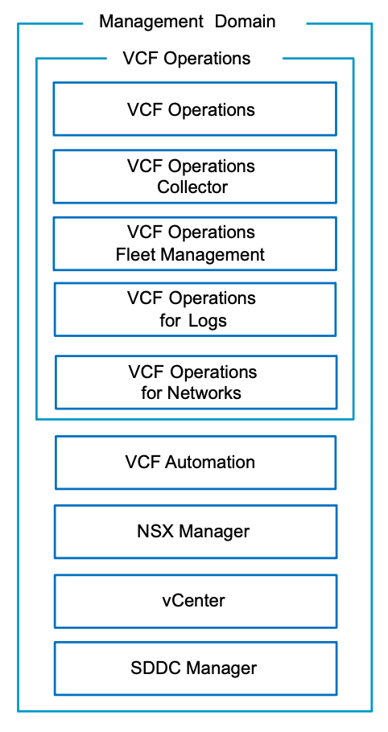

Management Domain Model Attributes
The Management Domain Model has the following attributes.
Attribute | Details
Resource allocation | - VCF fleet management components.  - VCF Instance components.  - NSX Edge nodes.  - Can also run business workloads.
VCF fleet management components | - The management domain in the first VCF Instance contains the following fleet-level management components:  - VCF Operations  - VCF Automation  - Management domains in additional VCF Instances contain the following instance-level management components:  - VCF Operations collector(s)
VCF Instance management components | - Contains the following management appliances for all workload domains:  - ESX hosts  - vCenter  - NSX Manager (dedicated)  - SDDC Manager

Management Domain Model Options
According to your objectives, the Management Domain Model can have options from the following design areas.
Design Area | Options
Cluster models | - First cluster:  - vSphere Single-Rack Cluster Model  - Layer 2 Multi-Rack Cluster Model  - vSphere Stretched Cluster Model (Day 2)  - Additional clusters:  - All cluster models.
VCF Operations models | - Simple VCF Operations Model  - High Availability VCF Operations Model
VCF Automation models | - Simple VCF Automation Model  - High Availability VCF Automation Model
NSX Manager models | - Simple NSX Manager Model  - High Availability NSX Manager Model

Management Domain Model Requirements
Table 3-542. Management Domain Design Requirements
Design Requirement ID | Design Requirement | Justification | Implication
VCF-WLD-REQD-CFG-001 | Deploy a management domain to host all management components for the VCF instance. | - Guarantees sufficient resources for management components.  - Enables the use of specific hardware to meet only the needs of the management components.  - Enables the use of dedicated physical compute, network and storage separately from those used for additional workloads.  - Enables separate life cycle management of management and workload components. | - You must carefully size the management domain to accommodate planned deployments of additional workload domains and management components.  - Hardware might not be fully utilized until full-scale deployment has been reached.

Management Domain Model Recommendations
Table 3-543. Management Domain Design Recommendations
Design Recommendation ID | Design Recommendation | Justification | Implication
VCF-WLD-RCMD-CFG-001 | If running business workloads in the management domain, configure the following vSphere resource pools to control resource usage by management and business workloads.  - cluster-name-rp-sddc-mgmt  - cluster-name-rp-sddc-edge  - cluster-name-rp-user-edge  - cluster-name-rp-user-vm | Ensures sufficient resources for the management components. | You must manually create the vSphere resource pools and manage their settings over time.

Workload Domain Model
As you expand your VCF fleet, you can add workload domains to a VCF Instance. Each workload domain is assigned a vCenter and NSX Manager.
Figure 3-59. Workload Domain Model in VMware Cloud Foundation
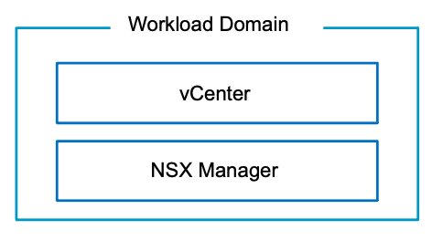

Workload Domain Model Attributes
A Workload Domain Model has the following attributes.
Attribute | Details
Resource allocation | - NSX Edge nodes.  - Business workloads.
vCenter Single Sign-On domain | Dedicated.

Workload Domain Model Options
According to your objectives, the Workload Domain Model can have options from the following design areas.
Design Area | Options
Cluster models | - vSphere Single-Rack Cluster Model  - Layer 2 Multi-Rack Cluster Model  - Layer 3 Multi-Rack Cluster Model  - vSphere Stretched Cluster Model (Day 2)
NSX Manager models | - Simple  - High Availability
NSX consumption models | - Dedicated NSX instance.  - Shared NSX instance.
Workload network type | - IPv4  - IPv6

Workload Domain Model Recommendations
Table 3-544. Workload Domain Design Recommendations
Design Recommendation ID | Design Recommendation | Justification | Implication
VCF-WLD-RCMD-CFG-002 | Use workload domains for customer workloads. | - Aligns with the VMware best practice of separating management workloads from customer workloads.  - Provides better long term flexibility and expansion options. | Requires additional hardware.

vSphere Cluster Detailed Design
A VCF Instance can include one or more of the supported vSphere Cluster Models. This section describes the options, requirements and recommendations for each vSphere Cluster Model.
- vSphere Single-Rack Cluster Model
- Layer 2 Multi-Rack Cluster Model
- Layer 3 Multi-Rack Cluster Model
- vSphere Stretched Cluster Model

vSphere Single-Rack Cluster Model
The Single-Rack Cluster Model is the simplest form of protection where workloads are deployed to a vSphere cluster in the same physical rack, in a single availability zone.
The Single-Rack Cluster Model relies on vSphere HA to protect workloads against host failures.
Figure 3-60. Single-Rack Cluster Model
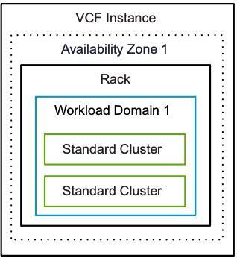

Single-Rack Cluster Model Attributes
A Single-Rack Cluster Model has the following attributes.
Attribute | Detail
Datacenters | Single datacenter.
Physical rack mapping | All cluster hosts exist in one physical rack.
Resilience | vSphere HA protects against host failures.

Single-Rack Cluster Model Sizing Considerations
You choose the number of ESX hosts per vSphere cluster based on storage type and workload domain considerations.
Attribute | Storage Type | VCF Installer Deployment Model | Management Domain (Default Cluster) | Reserved capacity for handling ESX host failures per cluster | Management Domain (Additional Clusters) or Workload Domain (All Clusters) | Reserved capacity for handling ESX host failures per cluster
Minimum number of ESX hosts | vSAN | Simple | Three (3) | - 33% CPU and memory  - Tolerates one host failure | Three (3) | - 33% CPU and memory  - Tolerates one host failure
 |  | High Availability | Four (4) | - 25% CPU and memory  - Tolerates one availability zone failure
 | NFS or FC | Simple | Two (2) | - 50% CPU and memory  - Tolerates one availability zone failure | Two (2) | - 50% CPU and memory  - Tolerates one availability zone failure
 |  | High Availability | Four (4) | - 25% CPU and memory  - Tolerates one availability zone failure
Important vSphere clusters are configured allowing for the failure of a single ESX host while still having enough resources to run all vSphere cluster workloads.
Attention * Designs should be completed in consultation with your storage vendor.

Single-Rack Cluster Model Options
A Single-Rack Cluster Model can leverage options from the design areas listed below, depending on objectives.
Design Area | Options
Distributed switch models | - Single Distributed Switch Model  - Storage Separation Distributed Switch Model  - Workload Separation Distributed Switch Model  - Storage and Workload Separation Distributed Switch Model
Storage models (principal) | - vSAN  - vSAN Single-Rack HCI ESA Storage Model  - vSAN Single-Rack HCI OSA Storage Model  - vSAN Single-Rack Storage Cluster Storage Model  - vSAN Single-Rack Compute Cluster Model  - Fibre Channel Storage Model  - NFS Storage Model

Single-Rack Cluster Model Design Requirements
Table 3-545. Common vSphere Cluster Design Requirements
Design Requirement ID | Design Requirement | Justification | Implication
VCF-CLS-REQD-CFG-001 | Create a vSphere cluster in each workload domain for the initial set of ESX hosts. | - Simplifies configuration by isolating management from customer workloads.  - Ensures that customer workloads have no impact on the management stack. | Management of multiple vSphere clusters and vCenter instances increases operational overhead.
VCF-CLS-REQD-CFG-002 | Allocate a minimum number of ESX hosts according to the vSphere cluster type being deployed. | Ensures correct level of redundancy to protect against host failure in the vSphere cluster. | To support redundancy, you must allocate additional ESX host resources.
VCF-CLS-REQD-CFG-003 | Use vSphere Lifecycle Manager images as the life cycle management method for all vSphere clusters.  Note Imported workload domains may be using vSphere Lifecycle Manager baselines. It is recommended to transition them to use vSphere Lifecycle Manager images. | vSphere Lifecycle Manager images simplify the management of firmware and vendor add-ons manually. | - A vSphere Lifecycle Manager cluster image is required during workload domain or vSphere cluster deployment.
VCF-CLS-REQD-CFG-004 | Use vSphere HA to protect all virtual machines against failures. | vSphere HA supports a robust level of protection for both ESX host and virtual machine availability. | You must provide sufficient resources on the remaining ESX hosts so that virtual machines can be restarted on those hosts in the event of an ESX host outage.
Table 3-546. Common vSphere Cluster Design Recommendations
Design Recommendation ID | Design Recommendation | Justification | Implication
VCF-CLS-RCMD-CFG-001 | Configure admission control for one (1) ESX host failure and percentage-based failover capacity. | - Using the percentage-based reservation works well in situations where virtual machines have varying and sometimes significant CPU or memory reservations.  - vSphere automatically calculates the reserved percentage according to the number of ESX host failures to tolerate and the number of ESX hosts in the vSphere cluster. | In a cluster of four (4) ESX hosts, the resources of only three (3) ESX hosts are available for use.
VCF-CLS-RCMD-CFG-002 | Enable VM Monitoring for each vSphere cluster. | VM Monitoring provides in-guest protection for most VM workloads. The application or service running on the virtual machine must be capable of restarting successfully after a reboot or the virtual machine restart is not sufficient. | None.
VCF-CLS-RCMD-CFG-003 | Set the advanced vSphere cluster setting das.iostatsinterval to 60 to deactivate monitoring the storage and network I/O activities of the management appliances. | Enables triggering a restart of a management appliance when an OS failure occurs and heartbeats are not received from VMware Tools instead of waiting additionally for the I/O check to complete. | If you want to specifically enable I/O monitoring, you must configure the das.iostatsinterval advanced setting.
VCF-CLS-RCMD-CFG-004 | Enable vSphere DRS on all vSphere clusters, using the default fully automated mode with medium threshold. | Provides the best trade-off between load balancing and unnecessary migrations with vMotion. | If a vCenter outage occurs, the mapping from virtual machines to ESX hosts might be difficult to determine.
VCF-CLS-RCMD-CFG-005 | Enable Enhanced vMotion Compatibility (EVC) on all vSphere clusters in the management domain. | Supports vSphere cluster upgrades without virtual machine downtime. | - You must enable EVC only if the vSphere clusters contain ESX hosts with CPUs from the same vendor.  - You must enable EVC on the default management domain vSphere cluster during bringup using the API and a JSON spec.
VCF-CLS-RCMD-CFG-006 | Set the vSphere cluster EVC mode to the highest available baseline that is supported for the lowest CPU architecture on the ESX hosts in the vSphere cluster. | Supports vSphere cluster upgrades without virtual machine downtime. | None.
VCF-CLS-RCMD-CFG-007 | If running business workloads in the management domain, configure the following vSphere resource pools to control resource usage by management and business workloads.  - cluster-name-rp-sddc-mgmt  - cluster-name-rp-sddc-edge  - cluster-name-rp-user-edge  - cluster-name-rp-user-vm | Ensures sufficient resources for the management components. | You must manually create the vSphere resource pools and manage their settings over time.
VCF-CLS-RCMD-CFG-008 | Use vSphere Cluster Services (vCLS) Retreat Mode. | System managed vCLS mode is deprecated. | You must manually change the vCLS mode.

Single-Rack Cluster Model Design Recommendations
In your vSphere cluster design, you can apply certain best practices for standard clusters.
Table 3-547. Common vSphere Cluster Design Recommendations
Design Recommendation ID | Design Recommendation | Justification | Implication
VCF-CLS-RCMD-CFG-001 | Configure admission control for one (1) ESX host failure and percentage-based failover capacity. | - Using the percentage-based reservation works well in situations where virtual machines have varying and sometimes significant CPU or memory reservations.  - vSphere automatically calculates the reserved percentage according to the number of ESX host failures to tolerate and the number of ESX hosts in the vSphere cluster. | In a cluster of four (4) ESX hosts, the resources of only three (3) ESX hosts are available for use.
VCF-CLS-RCMD-CFG-002 | Enable VM Monitoring for each vSphere cluster. | VM Monitoring provides in-guest protection for most VM workloads. The application or service running on the virtual machine must be capable of restarting successfully after a reboot or the virtual machine restart is not sufficient. | None.
VCF-CLS-RCMD-CFG-003 | Set the advanced vSphere cluster setting das.iostatsinterval to 60 to deactivate monitoring the storage and network I/O activities of the management appliances. | Enables triggering a restart of a management appliance when an OS failure occurs and heartbeats are not received from VMware Tools instead of waiting additionally for the I/O check to complete. | If you want to specifically enable I/O monitoring, you must configure the das.iostatsinterval advanced setting.
VCF-CLS-RCMD-CFG-004 | Enable vSphere DRS on all vSphere clusters, using the default fully automated mode with medium threshold. | Provides the best trade-off between load balancing and unnecessary migrations with vMotion. | If a vCenter outage occurs, the mapping from virtual machines to ESX hosts might be difficult to determine.
VCF-CLS-RCMD-CFG-005 | Enable Enhanced vMotion Compatibility (EVC) on all vSphere clusters in the management domain. | Supports vSphere cluster upgrades without virtual machine downtime. | - You must enable EVC only if the vSphere clusters contain ESX hosts with CPUs from the same vendor.  - You must enable EVC on the default management domain vSphere cluster during bringup using the API and a JSON spec.
VCF-CLS-RCMD-CFG-006 | Set the vSphere cluster EVC mode to the highest available baseline that is supported for the lowest CPU architecture on the ESX hosts in the vSphere cluster. | Supports vSphere cluster upgrades without virtual machine downtime. | None.
VCF-CLS-RCMD-CFG-007 | If running business workloads in the management domain, configure the following vSphere resource pools to control resource usage by management and business workloads.  - cluster-name-rp-sddc-mgmt  - cluster-name-rp-sddc-edge  - cluster-name-rp-user-edge  - cluster-name-rp-user-vm | Ensures sufficient resources for the management components. | You must manually create the vSphere resource pools and manage their settings over time.
VCF-CLS-RCMD-CFG-008 | Use vSphere Cluster Services (vCLS) Retreat Mode. | System managed vCLS mode is deprecated. | You must manually change the vCLS mode.
Table 3-548. Common vSphere Cluster Virtual Networking Infrastructure Design Recommendations
Design Recommendation ID | Design Recommendation | Justification | Implication
VCF-VNI-RCMD-CFG-001 | Use static IP pools to assign IP addresses to the host TEP interfaces. | - Removes the need for an external DHCP server for the host overlay VLANs.  - You can use NSX Manager to verify static IP pool configurations. | None.
VCF-VNI-RCMD-CFG-002 | Create an uplink profile with a load balance source teaming policy with all active uplinks for ESX hosts. | For increased resiliency and performance, supports the concurrent use of more than one physical NICs on the ESX hosts that are configured as transport nodes. | None.

vSphere Multi-Rack Cluster Model
The Multi-Rack Cluster Model allows you to protect workloads on vSphere clusters in your environment against a failure of a single fault domain by implementing your vSphere cluster across multiple fault domains within a single availability zone.
Incorporating multiple fault domains in your design can help reduce the blast radius of a failure and can increase application availability.
Figure 3-61. Multi-Rack Cluster Model
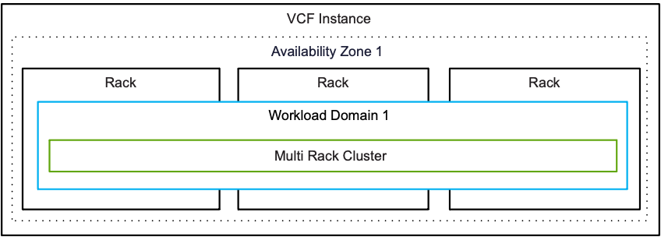

Multi-Rack Cluster Model
A Multi-Rack Cluster Model can be deployed using the following networking types.
Multi-Rack Cluster Type | Description
Layer 2 | - Hosts are installed horizontally across different physical racks.  - Each physical rack shares the same set of Layer 2 broadcast domains for each VLAN.
Layer 3 | - Hosts are installed horizontally across different physical racks.  - Each physical rack has a unique set of Layer 2 broadcast domains for each VLAN.

Multi-Rack Cluster Model Attributes
A Multi-Rack Cluster Model has the following attributes.
Attribute | Detail
Datacenters | Single datacenter
Cluster Rack Mapping | Hosts are installed horizontally across different physical racks.
Resilience | - vSphere HA protects workloads against host failures.  - Multiple fault domains protect workloads in the event of a failure of one or more fault domains/racks.
Availability Zones | - Layer 2 cluster type can be stretched across availability zones.  - Layer 3 cluster type is single availability zone only.
Networking | - Layer 2 (Including VXLAN/EVPN Fabric).  or  - Layer 3
Storage | Storage capable of surviving the failure of a single fault domain at the storage level.

Multi-Rack Cluster Model Sizing Considerations
You choose the number of ESX hosts per vSphere cluster based on storage type and workload domain considerations.
Attribute | Storage Type | Management Domain (First Cluster)** | Management Domain (Additional Clusters)  Workload Domain (All Clusters)
Minimum number of ESX hosts | vSAN | Four (4) | Three (3)
 | VMFS on FC* | Three (3) | Two (2)
Important vSphere clusters are configured allowing for the failure of a single ESX host while still having enough resources to run all vSphere cluster workloads.
Attention * Designs should be completed in consultation with your storage vendor.
** When using multi-rack clusters the first vSphere cluster in the management domain only supports the Layer 2 cluster model.

Multi-Rack Cluster Model VLANs and Subnets
Function | Layer 2 VLANs and Subnets | Layer 3 VLANs and Subnets
VM management | - Shared across racks.  - Highly available gateway at the ToR switch. | - Required per rack.  - Highly available gateway at the ToR switches or leaf nodes in the rack.
ESX management
vSphere vMotion
vSAN
Host overlay
NFS | Not supported. | Not supported.
NSX Edge Uplink01 | - Shared across racks  - Highly available gateway at the ToR switch. | Depends on NSX Edge design.
NSX Edge Uplink02
NSX Edge overlay

Multi-Rack Cluster Model Options
A Multi-Rack Cluster Model can leverage options from the design areas listed below, depending on objectives.
Design Area | Options
Distributed switch models | - Single Distributed Switch Model  - Storage Separation Distributed Switch Model  - Workload Separation Distributed Switch Model  - Storage and Workload Separation Distributed Switch Model
Storage models (principal) | - vSAN  - vSAN Multi-Rack HCI Storage Model  - vSAN Multi-Rack Compute Storage Model  - Fibre Channel Storage Model
Network models | - Layer 2  - Layer 3

Multi-Rack Cluster Model Design Requirements Can we add the NSX requirements to this design?
You must meet the following design requirements for the Multi-Rack Cluster Model. The vSphere cluster design considers the storage type for the vSphere cluster, the architecture model of the environment, and the lifecycle management method.
Table 3-549. Common vSphere Cluster Design Requirements
Design Requirement ID | Design Requirement | Justification | Implication
VCF-CLS-REQD-CFG-001 | Create a vSphere cluster in each workload domain for the initial set of ESX hosts. | - Simplifies configuration by isolating management from customer workloads.  - Ensures that customer workloads have no impact on the management stack. | Management of multiple vSphere clusters and vCenter instances increases operational overhead.
VCF-CLS-REQD-CFG-002 | Allocate a minimum number of ESX hosts according to the vSphere cluster type being deployed. | Ensures correct level of redundancy to protect against host failure in the vSphere cluster. | To support redundancy, you must allocate additional ESX host resources.
VCF-CLS-REQD-CFG-003 | Use vSphere Lifecycle Manager images as the life cycle management method for all vSphere clusters.  Note Imported workload domains may be using vSphere Lifecycle Manager baselines. It is recommended to transition them to use vSphere Lifecycle Manager images. | vSphere Lifecycle Manager images simplify the management of firmware and vendor add-ons manually. | - A vSphere Lifecycle Manager cluster image is required during workload domain or vSphere cluster deployment.
VCF-CLS-REQD-CFG-004 | Use vSphere HA to protect all virtual machines against failures. | vSphere HA supports a robust level of protection for both ESX host and virtual machine availability. | You must provide sufficient resources on the remaining ESX hosts so that virtual machines can be restarted on those hosts in the event of an ESX host outage.

Multi-Rack Cluster Model Design Recommendations

vSphere Multi-Rack Cluster Detailed Design
A VCF Instance can support one or more supported Multi-Rack Cluster Models. This section describes the options, requirements and recommendations for each Multi-Rack Cluster Model.
- Layer 2 Multi-Rack Cluster Model
- Layer 3 Multi-Rack Cluster Model

Layer 2 Multi-Rack Cluster Model
The Layer 2 Multi-Rack Cluster Model allows you to protect workloads on vSphere clusters in your environment against a failure of a single fault domain by implementing your vSphere cluster across multiple fault domains within a single availability zone. The networks are stretched across racks using a single broadcast domain for each network.
The Layer 2 Multi-Rack Cluster Model incorporates multiple fault domains in the design can help reduce the blast radius of a failure which can increase application availability. In this design the infrastructure networks are stretched across racks, this reduces the number of VLANs and subnets needed for the multi-rack deployment but also uses a single broadcast domain for each network.
Figure 3-62. Layer 2 Multi-Rack Cluster
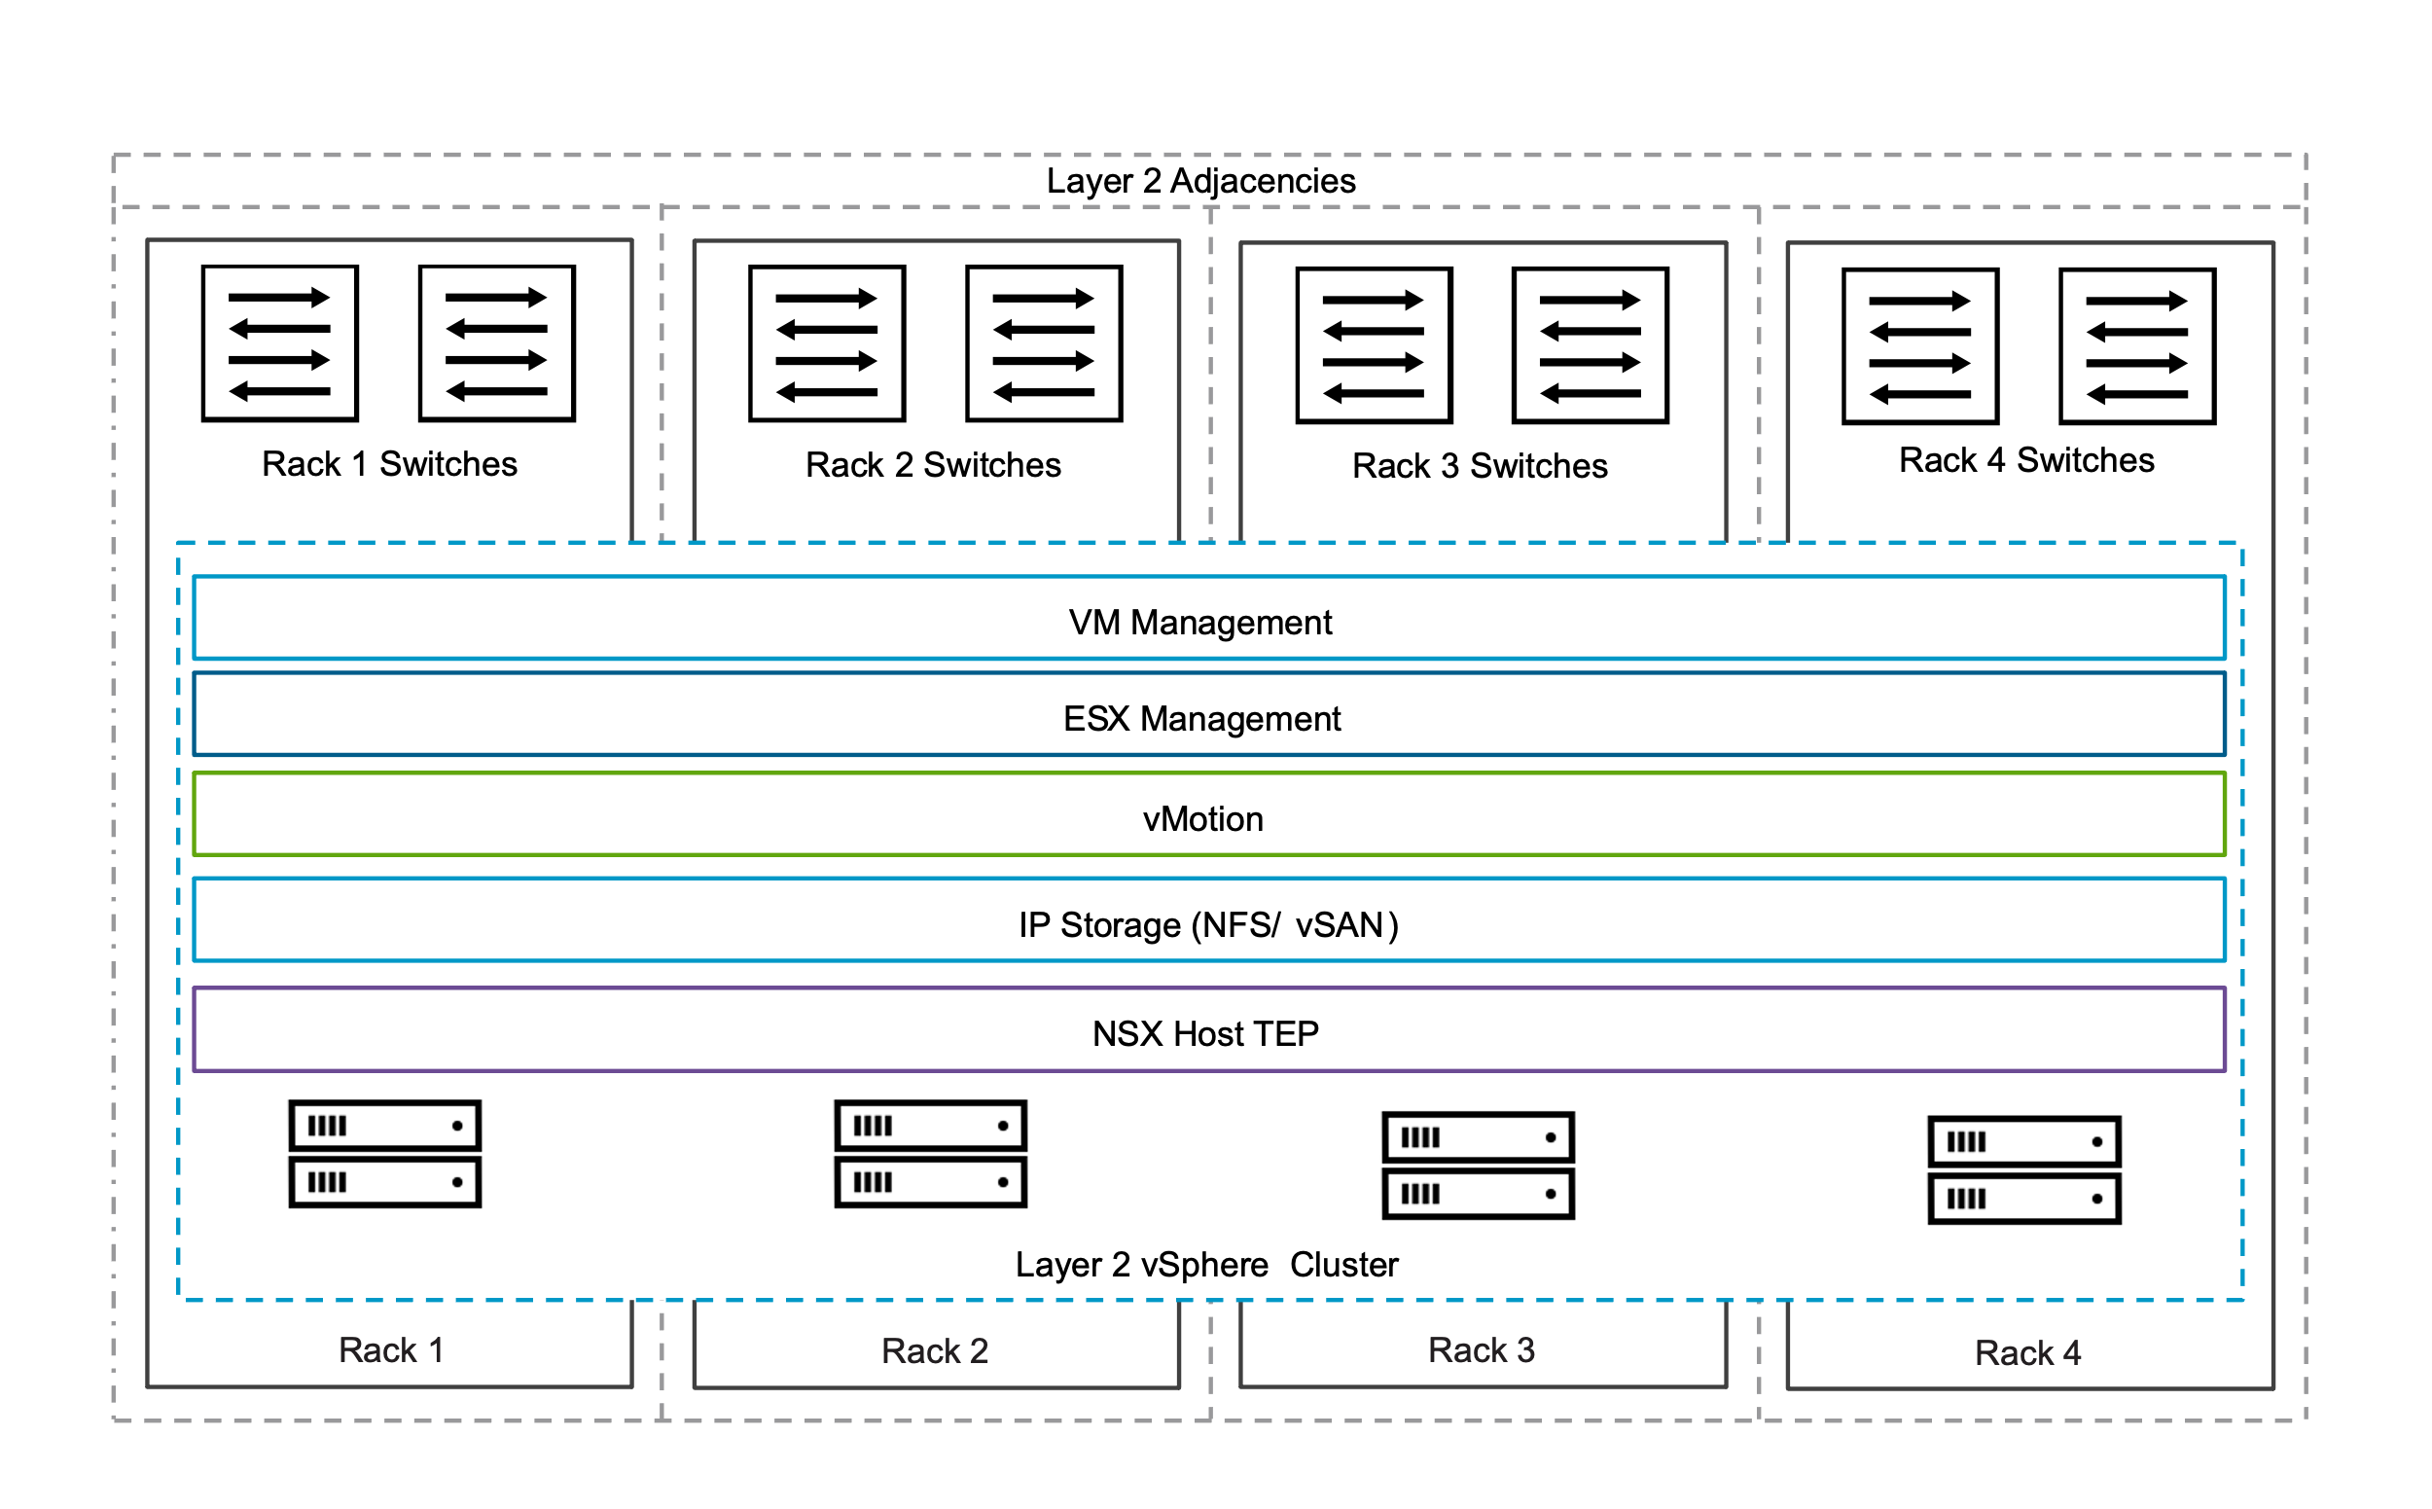

Layer 2 Multi-Rack Cluster Model Attributes
A Layer 2 Multi-Rack Cluster Model has the following attributes.
Attribute | Detail
Datacenters | Single datacenter
Cluster Rack Mapping | Hosts are installed horizontally across different physical racks.
Management Domain Clusters | Primary and additional clusters supported
Resilience | - vSphere HA protects workloads against host failures.  - Multiple fault domains protect workloads in the event of a failure of one or more fault domains/racks.
Availability Zones | - Cluster can be stretched across availability zones.
Networking | - Layer 2 (Including VXLAN/EVPN Fabric) - single broadcast domain for each network
Storage | Storage capable of surviving the failure of a single fault domain at the storage level.

Layer 2 Multi-Rack Cluster Model VLANs and Subnets
Function | VLANs and Subnets
VM management | - VLAN stretched across racks.  - Single subnet for each network  - Highly available gateway available across racks
ESX management
vSphere vMotion
vSAN
Host overlay
NFS
NSX Edge Uplink01 | - See NSX edge node design for details Rack Fault Tolerant using a Layer 2 Multi-Rack Cluster NSX Edge Cluster Model
NSX Edge Uplink02
NSX Edge overlay

Layer 2 Multi-Rack Cluster Model Sizing Considerations
You choose the number of ESX hosts per vSphere cluster based on storage type and workload domain considerations.
Attribute | Storage Type | Management Domain (First Cluster) Simple Deployment of Management Components | Management Domain (First Cluster) HA Deployment of Management Components | Management Domain (Additional Clusters)  Workload Domain (All Clusters)
Minimum number of ESX hosts | vSAN | Three (3) | Four (4) | Three (3)
 | VMFS on FC*  NFS* | Two (2) | Four (3) | Two (2)
Important vSphere clusters are configured allowing for the failure of a single ESX host while still having enough resources to run all vSphere cluster workloads.
Attention * Designs should be completed in consultation with your storage vendor.

Layer 2 Multi-Rack Cluster Model Options
A Layer 2 Multi-Rack Cluster Model can leverage options from the design areas listed below, depending on objectives.
Design Area | Options
Distributed switch models | - Single Distributed Switch Model  - Storage Separation Distributed Switch Model  - Workload Separation Distributed Switch Model  - Storage and Workload Separation Distributed Switch Model
Storage models (principal) | - vSAN  - vSAN Single-Rack HCI ESA Storage Model  - vSAN Single-Rack HCI OSA Storage Model  - Fibre Channel Storage Model  - NFS

Common Multi-Rack Cluster Design Requirements
Table 3-550. Common vSphere Cluster Design Requirements
Design Requirement ID | Design Requirement | Justification | Implication
VCF-CLS-REQD-CFG-001 | Create a vSphere cluster in each workload domain for the initial set of ESX hosts. | - Simplifies configuration by isolating management from customer workloads.  - Ensures that customer workloads have no impact on the management stack. | Management of multiple vSphere clusters and vCenter instances increases operational overhead.
VCF-CLS-REQD-CFG-002 | Allocate a minimum number of ESX hosts according to the vSphere cluster type being deployed. | Ensures correct level of redundancy to protect against host failure in the vSphere cluster. | To support redundancy, you must allocate additional ESX host resources.
VCF-CLS-REQD-CFG-003 | Use vSphere Lifecycle Manager images as the life cycle management method for all vSphere clusters.  Note Imported workload domains may be using vSphere Lifecycle Manager baselines. It is recommended to transition them to use vSphere Lifecycle Manager images. | vSphere Lifecycle Manager images simplify the management of firmware and vendor add-ons manually. | - A vSphere Lifecycle Manager cluster image is required during workload domain or vSphere cluster deployment.
VCF-CLS-REQD-CFG-004 | Use vSphere HA to protect all virtual machines against failures. | vSphere HA supports a robust level of protection for both ESX host and virtual machine availability. | You must provide sufficient resources on the remaining ESX hosts so that virtual machines can be restarted on those hosts in the event of an ESX host outage.
Table 3-551. Common vSphere Cluster Virtual Networking Infrastructure Design Requirements
Design Requirement ID | Design Requirement | Justification | Implication
VCF-VNI-REQD-CFG-001 | Configure all ESX hosts in the workload domain as transport nodes in NSX. | Enables distributed routing, logical segments, and distributed firewall. | None.
VCF-VNI-REQD-CFG-002 | Configure each ESX host as a transport node using transport node profiles. | - Enables the participation of ESX hosts and the virtual machines running on them connected to VPCs, NSX overlay segments and VLAN networks.  - Transport node profiles can only be applied at the cluster level. | None.
VCF-VNI-REQD-CFG-003 | Create a single overlay transport zone in the NSX instance for all overlay traffic across the host and NSX Edge transport nodes of the workload domain or multiple workload domains using a shared NSX instance. | Ensures that all VPCs and Overlay segments are available to all ESX hosts and NSX Edge nodes configured as transport nodes. | All clusters in all workload domains that share the same NSX Manager share the same overlay transport zone.

Common Multi-Rack Cluster Design Recommendations
Table 3-552. Common vSphere Cluster Design Recommendations
Design Recommendation ID | Design Recommendation | Justification | Implication
VCF-CLS-RCMD-CFG-001 | Configure admission control for one (1) ESX host failure and percentage-based failover capacity. | - Using the percentage-based reservation works well in situations where virtual machines have varying and sometimes significant CPU or memory reservations.  - vSphere automatically calculates the reserved percentage according to the number of ESX host failures to tolerate and the number of ESX hosts in the vSphere cluster. | In a cluster of four (4) ESX hosts, the resources of only three (3) ESX hosts are available for use.
VCF-CLS-RCMD-CFG-002 | Enable VM Monitoring for each vSphere cluster. | VM Monitoring provides in-guest protection for most VM workloads. The application or service running on the virtual machine must be capable of restarting successfully after a reboot or the virtual machine restart is not sufficient. | None.
VCF-CLS-RCMD-CFG-003 | Set the advanced vSphere cluster setting das.iostatsinterval to 60 to deactivate monitoring the storage and network I/O activities of the management appliances. | Enables triggering a restart of a management appliance when an OS failure occurs and heartbeats are not received from VMware Tools instead of waiting additionally for the I/O check to complete. | If you want to specifically enable I/O monitoring, you must configure the das.iostatsinterval advanced setting.
VCF-CLS-RCMD-CFG-004 | Enable vSphere DRS on all vSphere clusters, using the default fully automated mode with medium threshold. | Provides the best trade-off between load balancing and unnecessary migrations with vMotion. | If a vCenter outage occurs, the mapping from virtual machines to ESX hosts might be difficult to determine.
VCF-CLS-RCMD-CFG-005 | Enable Enhanced vMotion Compatibility (EVC) on all vSphere clusters in the management domain. | Supports vSphere cluster upgrades without virtual machine downtime. | - You must enable EVC only if the vSphere clusters contain ESX hosts with CPUs from the same vendor.  - You must enable EVC on the default management domain vSphere cluster during bringup using the API and a JSON spec.
VCF-CLS-RCMD-CFG-006 | Set the vSphere cluster EVC mode to the highest available baseline that is supported for the lowest CPU architecture on the ESX hosts in the vSphere cluster. | Supports vSphere cluster upgrades without virtual machine downtime. | None.
VCF-CLS-RCMD-CFG-007 | If running business workloads in the management domain, configure the following vSphere resource pools to control resource usage by management and business workloads.  - cluster-name-rp-sddc-mgmt  - cluster-name-rp-sddc-edge  - cluster-name-rp-user-edge  - cluster-name-rp-user-vm | Ensures sufficient resources for the management components. | You must manually create the vSphere resource pools and manage their settings over time.
VCF-CLS-RCMD-CFG-008 | Use vSphere Cluster Services (vCLS) Retreat Mode. | System managed vCLS mode is deprecated. | You must manually change the vCLS mode.
Table 3-553. Common vSphere Cluster Virtual Networking Infrastructure Design Recommendations
Design Recommendation ID | Design Recommendation | Justification | Implication
VCF-VNI-RCMD-CFG-001 | Use static IP pools to assign IP addresses to the host TEP interfaces. | - Removes the need for an external DHCP server for the host overlay VLANs.  - You can use NSX Manager to verify static IP pool configurations. | None.
VCF-VNI-RCMD-CFG-002 | Create an uplink profile with a load balance source teaming policy with all active uplinks for ESX hosts. | For increased resiliency and performance, supports the concurrent use of more than one physical NICs on the ESX hosts that are configured as transport nodes. | None.

Layer 3 Multi-Rack Cluster Model
The Layer 3 Multi-Rack Cluster Model allows you to protect workloads on vSphere clusters in your environment against a failure of a single fault domain by implementing your vSphere cluster across multiple fault domains within a single availability zone. The networks are isolated to a rack using a separate broadcast domain for each network per rack.
The Layer 3 Multi-Rack Cluster Model incorporates multiple fault domains in the design that can help reduce the blast radius of a failure which can increase application availability. In this design the VCF infrastructure networks are not stretched across racks, instead each rack has a separate VLAN and subnet. The network traffic is routed between the racks, this increases the number of VLANs and subnets needed for the layer 3 multi-rack deployment but also uses a single broadcast domain for each network thus reducing the impact of a layer 2 network issue across racks.
Figure 3-63. Layer 3 Multi-Rack Cluster
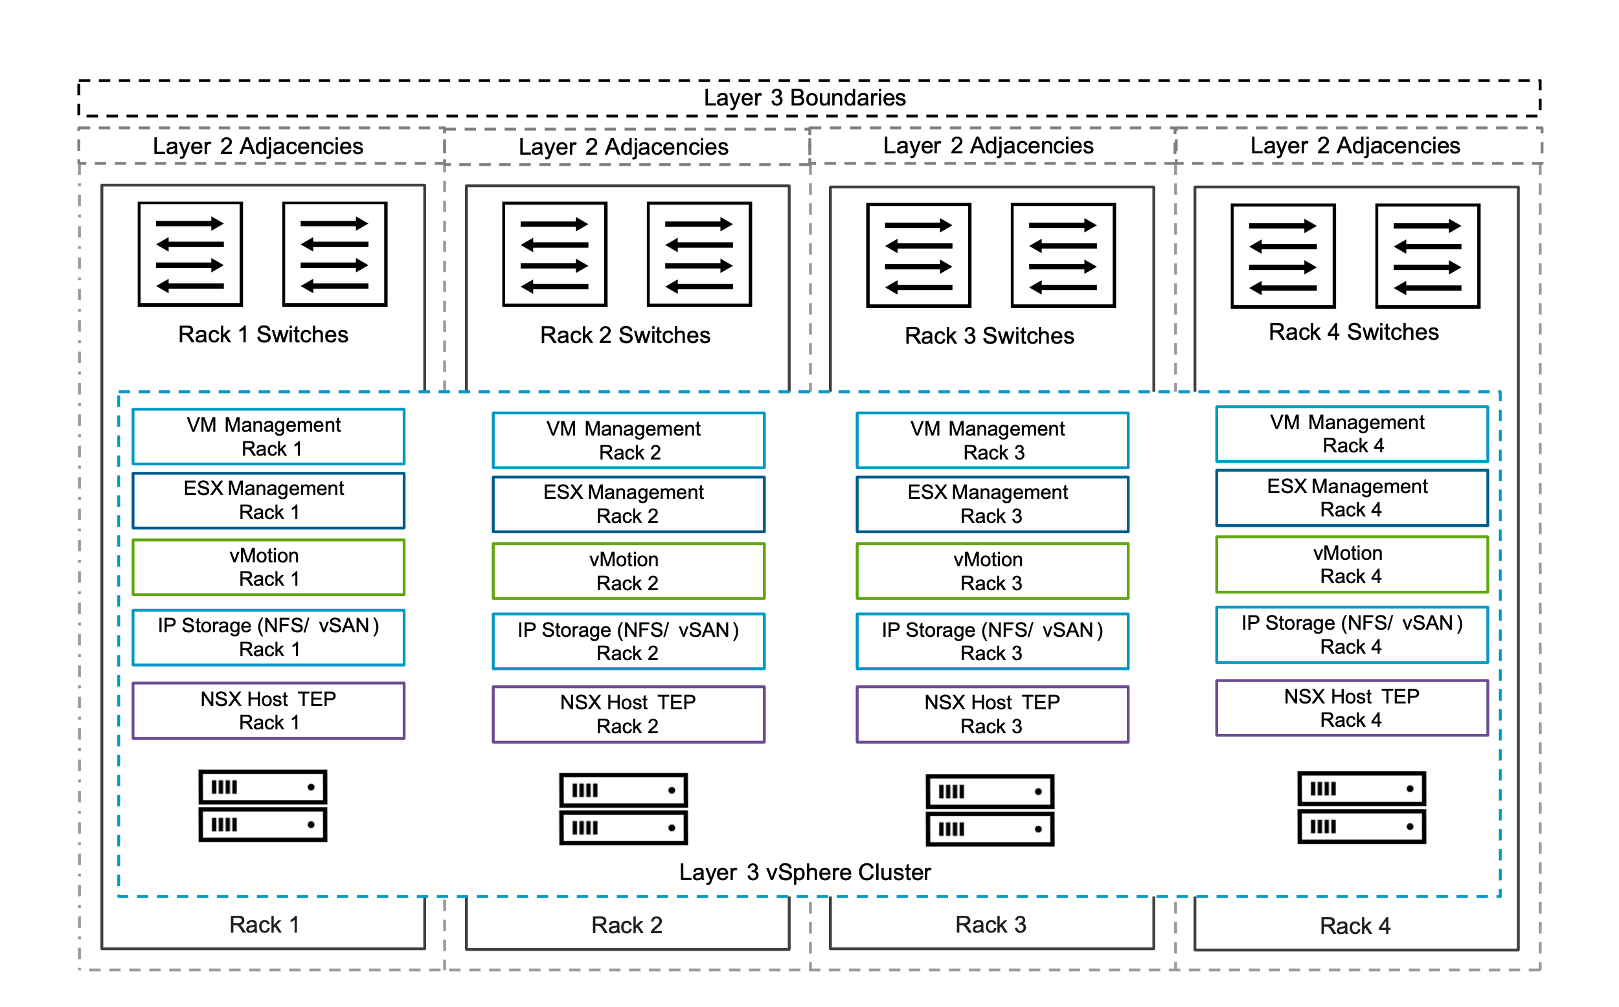

Layer 3 Multi-Rack Cluster Model Attributes
A Layer 3 Multi-Rack Cluster Model has the following attributes.
Attribute | Detail
Datacenters | Single datacenter
Cluster Rack Mapping | Hosts are installed horizontally across different physical racks.
Management Domain Clusters | Not supported for primary cluster, additional clusters supported
Resilience | - vSphere HA protects workloads against host failures.  - Multiple fault domains protect workloads in the event of a failure of one or more fault domains/racks.
Availability Zones | - Single availability zone only.
Networking | - Layer 3 routed networks with isolated broadcast domains per rack
Storage | Storage capable of surviving the failure of a single fault domain at the storage level.

Layer 3 Multi-Rack Cluster Model VLANs and Subnets
Function | Network Attributes
VM management | - VLAN local to the ToR switches per rack  - Separate subnet per rack  - Highly available gateway at the ToR switches  - Routable network across racks  - *Depends on NFS storage fabric network design
ESX management
vSphere vMotion
vSAN
Host overlay
NFS*
NSX Edge Uplink01 | - See NSX edge node design for details Rack Fault Tolerant using a Layer 3 Multi-Rack Cluster NSX Edge Cluster Model
NSX Edge Uplink02
NSX Edge overlay

Layer 3 Multi-Rack Cluster Model Sizing Considerations
You choose the number of ESX hosts per vSphere cluster based on storage type and workload domain considerations.
Attribute | Storage Type | Management Domain (Additional Clusters)  Workload Domain (All Clusters)
Minimum number of ESX hosts | vSAN | Three (3)
 | VMFS on FC*  NFS* | Two (2)
Important vSphere clusters are configured allowing for the failure of a single ESX host while still having enough resources to run all vSphere cluster workloads.

Layer 3 Multi-Rack Cluster Model Options
A Layer 3 Multi-Rack Cluster Model can leverage options from the design areas listed below, depending on objectives.
Design Area | Options
Distributed switch models | - Single Distributed Switch Model  - Storage Separation Distributed Switch Model  - Workload Separation Distributed Switch Model  - Storage and Workload Separation Distributed Switch Model
Storage models (principal) | - vSAN  - vSAN Single-Rack HCI ESA Storage Model  - vSAN Single-Rack HCI OSA Storage Model  - Fibre Channel Storage Model  - NFS

Common Multi-Rack Cluster Design Requirements
Table 3-554. Common vSphere Cluster Design Requirements
Design Requirement ID | Design Requirement | Justification | Implication
VCF-CLS-REQD-CFG-001 | Create a vSphere cluster in each workload domain for the initial set of ESX hosts. | - Simplifies configuration by isolating management from customer workloads.  - Ensures that customer workloads have no impact on the management stack. | Management of multiple vSphere clusters and vCenter instances increases operational overhead.
VCF-CLS-REQD-CFG-002 | Allocate a minimum number of ESX hosts according to the vSphere cluster type being deployed. | Ensures correct level of redundancy to protect against host failure in the vSphere cluster. | To support redundancy, you must allocate additional ESX host resources.
VCF-CLS-REQD-CFG-003 | Use vSphere Lifecycle Manager images as the life cycle management method for all vSphere clusters.  Note Imported workload domains may be using vSphere Lifecycle Manager baselines. It is recommended to transition them to use vSphere Lifecycle Manager images. | vSphere Lifecycle Manager images simplify the management of firmware and vendor add-ons manually. | - A vSphere Lifecycle Manager cluster image is required during workload domain or vSphere cluster deployment.
VCF-CLS-REQD-CFG-004 | Use vSphere HA to protect all virtual machines against failures. | vSphere HA supports a robust level of protection for both ESX host and virtual machine availability. | You must provide sufficient resources on the remaining ESX hosts so that virtual machines can be restarted on those hosts in the event of an ESX host outage.
Table 3-555. Common vSphere Cluster Virtual Networking Infrastructure Design Requirements
Design Requirement ID | Design Requirement | Justification | Implication
VCF-VNI-REQD-CFG-001 | Configure all ESX hosts in the workload domain as transport nodes in NSX. | Enables distributed routing, logical segments, and distributed firewall. | None.
VCF-VNI-REQD-CFG-002 | Configure each ESX host as a transport node using transport node profiles. | - Enables the participation of ESX hosts and the virtual machines running on them connected to VPCs, NSX overlay segments and VLAN networks.  - Transport node profiles can only be applied at the cluster level. | None.
VCF-VNI-REQD-CFG-003 | Create a single overlay transport zone in the NSX instance for all overlay traffic across the host and NSX Edge transport nodes of the workload domain or multiple workload domains using a shared NSX instance. | Ensures that all VPCs and Overlay segments are available to all ESX hosts and NSX Edge nodes configured as transport nodes. | All clusters in all workload domains that share the same NSX Manager share the same overlay transport zone.

Common Multi-Rack Cluster Design Recommendations
Table 3-556. Common vSphere Cluster Design Recommendations
Design Recommendation ID | Design Recommendation | Justification | Implication
VCF-CLS-RCMD-CFG-001 | Configure admission control for one (1) ESX host failure and percentage-based failover capacity. | - Using the percentage-based reservation works well in situations where virtual machines have varying and sometimes significant CPU or memory reservations.  - vSphere automatically calculates the reserved percentage according to the number of ESX host failures to tolerate and the number of ESX hosts in the vSphere cluster. | In a cluster of four (4) ESX hosts, the resources of only three (3) ESX hosts are available for use.
VCF-CLS-RCMD-CFG-002 | Enable VM Monitoring for each vSphere cluster. | VM Monitoring provides in-guest protection for most VM workloads. The application or service running on the virtual machine must be capable of restarting successfully after a reboot or the virtual machine restart is not sufficient. | None.
VCF-CLS-RCMD-CFG-003 | Set the advanced vSphere cluster setting das.iostatsinterval to 60 to deactivate monitoring the storage and network I/O activities of the management appliances. | Enables triggering a restart of a management appliance when an OS failure occurs and heartbeats are not received from VMware Tools instead of waiting additionally for the I/O check to complete. | If you want to specifically enable I/O monitoring, you must configure the das.iostatsinterval advanced setting.
VCF-CLS-RCMD-CFG-004 | Enable vSphere DRS on all vSphere clusters, using the default fully automated mode with medium threshold. | Provides the best trade-off between load balancing and unnecessary migrations with vMotion. | If a vCenter outage occurs, the mapping from virtual machines to ESX hosts might be difficult to determine.
VCF-CLS-RCMD-CFG-005 | Enable Enhanced vMotion Compatibility (EVC) on all vSphere clusters in the management domain. | Supports vSphere cluster upgrades without virtual machine downtime. | - You must enable EVC only if the vSphere clusters contain ESX hosts with CPUs from the same vendor.  - You must enable EVC on the default management domain vSphere cluster during bringup using the API and a JSON spec.
VCF-CLS-RCMD-CFG-006 | Set the vSphere cluster EVC mode to the highest available baseline that is supported for the lowest CPU architecture on the ESX hosts in the vSphere cluster. | Supports vSphere cluster upgrades without virtual machine downtime. | None.
VCF-CLS-RCMD-CFG-007 | If running business workloads in the management domain, configure the following vSphere resource pools to control resource usage by management and business workloads.  - cluster-name-rp-sddc-mgmt  - cluster-name-rp-sddc-edge  - cluster-name-rp-user-edge  - cluster-name-rp-user-vm | Ensures sufficient resources for the management components. | You must manually create the vSphere resource pools and manage their settings over time.
VCF-CLS-RCMD-CFG-008 | Use vSphere Cluster Services (vCLS) Retreat Mode. | System managed vCLS mode is deprecated. | You must manually change the vCLS mode.
Table 3-557. Common vSphere Cluster Virtual Networking Infrastructure Design Recommendations
Design Recommendation ID | Design Recommendation | Justification | Implication
VCF-VNI-RCMD-CFG-001 | Use static IP pools to assign IP addresses to the host TEP interfaces. | - Removes the need for an external DHCP server for the host overlay VLANs.  - You can use NSX Manager to verify static IP pool configurations. | None.
VCF-VNI-RCMD-CFG-002 | Create an uplink profile with a load balance source teaming policy with all active uplinks for ESX hosts. | For increased resiliency and performance, supports the concurrent use of more than one physical NICs on the ESX hosts that are configured as transport nodes. | None.

Layer 3 Multi-Rack Cluster Virtual Networking Design Requirements
Table 3-558. Layer 3 Multi-Rack Cluster Virtual Networking Infrastructure Design Requirements
Design Requirement ID | Design Requirement | Justification | Implication
VCF-VNI-L3MR-REQD-CFG-001 | Create an uplink profile for each rack. | Enables a Layer 3 boundary at the top-of-rack switches for host TEP traffic. | Requires additional subnet per rack.
VCF-VNI-L3MR-REQD-CFG-002 | Create a host TEP IP pool for each rack with a subnet allocated per rack and a gateway for the subnet. | - Provides the host TEP IP addressing for each rack  - Enables a Layer 3 boundary at the top-of-rack switches for host TEP traffic.  - Provides routing capabilities for the host TEPs between racks. | Requires additional subnet per rack.
VCF-VNI-L3MR-REQD-CFG-003 | Create NSX host sub transport node profiles for additional racks. | Enables NSX host transport node configuration per rack. | None.

Layer 3 Multi-Rack Cluster Virtual Networking Design Recommendations
Table 3-559. Layer 3 Multi-Rack Cluster Virtual Networking Infrastructure Design Recommendations
Design Recommendation ID | Design Recommendation | Justification | Implication
VCF-VNI-L3MR-REQD-CFG-001 | Use a separate host TEP transport VLAN ID per rack. | Enables a Layer 3 boundary at the top-of-rack switches for host TEP traffic. | Requires additional host TEP VLAN ID per rack.

vSphere Stretched Cluster Model
The Stretched Cluster Model allows you to protect workloads on vSphere clusters in your environment against a failure of a single fault domain by implementing a stretched cluster across multiple availability zones.
Incorporating multiple availability zones in your design can help reduce the blast radius of a failure and can increase application availability.
Figure 3-64. Stretched Cluster Model
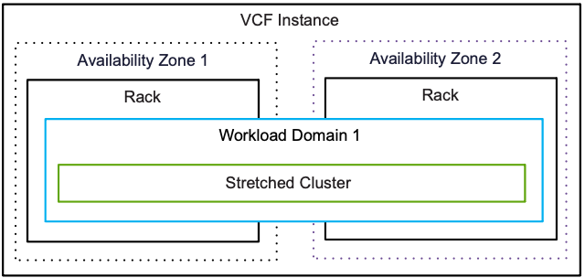

Stretched Cluster Model Attributes
A Stretched Cluster Model has the following attributes.
Attribute | Detail
Datacenters | Multiple datacenters
Cluster rack mapping | - Workload domain cluster with multiple availability zones, each zone in a single rack.  - Workload domain cluster with multiple availability zones, with Layer 2 multi-rack clusters in each zone.
Resilience | - vSphere HA protects workloads against host failures.  - Multiple availability zones protect against availability zone failures.
Bandwidth | - When using VMware vSAN stretched clusters, the bandwidth between the zones must be at least 10 Gbps and the round-trip latency must be less than 5 ms.  - When using storage array based stretched clusters, you must work with your storage vendor to define the bandwidth and latency requirements.
Management Domain Requirements | Having the management domain on a stretched cluster is a prerequisite to configure and implement stretched cluster in a workload domain. In this way, the critical management components managing the workload domains are still available if an availability zone failure occurs.
Availability Zones | - You can have up to two availability zones associated with a given stretched cluster.  - In the case of vSAN stretched clusters, a third, independent fault domain is required to host the vSAN witness appliance.

Stretched Cluster Model VLANs and Subnets
Function | VLANs and Subnets
VM management | Shared across availability zones
ESX management | Unique per availability zone
vSphere vMotion | Unique per availability zone
vSAN* | Unique per availability zone
Host overlay | Unique per availability zone
NFS* | Depends on stretched storage design
Note *Optional based on principal storage choice for the cluster

Stretched Cluster Model Sizing Considerations
You choose the number of ESX hosts per vSphere cluster based on storage type and workload domain considerations.
Attribute | Storage Type | VCF Installer Deployment Model | Management Domain (First Cluster) | Management Domain (Additional Clusters) Workload Domain (All Clusters)
Minimum number of ESX hosts | vSAN | Simple | Six (6) | Six (6)
 |  | Highly Available | Eight (8)
 | NFS, FC | Single | Two (2) * | Two (2) *
 |  | Highly Available | Eight (8) *
Important vSphere clusters are configured allowing for the failure of a single availability zone while still having enough resources to run all vSphere cluster workloads.
Attention * Storage and networking design requirements should be completed in consultation with your storage vendor.

Stretched Cluster Model Options
A Stretched Cluster Model can leverage options from the design areas listed below, depending on your objectives.
Design Area | Options
Distributed switch models | - Single Distributed Switch Model  - Storage Separation Distributed Switch Model  - Workload Separation Distributed Switch Model  - Storage and Workload Separation Distributed Switch Model
Storage models (principal) | - vSAN  - vSAN Stretched HCI Cluster Storage Model  - vSAN Stretched Storage Cluster Storage Model  - vSAN Stretched Compute Cluster Model  - Fibre Channel Storage Model

Stretched Cluster Model Design Requirements
You must meet the following design requirements for the Stretched Cluster Model in your design for VMware Cloud Foundation.
Table 3-560. Common vSphere Cluster Design Requirements
Design Requirement ID | Design Requirement | Justification | Implication
VCF-CLS-REQD-CFG-001 | Create a vSphere cluster in each workload domain for the initial set of ESX hosts. | - Simplifies configuration by isolating management from customer workloads.  - Ensures that customer workloads have no impact on the management stack. | Management of multiple vSphere clusters and vCenter instances increases operational overhead.
VCF-CLS-REQD-CFG-002 | Allocate a minimum number of ESX hosts according to the vSphere cluster type being deployed. | Ensures correct level of redundancy to protect against host failure in the vSphere cluster. | To support redundancy, you must allocate additional ESX host resources.
VCF-CLS-REQD-CFG-003 | Use vSphere Lifecycle Manager images as the life cycle management method for all vSphere clusters.  Note Imported workload domains may be using vSphere Lifecycle Manager baselines. It is recommended to transition them to use vSphere Lifecycle Manager images. | vSphere Lifecycle Manager images simplify the management of firmware and vendor add-ons manually. | - A vSphere Lifecycle Manager cluster image is required during workload domain or vSphere cluster deployment.
VCF-CLS-REQD-CFG-004 | Use vSphere HA to protect all virtual machines against failures. | vSphere HA supports a robust level of protection for both ESX host and virtual machine availability. | You must provide sufficient resources on the remaining ESX hosts so that virtual machines can be restarted on those hosts in the event of an ESX host outage.
Table 3-561. Stretched Cluster Model Design Requirements
Design Requirement ID | Design Requirement | Justification | Implication
VCF-CLS-REQD-CFG-005 | Enable the Override default gateway for this adapter setting on the vSAN VMkernel adapters on all ESX hosts. | Enables routing the vSAN data traffic through the vSAN network gateway rather than through the management gateway. | vSAN networks across availability zones must have a route to each other.
VCF-CLS-REQD-CFG-006 | Create a host group for each availability zone and add the ESX hosts in the zone to the respective group. | Makes it easier to manage which virtual machines run in which availability zone. | None.
Table 3-562. Common vSphere Cluster Virtual Networking Infrastructure Design Requirements
Design Requirement ID | Design Requirement | Justification | Implication
VCF-VNI-REQD-CFG-001 | Configure all ESX hosts in the workload domain as transport nodes in NSX. | Enables distributed routing, logical segments, and distributed firewall. | None.
VCF-VNI-REQD-CFG-002 | Configure each ESX host as a transport node using transport node profiles. | - Enables the participation of ESX hosts and the virtual machines running on them connected to VPCs, NSX overlay segments and VLAN networks.  - Transport node profiles can only be applied at the cluster level. | None.
VCF-VNI-REQD-CFG-003 | Create a single overlay transport zone in the NSX instance for all overlay traffic across the host and NSX Edge transport nodes of the workload domain or multiple workload domains using a shared NSX instance. | Ensures that all VPCs and Overlay segments are available to all ESX hosts and NSX Edge nodes configured as transport nodes. | All clusters in all workload domains that share the same NSX Manager share the same overlay transport zone.
Table 3-563. Stretched Cluster Virtual Networking Infrastructure Design Requirements
Design Requirement ID | Design Requirement | Justification | Implication
VCF-VNI-SC-REQD-CFG-001 | Create an uplink profile for each Availability zone | Enables different VLAN ids for Host TEP in each availability zone | Requires additional Host TEP VLAN in availability zone 2
VCF-VNI-SC-REQD-CFG-002 | Create NSX host sub transport node profile for second availability zone. | Enables NSX host transport node configuration per availability zone | None.

Stretched Cluster Model Design Recommendations
In your vSphere cluster design, you can apply certain best practices to the Stretched Cluster Model.
Table 3-564. Common vSphere Cluster Design Recommendations
Design Recommendation ID | Design Recommendation | Justification | Implication
VCF-CLS-RCMD-CFG-001 | Configure admission control for one (1) ESX host failure and percentage-based failover capacity. | - Using the percentage-based reservation works well in situations where virtual machines have varying and sometimes significant CPU or memory reservations.  - vSphere automatically calculates the reserved percentage according to the number of ESX host failures to tolerate and the number of ESX hosts in the vSphere cluster. | In a cluster of four (4) ESX hosts, the resources of only three (3) ESX hosts are available for use.
VCF-CLS-RCMD-CFG-002 | Enable VM Monitoring for each vSphere cluster. | VM Monitoring provides in-guest protection for most VM workloads. The application or service running on the virtual machine must be capable of restarting successfully after a reboot or the virtual machine restart is not sufficient. | None.
VCF-CLS-RCMD-CFG-003 | Set the advanced vSphere cluster setting das.iostatsinterval to 60 to deactivate monitoring the storage and network I/O activities of the management appliances. | Enables triggering a restart of a management appliance when an OS failure occurs and heartbeats are not received from VMware Tools instead of waiting additionally for the I/O check to complete. | If you want to specifically enable I/O monitoring, you must configure the das.iostatsinterval advanced setting.
VCF-CLS-RCMD-CFG-004 | Enable vSphere DRS on all vSphere clusters, using the default fully automated mode with medium threshold. | Provides the best trade-off between load balancing and unnecessary migrations with vMotion. | If a vCenter outage occurs, the mapping from virtual machines to ESX hosts might be difficult to determine.
VCF-CLS-RCMD-CFG-005 | Enable Enhanced vMotion Compatibility (EVC) on all vSphere clusters in the management domain. | Supports vSphere cluster upgrades without virtual machine downtime. | - You must enable EVC only if the vSphere clusters contain ESX hosts with CPUs from the same vendor.  - You must enable EVC on the default management domain vSphere cluster during bringup using the API and a JSON spec.
VCF-CLS-RCMD-CFG-006 | Set the vSphere cluster EVC mode to the highest available baseline that is supported for the lowest CPU architecture on the ESX hosts in the vSphere cluster. | Supports vSphere cluster upgrades without virtual machine downtime. | None.
VCF-CLS-RCMD-CFG-007 | If running business workloads in the management domain, configure the following vSphere resource pools to control resource usage by management and business workloads.  - cluster-name-rp-sddc-mgmt  - cluster-name-rp-sddc-edge  - cluster-name-rp-user-edge  - cluster-name-rp-user-vm | Ensures sufficient resources for the management components. | You must manually create the vSphere resource pools and manage their settings over time.
VCF-CLS-RCMD-CFG-008 | Use vSphere Cluster Services (vCLS) Retreat Mode. | System managed vCLS mode is deprecated. | You must manually change the vCLS mode.
Table 3-565. Stretched Cluster Model Design Recommendations
Design Recommendation ID | Design Recommendation | Justification | Implication
VCF-CLS-RCMD-CFG-008 | Increase admission control percentage to half of the ESX hosts in the vSphere cluster. | Allocating only half of a stretched cluster ensures that all VMs have enough resources if an availability zone outage occurs. | - In a vSphere cluster of eight (8) ESX hosts, the resources of only four (4) ESX hosts are available for use.  - If you add more ESX hosts to the default management vSphere cluster, add them in pairs, one per availability zone.
VCF-CLS-RCMD-CFG-009 | Create a virtual machine group for each availability zone and add the virtual machines in the zone to the respective group. | Ensures that virtual machines are located only in the assigned availability zone to avoid unnecessary vMotion migrations. | You must add virtual machines to the allocated group manually.
VCF-CLS-RCMD-CFG-010 | Create a should-run-on-hosts-in-group VM-Host affinity rule to run each group of virtual machines on the respective group of hosts in the same availability zone. | Ensures that virtual machines are located only in the assigned availability zone to avoid unnecessary vMotion migrations. | You must manually create the rules.
Table 3-566. Common vSphere Cluster Virtual Networking Infrastructure Design Recommendations
Design Recommendation ID | Design Recommendation | Justification | Implication
VCF-VNI-RCMD-CFG-001 | Use static IP pools to assign IP addresses to the host TEP interfaces. | - Removes the need for an external DHCP server for the host overlay VLANs.  - You can use NSX Manager to verify static IP pool configurations. | None.
VCF-VNI-RCMD-CFG-002 | Create an uplink profile with a load balance source teaming policy with all active uplinks for ESX hosts. | For increased resiliency and performance, supports the concurrent use of more than one physical NICs on the ESX hosts that are configured as transport nodes. | None.
Table 3-567. Stretched Cluster Virtual Networking Infrastructure Design Recommendations
Design Recommendation ID | Design Recommendation | Justification | Implication
VCF-VNI-SC-RCMD-CFG-001 | Create a host TEP IP pool for each availability zone with a subnet allocated per availability zone and a gateway configured for the network. | - Provides the host TEP IP addressing for each availability zone  - Enables a Layer 3 routed TEP traffic between availability zones.  - Using an external DHCP server for the host overlay VLANs in both availability zones is not required. | Requires additional subnet per availability zone.
VCF-VNI-SC-RCMD-CFG-002 | Configure an NSX sub-transport node profile for hosts in availability zone 2 | - The NSX transport node profile can remain attached when using two separate VLANs for host TEPs at each availability zone.  - You can use static IP pools for the host TEPs in each availability zone. | Changes to the host transport node configuration are done at the vSphere cluster level.

VCF Edge Detailed Design
VMware Cloud Foundation Edge extends the centralized management capabilities of the platform to geographically dispersed edge locations.
This section describes different design options for deploying VCF Edge, covering various needs and complexities.
Feature | 1-Node cluster in a VCF Instance | 2-Node with external storage (minimum) in a workload domain | 3-Node vSAN cluster (minimum) in a workload domain | 4-Node VCF Fleet with single domain and one or multiple clusters.
Prime Use Case | Remote / Branch Offices, Edge locations | Remote / Branch Offices, Edge locations | Small to medium-sized deployments | Large-scale, distributed environments or locally managed edge environments
Storage | Local or external NFS or FC | External NFS or FC (No vSAN) | vSAN or External Storage | vSAN or External Storage
Networking | - NSX supported  - vSphere Distributed Switch supported | - NSX supported  - vSphere Distributed Switch supported | - NSX supported  - vSphere Distributed Switch supported | - NSX supported  - vSphere Distributed Switch supported
Max Hosts per Cluster | 64 | 64 | 64 | 64
Max Workload Domains | Not supported | 24 | 24 | 24
Life cycle Management | Central or local life cycle management with vCenter | Central or local life cycle management with VCF Operation | Central or local life cycle management with VCF Operation | Central or local life cycle management with VCF Operation
Latency & Bandwidth Requirements | 100ms latency, 10 Mbps bandwidth | 100ms latency, 10 Mbps bandwidth | 100ms latency, 10 Mbps bandwidth | 100ms latency, 10 Mbps bandwidth
VKS Support | Yes | Yes | Yes | Yes
Key Advantage | Lower cost for edge deployments | Lower cost for edge deployments | Simplified management for smaller environments | Highly scalable, resilient architecture, can fit any deployment models such as centrally managed, locally managed and Isolated Edge.

VCF Edge Pattern 1: Centrally Managed Edge Compute Clusters in a Workload Domain
VCF Edge manages compute resources centrally for simplified operations and consistent infrastructure across distributed locations.
Figure 3-65. Centrally Managed VCF Edge Compute Clusters in a Single Workload Domain
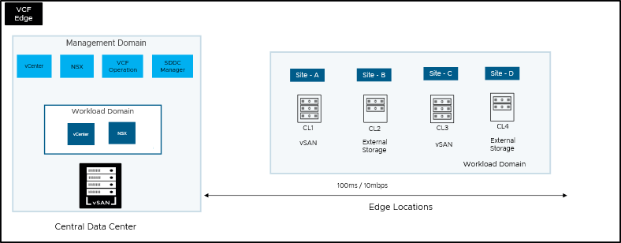
Design Attributes | Details
Centralized Management | Includes vCenter, NSX, VCF Operation, VCF Automation, and SDDC Manager. This indicates centralized management of the VCF environment for the the Edge locations.
Workload Domain for Edge | - Deploy a workload domain to have a dedicated vCenter and NSX instance in the central data center as part of the workload domain creation.  - Create site specific compute clusters. Each Edge site represents a vSphere compute cluster, and part of a VCF workload domain.
Storage Options at Edge | - Flexibility to choose vSAN or external storage.  - Mixed storage environment with both vSAN and external storage solutions.
Network Connectivity | - 100ms / 10Mbps latency and bandwidth requirement for connecting the central data center to VCF Edge sites.

VCF Edge Pattern 2: Segregated Edge deployment across Multi-Region Workload Domains
This design describes a multi-region edge architecture with segregated edge sites, each having dedicated workload domains. Each region possesses its own independent vCenter for daily operation.
Figure 3-66. VCF Edge Pattern 2: Segregated Edge deployment across Multi-Region Workload Domains
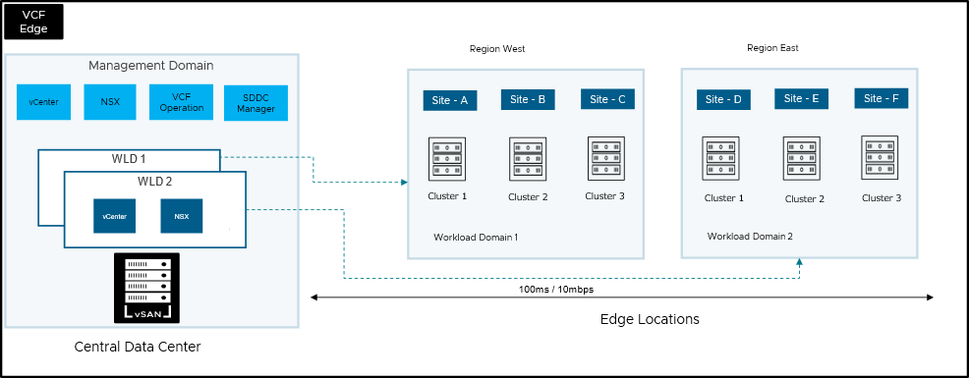
Design Attributes | Details
Centralized Management Domain | A central data center hosts the management components, including vCenter, NSX Manager, VCF Operation Manager, and SDDC Manager. This suggests centralized control and administration of the entire environment.
Workload Domains for each region | Each region represents a "Workload Domain" (Workload Domain 1 in Region West, Workload Domain 2 in Region East), logically separating the resources and management within each region.
Compute clusters for multiple sites within regions | Each region is further divided into multiple sites (Site A, B, C in Region West; Site D, E, F in Region East). This suggests a need for localized compute and storage resources at different physical locations.
Network Connectivity | Latency and Bandwidth: 100ms / 10Mbps, indicating latency and bandwidth requirement for connecting Central Data Center to Edge sites.

VCF Edge Pattern 3: Locally Managed Edge
Independent edge compute regions, each with its own local management infrastructure, operating autonomously across a distributed environment.
Figure 3-67. VCF Edge Pattern 3: Locally Managed Edge
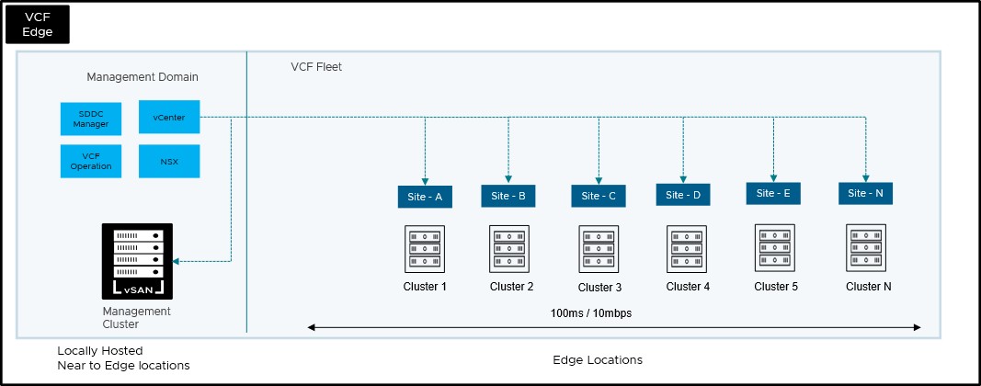
Design Attributes | Details
Management domain in a VCF Instance hosted near to edge locations | A management domain which consists of vCenter, VCF Operations, and NSX Manager is hosted near the edge locations. This ensures local management and administration of edge workloads near to edge locations. One vCenter manages both management and edge site workloads.
Clusters at edge locations | Each edge site contains a compute cluster, enabling the use of vSphere clusters for workload deployments at the edge site.
Network connectivity | Latency and Bandwidth: Minimum 100ms / 10Mbps, indicating latency and bandwidth requirement for both management and edge workloads. However, due to close proximity of both management and edge locations, this may not be an issue.
Figure 3-68. VCF Edge Pattern 3: Locally Managed Thick Edge
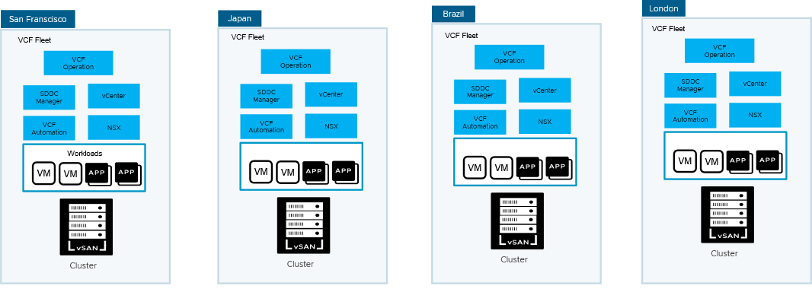
Best Fit Scenarios:
- Remote Industrial Sites (Oil Rigs, Mines, Offshore Platforms): These locations often have limited or intermittent connectivity, and local processing is crucial for real-time monitoring, control, and safety systems. Each VCF fleet can act as a self contained edge.
- Military and Defense: Secure and often disconnected environments with strict security protocols and the need for independent operation.
- Specific Healthcare Applications: Operating rooms or intensive care units where real-time data processing from local sensors and devices is critical for immediate patient care and cannot rely on external network stability.
- Autonomous Vehicles and Robotics in Isolated Areas: Self-driving vehicles or robots operating in environments without consistent network coverage need to process sensor data and make decisions locally.
- Smart Agriculture in Remote Farms: Farms in rural areas with poor connectivity can benefit from local data processing for environmental monitoring, automated irrigation, and drone-based analytics.
- Decentralized Research or Field Science Stations: Remote research outposts that require local data acquisition, processing, and storage without constant reliance on a central lab.

VCF Edge Pattern 4: VCF Fleet with Multi Region, Distributed Edge
A large-scale VCF Edge deployment spanning multiple geographical regions, encompassing numerous distributed edge locations, all managed as a unified VCF fleet for consistent operations and life cycle management across a wide and diverse infrastructure.
Figure 3-69. VCF Edge Pattern 4: VCF Fleet with Multi Region, Distributed Edge
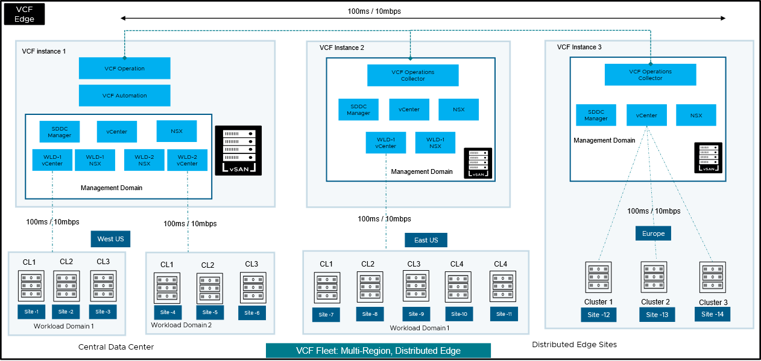
Design Attributes | Justification
Multi-Region Deployment | Addresses the need for global reach, localized services, data sovereignty requirements, and improved latency for users in different regions.
Centralized Management (Per Region) | Each major region (West US, East US, Europe) has its own independent VCF Instance (Instance 1, Instance 2, Instance 3) with its own Management Domain.  It offers localized control and management within each region, enhancing resilience against inter-region network disruptions and ensuring compliance with regional regulations. Meanwhile, centralized monitoring, licensing, and lifecycle management for each VCF instance are maintained from a central data center via VCF Operation.  VCF Fleet employs a dual-level management approach, combining centralized control with regional administration to optimize efficiency and scalability. This involves a division of responsibilities between Central IT and Regional IT teams:  - Central IT Responsibilities: Central IT provides overarching governance and standardization for the entire VCF Fleet. This includes:  Lifecycle Management: Centralized planning, coordination, and execution of upgrades and updates for all VCF instances across regions. This ensures consistency and reduces the risk of compatibility issues.  Certificate Management: Centralized management of certificates for all VCF components (vCenter, ESXi, NSX). This simplifies certificate renewals, improves security posture, and ensures compliance with organizational security policies.  Password Management: Defining and enforcing password policies across the VCF Fleet, including password complexity, rotation, and storage. Central IT may also manage the storage of highly privileged passwords.  Architecture and Standards: Defining the overall VCF architecture, including workload domain design, network segmentation, and storage configurations. This ensures consistency and best practices are followed across all regions.  Policy Enforcement: Defining and enforcing global policies related to security, compliance, and resource management.  - Regional IT Responsibilities: Regional IT teams are responsible for the day-to-day operations and management of the VCF instances within their specific region. This includes:  Day N Operations: Performing routine tasks such as monitoring, troubleshooting, and maintaining the health of the local VCF instances.  Resource Management: Managing local compute, storage, and network resources, including provisioning, allocation, and optimization.  User Management: Managing local user accounts, permissions, and access control within the region, in accordance with central policies.  Application Support: Supporting the deployment and operation of applications running on the local VCF infrastructure.  Local Compliance: Ensuring adherence to any region-specific regulatory or compliance requirements, in addition to central policies.
Distributed Edge Sites | Extends compute and application capabilities closer to users and data sources in geographically dispersed locations.
VCF Operations Collector (Regional) | Enables localized monitoring and data collection within each region, potentially for performance optimization and troubleshooting, especially given the WAN latency.
Best Fit Scenarios
- Organizations with geographically dispersed users or data sources: This is a fundamental requirement. If your users or data are spread across multiple cities, regions, or countries, VCF Fleet can help you bring applications and services closer to them.
- Edge workloads with strict latency requirements: If your applications need to respond quickly, VCF Fleet's distributed edge architecture can help minimize latency by deploying workloads closer to the source of the data or the end-user.
- Requirements for high availability and disaster recovery: VCF Fleet's multi-region capabilities enable you to deploy applications across multiple locations, ensuring that they remain available even if one location experiences an outage.
- Need for centralized management and consistent operations at scale: If you have a large number of vSphere deployments to manage, VCF Fleet simplifies management by providing a single point of control and enabling you to enforce consistent configurations and policies across all locations.

VCF Edge Pattern 5: Dark Site Edge
Dark Site Edge describes a VCF Edge deployment designed for environments with limited or no reliable external network connectivity.
Figure 3-70. VCF Edge Pattern 5: Dark Site Edge
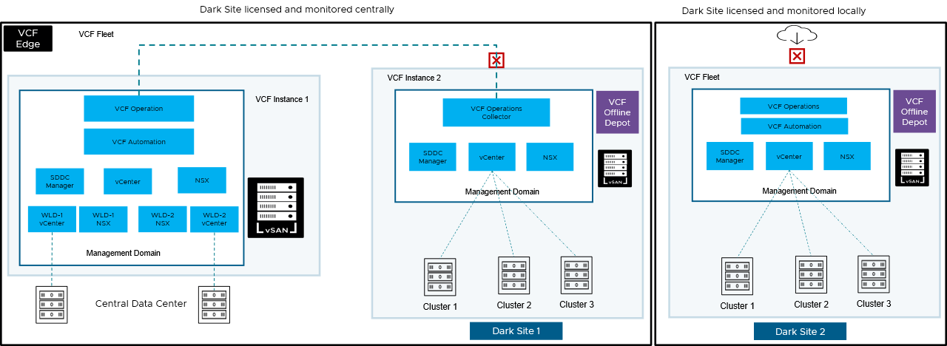
Design Attributes | Details
Isolated VCF Instance | The "Dark Site" has its own independent VCF instance, separate from the primary VCF Fleet.  A dark site has limited or no external network connectivity. An independent VCF instance ensures full functionality and management within the isolated environment without relying on external services.
Local Management Domain | VCF Instance 2 includes its own Management Domain components (VCF Operation Collector, SDDC Manager, vCenter and NSX).  Essential for the local management of the compute, network, and storage resources within the dark site's VCF instance. It provides the necessary control plane for the dark site's infrastructure.
Local Compute Clusters | VCF Instance 2 manages its own compute clusters.  These clusters provide the necessary compute resources to run workloads within the isolated dark site.  VCF Instance 3 with own VCF Fleet, dedicate to the site and manages its own compute clusters.
VCF Operations Collector | In the case of Dark Site 1, Data collected locally during offline mode and synchronized with VCF operations, when connectivity is established with central site. here might be periodically exported or analyzed locally.  In the case of Dark Site 2, Enables monitoring and potentially local operational insights within the dark site, even without direct connection to a outside world. Data collected here monitored and analyzed locally with dedicate VCF operation.
VCF Offline Depot | A local VCF Offline Depot is deployed within the dark site.  In the absence of direct internet connectivity, the Offline Depot serves as a local repository for software bundles, patches, and upgrades required for the VCF instance and its components. This ensures the lifecycle management of the dark site's VCF environment.
License Check-in | VCF Operation mandates a periodic license check-in (e.g., every 180 days, even for dark sites via their limited connectivity or alternative methods) to ensure the entire VCF environment, including isolated edge locations, remains compliant with licensing terms and to prevent operational disruptions.
Note If you are entitled for VCF Edge, you have the option to deploy a dark site edge using a combination of VCF Operations and vCenter only. Please refer to the other flexible design options available and select the one that best fits your requirements.
Best Fit Scenarios
- Strict Isolation and Security Requirements
- Unreliable or Intermittent Network Connectivity
- Autonomous Operations Requirement - Situations where the edge location needs to function independently for extended periods without external dependencies, including management, monitoring, and software updates.

VCF Edge Pattern 6: vSphere Supervisor at the Edge in a VCF Instance with Multiple Domains
This enables running Kubernetes workloads alongside traditional VMs at the edge, leveraging consistent VCF management and infrastructure.
Figure 3-71. VCF Edge Pattern 6: vSphere Supervisor at the Edge in a VCF Instance with Multiple Domains
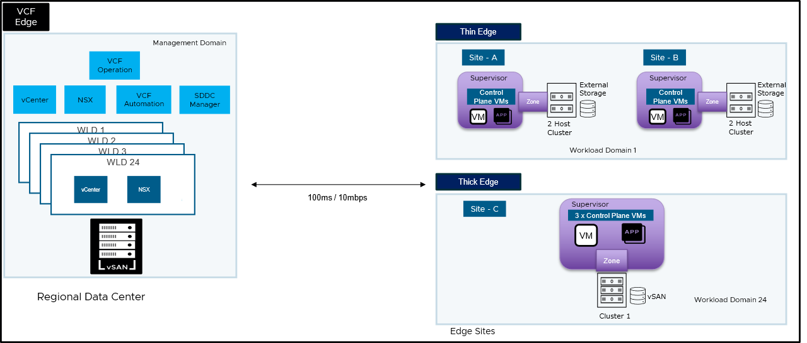
Design Attributes | Details
Centralized management domain | A central regional data center houses the core VCF management components: VCF Operations, vCenter, NSX, VCF Automation, and SDDC Manager.  Provides a unified and consistent management plane for the entire VCF Edge environment, including the edge sites.
Workload domains supporting edge | Workload domains provide logical separation and resource pooling within the central data center. Having multiple clusters within a workload domain offers flexibility in scaling resources and potentially isolating management components for different edge types such as thick edge or thin edge.
Thin edge | 2-host clusters in a workload domain minimizes the hardware footprint and cost for edge locations with limited resources.
Thick edge | Thick edge suggests a more substantial cluster with more resources. Supports more demanding workloads and provides greater local compute and storage capacity.
Supervisor cluster | Supervisor is enabled in the vSphere environment at each edge site. Enables the deployment and management of workloads in a declarative manner through Supervisor services alongside traditional virtual machines (VMs) directly at the edge, supporting modern, containerized applications.

VCF Edge Pattern 7: Supervisor Zonal separation at the Edge
Designing edge locations with vSphere Supervisor into distinct logical zones (e.g., Control Plane Zone, Worker Zone) for improved resource isolation, security, and resilience of the workloads.
Figure 3-72. VCF Edge Pattern 7: Supervisor Zonal separation at the Edge
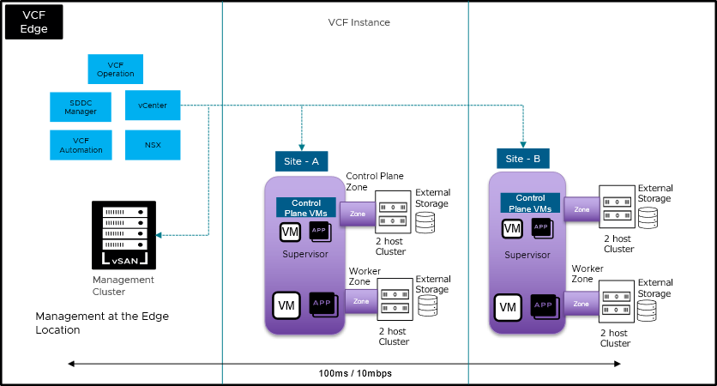
Design Attributes | Details
Management at the Edge Location | VCF Operation, SDDC Manager, vCenter, VCF Automation, and NSX are located within the same physical location as the edge sites.  Provides localized management, reducing latency for management operations and potentially improving resilience against WAN connectivity issues.
VCF Instance with single domain and multiple clusters | Both management and edge workload clusters are managed by one VCF domain and one vCenter.
Supervisor Cluster | Supervisor is enabled in the vSphere environment at each edge site. Enables the deployment and management of Kubernetes workloads alongside traditional virtual machines (VMs) directly at the edge, supporting modern, containerized applications.
Zonal Separation | Each edge site is further divided into Control Plane Zone and Workload Zone. Provides logical isolation and resource separation for critical control plane components and application workloads within each physical site, enhancing stability and security.  The Supervisor's Control Plane VMs reside within the dedicated "Control Plane Zone" at each site. Virtual machines and applications running workloads and acting as Kubernetes worker nodes reside within the dedicated "Worker Zone" at each site.
2 Host Cluster with External Storage | Both Control Plane and Worker Zones at each site running on separate 2-host clusters with external storage.
Best Fit Scenarios
Organizations Requiring Strong Local Control and Security: Environments where strict local control over the infrastructure and data is paramount, and minimizing external dependencies is a key requirement.
Important This design can be implemented with a VCF Instance with single workload domain or multiple domain and clusters inside the workload domain as described in Pattern 6 above.

VCF Edge Pattern 8: Single Host vSphere Supervisor at the Edge in a VCF Instance
Figure 3-73. VCF Edge Pattern 8: Single Host vSphere Supervisor at the Edge in a VCF Instance
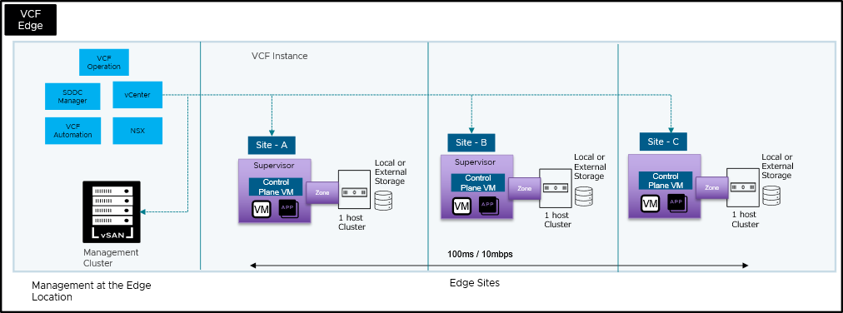
This design pattern, focuses on deploying a highly efficient and compact vSphere Supervisor footprint at remote or edge locations. Single host leverages vSphere Supervisor to bring Kubernetes capabilities directly to resource-constrained environments, while maintaining centralized management from a core VCF instance.
Design Attributes | Details
Single ESXi Host per Site | Each edge location is built upon a single physical ESXi server. Emphasizing a minimal hardware footprint.
vSphere Supervisor | vSphere Supervisor is enabled on the host which enables the deployment and management of Kubernetes workloads directly on the ESXi host. This includes the deployment of a "Control Plane VM" for the Supervisor functionality.
Centralized VCF Management | A VCF Fleet (comprising VCF Operation, VCF Automation, vCenter, and NSX) resides at a central data center or management location. Central vCenter instance manages the distributed edge sites.
Single Cluster Host Deployment | It is a manual process within the vCenter to create a cluster and add the host.
VSphere Supervisor Network | vSphere Distributed Switch (VDS) is used for vSphere Supervisor management and workload network
HA Admission control | vSphere HA is enabled on the cluster however, to make vSphere Supervisor to work, we have disabled HA Admission control in the cluster level in vCenter.
Storage Options | Only shared storage or local storage supported.
Network Connectivity | - Bandwidth: Aim for 1 Gbps or higher for efficient VM or container image image transfer. A minimum of 100 Mbps might be acceptable for smaller image s or less frequent deployments, but it will be slow.  - Latency: Keep latency below 100 ms for a smooth management experience. While deployments might complete with higher latency, the user experience will degrade.
Important To support single node vSphere Supervisor deployment, you must disable HA Admission Control on the vSphere Cluster in vCenter.
Best Fit Scenarios
- Numerous Far Edge Locations: Such as retail stores, bank branches, quick-service restaurants, remote industrial sites, or cellular towers, where space and IT staff are limited.
- Resource-Constrained Environments: Locations where deploying multiple servers or complex networking is not feasible due to physical limitations or cost.
- Applications Requiring Ultra-Low Latency: Workloads like IoT data ingestion and real-time analytics, AI/ML inference at the edge, or local POS systems that demand immediate responses.
- High Volume of Small Workloads: Deployments where many small, independent applications need to run close to the data source or end-user.
- Simplified Operations for Distributed Deployments: Organizations looking to standardize and automate the deployment and ongoing management of a large fleet of edge sites from a central location.
Benefits | Implications
Minimized Hardware Footprint: Significantly reduces the amount of physical hardware needed at each edge site.  Lowers CapEx (capital expenditure) for hardware, power, cooling, and space.  Reduced Operational Overhead: Simplifies local IT management at the edge due to fewer components. Leverages centralized VCF management for automated lifecycle operations (upgrades, patching), reducing the need for on-site IT staff.  Optimized for Edge Workloads: Enables deployment of cloud-native (Kubernetes) and traditional VM workloads directly at the edge. Facilitates ultra-low latency processing and data ingestion close to the source. | Limited High Availability/Resilience: A single ESXi host means a single point of failure. If the host goes down, all workloads at that specific edge site become unavailable. Requires robust strategies for application-level resilience or rapid recovery from a central location.  Resource Constraints: The single host limits the total compute, memory, and storage capacity available at the edge site. Careful sizing and workload placement are critical to avoid resource contention.  Storage Dependency: Reliance on local storage or direct-attached storage means storage failure directly impacts the site.  Connectivity Criticality: The WAN link to the central VCF Management Cluster is crucial for management, monitoring, and lifecycle operations. Latency and bandwidth limitations on the WAN as described in the design requirement  No vMotion for Local HA: With only one host, vMotion cannot be used for high availability within the edge site itself. If a host fails, VMs cannot automatically migrate to another host.
Important For multi-node VKS clusters deployed at the edge, the resilience of even localized workloads is significantly dependent on central vCenter management. Should a Kubernetes pod crash or its VKS worker node fail, the Kubernetes cluster runtime will automatically attempt to restart the pod. However, if that pod utilizes a persistent volume and needs to be restarted on an alternative VKS worker node within the cluster, the underlying vSphere Supervisor, which orchestrates the VKS cluster, must establish communication with vCenter Server to facilitate the necessary volume detach and attach operations between the nodes. Therefore, maintaining dedicated and stable connectivity to vCenter Server is paramount. Without this vital connection, the vSphere Supervisor is unable to coordinate with vCenter to provision resources or orchestrate the recovery of the pod, ultimately preventing the affected pod service from coming back online.

VCF Edge Pattern 9: Leveraging Existing VCF Operations for Far Edge Expansion
This design outlines how customers can extend their existing VCF Fleet to far edge locations with VCF Edge, leveraging VCF Operations for unified license management and monitoring.
Figure 3-74. VCF Edge Pattern 9: Leveraging Existing VCF Operations for Far Edge Expansion
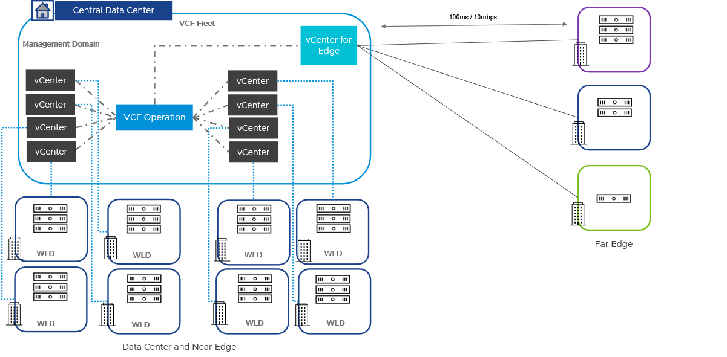
Design Attributes | Details
Existing VCF Fleet in a Data Center | A customer may already have a VCF Fleet running in their data center, supporting data center workloads or near edge workloads with VCF.
Expanding to Far Edge with VCF Edge license | As the customer expands to far edge locations with VCF Edge, they can leverage existing VCF Operations for license management and unified monitoring of both data center and edge.
vCenter for Far Edge locations | A vCenter can be deployed in an existing data center or co-location facility for far edge locations and can be connected to VCF Operations for license management. However, VCF Operation will not perform life cycle management of vCenter and hosts which are connected to this vCenter.
Lifecycle Management of vCenter and Edge Hosts | In this scenario, the lifecycle management of edge site hosts must be handled by vCenter for VCF Edge.

Other flexible design options with VCF Edge
VCF Edge offers flexibility in management of different VCF components in edge deployments.
You can tailor your edge deployment to your organization's needs by either deploying the VMware Cloud Foundation full stack or select components as required by the specific use case.

VCF Edge Option 1: VCF Operation with vCenter for Distributed Edge
A design where a central VCF Operation instance, leveraging one or more centrally located vCenter servers, is used to manage and monitor multiple geographically distributed edge locations.
Figure 3-75. VCF Edge Option 1: VCF Operation with vCenter for Distributed Edge
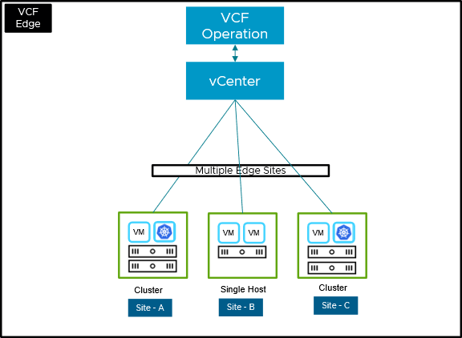
Design Attributes | Details
Central Monitoring | VCF Operation centrally monitors and manages licensing across the entire environment.
Central Management | vCenter instance manages multiple geographically distributed edge sites.
Hybrid Deployment Models | The design accommodates different deployment scales at the edge, including:  - Multi-Host Clusters: Providing compute and potentially storage resources across multiple physical hosts for higher availability and capacity (e.g., Site-A, Site-C).  - Single-Host Deployments: Offering a smaller footprint and potentially lower cost for less demanding edge locations (e.g., Site-B). Only supports for VM base workload deployments.
Network Connectivity | Latency and Bandwidth: 100 ms requirement for connecting vCenter to ESXi hosts. 500ms required for vSAN witness VM.
Deployment and Licensing | VCF Operation is the mandatory requirement along with vCenter to support this design.  Please deploy VCF Operation and vCenter manually or Using VCF installer with VVF option and then entitle VCF Edge license with VCF Operation.
Centralized License Check-in | If this design used for a dark site edge, then VCF Operation mandates a periodic license check-in (e.g., every 180 days, even for dark sites via their limited connectivity or alternative methods) to ensure the entire environment, including isolated edge locations, remains compliant with licensing terms and to prevent operational disruptions.

VCF Edge Option 2: Thin Edge with vSphere Supervisor on Two-Node vSAN
A resource-constrained edge deployment utilizing a small, two-node vSAN cluster to provide local storage for running both traditional VMs and modern containerized applications orchestrated by vSphere Kubernetes Service (VKS)
Figure 3-76. VCF Edge Option 2: Thin Edge with vSphere Supervisor on Two-Node vSAN
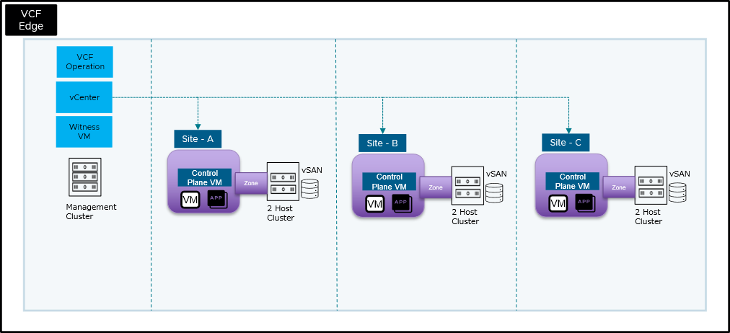
Design Requirement | Justification
Locally Managed or Centrally Managed | VCF Operation, vCenter, and a Witness VM are located in a Central Management Cluster. This cluster can be hosted locally at edge site or it can be hosted in a central or regional data center.
vSphere Supervisor | Supervisor is enabled in the vSphere environment at each edge site (within each 2-node cluster). This enables the deployment and management of Kubernetes workloads alongside traditional VMs.
vSAN for Local Storage | Each 2-node cluster utilizes vSAN for local shared storage.
Control Plane VM at each edge location | Provides the necessary control plane components for managing the Kubernetes environment and potentially other edge-specific services locally at each site.  Recommend to have 1 control plane VMs on 2 node vSAN cluster. With 1 CP VM on a two-node cluster, the Supervisor Cluster will be degraded but functioning if one of the nodes fails. While you've lost redundancy for the CP VM itself, the Kubernetes control plane remains operational on the surviving node, allowing existing workloads to continue running and management operations (though potentially with reduced performance) to still be possible.
Network Connectivity | Latency and Bandwidth: Minimum 100ms / 10Mbps required for connection between vCenter to the ESXi hosts.
Deployment and Licensing | VCF Operation is the mandatory requirement along with vCenter to support this design.  Please deploy VCF Operation and vCenter manually or Using VCF installer with VVF option and then entitle VCF Edge license with VCF Operation.
Note A key deviation from Pattern 6 is that this design does not incorporate a full VCF stack, but it does leverage vSAN.

VCF Edge Option 3: vSAN Witness Placement for Distributed Edge
Strategically locating the vSAN Witness component outside the primary data-bearing edge sites (e.g., in a central data center or in an independent site) to ensure quorum and data availability in 2-node vSAN edge deployments during site failures.
Figure 3-77. VCF Edge Option 3: vSAN Witness Placement for Distributed Edge
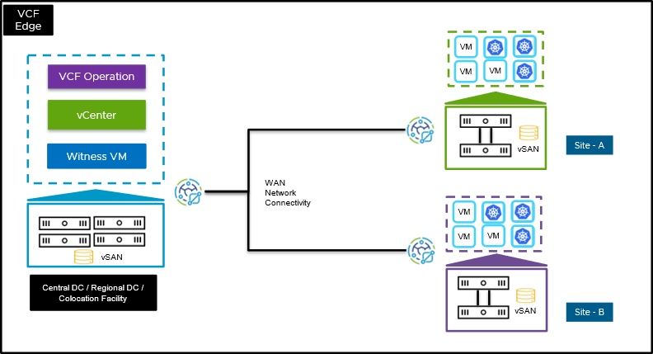
Design Requirement | Justification
Centralized Management | VCF Operation and vCenter are located in a Central DC or Regional DC or a Co-location Facility, managing the edge sites remotely.
2 Node vSAN at Edge Sites | Each edge site has its own vSAN storage.  Provides the local storage capacity and performance required for the VMs and container to run at each edge location.
vSAN Witness VM placement | Option 1: vSAN Witness VM in the Central DC/Regional DC/Co-location Facility.  This location offers maximum isolation from the potential failure domains of both edge sites, providing the highest level of resilience.  Option 2: If a Central DC/Regional DC/Co-location Facility is unavailable, implement a cross-site Witness VM configuration.  Hosting Site A's Witness VM on Site B and vice versa provides a degree of resilience against a single site failure when a dedicated third location is not feasible. However, be mindful of potential network latency between the sites.  Option 3: Embedded Witness Host - If using embedded hardware specifically designed for a vSAN Witness, consider local hosting at the Edge.  Embedded Witness appliances are often lightweight and designed for remote locations. However, carefully consider the management and potential single point of failure if the entire physical host housing the embedded Witness fails. This option should be evaluated based on specific hardware capabilities and risk tolerance.
Deployment and Licensing | VCF Operation is the mandatory requirement along with vCenter to support this design.  Please deploy VCF Operation and vCenter manually or Using VCF installer with VVF option and then entitle VCF Edge license with VCF Operation.
VSAN Witness Licensing | To license vSAN Witness:1) Attach your vSAN Witness Host or Appliance to the vCenter2) Assign your vSAN license to the vCenter3) The Witness host or appliance will be automatically licensed. vSAN Witness host cores do NOT consume capacity from your license capacity.
Network Connectivity | Latency and Bandwidth: 100 ms / 10Mbps required for connection between vCenter to the ESXi hosts.

VCF Network Detailed Design
This section covers all aspects of network design for vSphere clusters, NSX Edge clusters, VPC and consumption models for workloads deployed in the VCF Instance.
- Distributed Switch Detailed Design
- VMkernel Detailed Design
- Network I/O Control Detailed Design

Distributed Switch Detailed Design
A VCF Instance can support one or more supported Distributed Switch Models. This section describes the options, requirements and recommendations for each Distributed Switch Model.
- Single Distributed Switch Model
- Storage Separation Distributed Switch Model
- Workload Separation Distributed Switch Model
- Storage and Workload Separation Distributed Switch Model
- Dedicated vSphere Cluster for NSX Edge Node Distributed Switch Model
- vSAN Storage Cluster Separation Distributed Switch Model

Single Distributed Switch Model
A Single Distributed Switch Model in VMware Cloud Foundation provides a minimal deployment of networking using a single vSphere distributed switch for all network services such as management, vMotion, IP based storage and, NSX.
A Single Distributed Switch Model provides connectivity using the lowest number of physical NICs for each ESX host in the vSphere cluster while still providing availability from a single physical NIC failure, the network services running on the vSphere cluster will share the bandwidth provided by two physical NICs.
The Single Distributed Switch Model can be suited to vSphere clusters where the number of physical NICs must be reduced and the overall bandwidth requirements does not exceed that provided by two physical NICs. The bandwidth of the ESX host physical NICs will determine the network performance that can be achieved for the vSphere cluster.
Figure 3-78. Single Distributed Switch Model with 2 Physical NICs per ESX Host
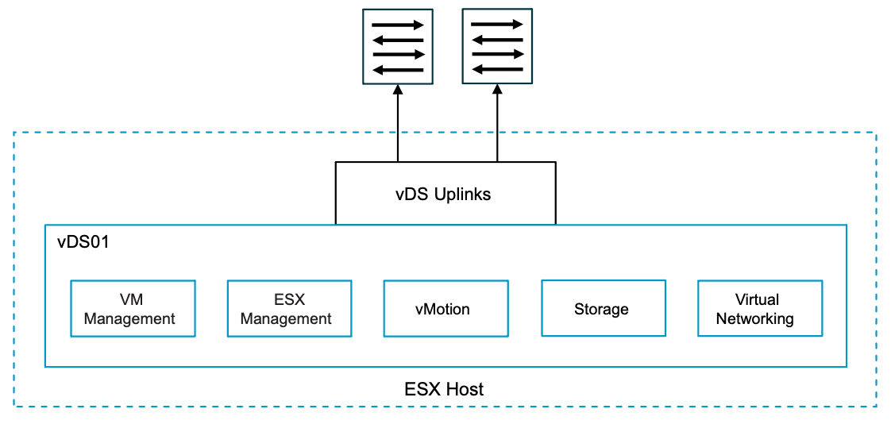

Single Distributed Switch Model Attributes
A Single Distributed Switch Model has the following attributes.
Attribute | Detail
Number of vSphere Distributed Switches | Single
Number of Physical NICs per ESX Host | Two (2)
Bandwidth | Shared for all network traffic
Network I/O Control | Enabled by default

Single Distributed Switch Model Options
A Single Distributed Switch Model can leverage options from the design areas listed below, depending on objectives.
Design Area | Options
Physical NIC Level Redundancy (NLR) | - Use a single 2-port NIC (no NLR).  - Use two separate 2-port NICs.  - Each traffic type is spread across two separate NIC to avoid single point of failure.  - Results in unused ports on NIC.
Load Balancing Option | - Route based on physical NIC load.  - Route based on the originating virtual port.  - Use explicit failover order.  - Route based on IP hash.
Data Path Mode | - Standard.  - Enhanced Datapath Standard (Default).  - Enhanced Datapath Dedicated.

Common Distributed Switch Design Requirements
Table 3-568. Common Distributed Switch Design Requirements
Design Requirements ID | Design Requirements | Justification | Implication
VCF-VDS-COM-REQD-CFG-001 | Do not share a vSphere Distributed Switch across different vSphere clusters.  (This applies to a greenfield deployment of a cluster using VCF automated workflows) | - Enables independent lifecycle management of vSphere Distributed Switch per vSphere cluster.  - Reduces the size of the fault domain. | For multiple vSphere clusters, you manage more vSphere Distributed Switches.

Common Distributed Switch Design Recommendations
Table 3-569. Common Distributed Switch Design Recommendations
Design Recommendations ID | Design Recommendations | Justification | Implication
VCF-VDS-COM-RCMD-CFG-001 | Configure the MTU size of the vSphere Distributed Switch to 9000 bytes for jumbo frames. | - Supports the MTU size required by system traffic types.  - Improves traffic throughput. | When adjusting the MTU packet size, you must also configure the entire network path (VMkernel ports, virtual switches, physical switches, and routers) to support the same MTU packet size.
VCF-VDS-COM-RCMD-CFG-002 | For NSX enabled vSphere Distributed Switch with Overlay or VLAN transport zone configure Enhanced Datapath Standard. | Provides the best performance for bandwidth and packets per second for the edge nodes running on the cluster. | The physical NIC must support the Enhanced Datapath - Interrupt Mode feature.
VCF-VDS-COM-RCMD-DPG-001 | Use ephemeral port binding for the VM management distributed port group (default setting). | - Using ephemeral port binding provides the option to recover the vCenter instance that is managing the vSphere Distributed Switch.  - The VM management network is not required for a multi-rack compute-only cluster in a VI workload domain | Port-level permissions and controls are lost across power cycles, and no historical context is saved.
VCF-VDS-COM-RCMD-DPG-002 | Use static port binding for all non-management distributed port groups (default setting). | Static binding ensures a virtual machine connects to the same port on the vSphere Distributed Switch. This allows for historical data and port-level monitoring. | Traffic not always deterministic, can be configured to another teaming policy during or after deployment if required.
VCF-VDS-COM-RCMD-DPG-003 | Use the Route based on physical NIC load teaming algorithm for the VM management distributed port group (default setting). | Reduces the complexity of the network design, increases resiliency, and can adjust to fluctuating workloads. | Traffic not always deterministic, can be configured to another teaming policy during or after deployment if required.
VCF-VDS-COM-RCMD-DPG-004 | Use the Route based on physical NIC load teaming algorithm for the ESX management distributed port group (default setting). | Reduces the complexity of the network design, increases resiliency, and can adjust to fluctuating workloads. | Traffic not always deterministic, can be configured to another teaming policy during or after deployment if required.
VCF-VDS-COM-RCMD-DPG-005 | Use the Route based on physical NIC load teaming algorithm for the vMotion distributed port group (default setting). | Reduces the complexity of the network design, increases resiliency, and can adjust to fluctuating workloads. | Traffic not always deterministic, can be configured to another teaming policy during or after deployment if required.

Single Distributed Switch Model Design Requirements
Table 3-570. Single Distributed Switch Model Design Requirements
Design Requirements ID | Design Requirements | Justification | Implication
VCF-VDS-SDS-REQD-CFG-001 | Use a single vSphere Distributed Switch per vSphere cluster. | Reduces the complexity of the network design. | Reduces the number of vSphere Distributed Switches that must be managed per vSphere cluster.
VCF-VDS-SDS-REQD-CFG-002 | Create the following distributed port groups on the vSphere Distributed Switch:  - VM management (mgmt domain only)  - ESX management  - vMotion  - Storage | Provides the required network services for the vSphere cluster. | VM management distributed port group needs to be manually created on additional vSphere clusters in the management domain and any workload domain vSphere clusters.
VCF-VDS-SDS-REQD-CFG-003 | For Layer 3 multi-rack cluster deployments create the following distributed port groups on the vSphere Distributed Switch for each additional rack:  - ESX management  - vMotion  - Storage (vSAN/NFS) | - Provides separate networks per rack in a multi-rack deployment.  - Storage traffic has a separate isolated layer 2 broadcast domain per rack | Additional port groups will be created for each additional rack
VCF-VDS-SDS-REQD-CFG-004 | For stretched cluster deployments create the following distributed port groups on the vSphere Distributed Switch for availability zone 2  - ESX management  - vMotion  - vSAN | - Provides separate networks per rack in a multi-rack deployment.  - vSAN traffic has a separate isolated layer 2 broadcast domain per availability zone | Additional port groups will be created for availability zone 2

Single Distributed Switch Model Design Recommendations
Table 3-571. Single Distributed Switch Model Design Recommendations
Design Recommendations ID | Design Recommendations | Justification | Implication
VCF-VDS-SDS-RCMD-DPG-001 | Use the Route based on physical NIC load teaming algorithm for any storage distributed port group (default setting). | Reduces the complexity of the network design, increases resiliency, and can adjust to fluctuating workloads. | Traffic not always deterministic, can be configured to another teaming policy during or after deployment if required.
VCF-VDS-SDS-RCMD-NIO-001 | Enable Network I/O Control on vSphere Distributed Switch (default setting). | Increases resiliency and performance when network traffic shares uplinks. | Network I/O Control might impact network performance for critical traffic types if misconfigured.
VCF-VDS-SDS-RCMD-NIO-002 | Set the share value for management traffic to Normal (default setting). | By keeping the default setting of Normal, management traffic is prioritized higher than vMotion but lower than vSAN traffic. Management traffic is important because it ensures that the hosts can still be managed during times of network contention. | None.
VCF-VDS-SDS-RCMD-NIO-003 | Set the share value for vMotion traffic to Low (default setting). | During times of network contention, vMotion traffic is not as important as virtual machine or storage traffic. | During times of network contention, vMotion takes longer than usual to complete.
VCF-VDS-SDS-RCMD-NIO-004 | Set the share value for virtual machines to High (default setting). | Virtual machines are the most important asset in a VCF Instance. Leaving the default setting of High ensures that they always have access to the network resources they need. | None.
VCF-VDS-SDS-RCMD-NIO-005 | Set the share value for principal IP-based storage traffic to High (default setting). | During times of network contention, storage traffic needs guaranteed bandwidth to support virtual machine performance. | None.
VCF-VDS-SDS-RCMD-NIO-006 | All other traffic types are set using default settings. | Other traffic types are only added during day 2 operations. | Can be manually adjusted on day 2 if required.

Storage Separation Distributed Switch Model
A Storage Separation Distributed Switch Model in VMware Cloud Foundation provides separation of storage traffic from all other network services running on the vSphere cluster.
A Storage Separation Distributed Switch Model requires two vSphere Distributed Switches to achieve this level of traffic separation where one vSphere Distributed Switch will be dedicated for storage traffic and the other will be used for all other network services, e.g. management, workload, vMotion, etc. Each vSphere Distributed Switch has two uplinks requiring four physical NICs on the ESX hosts.
The Storage Separation Distributed Switch Model can be suited to clusters where dedicated network bandwidth is required for storage traffic or if this traffic needs to be isolated to its own network fabric. This can be especially suited to vSphere clusters where dedicated bandwidth with no contention is required for storage traffic.
Figure 3-79. Storage Separation Distributed Switch Model With Single Network Fabric
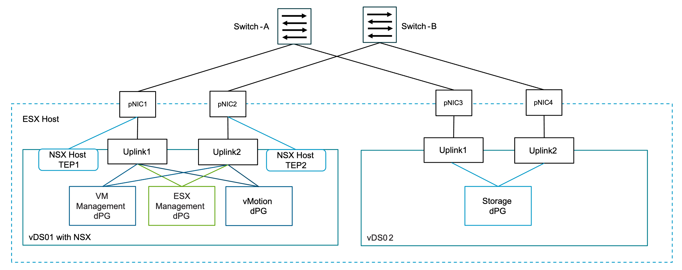

Storage Separation Distributed Switch Model Attributes
A Storage Separation Distributed Switch Model has the following attributes.
Attribute | Detail
Number of vSphere Distributed Switches | Two (2)
Number of Physical NICs per ESX Host | Four (4)
Bandwidth | - Shared for Management, vMotion, NSX Workload.  - Dedicated for IP Storage.

Storage Separation Distributed Switch Model Options
A Storage Separation Distributed Switch Model can leverage options from the design areas listed below, depending on objectives.
Design Area | Options
Network Fabric | - Single (all traffic on same fabric).  - Dual (storage traffic isolated to dedicated fabric).
Physical NIC Level Redundancy (NLR) | No NLR:  - Don't spread network traffic types across different network cards.  NLR:  - Use two or more network cards.  - Each traffic type is spread across separate network cards to avoid single point of failure.
Load Balancing Option | - Route based on physical NIC load.  - Route based on the originating virtual port.  - Use explicit failover order.  - Route based on IP hash.
Data Path Mode | - Standard.  - Enhanced Datapath Standard (Default).  - Enhanced Datapath Dedicated.

Common Distributed Switch Design Recommendations
Table 3-572. Common Distributed Switch Design Recommendations
Design Recommendations ID | Design Recommendations | Justification | Implication
VCF-VDS-COM-RCMD-CFG-001 | Configure the MTU size of the vSphere Distributed Switch to 9000 bytes for jumbo frames. | - Supports the MTU size required by system traffic types.  - Improves traffic throughput. | When adjusting the MTU packet size, you must also configure the entire network path (VMkernel ports, virtual switches, physical switches, and routers) to support the same MTU packet size.
VCF-VDS-COM-RCMD-CFG-002 | For NSX enabled vSphere Distributed Switch with Overlay or VLAN transport zone configure Enhanced Datapath Standard. | Provides the best performance for bandwidth and packets per second for the edge nodes running on the cluster. | The physical NIC must support the Enhanced Datapath - Interrupt Mode feature.
VCF-VDS-COM-RCMD-DPG-001 | Use ephemeral port binding for the VM management distributed port group (default setting). | - Using ephemeral port binding provides the option to recover the vCenter instance that is managing the vSphere Distributed Switch.  - The VM management network is not required for a multi-rack compute-only cluster in a VI workload domain | Port-level permissions and controls are lost across power cycles, and no historical context is saved.
VCF-VDS-COM-RCMD-DPG-002 | Use static port binding for all non-management distributed port groups (default setting). | Static binding ensures a virtual machine connects to the same port on the vSphere Distributed Switch. This allows for historical data and port-level monitoring. | Traffic not always deterministic, can be configured to another teaming policy during or after deployment if required.
VCF-VDS-COM-RCMD-DPG-003 | Use the Route based on physical NIC load teaming algorithm for the VM management distributed port group (default setting). | Reduces the complexity of the network design, increases resiliency, and can adjust to fluctuating workloads. | Traffic not always deterministic, can be configured to another teaming policy during or after deployment if required.
VCF-VDS-COM-RCMD-DPG-004 | Use the Route based on physical NIC load teaming algorithm for the ESX management distributed port group (default setting). | Reduces the complexity of the network design, increases resiliency, and can adjust to fluctuating workloads. | Traffic not always deterministic, can be configured to another teaming policy during or after deployment if required.
VCF-VDS-COM-RCMD-DPG-005 | Use the Route based on physical NIC load teaming algorithm for the vMotion distributed port group (default setting). | Reduces the complexity of the network design, increases resiliency, and can adjust to fluctuating workloads. | Traffic not always deterministic, can be configured to another teaming policy during or after deployment if required.

Storage Separation Distributed Switch Model Design Requirements
Table 3-573. Storage Separation Distributed Switch Model Design Requirements
Design Requirements ID | Design Requirements | Justification | Implication
VCF-VDS-SS-REQD-CFG-001 | Use two vSphere Distributed Switch per cluster:  - vDS01  - Management  - vMotion  - NSX  - vDS02  - Storage | - Separates storage traffic onto a dedicated vSphere Distributed Switch.  - Can provide maximum bandwidth and performance for storage traffic (NFS or vSAN) with no contention from other traffic on the ESX host physical NICs. | - Additional vSphere Distributed Switch required increasing management overhead.  - A higher number of ESX host physical NICs is required than using a single vSphere Distributed Switch with two (2) physical NICs per ESX host.  - Higher physical switch port density is required than the simple model.
VCF-VDS-SS-REQD-CFG-002 | Create the following distributed port groups on vDS01:  - VM management  - ESX management  - vMotion | Provides the required network services for the vSphere cluster. | VM management distributed port group needs to be manually created on additional clusters in the management domain and any workload domain vSphere clusters.
VCF-VDS-SS-REQD-CFG-003 | Create the following distributed port groups on vDS02:  - Storage | Provides connectivity for the hosts in the cluster to the storage network. | vSphere Distributed Switch storage traffic separation profile provides the required configuration.
VCF-VDS-SS-REQD-CFG-004 | For Layer 3 multi-rack cluster deployments create the following distributed port groups on the vSphere Distributed Switches for each additional rack:  vDS01:  - ESX management  - vMotion  vDS02:  - Storage | - Provides separate networks per rack in a multi-rack deployment.  - Storage traffic has a separate isolated layer 2 broadcast domain per rack. | Additional port groups will be created for each additional rack
VCF-VDS-SS-REQD-CFG-005 | For stretched cluster deployments create the following distributed port groups on the vSphere Distributed Switches for availability zone 2  vDS01:  - ESX management  - vMotion  vDS02:  - vSAN | - Provides separate networks per rack in a multi-rack deployment.  - vSAN traffic has a separate isolated layer 2 broadcast domain per availability zone. | Additional port groups will be created for availability zone 2

Storage Separation Distributed Switch Model Design Recommendations
Table 3-574. Storage Separation Distributed Switch Model Design Recommendations
Design Recommendations ID | Design Recommendations | Justification | Implication
VCF-VDS-SS-RCMD-DPG-001 | Use the Failover Order teaming algorithm for the storage port group. | Provides a consistent traffic flow through a single physical ToR switch without need to traverse Inter Switch Link during normal operations. | It needs to be manually configured during deployment using vSphere Distributed Switches custom profile option.
VCF-VDS-SS-RCMD-NIO-001 | Set the share value for management traffic to Normal for vDS01 (default setting). | By keeping the default setting of Normal, management traffic is prioritized higher than vMotion but lower than Principal storage traffic. Management traffic is important because it ensures that the hosts can still be managed during times of network contention. | None.
VCF-VDS-SS-RCMD-NIO-002 | Set the share value for vMotion traffic to Low for vDS01 (default setting). | During times of network contention, vMotion traffic is not as important as virtual machine traffic. | During times of network contention, vMotion takes longer than usual to complete.
VCF-VDS-SS-RCMD-NIO-003 | Set the share value for virtual machines to High for vDS01 (default setting). | Virtual machines are the most important asset in the SDDC. Leaving the default setting of High ensures that they always have access to the network resources they need. | None.
VCF-VDS-SS-RCMD-NIO-004 | All other traffic types are set using default settings. | Other traffic types are only added during day 2 operations. | Can be manually adjusted on day 2 if required.

Workload Separation Distributed Switch Model
A Workload Separation Distributed Switch Model in VMware Cloud Foundation provides a separation of workload traffic running on NSX segments from all other network services running on the vSphere cluster.
A Workload Separation Distributed Switch Model requires two vSphere Distributed Switches to achieve this level of traffic separation where one vSphere Distributed Switch will be dedicated for workload traffic and the other will be used for all other network services, e.g management, vMotion, etc. Each vSphere Distributed Switch has two uplinks so a minimum of four physical NICs is needed on the ESX hosts.
The Workload Separation Distributed Switch Model model can be suited to clusters where dedicated network bandwidth is required for workloads that cant be achieved with a shared network design using just two physical NICs. It also provides the option to isolate workload traffic to a separate network fabric if this is a requirement for the design.
Figure 3-80. Workload Separation Distributed Switch Model
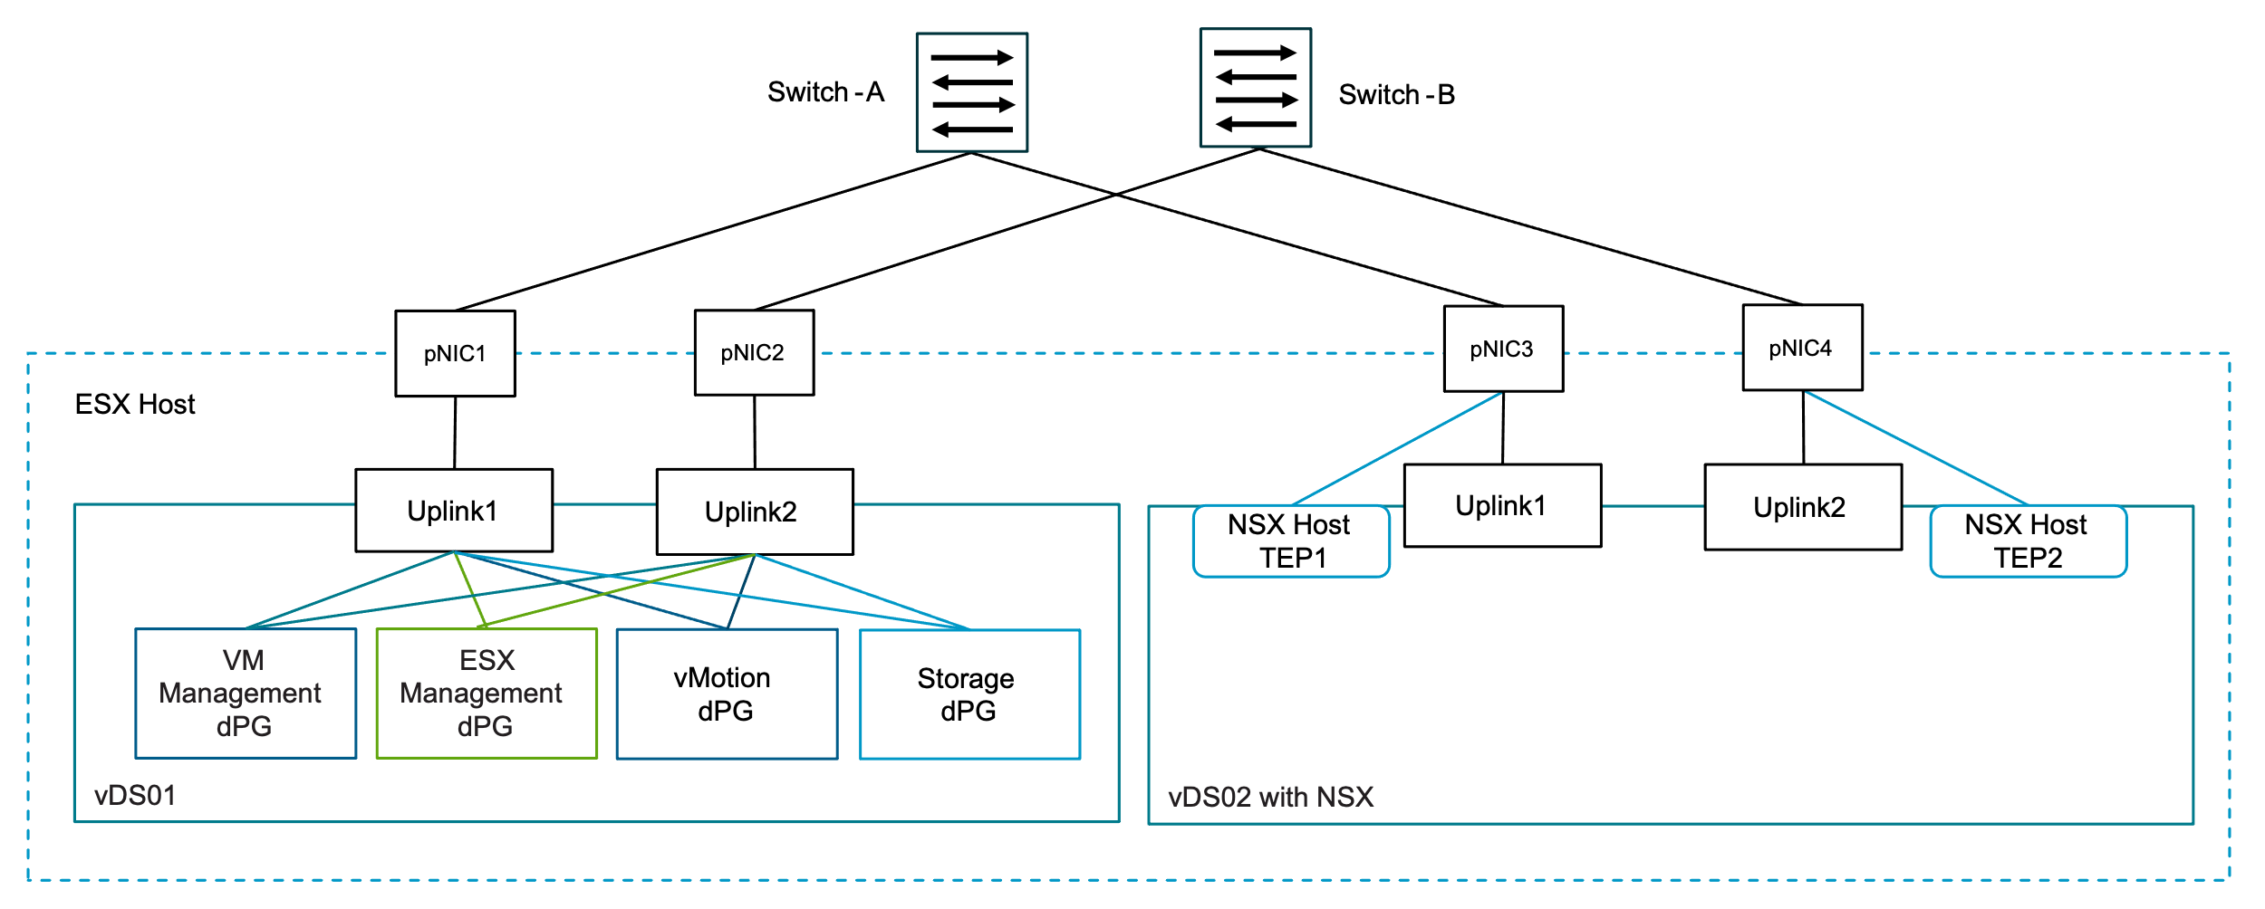

Workload Separation Distributed Switch Model Attributes
A Workload Separation Distributed Switch Model has the following attributes.
Attribute | Detail
Number of vSphere Distributed Switches | Two (2)
Number of Physical NICs per ESX Host | Four (4)
Bandwidth | - Shared for Management, vMotion, vSAN  - Dedicated for Workloads on NSX

Workload Separation Distributed Switch Model Options
A Workload Separation Distributed Switch Model can leverage options from the design areas listed below, depending on objectives.
Design Area | Options
Network Fabric | - Single (all traffic on same fabric).  - Dual (workload traffic using NSX and VPC networks isolated to a dedicated fabric).
Physical NIC Level Redundancy (NLR) | No NLR:  - Don't spread network traffic types across different network cards.  NLR:  - Use two separate 2-port Network Cards.  - Each traffic type is spread across two separate Network Cards to avoid single point of failure.
Load Balancing Option | - Route based on physical NIC load.  - Route based on the originating virtual port.  - Use explicit failover order.  - Route based on IP hash.
Data Path Mode | - Standard.  - Enhanced Datapath Standard (Default).  - Enhanced Datapath Dedicated.

Common Distributed Switch Design Recommendations
Table 3-575. Common Distributed Switch Design Recommendations
Design Recommendations ID | Design Recommendations | Justification | Implication
VCF-VDS-COM-RCMD-CFG-001 | Configure the MTU size of the vSphere Distributed Switch to 9000 bytes for jumbo frames. | - Supports the MTU size required by system traffic types.  - Improves traffic throughput. | When adjusting the MTU packet size, you must also configure the entire network path (VMkernel ports, virtual switches, physical switches, and routers) to support the same MTU packet size.
VCF-VDS-COM-RCMD-CFG-002 | For NSX enabled vSphere Distributed Switch with Overlay or VLAN transport zone configure Enhanced Datapath Standard. | Provides the best performance for bandwidth and packets per second for the edge nodes running on the cluster. | The physical NIC must support the Enhanced Datapath - Interrupt Mode feature.
VCF-VDS-COM-RCMD-DPG-001 | Use ephemeral port binding for the VM management distributed port group (default setting). | - Using ephemeral port binding provides the option to recover the vCenter instance that is managing the vSphere Distributed Switch.  - The VM management network is not required for a multi-rack compute-only cluster in a VI workload domain | Port-level permissions and controls are lost across power cycles, and no historical context is saved.
VCF-VDS-COM-RCMD-DPG-002 | Use static port binding for all non-management distributed port groups (default setting). | Static binding ensures a virtual machine connects to the same port on the vSphere Distributed Switch. This allows for historical data and port-level monitoring. | Traffic not always deterministic, can be configured to another teaming policy during or after deployment if required.
VCF-VDS-COM-RCMD-DPG-003 | Use the Route based on physical NIC load teaming algorithm for the VM management distributed port group (default setting). | Reduces the complexity of the network design, increases resiliency, and can adjust to fluctuating workloads. | Traffic not always deterministic, can be configured to another teaming policy during or after deployment if required.
VCF-VDS-COM-RCMD-DPG-004 | Use the Route based on physical NIC load teaming algorithm for the ESX management distributed port group (default setting). | Reduces the complexity of the network design, increases resiliency, and can adjust to fluctuating workloads. | Traffic not always deterministic, can be configured to another teaming policy during or after deployment if required.
VCF-VDS-COM-RCMD-DPG-005 | Use the Route based on physical NIC load teaming algorithm for the vMotion distributed port group (default setting). | Reduces the complexity of the network design, increases resiliency, and can adjust to fluctuating workloads. | Traffic not always deterministic, can be configured to another teaming policy during or after deployment if required.

Workload Separation Distributed Switch Model Design Requirements
Table 3-576. Workload Separation Distributed Switch Model Design Requirements
Design Requirements ID | Design Requirements | Justification | Implication
VCF-VDS-WS-REQD-CFG-001 | Use two (2) vSphere Distributed Switches per vSphere cluster:  - vDS01  - Mangement  - vMotion  - Storage  - vDS02  - NSX | - Separates NSX workload traffic onto dedicated vSphere Distributed Swtich.  - Can provide maximum bandwidth and performance for workload traffic with no contention from other traffic on the ESX host physical NICs. | - Additional vSphere Distributed Switches required increasing management overhead.  - A higher number of ESX host physical NICs is required than using a single vSphere Distributed Switch with two (2) physical NICs per ESX host.  - Higher physical switch port density is required than the simple model.
VCF-VDS-WS-REQD-CFG-002 | Create the following distributed port groups on vDS01:  - VM management  - ESX management  - vMotion  - Storage | Provides the required network services for the cluster. | VM mangement distributed port group needs to be manually created on additional clusters in the Mgmt domain and any workload domain clusters.
VCF-VDS-WS-REQD-CFG-003 | Configure vDS02 for NSX. | Provides NSX networking capabilities for the workloads on the cluster. | None.
VCF-VDS-WS-REQD-CFG-004 | For Layer 3 multi-rack cluster deployments create the following distributed port groups on the vSphere Distributed Switch for each additional rack:  - ESX management  - vMotion  - Storage (vSAN/NFS) | - Provides separate networks per rack in a multi-rack deployment.  - Storage traffic has a separate isolated layer 2 broadcast domain per rack | Additional port groups will be created for each additional rack
VCF-VDS-WS-REQD-CFG-005 | For stretched cluster deployments create the following distributed port groups on the vSphere Distributed Switch for availability zone 2  - ESX management  - vMotion  - vSAN | - Provides separate networks per rack in a multi-rack deployment.  - vSAN traffic has a separate isolated layer 2 broadcast domain per availability zone | Additional port groups will be created for availability zone 2

Workload Separation Distributed Switch Model Design Recommendations
Table 3-577. Workload Separation Distributed Switch Model Design Recommendations
Design Recommendations ID | Design Recommendations | Justification | Implication
VCF-VDS-WS-RCMD-DPG-001 | Use the Route based on physical NIC load teaming algorithm for the storage distributed port group on vDS01 (default setting). | Reduces the complexity of the network design, increases resiliency, and can adjust to fluctuating workloads. | Traffic not always deterministic, can be configured to another teaming policy during or after deployment if required.
VCF-VDS-WS-RCMD-NIO-001 | Enable Network I/O Control on vSphere Distributed Switch vDS01 (default setting). | Increases resiliency and performance when network traffic shares uplinks. | Network I/O Control might impact network performance for critical traffic types if misconfigured.
VCF-VDS-WS-RCMD-NIO-002 | Set the share value for management traffic to Normal for vDS01 (default setting). | By keeping the default setting of Normal, management traffic is prioritized higher than vMotion but lower than principal storage traffic. Management traffic is important because it ensures that the hosts can still be managed during times of network contention. | None.
VCF-VDS-WS-RCMD-NIO-003 | Set the share value for vMotion traffic to Low for vDS01 (default setting). | During times of network contention, vMotion traffic is not as important as storage traffic. | During times of network contention, vMotion takes longer than usual to complete.
VCF-VDS-WS-RCMD-NIO-004 | Set the share value for virtual machines to High for vDS01 (default setting). | Virtual machines are the most important asset in an VCF Instance. Leaving the default setting of High ensures that they always have access to the network resources they need. | None.
VCF-VDS-WS-RCMD-NIO-005 | Set the share value for principal IP-based Storage traffic to High for vDS01 (default setting). | During times of network contention, storage traffic needs guaranteed bandwidth to support virtual machine performance. | None.
VCF-VDS-WS-RCMD-NIO-006 | All other traffic types are set using default settings. | Other traffic types are only added during day 2 operations. | Can be manually adjusted on day 2 if required.

Storage and Workload Separation Distributed Switch Model
The Storage and Workload Separation Distributed Switch Model in VMware Cloud Foundation provides for full separation of storage and workload traffic from all other network traffic.
The Storage and Workload Separation Distributed Switch Model requires three vSphere Distributed Switches to achieve this level of traffic separation where both storage and workload have dedicated vSphere Distributed Switches and a third vSphere Distributed Switch will be used for all other network services, e.g. management, vMotion, etc. Each vSphere Distributed Switch has two uplinks requiring six physical NICs on the ESX hosts in the vSphere cluster connecting to each vSphere Distributed Switch. This basically combines the previous two network models providing isolation and high performance for storage and production workloads running on NSX segments or VPCs.
Figure 3-81. Storage and Workload Separation Distributed Switch Model
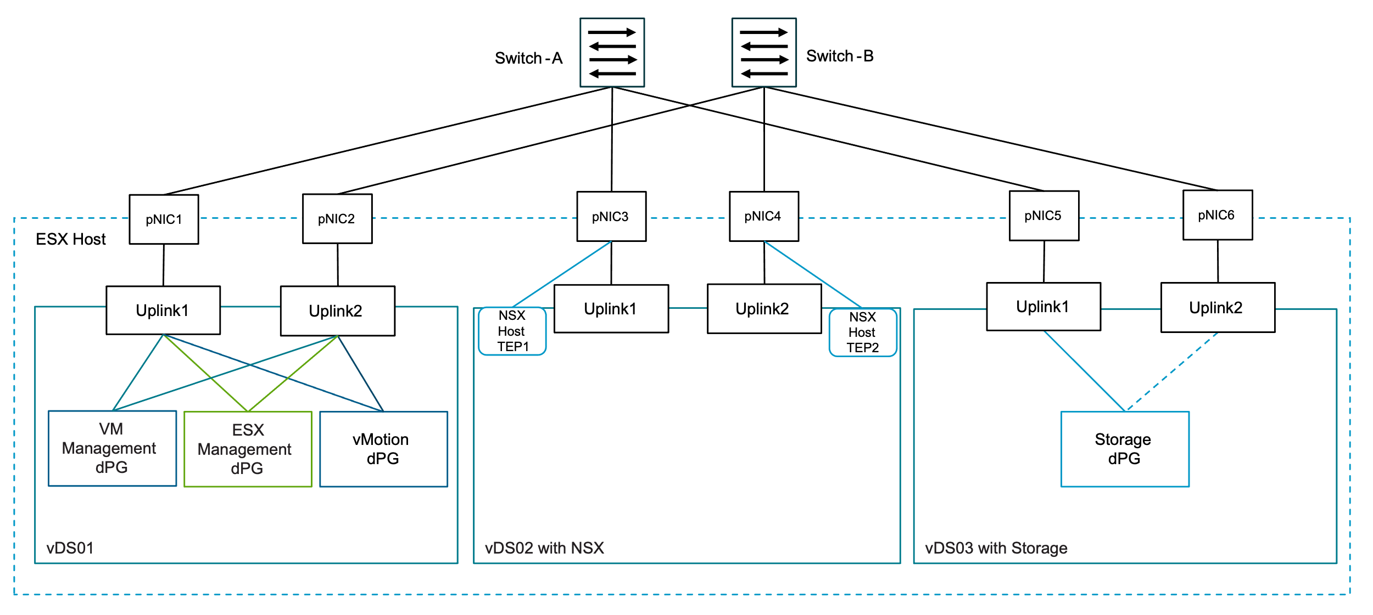

Storage and Workload Separation Distributed Switch Model Attributes
A Storage and Workload Separation Distributed Switch Model has the following attributes.
Attribute | Detail
Number of vSphere Distributed Switches | Three (3)
Number of Physical NICs per ESX Host | Six (6)
Bandwidth | - Shared for Management, vMotion.  - Dedicated for vSAN.  - Dediacted for NSX Workload.

Storage and Workload Separation Distributed Switch Model Options
A Storage and Workload Separation Distributed Switch Model can leverage options from the design areas listed below, depending on objectives.
Design Area | Options
Network Fabric | - Single (all traffic on same fabric).  - Dual (storage traffic isolated to dedicated fabric).
Physical NIC Level Redundancy (NLR) | No NLR:  - Don't spread network traffic types across different network cards.  NLR:  - Use two or more network cards.  - Each traffic type is spread across separate network cards to avoid single point of failure.
Load Balancing Option | - Route based on physical NIC load.  - Route based on the originating virtual port.  - Use explicit failover order.  - Route based on IP hash.
Data Path Mode | - Standard.  - Enhanced Datapath Standard (Default).  - Enhanced Datapath Dedicated.

Common Distributed Switch Design Recommendations
Table 3-578. Common Distributed Switch Design Recommendations
Design Recommendations ID | Design Recommendations | Justification | Implication
VCF-VDS-COM-RCMD-CFG-001 | Configure the MTU size of the vSphere Distributed Switch to 9000 bytes for jumbo frames. | - Supports the MTU size required by system traffic types.  - Improves traffic throughput. | When adjusting the MTU packet size, you must also configure the entire network path (VMkernel ports, virtual switches, physical switches, and routers) to support the same MTU packet size.
VCF-VDS-COM-RCMD-CFG-002 | For NSX enabled vSphere Distributed Switch with Overlay or VLAN transport zone configure Enhanced Datapath Standard. | Provides the best performance for bandwidth and packets per second for the edge nodes running on the cluster. | The physical NIC must support the Enhanced Datapath - Interrupt Mode feature.
VCF-VDS-COM-RCMD-DPG-001 | Use ephemeral port binding for the VM management distributed port group (default setting). | - Using ephemeral port binding provides the option to recover the vCenter instance that is managing the vSphere Distributed Switch.  - The VM management network is not required for a multi-rack compute-only cluster in a VI workload domain | Port-level permissions and controls are lost across power cycles, and no historical context is saved.
VCF-VDS-COM-RCMD-DPG-002 | Use static port binding for all non-management distributed port groups (default setting). | Static binding ensures a virtual machine connects to the same port on the vSphere Distributed Switch. This allows for historical data and port-level monitoring. | Traffic not always deterministic, can be configured to another teaming policy during or after deployment if required.
VCF-VDS-COM-RCMD-DPG-003 | Use the Route based on physical NIC load teaming algorithm for the VM management distributed port group (default setting). | Reduces the complexity of the network design, increases resiliency, and can adjust to fluctuating workloads. | Traffic not always deterministic, can be configured to another teaming policy during or after deployment if required.
VCF-VDS-COM-RCMD-DPG-004 | Use the Route based on physical NIC load teaming algorithm for the ESX management distributed port group (default setting). | Reduces the complexity of the network design, increases resiliency, and can adjust to fluctuating workloads. | Traffic not always deterministic, can be configured to another teaming policy during or after deployment if required.
VCF-VDS-COM-RCMD-DPG-005 | Use the Route based on physical NIC load teaming algorithm for the vMotion distributed port group (default setting). | Reduces the complexity of the network design, increases resiliency, and can adjust to fluctuating workloads. | Traffic not always deterministic, can be configured to another teaming policy during or after deployment if required.

Storage and Workload Separation Distributed Switch Model Design Requirements
Table 3-579. Storage and Workload Separation Distributed Switch Model Design Requirements
Requirements ID | Design Requirements | Justification | Implication
VCF-VDS-SWS-REQD-CFG-001 | Use three (3) vSphere Distributed Switch per vSphere cluster:  - vDS01  - Management  - vMotion  - vDS02  - Storage  - vDS03  - NSX Workloads | - Separates NSX workload traffic onto dedicated vSphere Distributed Switches.  - Separates storage traffic onto dedicated vSphere Distributed Switches.  - Can provide maximum bandwidth and performance for storage traffic (NFS or vSAN) with no contention from other traffic on the host physical NICs.  - Can provide maximum bandwidth and performance for workload traffic with no contention from other traffic on the host physical NICs. | - Additional vSphere Distributed Switches required increasing management overhead.  - A higher number of ESX host physical NICs is required than using a single vSphere Distributed Switches with two (2) physical NICs per ESX host.  - Higher number of ESX host physical NICs required, a minimum of six (6) with redundancy.
VCF-VDS-SWS-REQD-CFG-002 | Create the following distributed port groups on vDS01 and attach ESX VMkernels:  - VM management  - ESX management  - vMotion | Provides the required network services for the vSphere cluster. | VM management distributed port group needs to be manually created on additional clusters in the management domain and any workload domain vSphere clusters.
VCF-VDS-SWS-REQD-CFG-003 | Create the following distributed port groups on vDS02:  - Storage | Provides connectivity for the ESX hosts in the vSphere cluster to the storage network. | None.
VCF-VDS-SWS-REQD-CFG-004 | Configure vDS03 for NSX traffic. | Provides NSX networking capabilities for the workloads on the cluster. | None.
VCF-VDS-SWS-REQD-CFG-005 | For Layer 3 multi-rack cluster deployments create the following distributed port groups on the vSphere Distributed Switches for each additional rack:  vDS01:  - ESX management  - vMotion  vDS02:  - Storage | - Provides separate networks per rack in a multi-rack deployment.  - Storage traffic has a separate isolated layer 2 broadcast domain per rack. | Additional port groups will be created for each additional rack
VCF-VDS-SWS-REQD-CFG-006 | For stretched cluster deployments create the following distributed port groups on the vSphere Distributed Switches for availability zone 2  vDS01:  - ESX management  - vMotion  vDS02:  - vSAN | - Provides separate networks per rack in a multi-rack deployment.  - vSAN traffic has a separate isolated layer 2 broadcast domain per availability zone. | Additional port groups will be created for availability zone 2

Storage and Workload Separation Distributed Switch Model Design Recommendations
Table 3-580. Storage and Workload Separation Distributed Switch Model Design Recommendations
Design Recommendations ID | Design Recommendations | Justification | Implication
VCF-VDS-SWS-RCMD-DPG-001 | Use the Failover Order teaming algorithm for the storage (vSAN or NFS) distributed port group. | Only one uplink active which provides a consistent traffic flow through a single physical ToR switch without the need to traverse Inter Switch Link during normal operations. | It needs to be manually configured during deployment using vSphere Distributed Switch custom profile option.
VCF-VDS-SWS-RCMD-NIO-001 | Enable Network I/O Control on vSphere Distributed Switch vDS01 (default setting). | Increases resiliency and performance of the network when traffic shares uplinks. | Network I/O Control might impact network performance for critical traffic types if misconfigured.
VCF-VDS-SWS-RCMD-NIO-002 | Set the share value for management traffic to Normal for shared vDS01 (default setting). | By keeping the default setting of Normal, management traffic is prioritized higher than vMotion. Management traffic is important because it ensures that the hosts can still be managed during times of network contention | None.
VCF-VDS-SWS-RCMD-NIO-003 | Set the share value for vMotion traffic to Low for shared vDS01 (default setting). | During times of network contention, vMotion traffic is not as important as management traffic. | During times of network contention, vMotion takes longer than usual to complete.
VCF-VDS-SWS-RCMD-NIO-004 | Set the share value for virtual machines to High for DS01 (default setting). | Virtual machines are the most important asset in a VCF Instance. Leaving the default setting of High ensures that they always have access to the network resources they need. | None.
VCF-VDS-SWS-RCMD-NIO-005 | All other traffic types are set using default settings. | Other traffic types are only added during day 2 operations. | Can be manually adjusted on day 2 if required.

Dedicated vSphere Cluster for NSX Edge Node Distributed Switch Model
A Dedicated vSphere Cluster for NSX Edge Node Distributed Switch Model in VMware Cloud Foundation provides the network design for the deployment of NSX Edge nodes to the vSphere cluster. This vSphere cluster is dedicated to running only NSX Edges to provide for a large-scale, high-performance NSX Edge cluster deployment. To see more details please refer to NSX Edge Cluster Detailed Design.
The Dedicated vSphere Cluster for NSX Edge Node Distributed Switch Model uses two vSphere Distributed Switches with two uplinks to provide the connectivity for two NSX Edge nodes to run on each ESX host in the vSphere cluster.
Figure 3-82. Dedicated vSphere Cluster for NSX Edges Distributed Switch Model
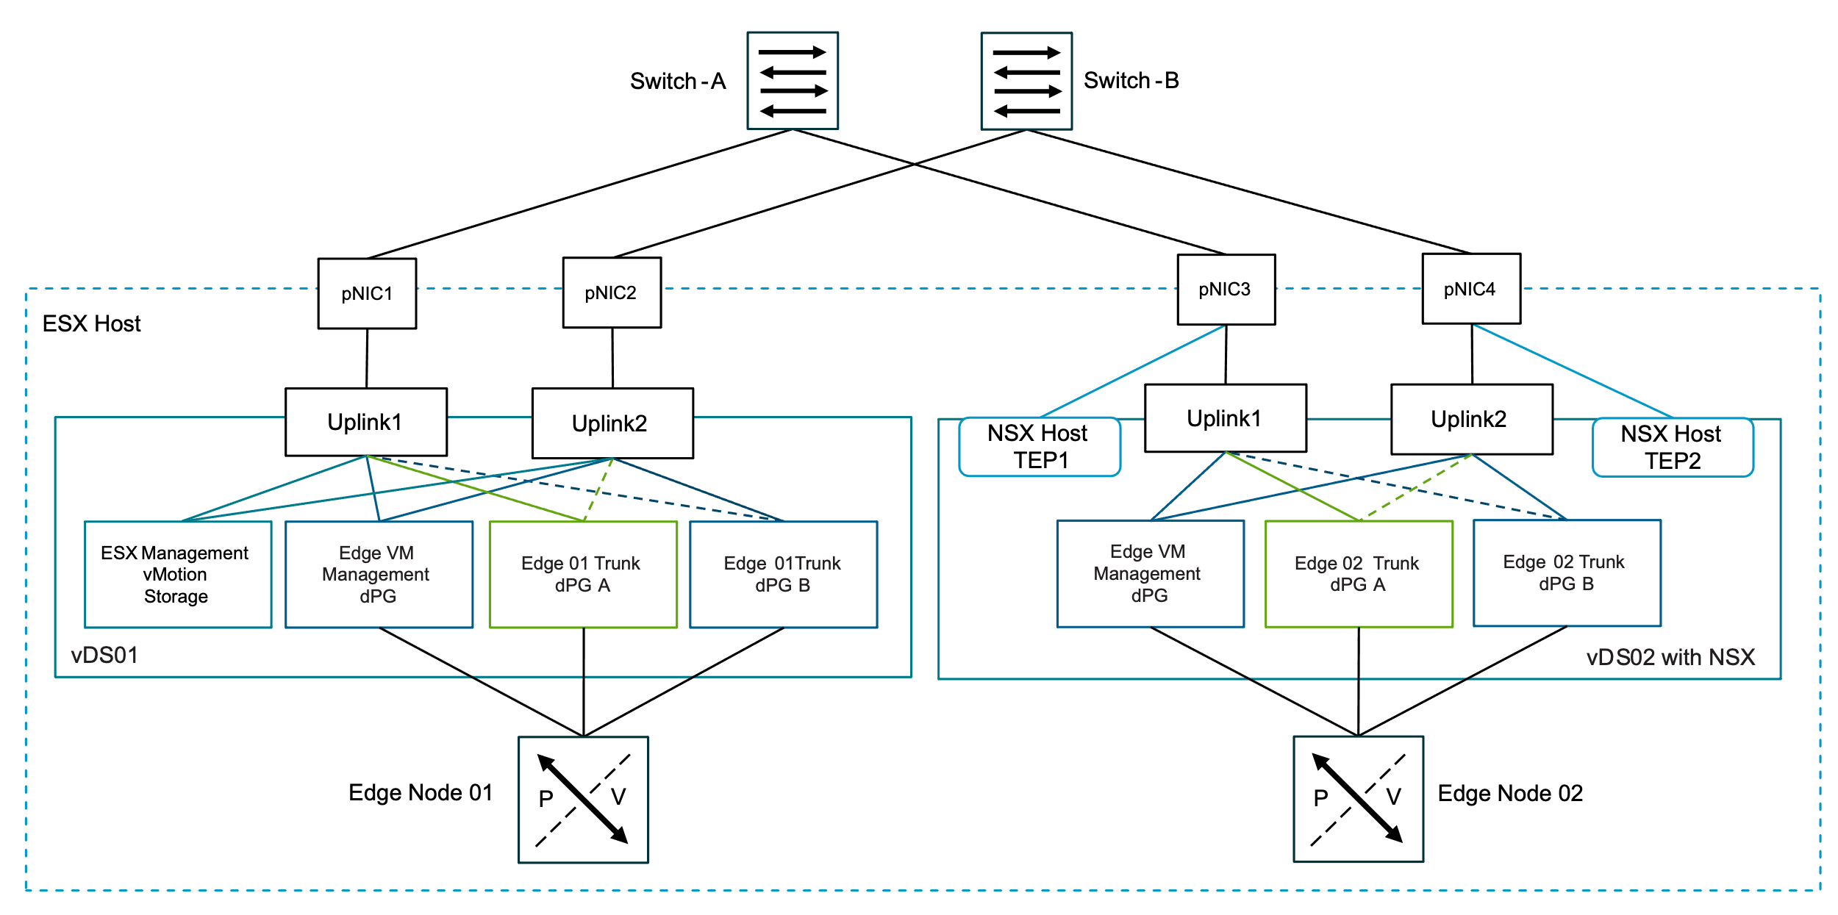

Dedicated vSphere Cluster for NSX Edge Node Distributed Switch Model Attributes
A Dedicated vSphere Cluster for NSX Edge Node Distributed Switch Model has the following attributes.
Attribute | Detail
Number of vSphere Distributed Switches | Two (2)
Number of Physical NICs per ESX Host | Four (4)
Bandwidth | - Each NSX Edge node has dedicated Uplink/TEP traffic per ESX host pNIC.  - No vMotion traffic as each NSX Edge node is pinned to an ESX host as per the design.  - vSAN traffic should be minimal as only two NSX Edge nodes deployed per ESX host.  - Host TEP traffic should be minimal as recommended to have no workload virtual machinces deployed using NSX overlay.

Dedicated vSphere Cluster for NSX Edge Node Distributed Switch Model Options
A Dedicated vSphere Cluster for NSX Edge Node Distributed Switch Model can leverage options from the design areas listed below, depending on objectives.
Design Area | Options
Network Fabric | Single (all traffic on same fabric).
Physical NIC Level Redundancy (NLR) | No NLR:  - Don't spread network traffic types across separate network cards.  NLR:  - Use two or more network cards.  - Each traffic type is spread across separate network cards to avoid single point of failure.
Load Balancing Option | - Route based on physical NIC load.  - Route based on the originating virtual port.  - Use explicit failover order. (only option for NSX edge node uplinks)  - Route based on IP hash.
Data Path Mode | - Standard.  - Enhanced Datapath Standard (Default).  - Enhanced Datapath Dedicated.

Common Distributed Switch Design Recommendations
Table 3-581. Common Distributed Switch Design Recommendations
Design Recommendations ID | Design Recommendations | Justification | Implication
VCF-VDS-COM-RCMD-CFG-001 | Configure the MTU size of the vSphere Distributed Switch to 9000 bytes for jumbo frames. | - Supports the MTU size required by system traffic types.  - Improves traffic throughput. | When adjusting the MTU packet size, you must also configure the entire network path (VMkernel ports, virtual switches, physical switches, and routers) to support the same MTU packet size.
VCF-VDS-COM-RCMD-CFG-002 | For NSX enabled vSphere Distributed Switch with Overlay or VLAN transport zone configure Enhanced Datapath Standard. | Provides the best performance for bandwidth and packets per second for the edge nodes running on the cluster. | The physical NIC must support the Enhanced Datapath - Interrupt Mode feature.
VCF-VDS-COM-RCMD-DPG-001 | Use ephemeral port binding for the VM management distributed port group (default setting). | - Using ephemeral port binding provides the option to recover the vCenter instance that is managing the vSphere Distributed Switch.  - The VM management network is not required for a multi-rack compute-only cluster in a VI workload domain | Port-level permissions and controls are lost across power cycles, and no historical context is saved.
VCF-VDS-COM-RCMD-DPG-002 | Use static port binding for all non-management distributed port groups (default setting). | Static binding ensures a virtual machine connects to the same port on the vSphere Distributed Switch. This allows for historical data and port-level monitoring. | Traffic not always deterministic, can be configured to another teaming policy during or after deployment if required.
VCF-VDS-COM-RCMD-DPG-003 | Use the Route based on physical NIC load teaming algorithm for the VM management distributed port group (default setting). | Reduces the complexity of the network design, increases resiliency, and can adjust to fluctuating workloads. | Traffic not always deterministic, can be configured to another teaming policy during or after deployment if required.
VCF-VDS-COM-RCMD-DPG-004 | Use the Route based on physical NIC load teaming algorithm for the ESX management distributed port group (default setting). | Reduces the complexity of the network design, increases resiliency, and can adjust to fluctuating workloads. | Traffic not always deterministic, can be configured to another teaming policy during or after deployment if required.
VCF-VDS-COM-RCMD-DPG-005 | Use the Route based on physical NIC load teaming algorithm for the vMotion distributed port group (default setting). | Reduces the complexity of the network design, increases resiliency, and can adjust to fluctuating workloads. | Traffic not always deterministic, can be configured to another teaming policy during or after deployment if required.

Dedicated vSphere Cluster for NSX Edge Node Distributed Switch Model Design Requirements
Table 3-582. Dedicated vSphere Cluster for NSX Edges Distributed Switch Model Design Requirements
Design Requirements ID | Design Requirements | Justification | Implication
VCF-VDS-DE-REQD-CFG-001 | Use two vSphere Distributed Switch per vSphere cluster:  - vDS01  - NSX Edge VM management  - vMotion  - Storage  - Edge Uplink  - vDS02  - NSX Edge VM management  - NSX - Host  - Edge TEP  - Edge Uplink | - Separates storage traffic onto a dedicated vSphere Distributed Switch.  - Can provide maximum bandwidth and performance for storage traffic (NFS or vSAN) with no contention from other traffic on the host physical NICs | - Additional vSphere Distributed Switch required increasing management overhead.  - A higher number of ESX host physical NICs is required than using a single vSphere Distributed Switch with two physical NICs per ESX host.  - Higher physical switch port density is required than the simple model.
VCF-VDS-DE-REQD-CFG-002 | Create the following distributed port groups on vDS01:  - NSX Edge VM management  - ESX management  - vMotion  - Storage  - Edge Uplinks | Provides the required network services for the cluster including edge connectivity. | - vSphere Distributed Switch workload traffic separation profile provides the required configuration for the ESX host.  - NSX Edge VM distributed port groups must be created manually.
VCF-VDS-DE-REQD-CFG-003 | Create the following Port Groups on vDS02  - NSX Edge VM management  - Edge Uplinks | Provides the required connectivity for edge management and edge TEP and edge uplink traffic. | - vSphere Distributed Switch workload traffic separation profile provides the required configuration.  - NSX Edge VM distributed port groups must be created manually.

Dedicated vSphere Cluster for NSX Edge Node Distributed Switch Model Recommendations
Table 3-583. Dedicated vSphere Cluster for NSX Edges Distributed Switch Model Design Recommendations
Design Recommendations ID | Design Recommendations | Justification | Implication
VCF-VDS-DE-RCMD-DPG-001 | Use the Route based on physical NIC load teaming algorithm for the storage port group on vDS01 (default setting). | Reduces the complexity of the network design, increases resiliency, and can adjust to fluctuating workloads. | None.
VCF-VDS-DE-RCMD-NIO-001 | Disable Network I/O Control on vSphere Distributed Switch vDS01. | Provides maximum possible performance for NSX Edges when Network I/O control is disabled. | It needs to be manually disabled.
VCF-VDS-DE-RCMD-NIO-002 | Disable Network I/O Control on vSphere Distributed Switch vDS02. | Provides maximum possible performance for NSX Edges when Network I/O control is disabled. | It needs to be manually disabled.

vSAN Storage Cluster Separation Distributed Switch Model
A vSAN Storage Cluster Separation Distributed Switch Model in VMware Cloud Foundation is used for storage clusters where the vSAN storage traffic is separated from all other traffic on the vSphere cluster.
A vSAN Storage Cluster Separation Distributed Switch Model requires two vSphere Distributed Switches to achieve a design where vSAN storage traffic requires it's own dedicated physical NICs for guaranteed bandwidth and optional vSAN storage traffic isolation through a separate storage fabric within a rack.
Figure 3-83. vSAN Storage Cluster Separation Distributed Switch Model Showing Optional Dedicated Storage Fabric
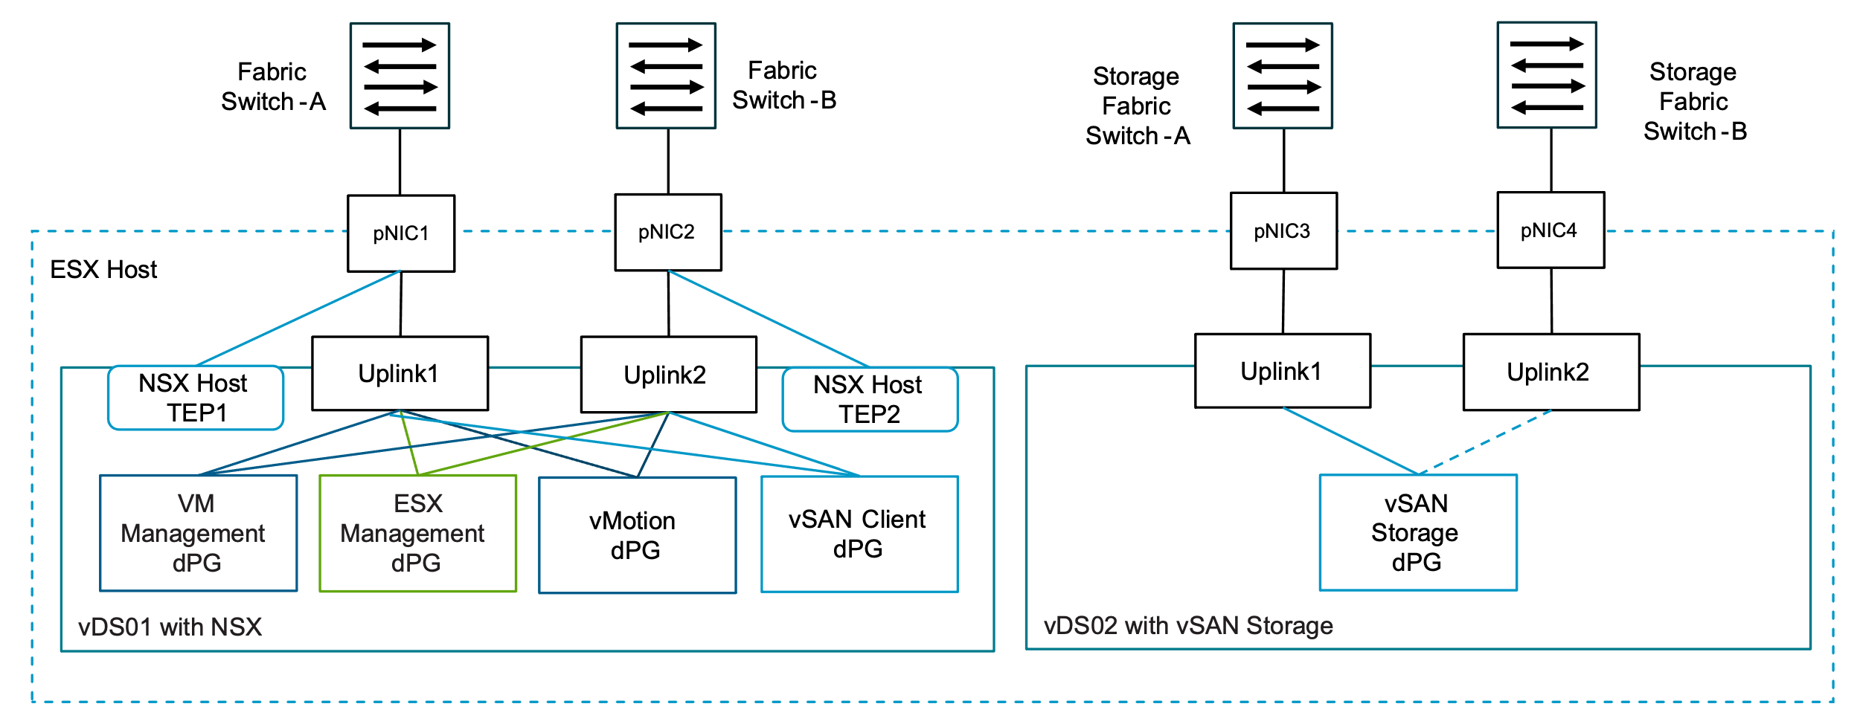

vSAN Storage Cluster Separation Distributed Switch Model Attributes
A vSAN Storage Cluster Separation Distributed Switch Model has the following attributes.
Attribute | Detail
Number of vSphere Distributed Switches | Two (2)
Number of Physical NICs per ESX Host | Four (4)
Bandwidth | - Dedicated for the vSAN storage traffic local to the cluster/rack.  - vSAN client traffic serving compute clusters is shared with management traffic.

vSAN Storage Cluster Separation Distributed Switch Model Options
A Storage Separation Distributed Switch Model can leverage options from the design areas listed below, depending on objectives.
Design Area | Options
Network Fabric | - Single ( All traffic on same fabric)  - Dual (Storage Cluster vSAN traffic isolated to dedicated fabric)
Physical NIC Level Redundancy (NLR) | No NLR:  - Dont spread network traffic types across different network cards  NLR:  - Use two or more network cards  - Each traffic type is spread across separate network cards to avoid single point of failure
Load Balancing Option | - Route based on physical NIC load.  - Route based on the originating virtual port  - Use explicit failover order.  - Route based on IP hash
Data Path Mode | - Standard  - Enhanced Datapath Standard (Default)  - Enhanced Datapath Dedicated

Common Distributed Switch Design Recommendations
Table 3-584. Common Distributed Switch Design Recommendations
Design Recommendations ID | Design Recommendations | Justification | Implication
VCF-VDS-COM-RCMD-CFG-001 | Configure the MTU size of the vSphere Distributed Switch to 9000 bytes for jumbo frames. | - Supports the MTU size required by system traffic types.  - Improves traffic throughput. | When adjusting the MTU packet size, you must also configure the entire network path (VMkernel ports, virtual switches, physical switches, and routers) to support the same MTU packet size.
VCF-VDS-COM-RCMD-CFG-002 | For NSX enabled vSphere Distributed Switch with Overlay or VLAN transport zone configure Enhanced Datapath Standard. | Provides the best performance for bandwidth and packets per second for the edge nodes running on the cluster. | The physical NIC must support the Enhanced Datapath - Interrupt Mode feature.
VCF-VDS-COM-RCMD-DPG-001 | Use ephemeral port binding for the VM management distributed port group (default setting). | - Using ephemeral port binding provides the option to recover the vCenter instance that is managing the vSphere Distributed Switch.  - The VM management network is not required for a multi-rack compute-only cluster in a VI workload domain | Port-level permissions and controls are lost across power cycles, and no historical context is saved.
VCF-VDS-COM-RCMD-DPG-002 | Use static port binding for all non-management distributed port groups (default setting). | Static binding ensures a virtual machine connects to the same port on the vSphere Distributed Switch. This allows for historical data and port-level monitoring. | Traffic not always deterministic, can be configured to another teaming policy during or after deployment if required.
VCF-VDS-COM-RCMD-DPG-003 | Use the Route based on physical NIC load teaming algorithm for the VM management distributed port group (default setting). | Reduces the complexity of the network design, increases resiliency, and can adjust to fluctuating workloads. | Traffic not always deterministic, can be configured to another teaming policy during or after deployment if required.
VCF-VDS-COM-RCMD-DPG-004 | Use the Route based on physical NIC load teaming algorithm for the ESX management distributed port group (default setting). | Reduces the complexity of the network design, increases resiliency, and can adjust to fluctuating workloads. | Traffic not always deterministic, can be configured to another teaming policy during or after deployment if required.
VCF-VDS-COM-RCMD-DPG-005 | Use the Route based on physical NIC load teaming algorithm for the vMotion distributed port group (default setting). | Reduces the complexity of the network design, increases resiliency, and can adjust to fluctuating workloads. | Traffic not always deterministic, can be configured to another teaming policy during or after deployment if required.

vSAN Storage Cluster Separation Distributed Switch Model Requirements
Table 3-585. Storage Separation Distributed Switch Model Design Requirements
Design Requirements ID | Design Requirements | Justification | Implication
VCF-VDS-SS-REQD-CFG-001 | Use two vSphere Distributed Switch per cluster:  - vDS01  - Management  - vMotion  - NSX  - vDS02  - Storage | - Separates storage traffic onto a dedicated vSphere Distributed Switch.  - Can provide maximum bandwidth and performance for storage traffic (NFS or vSAN) with no contention from other traffic on the ESX host physical NICs. | - Additional vSphere Distributed Switch required increasing management overhead.  - A higher number of ESX host physical NICs is required than using a single vSphere Distributed Switch with two (2) physical NICs per ESX host.  - Higher physical switch port density is required than the simple model.
VCF-VDS-SS-REQD-CFG-002 | Create the following distributed port groups on vDS01:  - VM management  - ESX management  - vMotion | Provides the required network services for the vSphere cluster. | VM management distributed port group needs to be manually created on additional clusters in the management domain and any workload domain vSphere clusters.
VCF-VDS-SS-REQD-CFG-003 | Create the following distributed port groups on vDS02:  - Storage | Provides connectivity for the hosts in the cluster to the storage network. | vSphere Distributed Switch storage traffic separation profile provides the required configuration.
VCF-VDS-SS-REQD-CFG-004 | For Layer 3 multi-rack cluster deployments create the following distributed port groups on the vSphere Distributed Switches for each additional rack:  vDS01:  - ESX management  - vMotion  vDS02:  - Storage | - Provides separate networks per rack in a multi-rack deployment.  - Storage traffic has a separate isolated layer 2 broadcast domain per rack. | Additional port groups will be created for each additional rack
VCF-VDS-SS-REQD-CFG-005 | For stretched cluster deployments create the following distributed port groups on the vSphere Distributed Switches for availability zone 2  vDS01:  - ESX management  - vMotion  vDS02:  - vSAN | - Provides separate networks per rack in a multi-rack deployment.  - vSAN traffic has a separate isolated layer 2 broadcast domain per availability zone. | Additional port groups will be created for availability zone 2

vSAN Storage Cluster Separation Distributed Switch Model Recommendations
Table 3-586. vSAN Storage Cluster Separation Distributed Switch Model Design Recommendations
Design Recommendations ID | Design Recommendations | Justification | Implication
VCF-VDS-VSCS-RCMD-DPG-001 | Use the Failover Order teaming algorithm for the vSAN distributed port group. | Provides a consistent traffic flow through a single physical ToR switch without need to traverse Inter Switch Link during normal operations. | It needs to be manually configured during deployment using vSphere Distributed Switch custom profile option.
VCF-VDS-VSCS-RCMD-NIO-001 | Disable Network I/O Control on vSphere Distributed Switch vDS02 dedicated for vSAN cluster storage traffic. | Provides the best performance for vSAN cluster traffic when Network I/O control is disabled and there is no sharing of traffic. | You must deactivate Network I/O Control manually after the cluster is deployed.
VCF-VDS-VSCS-RCMD-NIO-002 | Set the share value for management traffic to Normal for vDS01 (default setting). | By keeping the default setting of Normal, management traffic is prioritized higher than vMotion but lower than storage traffic. Management traffic is important because it ensures that the hosts can still be managed during times of network contention. | None.
VCF-VDS-VSCS-RCMD-NIO-003 | Set the share value for vMotion traffic to Low for vDS01 (default setting). | During times of network contention, vMotion traffic is not as important as virtual machine traffic. | During times of network contention, vMotion takes longer than usual to complete.
VCF-VDS-VSCS-RCMD-NIO-004 | Set the share value for virtual machines to High for vDS01 (default setting). | Virtual machines are the most important asset in the SDDC. Leaving the default setting of High ensures that they always have access to the network resources they need. | None.
VCF-VDS-VSCS-RCMD-NIO-005 | Set the share value for vSAN Client traffic to High for vDS01 (default setting) | During times of network contention, storage traffic needs guaranteed bandwidth to support virtual machine performance. | None.
VCF-VDS-VSCS-RCMD-NIO-006 | All other traffic types are set using default settings. | Other traffic types are only added during day 2 operations. | Can be manually adjusted on day 2 if required.

VMkernel Detailed Design
The VMkernel networking layer provides connectivity to hosts and handles the system traffic for management, vSphere vMotion, vSphere HA, vSAN, NSX Host TEPs, etc

VMkernel Network Adapter Design
The following are the VMKernels created on the ESX hosts used by clusters in VMware Cloud Foundation.
Table 3-587. VMkernel Network Adapter Configuration
VMkernel Adapter Service | Connected Distributed Port Group | Activated Services | Recommended MTU Size (Bytes)
ESX Management | ESX Management Port Group | Management Traffic | 1500 (Default)
vMotion | vMotion Port Group | vMotion Traffic | 9000
vSAN | vSAN Port Group | vSAN | 9000
NFS | NFS Port Group | NFS | 9000
Host TEPs | Not applicable | Not applicable | 9000

Network I/O Control Detailed Design
vSphere Network I/O Control version 3 is enabled by default on the vSphere Distributed Switches created in VMware Cloud Foundation and provides a mechanism to reserve bandwidth for system traffic based on the capacity of the physical adapters on an ESX host. This can be particularly useful when different traffic types share the same physical adapters on the hosts.

vSphere Distributed Switch Network I/O Control Options
Network I/O Control supports different mechanisms for resource management of system traffic related to infrastructure services, such vSAN, vMotion, etc and VM traffic. For system traffic shares are used to ensure a dedicated percentage of the bandwidth at time when there is contention on the physical adapter. Network I/O Control provisions bandwidth to the network adapters of virtual machines by using constructs of shares, reservation and limit. In VMware Cloud Foundation the default shares are applied to the system traffic, the table below shows the default values.
Traffic Type | Shares | Shares Value
Management Traffic | Normal | 50
Fault Tolerance (FT) Traffic | Low | 25
vMotion Traffic | Low | 25
VM Traffic | High | 100
iSCSI Traffic | Low | 25
NFS Traffic | Low* | 25
vSphere Replication (VR) Traffic | Low | 25
vSAN Traffic | High | 100
vSphere Data Protection Backup Traffic | Low | 25
vSphere Backup NFC Traffic | Normal | 50
NVMe over TCP | Normal | 50
Provisioning Traffic | Normal | 50
Depending on the the distributed switch configuration and the type of system traffic on the distributed virtual switch these value can be modified post deployment to meet the requirements of the environment.
Note * High if NFS storage is used as principal storage for the cluster
** Low if vSAN is not used as principal storage for the cluster
Note In some cases vSphere Network I/O Control needs to be disabled, for vSphere cluster hosting edge clusters, it is recommend to disable the feature.

Fleet Level Components Networking Detailed Design
The Fleet Level Components Networking Models have a number of connectivity options depending on the requirements. This section describes the options, requirements and recommendations for each Fleet Level Components Networking Models.
- Fleet Level Components on Shared Management Network Model
- Fleet Level Components on Dedicated Management Network Model
- Fleet Level Components on NSX Overlay Segment Model
- Fleet Level Components on NSX VLAN Segment Model
- Fleet Level Components on NSX Overlay Stretched Segment Model

Fleet Level Components on Shared Management Network Model
The fleet level management components can be deployed to the same vSphere Distributed Switch port group used for the VCF Instance management components, this can be achieved using VCF Installer during initial deployment of the VCF fleet.
Note VCF Operations collector and VCF Operations for networks collectors are considered instance level components. It is recommended to always deploy these components to the management domain VM management port group.
Figure 3-84. Fleet Level Components on Shared Management Network Model in VMware Cloud Foundation
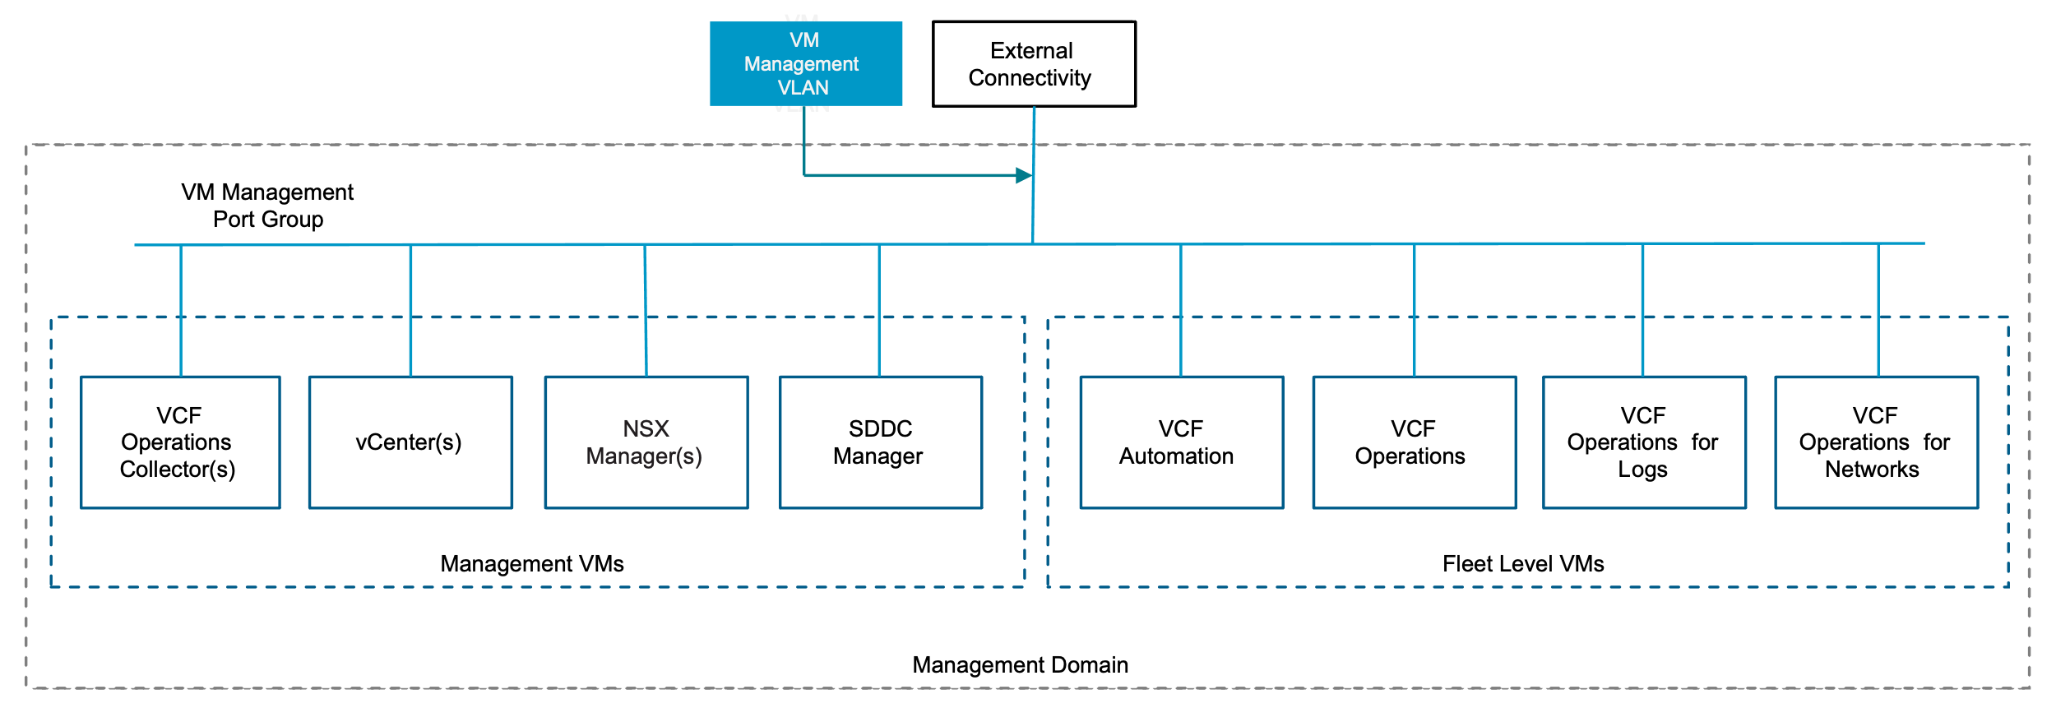

Fleet Level Components on Shared Management Network Model Attributes
A Fleet Level Components on Shared Management Network Model has the following attributes.
Attribute | Detail
Connectivity Type | vSphere VLAN Port Group
Network Isolation | No, sharing the same VLAN as the VCF management domain components
NSX Edge Cluster | Only if NSX load balancer is required
Stretching Networks between availability zones | Physical network fabric must stretch the VLAN between availability zones
Stretching Networks between regions | Not suited to disaster recovery use case as network is shared with management domain components, failover testing not supported.

Fleet Level Components on Shared Management Network Model Design Requirements
Table 3-588. Fleet Level Components on Shared Management Design Requirements
Design Requirement ID | Design Requirement | Justification | Implication
VCF-FLT-SM-REQD-001 | Use the management domain vCenter VM management port group for the Fleet level components | No additional network required | No logical network isolation
VCF-FLT-SM-REQD-002 | Use the same VLAN for Fleet level components and the VCF Instance managment VMs | No additional VLAN required | Separate physical firewall rules may not be possible with single VLAN

Fleet Level Components on Shared Management Network Model Design Recommendations
Table 3-589. Fleet Level Components on Shared Management Design Recommendations
Design Recommendation ID | Design Recommendation | Justification | Implication
VCF-FLT-SM-RCMD--001 | Deploy the fleet level components during initial deployment using VCF Installer. | Simplified deployment using UI. | None.

Fleet Level Components on Dedicated Management Network Model
The fleet level management components can be deployed to the dedicated vSphere Distributed Switch port group used only for the VCF fleet components, this has to be done as a day 2 operation after VCF Installer has deployed the management domain.
Figure 3-85. Fleet Level Components on Dedicated Management Network in VMware Cloud Foundation
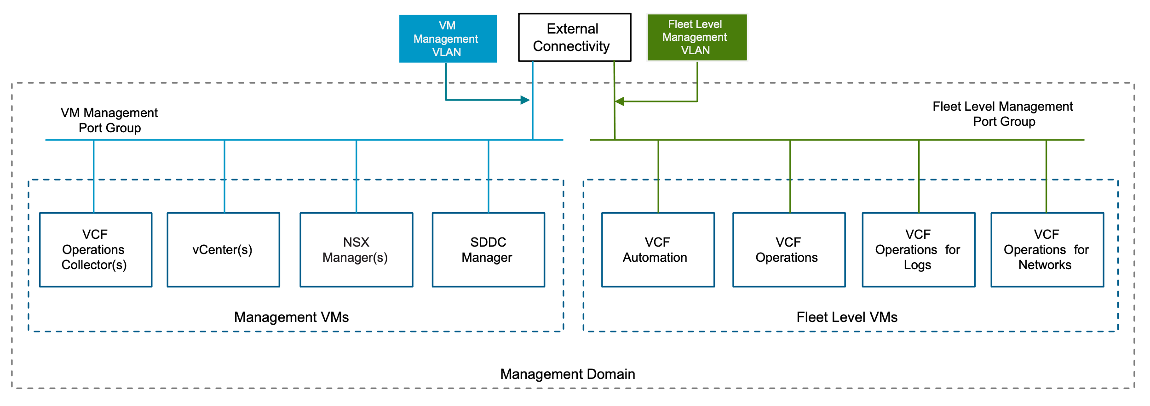

Fleet Level Components on Dedicated Management Network Model Attributes
A Fleet Level Components on Dedicated Management Network Model has the following attributes.
Attribute | Detail
Connectivity Type | vSphere VLAN Port Group
Network Isolation | Logically isolated using dedicated VLAN and port group
NSX Edge Cluster | Only if NSX load balancer is required
Stretching Networks between availability zones | Physical network fabric must stretch the VLAN between availability zones
Stretching Networks between regions | Physical network fabric must stretch the VLAN between regions

Fleet Level Components on Dedicated Management Network Model Design Requirements
Table 3-590. Fleet Level Components on Dedicated Management Design Requirements
Design Requirement ID | Design Requirement | Justification | Implication
VCF-FLT-DM-REQD-001 | Create a dedicated port group on the management vCenter management distributed switch | Used for Fleet level component connectivity | Needs to be manually created in vCenter
VCF-FLT-DM-REQD-002 | Use a dedicated port group on the management vCenter management distributed switch for the Fleet level components | Logically separates fleet level component traffic from the management domain VM Managemnent traffic | Requires additional manual steps for deployment
VCF-FLT-DM-REQD-003 | Use a dedicated VLAN for Fleet Level components | - Logical network isolation can be achieved for the Fleet Level component traffic  - Physical firewall can be used to secure access to this network | - Additional VLAN and subnet required  - For stretched management cluster VLAN must be stretched between sites to provide site high availability  - For disaster recovery use case the physical fabric will need to support stretching the network between VCF Instances or sites
VCF-FLT-DM-REQD-004 | Use SDDC Manager API to deploy the components day 2 | Provides the automated workflow to deploy the components to the dedicated network | - Fleet Level component install binaries must be downloaded to SDDC manager depot  - Json payload must be provided for the deployment

Fleet Level Components on Dedicated Management Network Model Design Recommendations
Table 3-591. Fleet Level Components on Dedicated Management Design Recommendations
Design Recommendation ID | Design Recommendation | Justification | Implication
VCF-FLT-DM-RCMD-001 | Use the VM Management network for the VCF Ops collectors, these are considered VCF instance level components and can reside on the same network as the Core components. | - Although supported to separate VCF Ops collectors onto it's own dedicated network this is not required  - The VCF Ops collectors typically communicate with the management components, keeping these in the same network can reduce the latency between components  - For stretched management cluster only single VLAN needs to be stretched for the Fleet Level components | API json payload needs to include VM Management network for instance level objects in the Region field

Fleet Level Components on NSX Overlay Segment Model
The fleet level management components can be deployed to an NSX overlay segment. This has to be done as a day 2 operation after VCF Installer has deployed the management domain. This provides the option to use the NSX load balancer for fleet level management components including VCF Operations and VCF Automation. It also provides the option to stretch the networks using NSX Federation if a disaster recovery solution is layered on top.
Figure 3-86. Fleet Level Components on NSX Overlay Segment Model in VMware Cloud Foundation
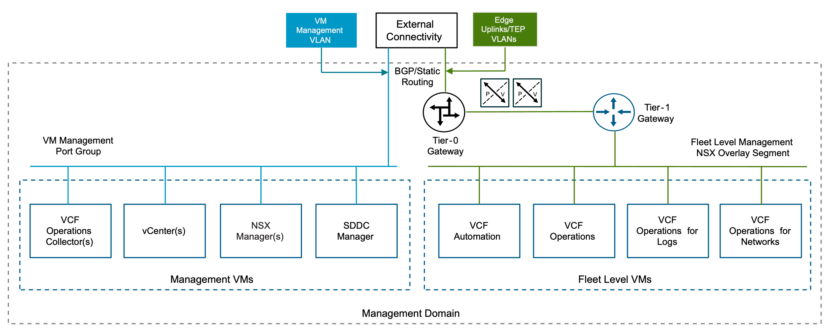

Fleet Level Components on NSX Overlay Segment Model Attributes
A Fleet Level Components on NSX Overlay Segment Network Model has the following attributes.
Attribute | Detail
Connectivity Type | NSX segment networking
Network Isolation | Yes, dedicated NSX segment
NSX Edge Cluster | Required for connectivity
Stretching Network between availability zones | NSX segment is stretched using NSX Overlay segment available on hosts in the cluster
Stretching Network between regions | NSX Federation can be used to stretch the NSX segment

Fleet Level Management on NSX Overlay Segment Model Common Design Requirements
You must meet the following design requirements for the design of the fleet level components on an NSX overlay segment for aVCF instance.
Table 3-592. Fleet Level Components on NSX Overlay Segment Common Design Requirements
Design Requirement ID | Design Requirement | Justification | Implication
VCF-FLT-NSX-OVR-REQD-001 | Create NSX edge cluster with centralized transit gateway in the management domain | Provides T0 gateway routing to the physical network | Additional routing configuration needed on the physical switches, e.g. BGP or static routing
VCF-FLT-NSX-OVR-REQD-002 | Create a T1 gateway and link to the T0 gateway | Provides connectivity to other networks for the NSX segment used for the Fleet level components | Manually created in NSX manager UI
VCF-FLT-NSX-OVR-REQD-003 | On the T1 advertise all connected segments and service ports | Advertises the segment subnet to the T0 | Manually created in NSX manager UI
VCF-FLT-NSX-OVR-REQD-004 | Create a segment on management domain overlay transport zone for Fleet Level components | Used for Fleet level component connectivity | Manually created in NSX manager UI
VCF-FLT-NSX-OVR-REQD-005 | Use a segment on management domain overlay transport zone for Fleet Level components | - NSX Load balancer can be used for Fleet level components  - NSX Segment can be stretched between VCF instances using NSX Federation  - Provides IP Mobility if the NSX segment is stretched between sites | Requires additional manual steps for deployment
VCF-FLT-NSX-OVR-REQD-006 | Use SDDC Manager API to deploy the components day 2 | Provides the automated workflow to deploy the components to the dedicated network | - Fleet Level component install binaries must be downloaded to SDDC manager depot  - Json payload must be provided for the deployment

Fleet Level Components on NSX VLAN Segment Model
The fleet level management components can be deployed to the dedicated NSX VLAN segment used only for the VCF fleet components, this has to be done as a day 2 operation after VCF Installer has deployed the management domain. This provides the option to use the NSX load balancer for Fleet level management components including VCF Operations and VCF Automation. This does not provide the option to stretch the networks between sites using NSX Federation.
Figure 3-87. Fleet Level Components on NSX VLAN Segment Model in VMware Cloud Foundation
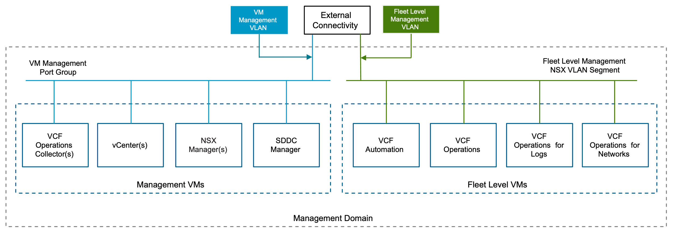

Fleet Level Components on NSX VLAN Segment Model Attributes
A Fleet Level Components on NSX Overlay Segment Network Model has the following attributes.
Attribute | Detail
Connectivity Type | NSX Segment Networking
Network Isolation | Yes, dedicated segment using VLAN
NSX Edge Cluster | Only if NSX load balancer is required
Stretching Network between availability zones | Physical network fabric must stretch the NSX VLAN segment between availability zones
Stretching Network between regions | Physical network fabric must stretch the NSX VLAN segment between regions

Fleet Level Components on NSX VLAN Segment Model Design Requirements
Table 3-593. Fleet Level Components on NSX VLAN Segment Design Requirements
Design Requirement ID | Design Requirement | Justification | Implication
VCF-FLT-NSX-VLAN-REQD-001 | Create a VLAN transport zone. | Required for VLAN segment connectivity. | Manually created in NSX manager UI.
VCF-FLT-NSX-VLAN-REQD-002 | Create a VLAN segment on management domain VLAN transport zone for Fleet Level components. | - Logical network isolation can be achieved for the Fleet Level component traffic  - Physical firewall can be used to secure access to this network | - Additional VLAN and subnet required  - For stretched management cluster VLAN must be stretched between sites to provide site high availability  - For disaster recovery use case the physical fabric will need to support stretching the network between VCF Instances or sites
VCF-FLT-NSX-VLAN-REQD-003 | Attach the VLAN transport zone to the transport node profile. | Required for VLAN connectivity from the ESX hosts | Manually created in NSX manager UI
VCF-FLT-NSX-VLAN-REQD-004 | Use a VLAN segment on management domain vlan transport zone for Fleet Level components. | Logically separates fleet level component traffic from the management domain VM Management traffic. | Requires additional manual steps for deployment.
VCF-FLT-NSX-VLAN-REQD-005 | Download fleet Level components install binaries to SDDC manger depot. | Required to install using SDDC manager API. | Offline or online depot needs to be configured on SDDC Manager.
VCF-FLT-NSX-VLAN-REQD-006 | Use SDDC Manager API to deploy the components day 2. | Provides the automated workflow to deploy the components to the dedicated network | Json payload must be provided for the deployment.

Fleet Level Components on NSX VLAN Segment Model Design Recommendations
Table 3-594. Fleet Level Components on NSX VLAN Segment Design Recommendations
Design Recommendation ID | Design Recommendation | Justification | Implication
VCF-FLT-NSX-VLAN-RCMD-001 | Create NSX Edge cluster in the management domain without Gateway and Routing. | Provides the option to use NSX load balancer for the fleet level components. | Only required if using NSX Load balancer.
VCF-FLT-NSX-VLAN-RCMD-002 | Place the VCF Ops collectors onto the VM Management network, these are considered VCF instance level components and can reside on the same network as the Core components. | - Although supported to separate VCF Ops collectors onto it's own dedicated network this is not required  - The VCF Ops collectors typically communicate with the management components, keeping these in the same network can reduce the latency between components  - For stretched management cluster only single VLAN needs to be stretched for the Fleet Level components | API json payload needs to include VM Management network for instance level objects in the Region field.

Fleet Level Components on NSX Overlay Stretched Segment Model
The fleet level management components can be deployed to an NSX overlay segment that is then stretched using NSX Federation between two VCF Instances in two different locations. This provides IP mobility for the fleet level VMs if they need to restarted or restored to another location.
Figure 3-88. Fleet Level Components on NSX Overlay Stretched Segment Model in VMware Cloud Foundation
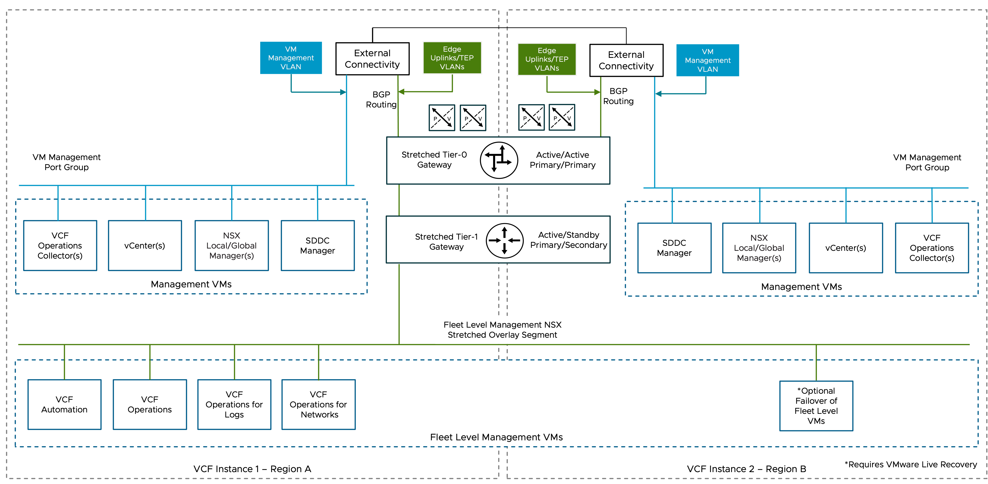

Fleet Level Components on NSX Overlay Stretched Segment Model Attributes
A Fleet Level Components on NSX Overlay Stretched Segment Network Model has the following attributes.
Attribute | Detail
Connectivity Type | NSX segment networking
Network Isolation | Yes, dedicated NSX segment
NSX Edge Cluster | Required for segment connectivity
Stretching Network between availability zones | NSX segment is stretched using NSX Overlay segment available on hosts in the cluster
Stretching Network between regions | NSX Federation is used to stretch the NSX segment between locations in each region

Fleet Level Components on NSX Overlay Stretched Segment Model Common Design Requirements
You must meet the following design requirements in your NSX overlay stretched design for a single VCF Instance and for multiple VCF Instances.
Table 3-595. Fleet Level Components on NSX Overlay Segment Common Design Requirements
Design Requirement ID | Design Requirement | Justification | Implication
VCF-FLT-NSX-OVR-REQD-001 | Create NSX edge cluster with centralized transit gateway in the management domain | Provides T0 gateway routing to the physical network | Additional routing configuration needed on the physical switches, e.g. BGP or static routing
VCF-FLT-NSX-OVR-REQD-002 | Create a T1 gateway and link to the T0 gateway | Provides connectivity to other networks for the NSX segment used for the Fleet level components | Manually created in NSX manager UI
VCF-FLT-NSX-OVR-REQD-003 | On the T1 advertise all connected segments and service ports | Advertises the segment subnet to the T0 | Manually created in NSX manager UI
VCF-FLT-NSX-OVR-REQD-004 | Create a segment on management domain overlay transport zone for Fleet Level components | Used for Fleet level component connectivity | Manually created in NSX manager UI
VCF-FLT-NSX-OVR-REQD-005 | Use a segment on management domain overlay transport zone for Fleet Level components | - NSX Load balancer can be used for Fleet level components  - NSX Segment can be stretched between VCF instances using NSX Federation  - Provides IP Mobility if the NSX segment is stretched between sites | Requires additional manual steps for deployment
VCF-FLT-NSX-OVR-REQD-006 | Use SDDC Manager API to deploy the components day 2 | Provides the automated workflow to deploy the components to the dedicated network | - Fleet Level component install binaries must be downloaded to SDDC manager depot  - Json payload must be provided for the deployment

Fleet Level Components on NSX Overlay Stretched Segment Model Design Requirements
Table 3-596. Fleet Level Components on NSX Overlay Stretched Segment Design Requirements
Design Requirement ID | Design Requirement | Justification | Implication
VCF-FLT-NSX-FED-REQD-001 | Allocate a separate VLAN for edge RTEP overlay that is different from the edge overlay VLAN. | The RTEP network must be on a VLAN that is different from the edge overlay VLAN. This is an NSX requirement that provides support for configuring different MTU size per network. | You must allocate another VLAN in the data center infrastructure.
VCF-FLT-NSX-FED-REQD-002 | Extend the Tier-0 gateway to the second VCF Instance. | - Supports ECMP north-south routing on all nodes in the NSX Edge cluster.  - Enables support for cross-instance Tier-1 gateways and cross-instance network segments. | The Tier-0 gateway deployed in the second instance is removed.
VCF-FLT-NSX-FED-REQD-003 | Set the Tier-0 gateway as primary for all VCF Instances. | - In NSX Federation, a Tier-0 gateway lets egress traffic from connected Tier-1 gateways only in its primary locations.  - Local ingress and egress traffic is controlled independently at the Tier-1 level. No segments are provisioned directly to the Tier-0 gateway.  - A mixture of network spans (local to a VCF Instance or spanning multiple instances) is enabled without requiring additional Tier-0 gateways and hence edge nodes.  - If a failure in a VCF Instance occurs, the local-instance networking in the other instance remains available without manual intervention. | Manually done through NSX Global manager UI
VCF-FLT-NSX-FED-REQD-004 | From the global Tier-0 gateway, establish BGP neighbor peering to the ToR switches connected to the second VCF Instance. | - Enables the learning and advertising of routes in the second VCF Instance.  - Facilitates a potential automated failover of networks from the first to the second VCF Instance. | Manually done through NSX Global manager UI
VCF-FLT-NSX-FED-REQD-005 | Use a stretched Tier-1 gateway and connect it to the Tier-0 gateway for cross-instance Fleet level networking. | - Enables network span between the VCF Instances because NSX network segments follow the span of the gateway they are attached to.  - Creates a two-tier routing architecture. | Manually done through NSX Global manager UI
VCF-FLT-NSX-FED-REQD-006 | Assign the NSX Edge cluster in each VCF Instance to the stretched Tier-1 gateway. Set the first VCF Instance as primary and the second instance as secondary. | - Enables cross-instance network span between the first and second VCF Instances.  - Enables deterministic ingress and egress traffic for the cross-instance network.  - If a VCF Instance failure occurs, enables deterministic failover of the Tier-1 traffic flow.  - During the recovery of the inaccessible VCF Instance, enables deterministic failback of the Tier-1 traffic flow, preventing unintended asymmetrical routing.  - Eliminates the need to use BGP attributes in the first and second VCF Instances to influence location preference and failover. | You must manually fail over and fail back the cross-instance network from the standby NSX Global Manager.
VCF-FLT-NSX-FED-REQD-007 | Extend the cross-instance NSX segment used to deploy the Fleet level management components to the second VCF Instance. | - Enables IP mobility without a complex physical network configuration.  - The fleet level management network must be available at both VCF instances. | Manually done through NSX Global manager UI

Fleet Level Components on NSX Overlay Stretched Segment Model Design Recommendations
Table 3-597. Fleet Level Components on NSX Overlay Stretched Segment Design Recommendations
Design Recommendation ID | Design Recommendation | Justification | Implication
VCF-FLT-NSX-BGP-RCMD-001 | Use Tier-1 gateway to control the span of fleet level management network and ingress and egress traffic in the VCF Instances. | Enables spanning multiple VCF Instances without requiring additional Tier-0 gateways and hence NSX Edge nodes. | To control location span, a Tier-1 gateway must be assigned to an edge cluster and hence has the Tier-1 SR component. East-west traffic between Tier-1 gateways with SRs need to physically traverse an NSX Edge node.

Storage Detailed Design
A VCF Instance can include one or more supported Storage Models. This section describes the options, requirements and recommendations for each model Storage Model.

vSAN Detailed Designs
The following section covers multiple vSAN designs that cover different vSAN deployment models such as single rack, mutli-rack , vSAN stretched cluster, or disaggregated vSAN storage and compute clusters. This section also covers vSAN specific networking requirements and recommendations.

vSAN Network Model
When designing ESX host networking for vSAN, determining the network configuration for vSAN traffic will have an impact on the Distributed Switch Model chosen for a given vSphere cluster. See Distributed Switch Detailed Design.
Figure 3-89. vSAN Networking Host Model - 2 pNIC
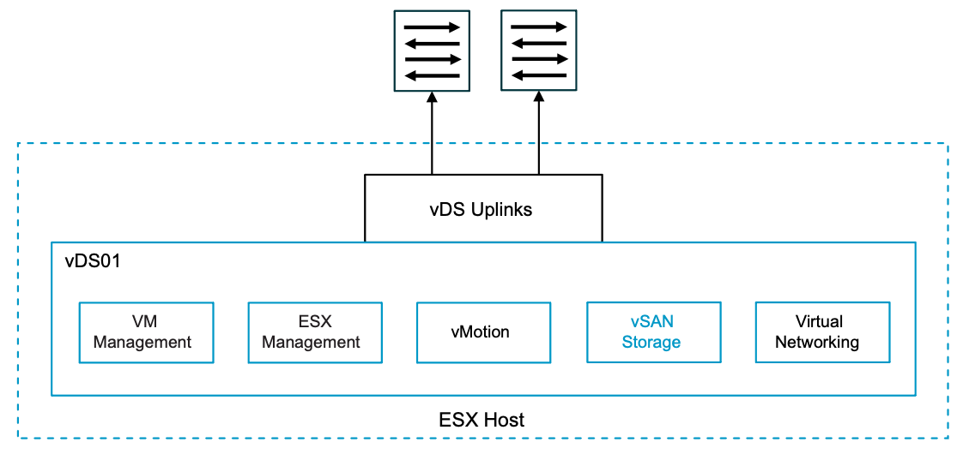
Figure 3-90. vSAN Networking Host Model Design - 4 pNIC
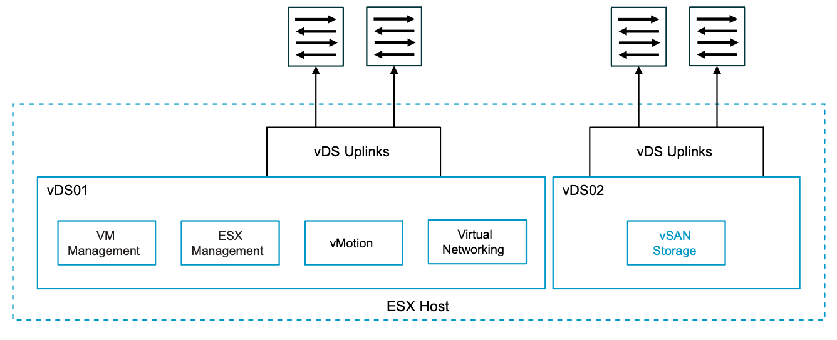
vSAN network design includes the following attributes to consider
Table 3-598. vSAN Network Attributes
Attribute | Detail
vSAN VMkernel | Dedicated VMkernel ports for vSAN traffic communication.
VLAN | VLANs are used for vSAN storage traffic to be isolated on a dedicated VLAN.
Physical networking | Dedicated or shared physical adapters for storage traffic.
vSphere Distributed Switches | vSphere Distributed Switches provides network services and connectivity, see Distributed Switch Detailed Design
vSAN traffic type | vSAN uses different traffic types for vSAN traffic types that are tagged to VMkernel adapters:  - vSAN Traffic- vSAN HCI and storage cluster traffic.  - vSAN Witness Traffic - vSAN Witness node traffic.  - vSAN Storage Cluster Client Traffic - vSAN client cluster traffic for datastore storage clusters.
vSAN network ports | vSAN communicates between each host in the cluster by using TCP / UDP. For the list of all supported vSAN ports and protocols, see the VMware Ports and Protocols portal at https://ports.broadcom.com/home/vSAN.
MTU size | vSAN must use a consistent MTU for all vSAN traffic types.
Table 3-599. vSAN Network Design Options
Design Area | Options
vSAN host networking | - 10GbE  - 25GbE or higher  Important vSAN ESA Ready node profile , vSAN-ESA-AF-0, is the only vSAN ESA ready node that supports 10GbE.  All other vSAN ESA nodes require 25GbE or greater. For more detail see https://partnerweb.vmware.com/comp_guide2/vsanesa_profile.php
Routing | Layer 2 connectivity between all vSAN hosts sharing the IP space or subnet. This can be achieved by:  - Deploying hosts in a physical rack that shares the same Layer 2 broadcast domain for vSAN network traffic.  - Deploying hosts horizontally across different physical racks while sharing the same Layer 2 broadcast domain for vSAN network traffic.
Layer 3 connectivity between vSAN hosts using Layer 3 routing:
- Multiple physical racks can have a unique set of Layer 2 broadcast domains that are routed via top of rack switches.
- Hosts deployed across multiple physical racks can consume different routed VLANS. See vSphere Multi-Rack Cluster Detailed Design
Distributed switch model | - Single Distributed Switch Model  - Workload Separation Distributed Switch Model  - Storage Separation Distributed Switch Model  - Storage and Workload Separation Distributed Switch Model
MTU | 1500 - 9000
NIC teaming and load balancing | vSAN will rely on distributed switches to determine load balancing and teaming. Design choices are listed here with justification and implications, see Distributed Switch Detailed Design
Table 3-600. Common vSAN Network Design Requirements
Design Requirement ID | Design Requirement | Justification | Implication
VCF-VSAN-NET-REQD-CFG-001 | vSAN requires a high speed, low latency network for synchronous replication of vSAN components.  Note vSAN can use 10GbE , 25GbE or greater. | 10GbE is the minimum network required for vSAN (ESA and OSA architectures  Caution There is limited support for 10GbE and vSAN ESA.  For vSAN ESA ready node, vSAN-ESA-AF-0 profile, only supports 10GbE. Please refer to https://partnerweb.vmware.com/comp_guide2/vsanesa_profile.php | - Using 10GbE for vSAN networking can severely limit vSAN performance and can introduce bandwidth constraints combined with high latency.  - Larger vSAN ESA nodes require 25GbE.  Caution Using 10GbE networking on vSAN ESA will trigger a vSAN cluster compliance check.  Please review Broadcom Knowledge base KB372309
VCF-VSAN-NET-REQD-CFG-002 | - Use a dedicated VLAN for a single rack cluster  Note You can share a single VLAN for multiple vSAN clusters within the same rack  - For stretched cluster topology, use a dedicated VLAN per availability zone. See vSAN Stretched HCI Cluster Storage Model  - For vSAN HCI multi-rack topology, VLAN requirements will depend on vSphere Multi-Rack Cluster Detailed Design if using L2 or L3 design | - For a single rack cluster using a dedicated VLAN allows for better storage traffic isolation and security.  - For vSAN Stretched Cluster VCF automated workflows, it is required to have two (2) VLANs, one VLAN per availability zone. | - For a single rack Cluster a VLAN ID must be allocated for use for a vSAN Cluster.  - For a vSAN Stretch Cluster topology two VLAN IDs must be allocated for use in a stretched cluster topology. These VLAN must be routable to each other  - For vSAN HCI multi-rack topology, VLAN requirements will depend on the deployment, if using L2 or L3 design
VCF-VSAN-NET-REQD-CFG-003 | - Use one (1) IPv4 IP address subnet for vSAN traffic in a single rack cluster.  - For vSAN stretch cluster topology, use two (2) IPv4 subnets, see Sample VLAN and IP Subnet Requirements for vSAN Stretched Cluster in a VCF Environment | The vSAN VMkernel in a VMware Cloud Foundation platform requires IPv4 addressing. | - You require an IPv4 subnet configured with a correctly sized subnet to support the number of free IP addresses for each vSAN node in a single rack vSAN Cluster.  - A gateway IP is required.
Table 3-601. Common vSAN Network Design Recommendations
Design Recommendation ID | Design Recommendation | Justification | Implication
VCF-VSAN-NET-RCMD-CFG-001 | 25GbE or higher for vSAN Data traffic is recommended. | - vSAN synchronous replication requires high bandwidth / low latency intra-node communication. While 10GbE is supported for vSAN 25GbE or higher networking is highly recommended to ensure consistent performance. | None.
VCF-VSAN-NET-RCMD-CFG-002 | Small scale workloads: Recommend two (2) physical NICs per vSAN node for small scale workloads, that utilize smaller vSAN ready node profiles.  For vSAN ESA ready node sizing guidance review https://partnerweb.vmware.com/comp_guide2/vsanesa_profile.php | - Simplifies deployment to use a single vDS model  - During periods of contention NIOC will distribute shares among competing traffic | Requires careful planning to ensure vSAN workload can share resources with other services such as vMotion and NSX workloads.  For high IO intensive workloads, 100GbE networking maybe required for vSAN ready nodes that require two phyiscal nics.
VCF-VSAN-NET-RCMD-CFG-003 | Large scale workloads:  Recommend four (4) physical NICs per vSAN node  For large scale / IO intensive workloads based on bigger vSAN ready node profiles.  For vSAN ESA ready node sizing guidance review https://partnerweb.vmware.com/comp_guide2/vsanesa_profile.php | - This guarantees storage traffic isolation and full bandwidth of physical network resources on a ESX host. | Additional vSphere Distributed Switches requires increasing management overhead with a higher number of ESX host physical NICs. For more information see  Storage and Workload Separation Distributed Switch Model  For high IO intensive workloads, 100GbE networking maybe required to satisfy bandwidth and latency requirements.
VCF-VSAN-NET-RCMD-CFG-004 | Configure the MTU size of the vSphere Distributed Switch to 9000 bytes for jumbo frames. See VCF-VDS-RCMD-CFG-003 | - Supports the MTU size required by system traffic types. Improves traffic throughput. | When adjusting the MTU packet size, you must also configure the entire network path (VMkernel ports, virtual switches, physical switches, and routers) to support the same MTU packet size.
VCF-VSAN-NET-RCMD-CFG-005 | For vSphere Single-Rack Cluster Model use Layer 2 networking for vSAN. | Layer 2 connectivity between all vSAN hosts sharing the subnet within a single rack simplifies deployment. | None.
VCF-VSAN-NET-RCMD-CFG-006 | For Layer 3 Multi-Rack Cluster Model with Layer 3 networking for vSAN. | Reduces fault domain of network to a specific rack and IP segment. | - Routing must be configured between each network subnet.  - Host to rack addressing needs to be planned in advance.  - Consider the number of hops and additional latency incurred while the traffic gets routed.
VCF-VSAN-NET-RCMD-CFG-007 | Use the Failover Order teaming algorithm for the vSAN storage port group. See VCF-VDS-SS-RCMD-DPG-001 | Provides a consistent traffic flow through a single physical ToR switch without need to traverse Inter Switch Link during normal operations. | It needs to be manually configured during deployment using vSphere Distributed Switches custom profile option.

Single-Rack Cluster Storage Models
A single rack vSAN storage architecture refers to a vSAN cluster deployed within a single physical rack or rack enclosure. This approach leverages the local vSAN compatible storage devices within the ESX hosts housed in that rack to create a shared, distributed datastore accessible to all hosts in a vSphere cluster. The following sections describe single-rack cluster models, A single-rack cluster can either be based on a vSAN ESA or OSA architecture, and can be deployed as vSAN storage cluster or a vSAN compute cluster.

vSAN Single-Rack HCI ESA Storage Model
vSAN ESA uses a single-tier architecture that utilizes high-performance flash storage devices. vSAN ESA supports only NVMe high performance storage devices.
Figure 3-91. vSAN Single-Rack HCI ESA Storage Model
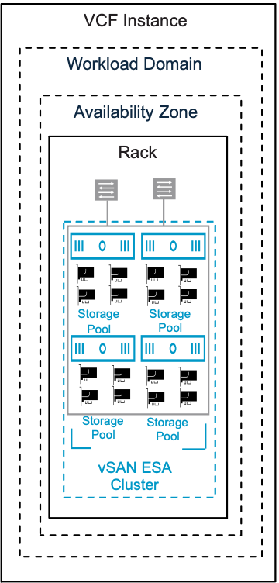
Table 3-602. vSAN Single-Rack HCI ESA Storage Model Attributes
Attribute | Detail
Single Tier | All data is stored on the same type of storage device, regardless of access frequency or importance.
Storage Pool | All NVMe Flash Storage.
Data Services | - Compression using Storage Policy (default).  - Encryption.  - Integrated File Services.  - vSAN iSCSI Target Service.  - vSAN storage clusters  - Stretched Cluster  - Fault Domains  - Kubernetes persistent storage services (block and file).  - Native scaleable snapshots
Table 3-603. vSAN Single-Rack HCI ESA Storage Model Options
Design Area | Options
Distributed switch models | - Single Distributed Switch Model  - Workload Separation Distributed Switch Model  - Storage Separation Distributed Switch Model  - Storage and Workload Separation Distributed Switch Model
vSAN ESA Cluster models | - vSAN Single-Rack HCI ESA Storage Model (current model)  - vSAN Single-Rack Storage Cluster Storage Model  - vSAN Stretched Storage Cluster Storage Model  - vSAN Stretched HCI Cluster Storage Model  - vSAN Multi-Rack HCI Storage Model  - vSAN HCI Datastore Sharing Model
Table 3-604. Common vSAN Design Requirements for All Models
Design Requirement ID | Design Requirement | Justification | Implication
VCF-VSAN-REQD-CFG-001 | Minimum vSAN cluster size. | Minimum valid vSAN HCI cluster is three (3) nodes all contributing to storage. | - Supports simple install of a management domain default vSphere cluster only.  - A three (3) node vSAN cluster will not offer automatic rebuild of components in the event of a failure.  - Using a smaller cluster limits the workload that can be placed on a vSAN cluster.  Important vSAN Storage Clusters require minimum four (4) vSAN Nodes see vSAN Single-Rack Storage Cluster Storage Model for more details
VCF-VSAN-REQD-CFG-002 | Provide sufficient raw capacity to meet the initial needs of the workload domain vSphere cluster. | Ensures that sufficient resources are present to create the workload domain vSphere cluster. | Requires determining the workload capacity requirements prior to deployment.  Note Refer to the VMware Cloud Foundation Planning and Preparation Workbook for accurate sizing guidance.
VCF-VSAN-REQD-CFG-003 | vSphere Lifecycle Management (vLCM) image based management is required for vSAN clusters. | - All new vSAN clusters, irrespective of OSA or ESA architectures, are required to be using vSphere Lifecycle Manager images for VMware Cloud Foundation.  - As per VCF-CLS-REQD-CFG-003 vSphere Lifecycle Manager images simplify the management of firmware and vendor add-ons. | Imported vSAN OSA clusters may use vLCM baselines, but have to be converted prior to upgrade to VMware Cloud Foundation 9.0.
VCF-VSAN-REQD-CFG-004 | Verify the hardware components used for vSAN deployments are on the vSAN hardware compatibility list. | Helps prevent hardware related issues during workload deployment and operation. | - Requires validating vSAN hardware to ensure its on the compatibility list prior to deployment.  - Restricts the number of devices that can be used to a certified list.  Note Refer to the vSAN hardware compatibility guide for certified hardware https://compatibilityguide.broadcom.com/.
VCF-VSAN-REQD-CFG-005 | Do not use NVMe storage devices attached to a Tri-Mode controller for vSAN diskgroups or storage pools. | - Discrete RAID controllers that support SATA/SAS/NVMe are often known as "Tri-mode controllers".  - VMware vSAN will only support SAS and SATA devices attached to a Tri-mode controller.  - NVMe devices attached to Tri-mode controller is NOT a vSAN supported configuration.  Note Refer to knowledge base article KB314305 | - NVMe devices are only supported directly connected to a PCIe slot on the bus.  - May require to work with server vendor to verify or modify configurations.
VCF-VSAN-REQD-CFG-006 | For vSAN HCI clusters, excluding vSAN storage clusters, configure the vSAN network gateway IP address as the isolation address for the cluster. | vSphere HA can validate against an IP address on the vSAN network if a host is isolated. | Allocate an additional IP address. Top of rack switches may configure a port for switch virtual interface (SVI) which can be used as the isolation address.  See VCF-VSAN-NET-REQD-CFG-003
VCF-VSAN-REQD-CFG-007 | For vSAN HCI clusters, excluding vSAN storage clusters, set the advanced cluster setting das.usedefaultisolationaddress to false. | vSphere HA in vSAN uses the ESX hosts management network default gateway IP for isolation detection when configured with default settings. This setting avoids conflicts if vSphere HA and vSAN triggers different responses when failures occur. | May require to configure a SVI (Switched Virtual Interface) gateway address for the VLAN assigned to the vSAN network.
Table 3-605. Common vSAN Design Recommendations for All Models
Design Recommendation ID | Design Recommendation | Justification | Implication
VCF-VSAN-RCMD-CFG-001 | It is recommended to start with four (4) vSAN nodes. | - This ensures vSAN objects will automatically rebuild in the case of a failure or maintenance event.  - This allows enabling Reserved Capacity on four (4) node clusters.  - This allows space efficient storage polices to be automatically configured when used with vSAN ESA clusters. | This will potentially increase cost and hardware footprint of vSAN cluster.
VCF-VSAN-RCMD-CFG-002 | Include TPM (Trusted Platform Module) in the hardware configuration of the ESX hosts. | Ensures that the keys issued to the hosts in a vSAN cluster using Data-at-Rest Encryption are cryptographically stored on a TPM device. | Can limit the choice of hardware configurations.
VCF-VSAN-RCMD-CFG-003 | Enable Reserved Capacity on vSAN clusters. | - Reserved Capacity will implement a sliding scale storage capacity resource reservation as the vSAN node count increases per vSAN cluster. For example, the Host Rebuild Reserve for a four (4) node cluster would be 25% while it would be just 8% for a twelve (12) node cluster. This avoids imposing a generic 30% capacity overhead of a vSAN Cluster, thus dynamically optimizing reserved storage capacity on vSAN.  - Recommendation is to design for vSphere cluster host counts large enough to lower the percentage needed for Reserved Capacity, This will provide the most efficient, yet agile vSphere cluster design. | - When enabled vSAN will impose two soft limits:  - Operations Reserve - limits for capacity needed to perform transient storage activities like storage policy changes, re-balancing.  - Host Rebuild Reserve - will reserve the capacity needed to absorb a sustained failure of a single ESX host in a vSAN cluster – to support an N+1 cluster design strategy.  - "Host Rebuild Reserve" has the following implications in a vSAN storage cluster that consist of only 4 hosts. When paired with the Auto-Policy Management feature, this will prevent vSAN storage clusters from being able to use space-efficient and more performant RAID-5 policy.  Caution vSAN capacity reserve is not supported in conjunction with the following vSAN Cluster typologies:  - Three (3) node clusters.  - vSAN stretched clusters.  - vSAN clusters using fault domains.
VCF-VSAN-RCMD-CFG-004 | Enable disk Automatic Re-balance. | - When enabled vSAN will attempt to automatically keep the storage consumption of each capacity drive within a default variance threshold of 30%.  - This allows vSAN to more evenly distribute the data across the discrete devices to achieve a balanced distribution of resources, and thus, improved performance. | - Adding or scaling out new hosts will trigger a disk rebalance and resynchronization.  - When adding or replacing failed resources, automatic rebalance may introduce additional data re-synchronization and as a result additional network traffic utilization  - re-synchronization may have an impact when vSAN clusters are network bandwidth constrained.
Table 3-606. Common vSAN Network Design Requirements
Design Requirement ID | Design Requirement | Justification | Implication
VCF-VSAN-NET-REQD-CFG-001 | vSAN requires a high speed, low latency network for synchronous replication of vSAN components.  Note vSAN can use 10GbE , 25GbE or greater. | 10GbE is the minimum network required for vSAN (ESA and OSA architectures  Caution There is limited support for 10GbE and vSAN ESA.  For vSAN ESA ready node, vSAN-ESA-AF-0 profile, only supports 10GbE. Please refer to https://partnerweb.vmware.com/comp_guide2/vsanesa_profile.php | - Using 10GbE for vSAN networking can severely limit vSAN performance and can introduce bandwidth constraints combined with high latency.  - Larger vSAN ESA nodes require 25GbE.  Caution Using 10GbE networking on vSAN ESA will trigger a vSAN cluster compliance check.  Please review Broadcom Knowledge base KB372309
VCF-VSAN-NET-REQD-CFG-002 | - Use a dedicated VLAN for a single rack cluster  Note You can share a single VLAN for multiple vSAN clusters within the same rack  - For stretched cluster topology, use a dedicated VLAN per availability zone. See vSAN Stretched HCI Cluster Storage Model  - For vSAN HCI multi-rack topology, VLAN requirements will depend on vSphere Multi-Rack Cluster Detailed Design if using L2 or L3 design | - For a single rack cluster using a dedicated VLAN allows for better storage traffic isolation and security.  - For vSAN Stretched Cluster VCF automated workflows, it is required to have two (2) VLANs, one VLAN per availability zone. | - For a single rack Cluster a VLAN ID must be allocated for use for a vSAN Cluster.  - For a vSAN Stretch Cluster topology two VLAN IDs must be allocated for use in a stretched cluster topology. These VLAN must be routable to each other  - For vSAN HCI multi-rack topology, VLAN requirements will depend on the deployment, if using L2 or L3 design
VCF-VSAN-NET-REQD-CFG-003 | - Use one (1) IPv4 IP address subnet for vSAN traffic in a single rack cluster.  - For vSAN stretch cluster topology, use two (2) IPv4 subnets, see Sample VLAN and IP Subnet Requirements for vSAN Stretched Cluster in a VCF Environment | The vSAN VMkernel in a VMware Cloud Foundation platform requires IPv4 addressing. | - You require an IPv4 subnet configured with a correctly sized subnet to support the number of free IP addresses for each vSAN node in a single rack vSAN Cluster.  - A gateway IP is required.
Table 3-607. Common vSAN Network Design Recommendations
Design Recommendation ID | Design Recommendation | Justification | Implication
VCF-VSAN-NET-RCMD-CFG-001 | 25GbE or higher for vSAN Data traffic is recommended. | - vSAN synchronous replication requires high bandwidth / low latency intra-node communication. While 10GbE is supported for vSAN 25GbE or higher networking is highly recommended to ensure consistent performance. | None.
VCF-VSAN-NET-RCMD-CFG-002 | Small scale workloads: Recommend two (2) physical NICs per vSAN node for small scale workloads, that utilize smaller vSAN ready node profiles.  For vSAN ESA ready node sizing guidance review https://partnerweb.vmware.com/comp_guide2/vsanesa_profile.php | - Simplifies deployment to use a single vDS model  - During periods of contention NIOC will distribute shares among competing traffic | Requires careful planning to ensure vSAN workload can share resources with other services such as vMotion and NSX workloads.  For high IO intensive workloads, 100GbE networking maybe required for vSAN ready nodes that require two phyiscal nics.
VCF-VSAN-NET-RCMD-CFG-003 | Large scale workloads:  Recommend four (4) physical NICs per vSAN node  For large scale / IO intensive workloads based on bigger vSAN ready node profiles.  For vSAN ESA ready node sizing guidance review https://partnerweb.vmware.com/comp_guide2/vsanesa_profile.php | - This guarantees storage traffic isolation and full bandwidth of physical network resources on a ESX host. | Additional vSphere Distributed Switches requires increasing management overhead with a higher number of ESX host physical NICs. For more information see  Storage and Workload Separation Distributed Switch Model  For high IO intensive workloads, 100GbE networking maybe required to satisfy bandwidth and latency requirements.
VCF-VSAN-NET-RCMD-CFG-004 | Configure the MTU size of the vSphere Distributed Switch to 9000 bytes for jumbo frames. See VCF-VDS-RCMD-CFG-003 | - Supports the MTU size required by system traffic types. Improves traffic throughput. | When adjusting the MTU packet size, you must also configure the entire network path (VMkernel ports, virtual switches, physical switches, and routers) to support the same MTU packet size.
VCF-VSAN-NET-RCMD-CFG-005 | For vSphere Single-Rack Cluster Model use Layer 2 networking for vSAN. | Layer 2 connectivity between all vSAN hosts sharing the subnet within a single rack simplifies deployment. | None.
VCF-VSAN-NET-RCMD-CFG-006 | For Layer 3 Multi-Rack Cluster Model with Layer 3 networking for vSAN. | Reduces fault domain of network to a specific rack and IP segment. | - Routing must be configured between each network subnet.  - Host to rack addressing needs to be planned in advance.  - Consider the number of hops and additional latency incurred while the traffic gets routed.
VCF-VSAN-NET-RCMD-CFG-007 | Use the Failover Order teaming algorithm for the vSAN storage port group. See VCF-VDS-SS-RCMD-DPG-001 | Provides a consistent traffic flow through a single physical ToR switch without need to traverse Inter Switch Link during normal operations. | It needs to be manually configured during deployment using vSphere Distributed Switches custom profile option.
Table 3-608. vSAN ESA Storage Model Design Requirements
Design Requirement ID | Design Requirement | Justification | Implication
VCF-VSAN-ESA-REQD-CFG-001 | Ensure vSAN certified Drives used for vSAN ESA clusters. | - When using VMware Cloud Foundation automated workflows, vSAN ESA cluster creation maybe blocked unless vSAN certified drives are detected.  - vSAN Auto policy will be enabled when vSAN certified components are detected. This allows vSAN to generate an optimal default storage policy, based on the cluster topology and the number of ESX hosts. | None.
VCF-VSAN-ESA-REQD-CFG-002 | 1.6 TB drive size or higher for vSAN ESA devices for storage pools. | Minimum supported vSAN ESA drive size is 1.6TB. | vSAN ESA supports up to 24 drives per node. Smaller capacity drives may constrain raw capacity of a vSAN node.
VCF-VSAN-ESA-REQD-CFG-003 | 16 Cores or higher per vSAN node. vSAN ESA has a minimum value of 16 cores per vSAN Node | Minimum vSAN ESA core count per node is 16 for the smallest vSAN Ready node, vSAN-ESA-AF-0. | Smaller number of cores per node may require more vSAN nodes to support targeted workloads.
VCF-VSAN-ESA-REQD-CFG-004 | Memory size per vSAN Ready node 128GB or higher | Minimum vSAN ESA memory is 128GB for the smallest vSAN Ready node. vSAN-ESA-AF-0. | - Smaller memory footprint per node will limit number of vSAN drives per node.  - Smaller memory footprint per node for vSAN ESA will limit VM workloads being placed on vSAN nodes.
Table 3-609. vSAN ESA Storage Model Design Recommendations
Design Recommendation ID | Design Recommendation | Justification | Implication
VCF-VSAN-ESA-RCMD-CFG-001 | - Specific size of drives used will depend on target workload.  - The recommendation is to use multiple storage devices per vSAN node  - NVMe TLC devices with a performance Class F (100000 - 349999) or higher with endurance class 3 DWPD or higher. | - The number of storage devices has an impact on the performance of vSAN ESA.  - NVMe drives with mixed-use endurance and performance class typically classified on the vSAN HCL as "3DWPD" (3 Drive Writes per Day) will give a balance between performance and durability. | - Smaller drive sizes will impact overall capacity of vSAN ESA. Large drive sizes will introduce larger capacity fault domain in case of failure.  - Sizing vSAN Nodes requires determining the workload capacity requirements prior to deployment. Refer to vSAN Sizer for recommended capacity at https://vcf.broadcom.com/tools/vsansizer/home.
VCF-VSAN-ESA-RCMD-CFG-002 | Its recommended to use vSAN ready nodes with high core count. | vSAN Express Storage Architecture (ESA) is designed to be highly parallel and leverages multiple CPU cores for improved performance, making it multithreaded, and optimized for NVMe- TLC based flash devices. | There will be a correlation between target workload, number of cores and NVMe devices per vSAN Node. Refer to vSAN Sizer for recommended capacity at https://vcf.broadcom.com/tools/vsansizer/home.
VCF-VSAN-ESA-RCMD-CFG-003 | Its recommended to use vSAN ready nodes with high memory capacity per vSAN node. | When enabled vSAN has required memory overheads and must have adequate resources account for VM workloads. | Refer to vSAN Sizer for recommended capacity at https://vcf.broadcom.com/tools/vsansizer/home.
VCF-VSAN-ESA-RCMD-CFG-004 | Recommend at least four (4) nodes for vSAN cluster size. | This ensures in the event of a fault domain failure, vSAN objects can be re-protected to maintain policy compliance.  In conjunction with auto policy management, four (4) node vSAN ESA clusters will allow vSAN to automatically create a default storage policy that is capacity optimized. | None.  Note vSAN Auto Policy default profile can be can be adjusted by an admin if necessary.
VCF-VSAN-ESA-RCMD-CFG-005 | - It is recommended to select the same minimum requirements for vSAN Storage cluster nodes as vSAN ESA HCI nodes.  - Please review vSAN Storage minimum node requirements | - vSAN Storage Cluster Nodes use the same architecture as regular vSAN ESA nodes.  - vSAN ESA nodes can be re-purposed for vSAN Storage Clusters or vSAN HCI Clusters | None.

vSAN Single-Rack HCI OSA Storage Model
vSAN OSA uses a two-tier storage architecture that utilizes distinct cache and capacity tier storage devices within a disk group construct. vSAN OSA can support a combination of flash and magnetic disks that can be a combination of SATA, SAS and NVMe storage devices.
Figure 3-92. vSAN Single-Rack HCI OSA Storage Model
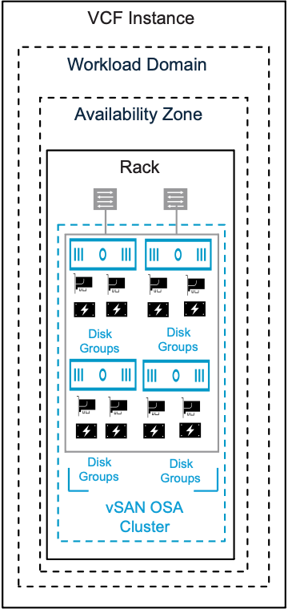
Table 3-610. vSAN Single-Rack HCI OSA Storage Model Attributes
Attribute | Detail
Two Tier | vSAN OSA architecture consists of two tiers: a cache tier for the purpose of write cache, and a capacity tier for persistent storage.
vSAN Storage devices | vSAN OSA can support of flash and magnetic disks that can be a combination of SATA, SAS and NVMe storage devices.
Data Services | - Deduplication and Compression at cluster / disk group level.  - Encryption.  - Integrated File Services.  - vSAN iSCSI Target Service.  - Stretched Cluster  - Fault Domains  - Kubernetes persistent storage services (block and file).
Table 3-611. vSAN Single-Rack HCI OSA Storage Model Options
Design Area | Options
Distributed switch models | - Single Distributed Switch Model  - Workload Separation Distributed Switch Model  - Storage and Workload Separation Distributed Switch Model
vSAN OSA Cluster models | - vSAN OSA Storage Model (current model)  - vSAN Stretched HCI Cluster Storage Model  - vSAN Multi-Rack HCI Storage Model  - vSAN HCI Datastore Sharing Model
Table 3-612. vSAN Single-Rack HCI OSA Storage Model Options
Design Options | Options
Deduplication and Compression | vSAN OSA can be deployed with duplication and compression either enabled or disabled at a vSAN Cluster level.  Note Enabling compression only data service is not allowed during VCF workload deployment.
vSAN Networking | vSAN OSA can utilize 10GbE , 25GbE or higher.  Please review vSAN Network Design Choices
Table 3-613. Common vSAN Design Requirements for All Models
Design Requirement ID | Design Requirement | Justification | Implication
VCF-VSAN-REQD-CFG-001 | Minimum vSAN cluster size. | Minimum valid vSAN HCI cluster is three (3) nodes all contributing to storage. | - Supports simple install of a management domain default vSphere cluster only.  - A three (3) node vSAN cluster will not offer automatic rebuild of components in the event of a failure.  - Using a smaller cluster limits the workload that can be placed on a vSAN cluster.  Important vSAN Storage Clusters require minimum four (4) vSAN Nodes see vSAN Single-Rack Storage Cluster Storage Model for more details
VCF-VSAN-REQD-CFG-002 | Provide sufficient raw capacity to meet the initial needs of the workload domain vSphere cluster. | Ensures that sufficient resources are present to create the workload domain vSphere cluster. | Requires determining the workload capacity requirements prior to deployment.  Note Refer to the VMware Cloud Foundation Planning and Preparation Workbook for accurate sizing guidance.
VCF-VSAN-REQD-CFG-003 | vSphere Lifecycle Management (vLCM) image based management is required for vSAN clusters. | - All new vSAN clusters, irrespective of OSA or ESA architectures, are required to be using vSphere Lifecycle Manager images for VMware Cloud Foundation.  - As per VCF-CLS-REQD-CFG-003 vSphere Lifecycle Manager images simplify the management of firmware and vendor add-ons. | Imported vSAN OSA clusters may use vLCM baselines, but have to be converted prior to upgrade to VMware Cloud Foundation 9.0.
VCF-VSAN-REQD-CFG-004 | Verify the hardware components used for vSAN deployments are on the vSAN hardware compatibility list. | Helps prevent hardware related issues during workload deployment and operation. | - Requires validating vSAN hardware to ensure its on the compatibility list prior to deployment.  - Restricts the number of devices that can be used to a certified list.  Note Refer to the vSAN hardware compatibility guide for certified hardware https://compatibilityguide.broadcom.com/.
VCF-VSAN-REQD-CFG-005 | Do not use NVMe storage devices attached to a Tri-Mode controller for vSAN diskgroups or storage pools. | - Discrete RAID controllers that support SATA/SAS/NVMe are often known as "Tri-mode controllers".  - VMware vSAN will only support SAS and SATA devices attached to a Tri-mode controller.  - NVMe devices attached to Tri-mode controller is NOT a vSAN supported configuration.  Note Refer to knowledge base article KB314305 | - NVMe devices are only supported directly connected to a PCIe slot on the bus.  - May require to work with server vendor to verify or modify configurations.
VCF-VSAN-REQD-CFG-006 | For vSAN HCI clusters, excluding vSAN storage clusters, configure the vSAN network gateway IP address as the isolation address for the cluster. | vSphere HA can validate against an IP address on the vSAN network if a host is isolated. | Allocate an additional IP address. Top of rack switches may configure a port for switch virtual interface (SVI) which can be used as the isolation address.  See VCF-VSAN-NET-REQD-CFG-003
VCF-VSAN-REQD-CFG-007 | For vSAN HCI clusters, excluding vSAN storage clusters, set the advanced cluster setting das.usedefaultisolationaddress to false. | vSphere HA in vSAN uses the ESX hosts management network default gateway IP for isolation detection when configured with default settings. This setting avoids conflicts if vSphere HA and vSAN triggers different responses when failures occur. | May require to configure a SVI (Switched Virtual Interface) gateway address for the VLAN assigned to the vSAN network.
Table 3-614. vSAN OSA Storage Model Design Requirements
Design Requirement ID | Design Requirement | Justification | Implication
VCF-VSAN-OSA-REQD-CFG-001 | vSAN OSA requires one storage device for caching and at least one storage device for capacity to create a valid disk group. | A valid vSAN OSA disk group comprises of one caching tier device (flash) and one capacity tier device (magnetic or flash). | Check all hardware against official hardware compatibility guide.
VCF-VSAN-OSA-REQD-CFG-002 | Each vSAN OSA node requires a minimum of one vSAN disk group. | - Each node in a vSAN OSA cluster contributes one or more disk groups to the cluster. | Disk groups can contribute to vSAN node memory overhead https://vcf.broadcom.com/tools/vsansizer/home for more prescriptive sizing guidance.
VCF-VSAN-REQD-CFG-003 | Do not use the storage I/O controllers that are running vSAN disk groups for another purpose. | Running non-vSAN filesystem, for example, VMFS, on a storage I/O controller that shares devices making up a vSAN disk group can impact vSAN performance and stability. | If non-vSAN disks are required in ESX hosts, you must have an additional storage I/O controller in the host.
Table 3-615. Common vSAN Network Design Requirements
Design Requirement ID | Design Requirement | Justification | Implication
VCF-VSAN-NET-REQD-CFG-001 | vSAN requires a high speed, low latency network for synchronous replication of vSAN components.  Note vSAN can use 10GbE , 25GbE or greater. | 10GbE is the minimum network required for vSAN (ESA and OSA architectures  Caution There is limited support for 10GbE and vSAN ESA.  For vSAN ESA ready node, vSAN-ESA-AF-0 profile, only supports 10GbE. Please refer to https://partnerweb.vmware.com/comp_guide2/vsanesa_profile.php | - Using 10GbE for vSAN networking can severely limit vSAN performance and can introduce bandwidth constraints combined with high latency.  - Larger vSAN ESA nodes require 25GbE.  Caution Using 10GbE networking on vSAN ESA will trigger a vSAN cluster compliance check.  Please review Broadcom Knowledge base KB372309
VCF-VSAN-NET-REQD-CFG-002 | - Use a dedicated VLAN for a single rack cluster  Note You can share a single VLAN for multiple vSAN clusters within the same rack  - For stretched cluster topology, use a dedicated VLAN per availability zone. See vSAN Stretched HCI Cluster Storage Model  - For vSAN HCI multi-rack topology, VLAN requirements will depend on vSphere Multi-Rack Cluster Detailed Design if using L2 or L3 design | - For a single rack cluster using a dedicated VLAN allows for better storage traffic isolation and security.  - For vSAN Stretched Cluster VCF automated workflows, it is required to have two (2) VLANs, one VLAN per availability zone. | - For a single rack Cluster a VLAN ID must be allocated for use for a vSAN Cluster.  - For a vSAN Stretch Cluster topology two VLAN IDs must be allocated for use in a stretched cluster topology. These VLAN must be routable to each other  - For vSAN HCI multi-rack topology, VLAN requirements will depend on the deployment, if using L2 or L3 design
VCF-VSAN-NET-REQD-CFG-003 | - Use one (1) IPv4 IP address subnet for vSAN traffic in a single rack cluster.  - For vSAN stretch cluster topology, use two (2) IPv4 subnets, see Sample VLAN and IP Subnet Requirements for vSAN Stretched Cluster in a VCF Environment | The vSAN VMkernel in a VMware Cloud Foundation platform requires IPv4 addressing. | - You require an IPv4 subnet configured with a correctly sized subnet to support the number of free IP addresses for each vSAN node in a single rack vSAN Cluster.  - A gateway IP is required.
Table 3-616. Common vSAN Design Recommendations for All Models
Design Recommendation ID | Design Recommendation | Justification | Implication
VCF-VSAN-RCMD-CFG-001 | It is recommended to start with four (4) vSAN nodes. | - This ensures vSAN objects will automatically rebuild in the case of a failure or maintenance event.  - This allows enabling Reserved Capacity on four (4) node clusters.  - This allows space efficient storage polices to be automatically configured when used with vSAN ESA clusters. | This will potentially increase cost and hardware footprint of vSAN cluster.
VCF-VSAN-RCMD-CFG-002 | Include TPM (Trusted Platform Module) in the hardware configuration of the ESX hosts. | Ensures that the keys issued to the hosts in a vSAN cluster using Data-at-Rest Encryption are cryptographically stored on a TPM device. | Can limit the choice of hardware configurations.
VCF-VSAN-RCMD-CFG-003 | Enable Reserved Capacity on vSAN clusters. | - Reserved Capacity will implement a sliding scale storage capacity resource reservation as the vSAN node count increases per vSAN cluster. For example, the Host Rebuild Reserve for a four (4) node cluster would be 25% while it would be just 8% for a twelve (12) node cluster. This avoids imposing a generic 30% capacity overhead of a vSAN Cluster, thus dynamically optimizing reserved storage capacity on vSAN.  - Recommendation is to design for vSphere cluster host counts large enough to lower the percentage needed for Reserved Capacity, This will provide the most efficient, yet agile vSphere cluster design. | - When enabled vSAN will impose two soft limits:  - Operations Reserve - limits for capacity needed to perform transient storage activities like storage policy changes, re-balancing.  - Host Rebuild Reserve - will reserve the capacity needed to absorb a sustained failure of a single ESX host in a vSAN cluster – to support an N+1 cluster design strategy.  - "Host Rebuild Reserve" has the following implications in a vSAN storage cluster that consist of only 4 hosts. When paired with the Auto-Policy Management feature, this will prevent vSAN storage clusters from being able to use space-efficient and more performant RAID-5 policy.  Caution vSAN capacity reserve is not supported in conjunction with the following vSAN Cluster typologies:  - Three (3) node clusters.  - vSAN stretched clusters.  - vSAN clusters using fault domains.
VCF-VSAN-RCMD-CFG-004 | Enable disk Automatic Re-balance. | - When enabled vSAN will attempt to automatically keep the storage consumption of each capacity drive within a default variance threshold of 30%.  - This allows vSAN to more evenly distribute the data across the discrete devices to achieve a balanced distribution of resources, and thus, improved performance. | - Adding or scaling out new hosts will trigger a disk rebalance and resynchronization.  - When adding or replacing failed resources, automatic rebalance may introduce additional data re-synchronization and as a result additional network traffic utilization  - re-synchronization may have an impact when vSAN clusters are network bandwidth constrained.
Table 3-617. Common vSAN Network Design Recommendations
Design Recommendation ID | Design Recommendation | Justification | Implication
VCF-VSAN-NET-RCMD-CFG-001 | 25GbE or higher for vSAN Data traffic is recommended. | - vSAN synchronous replication requires high bandwidth / low latency intra-node communication. While 10GbE is supported for vSAN 25GbE or higher networking is highly recommended to ensure consistent performance. | None.
VCF-VSAN-NET-RCMD-CFG-002 | Small scale workloads: Recommend two (2) physical NICs per vSAN node for small scale workloads, that utilize smaller vSAN ready node profiles.  For vSAN ESA ready node sizing guidance review https://partnerweb.vmware.com/comp_guide2/vsanesa_profile.php | - Simplifies deployment to use a single vDS model  - During periods of contention NIOC will distribute shares among competing traffic | Requires careful planning to ensure vSAN workload can share resources with other services such as vMotion and NSX workloads.  For high IO intensive workloads, 100GbE networking maybe required for vSAN ready nodes that require two phyiscal nics.
VCF-VSAN-NET-RCMD-CFG-003 | Large scale workloads:  Recommend four (4) physical NICs per vSAN node  For large scale / IO intensive workloads based on bigger vSAN ready node profiles.  For vSAN ESA ready node sizing guidance review https://partnerweb.vmware.com/comp_guide2/vsanesa_profile.php | - This guarantees storage traffic isolation and full bandwidth of physical network resources on a ESX host. | Additional vSphere Distributed Switches requires increasing management overhead with a higher number of ESX host physical NICs. For more information see  Storage and Workload Separation Distributed Switch Model  For high IO intensive workloads, 100GbE networking maybe required to satisfy bandwidth and latency requirements.
VCF-VSAN-NET-RCMD-CFG-004 | Configure the MTU size of the vSphere Distributed Switch to 9000 bytes for jumbo frames. See VCF-VDS-RCMD-CFG-003 | - Supports the MTU size required by system traffic types. Improves traffic throughput. | When adjusting the MTU packet size, you must also configure the entire network path (VMkernel ports, virtual switches, physical switches, and routers) to support the same MTU packet size.
VCF-VSAN-NET-RCMD-CFG-005 | For vSphere Single-Rack Cluster Model use Layer 2 networking for vSAN. | Layer 2 connectivity between all vSAN hosts sharing the subnet within a single rack simplifies deployment. | None.
VCF-VSAN-NET-RCMD-CFG-006 | For Layer 3 Multi-Rack Cluster Model with Layer 3 networking for vSAN. | Reduces fault domain of network to a specific rack and IP segment. | - Routing must be configured between each network subnet.  - Host to rack addressing needs to be planned in advance.  - Consider the number of hops and additional latency incurred while the traffic gets routed.
VCF-VSAN-NET-RCMD-CFG-007 | Use the Failover Order teaming algorithm for the vSAN storage port group. See VCF-VDS-SS-RCMD-DPG-001 | Provides a consistent traffic flow through a single physical ToR switch without need to traverse Inter Switch Link during normal operations. | It needs to be manually configured during deployment using vSphere Distributed Switches custom profile option.
Table 3-618. vSAN OSA Storage Model Design Recommendations
Design Recommendation ID | Design Recommendation | Justification | Implication
VCF-VSAN-OSA-RCMD-CFG-001 | Minimum two (2) disk-groups per vSAN node. | For optimal vSAN performance and availability , minimum of two (2) disk-groups per vSAN node is recommended | This requires two (2) cache disks that do not contribute to storage capacity.
VCF-VSAN-OSA-RCMD-CFG-002 | Use higher base CPU clock speed for ESX hosts is recommended. | vSAN OSA can be sensitive to CPU clock speed for scaling aggregate performance. | This may restrict certain hardware choices.

vSAN Single-Rack Storage Cluster Storage Model
VMware vSAN storage clusters (previously known as vSAN Max™) is a dis-aggregated storage solution for vSphere clusters. A vSAN Storage cluster provides storage resources to one or more vSAN Compute clusters. vSAN Storage Clusters are based on vSAN ESA architecture. vSAN Storage Clusters implements a de-converged network approach. A "de-converged storage network" (or non-converged storage network) refers to a network architecture where vSAN storage traffic is separated from vSAN compute client traffic. This facilitates using dedicated storage network adapters or physical ports, rather than sharing the same infrastructure.
Figure 3-93. vSAN Single-Rack Storage Cluster Storage Model
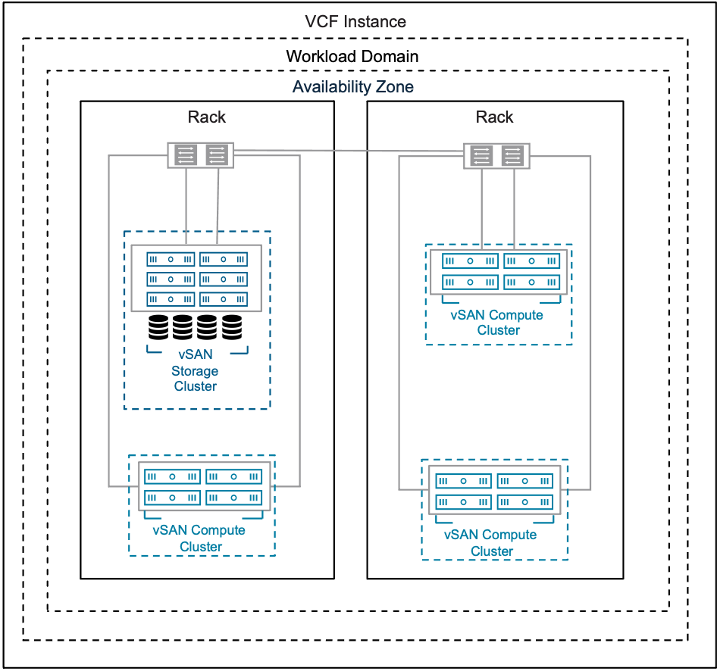
Table 3-619. vSAN Single-Rack Storage Cluster Storage Model Attributes
Attributes | Detail
vSAN Storage Cluster Architecture | vSAN Storage Clusters are based on vSAN Single-Rack HCI ESA Storage Model architecture
vSAN Compute Cluster | A vSAN Compute Cluster (vSphere cluster) that can consume vSAN Storage Cluster capacity
vSAN Storage Cluster Client Traffic | - vSAN Storage Clusters introduce a new vSAN networking traffic type to enable a de-converged storage network.  - This allows internal vSAN traffic, such as data replication, resync and rebalance to be logically separated from vSAN client cluster traffic.  - vSAN client cluster traffic is used for vSAN compute client traffic and can be described as a second vSAN network type configured on a vSAN Storage Cluster.
Table 3-620. vSAN Single-Rack Storage Cluster Storage Model Options
Design Area | Options
vSAN storage cluster client traffic | - Dis-aggregated vSAN Storage traffic  vSAN Storage traffic and vSAN VM IO traffic will be separated. If selected a new traffic type called vSAN Storage Cluster Client traffic. This will require an additional VMkernel interface and a separate network pool with an allocated IPv4 IP subnet and VLAN.  - Converged vSAN Storage Traffic  If selected vSAN traffic and vSAN VM IO traffic share the same physical resources.  - A vSAN Storage Cluster can be stretched or non stretched.
Distributed switch models | - Single Distributed Switch Model  - Workload Separation Distributed Switch Model  - Storage and Workload Separation Distributed Switch Model
MTU | 1500 - 9000
Table 3-621. Common vSAN Design Requirements for All Models
Design Requirement ID | Design Requirement | Justification | Implication
VCF-VSAN-REQD-CFG-001 | Minimum vSAN cluster size. | Minimum valid vSAN HCI cluster is three (3) nodes all contributing to storage. | - Supports simple install of a management domain default vSphere cluster only.  - A three (3) node vSAN cluster will not offer automatic rebuild of components in the event of a failure.  - Using a smaller cluster limits the workload that can be placed on a vSAN cluster.  Important vSAN Storage Clusters require minimum four (4) vSAN Nodes see vSAN Single-Rack Storage Cluster Storage Model for more details
VCF-VSAN-REQD-CFG-002 | Provide sufficient raw capacity to meet the initial needs of the workload domain vSphere cluster. | Ensures that sufficient resources are present to create the workload domain vSphere cluster. | Requires determining the workload capacity requirements prior to deployment.  Note Refer to the VMware Cloud Foundation Planning and Preparation Workbook for accurate sizing guidance.
VCF-VSAN-REQD-CFG-003 | vSphere Lifecycle Management (vLCM) image based management is required for vSAN clusters. | - All new vSAN clusters, irrespective of OSA or ESA architectures, are required to be using vSphere Lifecycle Manager images for VMware Cloud Foundation.  - As per VCF-CLS-REQD-CFG-003 vSphere Lifecycle Manager images simplify the management of firmware and vendor add-ons. | Imported vSAN OSA clusters may use vLCM baselines, but have to be converted prior to upgrade to VMware Cloud Foundation 9.0.
VCF-VSAN-REQD-CFG-004 | Verify the hardware components used for vSAN deployments are on the vSAN hardware compatibility list. | Helps prevent hardware related issues during workload deployment and operation. | - Requires validating vSAN hardware to ensure its on the compatibility list prior to deployment.  - Restricts the number of devices that can be used to a certified list.  Note Refer to the vSAN hardware compatibility guide for certified hardware https://compatibilityguide.broadcom.com/.
VCF-VSAN-REQD-CFG-005 | Do not use NVMe storage devices attached to a Tri-Mode controller for vSAN diskgroups or storage pools. | - Discrete RAID controllers that support SATA/SAS/NVMe are often known as "Tri-mode controllers".  - VMware vSAN will only support SAS and SATA devices attached to a Tri-mode controller.  - NVMe devices attached to Tri-mode controller is NOT a vSAN supported configuration.  Note Refer to knowledge base article KB314305 | - NVMe devices are only supported directly connected to a PCIe slot on the bus.  - May require to work with server vendor to verify or modify configurations.
VCF-VSAN-REQD-CFG-006 | For vSAN HCI clusters, excluding vSAN storage clusters, configure the vSAN network gateway IP address as the isolation address for the cluster. | vSphere HA can validate against an IP address on the vSAN network if a host is isolated. | Allocate an additional IP address. Top of rack switches may configure a port for switch virtual interface (SVI) which can be used as the isolation address.  See VCF-VSAN-NET-REQD-CFG-003
VCF-VSAN-REQD-CFG-007 | For vSAN HCI clusters, excluding vSAN storage clusters, set the advanced cluster setting das.usedefaultisolationaddress to false. | vSphere HA in vSAN uses the ESX hosts management network default gateway IP for isolation detection when configured with default settings. This setting avoids conflicts if vSphere HA and vSAN triggers different responses when failures occur. | May require to configure a SVI (Switched Virtual Interface) gateway address for the VLAN assigned to the vSAN network.
Table 3-622. vSAN Storage Cluster Model Design Requirements
Design Requirement ID | Design Requirement | Justification | Implication
VCF-VSAN-STG-CLU-REQD-CFG-001 | It is required to use vSAN ESA compatible hardware. | vSAN Storage Clusters are supported on vSAN ESA architecture | None.
VCF-VSAN-STG-CLU-REQD-CFG-002 | Provide at least four (4) ESX hosts. The maximum is thirty-two (32) ESX hosts in a vSAN Storage Cluster. | A vSAN storage cluster must contain at least four (4) ESX hosts. | Do not enable "Host Rebuild Reserve" capacity management mechanism in a vSAN storage cluster that consist of only 4 hosts. When paired with the Auto-Policy Management feature, this will prevent vSAN storage clusters from being able to use space-efficient RAID-5
VCF-VSAN-STG-CLU-REQD-CFG-003 | The minimum number of vSAN storage devices per ESX host is two (2). | Please Reference https://partnerweb.vmware.com/comp_guide2/vsanesa_profile.php
VCF-VSAN-STG-CLU-REQD-CFG-004 | The minimum number of CPU Cores per ESX host is twenty-four (24). | Please Reference https://partnerweb.vmware.com/comp_guide2/vsanesa_profile.php | None.
VCF-VSAN-STG-CLU-REQD-CFG-005 | The minimum supported memory per ESX host is 256GB. | Please Reference https://partnerweb.vmware.com/comp_guide2/vsanesa_profile.php | None.
VCF-VSAN-STG-CLU-REQD-CFG-006 | The minimum supported vSAN Node storage capacity is 20TB. | Please Reference https://partnerweb.vmware.com/comp_guide2/vsanesa_profile.php | None.
VCF-VSAN-STG-CLU-REQD-CFG-007 | A vSAN Storage Cluster can serve up to ten (10) vSAN Client clusters. | This is the supported maximum. | None.
VCF-VSAN-STG-CLU-REQD-CFG-008 | A vSAN Storage Cluster datastore can mounted by up to 104 vSAN client nodes. | This is the supported total maximum between Storage and client nodes, giving a total of 128 nodes
Table 3-623. Common vSAN Network Design Requirements
Design Requirement ID | Design Requirement | Justification | Implication
VCF-VSAN-NET-REQD-CFG-001 | vSAN requires a high speed, low latency network for synchronous replication of vSAN components.  Note vSAN can use 10GbE , 25GbE or greater. | 10GbE is the minimum network required for vSAN (ESA and OSA architectures  Caution There is limited support for 10GbE and vSAN ESA.  For vSAN ESA ready node, vSAN-ESA-AF-0 profile, only supports 10GbE. Please refer to https://partnerweb.vmware.com/comp_guide2/vsanesa_profile.php | - Using 10GbE for vSAN networking can severely limit vSAN performance and can introduce bandwidth constraints combined with high latency.  - Larger vSAN ESA nodes require 25GbE.  Caution Using 10GbE networking on vSAN ESA will trigger a vSAN cluster compliance check.  Please review Broadcom Knowledge base KB372309
VCF-VSAN-NET-REQD-CFG-002 | - Use a dedicated VLAN for a single rack cluster  Note You can share a single VLAN for multiple vSAN clusters within the same rack  - For stretched cluster topology, use a dedicated VLAN per availability zone. See vSAN Stretched HCI Cluster Storage Model  - For vSAN HCI multi-rack topology, VLAN requirements will depend on vSphere Multi-Rack Cluster Detailed Design if using L2 or L3 design | - For a single rack cluster using a dedicated VLAN allows for better storage traffic isolation and security.  - For vSAN Stretched Cluster VCF automated workflows, it is required to have two (2) VLANs, one VLAN per availability zone. | - For a single rack Cluster a VLAN ID must be allocated for use for a vSAN Cluster.  - For a vSAN Stretch Cluster topology two VLAN IDs must be allocated for use in a stretched cluster topology. These VLAN must be routable to each other  - For vSAN HCI multi-rack topology, VLAN requirements will depend on the deployment, if using L2 or L3 design
VCF-VSAN-NET-REQD-CFG-003 | - Use one (1) IPv4 IP address subnet for vSAN traffic in a single rack cluster.  - For vSAN stretch cluster topology, use two (2) IPv4 subnets, see Sample VLAN and IP Subnet Requirements for vSAN Stretched Cluster in a VCF Environment | The vSAN VMkernel in a VMware Cloud Foundation platform requires IPv4 addressing. | - You require an IPv4 subnet configured with a correctly sized subnet to support the number of free IP addresses for each vSAN node in a single rack vSAN Cluster.  - A gateway IP is required.
Table 3-624. Common vSAN Design Recommendations for All Models
Design Recommendation ID | Design Recommendation | Justification | Implication
VCF-VSAN-RCMD-CFG-001 | It is recommended to start with four (4) vSAN nodes. | - This ensures vSAN objects will automatically rebuild in the case of a failure or maintenance event.  - This allows enabling Reserved Capacity on four (4) node clusters.  - This allows space efficient storage polices to be automatically configured when used with vSAN ESA clusters. | This will potentially increase cost and hardware footprint of vSAN cluster.
VCF-VSAN-RCMD-CFG-002 | Include TPM (Trusted Platform Module) in the hardware configuration of the ESX hosts. | Ensures that the keys issued to the hosts in a vSAN cluster using Data-at-Rest Encryption are cryptographically stored on a TPM device. | Can limit the choice of hardware configurations.
VCF-VSAN-RCMD-CFG-003 | Enable Reserved Capacity on vSAN clusters. | - Reserved Capacity will implement a sliding scale storage capacity resource reservation as the vSAN node count increases per vSAN cluster. For example, the Host Rebuild Reserve for a four (4) node cluster would be 25% while it would be just 8% for a twelve (12) node cluster. This avoids imposing a generic 30% capacity overhead of a vSAN Cluster, thus dynamically optimizing reserved storage capacity on vSAN.  - Recommendation is to design for vSphere cluster host counts large enough to lower the percentage needed for Reserved Capacity, This will provide the most efficient, yet agile vSphere cluster design. | - When enabled vSAN will impose two soft limits:  - Operations Reserve - limits for capacity needed to perform transient storage activities like storage policy changes, re-balancing.  - Host Rebuild Reserve - will reserve the capacity needed to absorb a sustained failure of a single ESX host in a vSAN cluster – to support an N+1 cluster design strategy.  - "Host Rebuild Reserve" has the following implications in a vSAN storage cluster that consist of only 4 hosts. When paired with the Auto-Policy Management feature, this will prevent vSAN storage clusters from being able to use space-efficient and more performant RAID-5 policy.  Caution vSAN capacity reserve is not supported in conjunction with the following vSAN Cluster typologies:  - Three (3) node clusters.  - vSAN stretched clusters.  - vSAN clusters using fault domains.
VCF-VSAN-RCMD-CFG-004 | Enable disk Automatic Re-balance. | - When enabled vSAN will attempt to automatically keep the storage consumption of each capacity drive within a default variance threshold of 30%.  - This allows vSAN to more evenly distribute the data across the discrete devices to achieve a balanced distribution of resources, and thus, improved performance. | - Adding or scaling out new hosts will trigger a disk rebalance and resynchronization.  - When adding or replacing failed resources, automatic rebalance may introduce additional data re-synchronization and as a result additional network traffic utilization  - re-synchronization may have an impact when vSAN clusters are network bandwidth constrained.
Table 3-625. vSAN Storage Cluster Model Design Recommendations
Design Recommendation ID | Design Recommendation | Justification | Implication
VCF-VSAN-STG-CLU-RCMD-CFG-001 | Limit the size of the vSAN Storage cluster to twenty-four (24) ESX hosts. | Total ESX hosts, must not exceed 128.  - The total count of ESX hosts will comprise the aggregate number of ESX hosts in a vSAN Storage cluster and vSAN compute clusters. | Limits the maximum number of ESX hosts.  A vSAN Storage cluster with to twenty-four (24) ESX hosts provides support for up to ninety-siz (96) vSAN compute hosts which provides a compute-to-storage ratio of 3:1.
VCF-VSAN-STG-CLU-RCMD-CFG-002 | If a vSAN storage cluster consists of only four (4) ESX hosts, do not enable the Host Rebuild Reserve. | If the auto-policy management feature is turned on, prevents vSAN storage clusters from using adaptive RAID-5 storage policy. | vSAN does not reserve any of this capacity and presents it as free capacity for vSAN to self-repair if a single host failure occurs.
VCF-VSAN-STG-CLU-RCMD-CFG-003 | It is recommended to use storage traffic separation for vSAN Storage cluster traffic. | - Storage traffic separation will help guarantee dedicated physical host network resources for vSAN cluster traffic.  - Storage traffic separation will help isolate and secure vSAN Storage traffic from vSAN Client Cluster traffic | Implementing storage traffic separation may require additional physical and logical networking resources.
VCF-VSAN-STG-CLU-RCMD-CFG-004 | Depending on the vSAN client cluster traffic and vSAN Storage cluster traffic requirements, recommend to use separate physical host networking with different capabilities, such as bandwidth and latency. | - vSAN Storage replication traffic may have larger data rate requirement to vSAN Client traffic  - For example a 25GbE Ethernet may satisfy the requirement for vSAN client cluster traffic  - while 100GbE Ethernet offers a significantly higher data transfer rate (100Gbps) which may satisfy vSAN storage traffic requirements | Sizing of vSAN Client traffic and vSAN storage traffic may have to be evaluated depending on the requirements of the workload  Using higher bandwidth hardware can be more expensive due higher data transfer rate and the need for more complex equipment.

vSAN Single-Rack Compute Cluster Model
A vSAN Single-Rack Compute Cluster Model is a cluster of vSphere hosts configured to mount a remote vSAN datastore provided by vSAN storage clusters in the same workload domain.
Figure 3-94. vSAN Single-Rack Compute Cluster Model
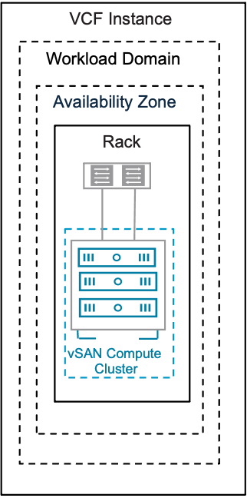
Table 3-626. vSAN Single-Rack Compute Cluster Model Attributes
Attribute | Detail
Datacenters | Single datacenter
Cluster Rack Mapping | Hosts are deployed within a single physical rack or rack enclosure.
Resilience | vSphere HA protects workloads against host failures.
Availability Zones | Single availability zone only.
Networking | Layer 2 networking
vSAN Compute Cluster | - A vSAN Compute Cluster is a vSphere Cluster Models with a vSAN Traffic Type defined  - The primary function of a vSAN compute cluster is to provide compute resources (CPU, memory) for running virtual machines, vSAN compute clusters do not contribute to storage.  - A vSAN compute cluster can act as a client to a vSAN storage cluster.  - A vSAN compute cluster does not have to be a certified vSAN Ready node, thus does not require certified vSAN local storage devices for vSAN use.
vSAN Network traffic | - vSAN Client cluster have dedicated VMkernel interfaces tagged with standard vSAN traffic type.  - The vSAN compute cluster nodes can optionally communicate with the vSAN storage cluster client traffic type defined on the storage cluster. (if configured)  - On the vSAN storage cluster, vSAN Storage Cluster Client Traffic can be tagged on a dedicated VMkernel interface on the vSAN storage cluster to have a disaggregated network design to separate vSAN compute traffic from vSAN storage traffic
vSAN Remote datastore | vSAN compute cluster will mount a remote datastore from vSAN storage cluster resources
Table 3-627. vSAN Single-Rack Compute Cluster Model Dependencies
Design Area | Dependency
vSAN Host networking traffic type | Route to vSAN storage network on vSAN storage cluster
 | Route to vSAN Storage Cluster Client Traffic network on vSAN storage cluster. (if configured)
Table 3-628. vSAN Compute Cluster Model Design Requirements
Design Requirement ID | Design Requirement | Justification | Implication
VCF-VSAN-COMP-CLU-REQD-CFG-001 | Minimum three (3) vSAN compute nodes is required for VCF provisioned clusters | Deploying compute clusters for VCF requires three(nodes) | none
VCF-VSAN-COMP-CLU-REQD-CFG-001 | vSAN networking must be configured on hosts in the Compute cluster. | A vSAN Compute cluster is a vSphere cluster with a vSAN networking element that enables it to mount a vSAN Storage Cluster | Requires planning for vSAN networking requirements to support planned VM workload.
VCF-VSAN-COMP-CLU-REQD-CFG-002 | vSAN Compute nodes must be commissioned as vSAN Compute Cluster type | This allows creation of vSAN Compute Clusters with vSAN compute node types | Requires new hosts to be commissioned to an exising network pool that has the correct networking attributes
VCF-VSAN-COMP-CLU-REQD-CFG-003 | A vSAN Client Cluster must be deployed within same VCF Workload domain as vSAN Storage Cluster is deployed | A vSAN Client cluster is not supported to be cross mounted across vCenter instances from a VCF workflow perspective | Requires vSAN client clusters to be deployed within a VCF workload domain.
VCF-VSAN-COMP-CLU-REQD-CFG-004 | All objects that make up a VM must reside on the same datastore. | This is currently the supported method for VMs deployed on vSAN Client Clusters | VM performance characteristics and fail-over responses will be consistent
VCF-VSAN-COMP-CLU-REQD-CFG-005 | A vSAN Compute cluster can mount up to 5 remote datastores | This is a supported maximum configuration | This will require careful planning from compute and networking sizing perspective
VCF-VSAN-COMP-CLU-REQD-CFG-006 | Configure vSphere HA failure response for Datastore with APD to be set to Power off and restart VMs. | This ensures Virtual machines respond appropriately to a HA event if a remote vSAN datastore is unavailable on a ESX host | None.
VCF-VSAN-COMP-CLU-REQD-CFG-007 | Ensure vSAN Compute Cluster latency to vSAN Storage Cluster is less than 5 milliseconds | vSAN compute clusters perform a precheck and require network latency between the client clusters and the server cluster of 5ms or less. | Ensure a high speed low latency network between vSAN compute clusters and vSAN Storage Clusters.
Tip vSAN Compute Clusters are essentially vSphere clusters and should inherit the same requirements and recommendations as outlined below
Table 3-629. Common vSphere Cluster Design Requirements
Design Requirement ID | Design Requirement | Justification | Implication
VCF-CLS-REQD-CFG-001 | Create a vSphere cluster in each workload domain for the initial set of ESX hosts. | - Simplifies configuration by isolating management from customer workloads.  - Ensures that customer workloads have no impact on the management stack. | Management of multiple vSphere clusters and vCenter instances increases operational overhead.
VCF-CLS-REQD-CFG-002 | Allocate a minimum number of ESX hosts according to the vSphere cluster type being deployed. | Ensures correct level of redundancy to protect against host failure in the vSphere cluster. | To support redundancy, you must allocate additional ESX host resources.
VCF-CLS-REQD-CFG-003 | Use vSphere Lifecycle Manager images as the life cycle management method for all vSphere clusters.  Note Imported workload domains may be using vSphere Lifecycle Manager baselines. It is recommended to transition them to use vSphere Lifecycle Manager images. | vSphere Lifecycle Manager images simplify the management of firmware and vendor add-ons manually. | - A vSphere Lifecycle Manager cluster image is required during workload domain or vSphere cluster deployment.
VCF-CLS-REQD-CFG-004 | Use vSphere HA to protect all virtual machines against failures. | vSphere HA supports a robust level of protection for both ESX host and virtual machine availability. | You must provide sufficient resources on the remaining ESX hosts so that virtual machines can be restarted on those hosts in the event of an ESX host outage.
Table 3-630. Common vSphere Cluster Design Recommendations
Design Recommendation ID | Design Recommendation | Justification | Implication
VCF-CLS-RCMD-CFG-001 | Configure admission control for one (1) ESX host failure and percentage-based failover capacity. | - Using the percentage-based reservation works well in situations where virtual machines have varying and sometimes significant CPU or memory reservations.  - vSphere automatically calculates the reserved percentage according to the number of ESX host failures to tolerate and the number of ESX hosts in the vSphere cluster. | In a cluster of four (4) ESX hosts, the resources of only three (3) ESX hosts are available for use.
VCF-CLS-RCMD-CFG-002 | Enable VM Monitoring for each vSphere cluster. | VM Monitoring provides in-guest protection for most VM workloads. The application or service running on the virtual machine must be capable of restarting successfully after a reboot or the virtual machine restart is not sufficient. | None.
VCF-CLS-RCMD-CFG-003 | Set the advanced vSphere cluster setting das.iostatsinterval to 60 to deactivate monitoring the storage and network I/O activities of the management appliances. | Enables triggering a restart of a management appliance when an OS failure occurs and heartbeats are not received from VMware Tools instead of waiting additionally for the I/O check to complete. | If you want to specifically enable I/O monitoring, you must configure the das.iostatsinterval advanced setting.
VCF-CLS-RCMD-CFG-004 | Enable vSphere DRS on all vSphere clusters, using the default fully automated mode with medium threshold. | Provides the best trade-off between load balancing and unnecessary migrations with vMotion. | If a vCenter outage occurs, the mapping from virtual machines to ESX hosts might be difficult to determine.
VCF-CLS-RCMD-CFG-005 | Enable Enhanced vMotion Compatibility (EVC) on all vSphere clusters in the management domain. | Supports vSphere cluster upgrades without virtual machine downtime. | - You must enable EVC only if the vSphere clusters contain ESX hosts with CPUs from the same vendor.  - You must enable EVC on the default management domain vSphere cluster during bringup using the API and a JSON spec.
VCF-CLS-RCMD-CFG-006 | Set the vSphere cluster EVC mode to the highest available baseline that is supported for the lowest CPU architecture on the ESX hosts in the vSphere cluster. | Supports vSphere cluster upgrades without virtual machine downtime. | None.
VCF-CLS-RCMD-CFG-007 | If running business workloads in the management domain, configure the following vSphere resource pools to control resource usage by management and business workloads.  - cluster-name-rp-sddc-mgmt  - cluster-name-rp-sddc-edge  - cluster-name-rp-user-edge  - cluster-name-rp-user-vm | Ensures sufficient resources for the management components. | You must manually create the vSphere resource pools and manage their settings over time.
VCF-CLS-RCMD-CFG-008 | Use vSphere Cluster Services (vCLS) Retreat Mode. | System managed vCLS mode is deprecated. | You must manually change the vCLS mode.

Multi-Rack Cluster Storage Models
A multi-rack storage architecture is a configuration of vSAN where the ESX hosts contributing storage to the vSAN cluster are physically located in different racks. This design is primarily used for rack awareness and to provide resilience against the failure of an entire rack. By spreading data across multiple racks, the architecture can tolerate the failure of an entire rack, as workloads can automatically restart affected virtual machines on ESX hosts in other racks. The following sections describe multi-rack cluster models. A multi-rack cluster can either be based on a vSAN ESA or OSA architecture, or a vSAN compute cluster.

vSAN Multi-Rack HCI Storage Model
The vSAN Multi-Rack HCI Storage Model is based on vSAN fault domains and a vSphere Multi-Rack Cluster Detailed Design. This offers rack level protection for workloads. This design protects virtual machines and vSAN objects against rack level failures.
Figure 3-95. vSAN Multi-Rack HCI Storage Model
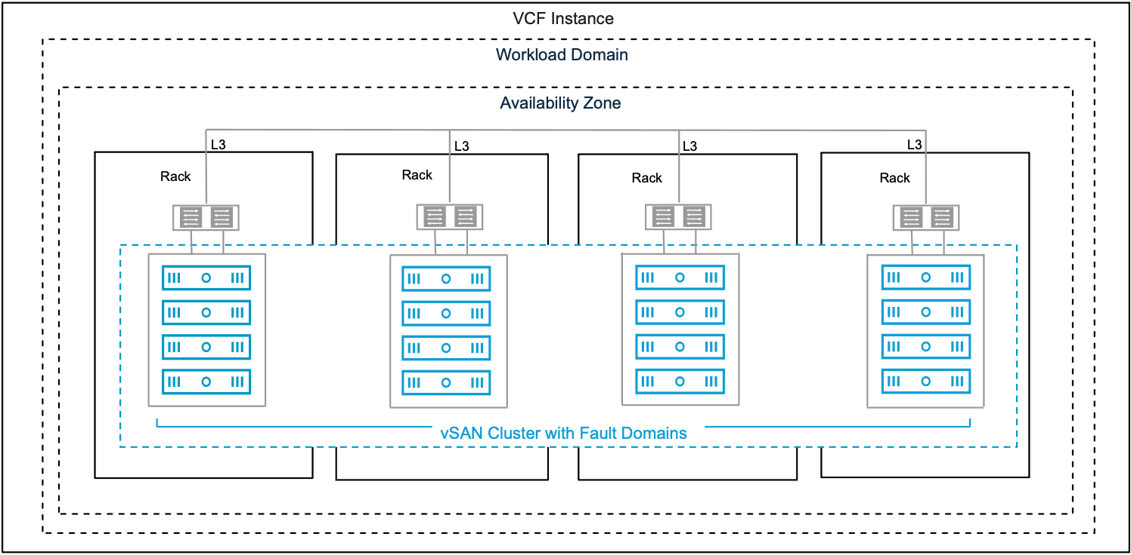
Attribute | Detail
vSAN HCI cluster | A cluster that provides both compute and storage to virtual machines.
vSAN Fault Domain | a logical grouping of hosts based on their physical location such as a rack that allows vSAN to protect against failures of an entire physical location.
vSAN datastore | A distributed datastore that supports features that require shared storage.
vSAN physical networking | Host network interfaces can be dedicated or shared with other traffic types.
vSAN availability | Workloads are protected by synchronously replicating objects in a vSAN cluster.
Data services | - Deduplication and/or Compression.  - Encryption.  - Integrated File Services.  - vSAN iSCSI Target Service.  - Kubernetes persistent storage. services (block and file)..
vSAN HCI Multi-Rack will share many of the same attributes as a vSphere Multi-Rack Cluster Detailed Design. One of the key choices is the network topology that a multi-rack deployment consumes.

Multi-Rack Cluster Model
A Multi-Rack Cluster Model can be deployed using the following networking types.
Multi-Rack Cluster Type | Description
Layer 2 | - Hosts are installed horizontally across different physical racks.  - Each physical rack shares the same set of Layer 2 broadcast domains for each VLAN.
Layer 3 | - Hosts are installed horizontally across different physical racks.  - Each physical rack has a unique set of Layer 2 broadcast domains for each VLAN.

vSAN Multi-Rack HCI Storage Model Attributes
A Multi-Rack Cluster Model has the following attributes.
Attribute | Detail
Datacenters | Single datacenter
Cluster Rack Mapping | Hosts are installed horizontally across different physical racks.
Resilience | - vSphere HA protects workloads against host failures.  - Multiple fault domains protect workloads in the event of a failure of one or more fault domains/racks.
Availability Zones | - Layer 2 cluster type can be stretched across availability zones.  - Layer 3 cluster type is single availability zone only.
Networking | - Layer 2 (Including VXLAN/EVPN Fabric).  or  - Layer 3
Storage | Storage capable of surviving the failure of a single fault domain at the storage level.

vSAN Multi-Rack HCI Storage Model VLANs and Subnets
Function | Layer 2 VLANs and Subnets | Layer 3 VLANs and Subnets
VM management | - Shared across racks.  - Highly available gateway at the ToR switch. | - Required per rack.  - Highly available gateway at the ToR switches or leaf nodes in the rack.
ESX management
vSphere vMotion
vSAN
Host overlay
NFS | Not supported. | Not supported.
NSX Edge Uplink01 | - Shared across racks  - Highly available gateway at the ToR switch. | Depends on NSX Edge design.
NSX Edge Uplink02
NSX Edge overlay
Table 3-631. Common vSAN Design Requirements for All Models
Design Requirement ID | Design Requirement | Justification | Implication
VCF-VSAN-REQD-CFG-001 | Minimum vSAN cluster size. | Minimum valid vSAN HCI cluster is three (3) nodes all contributing to storage. | - Supports simple install of a management domain default vSphere cluster only.  - A three (3) node vSAN cluster will not offer automatic rebuild of components in the event of a failure.  - Using a smaller cluster limits the workload that can be placed on a vSAN cluster.  Important vSAN Storage Clusters require minimum four (4) vSAN Nodes see vSAN Single-Rack Storage Cluster Storage Model for more details
VCF-VSAN-REQD-CFG-002 | Provide sufficient raw capacity to meet the initial needs of the workload domain vSphere cluster. | Ensures that sufficient resources are present to create the workload domain vSphere cluster. | Requires determining the workload capacity requirements prior to deployment.  Note Refer to the VMware Cloud Foundation Planning and Preparation Workbook for accurate sizing guidance.
VCF-VSAN-REQD-CFG-003 | vSphere Lifecycle Management (vLCM) image based management is required for vSAN clusters. | - All new vSAN clusters, irrespective of OSA or ESA architectures, are required to be using vSphere Lifecycle Manager images for VMware Cloud Foundation.  - As per VCF-CLS-REQD-CFG-003 vSphere Lifecycle Manager images simplify the management of firmware and vendor add-ons. | Imported vSAN OSA clusters may use vLCM baselines, but have to be converted prior to upgrade to VMware Cloud Foundation 9.0.
VCF-VSAN-REQD-CFG-004 | Verify the hardware components used for vSAN deployments are on the vSAN hardware compatibility list. | Helps prevent hardware related issues during workload deployment and operation. | - Requires validating vSAN hardware to ensure its on the compatibility list prior to deployment.  - Restricts the number of devices that can be used to a certified list.  Note Refer to the vSAN hardware compatibility guide for certified hardware https://compatibilityguide.broadcom.com/.
VCF-VSAN-REQD-CFG-005 | Do not use NVMe storage devices attached to a Tri-Mode controller for vSAN diskgroups or storage pools. | - Discrete RAID controllers that support SATA/SAS/NVMe are often known as "Tri-mode controllers".  - VMware vSAN will only support SAS and SATA devices attached to a Tri-mode controller.  - NVMe devices attached to Tri-mode controller is NOT a vSAN supported configuration.  Note Refer to knowledge base article KB314305 | - NVMe devices are only supported directly connected to a PCIe slot on the bus.  - May require to work with server vendor to verify or modify configurations.
VCF-VSAN-REQD-CFG-006 | For vSAN HCI clusters, excluding vSAN storage clusters, configure the vSAN network gateway IP address as the isolation address for the cluster. | vSphere HA can validate against an IP address on the vSAN network if a host is isolated. | Allocate an additional IP address. Top of rack switches may configure a port for switch virtual interface (SVI) which can be used as the isolation address.  See VCF-VSAN-NET-REQD-CFG-003
VCF-VSAN-REQD-CFG-007 | For vSAN HCI clusters, excluding vSAN storage clusters, set the advanced cluster setting das.usedefaultisolationaddress to false. | vSphere HA in vSAN uses the ESX hosts management network default gateway IP for isolation detection when configured with default settings. This setting avoids conflicts if vSphere HA and vSAN triggers different responses when failures occur. | May require to configure a SVI (Switched Virtual Interface) gateway address for the VLAN assigned to the vSAN network.
Table 3-632. vSAN HCI Multi-Rack Storage Cluster Model Additional Design Requirements
Design Requirement ID | Design Requirement | Justification | Implication
VCF-VSAN-L3MR-REQD-CFG-001 | For Layer 3 multi-rack clusters, configure the IP address of the vSAN Network Gateway for each rack accessible over Layer 3 as the isolation address for the nodes in that in the vSphere Cluster. | Enables vSphere HA to validate if an ESX host is isolated from the vSAN Network. | The IP address of the vSAN network gateway(s) must be highly available and reply to ICMP requests.
VCF-VSAN-L3MR-REQD-CFG-002 | Use a minimum of three (3) racks for the cluster. | Provides support for re-protecting vSAN objects if a single-rack failure occurs. | - Requires a minimum of 3 hosts in a cluster, distributed across three (3) racks.  - Will provide redundancy, but will not provide automatic rebuild of vSAN components.
VCF-VSAN-L3MR-REQD-CFG-003 | Configure vSAN fault domains and place the nodes of each rack in their fault domain. | Allows workload VMs to tolerate a rack failure by distributing copies of the data and witness components on nodes in separate racks. | Configure fault domains manually in vCenter after cluster expansion.
VCF-VSAN-L3MR-REQD-CFG-004 | Deactivate vSAN ESA auto policy management. | This feature is not supported with vSAN fault domains. | To align with the number of vSAN fault domains, it maybe necessary create a default storage policy manually.
VCF-VSAN-L3MR-REQD-CFG-005 | Do not enable reserved Capacity in a vSAN HCI multi-rack cluster. | vSAN capacity reserve is not supported in conjunction with the following vSAN cluster topologies:  - Three (3) node clusters.  - vSAN stretched clusters.  - vSAN clusters using fault domains | This will require manually calculating vSAN slack space.  Refer to the vSAN sizer for recommended capacity at https://vcf.broadcom.com/tools/vsansizer/home.
Table 3-633. Common vSAN Network Design Requirements
Design Requirement ID | Design Requirement | Justification | Implication
VCF-VSAN-NET-REQD-CFG-001 | vSAN requires a high speed, low latency network for synchronous replication of vSAN components.  Note vSAN can use 10GbE , 25GbE or greater. | 10GbE is the minimum network required for vSAN (ESA and OSA architectures  Caution There is limited support for 10GbE and vSAN ESA.  For vSAN ESA ready node, vSAN-ESA-AF-0 profile, only supports 10GbE. Please refer to https://partnerweb.vmware.com/comp_guide2/vsanesa_profile.php | - Using 10GbE for vSAN networking can severely limit vSAN performance and can introduce bandwidth constraints combined with high latency.  - Larger vSAN ESA nodes require 25GbE.  Caution Using 10GbE networking on vSAN ESA will trigger a vSAN cluster compliance check.  Please review Broadcom Knowledge base KB372309
VCF-VSAN-NET-REQD-CFG-002 | - Use a dedicated VLAN for a single rack cluster  Note You can share a single VLAN for multiple vSAN clusters within the same rack  - For stretched cluster topology, use a dedicated VLAN per availability zone. See vSAN Stretched HCI Cluster Storage Model  - For vSAN HCI multi-rack topology, VLAN requirements will depend on vSphere Multi-Rack Cluster Detailed Design if using L2 or L3 design | - For a single rack cluster using a dedicated VLAN allows for better storage traffic isolation and security.  - For vSAN Stretched Cluster VCF automated workflows, it is required to have two (2) VLANs, one VLAN per availability zone. | - For a single rack Cluster a VLAN ID must be allocated for use for a vSAN Cluster.  - For a vSAN Stretch Cluster topology two VLAN IDs must be allocated for use in a stretched cluster topology. These VLAN must be routable to each other  - For vSAN HCI multi-rack topology, VLAN requirements will depend on the deployment, if using L2 or L3 design
VCF-VSAN-NET-REQD-CFG-003 | - Use one (1) IPv4 IP address subnet for vSAN traffic in a single rack cluster.  - For vSAN stretch cluster topology, use two (2) IPv4 subnets, see Sample VLAN and IP Subnet Requirements for vSAN Stretched Cluster in a VCF Environment | The vSAN VMkernel in a VMware Cloud Foundation platform requires IPv4 addressing. | - You require an IPv4 subnet configured with a correctly sized subnet to support the number of free IP addresses for each vSAN node in a single rack vSAN Cluster.  - A gateway IP is required.
Table 3-634. Common vSAN Design Recommendations for All Models
Design Recommendation ID | Design Recommendation | Justification | Implication
VCF-VSAN-RCMD-CFG-001 | It is recommended to start with four (4) vSAN nodes. | - This ensures vSAN objects will automatically rebuild in the case of a failure or maintenance event.  - This allows enabling Reserved Capacity on four (4) node clusters.  - This allows space efficient storage polices to be automatically configured when used with vSAN ESA clusters. | This will potentially increase cost and hardware footprint of vSAN cluster.
VCF-VSAN-RCMD-CFG-002 | Include TPM (Trusted Platform Module) in the hardware configuration of the ESX hosts. | Ensures that the keys issued to the hosts in a vSAN cluster using Data-at-Rest Encryption are cryptographically stored on a TPM device. | Can limit the choice of hardware configurations.
VCF-VSAN-RCMD-CFG-003 | Enable Reserved Capacity on vSAN clusters. | - Reserved Capacity will implement a sliding scale storage capacity resource reservation as the vSAN node count increases per vSAN cluster. For example, the Host Rebuild Reserve for a four (4) node cluster would be 25% while it would be just 8% for a twelve (12) node cluster. This avoids imposing a generic 30% capacity overhead of a vSAN Cluster, thus dynamically optimizing reserved storage capacity on vSAN.  - Recommendation is to design for vSphere cluster host counts large enough to lower the percentage needed for Reserved Capacity, This will provide the most efficient, yet agile vSphere cluster design. | - When enabled vSAN will impose two soft limits:  - Operations Reserve - limits for capacity needed to perform transient storage activities like storage policy changes, re-balancing.  - Host Rebuild Reserve - will reserve the capacity needed to absorb a sustained failure of a single ESX host in a vSAN cluster – to support an N+1 cluster design strategy.  - "Host Rebuild Reserve" has the following implications in a vSAN storage cluster that consist of only 4 hosts. When paired with the Auto-Policy Management feature, this will prevent vSAN storage clusters from being able to use space-efficient and more performant RAID-5 policy.  Caution vSAN capacity reserve is not supported in conjunction with the following vSAN Cluster typologies:  - Three (3) node clusters.  - vSAN stretched clusters.  - vSAN clusters using fault domains.
VCF-VSAN-RCMD-CFG-004 | Enable disk Automatic Re-balance. | - When enabled vSAN will attempt to automatically keep the storage consumption of each capacity drive within a default variance threshold of 30%.  - This allows vSAN to more evenly distribute the data across the discrete devices to achieve a balanced distribution of resources, and thus, improved performance. | - Adding or scaling out new hosts will trigger a disk rebalance and resynchronization.  - When adding or replacing failed resources, automatic rebalance may introduce additional data re-synchronization and as a result additional network traffic utilization  - re-synchronization may have an impact when vSAN clusters are network bandwidth constrained.
Table 3-635. vSAN HCI Multi-Rack Storage Cluster Design Recommendations
Design Recommendation ID | Design Recommendation | Justification | Implication
VCF-VSAN-L3MR-RCMD-CFG-001 | Use four (4) Fault domains for vSAN HCI multi-rack | Provides support for re-protecting vSAN objects if a single-rack failure occurs. | - Requires a minimum of four(4) ESX hosts added to a cluster, distributed across four (4) racks.
VCF-VSAN-L3MR-RCMD-CFG-002 | Use Layer 3 networking between each fault domain (physical rack). | Provides fault isolation per fault domain or physical rack. | - Requires multiple IPv4 subnet per rack.  - Requires gateway per IPv4 subnet.  - Requires layer 3 routing between racks.

vSAN Multi-Rack Compute Cluster Model
A vSAN multi-rack compute cluster consumes storage from a vSAN storage cluster deployed in the same workload domain. A vSAN compute cluster can be spread over multiple racks routed via layer 3 networking. Similar to the Layer 3 Multi-Rack Cluster Model this allows protection of workloads on vSphere clusters in your environment against a failure of a single fault domain by implementing a vSAN compute cluster across multiple fault domains within a single availability zone. The networks are isolated to a rack using a separate broadcast domain for each network per rack.
Figure 3-96. vSAN Multi-Rack Compute Cluster Model
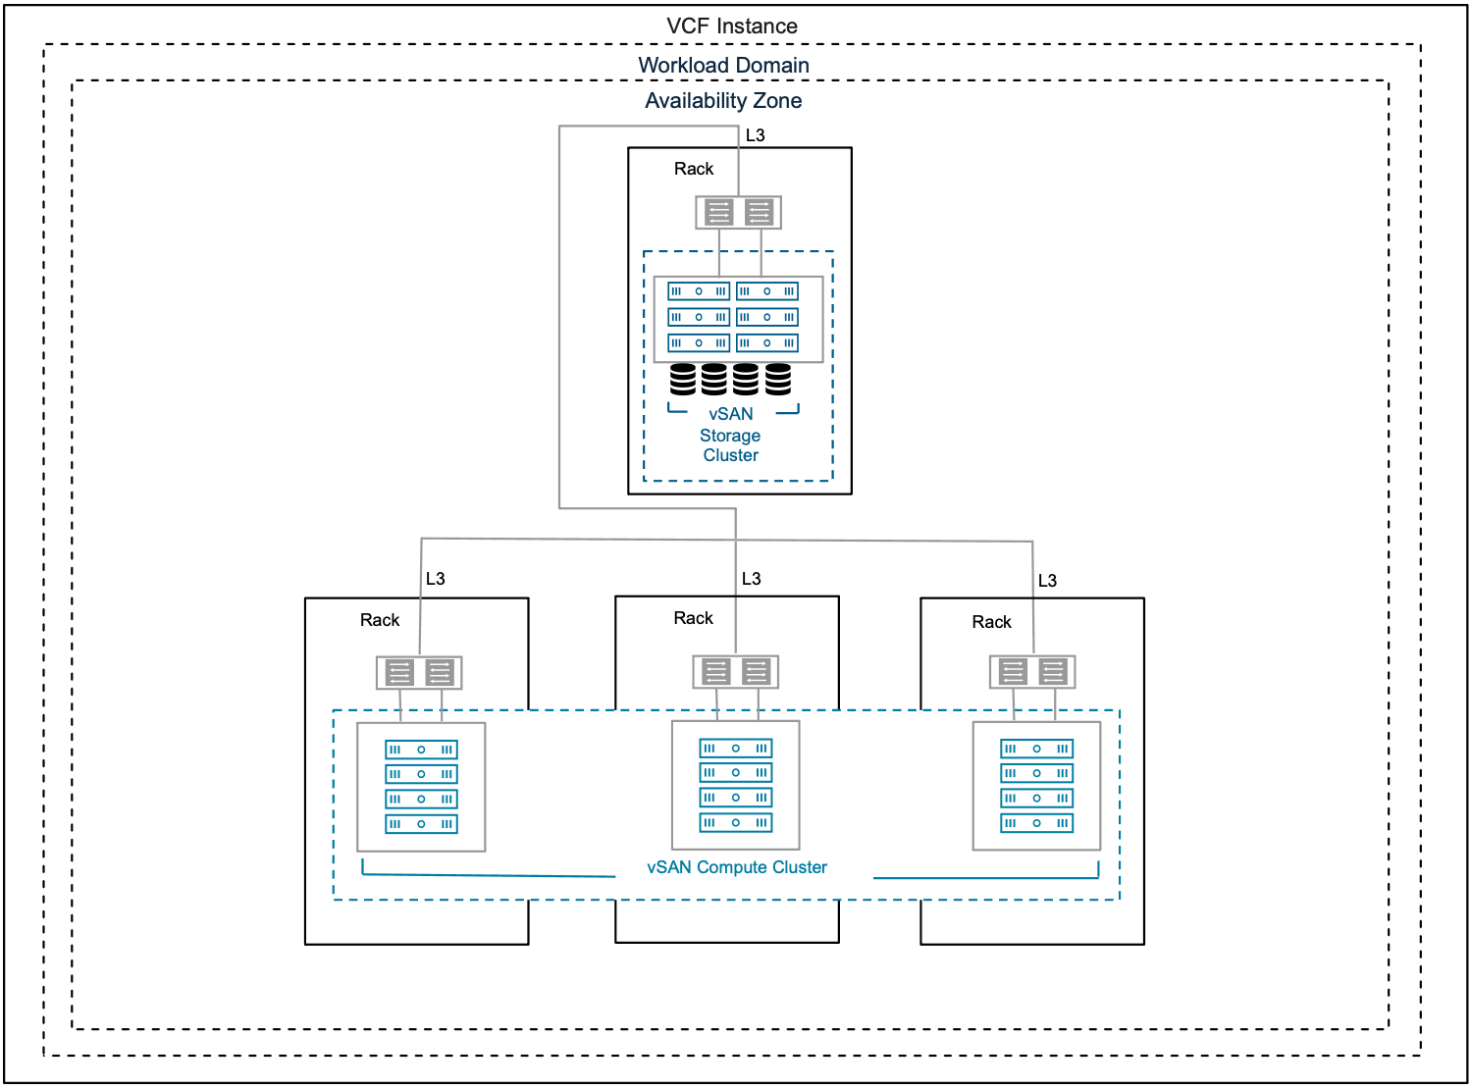
Table 3-636. vSAN Multi-Rack Compute Cluster Model Attributes
Attribute | Detail
Datacenters | Single datacenter
Cluster Rack Mapping | Hosts are deployed horizontally across different physical racks
Resilience | - vSphere HA protects workloads against host failures.  - Multiple fault domains protect workloads in the event of a failure of one or more fault domains/racks.
Availability Zones | - Single availability zone only.
Networking | - Layer 3 routed networks with isolated broadcast domains per rack
vSAN compute cluster | - A vSAN Compute Cluster is a vSphere Cluster Models with a vSAN Traffic Type defined  - The primary function of a vSAN compute cluster is to provide compute resources (CPU, memory) for running virtual machines, not storage.  - A vSAN compute-only cluster can act as a client to a vSAN Storage cluster.  - A vSAN compute cluster does not have to be a certified vSAN Ready node, thus does not require certified vSAN local storage devices for vSAN use.
vSAN network traffic | - vSAN client cluster have dedicated VMkernel interfaces tagged with standard vSAN traffic type.  - The vSAN compute cluster nodes can optionally communicate with the vSAN storage cluster client traffic type defined on the storage cluster. (if configured)  - On the vSAN storage cluster, vSAN Storage Cluster Client Traffic can be tagged on a dedicated VMkernel interface on the vSAN storage cluster to have a disaggregated network design to separate vSAN compute traffic from vSAN storage traffic
vSAN remote datastore | vSAN compute cluster will mount a remote datastore from vSAN storage cluster.
Table 3-637. vSAN Multi-Rack Compute Cluster Model Dependencies
Design Area | Dependency
vSAN host networking traffic type | Route to vSAN storage network on vSAN storage cluster
 | Route to vSAN Storage Cluster Client Traffic network on vSAN storage cluster. (if configured)
Tip vSAN Compute Clusters are essentially vSphere clusters and should inherit the same requirements and recommendations as outlined below
Table 3-638. Common vSphere Cluster Design Requirements
Design Requirement ID | Design Requirement | Justification | Implication
VCF-CLS-REQD-CFG-001 | Create a vSphere cluster in each workload domain for the initial set of ESX hosts. | - Simplifies configuration by isolating management from customer workloads.  - Ensures that customer workloads have no impact on the management stack. | Management of multiple vSphere clusters and vCenter instances increases operational overhead.
VCF-CLS-REQD-CFG-002 | Allocate a minimum number of ESX hosts according to the vSphere cluster type being deployed. | Ensures correct level of redundancy to protect against host failure in the vSphere cluster. | To support redundancy, you must allocate additional ESX host resources.
VCF-CLS-REQD-CFG-003 | Use vSphere Lifecycle Manager images as the life cycle management method for all vSphere clusters.  Note Imported workload domains may be using vSphere Lifecycle Manager baselines. It is recommended to transition them to use vSphere Lifecycle Manager images. | vSphere Lifecycle Manager images simplify the management of firmware and vendor add-ons manually. | - A vSphere Lifecycle Manager cluster image is required during workload domain or vSphere cluster deployment.
VCF-CLS-REQD-CFG-004 | Use vSphere HA to protect all virtual machines against failures. | vSphere HA supports a robust level of protection for both ESX host and virtual machine availability. | You must provide sufficient resources on the remaining ESX hosts so that virtual machines can be restarted on those hosts in the event of an ESX host outage.
Table 3-639. Common vSphere Cluster Design Recommendations
Design Recommendation ID | Design Recommendation | Justification | Implication
VCF-CLS-RCMD-CFG-001 | Configure admission control for one (1) ESX host failure and percentage-based failover capacity. | - Using the percentage-based reservation works well in situations where virtual machines have varying and sometimes significant CPU or memory reservations.  - vSphere automatically calculates the reserved percentage according to the number of ESX host failures to tolerate and the number of ESX hosts in the vSphere cluster. | In a cluster of four (4) ESX hosts, the resources of only three (3) ESX hosts are available for use.
VCF-CLS-RCMD-CFG-002 | Enable VM Monitoring for each vSphere cluster. | VM Monitoring provides in-guest protection for most VM workloads. The application or service running on the virtual machine must be capable of restarting successfully after a reboot or the virtual machine restart is not sufficient. | None.
VCF-CLS-RCMD-CFG-003 | Set the advanced vSphere cluster setting das.iostatsinterval to 60 to deactivate monitoring the storage and network I/O activities of the management appliances. | Enables triggering a restart of a management appliance when an OS failure occurs and heartbeats are not received from VMware Tools instead of waiting additionally for the I/O check to complete. | If you want to specifically enable I/O monitoring, you must configure the das.iostatsinterval advanced setting.
VCF-CLS-RCMD-CFG-004 | Enable vSphere DRS on all vSphere clusters, using the default fully automated mode with medium threshold. | Provides the best trade-off between load balancing and unnecessary migrations with vMotion. | If a vCenter outage occurs, the mapping from virtual machines to ESX hosts might be difficult to determine.
VCF-CLS-RCMD-CFG-005 | Enable Enhanced vMotion Compatibility (EVC) on all vSphere clusters in the management domain. | Supports vSphere cluster upgrades without virtual machine downtime. | - You must enable EVC only if the vSphere clusters contain ESX hosts with CPUs from the same vendor.  - You must enable EVC on the default management domain vSphere cluster during bringup using the API and a JSON spec.
VCF-CLS-RCMD-CFG-006 | Set the vSphere cluster EVC mode to the highest available baseline that is supported for the lowest CPU architecture on the ESX hosts in the vSphere cluster. | Supports vSphere cluster upgrades without virtual machine downtime. | None.
VCF-CLS-RCMD-CFG-007 | If running business workloads in the management domain, configure the following vSphere resource pools to control resource usage by management and business workloads.  - cluster-name-rp-sddc-mgmt  - cluster-name-rp-sddc-edge  - cluster-name-rp-user-edge  - cluster-name-rp-user-vm | Ensures sufficient resources for the management components. | You must manually create the vSphere resource pools and manage their settings over time.
VCF-CLS-RCMD-CFG-008 | Use vSphere Cluster Services (vCLS) Retreat Mode. | System managed vCLS mode is deprecated. | You must manually change the vCLS mode.
Table 3-640. vSAN Compute Cluster Model Design Requirements
Design Requirement ID | Design Requirement | Justification | Implication
VCF-VSAN-COMP-CLU-REQD-CFG-001 | Minimum three (3) vSAN compute nodes is required for VCF provisioned clusters | Deploying compute clusters for VCF requires three(nodes) | none
VCF-VSAN-COMP-CLU-REQD-CFG-001 | vSAN networking must be configured on hosts in the Compute cluster. | A vSAN Compute cluster is a vSphere cluster with a vSAN networking element that enables it to mount a vSAN Storage Cluster | Requires planning for vSAN networking requirements to support planned VM workload.
VCF-VSAN-COMP-CLU-REQD-CFG-002 | vSAN Compute nodes must be commissioned as vSAN Compute Cluster type | This allows creation of vSAN Compute Clusters with vSAN compute node types | Requires new hosts to be commissioned to an exising network pool that has the correct networking attributes
VCF-VSAN-COMP-CLU-REQD-CFG-003 | A vSAN Client Cluster must be deployed within same VCF Workload domain as vSAN Storage Cluster is deployed | A vSAN Client cluster is not supported to be cross mounted across vCenter instances from a VCF workflow perspective | Requires vSAN client clusters to be deployed within a VCF workload domain.
VCF-VSAN-COMP-CLU-REQD-CFG-004 | All objects that make up a VM must reside on the same datastore. | This is currently the supported method for VMs deployed on vSAN Client Clusters | VM performance characteristics and fail-over responses will be consistent
VCF-VSAN-COMP-CLU-REQD-CFG-005 | A vSAN Compute cluster can mount up to 5 remote datastores | This is a supported maximum configuration | This will require careful planning from compute and networking sizing perspective
VCF-VSAN-COMP-CLU-REQD-CFG-006 | Configure vSphere HA failure response for Datastore with APD to be set to Power off and restart VMs. | This ensures Virtual machines respond appropriately to a HA event if a remote vSAN datastore is unavailable on a ESX host | None.
VCF-VSAN-COMP-CLU-REQD-CFG-007 | Ensure vSAN Compute Cluster latency to vSAN Storage Cluster is less than 5 milliseconds | vSAN compute clusters perform a precheck and require network latency between the client clusters and the server cluster of 5ms or less. | Ensure a high speed low latency network between vSAN compute clusters and vSAN Storage Clusters.
Table 3-641. vSAN Compute Multi-Rack Storage Cluster Design Recommendations
Design Recommendation ID | Design Recommendation | Justification | Implication
VCF-VSAN-COMP-L3MR-RCMD-CFG-001 | Use Layer 3 networking between each fault domain (physical rack). | Provides fault isolation per fault domain or physical rack. | - Requires multiple IPv4 subnet per rack.  - Requires gateway per IPv4 subnet.  - Requires layer 3 routing between racks.

Stretched Cluster Storage Models
A vSAN Stretched Cluster provides a highly resilient and available storage architecture by distributing data and services across multiple locations,leveraging synchronous replication over a low-latency inter-site link A stretched cluster spans two distinct physical locations, acting as active-active sites for data storage. This means that data is synchronously replicated between the sites, providing redundancy in case of a site failure. The following vSAN cluster models can be deployed in a stretched cluster configuration, A vSAN HCI Cluster, a vSAN storage cluster or vSAN compute cluster.

Sample VLAN and IP Subnet Requirements for vSAN Stretched Cluster in a VCF Environment
In an environment stretched across multiple availability zones, Layer 2 networks must be stretched between the availability zones by the physical infrastructure. You also must provide a Layer 3 gateway that is highly available between availability zones. The method for stretching these Layer 2 networks and providing a highly available Layer 3 gateway is vendor-specific.
This section displays a sample configuration for an environment with a vSAN cluster stretched across two (2) availability zones.
For NSX Edge designs that have a requirement to be stretched, refer to NSX Edge Cluster Models for Dual Availability Zones.
Note
Table 3-642. vSAN Stretched Cluster VLAN and Subnet Sample Requirements and Recommendations
VLAN Function | Stretched Layer 2 VLAN | Availability Zone 1 | Availability Zone 2 | HA Layer 3 Gateway | Recommended MTU
VM Management | Yes | Yes | Yes | Yes | 1500
Host Management VLAN (AZ1) | No | Yes | No | Yes | 1500
vMotion VLAN (AZ1) | No | Yes | No | Yes | 9000
vSAN VLAN (AZ1) | No | Yes | No | Yes | 9000
NSX Host Overlay (AZ1) | No | Yes | No | Yes | 9000
Host Management VLAN (AZ2) | No | No | Yes | Yes | 1500
vMotion VLAN (AZ2) | No | No | Yes | Yes | 9000
vSAN VLAN (AZ2) | No | No | Yes | Yes | 9000
NSX Host Overlay (AZ2) | No | No | Yes | Yes | 9000
Important Networks that are not stretched can have same or different VLAN IDs on either Availability Zone.
Stretched Layer 2 Networks should have same VLAN ID on either availability zone.

vSAN Stretched HCI Cluster Storage Model
A vSAN Stretched HCI Cluster Storage Model is a cluster configuration where the ESX hosts, that comprise a single vSAN cluster, reside in two availability zones.
Figure 3-97. vSAN Stretched HCI Cluster Storage Storage Model
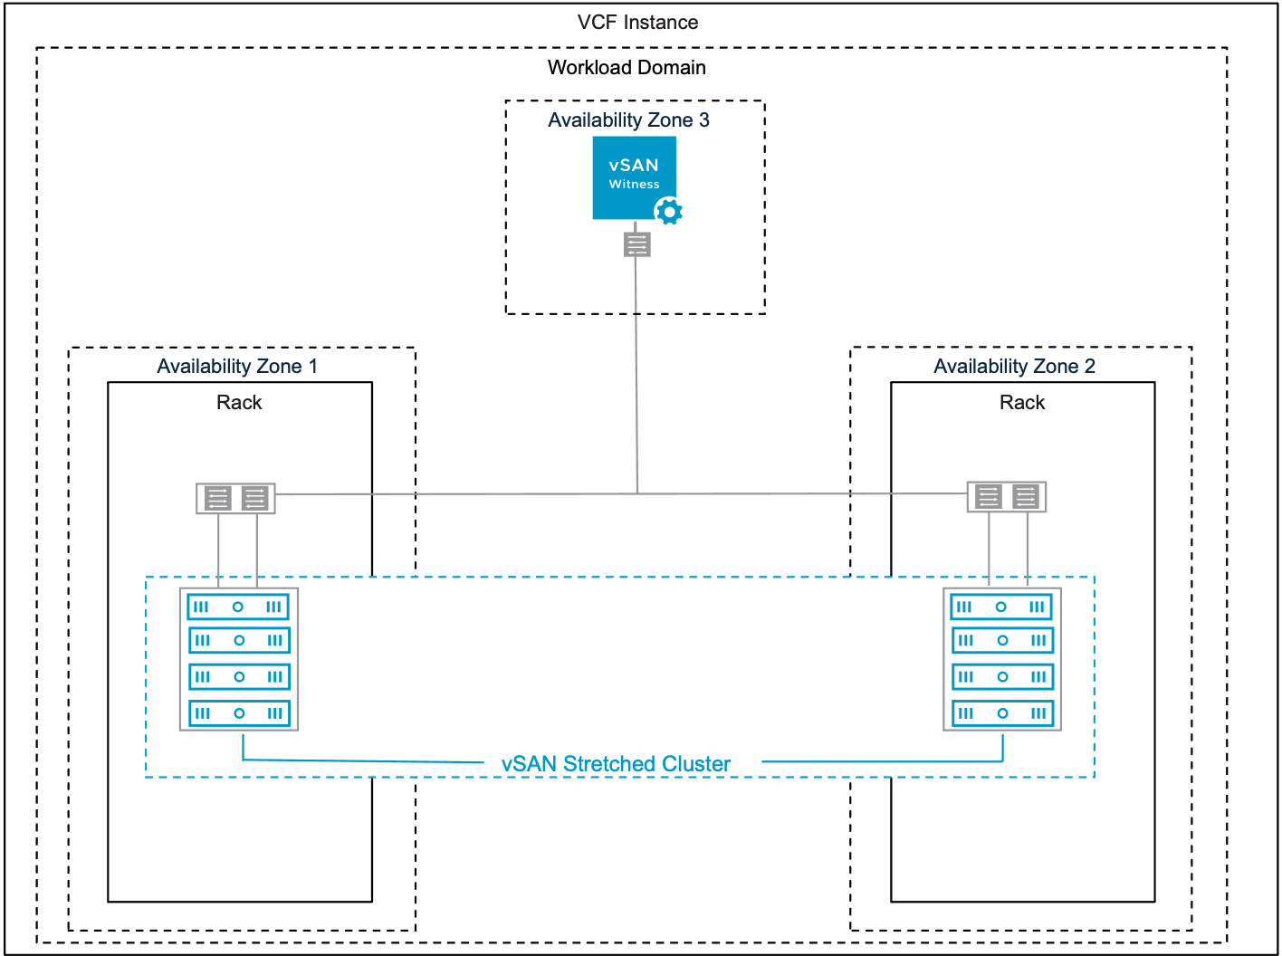
Table 3-643. vSAN Stretched Cluster Storage Model Attributes
Attribute | Detail
Fault domain / availability zone | - vSAN Stretched Clusters comprise of three (3) Fault domains. A fault domain comprises of one or more vSAN nodes.  - A fault domain or availability zone can represent a physical location. Fault domains / availability zones can either be two distinct data centers in a metro distance, or two safety or fire sectors (data halls) in the same large-scale datacenter.
vSAN traffic type | - vSAN Stretch Clusters utilize vSAN Traffic type for data traffic.  - vSAN Stretch Clusters utilize vSAN Witness Traffic type for vSAN meta-data traffic.  Note vSAN Stretch Storage Clusters (ESA) can be configured to use vSAN Storage Cluster Client traffic for vSAN compute client clusters. See vSAN Stretched Storage Cluster Storage Model.
vSAN witness appliance | A witness node is a pre-configured appliance that runs ESX and is distributed as an OVA file.
Table 3-644. vSAN Stretched HCI Cluster Storage Model Options
Design Area | Options
Storage models | - vSAN Single-Rack HCI ESA Storage Model  - vSAN Single-Rack HCI OSA Storage Model
Witness traffic separation | - Witness traffic separation allows you to use a distinct VMkernel adapter for vSAN witness traffic communication with the vSAN witness appliance.  - There are two choices when stretching a vSAN clusters.  - When enabled, the ESX management network is used to communicate with the vSAN witness node via the management network.  - When disabled, The vSAN data traffic network is used to communicate with the vSAN witness node. This requires routing the vSAN data network VLAN to the vSAN witness network.
Table 3-645. Common vSAN Design Requirements for All Models
Design Requirement ID | Design Requirement | Justification | Implication
VCF-VSAN-REQD-CFG-001 | Minimum vSAN cluster size. | Minimum valid vSAN HCI cluster is three (3) nodes all contributing to storage. | - Supports simple install of a management domain default vSphere cluster only.  - A three (3) node vSAN cluster will not offer automatic rebuild of components in the event of a failure.  - Using a smaller cluster limits the workload that can be placed on a vSAN cluster.  Important vSAN Storage Clusters require minimum four (4) vSAN Nodes see vSAN Single-Rack Storage Cluster Storage Model for more details
VCF-VSAN-REQD-CFG-002 | Provide sufficient raw capacity to meet the initial needs of the workload domain vSphere cluster. | Ensures that sufficient resources are present to create the workload domain vSphere cluster. | Requires determining the workload capacity requirements prior to deployment.  Note Refer to the VMware Cloud Foundation Planning and Preparation Workbook for accurate sizing guidance.
VCF-VSAN-REQD-CFG-003 | vSphere Lifecycle Management (vLCM) image based management is required for vSAN clusters. | - All new vSAN clusters, irrespective of OSA or ESA architectures, are required to be using vSphere Lifecycle Manager images for VMware Cloud Foundation.  - As per VCF-CLS-REQD-CFG-003 vSphere Lifecycle Manager images simplify the management of firmware and vendor add-ons. | Imported vSAN OSA clusters may use vLCM baselines, but have to be converted prior to upgrade to VMware Cloud Foundation 9.0.
VCF-VSAN-REQD-CFG-004 | Verify the hardware components used for vSAN deployments are on the vSAN hardware compatibility list. | Helps prevent hardware related issues during workload deployment and operation. | - Requires validating vSAN hardware to ensure its on the compatibility list prior to deployment.  - Restricts the number of devices that can be used to a certified list.  Note Refer to the vSAN hardware compatibility guide for certified hardware https://compatibilityguide.broadcom.com/.
VCF-VSAN-REQD-CFG-005 | Do not use NVMe storage devices attached to a Tri-Mode controller for vSAN diskgroups or storage pools. | - Discrete RAID controllers that support SATA/SAS/NVMe are often known as "Tri-mode controllers".  - VMware vSAN will only support SAS and SATA devices attached to a Tri-mode controller.  - NVMe devices attached to Tri-mode controller is NOT a vSAN supported configuration.  Note Refer to knowledge base article KB314305 | - NVMe devices are only supported directly connected to a PCIe slot on the bus.  - May require to work with server vendor to verify or modify configurations.
VCF-VSAN-REQD-CFG-006 | For vSAN HCI clusters, excluding vSAN storage clusters, configure the vSAN network gateway IP address as the isolation address for the cluster. | vSphere HA can validate against an IP address on the vSAN network if a host is isolated. | Allocate an additional IP address. Top of rack switches may configure a port for switch virtual interface (SVI) which can be used as the isolation address.  See VCF-VSAN-NET-REQD-CFG-003
VCF-VSAN-REQD-CFG-007 | For vSAN HCI clusters, excluding vSAN storage clusters, set the advanced cluster setting das.usedefaultisolationaddress to false. | vSphere HA in vSAN uses the ESX hosts management network default gateway IP for isolation detection when configured with default settings. This setting avoids conflicts if vSphere HA and vSAN triggers different responses when failures occur. | May require to configure a SVI (Switched Virtual Interface) gateway address for the VLAN assigned to the vSAN network.
Table 3-646. vSAN Stretched Cluster Model Design Requirements
Design Requirement ID | Design Requirement | Justification | Implication
VCF-VSAN-SC-REQD-CFG-001 | Two (2) availability zones and a third site for the witness appliance location. | Fault domains are mapped to availability zones to provide logical and physical ESX host separation and ensure a copy of vSAN data is always available even when an availability zone goes offline. | - This requires both availability zones to have an equal number of ESX hosts residing in each site, and are connected using a high bandwidth/low latency connection known as an inter-site link, or ISL.  - The third site should host the witness appliance and must not have a logical or physical dependency on either availability zone.
VCF-VSAN-SC-REQD-CFG-002 | The minimum latency required between the data sites hosting virtual machine objects should not exceed 5 milliseconds (ms) in round trip time (RTT), or 2.5ms one way. | The latency minimums exist largely to ensure that applications can write data resiliently across two sites in a timely manner. | Stretched cluster network latency requirements will dictate the realistic geographic distance between sites.
VCF-VSAN-SC-REQD-CFG-003 | The minimum latency required between witness site and the data sites should not exceed 200ms RTT, or 100ms one way. | The witness site only stores small amounts of metadata, and is not a part of the vSAN data path. | None.
VCF-VSAN-SC-REQD-CFG-004 | vSAN Stretched Cluster Data Site to Data Site Bandwidth minimum is no less than 10GbE.  - The vSAN Stretched Cluster Bandwidth Sizing document can be used for general guidance in sizing for vSAN OSA and ESA architectures. | The network requirements for the data-site to data site in a stretch cluster remain the same for both vSAN ESA and OSA. | - VM workloads will ultimately determine the network bandwidth demand between data-sites.  - Please review https://www.vmware.com/docs/vmw-vsan-stretched-cluster-bandwidth-sizing
VCF-VSAN-SC-REQD-CFG-005 | vSAN Stretched Cluster Data Site to Witness Site Bandwidth is based on number of VMs that is protected by a stretch cluster storage policy. | - Network communication from the data sites to the witness host appliance is comprised entirely of metadata and this is wholly dependent on the number of VM and components protected by vSAN Stretch Cluster polices.  - There is no minimum bandwidth defined as estimating the bandwidth required for the witness site is based on the number of VM components. | For accurate sizing please review https://www.vmware.com/docs/vmw-vsan-stretched-cluster-bandwidth-sizing
VCF-VSAN-SC-REQD-CFG-006 | Management Domain initial cluster  Minimum of eight (8) nodes for vSAN stretched cluster for high availability (HA) install | Management domain initial clusters deployed in high availability (HA) mode have a requirement for 4 nodes in a non-stretched deployment. Stretching a cluster is a day two operation and will require 4 additional hosts on the second availability zone. | vSAN stretched cluster will operate optimally with a balanced ESX host configuration on each availability zone and be able to tolerate a local site failure
VCF-VSAN-SC-REQD-CFG-007 | Workload domain clusters (except for management Domain initial cluster)  Minimum of six (6) nodes for vSAN stretched clusters | This will provide minimum requirements for site availability and site local availability, tolerating a site failure and one failure on each availability zone.  This will give a balance between a host failure on a local availability zone and a full availability zone failure. | vSAN stretched cluster will operate optimally with a balanced ESX host configuration on each availability zone and be able to tolerate a local site failure with minimum three (3) nodes per site.  However with three nodes per site, vSAN will not automatically rebuild objects that are impacted by a local failure.
VCF-VSAN-SC-REQD-CFG-008 | For vSAN OSA architecture  Modify the default Storage Policy as follows  - Site disaster tolerance: Site mirroring  - Failure to tolerate : One (1) failure RAID-1 (Mirroring) | Provides the minimum necessary protection for VMs in each availability zone, with the ability to recover from an availability zone outage.  - For vSAN ESA , Auto Policy configuration will automatically alter the default storage policy to reflect the number of hosts and underlying vSAN topology, when the cluster is converted to a stretch cluster. | - Additional Storage is necessary to satisfy the storage policy requirements in both availability zones.  - Additional policies can be configured for specific workloads depending on their individual performance or availability requirements which may differ from what the default vSAN stretched cluster policy.
VCF-VSAN-SC-REQD-CFG-009 | Deploy a vSAN witness appliance in a location that is not co-located to the ESX hosts in any of the availability zones. | Ensures availability of vSAN witness appliance in the event of a failure of one of the availability zones. | You must provide a third availability zone that is logically and physically independent of the data sites  The third site must be able to provide a environment capable to host the witness appliance.
VCF-VSAN-SC-REQD-CFG-010 | Deploy a witness appliance that corresponds to vSAN Architecture, (ESA or OSA). | Ensures the witness appliance deployed is compatible to the correct vSAN Storage architecture | None.
VCF-VSAN-SC-REQD-CFG-011 | Connect the first VMkernel (vmk0) adapter of the vSAN witness appliance to the management network in the witness site. | The ESX host management networks in both availability zones must be routed to the vSAN witness host management network in the third witness site. | When using witness traffic separation, the second interface on vSAN witness host (vmk1) can be removed.
VCF-VSAN-SC-REQD-CFG-012 | Configure vSAN Witness host identity as per standard ESX host recommendations. | - Allows vSAN Witness host to be managed identically as a ESX host.  - Ensures host identity, DNS and NTP is consistently configured | Apply the requirements for External Services Design
VCF-VSAN-SC-REQD-CFG-013 | Enable vSphere Lifecycle Manager images on the vSAN witness host. | - VMware Cloud Foundation 9.0 requires vSphere Lifecycle Manager images for ESX hosts.  - This will prevent warnings or vSAN health check alarms. | This requires either deploying or converting a vSAN witness host as a vSphere Lifecycle Manager image managed entity.
Table 3-647. Common vSAN Network Design Requirements
Design Requirement ID | Design Requirement | Justification | Implication
VCF-VSAN-NET-REQD-CFG-001 | vSAN requires a high speed, low latency network for synchronous replication of vSAN components.  Note vSAN can use 10GbE , 25GbE or greater. | 10GbE is the minimum network required for vSAN (ESA and OSA architectures  Caution There is limited support for 10GbE and vSAN ESA.  For vSAN ESA ready node, vSAN-ESA-AF-0 profile, only supports 10GbE. Please refer to https://partnerweb.vmware.com/comp_guide2/vsanesa_profile.php | - Using 10GbE for vSAN networking can severely limit vSAN performance and can introduce bandwidth constraints combined with high latency.  - Larger vSAN ESA nodes require 25GbE.  Caution Using 10GbE networking on vSAN ESA will trigger a vSAN cluster compliance check.  Please review Broadcom Knowledge base KB372309
VCF-VSAN-NET-REQD-CFG-002 | - Use a dedicated VLAN for a single rack cluster  Note You can share a single VLAN for multiple vSAN clusters within the same rack  - For stretched cluster topology, use a dedicated VLAN per availability zone. See vSAN Stretched HCI Cluster Storage Model  - For vSAN HCI multi-rack topology, VLAN requirements will depend on vSphere Multi-Rack Cluster Detailed Design if using L2 or L3 design | - For a single rack cluster using a dedicated VLAN allows for better storage traffic isolation and security.  - For vSAN Stretched Cluster VCF automated workflows, it is required to have two (2) VLANs, one VLAN per availability zone. | - For a single rack Cluster a VLAN ID must be allocated for use for a vSAN Cluster.  - For a vSAN Stretch Cluster topology two VLAN IDs must be allocated for use in a stretched cluster topology. These VLAN must be routable to each other  - For vSAN HCI multi-rack topology, VLAN requirements will depend on the deployment, if using L2 or L3 design
VCF-VSAN-NET-REQD-CFG-003 | - Use one (1) IPv4 IP address subnet for vSAN traffic in a single rack cluster.  - For vSAN stretch cluster topology, use two (2) IPv4 subnets, see Sample VLAN and IP Subnet Requirements for vSAN Stretched Cluster in a VCF Environment | The vSAN VMkernel in a VMware Cloud Foundation platform requires IPv4 addressing. | - You require an IPv4 subnet configured with a correctly sized subnet to support the number of free IP addresses for each vSAN node in a single rack vSAN Cluster.  - A gateway IP is required.
Table 3-648. Common vSAN Design Recommendations for All Models
Design Recommendation ID | Design Recommendation | Justification | Implication
VCF-VSAN-RCMD-CFG-001 | It is recommended to start with four (4) vSAN nodes. | - This ensures vSAN objects will automatically rebuild in the case of a failure or maintenance event.  - This allows enabling Reserved Capacity on four (4) node clusters.  - This allows space efficient storage polices to be automatically configured when used with vSAN ESA clusters. | This will potentially increase cost and hardware footprint of vSAN cluster.
VCF-VSAN-RCMD-CFG-002 | Include TPM (Trusted Platform Module) in the hardware configuration of the ESX hosts. | Ensures that the keys issued to the hosts in a vSAN cluster using Data-at-Rest Encryption are cryptographically stored on a TPM device. | Can limit the choice of hardware configurations.
VCF-VSAN-RCMD-CFG-003 | Enable Reserved Capacity on vSAN clusters. | - Reserved Capacity will implement a sliding scale storage capacity resource reservation as the vSAN node count increases per vSAN cluster. For example, the Host Rebuild Reserve for a four (4) node cluster would be 25% while it would be just 8% for a twelve (12) node cluster. This avoids imposing a generic 30% capacity overhead of a vSAN Cluster, thus dynamically optimizing reserved storage capacity on vSAN.  - Recommendation is to design for vSphere cluster host counts large enough to lower the percentage needed for Reserved Capacity, This will provide the most efficient, yet agile vSphere cluster design. | - When enabled vSAN will impose two soft limits:  - Operations Reserve - limits for capacity needed to perform transient storage activities like storage policy changes, re-balancing.  - Host Rebuild Reserve - will reserve the capacity needed to absorb a sustained failure of a single ESX host in a vSAN cluster – to support an N+1 cluster design strategy.  - "Host Rebuild Reserve" has the following implications in a vSAN storage cluster that consist of only 4 hosts. When paired with the Auto-Policy Management feature, this will prevent vSAN storage clusters from being able to use space-efficient and more performant RAID-5 policy.  Caution vSAN capacity reserve is not supported in conjunction with the following vSAN Cluster typologies:  - Three (3) node clusters.  - vSAN stretched clusters.  - vSAN clusters using fault domains.
VCF-VSAN-RCMD-CFG-004 | Enable disk Automatic Re-balance. | - When enabled vSAN will attempt to automatically keep the storage consumption of each capacity drive within a default variance threshold of 30%.  - This allows vSAN to more evenly distribute the data across the discrete devices to achieve a balanced distribution of resources, and thus, improved performance. | - Adding or scaling out new hosts will trigger a disk rebalance and resynchronization.  - When adding or replacing failed resources, automatic rebalance may introduce additional data re-synchronization and as a result additional network traffic utilization  - re-synchronization may have an impact when vSAN clusters are network bandwidth constrained.
Table 3-649. vSAN Stretched Cluster Model Design Recommendations
Design Recommendation ID | Design Recommendation | Justification | Implication
VCF-VSAN-SC_RCMD-001 | It is recommend that vSAN Stretched cluster topological use Layer 3 (routed) networking between the two data sites, and the witness site.  - The data sites will only be able to communicate with each other using the ISL  - The witness host should only be able to communicate with hosts in each data site directly, and not through another data site. | Layer 3 will help avoid spanning tree protocol (STP) from redirecting traffic across an undesirable link, such as the more bandwidth constrained link to the witness site | Ensure Layer 3 gateways are highly available such that it tolerates the failure of an entire availability zone.
VCF-VSAN-SC_RCMD-001 | Use witness traffic separation when stretching a vSAN cluster. | - Network Flexibility: You can configure different VLANs or subnets for vSAN data and witness traffic, allowing for better network segmentation and resource allocation.  - Mixed MTU: This will allow vSAN witness traffic type to use a different MTU size than the vSAN data traffic. This avoids configuring static routes between vSAN networks.  - Simplified Troubleshooting: Identifying and resolving network issues related to witness traffic becomes easier when it is isolated from the main vSAN data traffic. | This requires the vSAN witness network to be routable to both the ESX host management networks on either availability zone as well to VM management network if configured.
VCF-VSAN-SC-RCMD-CFG-002 | Configure the vSAN witness host to use the first VMkernel adapter (vmk0), that is the management interface, for vSAN witness traffic. | - Removes the requirement to have two IP addresses allocated to the vSAN witness host.  - Removes the requirement to have static routes in the witness as the witness traffic is routed over the management networks | - The management networks in both availability zones must be routed to the management witness site.  - Ensure to use the same MTU size as the host management interfaces.  Note Default MTU size is 1500 for management interfaces
VCF-VSAN-SC-RCMD-CFG-003 | Configure vSAN Storage policies to use "Force Provisioning" attribute. | This will allow for vSAN objects to be created in the event of an Availability zone being unavailable due to site maintenance or failure. | This would require modifying vSAN policies used as part of the stretched cluster.
VCF-VSAN-SC-RCMD-CFG-004 | Ensure DRS Host Groups, VM Groups, and VM/Host Rules are in conjunction with vSAN storage policies. | - This ensures that VM and vSAN data resilience desired outcomes are satisfied.  - This will suggest or force a behavior of VM placement in a vSAN stretched cluster while in steady state.  - This ensures vSphere HA will trigger the desired behavior in response to a failure. | - Requires creation of additional DRS Host groups, VM Groups, and VM/Host DRS Rules.  - The Placement rules should match the desired failure response.
VCF-VSAN-SC-RCMD-CFG-005 | vSphere HA Admission control fail-over capacity is configured to reserve 50% of the CPU and memory capacity of the entire stretched cluster. | This ensures that VMs can fail between AZs and have adequate resources. | Requires adequate capacity guarantee successful fail-over of protected workloads in the event of failure of an entire availability zone.
VCF-VSAN-SC-REQD-CFG-006 | Do not enable reserved Capacity in a vSAN stretched Cluster. | vSAN capacity reserve is not supported in conjunction with the following vSAN cluster topologies:  - Three (3) node clusters.  - vSAN stretched clusters.  - vSAN clusters using fault domains. | This will require manually calculating vSAN slack space.  Refer to the vSAN sizer for recommended capacity at https://vcf.broadcom.com/tools/vsansizer/home.

vSAN Stretched Storage Cluster Storage Model
This is a topology choice for a vSAN Storage Cluster. This topology is identical from a deployment perspective to a vSAN Stretched Cluster deployment. This allows for a vSAN Compute Cluster to mount a vSAN Stretched Storage Cluster to avail of higher availability. A vSAN Compute Cluster can also be stretched
Figure 3-98. vSAN Stretched Storage Cluster Storage Model
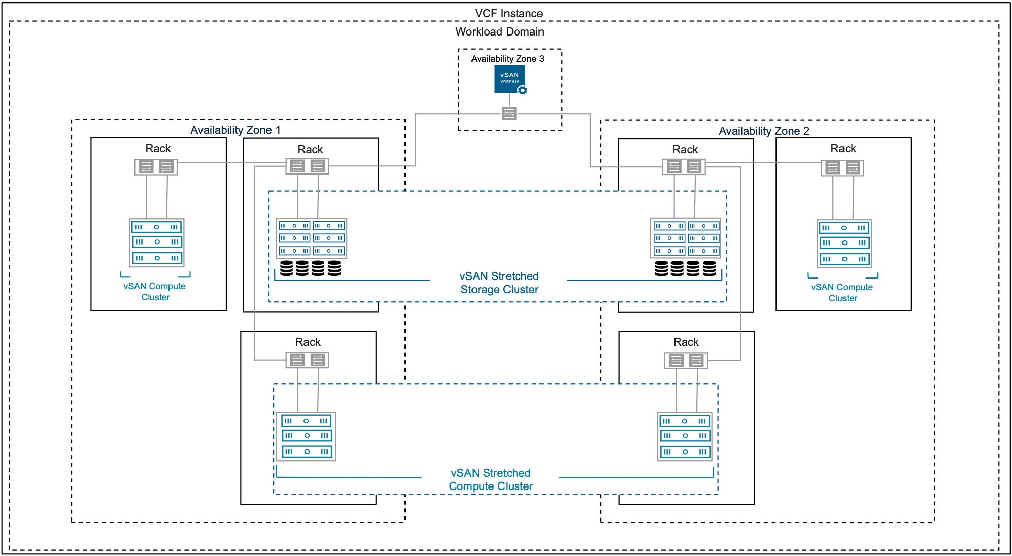
Tip vSAN Stretched Storage Clusters are essentially vSAN Stretched clusters and should inherit the same attributes.
Table 3-650. vSAN Stretched Cluster Storage Model Attributes
Attribute | Detail
Fault domain / availability zone | - vSAN Stretched Clusters comprise of three (3) Fault domains. A fault domain comprises of one or more vSAN nodes.  - A fault domain or availability zone can represent a physical location. Fault domains / availability zones can either be two distinct data centers in a metro distance, or two safety or fire sectors (data halls) in the same large-scale datacenter.
vSAN traffic type | - vSAN Stretch Clusters utilize vSAN Traffic type for data traffic.  - vSAN Stretch Clusters utilize vSAN Witness Traffic type for vSAN meta-data traffic.  Note vSAN Stretch Storage Clusters (ESA) can be configured to use vSAN Storage Cluster Client traffic for vSAN compute client clusters. See vSAN Stretched Storage Cluster Storage Model.
vSAN witness appliance | A witness node is a pre-configured appliance that runs ESX and is distributed as an OVA file.
Table 3-651. vSAN Stretched Storage Cluster Model Options
Design Area | Options
Witness traffic separation | - Witness traffic separation allows you to use a VMkernel adapter for vSAN witness traffic that is different from the adapter for vSAN data traffic.  - There are two choices when stretching a vSAN clusters.  - When enabled, the ESX management network is used to communicate with the vSAN witness node.  - When disabled, The vSAN data traffic network is used to communicate with the vSAN witness traffic.
vSAN storage cluster client traffic | - Dis-aggregated vSAN Storage traffic  vSAN Storage traffic and vSAN VM IO traffic will be separated. If selected a new traffic type called vSAN Storage Cluster Client traffic can be selected. This will require an additional VMkernel interface and a separate network pool with an allocated IPv4 Segment.  - Converged vSAN Storage Traffic  If selected vSAN traffic and vSAN VM IO traffic share the same physical resources.
Distributed switch models | - Single Distributed Switch Model  - Workload Separation Distributed Switch Model  - Storage and Workload Separation Distributed Switch Model  - vSAN Storage Cluster Separation Distributed Switch Model
MTU | 1500 - 9000
Table 3-652. vSAN Stretched Cluster Model Design Requirements
Design Requirement ID | Design Requirement | Justification | Implication
VCF-VSAN-SC-REQD-CFG-001 | Two (2) availability zones and a third site for the witness appliance location. | Fault domains are mapped to availability zones to provide logical and physical ESX host separation and ensure a copy of vSAN data is always available even when an availability zone goes offline. | - This requires both availability zones to have an equal number of ESX hosts residing in each site, and are connected using a high bandwidth/low latency connection known as an inter-site link, or ISL.  - The third site should host the witness appliance and must not have a logical or physical dependency on either availability zone.
VCF-VSAN-SC-REQD-CFG-002 | The minimum latency required between the data sites hosting virtual machine objects should not exceed 5 milliseconds (ms) in round trip time (RTT), or 2.5ms one way. | The latency minimums exist largely to ensure that applications can write data resiliently across two sites in a timely manner. | Stretched cluster network latency requirements will dictate the realistic geographic distance between sites.
VCF-VSAN-SC-REQD-CFG-003 | The minimum latency required between witness site and the data sites should not exceed 200ms RTT, or 100ms one way. | The witness site only stores small amounts of metadata, and is not a part of the vSAN data path. | None.
VCF-VSAN-SC-REQD-CFG-004 | vSAN Stretched Cluster Data Site to Data Site Bandwidth minimum is no less than 10GbE.  - The vSAN Stretched Cluster Bandwidth Sizing document can be used for general guidance in sizing for vSAN OSA and ESA architectures. | The network requirements for the data-site to data site in a stretch cluster remain the same for both vSAN ESA and OSA. | - VM workloads will ultimately determine the network bandwidth demand between data-sites.  - Please review https://www.vmware.com/docs/vmw-vsan-stretched-cluster-bandwidth-sizing
VCF-VSAN-SC-REQD-CFG-005 | vSAN Stretched Cluster Data Site to Witness Site Bandwidth is based on number of VMs that is protected by a stretch cluster storage policy. | - Network communication from the data sites to the witness host appliance is comprised entirely of metadata and this is wholly dependent on the number of VM and components protected by vSAN Stretch Cluster polices.  - There is no minimum bandwidth defined as estimating the bandwidth required for the witness site is based on the number of VM components. | For accurate sizing please review https://www.vmware.com/docs/vmw-vsan-stretched-cluster-bandwidth-sizing
VCF-VSAN-SC-REQD-CFG-006 | Management Domain initial cluster  Minimum of eight (8) nodes for vSAN stretched cluster for high availability (HA) install | Management domain initial clusters deployed in high availability (HA) mode have a requirement for 4 nodes in a non-stretched deployment. Stretching a cluster is a day two operation and will require 4 additional hosts on the second availability zone. | vSAN stretched cluster will operate optimally with a balanced ESX host configuration on each availability zone and be able to tolerate a local site failure
VCF-VSAN-SC-REQD-CFG-007 | Workload domain clusters (except for management Domain initial cluster)  Minimum of six (6) nodes for vSAN stretched clusters | This will provide minimum requirements for site availability and site local availability, tolerating a site failure and one failure on each availability zone.  This will give a balance between a host failure on a local availability zone and a full availability zone failure. | vSAN stretched cluster will operate optimally with a balanced ESX host configuration on each availability zone and be able to tolerate a local site failure with minimum three (3) nodes per site.  However with three nodes per site, vSAN will not automatically rebuild objects that are impacted by a local failure.
VCF-VSAN-SC-REQD-CFG-008 | For vSAN OSA architecture  Modify the default Storage Policy as follows  - Site disaster tolerance: Site mirroring  - Failure to tolerate : One (1) failure RAID-1 (Mirroring) | Provides the minimum necessary protection for VMs in each availability zone, with the ability to recover from an availability zone outage.  - For vSAN ESA , Auto Policy configuration will automatically alter the default storage policy to reflect the number of hosts and underlying vSAN topology, when the cluster is converted to a stretch cluster. | - Additional Storage is necessary to satisfy the storage policy requirements in both availability zones.  - Additional policies can be configured for specific workloads depending on their individual performance or availability requirements which may differ from what the default vSAN stretched cluster policy.
VCF-VSAN-SC-REQD-CFG-009 | Deploy a vSAN witness appliance in a location that is not co-located to the ESX hosts in any of the availability zones. | Ensures availability of vSAN witness appliance in the event of a failure of one of the availability zones. | You must provide a third availability zone that is logically and physically independent of the data sites  The third site must be able to provide a environment capable to host the witness appliance.
VCF-VSAN-SC-REQD-CFG-010 | Deploy a witness appliance that corresponds to vSAN Architecture, (ESA or OSA). | Ensures the witness appliance deployed is compatible to the correct vSAN Storage architecture | None.
VCF-VSAN-SC-REQD-CFG-011 | Connect the first VMkernel (vmk0) adapter of the vSAN witness appliance to the management network in the witness site. | The ESX host management networks in both availability zones must be routed to the vSAN witness host management network in the third witness site. | When using witness traffic separation, the second interface on vSAN witness host (vmk1) can be removed.
VCF-VSAN-SC-REQD-CFG-012 | Configure vSAN Witness host identity as per standard ESX host recommendations. | - Allows vSAN Witness host to be managed identically as a ESX host.  - Ensures host identity, DNS and NTP is consistently configured | Apply the requirements for External Services Design
VCF-VSAN-SC-REQD-CFG-013 | Enable vSphere Lifecycle Manager images on the vSAN witness host. | - VMware Cloud Foundation 9.0 requires vSphere Lifecycle Manager images for ESX hosts.  - This will prevent warnings or vSAN health check alarms. | This requires either deploying or converting a vSAN witness host as a vSphere Lifecycle Manager image managed entity.
Table 3-653. vSAN Stretch Storage Cluster Model Additional Design Requirements
Design Requirement ID | Design Requirement | Justification | Implication
VCF-VSAN-SC-STG-CLU-REQD-CFG-001 | Use four (4) vSAN Nodes per availability zone (total of 8 vSAN data nodes). | This satisfy the requirement to have at least four nodes for a vSAN Storage cluster. Having four (4) vSAN nodes per availability zone will provide a balance of capacity and availability | This is an additional requirement for a standard vSAN stretch cluster and will require additional vSAN Nodes.
Table 3-654. vSAN Stretch Storage Cluster Model Additional Design Recommendations
Design Recommendation ID | Design Recommendation | Justification | Implication
VCF-VSAN-SC-STG-CLU-RCMD-CFG-001 | A recommendation of seven (7) hosts in each availability zone (total of 14 vSAN Data nodes) | This will ensure a cluster could support a storage policy with a secondary level of resilience of FTT=2 using RAID-6 erasure coding, and allow vSAN to regain its prescribed level of resilience in the event of a sustained host outage. | An additional host beyond the minimum required allows vSAN to reconstruct the stripe and parity in the most efficient way, with the fewest performance implications.
VCF-VSAN-SC-STG-CLU-RCMD-CFG-002 | Use Witness Traffic Separation | Removes the requirement for the backend data node network to route with the vSAN Witness Host vmkernel interface  Removes the requirement of static routes between vSAN data node traffic | Simpler network design avoids complex routing between vSAN data nodes and vSAM Witness host

vSAN Stretched Compute Cluster Model
Is a cluster of vSphere hosts deployed over multiple availability zones, configured to to mount a remote vSAN datastore provided by vSAN Stretched Storage clusters in the same workload domain.
Figure 3-99. vSAN Stretched Compute Cluster Storage Model
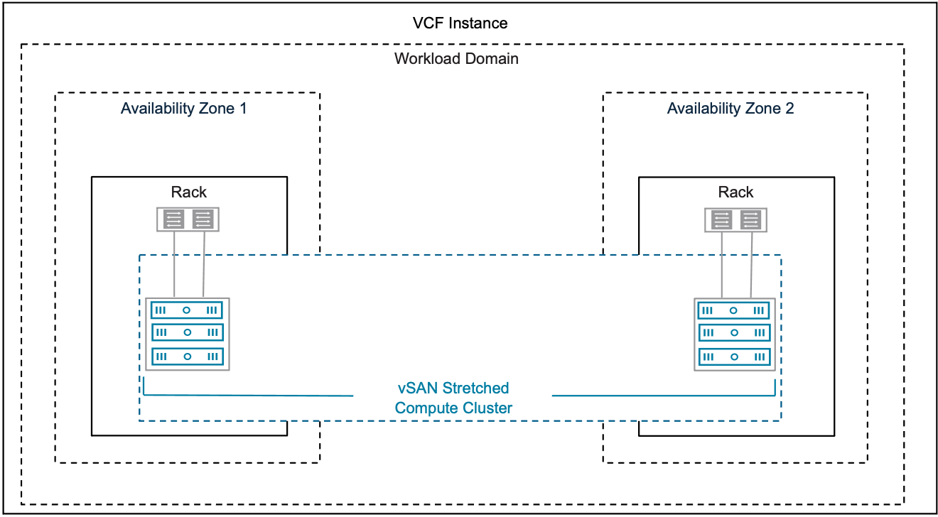
vSAN Stretched compute clusters are essentially vSAN compute clusters stretched over two availability zones and should inherit the same attributes. Additional attributes are outlined below.
Table 3-655. vSAN Stretched Compute Cluster Storage Model Attributes
Attributes | Details
Fault domain / availability zone | - vSAN stretched compute clusters comprise of two (2) fault domains.  - A fault domain or availability zone can represent a physical location. Fault domains / availability zones can either be two distinct data centers within a metro distance, or two safety or fire sectors (data halls) in the same large-scale datacenter.
vSAN Storage Cluster Client Traffic | vSAN Storage Cluster Client Traffic must be tagged on a VMkernel interface on the storage cluster.  When enabled, the vSAN compute cluster nodes will use the vSAN client traffic (on the storage cluster) to communicate with storage cluster nodes for VM IO traffic.
vSAN Remote Datastore | This is a datastore shared from a vSAN storage cluster.
Table 3-656. vSAN Stretched Compute Cluster Storage Model Options
Design Area | Options
Distributed switch models | - Single Distributed Switch Model  - Workload Separation Distributed Switch Model  - Storage and Workload Separation Distributed Switch Model
vSAN Storage Cluster Client VMkernel MTU size | 1500 - 9000
vSAN Compute Site Coupling | vSAN Compute Site Coupling  This is the concept of configuring and establishing site affinity to the vSAN objects when mounting a vSAN client cluster to a stretched cluster to take advantage of the most optimal path to the data.  Compute Cluster Site Coupling can be configured to either availability zone , depending on the characteristics of the network fabric.  This addresses scenarios where networking between availability zones has significant differences, This is defined this as asymmetrical and symmetrical network connectivity.  Asymmetrical network connectivity would describe a topology where the network capabilities (latency & bandwidth) between availability zones could be less than the network capabilities between a local vSAN compute cluster and vSAN Storage Cluster fault domain within the same physical location  E.g. A stretched cluster spanning across two physical sites with site local compute clusters mounting the shared datastore.  Symmetrical network connectivity would describe a topology where the network capabilities connecting the availability zones would be the same as the network capabilities between the client cluster and server cluster within each availability zones. Connectivity across each availability zone is equal across all connectivity possibilities.  Eg. A stretched cluster spanning across multiple rooms within a physical data-center.
vSAN storage cluster Client Traffic | - When disabled vSAN client cluster will share the same network with vSAN Storage Cluster traffic
 | - When enabled, the vSAN compute cluster client nodes will communicate via the vSAN client traffic on the storage cluster nodes for vSAN client cluster traffic
Table 3-657. vSAN Compute Cluster Model Design Requirements
Design Requirement ID | Design Requirement | Justification | Implication
VCF-VSAN-COMP-CLU-REQD-CFG-001 | Minimum three (3) vSAN compute nodes is required for VCF provisioned clusters | Deploying compute clusters for VCF requires three(nodes) | none
VCF-VSAN-COMP-CLU-REQD-CFG-001 | vSAN networking must be configured on hosts in the Compute cluster. | A vSAN Compute cluster is a vSphere cluster with a vSAN networking element that enables it to mount a vSAN Storage Cluster | Requires planning for vSAN networking requirements to support planned VM workload.
VCF-VSAN-COMP-CLU-REQD-CFG-002 | vSAN Compute nodes must be commissioned as vSAN Compute Cluster type | This allows creation of vSAN Compute Clusters with vSAN compute node types | Requires new hosts to be commissioned to an exising network pool that has the correct networking attributes
VCF-VSAN-COMP-CLU-REQD-CFG-003 | A vSAN Client Cluster must be deployed within same VCF Workload domain as vSAN Storage Cluster is deployed | A vSAN Client cluster is not supported to be cross mounted across vCenter instances from a VCF workflow perspective | Requires vSAN client clusters to be deployed within a VCF workload domain.
VCF-VSAN-COMP-CLU-REQD-CFG-004 | All objects that make up a VM must reside on the same datastore. | This is currently the supported method for VMs deployed on vSAN Client Clusters | VM performance characteristics and fail-over responses will be consistent
VCF-VSAN-COMP-CLU-REQD-CFG-005 | A vSAN Compute cluster can mount up to 5 remote datastores | This is a supported maximum configuration | This will require careful planning from compute and networking sizing perspective
VCF-VSAN-COMP-CLU-REQD-CFG-006 | Configure vSphere HA failure response for Datastore with APD to be set to Power off and restart VMs. | This ensures Virtual machines respond appropriately to a HA event if a remote vSAN datastore is unavailable on a ESX host | None.
VCF-VSAN-COMP-CLU-REQD-CFG-007 | Ensure vSAN Compute Cluster latency to vSAN Storage Cluster is less than 5 milliseconds | vSAN compute clusters perform a precheck and require network latency between the client clusters and the server cluster of 5ms or less. | Ensure a high speed low latency network between vSAN compute clusters and vSAN Storage Clusters.
Table 3-658. vSAN Stretched Compute Cluster Models Additional Design Requirements
Design Requirement ID | Design Requirement | Justification | Implication
VCF-VSAN-SC-COMP-CLU-REQD-CFG-001 | Minimum four (4) nodes for a stretched compute cluster.  This allows for a two (2) plus two (2) configuration where the compute nodes are distributed equally between both availability zones. | This satisfies the constraint of minimum three (3) nodes for a vSAN compute cluster and provides equal resources on both availability zones. | None.
VCF-VSAN-SC-COMP-CLU-REQD-CFG-002 | Ensure DRS Host Groups, VM Groups, and VM/Host Rules in conjunction with vSAN Storage Toplogies and policies are aligned. | - This ensures that VM and vSAN data resilience desired outcomes are satisfied.  - This will suggest or force a behavior of VM placement that reflects the storage topology backing the Virtual machine data. | - Requires creation of additional DRS Host groups, VM Groups, and VM/Host DRS Rules.  - The Placement rules should match the desired failure response.
Table 3-659. vSAN Stretched Compute Cluster Model Additional Design Recommendations
Design Recommendation ID | Design Recommendation | Justification | Implication
VCF-VSAN-SC-COMP-CLU-RCMD-CFG-001 | Configure site coupling between the vSAN client cluster and the server cluster so they are 'affinitized' or “coupled” to prevent vSAN Cluster client IO traversing over a sub optimal network route. | - If there is a defined disparity in connectivity, (asymmetric network connectivity) Configuring site coupling will help maintain data affinity from an availability zone perspective between the client cluster and the server cluster fault domains.  - Establishing site affinity (e.g. inter-site coupling) assists with both read and write operations.  - For writes, it ensures that a write operation would only need to perform a single round trip across an inter-site link (ISL), and not two.  - For reads the IO path would remain local between the client and server cluster | It is possible to have a client stretched cluster use a server stretched cluster that do not share any physical site. As a result, this may change coupling or network affinity, as there may not necessarily be a preferred path, and may be deemed a symmetric connection.  Note Site coupling can be changed non-disruptively without any need to unmount or remount a datastore.

vSAN Datastore Sharing Storage Model
This allows multiple independent vSAN HCI Clusters to consume storage of adjacent vSAN storage resources within the same workload domain. Also known as “cross-cluster capacity sharing” this represents the highly flexible cross-cluster capacity sharing capabilities between vSAN clusters. This feature was formerly referred to as “HCI Mesh.”
Figure 3-100. vSAN HCI Datastore Sharing Storage Model
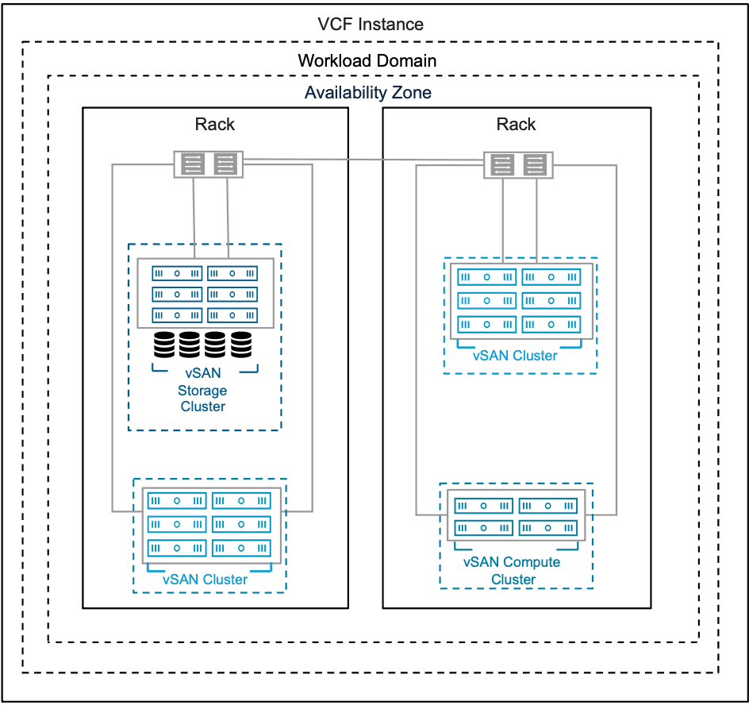
Table 3-660. vSAN HCI Datastore Sharing Storage Model Attributes
Attributes | Detail
vSAN Cluster | This allows multiple independent vSAN Clusters to consume storage of adjacent vSAN storage resources within the same workload domain  vSAN Cluster can be either a client cluster or a server cluster  vSAN Clusters are based on vSAN Single-Rack HCI ESA Storage Model or vSAN Single-Rack HCI OSA Storage Model.
.vSAN Remote Datastore | vSAN Storage that is shared to a client cluster, such as another vSAN HCI Cluster or a vSAN Compute Cluster
vSAN Compute Cluster | A vSAN Compute Cluster (vSphere cluster) that can consume vSAN Storage cluster capacity
Storage models | - Principle Storage:  - vSphere (vSAN Compute) Clusters can consume a remote datastore as principle storage  - Supplemental Storage:  - vSAN storage can be shared to adjacent clusters within the same workload domain as supplemental storage.
vSAN Storage Cluster Client Traffic | - vSAN storage clusters introduce a new vSAN networking traffic type to enable a de-converged storage network.  - This allows internal vSAN traffic, such as data replication, resync and rebalance to be logically and physically separated from Virtual Machine / vSAN Storage Cluster Client traffic.  - vSAN Cluster Client Traffic is used for vSAN client cluster trafffic and can be described as a second vSAN network type on a vSAN Storage Cluster.
Table 3-661. vSAN HCI Datastore Sharing Choices
Design Area | Options
vSAN Host networking | - Share vSAN traffic with vSAN Client cluster traffic
 | - Use vSAN Storage Cluster Client Traffic, use dedicated client traffic for VM IO traffic
Table 3-662. Common vSAN Design Requirements for All Models
Design Requirement ID | Design Requirement | Justification | Implication
VCF-VSAN-REQD-CFG-001 | Minimum vSAN cluster size. | Minimum valid vSAN HCI cluster is three (3) nodes all contributing to storage. | - Supports simple install of a management domain default vSphere cluster only.  - A three (3) node vSAN cluster will not offer automatic rebuild of components in the event of a failure.  - Using a smaller cluster limits the workload that can be placed on a vSAN cluster.  Important vSAN Storage Clusters require minimum four (4) vSAN Nodes see vSAN Single-Rack Storage Cluster Storage Model for more details
VCF-VSAN-REQD-CFG-002 | Provide sufficient raw capacity to meet the initial needs of the workload domain vSphere cluster. | Ensures that sufficient resources are present to create the workload domain vSphere cluster. | Requires determining the workload capacity requirements prior to deployment.  Note Refer to the VMware Cloud Foundation Planning and Preparation Workbook for accurate sizing guidance.
VCF-VSAN-REQD-CFG-003 | vSphere Lifecycle Management (vLCM) image based management is required for vSAN clusters. | - All new vSAN clusters, irrespective of OSA or ESA architectures, are required to be using vSphere Lifecycle Manager images for VMware Cloud Foundation.  - As per VCF-CLS-REQD-CFG-003 vSphere Lifecycle Manager images simplify the management of firmware and vendor add-ons. | Imported vSAN OSA clusters may use vLCM baselines, but have to be converted prior to upgrade to VMware Cloud Foundation 9.0.
VCF-VSAN-REQD-CFG-004 | Verify the hardware components used for vSAN deployments are on the vSAN hardware compatibility list. | Helps prevent hardware related issues during workload deployment and operation. | - Requires validating vSAN hardware to ensure its on the compatibility list prior to deployment.  - Restricts the number of devices that can be used to a certified list.  Note Refer to the vSAN hardware compatibility guide for certified hardware https://compatibilityguide.broadcom.com/.
VCF-VSAN-REQD-CFG-005 | Do not use NVMe storage devices attached to a Tri-Mode controller for vSAN diskgroups or storage pools. | - Discrete RAID controllers that support SATA/SAS/NVMe are often known as "Tri-mode controllers".  - VMware vSAN will only support SAS and SATA devices attached to a Tri-mode controller.  - NVMe devices attached to Tri-mode controller is NOT a vSAN supported configuration.  Note Refer to knowledge base article KB314305 | - NVMe devices are only supported directly connected to a PCIe slot on the bus.  - May require to work with server vendor to verify or modify configurations.
VCF-VSAN-REQD-CFG-006 | For vSAN HCI clusters, excluding vSAN storage clusters, configure the vSAN network gateway IP address as the isolation address for the cluster. | vSphere HA can validate against an IP address on the vSAN network if a host is isolated. | Allocate an additional IP address. Top of rack switches may configure a port for switch virtual interface (SVI) which can be used as the isolation address.  See VCF-VSAN-NET-REQD-CFG-003
VCF-VSAN-REQD-CFG-007 | For vSAN HCI clusters, excluding vSAN storage clusters, set the advanced cluster setting das.usedefaultisolationaddress to false. | vSphere HA in vSAN uses the ESX hosts management network default gateway IP for isolation detection when configured with default settings. This setting avoids conflicts if vSphere HA and vSAN triggers different responses when failures occur. | May require to configure a SVI (Switched Virtual Interface) gateway address for the VLAN assigned to the vSAN network.
Table 3-663. vSAN HCI Datastore Sharing Model Design Requirements
Design Requirement ID | Design Requirement | Justification | Implication
VCF-VSAN-HCI-DS-REQD-CFG-001 | A vSAN Client or Server Cluster must be deployed within the same VCF Workload domain | A vSAN Client or Server cluster is not supported to be cross mounted across multiple vCenter instances from a VCF workflow perspective | Requires vSAN client and server clusters to be deployed within a VCF workload domain.
VCF-VSAN-HCI-DS-REQD-CFG-001 | vSAN Datastore Sharing is not supported if either vSAN client cluster and vSAN server cluster use different vSAN architectures (ESA/ OSA), | Client and Server vSAN Clusters must have the same vSAN architecture. vSAN workflows have guardrails to prevent asymmetrical vSAN architectures to use vSAN Datastore sharing | Cannot mix vSAN OSA clusters and vSAN ESA clusters for cross datastore sharing.  This may restrict scaling out storage resources if mixed vSAN cluster architectures are deployed within the same workload domain
VCF-VSAN-HCI-DS-REQD-CFG-002 | A vSAN client cluster can mount up to 5 remote datastores | This is a supported maximum configuration | This will require careful planning from compute and networking sizing perspective
VCF-VSAN-HCI-DS-REQD-CFG-003 | A vSAN HCI Server cluster can serve its local datastore to up to 10 client clusters. | This is a supported maximum configuration | This will require careful planning from compute and networking sizing perspective
VCF-VSAN-HCI-DS-REQD-CFG-004 | vSAN networking must be configured on hosts in the Compute cluster. | A vSAN Compute cluster is a vSphere cluster with vSAN networking configured that enables it to mount a vSAN Storage Cluster | If vSAN Compute client network is configured on the vSAN storage cluster it must be able to establish connectivity to vSAN compute cluster.
VCF-VSAN-HCI-DS-REQD-CFG-005 | All objects that make up a VM must reside on the same datastore. | This is currently the supported method for VMs deployed on vSAN Client Clusters | VM performance characteristics and fail-over responses will be consistent
VCF-VSAN-HCI-DS-REQD-CFG-006 | Configure vSphere HA failure response for Datastore with APD to be set to Power off and restart VMs. | This ensures Virtual machines respond appropriately to a HA event if a remote vSAN datastore is unavailable on a ESX host | None.
VCF-VSAN-HCI-DS-REQD-CFG-007 | Ensure vSAN client Cluster latency to vSAN server Cluster is less than 5 milliseconds | vSAN client clusters perform a precheck and require network latency between the client clusters and the server cluster of 5ms or less. | Ensure a high speed low latency network between vSAN compute clusters and vSAN Storage Clusters.
Table 3-664. Common vSAN Network Design Requirements
Design Requirement ID | Design Requirement | Justification | Implication
VCF-VSAN-NET-REQD-CFG-001 | vSAN requires a high speed, low latency network for synchronous replication of vSAN components.  Note vSAN can use 10GbE , 25GbE or greater. | 10GbE is the minimum network required for vSAN (ESA and OSA architectures  Caution There is limited support for 10GbE and vSAN ESA.  For vSAN ESA ready node, vSAN-ESA-AF-0 profile, only supports 10GbE. Please refer to https://partnerweb.vmware.com/comp_guide2/vsanesa_profile.php | - Using 10GbE for vSAN networking can severely limit vSAN performance and can introduce bandwidth constraints combined with high latency.  - Larger vSAN ESA nodes require 25GbE.  Caution Using 10GbE networking on vSAN ESA will trigger a vSAN cluster compliance check.  Please review Broadcom Knowledge base KB372309
VCF-VSAN-NET-REQD-CFG-002 | - Use a dedicated VLAN for a single rack cluster  Note You can share a single VLAN for multiple vSAN clusters within the same rack  - For stretched cluster topology, use a dedicated VLAN per availability zone. See vSAN Stretched HCI Cluster Storage Model  - For vSAN HCI multi-rack topology, VLAN requirements will depend on vSphere Multi-Rack Cluster Detailed Design if using L2 or L3 design | - For a single rack cluster using a dedicated VLAN allows for better storage traffic isolation and security.  - For vSAN Stretched Cluster VCF automated workflows, it is required to have two (2) VLANs, one VLAN per availability zone. | - For a single rack Cluster a VLAN ID must be allocated for use for a vSAN Cluster.  - For a vSAN Stretch Cluster topology two VLAN IDs must be allocated for use in a stretched cluster topology. These VLAN must be routable to each other  - For vSAN HCI multi-rack topology, VLAN requirements will depend on the deployment, if using L2 or L3 design
VCF-VSAN-NET-REQD-CFG-003 | - Use one (1) IPv4 IP address subnet for vSAN traffic in a single rack cluster.  - For vSAN stretch cluster topology, use two (2) IPv4 subnets, see Sample VLAN and IP Subnet Requirements for vSAN Stretched Cluster in a VCF Environment | The vSAN VMkernel in a VMware Cloud Foundation platform requires IPv4 addressing. | - You require an IPv4 subnet configured with a correctly sized subnet to support the number of free IP addresses for each vSAN node in a single rack vSAN Cluster.  - A gateway IP is required.
Table 3-665. Common vSAN Design Recommendations for All Models
Design Recommendation ID | Design Recommendation | Justification | Implication
VCF-VSAN-RCMD-CFG-001 | It is recommended to start with four (4) vSAN nodes. | - This ensures vSAN objects will automatically rebuild in the case of a failure or maintenance event.  - This allows enabling Reserved Capacity on four (4) node clusters.  - This allows space efficient storage polices to be automatically configured when used with vSAN ESA clusters. | This will potentially increase cost and hardware footprint of vSAN cluster.
VCF-VSAN-RCMD-CFG-002 | Include TPM (Trusted Platform Module) in the hardware configuration of the ESX hosts. | Ensures that the keys issued to the hosts in a vSAN cluster using Data-at-Rest Encryption are cryptographically stored on a TPM device. | Can limit the choice of hardware configurations.
VCF-VSAN-RCMD-CFG-003 | Enable Reserved Capacity on vSAN clusters. | - Reserved Capacity will implement a sliding scale storage capacity resource reservation as the vSAN node count increases per vSAN cluster. For example, the Host Rebuild Reserve for a four (4) node cluster would be 25% while it would be just 8% for a twelve (12) node cluster. This avoids imposing a generic 30% capacity overhead of a vSAN Cluster, thus dynamically optimizing reserved storage capacity on vSAN.  - Recommendation is to design for vSphere cluster host counts large enough to lower the percentage needed for Reserved Capacity, This will provide the most efficient, yet agile vSphere cluster design. | - When enabled vSAN will impose two soft limits:  - Operations Reserve - limits for capacity needed to perform transient storage activities like storage policy changes, re-balancing.  - Host Rebuild Reserve - will reserve the capacity needed to absorb a sustained failure of a single ESX host in a vSAN cluster – to support an N+1 cluster design strategy.  - "Host Rebuild Reserve" has the following implications in a vSAN storage cluster that consist of only 4 hosts. When paired with the Auto-Policy Management feature, this will prevent vSAN storage clusters from being able to use space-efficient and more performant RAID-5 policy.  Caution vSAN capacity reserve is not supported in conjunction with the following vSAN Cluster typologies:  - Three (3) node clusters.  - vSAN stretched clusters.  - vSAN clusters using fault domains.
VCF-VSAN-RCMD-CFG-004 | Enable disk Automatic Re-balance. | - When enabled vSAN will attempt to automatically keep the storage consumption of each capacity drive within a default variance threshold of 30%.  - This allows vSAN to more evenly distribute the data across the discrete devices to achieve a balanced distribution of resources, and thus, improved performance. | - Adding or scaling out new hosts will trigger a disk rebalance and resynchronization.  - When adding or replacing failed resources, automatic rebalance may introduce additional data re-synchronization and as a result additional network traffic utilization  - re-synchronization may have an impact when vSAN clusters are network bandwidth constrained.
Table 3-666. Common vSAN Network Design Recommendations
Design Recommendation ID | Design Recommendation | Justification | Implication
VCF-VSAN-NET-RCMD-CFG-001 | 25GbE or higher for vSAN Data traffic is recommended. | - vSAN synchronous replication requires high bandwidth / low latency intra-node communication. While 10GbE is supported for vSAN 25GbE or higher networking is highly recommended to ensure consistent performance. | None.
VCF-VSAN-NET-RCMD-CFG-002 | Small scale workloads: Recommend two (2) physical NICs per vSAN node for small scale workloads, that utilize smaller vSAN ready node profiles.  For vSAN ESA ready node sizing guidance review https://partnerweb.vmware.com/comp_guide2/vsanesa_profile.php | - Simplifies deployment to use a single vDS model  - During periods of contention NIOC will distribute shares among competing traffic | Requires careful planning to ensure vSAN workload can share resources with other services such as vMotion and NSX workloads.  For high IO intensive workloads, 100GbE networking maybe required for vSAN ready nodes that require two phyiscal nics.
VCF-VSAN-NET-RCMD-CFG-003 | Large scale workloads:  Recommend four (4) physical NICs per vSAN node  For large scale / IO intensive workloads based on bigger vSAN ready node profiles.  For vSAN ESA ready node sizing guidance review https://partnerweb.vmware.com/comp_guide2/vsanesa_profile.php | - This guarantees storage traffic isolation and full bandwidth of physical network resources on a ESX host. | Additional vSphere Distributed Switches requires increasing management overhead with a higher number of ESX host physical NICs. For more information see  Storage and Workload Separation Distributed Switch Model  For high IO intensive workloads, 100GbE networking maybe required to satisfy bandwidth and latency requirements.
VCF-VSAN-NET-RCMD-CFG-004 | Configure the MTU size of the vSphere Distributed Switch to 9000 bytes for jumbo frames. See VCF-VDS-RCMD-CFG-003 | - Supports the MTU size required by system traffic types. Improves traffic throughput. | When adjusting the MTU packet size, you must also configure the entire network path (VMkernel ports, virtual switches, physical switches, and routers) to support the same MTU packet size.
VCF-VSAN-NET-RCMD-CFG-005 | For vSphere Single-Rack Cluster Model use Layer 2 networking for vSAN. | Layer 2 connectivity between all vSAN hosts sharing the subnet within a single rack simplifies deployment. | None.
VCF-VSAN-NET-RCMD-CFG-006 | For Layer 3 Multi-Rack Cluster Model with Layer 3 networking for vSAN. | Reduces fault domain of network to a specific rack and IP segment. | - Routing must be configured between each network subnet.  - Host to rack addressing needs to be planned in advance.  - Consider the number of hops and additional latency incurred while the traffic gets routed.
VCF-VSAN-NET-RCMD-CFG-007 | Use the Failover Order teaming algorithm for the vSAN storage port group. See VCF-VDS-SS-RCMD-DPG-001 | Provides a consistent traffic flow through a single physical ToR switch without need to traverse Inter Switch Link during normal operations. | It needs to be manually configured during deployment using vSphere Distributed Switches custom profile option.
Table 3-667. vSAN HCI Datastore Sharing Storage Model Design Recommendations
Design Recommendation ID | Design Recommendation | Justification | Implication
VCF-VSAN-HCI-DS-RCMD-CFG-001 | Use uniform vSAN architectures for cross datastore sharing | Provides most flexibility when sharing vSAN datastores | May restrict hardware choices within an existing workload domain
VCF-VSAN-HCI-DS-RCMD-CFG-002 | Use vSAN Storage Cluster Client Traffic, use dedicated client traffic for VM IO traffic | Provides network separation and isolation between vSAN replication traffic and vSAN client VM traffic | This can be restrictive to only new clusters within a workload domain, depending on how they were commissioned.

NFS Storage Model
VMware Cloud Foundation can use NFSv3 Storage as the principal storage or supplemental storage for both the management domain and workload domains. NFSv4.1 is only supported as a supplemental storage option. The size of the compute and storage resources for the type of workload domain and will determine how the NFS architecture, topology, and how NFS Storage is consumed.

NFS Storage Model Attributes
A NFS Storage Model has the following attributes.
Attribute | Detail
Storage Model | Principal (NFSv3 only), Supplemental (NFSv3 or NFSv4.1)
Data Services | Supports underlying data services provided by storage array
Distributed file system | Uses a network protocol to manage data access between the storage server and vSphere host.

NFS Storage Model Options
A NFS Storage Model can leverage options from the design areas listed below, depending on objectives.
Design Area | Options | Detail
Distributed switch models | - Single Distributed Switch Model  - Workload Separation Distributed Switch Model  - Storage and Workload Separation Distributed Switch Model
Cluster models | - vSphere Single-Rack Cluster Model  - Layer 2 Multi-Rack Cluster Model  - Layer 3 Multi-Rack Cluster Model | Multi-rack NFS storage design will be dependant on the Storage vendor design.
Number of connections to NFS datastore(s) | - Single NFS VMkernel port (default)  - Additional NFS VMkernel ports  - nConnect | Using multiple connections to NFS datastores can offer increased bandwidth, redundancy, and traffic isolation  Note Configuring additional VMkernel ports or nConnect requires manual configuration.
Datastore clusters | - Enable  - Disable | vSphere Storage DRS is used to manage datastore clusters: A collection of datastores with a shared storage type and a shared management interface.
Table 3-668. NFS Storage Model Design Requirements
Design Requirement ID | Design Requirement | Justification | Implication
VCF-NFS-REQD-CFG-001 | Minimum vSphere Cluster with NFS storage. | - The minimum number of vSphere hosts in a vSphere Cluster with a NFS datastore is two (2).  - Ensures availability requirements are met. | - Supports simple install of a management domain default vSphere cluster only.  - Using a smaller cluster limits the workload that can be placed on a vSAN cluster  - If one of the ESX hosts is not available due to failure or maintenance, the CPU commitment ratio becomes 2:1.
VCF-NFS-REQD-CFG-002 | Provide sufficient raw capacity to meet the initial needs of the workload domain vSphere cluster. | Ensures that sufficient resources are present to create the workload domain vSphere cluster. | Requires determining the workload capacity requirements prior to deployment.
VCF-NFS-REQD-CFG-003 | All physical NICs must be:  - Placed in the correct PCIe slot on the ESX host.  - On the hardware compatibility list.  - The same manufacturer and model.  - Have identical firmware and drivers. | Proper configuration ensures data reliability and performance requirements can be met. | - Restricts the number of NICs that can be used due to hardware compatibility list consideration.  - Additional configuration is required to ensure correct firmware versions are set.
Table 3-669. NFS Storage Model Design Recommendations
Design Recommendation ID | Design Recommendation | Justification | Implication
VCF-NFS-RCMD-CFG-001 | It is recommended to start four (4) vSphere Servers. | - Ensures correct level of redundancy to protect against host failure in the vSphere cluster.  - Supports the High Availability install of a management domain default vSphere cluster. | Higher costs incurred for additional Hosts, NICs, cables, and network switches.
VCF-NFS-RCMD-CFG-002 | Use two (2) or more physical NICs with throughput greater than 10 GbE. | - The use of multiple NICs and network switches can improve redundancy, increase bandwidth, and help distribute I/O load. | - Higher costs incurred for additional NICs, cables, and network switches.  - Using a single physical NIC does not provide failover in a failure occurs.
VCF-NFS-RCMD-CFG-003 | Configure VMkernel Binding for NFS Datastore | - Enhances performance by isolating a specific VMkernel to handle NFS traffic.  - Simplified trouble shooting. | Prevents NFS traffic being redirected via an alternate route in case the NFS VMkernel adapter fails.
VCF-NFS-RCMD-CFG-004 | Configure jumbo frames (MTU 9000) for NFS traffic. | Jumbo frames offer benefits such as increased network efficiency, reduced CPU load, and improved throughput. | Physical infrastructure must support jumbo frames end to end.
VCF-NFS-RCMD-CFG-005 | Install storage hardware acceleration in vSphere (VAAI). | - Reduced ESX host CPU load.  - Reduced storage network bandwidth.  - Improved performance. | - Additional configuration is required.  - VAAI requires manual upgrade. Follow vendor guidance during upgrade procedure.
VCF-NFS-RCMD-CFG-006 | Use nConnect to increase the number of connections to NFS datastore(s). | Using multiple connections to NFS datastores can offer increased bandwidth, redundancy, and traffic isolation. | Datastore must be mounted with esxcli command.
VCF-NFS-RCMD-CFG-007 | Configure vCenter alarms that monitors disk capacity.  Build vCenter alarms or deploy array specific management pack(s) for VCF Operations to ensure that someone is notified when the volume reaches a pre-defined threshold. | If the NFS datastore becomes full virtual machines will be unable to write. | Additional configuration is required.

Fibre Channel Storage Model
VMware Cloud Foundation supports Fibre Channel Storage as principal or supplemental storage for the management domain and workload domains. Review the choices and requirements and follow the recommendations.

Fibre Channel Storage Model Attributes
A Fibre Channel Storage Model has the following attributes.
Attribute | Detail
Storage models | Principal, Supplemental
Data Services | Supports underlying data services provided by storage array
SCSI interface protocol | Uses a FC protocol to manage data access between the storage fabric and vSphere host.

Fibre Channel Storage Model Options
A Fibre Channel Storage Model can leverage options from the design areas listed below, depending on objectives.
Design Area | Options | Detail
Distributed switch models | - Single Distributed Switch Model  - Workload Separation Distributed Switch Model | Fibre Channel does not use the physical network. As a result not all Network Models are available
Cluster models | - vSphere Single-Rack Cluster Model  - Layer 2 Multi-Rack Cluster Model  - Layer 3 Multi-Rack Cluster Model
SAN Fabric | - HBAs  - Single  - Multiple  - Switches  - Single  - Multiple  - Zoning  - Single-initiator  - Multi-initiator | Follow Storage Vendor Best Practices for configuration of the SAN Fabric.
Storage Array | - Storage Provisioning  - Host Registration  - LUN Masking | Follow Storage Vendor Best Practices for configuration of the Storage Array.
Path Selection Policy | - Round Robin (VMW_PSP_RR)  - Fixed  - Most Recently Used (MRU) | Follow Storage Vendor Best Practices for configuration of the Storage Array.
Datastore clusters | - Enable  - Disable | vSphere Storage DRS is used manage Datastore clusters: A collection of datastores with a shared storage type and a shared management interface.
Raw Device Mapping (RDM) | - Physical Compatibility Mode  - Virtual Compatibility Mode | RDM is supported. Customers must make sure to maintain consistent LUN IDs across all hosts in the vSphere Cluster.
Table 3-670. Fibre Channel Storage Model Design Requirements
Design Requirement ID | Design Requirement | Justification | Implication
VCF-FC-REQD-CFG-001 | Minimum vSphere Cluster with Fiber Channel storage. | - The minimum number of vSphere hosts in a vSphere Cluster with a Fibre Channel datastore is two (2).  - Ensures availability requirements are met. | - Supports simple install of a management domain default vSphere cluster only.  - Using a smaller cluster limits the workload that can be placed on a vSAN cluster  - If one of the ESX hosts is not available due to failure or maintenance, the CPU commitment ratio becomes 2:1.
VCF-FC-REQD-CFG-002 | Provide sufficient raw capacity to meet the initial needs of the workload domain vSphere cluster. | Ensures that sufficient resources are present to create the workload domain vSphere cluster. | Requires determining the workload capacity requirements prior to deployment.
VCF-FC-REQD-CFG-003 | Configure one or more HBAs. | At least one (1) HBA is required to access fibre channel storage. | Using a single HBA does not provide failover in the event of a HBA or fibre-channel switch failure.
VCF-FC-REQD-CFG-004 | All Fibre channel HBAs must be:  - Placed in the correct PCIe slot on the ESX host.  - On the VMware hardware compatibility list.  - The same manufacturer and model.  - Have identical firmware and drivers. | Proper configuration ensures data reliability and performance requirements can be met. | - Restricts the number of HBAs that can be used due to HCL consideration.  - Additional configuration is required to ensure correct firmware versions are set.
Table 3-671. Fibre Channel Storage Model Design Recommendations
Design Recommendation ID | Design Recommendation | Justification | Implication
VCF-FC-RCMD-CFG-001 | It is recommended to start four (4) vSphere Servers. | - Ensures availability requirements are met.  - Ensures correct level of redundancy to protect against host failure in the vSphere cluster.  - Supports the High Availability install of a management domain default vSphere cluster. | Higher costs incurred for additional Hosts, HBAs, cables, fibre channel switches.
VCF-FC-RCMD-CFG-002 | Use two (2) or more HBAs. | The use of multiple HBAs and multiple fibre-channel switches can improve redundancy, increase bandwidth, and help distribute I/O load. | Higher costs incurred for additional HBAs, cables, fibre channel switches.
VCF-FC-RCMD-CFG-003 | Adjust the queue depth based on storage vendor best practices. | Maintains uniform queue depth across all HBAs in a cluster. | Modifying the HBA queue depth requires manual configuration.
VCF-FC-RCMD-CFG-004 | Provision the datastore virtual disk format as thick-provisioned eager-zeroed.. | - Allocates the entire disk at creation ensuring data integrity and security.  - Offers best performance. | May take longer to format when ESX hardware acceleration is not used. VAAI supports the SCSI operation WRITE SAME which speeds up the format.
VCF-FC-RCMD-CFG-005 | Use the VMware Path Selection Policy (PSP) Round Robin (RR). | - Offers increased performance, faster Path Failover Time  - Balances IO across your storage array. | Additional configuration of the ESX host.
VCF-FC-RCMD-CFG-006 | Configure the Round Robin IOPS limit based on the storage vendor's best practice. | Adjusting the limit can provide a positive impact to performance and is recommended by most storage vendors. | Additional configuration of the ESX host.
VCF-FC-RCMD-CFG-007 | Install and register a VASA storage provider in vSphere. | - Provides a complete "end-to-end" view of your infrastructure as the storage system information will be visible in vCenter.  - Provides additional storage capabilities. | Additional configuration is required.
VCF-FC-RCMD-CFG-008 | Install storage hardware acceleration in vSphere (VAAI). | - Reduced ESX host CPU load.  - Reduced storage network bandwidth.  - Improved performance. | - Additional configuration is required.  - VAAI requires manual upgrade. Follow vendor guidance during upgrade procedure.
VCF-FC-RCMD-CFG-009 | Private LUNs such as boot LUNs should not be connected to all ESX hosts in the cluster. They should only be connected to the ESX host that they are enabling. | Prevents access to the boot volume from other ESX hosts. | May require additional configuration such as LUN Masking to ensure the boot LUN is not accessible by other ESX hosts in the vSphere cluster.
VCF-FC-RCMD-CFG-010 | Use VMFS version 6. | Use the latest supported VMFS version. VMFS 6 enables advanced format (512e) and Automatic Space Reclamation support. | VMFS version must be selected when the datastore is created.
VCF-FC-RCMD-CFG-011 | Configure vCenter alarms that monitors disk capacity.  Build vCenter alarms or deploy array specific management pack(s) for VCF Operations to ensure that someone is notified when the volume reaches a pre-defined threshold. | If the VMFS datastore becomes full virtual machines will be unable to write. | Additional configuration is required.

vCenter Detailed Design
The vCenter design considers the location, size, high availability, and identity domain isolation of the vCenter instances for the workload domains in a VCF fleet.

vCenter Attributes
A vCenter has the following attributes.
Table 3-672. vCenter Attributes
Design Area | Attributes
vCenter Deployment Type | - One vCenter instance for the management domain that manages the management components of the VCF Instance  - Optionally, additional vCenter instances for workload domains to support workloads.  - vSphere HA protecting all vCenter appliances.
vCenter Single Sign-On | - Each vCenter has a distinct vCenter Single Sign-On domain.  - Can be linked for sharing of tags using vCenter Linking Groups in VCF Operations.

Methods for Protecting vCenter
VMware Cloud Foundation supports multi-rack management vSphere clusters, vSAN stretched clusters, or 3rd party synchronous replication solutions such as metro clusters that are designed to provide disaster recovery and/or high availability for the entire management stack (vCenter, NSX Manager, etc.) as opposed to a single vCenter.
Table 3-673. Methods for Protecting vCenter
High Availability Method | Supported in VMware Cloud Foundation | Considerations
vSphere High Availability | Yes | - You must ensure sufficient resources in the cluster to allow VMs to restart on another host in the event of a host failure
vCenter High Availability (vCenter HA) | No | - vCenter services must fail over to the passive node so there is no continuous availability.  - Recovery time can be up to 15 mins.  - You must meet additional networking requirements for the private network.  - vCenter HA requires additional resources for the passive and witness nodes.  - Lifecycle management is complicated because you must manually delete and recreate the standby virtual machines during a lifecycle management operation.
vSphere Fault Tolerance (vSphere FT) | No | - The vCPU limit of vSphere FT vCPU would limit vCenter appliance size to medium.  - You must provide a dedicated network.

vCenter Design Requirements
Table 3-674. vCenter Design Requirements for VMware Cloud Foundation
Design Requirement ID | Design Requirement | Justification | Implication
VCF-VCS-REQD-CFG-001 | Deploy a dedicated vCenter appliance for the management domain of the VCF Instance. | - Isolates vCenter failures to management or customer workloads.  - Isolates vCenter operations between management and business workloads.  - Supports a scalable vSphere cluster design where you can reuse the management components as more customer workloads are added to the VCF Instance .  - Simplifies capacity planning for customer workloads because you do not consider management workloads for the workload domain vCenter.  - Improves the ability to upgrade the vSphere environment and related components by enabling for explicit separation of maintenance windows:  - Management workloads remain available while you are upgrading the tenant workloads.  - Workloads remain available while you are upgrading the management nodes.  - Supports clear separation of roles and responsibilities to ensure that only administrators with granted authorization can control the management workloads.  - Facilitates quicker troubleshooting and problem resolution.  - Simplifies disaster recovery operations by supporting a clear separation between recovery of the management components and tenant workloads.  - Provides isolation of potential network issues by introducing network separation of the vSphere clusters in the VCF Instance. | Requires a separate license for the vCenter instance in the management domain
VCF-VCS-REQD-NET-001 | Place all workload domain vCenter appliances on the VM management network in the management domain. | - Simplifies IP addressing for management VMs by using the same VLAN and subnet.  - Provides simplified secure access to management VMs in the same VLAN network. | None.
VCF-VCS-REQD-SSO-001 | Create all vCenter instances within a VCF Instance in their own unique vCenter Single Sign-On domain. | - Sharing vCenter Single Sign-On domains is not supported.  - Enables isolation at the vCenter Single Sign-On domain layer for increased security separation.  - Supports up to 25 workload domains. | - Each vCenter instance is managed through its own pane of glass using a different set of administrative credentials.  - You must manage password rotation for each vCenter Single Sign-On domain separately.
Table 3-675. vCenter Design Recommendations for VMware Cloud Foundation
Design Recommendation ID | Design Recommendation | Justification | Implication
VCF-VCS-RCMD-CFG-001 | Deploy an appropriately sized vCenter appliance for each workload domain. | Ensures resource availability and usage efficiency per workload domain. | You must ensure adequate compute resources are available to run all vCenter appliances.
VCF-VCS-RCMD-CFG-002 | Deploy a vCenter appliance with the appropriate storage size. | Ensures resource availability and usage efficiency per workload domain. | You must ensure adequate storage resources are available to run all vCenter appliances.
VCF-VCS-RCMD-CFG-003 | Protect workload domain vCenter appliances by using vSphere HA. | vSphere HA is the only supported method to protect vCenter availability in VCF. | vCenter becomes unavailable during a vSphere HA failover.
VCF-VCS-RCMD-CFG-004 | In vSphere HA, set the restart priority policy for the vCenter appliance to high. | vCenter is the management and control plane for physical and virtual infrastructure. In a vSphere HA event, to ensure the rest of the SDDC management stack comes up faultlessly, the workload domain vCenter must be available first, before the other management components come online. | If the restart priority for another virtual machine is set to highest, the connectivity delay for the management components will be longer.

ESX Detailed Design
In the design of the ESX host configuration for your VMware Cloud Foundation platform, consider the resources, networking, and security policies that are required to support the virtual machines in each workload domain cluster.

ESX Hardware and Sizing Considerations
For more information on host sizing, refer to the Planning and Preparation workbook, and the VMware Cloud Foundation Sizer.
Table 3-676. ESX Hardware and Sizing Considerations
Hardware Element | Considerations
BIOS/Firmware | Ensure the ESX host hardware is on the HCL and that you are running the latest supported BIOS & firmware.
CPU | - Total CPU requirements for the workloads that are running in the cluster.  - Host failure and maintenance scenarios.  Keep the over-commitment ratio vCPU-to-pCPU less than or equal to 2:1 for the management domain and less than or equal to 8:1 for workload domains.  - Number of physical cores, not logical cores.  - Simultaneous multi-threading (SMT) in CPUs improve CPU performance however the performance enhancement will not be equivalent to 100% more CPU power.
Memory | - Total memory requirements for the workloads that are running in the cluster.  - When sizing memory for the ESX hosts in a cluster, to reserve the resources of one host for failover or maintenance, set the admission control setting to N+1, which reserves the resources of one host for failover or maintenance.  - vSAN OSA.  - To support the maximum number of disk groups, you must provide 32 GB of RAM.  - vSAN ESA.  - You must provide 512 GB of RAM.
Storage | - Use high-endurance devices such as a hard drive or SSD for boot device.  - Use a 128GB or greater boot device to maximize the space available for ESX-OS Data.  - Use hosts with homogeneous configuration.
Network | - Use multiple physical NICs connected to multiple ToR switches to ensure redundancy.  - 25GbE is recommended
Power | - Use redundant power supplies, preferably connected to separate circuits to ensure availability.  - Consider the impact of enabling Power Management on your ESX hosts. In order to allow ESX to control CPU power-saving features you need to set power management in the BIOS to OS Controlled Mode.

ESX Design Requirements and Recommendations
In your ESX design, you apply certain best practices.
Table 3-677. ESX Design Requirements
Design Requirement ID | Design Requirement | Justification | Implication
VCF-ESX-REQD-CFG-001 | Install no less than the minimum number of ESX hosts required for the vSphere cluster model being deployed. | - Ensures availability requirements are met.  - If one of the ESX hosts is not available because of a failure or maintenance event, the CPU over-commitment ratio becomes 2:1. | None.
VCF-ESX-REQD-CFG-002 | Ensure each ESX host matches the required CPU, memory and storage specification. | Ensures workloads will run without contention even during failure and maintenance conditions. | Assemble the server specification and number according to the sizing in VMware Cloud Foundation Planning and Preparation Workbook which is based on projected deployment size.
VCF-ESX-REQD-SEC-001 | Regenerate the certificate of each ESX host after assigning the ESX host an FQDN. | Establishes a secure connection with the VCF Installer during the initial deployment and prevents man-in-the-middle (MiTM) attacks. | You must manually regenerate the certificates of the ESX hosts before the deployment.
Table 3-678. ESX Design Recommendations
Design Recommendation ID | Design Recommendation | Justification | Implication
VCF-ESX-RCMD-CFG-001 | When using vSAN as primary storage in the management domain, use vSAN ReadyNodes for each ESX host. | Your management domain is fully compatible with vSAN at deployment.  Note For information about the models of physical servers that are vSAN-ready, see vSAN Compatibility Guide for vSAN ReadyNodes. | - Hardware choices might be limited.  - If you plan to use a server configuration that is not a vSAN ReadyNode, your CPU, disks, and I/O modules must be listed on the VMware Compatibility Guide under CPU Series and vSAN Compatibility List aligned to the ESX version.
VCF-ESX-RCMD-CFG-002 | Allocate ESX hosts with uniform configuration across the default management vSphere cluster. | A balanced vSphere cluster has these advantages:  - Predictable performance even during hardware failures.  - Minimal impact of resynchronization or rebuild operations on performance. | You must apply vendor sourcing, budgeting, and procurement considerations for uniform server nodes on a per cluster basis.
VCF-ESX-RCMD-CFG-003 | When sizing CPU, do not consider multi-threading technology and associated performance gains. | Although multi-threading technologies increase CPU performance, the performance gain depends on running workloads and differs from one case to another. | Because you must provide more physical CPU cores, costs increase and hardware choices become limited.
VCF-ESX-RCMD-CFG-004 | Install and configure all ESX hosts in the default management vSphere cluster to boot using a 128-GB device or larger. | Provides ESX hosts that have large memory, that is, greater than 512 GB, with enough space for the scratch partition when using vSAN. | None.
VCF-ESX-RCMD-CFG-005 | Use the default configuration for the scratch partition on all ESX hosts in the default management vSphere cluster. | - If a failure in the vSAN cluster occurs, the ESX hosts remain responsive and log information is still accessible.  - It is not possible to use a vSAN datastore for the scratch partition. | None.
VCF-ESX-RCMD-CFG-006 | For workloads running in the default management vSphere cluster, save the virtual machine swap file at the default location. | Simplifies the configuration process. | Increases the amount of replication traffic for management workloads that are recovered as part of the disaster recovery process.
VCF-ESX-RCMD-NET-001 | Place the ESX hosts in each management domain vSphere cluster on the ESX management network that is separate from the VM management network. | - Enables the separation of the physical VLAN between ESX hosts and the other management components for security reasons.  - The VM management network is not required for a multi-rack compute-only cluster in a workload domain. | Increases the number of VLANs required.
VCF-ESX-RCMD-NET-002 | Place the ESX hosts in each workload domain on a separate ESX host management VLAN-backed network. | Enables the separation of the physical VLAN between the ESX hosts in different workload domains for security reasons. | Increases the number of VLANs required. For each workload domain, you must allocate a separate management subnet.
VCF-ESX-RCMD-NET-003 | Use dedicated VLANs for each traffic type. | Enables the separation of the physical VLAN for vSAN, vMotion, NFS & backup traffic. | Increases the number of VLANs required. For each traffic type you must allocate a separate VLAN and subnet.
VCF-ESX-RCMD-SEC-001 | Set the advanced setting UserVars.SuppressShellWarning to 0 across all ESX hosts in the management domain. | - Ensures compliance with the vSphere Security Configuration Guide and with security best practices  - Enables the warning message that appears in the vSphere client every time SSH access is activated on an ESX host. | You must turn off SSH enablement warning messages manually when performing troubleshooting or support activities.

External Services Detailed Design
IP addressing scheme, name resolution, and time synchronization must support the requirements of the VMware Cloud Foundation platform.

External Services Design Requirements for VMware Cloud Foundation
Table 3-679. Network Time Protocol Design Requirements
Design Requirement ID | Design Requirement | Justification | Implication
VCF-NET-REQD-NTP-001 | Configure time synchronization using an internal NTP time source for all management components. | Ensures that all management components are synchronized with a valid time source. | An operational NTP service must be available in the environment.
VCF-NET-REQD-NTP-002 | Set the NTP service for all management components to start automatically. | Ensures that the NTP service remains synchronized after you restart a component. | None.

Data Center Network Requirements
This section describes the options, requirements and recommendations for the data center network requirements.
Due to the large number hardware specifics between data centers, no one-size-fits-all approach to data center network design exists. The specifics of bandwidth requirements depend heavily on the dynamism of the workloads. Environments with high VM churn, high VM storage I/O, or high inter-VM communication need more network resources than computationally intensive workloads. Moreover, very latency-sensitive applications will require special consideration even at low bandwidth.
Note The terms "performant" and "adequate" describe a network sized and configured to meet the requirements for VCF components, considering the expected workloads and traffic flows in the production environment. Network paths must be reliable and stable, as even low levels of packet loss and retransmits will result in a substantial decrease in performance and throughput.

Sites, Availability Zones, and Rack Fault Tolerance
Underneath the virtual infrastructure is the physical. Servers, storage, and network switches are all physical objects which reside in physical locations. VMware Cloud Foundation utilizes compute, storage, and network virtualization to abstract consumption from the physical underpinnings.
A key design aspect of a highly available deployment is to ensure components are distributed into different physical locations to avoid faults from a common source. It is up to each customer to evaluate their own risk tolerance and fault isolation requirements.
The following are typical levels of physical fault tolerance found within an enterprise.
Sites: A separate site is typically a considerable geographic distance apart. In some instances, connectivity between this site may have higher latency (over 10ms RTT) or lower bandwidth, so synchronous data replication technologies are impractical.
Availability Zones: These are separate sites that are geographically close with low latency (under 10ms RTT) and high-bandwidth connectivity. These may be physically separate buildings or parts of an existing data center that meet the customer's goals for physical fault tolerance. There may be a common or separate network fabric between the AZs - however the network must be able to provide a stretch L2 network between these sites to support mobility of management appliances. AZs should have independent network paths such that the failure of one AZ does not impact another.
Note With some fabrics, the network vendor does not support BGP peering over the Layer 2 networks stretched between sites.
Witness Site: Clustered technologies require a 3rd tie-breaker site to enable automated fast recovery. These witness sites may be a separate AZ or separate Site. Network paths to other sites should be independent of each other. Inter-site connections may have higher latency and lower bandwidth connections.
Racks: A rack is a physical location within a site or availability zone that contains physical servers or storage components. Each rack typically has dedicated network switches to which all rack components connect. Typically, connectivity within a rack provides the best network performance to other components within the rack with minimal or no over-subscription. For this design, all servers connected to the same physical network switch are considered part of the same 'rack' regardless of where they are physically located within the data center.

Physical Data Center Network Design
This section describes requirement and recommendations related to physical characteristics of the data center network

Fabric Options
Table 3-680. Data Center Rack to Network Switch and ESX Host Co-location
Physical Location of hosts and connected switches. | Description | Benefits | Implications
Hosts and switches co-located | Connect ESX hosts only to network switches within the same physical rack. | - Aligns fault domain associated with first link connectivity between hosts and network switches to a rack boundary.  - ESX hosts share the same fate as their connected switches. | None.
Host and switches distributed | ESX hosts connect to network switches in other racks. | - ESX hosts may share separate fate from connected switches.  - Allows for different physical resiliency for hosts vs switches. | - More complex cabling.  - Fault domain for ESX hosts includes associated network switches.
Table 3-681. Layer 2 Network Spanning Models
Fabric Type | Example | VLAN Segment Presentation
Layer 2 Fabric | Traditional three-layer - Core/ Aggregate / Access | Same across all racks
Layer 3 Fabric | Traditional Leaf/Spine | Unique per rack.
Layer 3 Fabric with Hardware SDN | Traditional Leaf/Spine with BPG-EVPN | Same across all racks
Table 3-682. Host to Physical Switch Mapping Models
Number of Switches per ESX Host | Description | Benefits | Implications
Single switch per ESX host | A single ESX host with one (1) or more physical NICs are connected to a single physical switch for all network connectivity. | - Lowest cost.  - Simple networking design.  - Non-blocking connectivity between ESX hosts on single switch. | - No ESX host level physical network path redundancy.  - Switch or link outage will isolate ESX host.  - Switch maintenance may isolate ESX host.
Multiple switches per ESX host | A single ESX host with two (2) or more physical NICs are connected to two (2) or more physical switches for network connectivity. | When properly configured, provides host-level physical network path redundancy. | - An additional switch is needed.  - Must provide gateway redundancy.  - Inter-switch path must be appropriately sized.  - Needs to provide MAC mobility between switches, via inter-switch link or fabric overlay.
Note For the purpose of VMware Cloud Foundation networking, switches utilized for out-of-band connectivity to the host are out of scope.
Table 3-683. Number of Fabrics per ESX Host
Number of Connected Fabrics per ESX Host | Description | Benefits | Implications
Single L2/L3 domain for all switches | - All ESX host physical NICs are connected to a common physical fabric.  - Physical NICs may have different logical networks (VLANs), but connect to a single physical fabric. Network flows thru the fabric are mixed with all other traffic. | - Lowest cost.  - Simple networking design.  - Ability to share all fabric bandwidth with all traffic types.  - Can utilize vSphere traffic shaping (NETIOC and teaming policies) to prioritize traffic flows. | - Improperly sized fabric links can result in congestion of specific traffic types.  - Relies on traffic shaping within the ESX host and fabric to manage congestion and allocated bandwidth.
Separate L2/L3 domain for switches | - ESX host physical NICs are connected to two (2) or more physical fabrics, where each fabric has (one) 1 or more physical NICs connected.  - Fabrics are physically separated.  - Network flows through one fabric are physically isolated from the other fabric.  - Commonly used to physically isolate critical network traffic such as storage or workloads, or to separate infrastructure traffic from workload traffic. | - Provided physical isolation of some traffic types from another.  - Traffic types may egress network via different paths. | - Additional cost requiring additional NICs, switches and fabric.  - Complex design.  - VCF Networking Overlay segments and VPCs will only be available on one fabric.
Table 3-684. Fabric Subscription Ratio
Over-subscription Models | Description | Benefits | Implications
Over-subscribed Fabric | - The total aggregate bandwidth of all utilized ESX host ports is less than the total aggregate bandwidth to/through the fabric.  - Traffic flows pinned to the same switch are line rate; however, ESX hosts connected to different switches will pass through congested paths in the fabric. | Lowest cost. | - Improperly sized fabric links can result in congestion of specific traffic types.  - Congestion of storage or workload traffic will impact workload performance.  - Pinning of traffic flow is manual and error prone.
Non-blocking within a vSphere cluster | - All ESX hosts within a vSphere cluster have non-blocking paths to all other ESX hosts within that vSphere cluster. Paths to ESX hosts outside of the vSphere cluster may traverse oversubscribed fabric links and are subject to congestion.  - Typically, all ESX hosts are connected to a single switch or a pair of switches with a high-bandwidth link between them. | Limits congestion for intra-cluster traffic such as vSAN or vMotion traffic. | - Requires additional high bandwidth paths or inter-switch links between all switches connected to ESX hosts in a vSphere cluster.  - Impractical with vSphere clusters that span racks.
Non-blocking within VCF Instance | - All ESX hosts within the VCF Instance have a non-blocking path to all other ESX hosts within the vSphere cluster.  - Uplinks from the top of the rack switch are sized equal to the aggregate bandwidth of all utilized ESX host switch ports. | Limits congestion through the entire VCF Instance. | - Higher cost.  - Impractical for large deployments.

Routing Models
VMware Cloud Foundation supports the following routing options:
Routing Type | Description | Benefits | Implications
Static routing | - The network administrator manages the routing information, adding routing information to the routing table.  - If any change occurs in the network, the administrator has to update the related information in the routing table. | - No dynamic routing protocol is required on the ToR switches.  - Might reduce ToR switch license costs. | - You must manually create static routes in NSX Manager on the Tier-0 gateway.  - If required, you must manually create an High Availability VIP in the NSX Manager on the Tier-0 gateway to provide redundancy across ToR switches.
Static routing with BFD | - The network administrator manages the routing information, adding routing information to the routing table.  - If any change occurs in the network, the administrator has to update the related information in the routing table.  - Use of BFD can provide resilience in the event of edge node or switch failure. | - No dynamic routing protocol is required on the ToR switches.  - Might reduce ToR switch license costs. | You must manually create static routes in NSX Manager on the Tier-0 gateway.  If required, you must manually create an High Availability VIP in the NSX Manager on the Tier-0 gateway to provide redundancy across ToR switches.
OSPF | The routing protocol automatically adds and manages the routing information in the routing table. If any change occurs in the network, the routing protocol automatically updates the related information in the routing table. If any new segments or subnets are added in NSX, they are automatically added to the routing table. | If the physical fabric is running OSPF routing protocol, using OSPF at the virtual layer might be a simpler approach for the network administrator. | Needs additional manual configuration. See VMware Knowledge Base article 85916.  Not supported with NSX Federation.  Combined use of BGP and OSPF on a single Tier-0 gateway not supported.
eBGP | BGP is known as an exterior gateway protocol. It is designed to share routing information between disparate networks, known as autonomous systems (ASes).  When multiple BGP-derived paths exist, the protocol chooses a path to send traffic based on certain criteria.  The routing protocol automatically adds and manages the routing information in the routing table. If any new segments or subnets are added in NSX, they are automatically added to the routing table. | Fully supported by the automated edge workflows in VMware Cloud Foundation.  Fully supported for all VMware Cloud Foundation topologies. | None.
Note iBGP is not recommended due to full-mesh peering requirements.

Network Latency
Latency is the total round trip time measured between hosts and/or VMs listed below. Ensure that latency requirements are met even under high operational load.
Latency Between... | Maximum Latency
ESX hosts in a vSphere cluster | 10ms
ESX hosts, which contain NSX Edge nodes that are part of the same NSX Edge cluster | 10ms
ESX hosts in a vSAN Stretched cluster to the vSAN witness | 150ms
vSphere clusters in workload domain | 100ms
Workload domains in a VCF Instance | 100ms
VCF Instances in a VCF fleet | 100ms
Note High latency can affect workload performance and VCF Operations. It's important to minimize latency whenever possible.
Table 3-685. Network Latency Design Requirements
Design Requirement ID | Design Requirement | Justification | Implication
VCF-NET-REQD-LAT-001 | Ensure maximum latency between ESX hosts within a vSphere Cluster is under 10ms. | With vSAN Storage, VM write latency is impacted by latency between hosts. | Clusters with connections to multiple switches must have appropriately sized paths between all switches—ISL, Fabric paths, etc.  In stretch clusters, all hosts must be within 10ms of each other.  Network links must be adequately sized to avoid latency spikes caused by congestion.
VCF-NET-REQD-LAT-002 | Ensure maximum latency between ESX hosts which contain NSX Edge nodes that are part of the same NSX Edge cluster is under 10ms | NSX Edge nodes use BFD to provide rapid failover of NSX services. | All host that contain or could contain edge nodes which are part of an edge node cluster must be within 10ms of each other.
VCF-NET-REQD-LAT-003 | Ensure maximum latency between ESX hosts in a VSAN Stretch Cluster to the VSAN Witness is under 150ms | Maximum latency supported for a vSAN stretched cluster witness connectivity.
VCF-NET-REQD-LAT-004 | Ensure maximum latency between vSphere clusters in a workload domain is under 100ms | Maximum latency supported for a NSX Managers to Transport Nodes and vCenter to ESX Hosts. | With remote sites, links must be adequately performant.  Remote sites must be geographically close.
VCF-NET-REQD-LAT-005 | Ensure maximum latency between workload domains in a VCF Instance is under 100ms | Maximum latency supported for a VCF Operations to ESX Hosts.
VCF-NET-REQD-LAT-006 | Ensure maximum latency between VCF Instances in a VCF fleet is under 100ms | Maximum latency supported for a VCF Operations to managed entities and NSX Federation to managed NSX Local Managers.. | With remote sites, links must be adequately performant.

Maximum Transmission Unit / Jumbo Frames
Geneve packets between Host TEPs and Edge TEPs have the DF flag set and can not be fragmented. Other traffic types gain a throughput increase by larger frame types.

Data Center MTU Requirements
MTU Between | Minimum MTU | Recommended MTU
ESX hosts in a vSphere cluster | 1700* | 9000
ESX hosts which contain NSX Edge nodes that are part of the same NSX Edge cluster | 1700* | 9000
ESX hosts in a vSAN stretched cluster to the vSAN witness | 1500 | 1500
vSphere clusters in a workload domain | 1700* | 9000
Workload domains in a VCF Instance | 1500 | 9000
VCF Instances in a VCF fleet | 1500 | 1500-9000
Note * 1600 is the minimum required MTU, however 1700 is recommended to address future expansion of the geneve header.

Host to Host Bandwidth
Ensure adequate bandwidth between all host NICs within a cluster. Two hosts connected to the same switch will typically not have any fabric-induced bottleneck. However, hosts connected to different switches within the same rack or in different racks may have limited bandwidth due to the over-subscription of links between switches or through the core/spine of the fabric. Considering the actual traffic flows when determining the required bandwidth at each point in the fabric.

Network Link Aggregation
Link Aggregation within Fabric
Link aggregation within the fabric - between fabric switches, i.e., leaf and spine switches, or ISL between top of rack switches - is supported. Ensure that the fabric vendor supports peering of BGP across link aggregation paths from non-fabric endpoints - such as NSX Edge Node.
Link Aggregation to Host
Link aggregation to the host is supported but not recommended - the default switch independent load-based teaming (LBT) provides benefits similar to those of LACP without added configuration complexity.
The use of LACP-based dynamic link aggregation between the ESX host and the Top of Rack is supported, provided that:
The switch port for the first pNIC in each host is configured to enable a link and traffic to flow before receiving LACP PDU - i.e., LACP Failback mode.
Ensure that the fabric vendor supports peering of BGP across link aggregation paths from non-fabric endpoints - such as NSX Edge Node.
The use of other link aggregation technologies - static, EtherChannel, etc. - is not supported.
When using link aggregation, ensure the host VMkernels are correctly configured to utilize a single VMkernel per traffic type. NSX Edge nodes should utilize a single uplink design.
Table 3-686. Link Aggregation in Fabric Design Choices
Design Choice | Justification | Implication
Use of link aggregation between switching within the fabric | Provides additional bandwidth and resilience while presenting as on logical link  Preferred by some fabric types to avoid spanning tree convergence | If using BGP for peering to NSX Tier 0, network fabric provider must support peer session to traverse path from NSX Edge to fabric neighbor.  Requires implementation of proprietary MLAG protocols to support redundancy across devices, may be a challenge in a multi vendor fabric.
Do not use link aggregation withing the switching fabric | Utilizes standardized protocols to simplify interoperability between switches from different vendors.  Easier to scale the spine layer compared to MLAG-based fabrics  Uplinks in separate L2 domains provide more robust protection from Layer 2 events, such as broadcast storms or temporary loops.  Preferred by some fabric types | Operation of Layer 3 or Hardware-SDN Fabric may be more complex.
Table 3-687. Link Aggregation to Host Design Choices
Design Choice | Justification | Implication
Use independent uplinks without LACP link aggregation between the fabric switch and the ESX host. | Simplest Configuration  vSphere Distributed Switch Teaming switching independent load based teaming provide adequate balancing.  Can support deterministic traffic path using Active/Standby teaming.  Easier to troubleshoot deterministic traffic paths.  Additional VMkernels allow added bandwidth and resilience at application layer.  vSphere Distributed Switch will not create a network loop when multiple pNICs are connected to the same fabric. | None.
Use LACP link aggregation between the fabric switch and the ESX host. | Aligns with specific customer fabric operations practices. | Requires specific LACP configuration and switch setup.  API Only  Not all vSphere features are supported with LACP. See KB 324555  Peering between NSX Edge and Fabric may not be supported with some switch vendors/models.  Non-deterministic traffic flow complicates troubleshooting.
Table 3-688. Link Aggregation Design Recommendations
Design Recommendation ID | Design Recommendation | Justification | Implication
VCF-NET-REQD-LAG-001 | Ensure each connection between the fabric switch and host operates as an independent uplink. | While dynamic link aggregation with LACPv2 is supported, it adds additional considerations to the deployment and operation of the SDDC.  Use of independent links provides flexibility and deployment simplicity while providing similar resilience and performance.  Independent uplinks allow for a mix of active/standby and active/active traffic patterns by traffic type.  Independent uplinks allow infrastructure traffic VMKs to independently balance traffic patterns.  Independent uplinks allow storage traffic a deterministic traffic path.  Independent uplinks provide NSX Edge Nodes BGP Peering a predictable fabric path to the BGP Neighbor.  Independent uplinks do not require the configuration of switch specific aggregation protocols. | None

Number of Connected Top of Rack Switches per Host
Each physical NIC from the ESX host may be connected to the same or different switches. In a properly configured fabric, connecting multiple switches will provide connectivity continuity during a switch outage due to failure or maintenance.
Physical NICs from a host may connect to multiple switches provided that:
All physical NICs associated with a single Host VDS are connected to the same fabric, with identical access to all pertinent VLANs and gateways.
Ensure that the failure of a switch will not result in the loss of next-hop gateway availability. The use of VRRP or similar technology is recommended.
Table 3-689. Top of Rack Switch per Host Choices
Design Choice | Justification | Implication
Connect all ESX hosts to a single top of rack switch per VDS. The fabric switch may be dedicated or shared for hosts with multiple VDS. | Lowest cost option. | No redundancy.  Top of Rack switch failure or maintenance may result in isolation of the host.
Connect all ESX hosts to two or more top of rack Switches. The fabric switch may be dedicated or shared for hosts with multiple VDS. | When properly configured, provides redundant links to the fabric.  Top of Rack switch failure or maintenance may not result in isolation of the host.  Additional fabric bandwidth. | Required additional switches.
Table 3-690. Top of Rack Switch per ESX Host Design Requirements
Design Requirement ID | Design Requirement | Justification | Implication
VCF-NET-REQD-TOR-001 | Each ESX host must be connected to at least one network switch for IP connectivity. | ESX hosts require IP connectivity to other ESX hosts and management VMs for management, control, and dataplane communication. | None.
Table 3-691. Top of Rack Switch per ESX Host Design Recommendations
Design Recommendation ID | Design Recommendation | Justification | Implication
VCF-NET-RCMD-TOR-001 | Connect each ESX host to two (2) or more top of rack switches. The fabric switch may be dedicated or shared for ESX hosts with multiple vSphere Distributed Switches. | Provides excellent performance, and resilience. | Required additional switches.

Number of connected Fabrics per Hosts
Each VDS may only be associated with a single Fabric. When hosts are configured with multiple VDSs, each VDS may be associated with a different fabric. For instance, in the Storage Separation Distributed Switch Model design option, the physical NICs associated with the VDS dedicated to storage traffic may be physically separated from the default data center fabric.
IP connectivity between all physical NICs, regardless of associated fabric, is required. Fabrics isolated from each other are not supported for infrastructure traffic (VMKs, TEPs, etc).
Table 3-692. Fabrics per Host Choices
Design Choice | Justification | Implication
Connect all ESX hosts to a single network fabric. | Unified fabric is adequate to support VCF Operations and workloads.  Physical (pNICs) and logical (VLANs) provide adequate isolation between traffic types.  Where dedicated bandwidth is required, additional physical NICs provide adequate separation. | Network Fabric must be correctly designed and monitored to ensure no congestion points for latency sensitive traffic such as storage.
Connect all ESX hosts to two or more network fabrics. | Provides physical separation between traffic types.  May offer a different path out of the fabric.  Separates critical traffic types (Workloads, storage, etc) on to physically separate fabric. | Required additional fabric.
Table 3-693. Fabrics per ESX Host Design Requirements
Design Requirement ID | Design Requirement | Justification | Implication
VCF-NET-REQD-FBR-001 | Each ESX host must be connected to at least one network fabric for IP connectivity. | ESX hosts require IP connectivity to other ESX hosts and management VMs for management, control, and dataplane communication. | None.
Table 3-694. Fabrics per ESX Host Design Recommendations
Design Recommendation ID | Design Recommendation | Justification | Implication
VCF-NET-RCMD-FBR-001 | Connect all ESX hosts to a single network fabric. | Unified fabric is adequate to support VCF Operations and workloads. | Network fabric must be correctly designed and monitored to ensure no congestion points for latency sensitive traffic such as storage.
Table 3-695. Host Switch Port Design Requirements
Design Requirement ID | Design Requirement | Justification | Implication
VCF-NET-REQD-SWT-001 | Ensure host switch switch port is compatible with host pNIC regarding speed. | Required for adequate throughput from fabric to hosts. | None.
VCF-NET-REQD-SWT-002 | Ensure MTU of host switch port used for NSX Host or Edge TEP traffic is set to the largest MTU of any traffic type to host, 1700 minimum. | MTU may be set and different points in the data center fabric. MTU of switch port must but adequate to handle larger MTU required for NSX Edge and NSX Host TEP traffic. | None.
VCF-NET-REQD-SWT-003 | Ensure MTU of host switch port is set to the largest MTU of any traffic type (excluding NSX Host or Edge TEP) to host, 1500 minimum. | MTU may be set and different points in the data center fabric. MTU of switch port for hosts which do not contain NSX Edges or are not configured as NSX Transport Nodes may be configure with standard frame size. | None.
Table 3-696. Host Switch Port Design Recommendations
Design Recommendation ID | Design Recommendation | Justification | Implication
VCF-NET-RCMD-SWT-001 | Configure switch host ports in Trunk mode using 802.1q tagging. | Enables use of VLANs for logical separation of infrastructure traffic functions. | Additional VLANs IDs are needed for each traffic function.
VCF-NET-RCMD-SWT-002 | Configure the trunk ports connected to ESX NICs as trunk PortFast. | Reduces the time to transition ports over to the forwarding state. | None.
VCF-NET-RCMD-SWT-003 | Enable Layer 2 network device discovery protocol such as LLDP or CDP. | Simplifies troubleshooting of network connectivity issues. | May not align with organizational security guidelines.
VCF-NET-RCMD-SWT-004 | Configure host port MTU of 9000 or larger. | MTU of host port must be equal to or larger than largest traffic MTU. | None.

Network Fabric Detailed Design
The data center network fabric supports the VCF private cloud in achieving the desired availability goals. The exact model chosen should align with the customer availability and resilience goals.

Network Fabric Models
There are three Network Fabric Models which a vSphere cluster is built upon:
Single-Rack Network Fabric Model
Multi-Rack Network Fabric Model
Multi Availability Zone Network Fabric Model

Common Design Requirements
The data center network fabric provides VLANs to support the operation of the VCF domain. These VLANs can be grouped into a few categories of common requirements.
Table 3-697. VLAN Traffic Types
Traffic Type | Usage | Presented To | Notes
ESX Infrastructure Traffic | Provides connectivity for ESX Management, vMotion, vSAN, etc. | All ESX hosts PNICs that host VMkernels. | Used for vSAN witness traffic in stretched cluster model.
VM Management Traffic | Connectivity for management VMs and appliances. I.e vCenter, NSX Edge nodes, VCF Automation, etc. | All ESX hosts in first management clsuter.  All ESX hosts that contain NSX Edge nodes. | Optional segment that may be shared with ESX management VMkernel Segment.
Edge Node Uplink Networks | North-South data path for traffic to/from NSX Overlay Segments.  Utilized for BGP peering from NSX Edge nodes to fabric. | All NSX Edge nodes with Tier-0 configured.
NSX Host and Edge TEPs | East-West data path for NSX overlay traffic (encapsulated in GENEVE). | All ESX hosts prepared for NSX overlay networking.  All NSX Edge nodes.
NSX Edge RTEP | East-west data path for NSX cross-instance traffic when using NSX Federation. | NSX Edge nodes prepared for NSX Federation. | Optional.
Workload VM Segments | Provides connectivity for customer workloads. | ESX hosts based on customer use case need.
Table 3-698. VLAN MTUs
Traffic Type | Minimum MTU | Recommended MTU | Notes
ESX Infrastructure Segments | 1500 | ESX management VMK - 1500  Other VMKs - 9000** | Used for vSAN witness traffic in Multi-AZ cluster model.
VM Management Segments | 1500 | 1500 | Optional segment that may be shared with ESX management VMK Segment.
Edge Node Uplink Segments | 1500 | 9000
NSX Host and Edge TEPs | 1700*** | 9000
NSX Edge RTEP | 1500 | 9000* | NSX RTEPs are used with NSX Federation.
Workload VM Segments | Based on customer requirements
Note * Alignment of this MTU with enterprise inter-site links MTU is recommended. With vSAN Stretch Cluster clusters, the management VMkernel can be used for vSAN witness traffic, which will traverse inter-site links. With NSX Federation, the RTEP will traverse inter-site links - a larger MTU is not required, but a larger MTU will minimize frame segmentation for cross-instance traffic flows.
** Refer to the storage design section for storage-specific MTU recommendations.
*** To support NSX overlay traffic over Geneve, the recommended MTU is 9000, with a minimum recommended MTU of 1700. Geneve is supported with MTU as low as 1600, but that is not the recommended minimum as it does not provide adequate overhead for future Geneve header expansion.
Table 3-699. Infrastructure VLAN MTU Design Requirements
Design Requirement ID | Design Requirement | Justification | Implication
VCF-NET-REQD-MTU-001 | Ensure all VLAN segment MTU are less than or equal to the fabric MTU. | Segment MTU greater then fabric MTU may result in fragmentation during transport. | None.
VCF-NET-REQD-MTU-002 | Ensure the VLAN segment and first hop gateway for ESX management VMKs is configured to 1500 or greater. | Standard ethernet frame size is sufficient. | None.
VCF-NET-REQD-MTU-003 | Ensure the VLAN segment and first hop gateway for management component VMs is configured to 1500 or greater. | Standard ethernet frame size is sufficient. | None.
VCF-NET-REQD-MTU-004 | Ensure the VLAN segment and first hop gateway for ESX VMKs for IP Storage or VSAN are configured to 1500 or greater. | Standard ethernet frame size is sufficient. | None.
VCF-NET-REQD-MTU-005 | Ensure the VLAN segment and first hop gateway for ESX VMKs for vMotion are configured to 1500 or greater. | Standard ethernet frame size is sufficient. | None.
VCF-NET-REQD-MTU-006 | Ensure the VLAN segment and first hop gateway for ESX VMKs for host TEP and Edge Node TEP are configured to 1700 or greater. | Geneve overlay requires 1600. However, 1700 provides additional overhead for future geneve header expansion. | Jumbo frames must be configured end-to-end, including all intermediate segments and gateways.
VCF-NET-REQD-MTU-007 | Ensure the the VLAN segment utilized for BGP Peering to the edge node is configured to 1500 or greater. | Standard ethernet frame size is sufficient. | None.
Table 3-700. Infrastructure VLAN MTU Design Recommendations
Design Recommendation ID | Design Recommendation | Justification | Implication
VCF-NET-RCMD-MTU-001 | Ensure the VLAN segment and first hop gateway for ESX management VMKs is configured to 1500. | Standard ethernet frame size is sufficient.  VSAN Witness traffic may traverse WAN links that do not support jumbo frames. | None.
VCF-NET-RCMD-MTU-002 | Ensure the VLAN segment and first hop gateway for management component VMs is configured to 9000 or greater. | Jumbo frames provide additional throughput and reduced overhead where large data transfers may occur. | Jumbo frames must be configured end-to-end, including all intermediate segments and gateways.
VCF-NET-RCMD-MTU-003 | Ensure the VLAN segment and first hop gateway for ESX VMKs for IP Storage or VSAN are configured to 9000 or greater. | Jumbo frames provide additional throughput and reduced overhead where large data transfers may occur. | Jumbo frames must be configured end-to-end, including all intermediate segments and gateways.
VCF-NET-RCMD-MTU-004 | Ensure the VLAN segment and first hop gateway for ESX VMKs for vMotion are configured to 9000 or greater. | Jumbo frames provide additional throughput and reduced overhead where large data transfers may occur. | Jumbo frames must be configured end-to-end, including all intermediate segments and gateways.
VCF-NET-RCMD-MTU-005 | Ensure the VLAN segment and first hop gateway for ESX VMKs for Host TEP and Edge Node TEP are configured to 9000 or greater. | Jumbo frames enable larger overlay network segment sizes. Workload Overlay Segments must be 200 bytes smaller than the MTU. | Jumbo frames must be configured end-to-end, including all intermediate segments and gateways.
VCF-NET-RCMD-MTU-006 | Ensure the the VLAN segment utilized for Edge Node Uplinks and BGP Peering to the edge node is configured to 9000 or greater. | Edge Node Uplink segments carry workload overlay segment traffic to the data center fabric.  BGP peering occurs over Edge Node Uplink segments. Jumbo frames provide additional throughput and reduced overhead where large BGP peer updates may occur. | Jumbo frames must be configured end-to-end, including all intermediate segments and gateways.
NSX Overlay segment MTU
NSX overlay segments within an NSX VPC or not, must account for the Geneve encapsulation overhead. The maximum overlay segment MTU equals the Host/Edge TEP MTU minus 200 bytes. I.e., if the Host/Edge TEP MTU is 9000, the maximum overlay segment MTU is 8800.
Table 3-701. VCF Overlay Segment Design Requirements
Design Requirement ID | Design Requirement | Justification | Implication
VCF-NET-REQD-OVL-001 | Ensure overlay segments utilize an MTU which is 200 less then the Host TEP MTU. | Geneve packets are flagged DF (Do not fragment) and will be dropped by network devices if over MTU.  It is recommended that 200 bytes be reserved for the Gevene IP Header. | Jumbo frames must be configured end-to-end, including all intermediate segments and gateways.

IP Connectivity
All components of the VCF solution require IP connectivity to the other components in the VCF solution. In environments with multiple fabrics per cluster, routing for IP connectivity is required.
Table 3-702. IP Connectivity Choices
Design Choice | Justification | Implication
Provide internet connectivity to Broadcom services from the VCF Operations and SDDC Manager VMs | Required to download license files and upload license usage.  Required to download new updates.  Utilized for support bundles. | VMware Cloud Foundation management components must be able to directly connect to a Broadcom service via internet.
Provide internet connectivity to Broadcom services from the VCF Ops and SDDC Manager VMs via a properly configured HTTP proxy. | Required to download license files and upload license usage.  Required to download new updates.  Utilized for support bundles. | Requires setup and configuration of external proxy server.
Utilize a manual offline method for license and depot sync. | Useful in dark site without internet connectivity | Requires setup and configuration of depot server for software updates  Require manual operations that would otherwise be automatic when internet access is available.

Internet Connectivity Requirements
Dark Sites
The management domains require internet connectivity, directly or through a proxy, to support lifecycle and licensing management. Manual processes are available for dark sites.
Table 3-703. IP Connectivity Design Requirements
Design Requirement ID | Design Requirement | Justification | Implication
VCF-NET-REQD-IPC-001 | Ensure IP connectivity between all management component VMs and ESX hosts within a VCF Instance. | Management and cluster planes reside in the management component VMs and must be able to access ESX VMs for proper operations.  ESX hosts require IP connectivity within and between clusters to support cluster-level operations such as vMotion, networking, and vSAN Storage. | Fabric must provide routing between management VLANs and ESX VMKs.  IPs used for VMKs must be routable within/between data centers that contain the VCF fleet.
Table 3-704. IP Connectivity Design Recommendations
Design Recommendation ID | Design Recommendation | Justification | Implication
VCF-NET-RCMD-IPC-001 | Provide internet connectivity to Broadcom services from the VCF Ops and SDDC Manager VMs | Provides automated license management.  Provides easiest method for software update downloads.  Provides easiest method for support. | VMware Cloud Foundation management components must be able to directly connect to a Broadcom service via internet.  Appropriate outbound firewall ports must be opened.

Guideline for Infrastructure IP Addressing
Infrastructure Networks
All infrastructure networks (management VMkernels, primary storage, vMotion, etc) must be IPv4 based. The number of IPs required in each segment varies based on the cluster size, storage type, and VMkernel design for each infrastructure traffic type. As a general rule, one IP should be available for each pNIC utilized for each infrastructure traffic type except management traffic which is one IP per host.
Note Workload VLAN and Overlay Segments may leverage IPv6.
Infrastructure Traffic Type | Minimum IPs required Per Host
Management VMK* | 1 per host
vMotion VMK | 1 per host
Storage VMKs (VSAN, NFS, iSCSI) ** | 1 per host per VMK
Note Expansion or shrinkage of the IP subnet for a specific traffic type is not recommended. Adding additional IP address ranges to an existing IP Subnet (without changing subnet mask) is supported.
Table 3-705. IP Assignment Design Requirements
Design Requirements ID | Design Requirement | Justification | Implication
VCF-NET-REQD-IPA-001 | Allocate statically assigned IPv4 addresses and host names for all management components. | Ensures stability across the VCF fleet, and makes it simpler to maintain, track, and implement DNS configuration. | You must provide precise IP address management.
VCF-NET-REQD-IPA-002 | Configure forward and reverse DNS records for all management components. | Ensures that all components are accessible by using a fully qualified domain name instead of using IP addresses. It is easier to remember and connect to components across the VCF fleet. | You must provide DNS records for each component.
Table 3-706. IP Assignment Design Recommendations
Design Recommendation ID | Design Recommendation | Justification | Implication
VCF-NET-RCMD-IPA-001 | Ensure your subnets are scaled appropriately to allow for expansion. | Expanding subnets at a later time is disruptive.  VCF does not support changing of subnet masks for infrastructure networks. | None.
VCF-NET-RCMD-IPA-002 | Use the RFC 1918 IPv4 address space for these subnets and allocate one octet by VCF Instance and another octet by function. | VCF Management and Infrastructure components do not require public IPs. | None.

Guideline for Infrastructure IP Addressing
All infrastructure networks (management VMkernels, primary storage, vMotion, etc) must be IPv4 based. The number of IPs required in each segment varies based on the cluster size, storage type, and VMkernel design for each infrastructure traffic type. As a general rule, one IP should be available for each pNIC utilized for each infrastructure traffic type except management traffic which is one IP per host.
Note Workload VLAN and Overlay Segments may leverage IPv6.
Infrastructure Traffic Type | Minimum IPs required Per Host
Management VMK* | 1 per host
vMotion VMK | 1 per host
Storage VMKs (VSAN, NFS, iSCSI) ** | 1 per host per VMK
Note Expansion or shrinkage of the IP subnet for a specific traffic type is not recommended. Adding additional IP address to an existing IP Subnet (without changing subnet mask) is supported.
Table 3-707. IP Connectivity Design Requirements
Design Requirement ID | Design Requirement | Justification | Implication
VCF-NET-REQD-IPC-001 | Ensure IP connectivity between all management component VMs and ESX hosts within a VCF Instance. | Management and cluster planes reside in the management component VMs and must be able to access ESX VMs for proper operations.  ESX hosts require IP connectivity within and between clusters to support cluster-level operations such as vMotion, networking, and vSAN Storage. | Fabric must provide routing between management VLANs and ESX VMKs.  IPs used for VMKs must be routable within/between data centers that contain the VCF fleet.
Table 3-708. IP Assignment Design Recommendations
Design Recommendation ID | Design Recommendation | Justification | Implication
VCF-NET-RCMD-IPA-001 | Ensure your subnets are scaled appropriately to allow for expansion. | Expanding subnets at a later time is disruptive.  VCF does not support changing of subnet masks for infrastructure networks. | None.
VCF-NET-RCMD-IPA-002 | Use the RFC 1918 IPv4 address space for these subnets and allocate one octet by VCF Instance and another octet by function. | VCF Management and Infrastructure components do not require public IPs. | None.
Note The RFC 6598 100.64.0.0/10 address block is utilized for allocating Inter-Tier Transit Links for internal connectivity within the NSX SDN between the Tier 0 and Tier 1 components. This address space is not externally advertised. If this 100.64.0.0/10 block is utilized elsewhere in the enterprise, and alternative address block for the Inter-Tier Transit Link may be provided to VCF during deployment time.
Note Changing of the Inter-tier transit link after deployment is complete is not recommended.

Guideline for Workload IP Addressing
Workload networks - VLAN or Overlay - may utilize IPv4 or IPv6 addressing. Sizing of these segments is determined by customer needs.
To simplify IP route management, it is recommended that all overlay workload segments come from a 1 or more larger super-net blocks which are delegated to the NSX SDN via BGP, or static routing. Refer to the Networking Models for more details.

First Hop Gateway
A first hop gateway refers to the first router a network packet encounters as it leaves an VLAN segment enroute to another another network in the data center.
The data center fabric may provide resilience to the first hop gateway via VRRP or other method. Depending upon the Availability model chosen, and the scope/span of the VLAN segment it is associated with, the gateway will need to tolerate the failure of an individual switch, rack, or entire availability zone.
Table 3-709. First Hop Gateway Choices
First Hop Gateway Availability | Highly Available - Between AZs | The First Hop Gateway must be provided by a single highly available IP which can fail-over (Active/Standby) between AZs, or be present in each AZ simultaneously (Active/Active).
 | Highly Available - Within a Rack | The First Hop Gateway must be provided by a single highly available IP that can fail over (Active/Standby) between the top-of-rack switches or be present in each top of rack simultaneously (Active/Active).
 | None | A highly available First Hop Gateways may be provided, but is not required for this VLAN Segment.
Table 3-710. First Hop Gateway Design Requirements
Design Requirement ID | Design Requirement | Justification | Implication
VCF-NET-REQD-GTW-001 | Provide a first hop gateway for all infrastucture VLAN segments. | A data center provided gateway is required for connectivity to other segments within and outside of the data center. | None.
VCF-NET-REQD-GTW-002 | Ensure first hop gateway is configured with appropriate MTU for VLAN segment. | MTU may be set and different points in the data center fabric. Ensure gateway MTU is appropriately set for traffic types which will traverse it. | None.
Table 3-711. First Hop Gateway Design Recommendations
Design Recommendation ID | Design Recommendation | Justification | Implication
VCF-NET-RCMD-GTW-001 | Use the IP address of the floating interface for Virtual Router Redundancy Protocol (VRPP) or Hot Standby Routing Protocol (HSRP) as the gateway. | Provides high availability to the first hop gateway. | None.
VCF-NET-RCMD-GTW-002 | For network segments which are stretched between availability zones - have a Layer 3 gateway at the first hop that is highly available such that it tolerates the failure of an entire availability zone, | When VMs move between availability zones during a failure, the first hop gateway must be available on the same IP. | Requires network fabric provide ability to failover first hop gateway IP between AZs.
Note Edge Uplink networks used with BGP Peering may receive the next hop gateway and availability via BGP.

Infrastructure VLANs
Note Infrastructure networks are those used to provide management, control, overlay and IP Storage communications within a VCF Instance. Workload networks are those which provide IP connectivity to non-management workloads.
The required span of an L2 segment depends on the type of traffic and the design of the host cluster chosen (insert link). Using a separate 802.1q-based VLAN for each type of infrastructure network traffic within each cluster is advisable.
VMkernel Segment: Each cluster's network function should separated into its own VMkernel and L2 domain. For clusters that span multiple racks or availability zones, different VLAN IDs and L2 domains may be utilized for each VMkernel traffic type in each rack.
VM Segments: Any infrastructure VLAN that supports management or workload VMs must be equally accessible to all hosts within the cluster. Additionally, the VLAN must be reachable across all racks or availability zones associated with the vSphere Cluster. The VLAN ID must be consistent across all hosts/racks/AZ.
The gateway for these VLANs should also be resilient enough to handle the failure of a single switch, rack, or availability zone. The use of a First Hop Redundancy Protocol (FHRP) is recommended
Note For cluster-level VLAN scope, each ESX host must have the same VLAN ID and VLAN segment presented, including clusters that span racks or availability zones. The first hop gateway must also be highly available across racks or availability zones.

Single-Rack Network Fabric Model
This section describes the VLAN and gateway requirements to support the vSphere Single-Rack Cluster Model.
The data center network fabric provides connectivity to the vSphere clusters. The vSphere Cluster Models and Storage Models chosen will determine which data center availability model is required to support the connectivity and availability within the cluster. This section describes the requirements to support a vSphere Single-Rack Cluster Model. Depending upon the Storage type chosen, additional VLAN requirements may apply.
Note If this rack will contain NSX Edge Nodes, additional VLAN Requirements will apply. NSX Edge Cluster Models for Single Availability Zone
Table 3-712. Infrastructure VLAN Scope and First Hop Gateway Availability for Single Rack
Traffic Type |  | Required VLAN Scope | First Hop Gateway Availability | MTU
 |  |  |  | minimum | preferred
Management VM Appliances* |  | Rack Local | Highly Available | 1500 | 1500
ESX host | ESX management VMK * |  |  |  | 1500
 | IP Storage VMKs (VSAN, NFS, iSCSI) |  |  |  | 9000
 | vMotion VMK
 | Host TEP |  |  | 1700
NSX Edge node | Depends on NSX Edge Cluster Models design chosen
 | Edge Node management | Rack Local | Highly Available | 1500 | 9000
 | Edge TEP |  |  | 1700
 | Edge RTEP |  |  | 1500
 | Edge Uplink |  | Static Routing - Highly Available  BGP - None | 1700* When using separate VLAN segments for management component VMs and ESX VMKs.
Table 3-713. Workload VLAN Scope and First Hop Gateway Availability for Single Rack
Traffic Type | Required VLAN Scope | First Hop Gateway Availability | MTU
 |  |  | minimum | preferred
VLAN segment for workload VMs | Rack Local | Highly Available | 1500 | 9000
VLAN segment for DTGW | Rack Local | Highly Available | 1500 | 9000

Multi-Rack Network Fabric Model
This section describes the VLAN and gateway requirements to support a vSphere cluster within multiple racks.
The data center fabric provides connectivity to the vSphere clusters. The vSphere Cluster Models and Storage Models chosen will determine which data center availability model is required to support the connectivity and availability within the cluster. This section describes the requirements to support a vSphere Multi-Rack Cluster Detailed Design. Depending upon the Storage type chosen, additional VLAN requirements may apply.

Multi-Rack Network Fabric Model with Layer 2
In this model, all VLANs are stretched across all hosts within the cluster. This stretch is provided by the data center fabric using its intrinsic capabilities.
Table 3-714. Infrastructure VLAN Scope and First Hop Gateway Availability for Layer 2 Multi Rack
Traffic Type |  | Required VLAN Scope | First Hop Gateway Availability | MTU
 |  |  |  | minimum | preferred
Management component VMs |  | Across Racks | Highly Available - Between Racks | 1500 | 9000
ESX host | ESX management VMK * |  |  |  | 1500
 | IP Storage VMKs (VSAN, NFS, iSCSI) |  |  |  | 9000
 | vMotion VMK
 | Host TEP |  |  | 1700
NSX Edge node | Depends on NSX Edge Cluster Models design chosen
 | Edge Node Management | AZ Local - Across Racks | Highly Available - Between Racks | 1500 | 9000
 | Edge TEP |  |  | 1700
 | Edge RTEP |  |  | 1500
 | Edge Uplink |  | Static Routing - Highly Available  BGP - None | 1700* When using separate VLAN segments for management component VMs and ESX VMKs.
Table 3-715. Workload VLAN Scope and First Hop Gateway Availability for Layer 2 Multi Rack
Traffic Type | Required VLAN Scope | First Hop Gateway Availability | MTU
 |  |  | minimum | preferred
VLAN Segement for Workload VMs | AZ Local | Highly Available - Between Racks | 1500 | 9000
VLAN segment for DTGW | AZ Local | Highly Available - Between Racks | 1500 | 9000

Multi-Rack Network Fabric Model with Layer 3
In this model, VLAN segments are isolated to individual racks within the data center. Host within the cluster may come from different racks with different VLAN segments presented to them.
Note For clusters with management VM appliances, some VLAN Segments will need to be stretched across all hosts within the cluster. This stretch is provided by the data center fabric using its intrinsic capabilities. Use of the Layer 3 Mutli-Rack model in these clusters will minimize, but not eliminate, the use of stretch VLAN segments from the fabric.
Table 3-716. Infrastructure VLAN Scope and First Hop Gateway Availability for Layer 3 Multi Rack
Traffic Type |  | Required VLAN Scope | First Hop Gateway Availability | MTU
 |  |  |  | minimum | preferred
Management VM Appliances |  | AZ Local - Across Racks | Highly Available - Between Racks | 1500 | 9000
ESX host | ESX management VMK * | Host Local | Highly Available - Within a Rack |  | 1500
 | IP Storage VMKs (VSAN, NFS, iSCSI) |  |  |  | 9000
 | vMotion VMK
 | Host TEP |  |  | 1700
NSX Edge node | Depends on NSX Edge Cluster Models design chosen
 | Edge Node Management | AZ Local - Across Racks | Highly Available - Within a Rack | 1500 | 9000
 | Edge TEP |  |  | 1700
 | Edge RTEP |  |  | 1500
 | Edge Uplink |  | Static Routing - Highly Available  BGP - None | 1700* When using separate VLAN segments for management component VMs and ESX VMKs.
Table 3-717. Workload VLAN Scope and First Hop Gateway Availability for Layer 3 Multi Rack
Traffic Type | Required VLAN Scope | First Hop Gateway Availability | MTU
 |  |  | minimum | preferred
VLAN segement for workload VMs | AZ Local | Highly Available - Between Racks | 1500 | 9000
VLAN segment for DTGW | AZ Local | Highly Available - Between Racks | 1500 | 9000

Multi Availability Zone Network Fabric Model
This section describes the VLAN and gateway requirements to support a vSphere cluster within multiple availability zones.
This design requires the minimum number of VLAN Segments to be stretched between each availability zone. Stretched segments provide a single Layer 2/Layer 3 domain between both availability zones for virtual machines, which will move between the availability zones during an outage. For stretched VLAN segments, the first hop gateway must also be highly available between availability zones. Special consideration must be given to VLAN Segments for NSX Edge uplinks as BGP peering from the NSX Edge Node to the fabric will occur over these VLANs.
Note VLAN IDs are a switch-level numerical label identifying an Layer 2/Layer 3 Domain. Sometimes, the same VLAN ID may identify different Layer 2/Layer 3 domains in the fabric, or different VLAN IDs may identify the same Layer 2/Layer 3 domain. A distributed port group can be associated with a single VLAN ID. Any distributed port groups that support virtual machines must have the same VLAN ID and Layer 2/Layer 3 domain mapping across the entire vSphere cluster. Different VLAN IDs may be used for different vSphere clusters which do not share a common vSphere Distributed Switch.
Requirement | Option | Description
Required VLAN Scope | Global between availability zones | For this traffic type, a single VLAN segment with the same VLAN ID is presented to all ESX hosts in both availability zones.
 | Availability zone Local | A single VLAN segment with the same VLAN ID is presented to all ESX hosts in individual availability zones. ESX hosts in the second availability zone may have different VLAN segments/VLAN IDs for this traffic type.
 | Host Local | A single VLAN segment with the same VLAN ID is presented to the pNICs for an ESX host. Individual ESX hosts may have different VLAN segments/VLAN IDs for this traffic type.
First Hop Gateway Availability | Highly Available - Between AZs | The first hop gateway must be provided by a single highly available IP which can fail-over (Active/Standby) between availability zones, or be present in each availability zone simultaneously (Active/Active).
 | Highly Available - Within a Rack | The first hop gateway must be provided by a single highly available IP that can fail over (Active/Standby) between the top-of-rack switches or be present in each top of rack simultaneously (Active/Active).
 | None | A highly available first hop gateway may be provided, but is not required for this VLAN segment.
MTU | Minimum | This is the minimum MTU for the VLAN segment. All intermediate devices must be able to forward traffic without fragmentation.
 | Preferred | This is the best practices recommend MTU for the VLAN segment. All intermediate devices must be able to forward traffic without fragmentation.
Table 3-718. Infrastructure VLAN Scope and First Hop Gateway Availability for Multiple AZ
Traffic Type |  | Required VLAN Scope | First Hop Gateway Availability | MTU
 |  |  |  | minimum | preferred
Management component VMs |  | Global between AZs | Highly Available - Between AZs | 1500 | 9000
ESX host** | ESX management VMK * | Host Local | Highly Available - Within a Rack |  | 1500
 | IP Storage VMKs (VSAN, NFS, iSCSI) |  | Highly Available - Within Rack |  | 9000
 | vMotion VMK |  | Highly Available - Within Rack
 | Host TEP |  | Highly Available - Within Rack | 1700
NSX Edge node | Depends on NSX Edge Cluster Models design chosen
 | Edge Node Management | Global between AZs  or  AZ Local | Highly Available - Within Rack | 1500 | 9000
 | Edge TEP |  |  | 1700
 | Edge RTEP |  |  | 1500
 | Edge Uplink |  | Static Routing - Highly Available - Within Rack  BGP - None | 1700* When using separate VLAN segments for management component virtual machines and ESX VMkernels.
** In this table, ESX host infrastructure VLANs are limited to an individual availability zone. Stretching of these VLANs between availability zones is supported, however the first hop gateway must also be highly available between availability zones.
Table 3-719. Workload VLAN Scope and First Hop Gateway Availability for Multiple Availability Zones
Traffic Type | Required VLAN Scope | First Hop Gateway Availability | MTU
 |  |  | minimum | preferred
VLAN segement for workload VMs | Global between availability zones | Highly Available - Between availability zones | 1500 | 9000
VLAN segment for DTGW | Global between availability zones | Highly Available - Between availability zones | 1500 | 9000

IP Connectivity and Symmetry
Traffic must be routed between availability zones for all VLAN segments.
For VLAN segments which stretch between availability zone, it is up to the fabric to determine ingress and egress paths. Symetrical routing is recommended for ease of troubleshooting.
For overlay segments which stretch between availability zones, the ingress and egress path depends upon the edge design and routing model chosen. For NSX Edge designs which leverage static routing, the fabric will determine ingress and egress. For NSX Edge designs that leverages eBGP, a combination of the fabric and NSX Edge gateway will determine ingress and egress paths.

Witness Location
For vSAN stretched cluster, an independent witness site is required. This requires independent network paths from each availability zone to the witness site, such that the failure of an individual availability zone does not impact the traffic path from the other availability zones to the witness site.
VSAN witness traffic flows between the ESX management VMKernels and the vSAN Witness node. This traffic uses the MTU of the ESX management VMKernels.

Availability Zone Data Center Interconnect
The data center interconnect between the availability zones must be appropriately sized to handle all workload and storage replication traffic.

Information Security Detailed Design
You design management of access controls, certificates and accounts for VMware Cloud Foundation according to the requirements of your organization.

Access Management Design
Each component in a VMware Cloud Foundation platform has specific access methods. From a security perspective, you must be aware of these access methods to ensure you only grant access to each component to the right users.
Table 3-720. Access Methods for each VCF Component
Component | Access Method | Additional Information
SDDC Manager | UI  API  SSH | SSH is active by default. root user access is not permitted.
NSX Local Manager | UI  API  SSH | SSH is deactivated by default.
NSX Edge | API  SSH | SSH is deactivated by default.
NSX Global Manager | UI  API  SSH | SSH setting is defined during deployment.
vCenter | UI  API  SSH  VAMI | SSH is active by default.
ESX | Direct Console User Interface (DCUI)  ESX Shell  SSH  VMware Host Client | SSH and ESX shell are deactivated by default.
VCF Operations | UI  API  SSH | SSH is active by default.
VCF Operations fleet management | API  SSH | SSH is active by default.
VCF Operations collector | API  SSH | SSH is active by default.
VCF Operations for logs | UI  API  SSH | SSH is active by default.
VCF Operations for networks | UI  API  SSH | SSH is active by default. root user access is not permitted.
VCF Automation | UI  API  SSH | SSH is active by default.
VCF Identity Broker | API  SSH | SSH is active by default.
vSphere Supervisor | UI  API  CLI  SSH | UI is via vCenter  CLI requires Kubernetes CLI Tools  SSH is active by default.

Account Management Design
You design account management for your VMware Cloud Foundation platform according to industry standards and the requirements of your organization.

Password Management Methods
Multiple methods for managing password life cycle are supported.
Table 3-721. Password Management Methods in VMware Cloud Foundation
Method | Description
Update | Update password for a single account with a manually entered password
Remediate | Reconcile a single account with a password that has been set manually at the component.
Manual | Update a password manually directly in the component.

Account and Password Management
VMware Cloud Foundation comprises multiple types of interactive, local, and service accounts. Each account has different attributes and can be managed in the following ways:
For more information on password complexity, account lockout or integration with additional Identity Providers, refer to the Identity and Access Management for VMware Cloud Foundation.
Table 3-722. Account and Password Management in VMware Cloud Foundation
Component | User Account | Password Management | Additional Information
SDDC Manager/VCF Installer | admin@local | Manual by using the SDDC Manager API.  Default Expiry: Never | Local appliance account.API access (break-glass account).
 | vcf | Manual by using the OS.  Default Expiry: 365 days | Local appliance account.  OS level access.
 | root | Manual by using the OS.  Default Expiry: 365 days | Local appliance account.  OS level access.
 | backup | Update or remediate by using the VCF Operations UI or API.  Default Expiry: 365 days | Local appliance account.  OS level access.
 | administrator@vsphere.local | Update or remediate by using the VCF Operations UI or API.  Default Expiry: 90 days | vCenter Single Sign-On account.  Application and API access.  Additional VMware Cloud FoundationAdmin account required to perform manual password rotation.
NSX Local Manager | admin | Update or remediate by using the VCF Operations UI or API.  Default Expiry: 90 days | Local appliance account.OS level, API, and application access.
 | root | Update or remediate by using the VCF Operations UI or API.  Default Expiry: 90 days | Local appliance account.  OS level access.
 | audit | Update or remediate by using the VCF Operations UI or API.  Default Expiry: 90 days | Local appliance account.  OS level access.  Read-only application level access.
 | svc-sddc-manager-hostname-nsx-vip-hostname-uid | System managed.  Automatically rotated every 30 days by default.  Default Expiry: 90 | Service account between SDDC Manager and NSX.
 | svc-ops-nsx-uid | System managed.  Default Expiry: Never | Service account between VCF Operations and NSX.
 | svc-net_uid | System managed.  Default Expiry: Never | Service account between VCF Operations for networks and NSX.
 | svc-vcfa_uid | System managed.  Default Expiry: Never | Service account between VCF Automation and NSX.
NSX Edge | admin | Update or remediate by using the VCF Operations UI or API.  Default Expiry: 90 days | Local appliance account.  OS level, API, and application access.
 | root | Update or remediate by using the VCF Operations UI or API.  Default Expiry: 90 days | Local appliance account.  OS level access.
 | audit | Update or remediate by using the VCF Operations UI or API.  Default Expiry: 90 days | Local appliance account.  OS level access.  Read-only application level access.
NSX Global Manager | admin | Manual by using the NSX Global Manager UI or API.  Default Expiry: 90 days | Local appliance account.  OS level, API, and application access.
 | root | Manual by using each NSX Global Manager appliance.  Default Expiry: 90 days | Local appliance account.  OS level access.
 | audit | Manual by using the NSX Global Manager UI or API.  Default Expiry: 90 days | Local appliance account.  OS level access.  Read-only application level access.
vCenter | root | Update or remediate by using the VCF Operations UI or API.  Default Expiry: 90 days | Local appliance account.  OS level access.  VAMI access.
 | administrator@isolatedsso.local | Update or remediate by using the VCF Operations UI or API.  Default Expiry: 90 days | vCenter Single Sign-On account.  Application and API access.  Relevant to isolated workload domain.
 | svc-sddc-manager-hostname-vcenter-hostname@vsphere.local | System managed.  Automatically rotated every 30 days by default.  Default Expiry: 90 | Service account between SDDC Manager and vCenter.  Administrator role.
 | svc-nsx-manager-hostname-vcenter-hostname@vsphere.local | System managed.  Automatically rotated every 30 days by default.  Default Expiry: 90 | Service account between NSX Manager and vCenter.  Administrator role.svc-vcf-ops-fleet-management-hostname-vcenter-server-hostname@vsphere.localSystem managed.
 |  | Automatically rotated every 30 days by default.  Default Expiry: None | Service account between VCF Operations fleet management and vCenter.  Administrator role.
 | svc-ops-vc-vcf-ops-cluster-uid@vsphere.local | System managed.  Automatically rotated every 30 days by default.  Default Expiry: None | Service account between VCF Operations and vCenter.  Administrator role.
 | svc-vcfa_uid@vsphere.local | System managed  Automatically rotated every 30 days by default.  Default Expiry: None | Service account between VCF Automation and vCenter.  Administrator role.
 | svc-vcfsp-vc-uid@vsphere.local | System managed  Automatically rotated every 30 days by default.  Default Expiry: None | Service account between VCF Services Platform and vCenter.  VCF Services Platform role.
 | svc-vcfsp-vc-admin-uid@vsphere.local | System managed.  Automatically rotated every 30 days by default.  Default Expiry: None | Service account between VCF Services Platform and vCenter.  VCF Services Platform Admin role.
ESX | root | Update or remediate by using the VCF Operations UI or API.  Default Expiry: 99999 (never) | Local root account.
 | svc-vcf-ESX-hostname | Update or remediate by using the VCF Operations UI or API.  Default Expiry: 99999 (never) | Service account between SDDC Manager and the ESX host.
VCF Operations | admin | Update or remediate by using the VCF Operations UI or API.  Default Expiry: Never | API and application access.
 | root | Update or remediate by using the VCF Operations UI or API.  Default Expiry: 90 days | Local appliance account.  OS level access.
VCF Operations Fleet Management Appliance | admin@local | Update or remediate by using the VCF Operations UI or API.  Default Expiry: Never | API and application access.
 | root | Update or remediate by using the VCF Operations UI or API.  Default Expiry: 90 days | Local appliance account.  OS level access.
VCF Operations Collectors | root | Update or remediate by using the VCF Operations UI or API.  Default Expiry: 90 days | Local appliance account.  OS level access.
VCF Automation | vmware-system-user | Update or remediate by using the VCF Operations UI or API. | Local appliance account.  OS level access.
VCF Identity Broker | vmware-system-user | Update or remediate by using the VCF Operations UI or API. | Local appliance account.  OS level access.
VCF Operations for logs | admin | Update or remediate by using the VCF Operations UI or API.  Default Expiry: Never | API and application access.
 | root | Update or remediate by using the VCF Operations UI or API.  Default Expiry: 90 days | Local appliance account.  OS level access.
VCF Operations for networks | admin@local | Update or remediate by using the VCF Operations UI or API.  Default Expiry: Never | API and application access.
 | root | Manual by using the OS.  Default Expiry: 99999 (never) | Local appliance account.  OS level access.
 | support | Update or remediate by using the VCF Operations UI or API.  Default Expiry: 99999 (never) | Local appliance account.  OS level access.
 | consoleuser | Update or remediate by using the VCF Operations UI or API.  Default Expiry: 99999 (never) | Local appliance account.  cli access.
VCF Operations for networks collector | support | Update or remediate by using the VCF Operations UI or API.  Default Expiry: 99999 (never) | Local appliance account.  OS level access.
 | consoleuser | Update or remediate by using the VCF Operations UI or API.  Default Expiry: 99999 (never) | Local appliance account.  cli access.
vSphere Supervisor | vmware-system-user | Encoded in control plane namespace secret. | Local appliance account.  OS level access.

Account Management Design Recommendations
In your account management design, you can apply certain best practices.
Table 3-723. Account and Password Management Design Recommendations
Design Recommendation ID | Design Recommendation | Justification | Implication
VCF-SEC-RCMD-ACT-001 | Enable scheduled password rotation in VCF Operations for all accounts supporting scheduled rotation. | Increases the security posture of your VCF fleet.  Simplifies password management across your VCF fleet management components. | You must retrieve new passwords by using the API if you must use accounts interactively.
VCF-SEC-RCMD-ACT-002 | Establish operational practice to rotate passwords using VCF Operations on components that do not support scheduled rotation in VCF Operations. | Rotates passwords and automatically remediates VCF Operations databases for those user accounts. | None.
VCF-SEC-RCMD-ACT-003 | Establish operational practice to manually rotate passwords on components that cannot be rotated by VCF Operations. | Maintains password policies across components not handled by VCF Operations password management. | None.

Certificate Management Design
You design certificate management for VMware Cloud Foundation according to industry standards and the requirements of your organization.
Access to all management component interfaces must be over a Secure Socket Layer (SSL) connection. During deployment, each component is assigned a certificate from a default signing CA. Replace the default certificate with a trusted enterprise CA-signed certificate to provide secure access to each component.
Table 3-724. Certificate Management in VMware Cloud Foundation
Component | Default Signing CA | Life cycle for CA-Signed Certificates
SDDC Manager | Management domain VMCA | VCF Operations
NSX Local Manager | Management domain VMCA | VCF Operations
NSX Edges | Not applicable | Not applicable
NSX Global Manager | Self Signed | Manual
vCenter | Local workload domain VMCA | VCF Operations
ESX | Local workload domain VMCA | VCF Operations
VCF Operations | VCF Operations fleet management locker | VCF Operations
VCF Operations fleet management appliance | VCF Operations fleet management locker | VCF Operations
VCF Automation | VCF Operations fleet management locker | VCF Operations
VCF Operations logs | VCF Operations fleet management locker | VCF Operations
VCF Operations networks | VCF Operations fleet management locker | VCF Operations
vSphere Supervisor | Local workload domain VMCA | Automatic / Manual
Table 3-725. Certificate Management Design Recommendations
Design Recommendation ID | Design Recommendation | Justification | Implication
VCF-SEC-RCMD-CERT-001 | Replace the default VMCA or signed certificates on all management components with a certificate that is signed by an internal certificate authority. | Ensures that the communication to all management components is secure. | Replacing the default certificates with trusted CA-signed certificates from a certificate authority might increase the deployment preparation time because you must generate and submit certificate requests.
VCF-SEC-RCMD-CERT-002 | Use a SHA-2 algorithm or higher for signed certificates. | The SHA-1 algorithm is considered less secure and has been deprecated. | Not all certificate authorities support SHA-2 or higher.
VCF-SEC-RCMD-CERT-003 | Perform SSL certificate life cycle management for all management appliances by using VCF Operations. | VCF Operations supports automated SSL certificate lifecycle management rather than requiring a series of manual steps. | Certificate management for NSX Global Manager instances must be done manually.

VCF Identity Broker Detailed Design
A VMware Cloud Foundation platform can include one of the two supported VCF Identity Broker Models. This section describes the design requirements, recommendations, and choices for each VCF Identity Broker Model.
Embedded VCF Identity Broker Model
Appliance VCF Identity Broker Model

Embedded VCF Identity Broker Model
The Embedded VCF Identity Broker Model is the simplest form of configuring VCF Single Sign-On for VMware Cloud Foundation. The deployment fits new VMware Cloud Foundation platforms, or deployments that have lower requirements for availability.
Figure 3-101. Embedded VCF Identity Broker Model
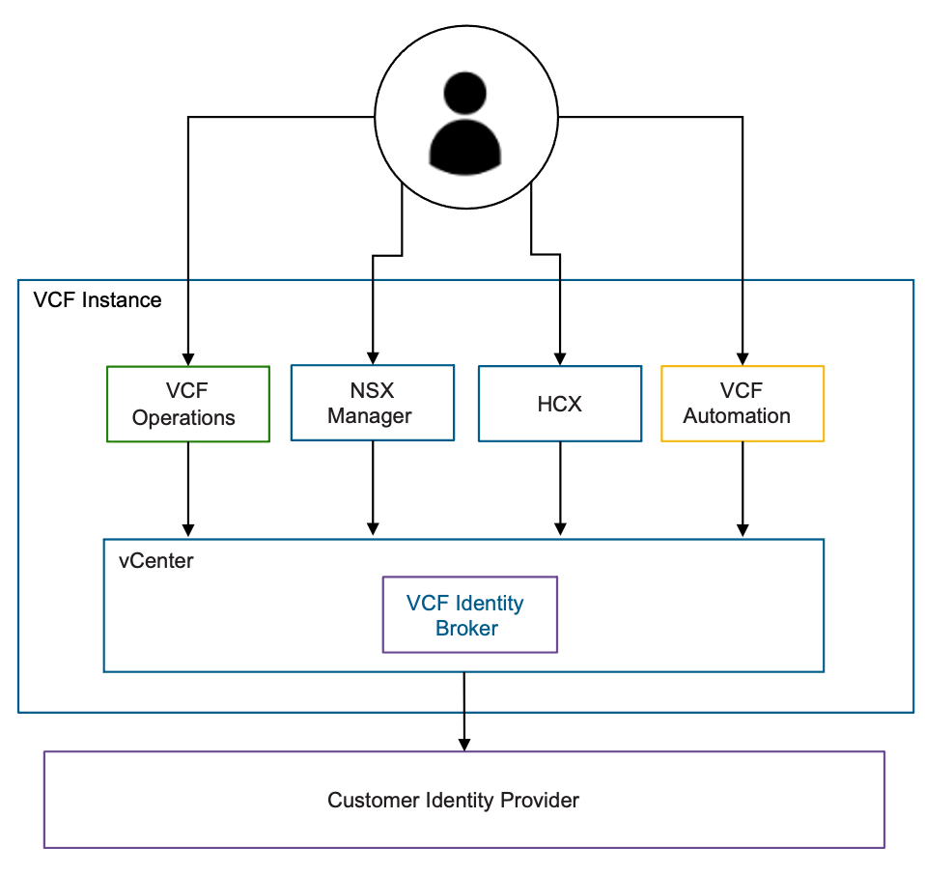

Embedded VCF Identity Broker Attributes
The Embedded VCF Identity Broker Model has the following attributes.
Attribute | Detail
Service Location | VCF Identity Broker runs as a service within the management domain vCenter.
Deployment mechanism | As an embedded service running on vCenter, no additional deployment is required.
Number of Nodes | 1 (As part of vCenter)
Deployment Timing | As an embedded service running on vCenter, no additional deployment is required.
Scale considerations | One VCF Identity Broker per VCF instance.
Supported services | For support directories and IdPs, see Identity Providers and Protocols Supported for Single Sign-On.
Backup and restore | As part of the vCenter Backup/Restore.
High Availability | High Availability is provided by vSphere HA as this service runs as part of the vCenter appliance.
Operational Impacts | As this services run as part of vCenter, maintenance tasks performed on the vCenter instance also impact your ability to authenticate to the VMware Cloud Foundation components.
Migration path | To migrate from embedded to the appliance it requires a reset of the VCF Single Sign-On configuration. Users must be re-added to components.

Embedded VCF Identity Broker Model Design Requirements
Table 3-726. Embedded VCF Identity Broker Model Design Requirements
Design Requirement ID | Design Requirement | Justification | Implications
VCF-SSO-REQD-EMB-001 | Leverage the embedded VCF Identity Broker in the first management domain vCenter. | Simplifies the authentication configuration for the VMware Cloud Foundation platform.  Simplifies the operational overhead. | Limits the Scale supported by the embedded model.  Limits the availability of the authentication service in a VMware Cloud Foundation platform.
VCF-SSO-REQD-EMB-002 | Connect the embedded VCF Identity Broker to your corporate IdP. | Provides directory service (users and group) and user authentication service to the VCF Identity Broker service. | None.

Appliance VCF Identity Broker Model
To avoid a single point of failure for your authentication services, you can use the Appliance VCF Identity Broker Model, where you deploy a standalone appliance through VCF Operations fleet management prior to performing the VCF Single Sign-On configuration. Use this option if you have critical up-time requirements or a complex multi-instance multi-site VMware Cloud Foundation platform.
Figure 3-102. Appliance VCF Identity Broker Model
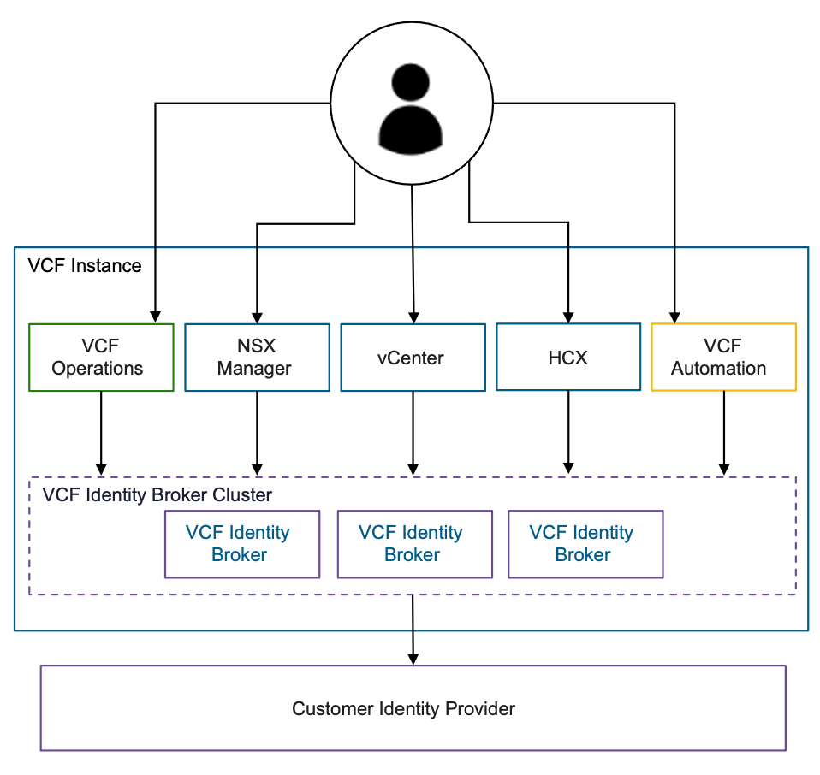

Appliance VCF Identity Broker Model Attributes
The Appliance VCF Identity Broker Model has the following attributes.
Attribute | Detail
Service Location | VCF Identity Broker runs as stand alone appliance.
Deployment mechanism | Deployed through VCF Operations fleet management prior to VCF Single Sign-On configuration.
Number of Nodes | three node cluster.
Deployment Timing | Day 2 Operation
Scale considerations | It is recommended that one VCF Identity Broker support up to 5 VCF instances.
Supported services | For support directories and IdPs, see Identity Providers and Protocols Supported for Single Sign-On.
Backup and restore | Independent Backup/Restore process.
High Availability | High Availability is provided by a distributed 3 node deployment running each node on separate vSphere hosts.
Operational Impacts | As an isolated, external service, operational tasks performed on vCenter do not impact the authentication stack of the VMware Cloud Foundation components.
Migration path | To migrate from the appliance to embedded requires a reset of the VCF Single Sign-On configuration. Users must be re-added to components.

Appliance VCF Identity Broker Model Design Requirements
Table 3-727. Appliance VCF Identity Broker Model Design Requirements
Design Requirement ID | Design Requirement | Justification | Implications
VCF-SSO-REQD-EXT-001 | Deploy the appliance VCF Identity Broker in the first management domain vCenter. | Provides high availability to the authentication source for a VCF Instance.  Provides additional scale. | Increases the operational overhead of managing the VCF Identity Broker service.
VCF-SSO-REQD-EXT-002 | Connect the appliance VCF Identity Broker to your corporate IdP. | Provides directory services (users and group) and user authentication service to the VCF Identity Broker service. | None.

VCF Single Sign-On Detailed Design
VMware Cloud Foundation includes support for one or more VCF Single Sign-On Models. This section describes the options, requirements and recommendations for each VCF Single Sign-On Model.
VCF Fleet-Wide Single Sign-On Model
Cross VCF Instance Single Sign-On Model
Single VCF Instance Single Sign-On Model

VCF Fleet-Wide Single Sign-On Model
With this topology each VCF fleet contains a single VCF Identity Broker deployment. A user can log in once and gain VCF Single Sign-On capabilities for all components across all VCF instances in the same VCF fleet.
For each of these VCF Single Sign-On Models, both VCF Identity Broker Models are supported (embedded and appliance), however it is recommended to use the Appliance VCF Identity Broker Model for multi-VCF Instance Single Sign-On deployments due to availability and scale.
Figure 3-103. VCF Fleet-Wide Single Sign-On Model
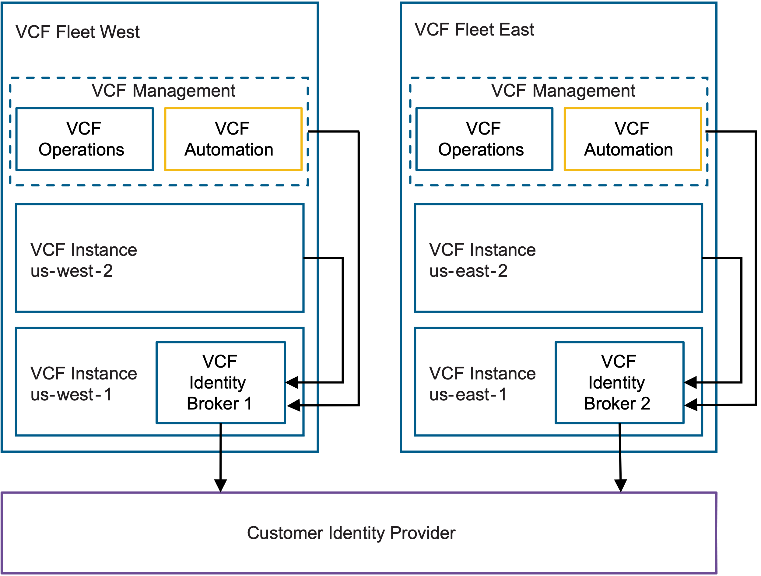
Table 3-728. VCF Fleet-Wide Single Sign-On Model Attributes
Attribute | Detail
Scale | Low Scale - A single VCF Identity Broker services all VCF Instances in your VCF fleet.
Resources requirements | Low Resource Footprint - A single VCF Identity Broker deployment is required for one VCF fleet.
Operational Overhead | Low Operational Overhead - A VCF Identity Broker per VCF fleet will need to be managed separately for operational tasks such as backup / restore.
Availability | Low Availability per Private Cloud - A single VCF Identity Broker servicing all VCF Instances in your VCF fleet.
Blast Radius | Large Blast Radius - An outage of one VCF Identity Broker appliance will impact logins for a single VCF fleet.
Single Sign-On scope | Large SSO Scope - Users will not need to re-authenticate when moving between different VCF instances within the same VCF fleet..
Table 3-729. VCF Fleet-Wide Single Sign-On Design Model Design Requirements
Design Requirement ID | Design Requirement | Justification | Implications
VCF-SSO-REQD-VFL-001 | Deploy VCF Identity Broker in the management domain of the first VCF Instance. | Provides an authentication service for the first VCF Instance.  Provides VCF Single Sign-On capabilities to the first VCF Instance. | Workload domains will use the same authentication source as management domain
VCF-SSO-REQD-VFL-002 | Configure additional VCF Instances in the VCF fleet to consume the same VCF Identity Broker configured in the first VCF Instance. | Provides an authentication source for all components in the VCF fleet.  Provides VCF Single Sign-On capabilities to all components in the VCF fleet. | An impact to the VCF Identity Broker service will impact the VCF fleet.

Cross VCF Instance Single Sign-On Model
The Cross VCF Instance Single Sign-On Model, includes multiple VCF Identity Broker instances. Each VCF Identity Broker instance serves a defined set of VCF instances in the same VCF fleet. VCF management components, such as VCF Operations and VCF Automation, can connect to only one of VCF Identity Broker instances for Single Sign-On.
Figure 3-104. Cross VCF Instance Single Sign-On Model
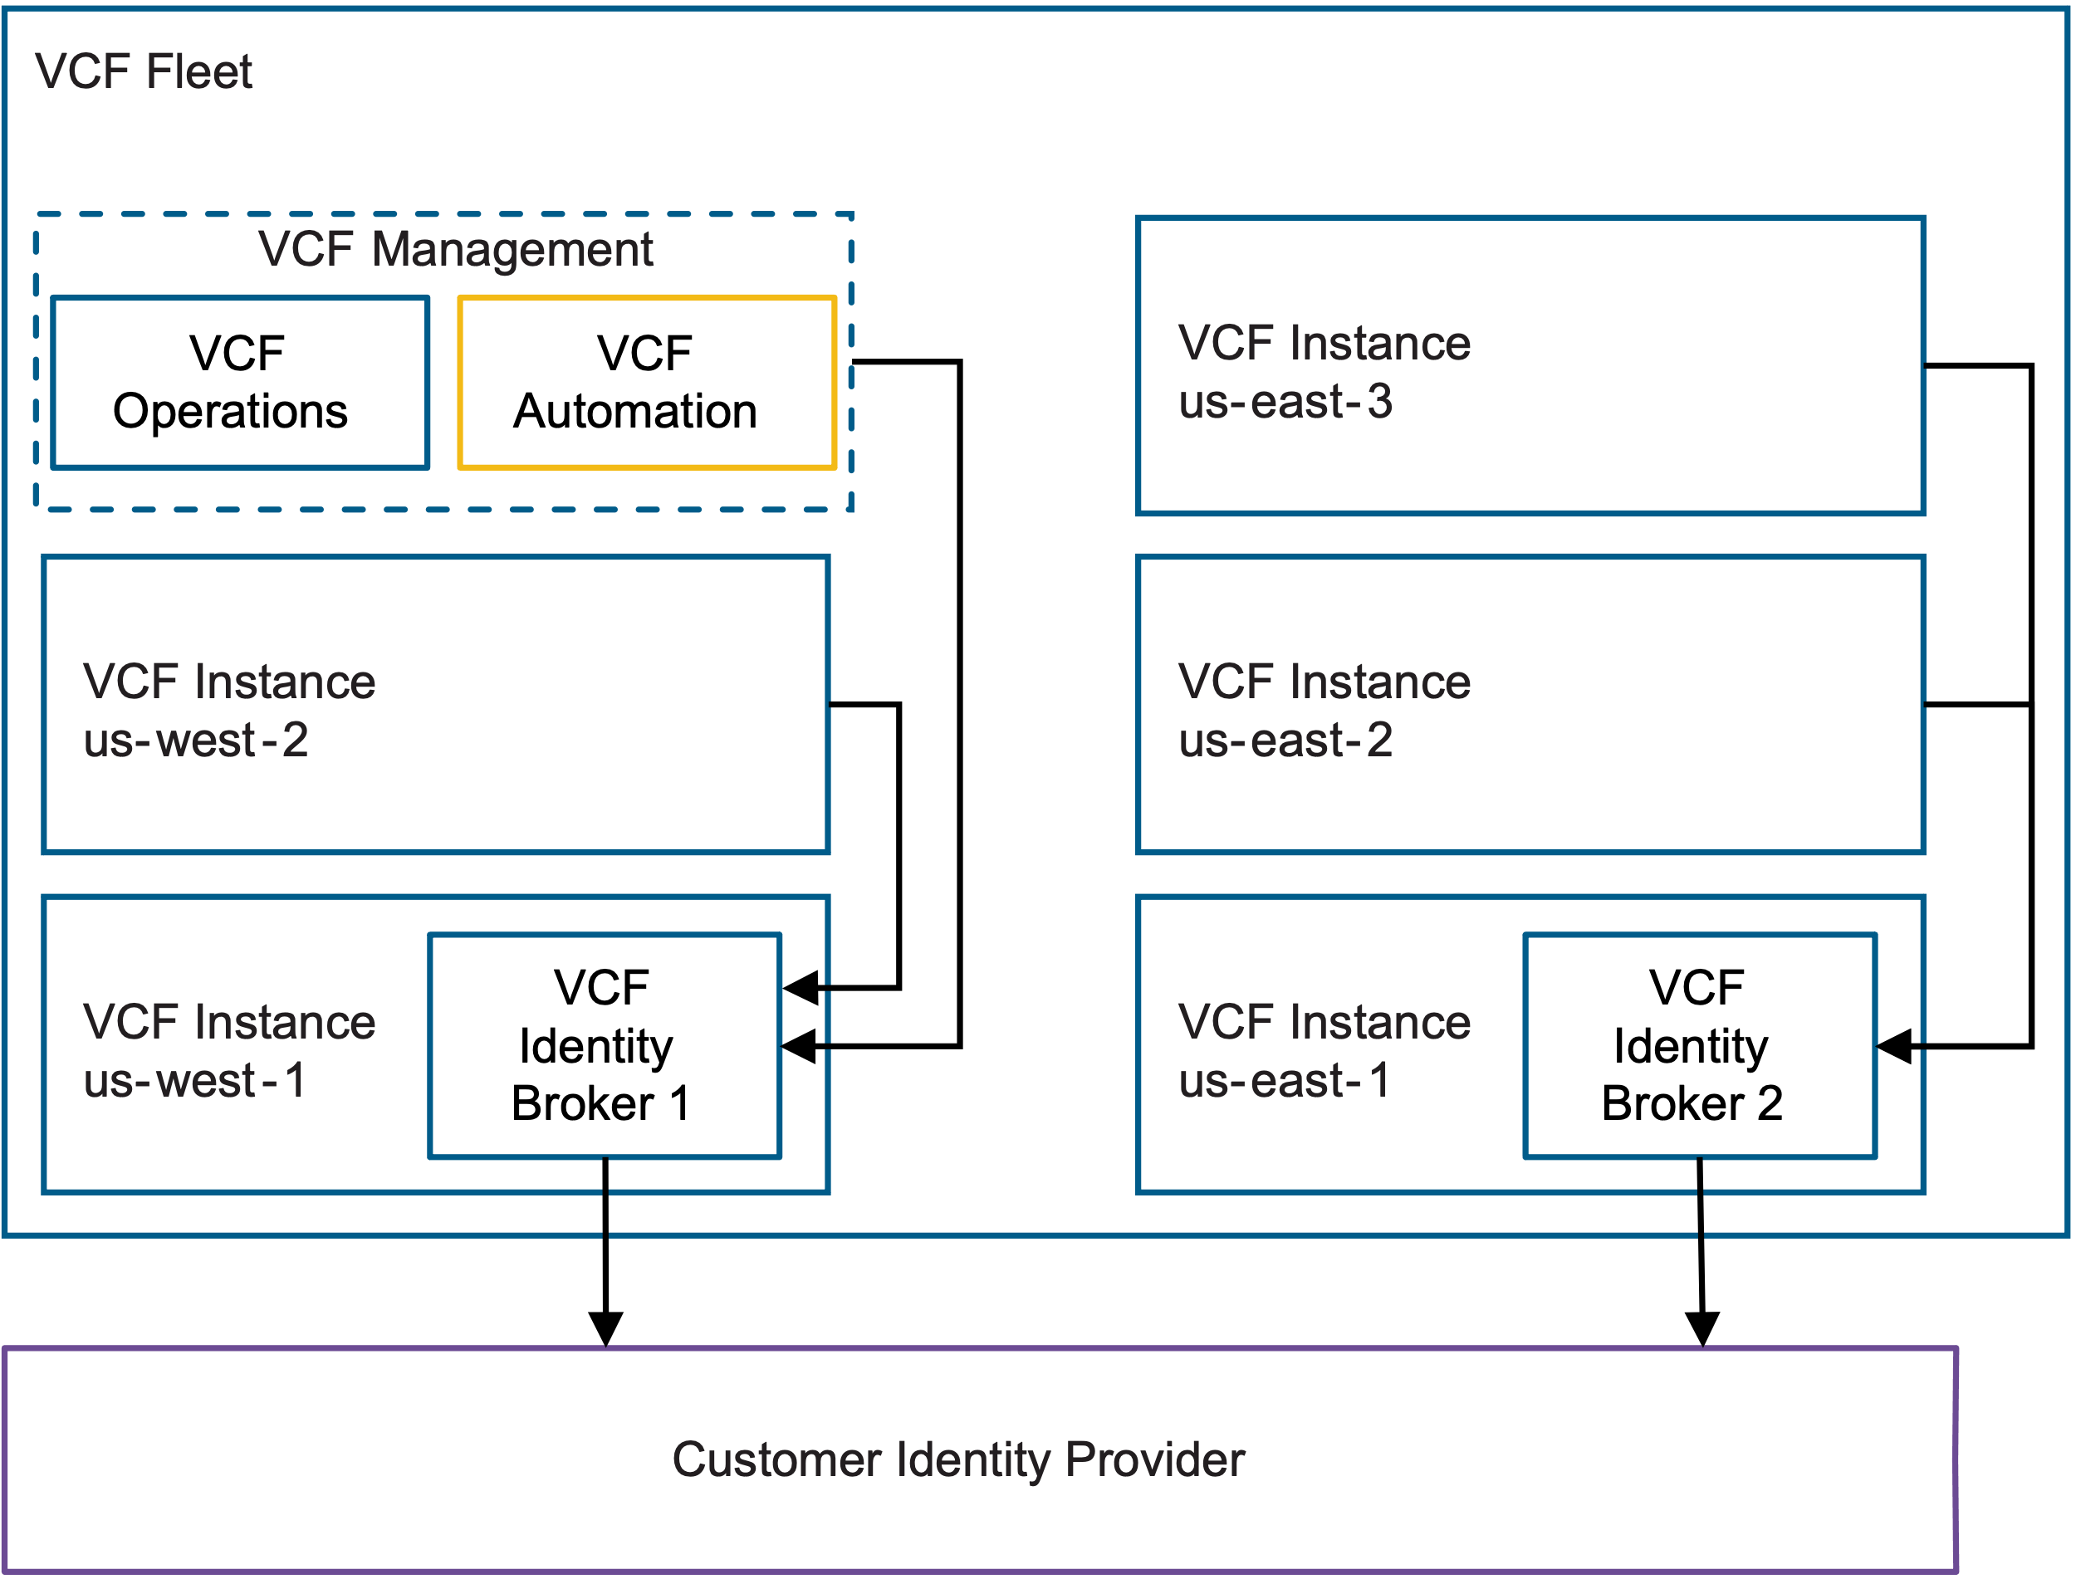
Table 3-730. Cross VCF Instance Single Sign-On Model Attributes
Attribute | Detail
Scale | Balanced Scale - A single VCF Identity Broker services a set of VCF Instances in your VCF fleet.
Resources requirements | Balanced Resource Footprint - Additional VCF Identity Broker deployment will require additional compute / memory / storage.
Operational Overhead | Balanced Operational Overhead - Additional VCF Identity Broker will need to managed separately for operational tasks such as backup / restore.
Availability | Balanced Availability per Private Cloud - A single VCF Identity Broker servicing a set of VCF Instances in the VCF fleet.
Blast Radius | Balanced Blast Radius - An outage of your VCF Identity Broker deployment will impact authentication across a set of VCF Instances connected to this VCF Identity Broker.
Single Sign-On scope | Balanced SSO Scope - With one VCF Identity Broker deployment for a set of VCF Instances, users authentication will carry across instances in the same fleet requiring no additional re-authentication.
Table 3-731. Cross VCF Instance Single Sign-On Model Design Requirements
Design Requirement ID | Design Requirement | Justification | Implications
VCF-SSO-REQD-VCI-001 | Deploy VCF Identity Broker in the management domain of a VCF Instance. | Provides an authentication source for the VCF Instance.  Provides VCF Single Sign-On capabilities to the VCF Instance. | All VMware Cloud Foundation platform components will use the same authentication source.
VCF-SSO-REQD-VCI-002 | Configure additional VCF Instances in the same VCF fleet to consume the same VCF Identity Broker configured in the first VCF Instance. | Provides an authentication source for all components in the configured VCF Instances.  Provides VCF Single Sign-On capabilities to all components in the configured VCF Instances. | Any impact to the VCF Identity Broker service will impact all VCF Instances configured to use it.

Single VCF Instance Single Sign-On Model
With this topology each VCF Instance will utilize its own dedicated VCF Identity Broker. The VCF Single Sign-On scope will be limited to the VCF Instance. VCF management components, such as VCF Operations and VCF Automation, can connect to only one of VCF Identity Broker instances for Single Sign-On.
Figure 3-105. Single VCF Instance Single Sign-On Model
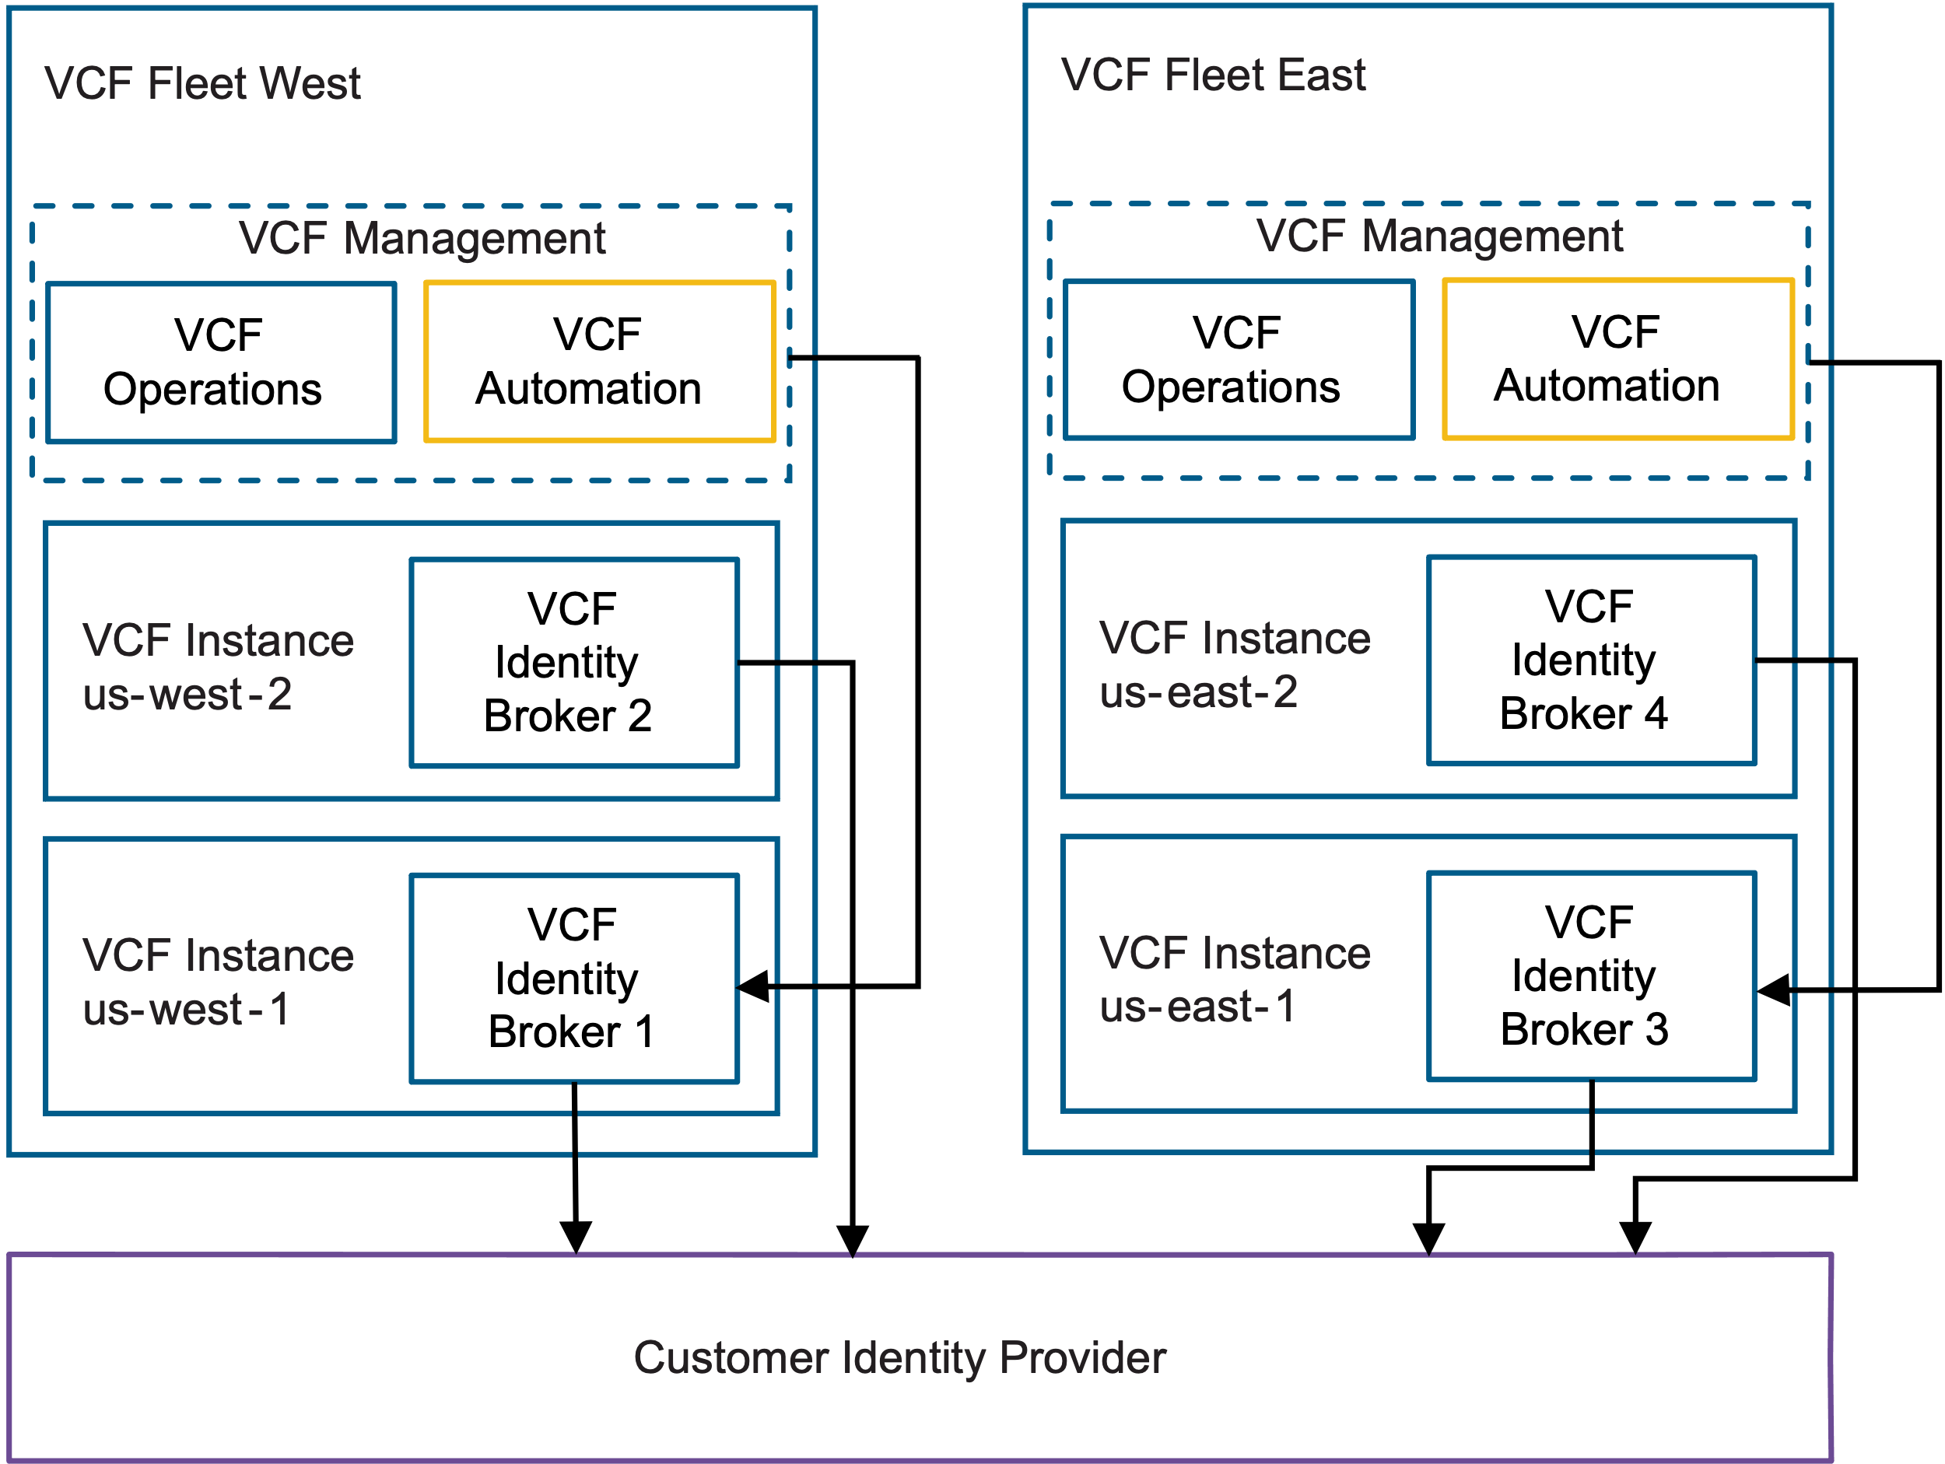
Table 3-732. Single VCF Instance Single Sign-On Model Attributes
Attribute | Detail
Scale | High Scale - A single VCF Identity Broker services each VCF Instance.
Resources requirements | Large Resource Footprint - Each VCF Identity Broker deployment will require additional compute / memory / storage resources.
Operational Overhead | High Operational Overhead - Each VCF Identity Broker will need to be managed separately for operational tasks such as backup / restore.
Availability | High Availability per Private Cloud - A single VCF Identity Broker servicing each VCF Instance.
Blast Radius | Small Blast Radius - An outage of one VCF Identity Broker instance will only impact logins for the VCF Instance associated with it.
Single Sign-On scope | Small SSO scope - For each VCF Identity Broker deployment users will have an additional Single Sign-On scope. Moving across instances will require re-entering credentials.
Table 3-733. Single VCF Instance Single Sign-On Design Model Design Requirements
Design Requirement ID | Design Requirement | Justification | Implications
VCF-SSO-REQD-VSI-001 | Deploy VCF Identity Broker in the management domain of the first VCF Instance. | Provides an authentication service for the first VCF Instance.  Provides VCF Single Sign-On capabilities to the first VCF Instance. | Workload domains will use the same authentication source as management domain.

NSX Management and Control Plane Detailed Design
Following the principles of this design and of each product, you determine the size, deploy and configure NSX Manager as part of your VMware Cloud Foundation deployment.

NSX Manager Model
When you deploy NSX Manager appliances, either with a local or global scope, you deploy the appliance with a size and availability suitable for your environment's scale and availability requirements.

NSX Global Manager Model
For an environment with multiple VCF Instances, you can use NSX Federation, which requires the manual deployment of NSX Global Manager nodes. Consider the placement requirements for using NSX Global Manager in VCF, and the best practices for having an NSX Global Manager cluster operate in an optimal way, such as the number and size of the nodes and high availability on a standard or stretched management cluster.

Simple NSX Manager Model
This model addresses use cases requiring a minimal infrastructure footprint, lower scale, and lower availability requirements.

Simple NSX Manager Model Attributes
Attribute | Detail
Deployment Size | Single NSX Manager Appliance with Internal VIP
Availability | vSphere HA protects the node applying high restart priority  Slower recovery from node failure
Infrastructure Impact during Upgrade | Management and control plane impacted during upgrade operations.  Deployment/Power-on/Restart/vMotion of VMs may be impacted.
Virtual Networking Scale | Reduced scale
API Request Scale | Limited scale
Table 3-734. Common NSX Manager Design Requirements for All Models
Design Requirement ID | Design Requirement | Justification | Implication
VCF-NSX-LM-REQD-CFG-001 | Place the appliances of the NSX Manager cluster on the VM management network in the management domain. | Simplifies IP addressing for management compomentes by using the same VLAN and subnet.  Provides simplified secure access to management components in the same VLAN network. | None.
VCF-NSX-LM-REQD-CFG-002 | Create a virtual IP (VIP) address for the NSX Manager cluster for the workload domain. | Utilized for user interface and API of NSX Manager.  In a clustered configuration, provides high availability.  In a non-clustered configuration, prepares for future expansion. | In a clustered configuration, the VIP address feature provides high availability only. It does not load-balance requests across the cluster.  When using the VIP address feature, all NSX Manager nodes must be deployed on the same Layer 2 network.
VCF-NSX-LM-REQD-CFG-003 | In vSphere HA, set the restart priority policy for each NSX Manager appliance to high. | NSX Manager implements the control plane for virtual network segments. vSphere HA restarts the NSX Manager appliances first so that other virtual machines that are being powered on or migrated by using vSphere vMotion while the control plane is offline lose connectivity only until the control plane quorum is re-established.  Setting the restart priority to high reserves the highest priority for flexibility for adding services that must be started before NSX Manager. | If the restart priority for another management appliance is set to highest, the connectivity delay for management appliances will be longer.
Table 3-735. Common NSX Manager Model Design Recommendations for All Models
Design Recommendation ID | Design Recommendation | Justification | Implication
VCF-NSX-LM-RCMD-CFG-001 | Deploy appropriately sized nodes in the NSX Manager cluster for the workload domain.  Note Check VMware Configuration Maximums to select the right NSX Managers form factor for your scale needs. | Ensures resource availability and usage efficiency per workload domain. | You must have sufficient resources in the management domain default vSphere cluster to run three (3) NSX Manager nodes.
Table 3-736. NSX Manager Simple Deployment Model Design Requirements
Design Requirement ID | Design Requirement | Justification | Implication
VCF-NSX-LM-REQD-CFG-004 | Deploy a single NSX Manager node in the management domain default vSphere cluster for configuring and managing the network services for the VCF domain. | Supports the objective of a small scale deployment. | Slower recovery from node failure.  Management and control plane impacted during upgrade operations.  Supports limited scale.
Table 3-737. Common NSX Manager Design Recommendations for Stretched Clusters for All Models
Design Recommendation ID | Design Recommendation | Justification | Implication
VCF-NSX-LM-RCMD-CFG-002 | Add the NSX Manager appliances to the virtual machine group for the first availability zone. | Ensures that, by default, the NSX Manager appliances are powered on a host in the primary availability zone. | None.

High Availability NSX Manager Model
This model addresses use cases requiring the highest scale, optimized operations, and maximum availability requirements.

High Availability NSX Manager Model Attributes
Attribute | Detail
Deployment Size | Three-node cluster of NSX Manager appliances with internal virtual IP
Availability | Highly available cluster of virtual IP NSX Manager appliances with rapid recovery of a single-node failure.  vSphere HA recovers a node applying high restart priority  Anti-affinity rule to keep cluster nodes on different ESX hosts.
Infrastructure Impact during Upgrade | No impact to control plane during upgrade operations.
Virtual Networking Scale | Enterprise scale up to NSX configuration maximums
API Request Scale | Internal virtual IP directs API requests to a single NSX Manager appliance
Table 3-738. Common NSX Manager Design Requirements for All Models
Design Requirement ID | Design Requirement | Justification | Implication
VCF-NSX-LM-REQD-CFG-001 | Place the appliances of the NSX Manager cluster on the VM management network in the management domain. | Simplifies IP addressing for management compomentes by using the same VLAN and subnet.  Provides simplified secure access to management components in the same VLAN network. | None.
VCF-NSX-LM-REQD-CFG-002 | Create a virtual IP (VIP) address for the NSX Manager cluster for the workload domain. | Utilized for user interface and API of NSX Manager.  In a clustered configuration, provides high availability.  In a non-clustered configuration, prepares for future expansion. | In a clustered configuration, the VIP address feature provides high availability only. It does not load-balance requests across the cluster.  When using the VIP address feature, all NSX Manager nodes must be deployed on the same Layer 2 network.
VCF-NSX-LM-REQD-CFG-003 | In vSphere HA, set the restart priority policy for each NSX Manager appliance to high. | NSX Manager implements the control plane for virtual network segments. vSphere HA restarts the NSX Manager appliances first so that other virtual machines that are being powered on or migrated by using vSphere vMotion while the control plane is offline lose connectivity only until the control plane quorum is re-established.  Setting the restart priority to high reserves the highest priority for flexibility for adding services that must be started before NSX Manager. | If the restart priority for another management appliance is set to highest, the connectivity delay for management appliances will be longer.
Table 3-739. Common NSX Manager Model Design Recommendations for All Models
Design Recommendation ID | Design Recommendation | Justification | Implication
VCF-NSX-LM-RCMD-CFG-001 | Deploy appropriately sized nodes in the NSX Manager cluster for the workload domain.  Note Check VMware Configuration Maximums to select the right NSX Managers form factor for your scale needs. | Ensures resource availability and usage efficiency per workload domain. | You must have sufficient resources in the management domain default vSphere cluster to run three (3) NSX Manager nodes.
Table 3-740. High Availability NSX Manager Model Design Requirements
Design Requirement ID | Design Requirement | Justification | Implication
VCF-NSX-LM-REQD-CFG-005 | Deploy three (3) NSX Manager nodes in the management domain default vSphere cluster for configuring and managing the network services for the VCF domain. | Supports high availability of the NSX manager cluster. | You must have sufficient resources in the default cluster of the management domain to run three NSX Manager nodes.
Table 3-741. High Availability NSX Manager Model Design Recommendations
Design Recommendation ID | Design Recommendation | Justification | Implication
VCF-NSX-LM-RCMD-CFG-002 | Apply VM-VM anti-affinity rules in vSphere Distributed Resource Scheduler (vSphere DRS) to the NSX Manager appliances. | Keeps the NSX Manager appliances running on different ESX hosts for high availability. | You must allocate at least four physical hosts so that the three NSX Manager appliances continue running if an ESX host failure occurs.
Table 3-742. Common NSX Manager Design Recommendations for Stretched Clusters for All Models
Design Recommendation ID | Design Recommendation | Justification | Implication
VCF-NSX-LM-RCMD-CFG-002 | Add the NSX Manager appliances to the virtual machine group for the first availability zone. | Ensures that, by default, the NSX Manager appliances are powered on a host in the primary availability zone. | None.

High Availability NSX Manager With External Load Balancer Model
This model addresses use cases requiring improved API performance while maintaining highest scale, optimized operations, and maximum availability.

High Availability NSX Manager With External Load Balancer Model Attributes
Attribute | Detail
Deployment Size | 3-node cluster of NSX Manager appliances with internal virtual IPs for management.  Additional virtual IP on external Load Balancer for API requests
Availability | Highly available cluster of NSX Manager appliances with rapid recovery of a single-node failure.  vSphere HA recovers a node applying high restart priority  Anti-affinity rule to keep cluster nodes on different ESX hosts.
Infrastructure Impact during Upgrade | No impact to control plane during upgrade operations.
Virtual Networking Scale | Enterprise scale up to NSX Configuration Maximums
API Request Scale | Increase API based management scale for high-churn environments.  External virtual IP distributes API requests across all NSX Manager nodes.
Table 3-743. Common NSX Manager Design Requirements for All Models
Design Requirement ID | Design Requirement | Justification | Implication
VCF-NSX-LM-REQD-CFG-001 | Place the appliances of the NSX Manager cluster on the VM management network in the management domain. | Simplifies IP addressing for management compomentes by using the same VLAN and subnet.  Provides simplified secure access to management components in the same VLAN network. | None.
VCF-NSX-LM-REQD-CFG-002 | Create a virtual IP (VIP) address for the NSX Manager cluster for the workload domain. | Utilized for user interface and API of NSX Manager.  In a clustered configuration, provides high availability.  In a non-clustered configuration, prepares for future expansion. | In a clustered configuration, the VIP address feature provides high availability only. It does not load-balance requests across the cluster.  When using the VIP address feature, all NSX Manager nodes must be deployed on the same Layer 2 network.
VCF-NSX-LM-REQD-CFG-003 | In vSphere HA, set the restart priority policy for each NSX Manager appliance to high. | NSX Manager implements the control plane for virtual network segments. vSphere HA restarts the NSX Manager appliances first so that other virtual machines that are being powered on or migrated by using vSphere vMotion while the control plane is offline lose connectivity only until the control plane quorum is re-established.  Setting the restart priority to high reserves the highest priority for flexibility for adding services that must be started before NSX Manager. | If the restart priority for another management appliance is set to highest, the connectivity delay for management appliances will be longer.
Table 3-744. Common NSX Manager Model Design Recommendations for All Models
Design Recommendation ID | Design Recommendation | Justification | Implication
VCF-NSX-LM-RCMD-CFG-001 | Deploy appropriately sized nodes in the NSX Manager cluster for the workload domain.  Note Check VMware Configuration Maximums to select the right NSX Managers form factor for your scale needs. | Ensures resource availability and usage efficiency per workload domain. | You must have sufficient resources in the management domain default vSphere cluster to run three (3) NSX Manager nodes.
Table 3-745. High Availability NSX Manager With External Load Balancer Model Design Requirements
Design Requirement ID | Design Requirement | Justification | Implication
VCF-NSX-LM-REQD-CFG-006 | Deploy three (3) NSX Manager nodes in the management domain default vSphere cluster for configuring and managing the network services for the workload domain. | Supports high availability of the NSX manager cluster. | You must have sufficient resources in the default cluster of the management domain to run three NSX Manager nodes.
Table 3-746. High Availability NSX Manager With External Load Balancer Model Design Recommendations
Design Recommendation ID | Design Recommendation | Justification | Implication
VCF-NSX-LM-RCMD-CFG-003 | Apply VM-VM anti-affinity rules in vSphere Distributed Resource Scheduler (vSphere DRS) to the NSX Manager appliances. | Keeps the NSX Manager appliances running on different ESX hosts for high availability. | You must allocate at least four physical hosts so that the three NSX Manager appliances continue running if an ESX host failure occurs.
VCF-NSX-LM-RCMD-CFG-004 | Create an additional virtual IP (VIP) address for the NSX Manager cluster for the workload domain and assign it to an externally provided load balancer. | Provides separte VIP for stateless API requests.  Internal VIP is reserved for session persistant management UI usage. | Requires additional IP address.
VCF-NSX-LM-RCMD-CFG-005 | Configure external load balancer to round-robin traffic without source persistence between the three NSX Manager Node IPs. | Ensures stateless API request traffic is balanced across all available NSX Manager Appliances. | Requires externally managed HTTP load balancer.
VCF-NSX-LM-RCMD-CFG-006 | Configure external load balancer to monitor health of NSX Manager Nodes. | Ensures continuted availabilty of API endpoint during upgrade or outage of a single NSX Manager Appliance. | Requires externally managed HTTP load balancer.
Table 3-747. Common NSX Manager Design Recommendations for Stretched Clusters for All Models
Design Recommendation ID | Design Recommendation | Justification | Implication
VCF-NSX-LM-RCMD-CFG-002 | Add the NSX Manager appliances to the virtual machine group for the first availability zone. | Ensures that, by default, the NSX Manager appliances are powered on a host in the primary availability zone. | None.

High Availability NSX Global Manager Model
This model addresses use cases requiring the highest scale, optimized operations, and maximum availability requirements.

High Availability NSX Global Manager Model Attributes
Attribute | Detail
Deployment Size | 3-node cluster of NSX Manager Appliances with internal virtual IP for management.
Availability | Highly available cluster of NSX Global Manager appliances with rapid recovery of a single node failure.  vSphere HA recovers a node applying high restart priority  Anti-affinity rule to keep cluster nodes on different ESX hosts
Infrastructure Impact during Upgrade | No impact to control plane during upgrade operations.
Virtual Networking Scale | Enterprise scale up to NSX Configuration Maximums
Table 3-748. Common High Availability NSX Global Manager Design Recommendation for VMware Cloud Foundation
Design Recommendation ID | Design Recommendation | Justification | Implication
VCF-NSX-GM-RCMD-CFG-001 | Place the appliances of the NSX Global Manager cluster on the VM management network in each VCF Instance. | Simplifies IP addressing for management VMs.  Provides simplified secure access to all management VMs in the same VLAN network. | None.
VCF-NSX-GM-RCMD-CFG-002 | Deploy appropriately sized nodes in the NSX Global Manager cluster for the workload domain.  Note Check VMware Configuration Maximums to select the right NSX Global Managers form factor for your scale needs. | Ensures resource availability and usage efficiency per workload domain. | Incorrectly sized NSX Global Managers might impact the ability to scale according to the requirements.
VCF-NSX-GM-RCMD-CFG-003 | Create a virtual IP (VIP) address for the NSX Global Manager cluster for the workload domain. | Provides high availability of the user interface and API of NSX Global Manager. | The VIP address feature provides high availability only. It does not load-balance requests across the cluster.  When using the VIP address feature, all NSX Global Manager nodes must be deployed on the same Layer 2 network.
VCF-NSX-GM-RCMD-CFG-004 | In vSphere HA, set the restart priority policy for each NSX Global Manager appliance to medium. | NSX Global Manager implements the management plane for global segments and firewalls.  NSX Global Manager is not required for control plane and data plane connectivity.  Setting the restart priority to medium reserves the high priority for services that impact the NSX control or data planes. | Management of NSX global components will be unavailable until the NSX Global Manager virtual machines restart.  The NSX Global Manager cluster is deployed in the management domain, where the total number of virtual machines is limited and where it competes with other management components for restart priority.
VCF-NSX-GM-RCMD-SEC-001 | Establish an operational practice to capture and update the thumbprint of the NSX Local Manager certificate on NSX Global Manager every time the certificate is updated by using SDDC Manager. | Ensures secured connectivity between the NSX Manager instances.  Each certificate has its own unique thumbprint. NSX Global Manager stores the unique thumbprint of the NSX Local Manager instances for enhanced security.  If an authentication failure between NSX Global Manager and NSX Local Manager occurs, objects that are created from NSX Global Manager will not be propagated to the software-defined network. | The administrator must establish and follow an operational practice by using a runbook or automated process to ensure that the thumbprint is up-to-date.
VCF-NSX-GM-RCMD-CFG-005 | Deploy three (3) NSX Global Manager nodes for the workload domain to support NSX Federation across VCF Instances. | Provides high availability for the NSX Global Manager cluster. | You must have sufficient resources in the management domain default vSphere cluster to run three (3) NSX Global Manager nodes.
VCF-NSX-GM-RCMD-CFG-006 | Apply VM-VM anti-affinity rules in vSphere DRS to the NSX Global Manager appliances. | Keeps the NSX Global Manager appliances running on different ESX hosts for high availability. | You must allocate at least four (4) physical hosts so that the three (3) NSX Manager appliances continue running if an ESX host failure occurs.
Table 3-749. Common High Availability NSX Global Manager Design Recommendations for Stretched Clusters in VMware Cloud Foundation
Design Recommendation ID | Design Recommendation | Justification | Implication
VCF-NSX-GM-RCMD-CFG-007 | Add the NSX Global Manager appliances to the virtual machine group for the first availability zone. | Ensures that, by default, the NSX Global Manager appliances are powered on a host in the primary availability zone. | Must be manually configured.

High Availability with Standby NSX Global Manager Cluster Model
This model ensures enhanced business continuity by implementing a standby NSX Global Manager Cluster.

High Availability with Standby NSX Global Manager Model Attributes
Attribute | Detail
Deployment Size | Two NSX Global Manager clusters  3-node active cluster of NSX Manager appliances with internal virtual IP for management  3-node standby cluster of NSX Manager appliances with internal virtual IP for management.
Availability | Highly available cluster of NSX Global Manager appliances with rapid recovery of a single-node failure.  vSphere HA recovers a node applying high restart priority  Anti-affinity rule to keep cluster nodes on different ESX hosts  Replication from active cluster to standby cluster  Ability to promote standby cluster to active.
Infrastructure Impact during Upgrade | No impact to control plane during upgrade operations.
Virtual Networking Scale | Enterprise scale up to NSX Configuration Maximums
Table 3-750. Common High Availability NSX Global Manager Design Recommendation for VMware Cloud Foundation
Design Recommendation ID | Design Recommendation | Justification | Implication
VCF-NSX-GM-RCMD-CFG-001 | Place the appliances of the NSX Global Manager cluster on the VM management network in each VCF Instance. | Simplifies IP addressing for management VMs.  Provides simplified secure access to all management VMs in the same VLAN network. | None.
VCF-NSX-GM-RCMD-CFG-002 | Deploy appropriately sized nodes in the NSX Global Manager cluster for the workload domain.  Note Check VMware Configuration Maximums to select the right NSX Global Managers form factor for your scale needs. | Ensures resource availability and usage efficiency per workload domain. | Incorrectly sized NSX Global Managers might impact the ability to scale according to the requirements.
VCF-NSX-GM-RCMD-CFG-003 | Create a virtual IP (VIP) address for the NSX Global Manager cluster for the workload domain. | Provides high availability of the user interface and API of NSX Global Manager. | The VIP address feature provides high availability only. It does not load-balance requests across the cluster.  When using the VIP address feature, all NSX Global Manager nodes must be deployed on the same Layer 2 network.
VCF-NSX-GM-RCMD-CFG-004 | In vSphere HA, set the restart priority policy for each NSX Global Manager appliance to medium. | NSX Global Manager implements the management plane for global segments and firewalls.  NSX Global Manager is not required for control plane and data plane connectivity.  Setting the restart priority to medium reserves the high priority for services that impact the NSX control or data planes. | Management of NSX global components will be unavailable until the NSX Global Manager virtual machines restart.  The NSX Global Manager cluster is deployed in the management domain, where the total number of virtual machines is limited and where it competes with other management components for restart priority.
VCF-NSX-GM-RCMD-SEC-001 | Establish an operational practice to capture and update the thumbprint of the NSX Local Manager certificate on NSX Global Manager every time the certificate is updated by using SDDC Manager. | Ensures secured connectivity between the NSX Manager instances.  Each certificate has its own unique thumbprint. NSX Global Manager stores the unique thumbprint of the NSX Local Manager instances for enhanced security.  If an authentication failure between NSX Global Manager and NSX Local Manager occurs, objects that are created from NSX Global Manager will not be propagated to the software-defined network. | The administrator must establish and follow an operational practice by using a runbook or automated process to ensure that the thumbprint is up-to-date.
VCF-NSX-GM-RCMD-CFG-005 | Deploy three (3) NSX Global Manager nodes for the workload domain to support NSX Federation across VCF Instances. | Provides high availability for the NSX Global Manager cluster. | You must have sufficient resources in the management domain default vSphere cluster to run three (3) NSX Global Manager nodes.
VCF-NSX-GM-RCMD-CFG-006 | Apply VM-VM anti-affinity rules in vSphere DRS to the NSX Global Manager appliances. | Keeps the NSX Global Manager appliances running on different ESX hosts for high availability. | You must allocate at least four (4) physical hosts so that the three (3) NSX Manager appliances continue running if an ESX host failure occurs.
Table 3-751. Highly Available with Standby NSX Global Manager Cluster Model Design Recommendations for VMware Cloud Foundation
Design Recommendation ID | Design Recommendation | Justification | Implication
VCF-NSX-GM-RCMD-CFG-008 | Deploy an additional NSX Global Manager Cluster in the second VCF Instance. | Enables recoverability of NSX Global Manager in the second VCF Instance if a failure in the first VCF Instance occurs. | Requires additional NSX Global Manager nodes in the second VCF Iinstance.
VCF-NSX-GM-RCMD-CFG-009 | Set the NSX Global Manager cluster in the second VCF Instance as standby. | Enables recoverability of NSX Global Manager in the second VCF Instance if a failure in the first instance occurs. | None
Table 3-752. Common High Availability NSX Global Manager Design Recommendations for Stretched Clusters in VMware Cloud Foundation
Design Recommendation ID | Design Recommendation | Justification | Implication
VCF-NSX-GM-RCMD-CFG-007 | Add the NSX Global Manager appliances to the virtual machine group for the first availability zone. | Ensures that, by default, the NSX Global Manager appliances are powered on a host in the primary availability zone. | Must be manually configured.

Network Consumption Models
VMware Cloud Foundation (VCF) offers various approaches to network consumption. Administrators can select the model the best suit their requirements regarding how network and security services are created and life-cycled.

VCF Automation All Apps Orgs network consumption model
When the goal is to leverage the VCF infrastructure via VCF Automation via All Apps Orgs, where the management of compute , storage and and network is centralized via single UI/API, the cloud user should not interact directly with the NSX UI/API other than for troubleshooting purposes. The cloud user should create and administer NSX VPCs via the VCF Automation API/UI.

Network Consumption models based on custom topologies
This category encompasses designs where the deployment of workloads and network topologies are decoupled or only loosely coupled. A common example is a scenario where the network administrator manually creates a topology for a specific use case or tenants in NSX, then the VI Admin deploys workloads on top of that manually or via some automation.
Leveraging automation implies that the automation solution can discover the NSX-created networks (e.g., VPC subnets) or the corresponding vSphere dvpgs so that workloads can be connected to them. The automation solution doesn't require any awareness of how those networks are wired into the larger network design, which can be independently controlled by the network administrator in NSX. The network administrators have full freedom to deploy the Network Workload Design that best meets the application requirements. Various Network Workload designs are available and presented in the relevant section. The NSX administrator can select one for the entire infrastructure or mix multiple designs of the same or different types for different tenants or use cases.
The network consumption models based on custom topologies we will cover are:
Virtual Private Cloud (VPC) Network Virtualization model
NSX Segment Network Virtualization model
VLAN Networking model

Virtual Private Cloud (VPC) Network Virtualization model
A VPC is a cloud networking construct, a secure, isolated virtual network within a cloud environment. NSX VPCs bring the same characteristics and consumption model of the public cloud to VCF.
The NSX VPC is a foundational and required component for designs requiring VCF Automation All Apps Orgs, but it is also the recommended network consumption model for any custom topology aimed at supporting the manual deployment of workloads, VCF Automation VM Only Orgs, or third-party automation tools.
Starting with VCF 9, VPCs can be managed from the vCenter inventory networking tab making the vSphere client the single interface for managing compute, network, and storage for simple single-tenant deployments. Multi-tenant deployments not requiring the strong separation provided by VCF Automation All Apps Orgs can leverage VPCs within the NSX multi-tenancy framework to provide self-service network and security services via the NSX UI and API.

NSX Segment Network Virtualization model
This model leverages Policy NSX objects such as Tier-0/Tier-1 Gateways and segments to deploy network topologies. This model allows the Network Administrator to leverage all of the advanced NSX network capabilities but requires more extensive networking and NSX-specific knowledge.
This model does not support VCF Automation All Apps Orgs, and while it does support supervisor services, it is recommended that new deployments of supervisor embrace the VPC-based topology.
For custom topologies, the VPC model is still the preferred approach for its simplicity and seamless integration with other VCF components such as vCenter.
The NSX Segment Network Virtualization model should be considered when the capabilities it provides compared to the VPC model are critical to meeting the design requirements. Among those, the ability to extend network topologies across workload domains in different VCF instances via NSX Federation is a primary use case.
Table 3-753. Comparison between NSX Segment and VPC models
Exclusive capabilities of the NSX Segment Network Virtualization Model | Alternatives when using the VPC Network Virtualization model
NSX Federation:  Stretched Layer 2 and Layer 3 topologies across NSX Domains  Single point of management for security policies across NSX Domains  VM Mobility across NSX Domains | Use a shared NSX Domain across VI WLDs  With separate NSX Domains, the NSX Enterprise Admin can leverage NSX federation to provide a single point of management for security policies across VPCs in different NSX domains  Duplicating VPCs with the same networking layout across NSX Domains allows the recovery of VMs one VPC at a time (It requires filtering the VPC IP ranges at the secondary site on the upstream Tier-0 gateway or VRF until the recovery process is initiated)
VPNs on Tier-1 Gateways | Configure VPNs on upstream VRF or Tier-0 Gateway, where dynamic routing is supported and peer redundancy can be provided.
Advanced Security Features supported on Tier-1 Gateway (Firewall Add-On required):  Identity Firewall  URL Filtering  FQDN Analysis  IDS/IPS  Malware Detection  TLS Inspection | Enable those capabilities on the upstream VRF or Tier-0 Gateway when supported(i.e., IDS/IPS, Identity Firewall), Firewall Add-On is required  Enable the equivalent Distributed Service when available (i.e. Distributed IDS/IPS or Distributed Malware Protection), Firewall Add-On is required

VLAN Networking Model
In this model, the only VCF component participating in the networking functionalities is the VDS, responsible for switching the traffic between the VMs running in the hypervisor and the physical uplinks. Once the packets are delivered to the upstream physical switch, it is the responsibility of the physical fabric to deliver them to the appropriate destination.Virtual machines are connected to distributed port-groups or NSX VLAN segments.
This model lacks the benefits provided by the NSX network virtualization which decouples the physical network from the topology requirements of the applications and services that run on top of it. With network virtualization, the physical fabric can be designed and operated based on a simpler and more stable model that does not require following the application's lifecycle. The role of adapting to the ever-changing application requirements is offloaded to the NSX network virtualization layer while the physical fabric design can be centered around maximizing throughput and high availability, minimizing latency, and optimizing operational efficiency.
The VLAN networking model is supported in VCF and may be appropriate for specific use cases, but it is not recommended for the majority of scenarios as it lacks the benefits provided by network virtualization. The benefits of network virtualization are summarized in the table below.

Comparison VLAN Networking vs Network Virtualization (VPC or NSX Segment)
Attribute | VLAN Networking | Network Virtualization (VPC or Policy NSX)
VM Mobility | VM mobility is limited to the span of a VLAN (usually one rack) | VM mobility across Layer 3 boundaries – any topology
Rack Availability | Achieving rack availability via vSphere HA is not possible without extending VLANs between racks | Easy to achieve rack availability via vSphere HA for compute workloads regardless of the network fabric topology
Resource Pooling | Resource pooling is limited by the VLAN span | Heterogenous islands of computing are easily integrated. vSphere clusters can be distributed across N racks regardless of the network fabric topology
Infrastructure Agility | Slow application deployment dependent on physical network reconfigurations | The physical network is abstracted. No changes are required to support the application lifecycle
Change Management | Network changes require the reconfiguration of multiple devices | Single point of management for the entire logical network. The network can embrace an Infrastructure as Code (IoC) approach, where network constructs follow the application lifecycle
Disaster Recovery | Disaster recovery requires re-IP or extending networks across sites via the physical network | Easy disaster recovery without re-IP via NSX Federation (NSX Segment only) or Multi-AZ design.
L2 Scale | Fundamentally tied to MAC learning and L2 discovery over different types of underlay technology (e.g., traditional L2, EVPN) | Programmed from vSphere, and thus no MAC learning and abstracted from the physical network, reducing the leaf switch scale requirements
L2 Security | Physical fabric is directly exposed to L2 frames generated by the VMs (e.g., STP BPDU) | NSX Overlay isolates the physical fabric from the Layer 2 frames generated by the endpoints
Support of Advanced Networking (i.e., NAT, Firewall) | Tied to physical ASIC and limited by switch vendor | Software-defined allows scaling of the networking and security stack
When using VLAN networking two options are available:
Create distributed port-groups (dvpgs) in vCenter
Create VLAN Segments in NSX Manager
When enabling "NSX on dvgps" for a vSphere cluster in NSX, workloads connected to dvpgs can leverage the same NSX distributed services as those connected to NSX Segments or VPC subnets. Those services include the vDefend Distributed Firewall (available as an advanced service), spoofguard, and any other services that can be applied via NSX segment profiles.
To use VLAN segments, workloads must be placed on the NSX-managed distributed virtual port groups that are automatically created when a VLAN segment is defined in NSX.
From a scalability perspective, using VLAN segments is better suited for larger environments with a high number of VDSs, vCenters, and dvpgs. When creating a VLAN segment in NSX, a corresponding vCenter dpvg is automatically created on any VDS part of the corresponding VLAN TZ. This provides simpler lifecycle management of VLAN networks via NSX manager in environments with numerous VDSs, across single or multiple vCenters. This consideration is particularly relevant for VMware Cloud Foundation platforms where each vSphere cluster has a dedicated VDS, increasing the number of VDSs and dvpgs to be managed.
Table 3-754. Comparison Distributed Switch Port-Groups vs VLAN Segments
Feature | Option 1: vCenter Distributed Switch Port-Groups | Option 2: NSX VLAN Segments
Creation Method | Created directly in vCenter | Created in NSX Manager
NSX Services Support | Supported via "NSX on dvpgs" feature | Natively supported
Compatible Services | Distributed firewall, spoofguard, segment profiles (They require applying NSX to distributed port-groups) | Distributed firewall, spoofguard, segment profiles
Workload Placement | VMs connected to vCenter-managed dvpgs | VMs connected to NSX-managed dvpgs (auto-created)
Scalability | Suitable for smaller environments | Better for larger environments with many VDSs and vCenters
Lifecycle Management | Individual management of dvpgs in vCenter | Simplified management through NSX Manager
Multi-VDS Deployment | Requires manual creation of dvpgs on each VDS | Auto-creates corresponding dvpgs on all VDSs in VLAN TZ

NSX Federation
NSX Federation provides a single point of management for workload networking and security across NSX domains, regardless if those NSX domains are associated to workload domains, within, or across VCF Instances.
NSX Federation is compatible with all the network consumption models listed in the previous section but the level of integration and the benefits it can provide vary across them. The table below summarize its capabilities in the context of each of the available network consumption models.
The capabilities considered are :
NSX Enterprise Admin centrally manages security policy and groups across NSX Domains
Layer 2 and Layer 3 network topology extension across NSX Domains
Note Tenant (NSX Project) admins, and VPC admins do not have the ability to configure global groups and security policies spanning multiple NSX Domains, nor managing local groups and security policies for multiple NSX Domains via the NSX Global Manager.
Table 3-755. NSX Federation capabilities in the different Network Consumption Models
Network Consumption Model
 | NSX Enterprise Admin centrally manages security policy and groups across NSX Domains | Layer 2 and Layer 3 network topology extension across NSX Domains
VCF Automation All Apps Orgs | Yes. Tenant or VPC scoped groups and security policies are local to a single NSX Domain. | No
Virtual Private Cloud (VPC) Network Virtualization | Yes. Tenant or VPC scoped groups and security policies are local to a single NSX Domain. | No
NSX Segment Network Virtualization | Yes | Yes
VLAN Networking | Yes | No
When extending networking and security services across workload domains part of the same VCF Instance, the goal can be achieved via NSX Federation or by sharing the NSX domain across the workload domains. When extending networking and security services across workload domains as part of different VCF Instances, NSX Federation is the only option. For workload domains that are part of the same VCF Instance, the two methods are compared in the table below
Table 3-756. Comparison of NSX Federation vs Shared NSX Domain Capabilities for cross Workload Domain Networking
Attribute | NSX Federation | Shared NSX domain | Considerations
Cross workload domain traffic | Cross workload domain traffic goes trough the NSX Edge nodes. | Cross workload domain traffic leverages fully distributed forwarding on the ESX host. | Consider the amount of cross workload domain traffic. If NSX Federation is selected, size the NSX Edge node accordingly, and distribute workloads on separate segments and Tier-1 gateways to spread the load across multiple NSX Edge nodes.
MTU | Cross workload domain traffic supports any MTU via TCP mss adjustment and fragmentation. | Appropriate MTU must be available end-to-end (workload MTU + 200 bytes). | If MTU cannot be guaranteed end-to-end, NSX Federation provides a solution.
Local egress | Yes | No | Implementing Local egress causes asymmetric north-south routing across the workload domains unless each stretched segment has workloads in a single workload domain and inbound routing is configured appropriately.
Management plane availability | Active/Standby model for Global Managers. Active and Standby clusters can be deployed in the same or different VCF Instances. Layer 3 connectivity is required. No layer2 connectivity is required between Active and Standby Global Manager cluster. | Single NSX Manager cluster across workload domain. Recovery must be provided by the underlying infrastructure, for example via a stretched vSphere cluster. | NSX Federation is the preferred solution for disaster recovery use cases.
Control plane availability | Independent per workload domain. | Shared across workload domains. | In a design with a shared NSX domain accross workload domains model requiring the recovery of workloads across such workload domains, workloads cannot be recovered until the control plane (NSX Manager appliances) is recovered. This limitation does not affect designs based on NSX Federation as each workload domain has an independent local control plane.
Feature support | Some NSX features are not available.  Refer to the NSX documentation for an up to date comprehensive list. | Full NSX feature support. | When the design requires the adoption of specific capabilities, NSX Federation may not meet those requirements.

Workload Networking Detailed Designs
This section outlines various workload network models for virtualized data center environments.

Overview
The section covers several key topology models including:
VPC with Full Services Model: Offering full centralized services with Active/Standby gateways. It's the only model supported by VMware Kubenetes Engine (VKS) and VCF Automation all Apps Orgs.
VPC Scalable Model: Providing scalable North-South throughput with Active/Active gateways
VPC Getting-Started Model: A simplified deployment without NSX Edge Nodes
Scalable NSX Segment Network Virtualization: Supporting NSX federation and VM mobility across VCF Instances
Large-Scale Composite Topologies Model: Designed for service providers managing multi-tenant environments. It can be based on VPC or NSX Segment consumtion models, or both.
Each workload networking model presents different tradeoffs between simplicity, performance, service availability, and scalability. The corresponding design library elements explain the architecture overview, key benefits, limitations, and specific deployment considerations for each model.

VPC with Full Services Workload Networking Model
The model uses a primary (Tier-0) Gateway configured in Active/Standby mode. It provides a VPC-compatible workload domain with network connectivity established via a Centralized Transit Gateway. Individual tenants connect to the Tier-0 Gateway through their own Active/Standby Transit Gateways (TGWs). This workload networking model is the base building block to support all the VCF Automation tenancy models described in VCF Automation Provider Tenant Models and Multi Tenancy Consumption Patterns. It can also be used in single tenant deployments without the integration with VCF Automation.

VPC with Full Services Workload Networking Model Attributes
A VPC with Full Services Workload Networking Model has the following attributes.
Attribute | Detail
Transit Gateway Type | Centralized
NSX Edge nodes required | Yes
Tier-0 Gateway HA Mode | Active/Standby
Network consumption model | VPC
NSX Tenancy Constructs | NSX Projects, VPCs
Consumption options | vCenter UI/API  VCF Automation All Apps Orgs  vSphere Supervisor (i.e. VM Service, VKS, and more)  NSX UI/API
Provider gateway Type | Tenant Dedicated Tier-0 Gateway  Tenant Shared Tier-0 Gateway  Tenant Dedicated VRF Gateway

Gateway Deployment Options
Table 3-757. VPC with Full Services Workload Networking Model Options
Design Area | Options
Gateway Deployment Options | Single Tenant  Shared across multiple tenants  Dedicated, one Gateway for each tenant
VRF Adoption (Only applies if the Gateway is shared) | Yes or No
Figure 3-106. Shared Gateway Option
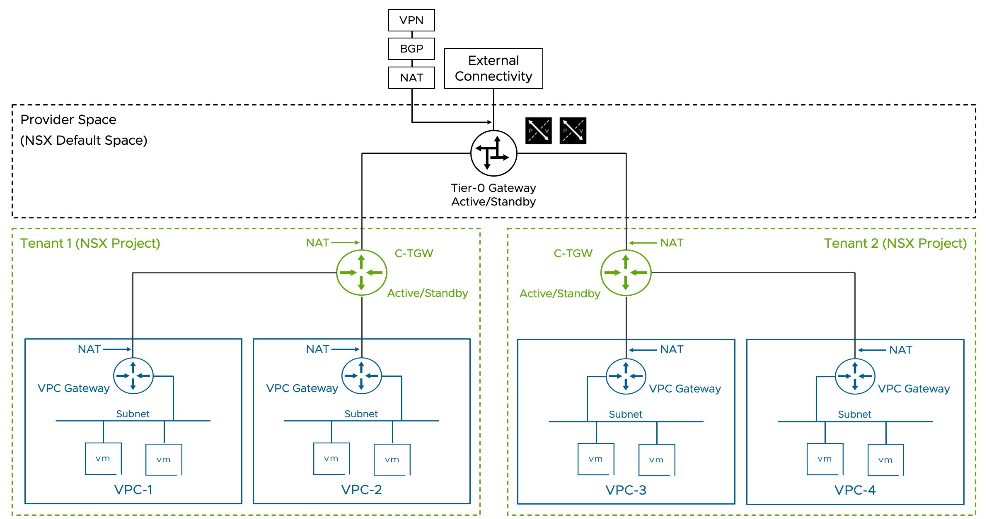
Figure 3-107. Dedicated Gateway Option
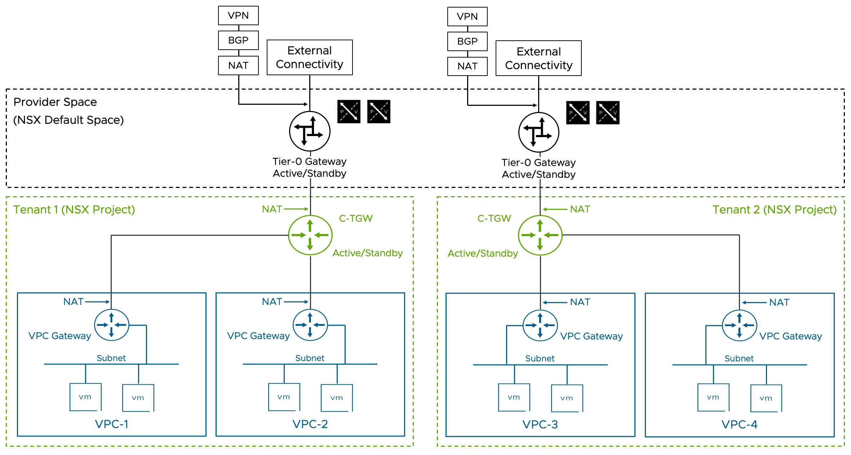

Performance Considerations
The Active/Standby configuration of both gateways (Tier-0 and TGW) limits north-south throughput to a single edge node's capacity. However, this setup provides the necessary stateful services for VCF Automation and VKS, including source NAT on TGW and VPC Auto-SNAT. For improved throughput, it's recommended to:
Use a dedicated Tier-0 Gateways per tenant
Limit tenant size to match single-edge node capacity

VRF Integration
When tenants need dedicated external network access or VPN connections but dedicated edge nodes are impractical, NSX VRFs (Virtual Routing and Forwarding) offer a solution:
VRFs provide similar capabilities to dedicated Tier-0 Gateways
Multiple VRFs can share a single edge node with their parent Tier-0 Gateway
VRF limitations in this topology:
NAT is the only network service available on the inter-VRF connection to the parent Tier-0 Gateway
Gateway firewall and VPN services are restricted to uplink interfaces
VRF Gateways can be shared by multiple tenants. This variation may be desirable when multiple tenants, but not all, need access to the same set of upstream resources, such as VPNs, private WAN circuits, or VRFs in the physical network. When all tenants need access to the same upstream resources, a shared Tier-0 gateway is the most appropriate choice.
Figure 3-108. Dedicated VRF Gateway Option
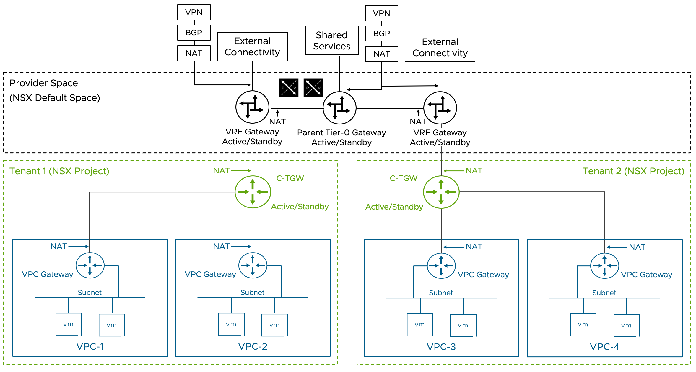

VPC with Full Services Workload Networking Model Design Requirements for Single Tenant or Shared Gateway
Table 3-758. VPC Full Services Model Design Requirements
Design Requirement ID | Design Requirement | Justification | Implication
VCF-WLDNET-VPCFSVC-REQD-CFG-001 | Two (2) NSX Edge nodes must be available. | This model requires the centralized security services provided by the NSX Edge nodes.  Exactly two (2) nodes are required to support an Active/Standby Tier-0 gateway. | Additional resources must be available to support the NSX edge nodes.
VCF-WLDNET-VPCFSVC-REQD-CFG-002 | Use large or X-Large nodes if using NSX Edge appliance form factor, or use bare-metal NSX Edge. | Supervisor cluster requires load balancing services to be instantiated on the NSX Edge nodes. | Additional resources must be available to support the NSX Edge nodes.
VCF-WLDNET-VPCFSVC-REQD-CFG-003 | Use Centralized Connectivity for the connectivity of the Transit Gateway in the Default Project. | This model requires the centralized services provided by the NSX Edge nodes. | Additional resources must be available to support the NSX edge node, following one of the models described in the edge design section.
VCF-WLDNET-VPCFSVC-REQD-CFG-004 | Tier-0 gateway must be deployed in Active/Standby HA mode. | VCF Automation All Apps Orgs require VPC Auto SNAT.  VPC Auto SNAT requires an Active/Standby Tier-0 gateway. | A single edge processes the entirety of the North-South traffic.  Scaling North-South traffic requires distributing Tenants across multiple Tier-0 gateways.

VPC with Full Services Workload Networking Model Design Recommendations for Single Tenant or Shared Gateway
Table 3-759. VPC Full Services Model Design Recommendations
Design Recommendation ID | Design Recommendation | Justification | Implication
VCF-WLDNET-VPCFSVC-RCMD-CFG-01 | Use External BGP (EBGP) as the routing protocol between the Tier-0 gateway and the physical network. | BGP is a scalable solution to interconnect the virtual network environment to the physical fabric.  New dynamically created networks in the VMware Cloud Foundation platform are automatically advertised to the physical network. BGP is a standard protocol supported by the majority of the datacenter switches.  EBGP simplifies the interconnection compared to internal BGP (IBGP) by eliminating the need for full-mesh peering and creating a clear boundary between the administrative domains of VMware Cloud Foundation and the physical network. | Physical switches must support EBGP.
VCF-WLDNET-VPCFSVC-RCMD-CFG-02 | Use a unique private BGP AS number for the Tier-0 gateway. | It prevents advertisements from being dropped by the BGP loop detection check. If the peering devices only advertise the default route, having a unique BGP AS may not be necessary. It is assumed that the Tier-0 is peering to internal devices and it's not an Internet-facing router, in which case a public AS number is required. | A unique BGP AS must be available for the Tier-0.
VCF-WLDNET-VPCFSVC-RCMD-CFG-03 | Each of the two (2) NSX Edge nodes where the Active/Standby Tier-0 Gateway runs will peer with two separate physical network devices. | It provides redundancy at the physical network layer, without requiring an edge failover. | If the NSX Edge is deployed in a virtual machine form factor, the ESX host where it runs must be connected to two (2) physical switches running BGP.  If the NSX Edge is a bare-metal NSX Edge, the server where the bare-metal NSX Edge software is installed must be connected to two (2) physical switches running BGP.
VCF-WLDNET-VPCFSVC-RCMD-CFG-04 | The physical network devices peering to the Tier-0 Gateway are physically connected to the ESX host where the NSX Edges run, or to the bare-metal NSX Edge. | The Layer 3 peering is not dependent on any Layer 2 technology, making it easier to map a physical failure to a routing convergence.  Peering over a VLAN transported over multiple physical switches and over potentially multiple redundant paths increases the operational complexity of the design. | The physical switches connected to the ESX host where the NSX Edge Node is running or those connected to a bare-metal NSX Edge must be BGP capable.
VCF-WLDNET-VPCFSVC-RCMD-CFG-05 | If using edge VMs, use two (2) interfaces for data path fastpath traffic. | Two (2) data plane fastpath interfaces provide redundancy for both VLAN and Overlay traffic. Using the additional two (2) data plane fastpath interfaces does not increase the performance of the NSX edge VM in the majority of situations, in particular when the additional vNics leverage the same set of pNICs. When the ESX hosts have four (4) pNICs available to the NSX Edge appliances, we recommend the use of multiple NSX Edge nodes connected to different sets of pNICs. | Two (2) physical NICs must be available on the ESX hosts where the NSX Edge Node in VM form factor is running.
VCF-WLDNET-VPCFSVC-RCMD-CFG-06 | If using bare-metal NSX Edge, use four (4) pNIC interfaces for data path traffic | Bare-metal NSX Edge nodes are generally limited by the speed of their interfaces. In most cases, increasing the number of interfaces in use will linearly improve the throughput that can be achieved. | Four (4) data plane fastpath pNIC must be available on the bare-metal NSX Edge server.  Using two (2) 100G pNICs is a good option for bare-metal NSX Edges when four (4) pNICs are not available.
VCF-WLDNET-VPCFSVC-RCMD-CFG-07 | Each edge data path interface transports both VLAN and TEP traffic. | Two (2) data path interfaces are sufficient to provide redundancy for both types of traffic. | Inbound and outbound traffic from the virtual network are mixed on the same vNICs, making monitoring less intuitive.
VCF-WLDNET-VPCFSVC-RCMD-CFG-08 | Every NSX Edge shares the same VLAN to peer to a specific physical device. With two (2) physical devices, it means two (2) peering VLANs are needed. | Adding or replacing additional edge nodes to the NSX Edge node cluster doesn't require creating new VLANs on the physical fabric. | Peering subnet ranges should accommodate NSX Edge cluster growth.
VCF-WLDNET-VPC-RCMD-CFG-09 | Use /28 or larger uplink peering subnets are recommended. | Allow to scale the Tier-0 gateway to eight (8) NSX Edge nodes when in an Active/Active configuration. | For an Active/Standby Tier-0, the peering subnets can be smaller as the Tier-0 is limited to two (2) NSX Edge nodes.
VCF-WLDNET-VPCFSVC-RCMD-CFG-10 | Peering VLANs are transported on trunk port groups connected to the edge fp-eth0 and fp-eth1 interfaces. | Trunk port groups allow to transport both peering VLAN and TEP VLAN traffic on the same edge vNIC.  Trunk port groups allow seamless integration of VRFs and service interfaces for VLANs. | Peering VLANs and TEP VLAN are transported on the same peering port-groups but they have different NIC teaming requirements.  Peering VLANs do not need to failover between uplinks, the TEP VLAN does.  The teaming policy for port group must be active/standby to satisfy the TEP VLAN requirement.  Physical switches should prune the peering VLAN from their interfaces where they are not required and should avoid transporting them on the inter-switch link, or via a physical overlay extension (e.g., VXLAN in an EVPN fabric)
VCF-WLDNET-VPCFSVC-RCMD-CFG-11 | Set the MTU of the Tier-0 external interfaces to the MTU of the peering interface on the physical network switches (e.g., 9000). | Some network devices set the df bit to "Do not Fragment" on the BGP peering session, a mismatch in the MTU may cause peering issues. | Manual configuration is required.
VCF-WLDNET-VPCFSVC-RCMD-CFG-12 | Set the global gateway MTU to the value of the external interfaces of the Tier-0 gateway minus 200 (i.e., 8800 = 9000 -200). | Avoid fragmentation at the NSX layer when packets larger than the default 1500 bytes are exchanged between workloads in the virtual network and workloads on the physical network. | Must be set post deployment in NSX as a global setting.
VCF-WLDNET-VPCFSVC-RCMD-CFG-13 | Enable BFD between the Tier-0 gateway and the physical devices. | Provide fast failure detection and failover with minimal CPU overhead. It permits leaving the BGP timers to their default. | Physical switches need to support BFD.
VCF-WLDNET-VPCFSVC-RCMD-CFG-14 | Use the default BGP timers, 60/180. | When BFD is enabled, there is no need to lower the default BGP timer settings increasing edge CPU overhead. | BFD is required for fast failure detection and failover.  If BFD is not available on the physical switches, BGP timers can be lowered to allow a faster failover.
VCF-WLDNET-VPCFSVC-RCMD-CFG-15 | On the Tier-0 Gateway, enable redistribution of the following network types into BGP:  Transit Gateway Static | In this model, all workloads are connected to transit gateways. This setting allows for VPC public subnets, NAT IPs, and load balancer VIPs to be advertised to the physical network. | All VPC public subnets, NAT IPs, and load balancer VIPs will be advertised to all BGP peers. If filtering is required, route filters should be configured.
VCF-WLDNET-VPCFSVC-RCMD-CFG-16 | Create a route filter allowing the advertisement of the default route only from the physical network to the Tier-0 Gateway. A corresponding summarization from the physical network is recommended. | In most cases, the virtual network is a stub network with a single exit point. The filtering reduces the Tier-0 routing table, simplifying troubleshooting and potentially reducing converge time. It also prevents RFP checks from being triggered by asymmetric routing advertisements from the physical switches. | If the virtual network has multiple exit points, for example, one to shared services and one as a private interconnection to the tenant's remote data center, this recommendation cannot be implemented. In such cases reducing the routing table size via summarization is still recommended.
VCF-WLDNET-VPCFSVC-RCMD-CFG-17 | Leave the RPF check enabled (set to strict) on all four external interfaces of the Tier-0 Gateway. | RPF check mitigates IP Address spoofing attacks. | Asymmetric routing advertisements (Not asymmetric routing, which is normal in any ECMP configuration a supported by the RFP check) from the physical switches will trigger the RPF check and drop nonmalicious traffic. RPF check should be enabled only if consistent routing advertisement from all BGP peers can be guaranteed via route summarization and filtering.
VCF-WLDNET-VPCFSVC-RCMD-CFG-18 | Set BGP Graceful restart to Helper-only. | Graceful restart may slow down the BGP convergence by waiting for the peer device control plane to recover. Helper-only ensures that routing convergence is delayed only when a peer device negotiates graceful restart. The helper-only setting will allow the Tier-0 gateway to adapt to the peer device behavior. | If the peer device doesn't support graceful restart or if graceful restart is not desirable it may be better to disable graceful restart altogether.
VCF-WLDNET-VPCFSVC-RCMD-CFG-19 | Set the Forwarding Up timer to 5 seconds (Default). | This will delay traffic from being forwarded to the edge from the virtual network before the routing table is fully populated. | -
VCF-WLDNET-VPCFSVC-RCMD-CFG-20 | If leveraging this topology for VCF Automation All Apps Orgs, use the Default Project for system namespace's VPCs. | When VCFA All Apps Orgs are in use, in each Organization will have its dedicated NSX Project. The Default space will not be used and it will be available to be consumed by system VPCs to support the IaaS control plane. The WLD creation workflow follows this model when the new WLD has a new dedicated NSX Manager. | This approach is not recommended if the NSX default project is also consumed via other means, for example via the vCenter UI, which allows the configuration of VPCs in the default project. In general, when VCF Automation is in use, it's not recommended to mix another network consumption vehicle in the same workload domain.
VCF-WLDNET-VPCFSVC-RCMD-CFG-21 | In the Default VPC Connectivity Profile of the Default project set the NSX Edge cluster as the same where the Tier-0 Gateway is deployed. | This choice will lead to the VPC centralized services running on the same pair of edge nodes as the Tier-0 Gateway and TGW. Because all traffic for the tenant will traverse the single edge node where the TGW and Tier-0 Gateways are active. Scaling the VPC services on a dedicated edge cluster is generally not beneficial in this model because of the Active/Standby nature of the Tier-0 gateway. A better scaling strategy is to create parallel topologies with A/S Tier-0 Gateways sharing the edge cluster with VPC centralized services, one topology per tenant, following the dedicated gateway model. | Edge Nodes will leverage additional CPU cycles to serve Tier-0 Gateway, TGW, and VPC centralized services. Monitor the CPU utilization via one of the following methods:  NSX Edge CLI  NSX API/UI  VCF Ops  Do not use the vCenter UI graphs to monitor the NSX Edge CPU utilization as it will provide unreliable results.
VCF-WLDNET-VPCFSVC-RCMD-CFG-22 | In the default VPC Connectivity Profile of the Default project enable N-S Services. | N-S services are required for VPC's Auto-SNAT, SNAT, and DNAT services, which are necessary for VCFA All Apps Orgs and VKS. | Any traffic between different VPCs will traverse the NSX edge node.
VCF-WLDNET-VPCFSVC-RCMD-CFG-23 | In the default VPC Connectivity Profile of the Default project enable Default Outbound NAT. | Auto-SNAT is necessary for VCFA All Apps Orgs and VKS. | Any traffic between different VPCs will traverse the NSX edge node.
VCF-WLDNET-VPCFSVC-RCMD-CFG-24 | In the Default VPC Connectivity Profile of the Default project, assign an IP range of enterprise-wide routable IPs to the external IP block ( a /24 CIDR or larger is preferred). | This IP range will be used for any tenant outbound and inbound traffic. It means that any NAT IP, Public subnet range, or Load Balancer VIP will be assigned from this range. | If the IP range is exhausted, additional CIDRs can be added up to a total of 5. Ranges can be added in a CIDR format only.
VCF-WLDNET-VPCFSVC-RCMD-CFG-25 | In the Default VPC Connectivity Profile of the Default project, assign an IP range of non-routable IPs to the Private-TGW IP block ( a /23 CIDR or larger is preferred). | This IP range will be used for inter-VPC connectivity within the tenant boundary. It will be used to assign CIDRs for Private TGW VPC Subnets. | Workloads on Private-TGW subnets will be reachable from any other tenant workloads without requiring NAT, but no connectivity from workloads outside of the tenant boundary will be available without exposing the workloads via a NAT Rule, or a Load Balancer VIP, or an external IP.

Next steps
Once the workload networking for single tenant or shared gateway multi-tenant setup is ready the following options are available:
Provision tenant-specific networking via tenant manager in VCF Automation
Start VPC consumption via vCenter
Expand the design to the dedicated gateway option
Expand the design with VRF integration

VPC with Full Services Workload Networking Model Design Requirements for Dedicated Gateway
The following design requirements and recommendations assume that the design for "VPC with Full Services model" for single tenant or shared gateway model has been provisioned already
Table 3-760. Dedicated Gateway Model Design Requirements
Design Requirement ID | Design Requirement | Justification | Implication
VCF-WLDNET-VPCFSVC-REQD-CFG-05 | The "VPC Full Services Model for single tenant or shared gateway options" must be in place. | The "VPC Full Services Model for single tenant or shared gateway options" will support the system VPCs and optionally any tenant deployed following the shared gateway model. | Two additional edge nodes are required solely to support the System VPCs.
VCF-WLDNET-VPCFSVC-REQD-CFG-06 | Two (2) NSX Edge nodes (Large, X-Large, or bare metal) must be available for each tenant adhering to the dedicated gateway deployment model. | Each tenant will have exclusive access to the resources provided by a pair of edge nodes. This will limit resource contention and will allow the multi-tenant design to scale.  Also, the provider will be able to configure tenant services on a tenant-dedicated Tier-0 gateway, for example VPNs, leveraging tenant-specific IP addresses for local and remote networks. | Additional ESX hosts or pNICs must be available to support the additional edge nodes. In most cases, connecting multiple edge nodes to the same pair of pNICs will not achieve the desired scalability objective.
VCF-WLDNET-VPCFSVC-REQD-CFG-07 | A tier-0 in Active/Standby mode must be deployed for each tenant adhering to the dedicated gateway deployment model. | VPC Auto SNAT requires an Active/Standby Tier-0 gateway. VCFA All Apps Orgs require VPC Auto SNAT. | A single edge processes the entirety of the North-South traffic for the tenant.

VPC with Full Services Workload Networking Model Design Recommendations for Dedicated Gateway
Table 3-761. Dedicated Gateway Model Design Recommendations
Design Recommendation ID | Design Recommendation | Justification | Implication
VCF-WLDNET-VPCFSVC-RCMD-CFG-26 | Use EBGP as the routing protocol between the Tier-0 gateway and the physical network. | BGP is a scalable solution to interconnect the virtual network environment to the physical fabric.  New dynamically created networks in the VCF environment are automatically advertised to the physical network. BGP is a standard protocol supported by the majority of the datacenter switches.  EBGP simplifies the interconnection compared to IBGP by eliminating the need for full-mesh peering and creating a clear boundary between the administrative domains of VCF and the physical network. | Physical switches must support EBGP.
VCF-WLDNET-VPCFSVC-RCMD-CFG-27 | Use a unique private BGP AS number for the Tier-0 gateway. | It prevents advertisements from being dropped by the BGP loop detection check. If the peering devices only advertise the default route, having a unique BGP AS may not be necessary. It is assumed that the Tier-0 is peering to internal devices and it's not an Internet-facing router, in which case a public AS number is required. | A unique BGP AS must be available for the Tier-0
VCF-WLDNET-VPCFSVC-RCMD-CFG-28 | Each of the two edge nodes where the Active/Standby Tier-0 Gateway runs will peer with two separate physical network devices. | It provides redundancy at the physical network layer, without requiring an edge failover. | If the NSX Edge is a virtual machine, the ESX host where it runs must be connected to two physical switches running BGP. If the NSX edge is a Bare Metal edge, the server where the BM edge software is installed must be connected to two physical switches running BGP.
VCF-WLDNET-VPCFSVC-RCMD-CFG-29 | The physical network devices peering to the Tier-0 Gateway are physically connected to the ESX host where the NSX Edges run, or to the bare-metal NSX Edge. | The Layer 3 peering is not dependent on ant L2 technology, making it easier to map a physical failure to a routing convergence.  Peering over a VLAN transported over multiple physical switches and over potentially multiple redundant paths increases the operational complexity of the design. | The physical switches connected to the ESX host where the NSX Edge appliances are running or those connected to a bare-metal NSX Edge must be BGP capable.
VCF-WLDNET-VPCFSVC-RCMD-CFG-30 | If using NSX Edge appliances, use two (2) interfaces for data plane fastpath traffic. | Two data plane fastpath interfaces provide .redundancy for both VLAN and Overlay traffic. Using the additional two (2) data plane fastpath interfaces does not increase the performance of the NSX edge VM in the majority of situations, in particular when the additional vNics leverage the same set of pNICs. When the ESX hosts have four (4) pNICs available to the edge VMs, we recommend the use of multiple edge nodes connected to different sets of pNICs. | Two (2) pNIC must be available on the ESX hosts where the NSX Edge VM is running.
VCF-WLDNET-VPCFSVC-RCMD-CFG-31 | If using bare metal edge, use four (4) pNIC interfaces for data plane fastpath traffic. | Bare metal NSX edge nodes are generally limited by the speed of their interfaces. In most cases, increasing the number of interfaces in use will linearly improve the throughput that can be achieved. | 4 data plane fastpath pNIC must be available on the bare metal edge server.  Using 2 100G pNICs is a good option for bare metal edges when 4 pNICs are not available.
VCF-WLDNET-VPCFSVC-RCMD-CFG-32 | Each edge data plane fastpath interface transports both VLAN and TEP traffic. | Two data plane fastpath interfaces are sufficient to provide redundancy for both types of traffic. | Inbound and outbound traffic from the virtual network are mixed on the same vNICs, making monitoring less intuitive.
VCF-WLDNET-VPCFSVC-RCMD-CFG-33 | Every edge shares the same VLAN to peer to a specific physical device. With two physical devices, it means two peering VLANs are needed. | Adding or replacing additional edge nodes to the NSX edge node cluster doesn't require creating new VLANs on the physical fabric. | Peering subnet ranges should accommodate NSX edge cluster growth.
VCF-WLDNET-VPC-RCMD-CFG-34 | Use /28 or larger uplink peering subnets are recommended. | Allow to scale the Tier-0 gateway to 8 edge nodes when in an Active/Active configuration. | For an Active/Standby Tier-0, the peering subnets can be smaller as the Tier-0 is limited to 2 edge nodes.
VCF-WLDNET-VPCFSVC-RCMD-CFG-35 | Peering VLANs are transported on trunk port groups connected to the edge fp-eth0 and fp-eth1 interfaces. | Trunk port groups allow to transport both peering VLAN and TEP VLAN traffic on the same edge vNIC.  Trunk port groups allow seamless integration of VRFs and service interfaces for VLANs. | Peering VLANs and TEP VLAN are transported on the same peering port-groups but they have different NIC teaming requirements.Peering VLANs do not need to failover between uplinks, the TEP VLAN does. The teaming policy for port group must be active/standby to satisfy the TEP VLAN requirement. Physical switches should prune the peering VLAN from their interfaces where they are not required and should avoid transporting them on the inter-switch link, or via a physical overlay extension (e.g., VXLAN in an EVPN fabric)
VCF-WLDNET-VPCFSVC-RCMD-CFG-36 | Set the MTU of the Tier-0 external interfaces to the MTU of the peering interface on the physical network switches (e.g., 9000). | Some network devices set the df bit to "Do not Fragment" on the BGP peering session, a mismatch in the MTU may cause peering issues. | Manual configuration is required.
VCF-WLDNET-VPCFSVC-RCMD-CFG-37 | Set the global gateway MTU to the value of the external interfaces of the Tier-0 gateway minus 200 (i.e., 8800 = 9000 -200). | Avoid fragmentation at the NSX layer when packets larger than the default 1500 bytes are exchanged between workloads in the virtual network and workloads on the physical network. | Must be set post deployment in NSX as a global setting.
VCF-WLDNET-VPCFSVC-RCMD-CFG-38 | Enable BFD between the Tier-0 gateway and the physical devices. | Provide fast failure detection and failover with minimal CPU overhead. It permits leaving the BGP timers to their default. | Physical switches need to support BFD.
VCF-WLDNET-VPCFSVC-RCMD-CFG-39 | Use the default BGP timers, 60/180. | When BFD is enabled, there is no need to lower the default BGP timer settings increasing edge CPU overhead. | BFD is required for fast failure detection and failover.  If BFD is not available on the physical switches, BGP timers can be lowered to allow a faster failover.
VCF-WLDNET-VPCFSVC-RCMD-CFG-40 | On the Tier-0 Gateway, enable redistribution of the following network types into BGP:  Transit Gateway Static | In this model, all workloads are connected to transit gateways. This setting allows for VPC public subnets, NAT IPs, and load balancer VIPs to be advertised to the physical network. | All VPC public subnets, NAT IPs, and load balancer VIPs will be advertised to all BGP peers. If filtering is required, route filters should be configured.
VCF-WLDNET-VPCFSVC-RCMD-CFG-41 | Create a route filter allowing the advertisement of the default route only from the physical network to the Tier-0 Gateway. A corresponding summarization from the physical network is recommended. | In most cases, the virtual network is a stub network with a single exit point. The filtering reduces the Tier-0 routing table, simplifying troubleshooting and potentially reducing converge time. It also prevents RFP checks from being triggered by asymmetric routing advertisements from the physical switches. | If the virtual network has multiple exit points, for example, one to shared services and one as a private interconnection to the tenant's remote data center, this recommendation cannot be implemented. In such cases reducing the routing table size via summarization is still recommended.
VCF-WLDNET-VPCFSVC-RCMD-CFG-42 | Leave the RPF check enabled (set to strict) on all four external interfaces of the Tier-0 Gateway. | RPF check mitigates IP address spoofing attacks. | Asymmetric routing advertisements (Not asymmetric routing, which is normal in any ECMP configuration a supported by the RFP check) from the physical switches will trigger the RPF check and drop nonmalicious traffic. RPF check should be enabled only if consistent routing advertisement from all BGP peers can be guaranteed via route summarization and filtering.
VCF-WLDNET-VPCFSVC-RCMD-CFG-43 | Set BGP Graceful restart to Helper-only. | Graceful restart may slow down the BGP convergence by waiting for the peer device control plane to recover. Helper-only ensures that routing convergence is delayed only when a peer device negotiates graceful restart. The helper-only setting will allow the Tier-0 gateway to adapt to the peer device behavior. | If the peer device doesn't support graceful restart or if graceful restart is not desirable it may be better to disable graceful restart altogether.
VCF-WLDNET-VPCFSVC-RCMD-CFG-44 | Set the Forwarding Up timer to 5 seconds (default). | This will delay traffic from being forwarded to the edge from the virtual network before the routing table is fully populated. | None.

VPC with Full Services Workload Networking Model Design Requirements for VRF Integration
Table 3-762. VRF Integration Design Requirements
Requirement ID | Design Requirement | Justification | Implication
VCF-WLDNET-VPCFSVC-REQD-CFG-08 | The "VPC Full Services Model for single tenant or shared gateway options" must be in place | The "VPC Full Services Model for single tenant or shared gateway options" will support the system VPCs and optionally any tenant deployed following the shared gateway model. | None.
VCF-WLDNET-VPCFSVC-REQD-CFG-09 | Each tenant requiring a VRF will have a dedicated VRF deployed in Active/Standby Mode | The provider will be able to configure tenant services on a tenant-dedicated VPN, for example, VPNs leveraging tenant-specific IP addresses for local and remote networks. | Additional ESX hosts or pNICs must be available to support the additional edge nodes. In most cases, connecting multiple edge nodes to the same pair of pNICs will not achieve the desired scalability objective.
VCF-WLDNET-VPCFSVC-REQD-CFG-10 | The tenant VRFs must be associated with the Tier-0 (Parent Tier-0) provisioned as part of the "VPC Full Services Model for single tenant or shared gateway options" | VPC Auto SNAT requires an Active/Standby Tier-0 gateway or VRF. VCFA All Apps Orgs require VPC Auto SNAT. | A single NSX Edge processes the entirety of the North-South traffic for the tenant.
VCF-WLDNET-VPCFSVC-REQD-CFG-11 | Each VRF uses two dedicated peering VLANs | VRFs sharing the same NSX edge node cannot share the same VLAN ID for any of their external interfaces | New VLANs must be created any time a new VRF is provisioned. In highly dynamic environments incorporating inline EVPN in the design will remove this design requirement.

VPC with Full Services Workload Networking Model Design Recommendations for VRF Integration
Recommendation ID | Design Recommendation | Justification | Implication
VCF-WLDNET-VPCFSVC-RCMD-CFG-45 | Use external BGP (EBGP) as the routing protocol between the VRF gateway and the physical network | BGP is a scalable solution to interconnect the virtual network environment to the physical fabric.  New dynamically created networks in the VCF environment are automatically advertised to the physical network. BGP is a standard protocol supported by the majority of the datacenter switches.  EBGP simplifies the interconnection compared to internal BGP (IBGP) by eliminating the need for full-mesh peering and creating a clear boundary between the administrative domains of VCF and the physical network. | Physical switches must support EBGP
VCF-WLDNET-VPCFSVC-RCMD-CFG-46 | Use a unique private BGP AS number for the VRF gateway | It prevents advertisements from being dropped by the BGP loop detection check. If the peering devices only advertise the default route, having a unique BGP AS may not be necessary. It is assumed that the Tier-0 is peering to internal devices and it's not an Internet-facing router, in which case a public AS number is required. | A unique BGP AS must be available for each VRF
VCF-WLDNET-VPCFSVC-RCMD-CFG-47 | The VRF will peer to the same physical devices as the Parent Tier-0 Gateway | VRF HA status is dependent on the HA status of the parent Tier-0 gateway. For this reason, the VRF and the Parent Tier-0 gateway must share the same type of physical failures and react to them consistently. Specifically, the design should avoid the VRF having an NSX Edge node in the "All BGP peers down" state while the parent T0 does not. More details are in the NSX Design Guide version 4.2.1 Chapter 4. | Designs where each VRF peers with a different upstream device incorporate additional risk. The risk can be avoided via the dedicated gateway model, which is not affected by this behavior as each Tier-0 gateway maintains its own HA state.  If VRFs with different upstream gateways are in use, the risk can be mitigated by peering each VRF edge node to multiple upstream devices to limit the chance of a VRF having an edge node in the "All BGP peers down" state while the Parent Tier-0 does not.
VCF-WLDNET-VPCFSVC-RCMD-CFG-48 | Peering VLANs are transported on trunk port groups connected to the edge fp-eth0 and fp-eth1 interfaces. | Trunk port groups allow to transport both peering VLAN and TEP VLAN traffic on the same edge vNIC.  Trunk port groups allow seamless integration of VRFs and service interfaces for VLANs. | Peering VLANs and TEP VLAN are transported on the same peering port-groups but they have different NIC teaming requirements.Peering VLANs do not need to failover between uplinks, the TEP VLAN does. The teaming policy for port group must be active/standby to satisfy the TEP VLAN requirement. Physical switches should prune the peering VLAN from their interfaces where they are not required and should avoid transporting them on the inter-switch link, or via a physical overlay extension (e.g., VXLAN in an EVPN fabric)
VCF-WLDNET-VPCFSVC-RCMD-CFG-49 | Set the MTU of the Tier-0 external interfaces to the MTU of the peering interface on the physical network switches (e.g., 9000) | Some network devices set the df bit to "Do not Fragment" on the BGP peering session, a mismatch in the MTU may cause peering issues | Manual configuration is required
VCF-WLDNET-VPCFSVC-RCMD-CFG-50 | Enable BFD between the VRF gateway and the physical devices | Provide fast failure detection and failover with minimal CPU overhead. It permits leaving the BGP timers to their default. | Physical switches need to support BFD
VCF-WLDNET-VPCFSVC-RCMD-CFG-51 | Use the default BGP timers, 60/180 | When BFD is enabled, there is no need to lower the default BGP timer settings increasing edge CPU overhead. | BFD is required for fast failure detection and failover  If BFD is not available on the physical switches, BGP timers can be lowered to allow a faster failure detection and failover
VCF-WLDNET-VPCFSVC-RCMD-CFG-52 | On the VRF, enable redistribution of the following network types into BGP:  Transit Gateway Static | In this model, all workloads are connected to transit gateways. This setting allows for VPC public subnets, NAT IPs, and load balancer VIPs to be advertised to the physical network. | All VPC public subnets, NAT IPs, and load balancer VIPs will be advertised to all BGP peers. If filtering is required, route filters should be configured.
VCF-WLDNET-VPCFSVC-RCMD-CFG-53 | Create a ingress route filter allowing the advertisement of the default route only from the physical network to the VRF Gateway. A corresponding summarization from the physical network is recommended. | In most cases, the virtual network is a stub network with a single exit point. The filtering reduces the Tier-0 routing table, simplifying troubleshooting and potentially reducing converge time. It also prevents RFP checks from being triggered by asymmetric routing advertisements from the physical switches. | If the virtual network has multiple exit points, for example, one to shared services and one as a private interconnection to the tenant's remote data center, this recommendation cannot be implemented. In such cases reducing the routing table size via summarization is still recommended.
VCF-WLDNET-VPCFSVC-RCMD-CFG-54 | Leave the RFP check enabled (set to strict) on all four external interfaces of the Tier-0 Gateway | RPF check mitigates IP Address Spoofing Attacks | Asymmetric routing advertisements from the physical switches will trigger the RPF check and drop nonmalicious traffic. RPF check should be enabled only if consistent routing advertisement from all BGP peers can be guaranteed via route summarization and filtering.
VCF-WLDNET-VPCFSVC-RCMD-CFG-55 | Set BGP Graceful restart to Helper-only | Graceful restart may slow down the BGP convergence by waiting for the peer device control plane to recover. Helper-only ensures that routing convergence is delayed only when a peer device negotiates graceful restart. The helper-only setting will allow the Tier-0 gateway to adapt to the peer device behavior. | If the peer device doesn't support graceful restart or if graceful restart is not desirable it may be better to disable graceful restart altogether.
VCF-WLDNET-VPCFSVC-RCMD-CFG-56 | Set the Forwarding Up timer to 5 seconds (Default) | This will delay traffic from being forwarded to the edge from the virtual network before the routing table is fully populated | None

VPC Scalable Workload Networking Model
This model employs a Tier-0 Gateway in Active/Active stateless mode, requiring a VPC-ready workload domain connected to a Centralized Gateway. Tenant VPCs connect to the Tier-0 Gateway through a stateless Active/Active Transit Gateways (TGWs). This topology is recommended for most scenarios due to its scalability and simplified management approach.
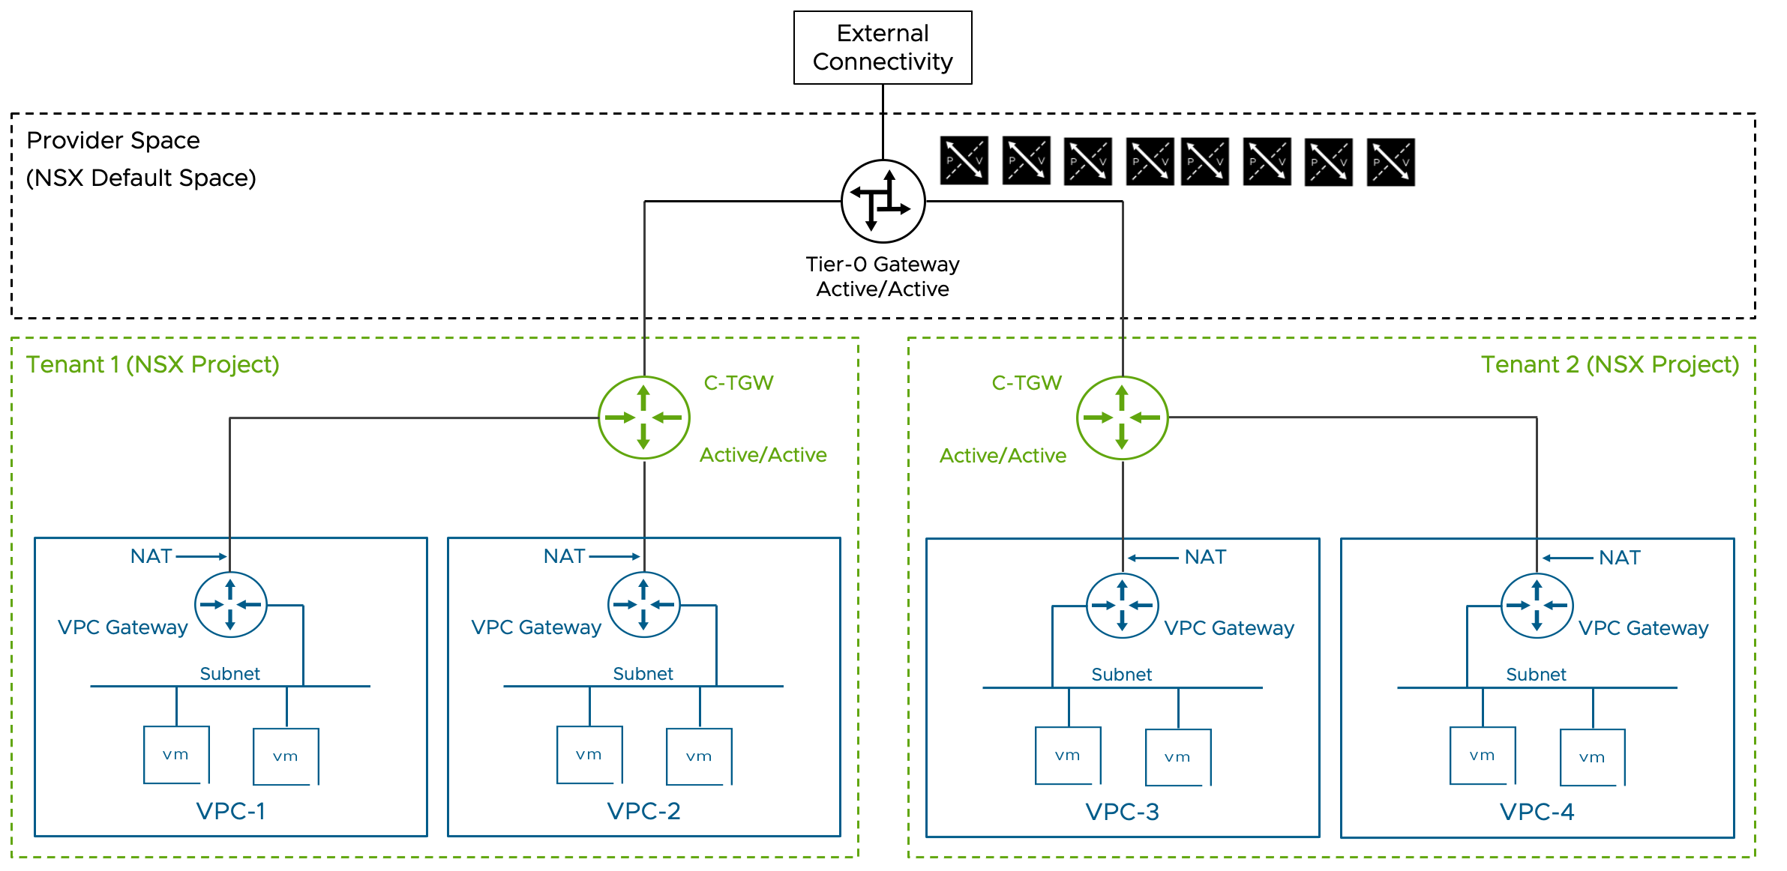

VPC Scalable Workload Networking Model Attributes
A VPC Scalable Workload Networking Model has the following attributes.
Attribute | Detail
Transit Gateway Type | Centralized
NSX Edge nodes required | Yes
Tier-0 Gateway HA Mode | Active/Active stateless
Network consumption model | VPC
NSX Tenancy Constructs | NSX Projects, VPCs
Consumption options | vCenter UI/API  NSX UI/API
VPC North-South Services | Disabled (Preferred)  Enabled
Provider gateway Type | Tier-0 Gateway  VRF Gateway

Key Benefits
Superior north-south throughput scalability
Single Tier-0 gateway supports multiple VPC environments
Allows environment growth before requiring additional Tier-0 Gateways
Reduces complexity in VPC distribution planning

Limitations
Does not support Auto S-NAT required for specific use cases (e.g., VCF Automation All Apps Orgs and VKS)
Only supports stateless NAT and stateless GFW on the Tier-0, stateless NAT only on the TGW.
Network services, when required, can be implemented at the VPC level.
Does not support VPNs.

Performance Optimization
Best performance is achieved through:
Stateless Active/Active Tier-0 Gateway
VPCs with disabled North-South services to maximize distributed routing benefits
Enabling North-South services for specific VPCs is supported, but it should be limited to when those services are required.

North-South Services considerations
Enable North-South services for VPCs only when necessary for:
NAT (Network Address Translation)
Centralized firewall requirements
Mixing VPCs with and without Nort-South services enabled is supported in this topology.
Note: Enabling North-South traffic affects inter-VPC communication by routing all traffic through the NSX Edge Node, regardless of subnet type (Public, Private-TGW, or Private-VPC). It also limits the Nort-South throughput of the VPC to a single Edge Node.

VRF Integration
VRF can be incorporated into the topology when tenants need dedicated external network access or when the VRF separation of the physical fabric must be extended into the virtual network.
VRF limitations in this topology:
Stateless NAT is the only network service available on the inter-VRF connection to the parent Tier-0 Gateway

VPC Scalable Workload Networking Model Design Requirements
Requirement ID | Design Requirement | Justification | Implication
VCF-WLDNET-VPCSCL-REQD-CFG-01 | A minimum of two NSX Edge nodes must be available | This model requires the centralized services provided by the NSX Edge nodes.  Two NSX edge nodes are the minimum to provide high availability. All edges will contribute to N-S throughput and services.We can scale The NSX edge cluster to up to 8 edge nodes. | Resources must be available for the edge nodes.  When scaling out the edge cluster, additional ESX hosts or pNICs must be available to support the additional edge nodes. In most cases, connecting multiple edge nodes to the same pair of pNICs will not achieve the desired scalability objective.
VCF-WLDNET-VPCSCL-REQD-CFG-02 | Use Centralized Connectivity for the connectivity of the Transit Gateway in the Default Project | This model requires the centralized services provided by the NSX Edge nodes | Traffic from DR-Only VPCs will be spread across all the edge nodes available via ECMP hashing.  The resources of a single edge node will limit each VPC with N-S services enabled.

VPC Scalable Workload Networking Model Design Recommendations
Recommendation ID | Design Recommendation | Justification | Implication
VCF-WLDNET-VPCSCL-RCMD-CFG-01 | Use external BGP (EBGP) as the routing protocol between the Tier-0 gateway and the physical network. | BGP is a scalable solution to interconnect the virtual network environment to the physical fabric.  New dynamically created networks in the VCF environment are automatically advertised to the physical network. BGP is a standard protocol supported by the majority of the datacenter switches.  EBGP simplifies the interconnection compared to Internal BGP (IBGP) by eliminating the need for full-mesh peering and creating a clear boundary between the administrative domains of VCF and the physical network. | Physical switches must support EBGP.
VCF-WLDNET-VPCSCL-RCMD-CFG-02 | Use a unique private BGP AS number for the Tier-0 gateway. | It prevents advertisements from being dropped by the BGP loop detection check. If the peering devices only advertise the default route, having a unique BGP AS may not be necessary. It is assumed that the Tier-0 is peering to internal devices and it's not an Internet-facing router, in which case a public AS number is required. | A unique BGP AS must be available for the Tier-0.
VCF-WLDNET-VPCSCL-RCMD-CFG-03 | Each of the Edge Nodes where the Active/Active Tier-0 Gateway runs will peer with two separate physical network devices. | It provides redundancy at the physical network layer, without requiring an edge failover. | If the NSX edge is a virtual machine, the ESX host where it runs must be connected to two physical switches running BGP. If the NSX edge is a Bare Metal edge, the server where the BM edge software is installed must be connected to two physical switches running BGP.
VCF-WLDNET-VPCSCL-RCMD-CFG-04 | The physical network devices peering to the Tier-0 Gateway are physically connected to the ESX host where the NSX edges run, or to the NSX bare metal edge. | The Layer 3 peering is not dependent on ant L2 technology, making it easier to map a physical failure to a routing convergence.  Peering over a VLAN transported over multiple physical switches and over potentially multiple redundant paths increases the operational complexity of the design. | The physical switches connected to the ESX host where the edge VM is running or those connected to a bare metal edge must be BGP capable.
VCF-WLDNET-VPCSCL-RCMD-CFG-05 | If using edge VMs, use two interfaces for data plane fastpath traffic | Two data plane fastpath interfaces provide redundancy for both VLAN and Overlay traffic. Using the additional 2 data plane fastpath interfaces does not increase the performance of the NSX edge VM in the majority of situations, in particular when the additional vNics leverage the same set of pNICs. When the ESX hosts have 4 pNICs available to the edge VMs, we recommend the use of multiple edge nodes connected to different sets of pNICs. | 2 pNIC must be available on the ESX hosts where the NSX Edge VM is running.
VCF-WLDNET-VPCSCL-RCMD-CFG-06 | If using bare metal edge, use 4 pNIC interfaces for data path fastpath traffic | Bare metal NSX edge nodes are generally limited by the speed of their interfaces. In most cases, increasing the number of interfaces in use will linearly improve the throughput that can be achieved. | 4 data plane fastpath pNIC must be available on the bare metal edge server  Using 2 100G pNICs is a good option for bare metal edges when 4 pNICs are not available.
VCF-WLDNET-VPCSCL-RCMD-CFG-07 | Each NSX Edge Node data plane fastpath interface transports both VLAN and TEP traffic | Two data plane fastpath interfaces are sufficient to provide redundancy for both types of traffic | Inbound and outbound traffic from the virtual network are mixed on the same vNICs, making monitoring less intuitive.
VCF-WLDNET-VPCSCL-RCMD-CFG-08 | Every edge shares the same VLAN to peer to a specific physical device. With two physical devices, it means two peering VLANs are needed | Adding or replacing additional edge nodes to the NSX edge node cluster doesn't require creating new VLANs on the physical fabric | Peering subnet ranges should accommodate NSX edge cluster growth.
VCF-WLDNET-VPCSCL-RCMD-CFG-09 | Use /28 or larger uplink peering subnets are recommended | Allow to scale the Tier-0 gateway to 8 edge nodes when in an Active/Active configuration | For an Active/Standby Tier-0, the peering subnets can be smaller as the Tier-0 is limited to 2 NSX Edge Nodes.
VCF-WLDNET-VPCSCL-RCMD-CFG-10 | Peering VLANs are transported on trunk port groups connected to the edge fp-eth0 and fp-eth1 interfaces. | Trunk port groups allow to transport both peering VLAN and TEP VLAN traffic on the same edge vNIC.  Trunk port groups allow seamless integration of VRFs and service interfaces for VLANs. | Peering VLANs and TEP VLAN are transported on the same peering port-groups but they have different NIC teaming requirements.  Peering VLANs do not need to failover between uplinks, the TEP VLAN does.  The teaming policy for port group must be active/standby to satisfy the TEP VLAN requirement. Physical switches should prune the peering VLAN from their interfaces where they are not required and should avoid transporting them on the inter-switch link, or via a physical overlay extension (e.g., VXLAN in an EVPN fabric)
VCF-WLDNET-VPCSCL-RCMD-CFG-11 | Set the MTU of the Tier-0 external interfaces to the MTU of the peering interface on the physical network switches (e.g., 9000) | Some network devices set the df bit to "Do not Fragment" on the BGP peering session, a mismatch in the MTU may cause peering issues | Manual configuration is required
VCF-WLDNET-VPCSCL-RCMD-CFG-12 | Set the global gateway MTU to the value of the external interfaces of the Tier-0 gateway minus 200 (i.e., 8800 = 9000 -200) | Avoid fragmentation at the NSX layer when packets larger than the default 1500 bytes are exchanged between workloads in the virtual network and workloads on the physical network. | Must be set post deployment in NSX as a global setting
VCF-WLDNET-VPCSCL-RCMD-CFG-13 | Enable BFD between the Tier-0 gateway and the physical devices | Provide fast failure detection and failover with minimal CPU overhead. It permits leaving the BGP timers to their default. | Physical switches need to support BFD
VCF-WLDNET-VPCSCL-RCMD-CFG-14 | Use the default BGP timers, 60/180 | When BFD is enabled, there is no need to lower the default BGP timer settings increasing edge CPU overhead. | BFD is required for fast failure detection and failover  If BFD is not available on the physical switches, BGP timers can be lowered to allow a faster failure detection and failover.
VCF-WLDNET-VPCSCL-RCMD-CFG-15 | On the Tier-0 Gateway, enable redistribution of the following network types into BGP:  Transit Gateway Static | In this model, all workloads are connected to transit gateways. This setting allows for VPC public subnets, NAT IPs, and load balancer VIPs to be advertised to the physical network. | All VPC public subnets, NAT IPs, and load balancer VIPs will be advertised to all BGP peers. If filtering is required, route filters should be configured.
VCF-WLDNET-VPCSCL-RCMD-CFG-16 | Create a ingress route filter allowing the advertisement of the default route only from the physical network to the Tier-0 Gateway. A corresponding summarization from the physical network is recommended. | In most cases, the virtual network is a stub network with a single exit point. The filtering reduces the Tier-0 routing table, simplifying troubleshooting and potentially reducing converge time. It also prevents RFP checks from being triggered by asymmetric routing advertisements from the physical switches. | If the virtual network has multiple exit points, for example, one to shared services and one as a private interconnection to the tenant's remote data center, this recommendation cannot be implemented. In such cases reducing the routing table size via summarization is still recommended.
VCF-WLDNET-VPCSCL-RCMD-CFG-17 | Leave the RPF check enabled (set to strict) on all four external interfaces of the Tier-0 Gateway | RPF check mitigates IP Address Spoofing Attacks | Asymmetric routing advertisements (Not asymmetric routing, which is normal in any ECMP configuration a supported by the RFP check) from the physical switches will trigger the RPF check and drop nonmalicious traffic. RPF check should be enabled only if consistent routing advertisement from all BGP peers can be guaranteed via route summarization and filtering.
VCF-WLDNET-VPCSCL-RCMD-CFG-18 | Set BGP Graceful restart to Helper-only | Graceful restart may slow down the BGP convergence by waiting for the peer device control plane to recover. Helper-only ensures that routing convergence is delayed only when a peer device negotiates graceful restart. The helper-only setting will allow the Tier-0 gateway to adapt to the peer device behavior. | If the peer device doesn't support graceful restart or if graceful restart is not desirable it may be better to disable graceful restart altogether.
VCF-WLDNET-VPCSCL-RCMD-CFG-19 | Set the Forwarding Up timer to 5 seconds (Default) | This will delay traffic from being forwarded to the edge from the virtual network before the routing table is fully populated | None.
VCF-WLDNET-VPCSCL-RCMD-CFG-20 | In the default VPC Connectivity Profile of the Default project disable N-S Services | The goal is to have all VPCs in DR-Only mode unless required. Traffic from DR-Only VPCs will be spread across all the edge nodes available via ECMP hashing increasing the scalability of the solution. | N-S services will not be available for the VPC unless the user changes the default connectivity profile assigned to the VPC. VPCs created from vCenter can only use the default connectivity profile at creation time ( The connectivity profile can be later changed in NSX if desired)
VCF-WLDNET-VPCSCL-RCMD-CFG-21 | In the default VPC Connectivity Profile of the Default project disable Default Outbound NAT | Default outbound NAT requires N-S services, which we disable to have the VPCs in DR-Only Mode | Default outbound NAT will not be available for the VPC unless the user changes the default connectivity profile assigned to the VPC. VPCs created from vCenter can only use the default connectivity profile at creation time ( The connectivity profile can be later changed in NSX if desired)
VCF-WLDNET-VPCSCL-RCMD-CFG-22 | In the Default VPC Connectivity Profile of the Default project, assign an IP range of enterprise-wide routable IPs to the external IP block ( a /21 CIDR or larger is preferred) | This IP range will be used for any tenant outbound and inbound traffic. It means that any NAT IP or Public subnet range will be assigned from this range. Because the majority of VPC will be configured as DR-Only mode, many subnets will be of type "Public" to allow direct access to the workloads without NAT. The range should be sized accordingly, and for this reason, we present a sample size of /21 compared to the /24 we have for the VPC with Full Services model which makes a broader use of NAT | If the range is exhausted additional CIDRs can be added up to a total of 5. Ranges can be added in a CIDR format only.
VCF-WLDNET-VPCSCL-RCMD-CFG-23 | In the Default VPC Connectivity Profile of the Default project, assign a non-routable CIDR to the Private-TGW IP block | The range will be used to carve out Private TGW subnets in the default project. Those subnets allow No-NAT communication between VPCs but prevent connectivity upstream of the D-TGW without the use of an External IP | If Private TGW subnets are not required, this configuration can be omitted.
VCF-WLDNET-VPCSCL-RCMD-CFG-24 | In the default Project create a custom VPC Connectivity Profile named "N-S_Services_enabled" | Provide the option to consume N-S services for specific VPCs | Any traffic between different VPCs will traverse the NSX edge node if at least one of them is using the non-default connectivity profile with N-S services enabled.
VCF-WLDNET-VPCSCL-RCMD-CFG-25 | In the custom VPC Connectivity Profile named "N-S_Services_enabled" set the NSX Edge Cluster as the same where the Active/Active Tier-0 Gateway is deployed | This choice will lead to the VPC centralized services running on the same set of edge nodes as the Tier-0 Gateway and TGW. For each VPC leveraging this non-default connectivity profile, the traffic will traverse the single edge node where the VPC services are active. Scaling the VPC services on a dedicated edge cluster is generally not beneficial, at least not until the T0 has been maximized to 8 edge nodes. | Edge Nodes will leverage additional CPU cycles to serve Tier-0 Gateway, TGW, and VPC centralized services. Monitor the CPU utilization via one of the following methods:  NSX Edge CLI  NSX API/UI  VCF Ops  Do not use the vCenter UI graphs to monitor the NSX Edge CPU utilization as it will provide unreliable results.
VCF-WLDNET-VPCSCL-RCMD-CFG-26 | In the custom VPC Connectivity Profile named "N-S_Services_enabled" enable N-S Services | Provide the option to consume N-S services for specific VPCs | Any traffic between different VPCs will traverse the NSX edge node if at least one of them is using the non-default connectivity profile with N-S services enabled.
VCF-WLDNET-VPCSCL-RCMD-CFG-28 | In the custom VPC Connectivity Profile named "N-S_Services_enabled" disable Default Outbound NAT | Default Outbound NAT is not available when the TGW is connected to an Active/Active Tier-0 Gateway. | Workloads on Private VPC or Private TGW subnets will not have outbound connectivity by default. A SNAT rule can be configured on the VPC to allow outbound connectivity.

VPC Getting Started Workload Networking Model
This model enables rapid adoption of VPC network virtualization without requiring NSX Edge VM deployment. It uses a Distributed Transit Gateway (DTGW), which differs from previous models by utilizing distributed rather than centralized connectivity. This topology offers a simplified starting point for organizations looking to implement VPC network virtualization with minimal infrastructure requirements. No centralized network service is available in this topology.
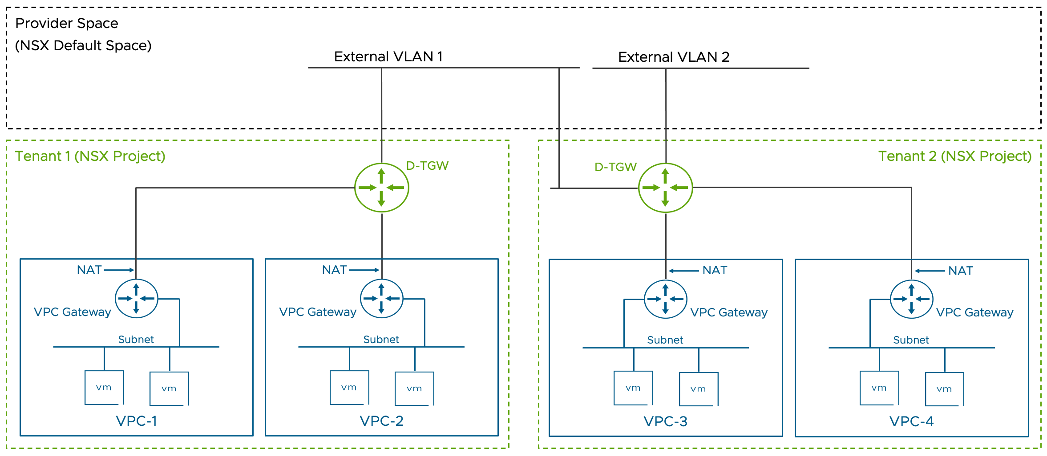

VPC Getting Started Workload Networking Model Attributes
A VPC Getting Started Workload Networking Model has the following attributes.
Attribute | Detail
Transit Gateway Type | Distributed
NSX Edge nodes required | No
Tier-0 Gateway HA Mode | Does Not Apply
Network consumption model | VPC
NSX Tenancy Constructs | NSX Projects, VPCs
Consumption options | vCenter UI/API  NSX UI/API

Key Components
Distributed Transit Gateway (DTGW)
External VLAN connection to the physical network
Direct interconnection between DTGW and physical fabric via the external VLAN

External VLAN Requirements
The external VLAN must be accessible to all ESX hosts running VPC workloads.
For multi-pNIC ESX hosts, the external VLAN must be available on NSX TEP-enabled pNICs

Network Traffic considerations
All external traffic must route through the external VLAN gateway IP
Servers on the external VLAN cannot directly access VPC workloads
VPC workloads on "private VPC" or "private TGW" subnets can only be exposed to external clients using External IPs

Network Services Considerations
NAT rule configuration is not available
VPC and TGW centralized firewall and NAT are not available
VPC Auto-SNAT is not available
DHCP is only supported via Distributed DHCP
No option to integrate VPN services

VPC Getting Started Workload Networking Model Design Requirements
Requirement ID | Design Requirement | Justification | Implication
VCF-WLDNET-VPCGSTRT-REQD-CFG-01 | In the physical fabric, extend one external VLAN across the entire NSX Domain (one or more WLDs) | It provides connectivity for external IPs or public subnets for VMs in VPCs connected to the Distributed TGW. | Physical fabric must meet this requirement. If meeting this requirement is impossible, an alternative solution incorporating NSX Edges and C-TGW should be implemented.
VCF-WLDNET-VPCGSTRT-REQD-CFG-02 | Make the external VLAN available on the VDS and pNICs where the NSX TEPs are connected | Public subnets and External IPs of VMs in VPCs connected to the Distributed TGW are presented to the external VLAN via the uplinks where TEPs are enabled. | Physical fabric must be configured to allow the external VLANs on the correct ESX interfaces.
VCF-WLDNET-VPCGSTRT-REQD-CFG-03 | Do not connect any device on the external VLAN except for the physical switches | Devices on the external network will not have connectivity to VPC external IP because the D-TGW responds to ARP requests sourced from the external VLAN gateway only. | External VLAN must be dedicated to external IP and VPC public subnets and cannot be shared with any other workloads.
VCF-WLDNET-VPCGSTRT-REQD-CFG-04 | In the Default VPC Connectivity Profile of the Default project, assign a range of enterprise-wide routable IPs part of the external VLAN CIDR as the external IP Block | This range will be used for any VPC inbound and outbound traffic. Any External IP or Public subnet will be assigned from this range. | If the range is exhausted additional CIDRs can be added up to a total of 5. Ranges can be added in a CIDR format only.
VCF-WLDNET-VPCGSTRT-REQD-CFG-05 | Exclude any IP assigned to physical network devices on the external network from assignment to VPCs if the external block includes them | IP Address conflicts may arise if the exclusion is not configured | The external VLAN Gateway IP is excluded by default. Additional Exclusion can be configured via the NSX API, by allocating those IPs to the default project.
VCF-WLDNET-VPCGSTRT-REQD-CFG-06 | In the default VPC Connectivity Profile of the Default project disable N-S Services | N-S services are not available when using D-TGW | If N-S services are required, an alternative solution incorporating NSX Edges and C-TGW should be implemented.
VCF-WLDNET-VPCGSTRT-REQD-CFG-07 | In the default VPC Connectivity Profile of the Default project disable Default Outbound NAT | Default Outbound NAT requires N-S services | If N-S services are required, an alternative solution incorporating NSX Edges and C-TGW should be implemented.

VPC Getting Started Workload Networking Model Design Recommendations
Recommendation ID | Design Recommendation | Justification | Implication
VCF-WLDNET-VPCGSTRT-RCMD-CFG-01 | In the Default VPC Connectivity Profile of the Default project, assign a non-routable CIDR to the Private-TGW IP block | The range will be used to carve out Private TGW subnets in the default project. Those subnets allow No-NAT communication between VPCs but prevent connectivity upstream of the D-TGW without the use of an External IP | If Private TGW subnets are not required, this step can be omitted.

NSX Segment Network Virtualization Scalable Workload Networking Model
This model resembles the "VPC Scalable topology" model. It employs a Tier-0 Gateway in Active/Active stateless mode, but rather than using a Centralized Transit Gateway (CTGW) and VPCs, Tier-1 gateways are directly connected to the Tier-0 gateway. As the "VPC Scalable topology" model, this topology is recommended for its scalability and simplified management approach. While it lacks the benefits of the simplified consumption model of a VPC-based topology, it allows the incorporation of advanced use cases such as network stretch across NSX Domains via NSX Federation and the adoption of centralized advanced security features.
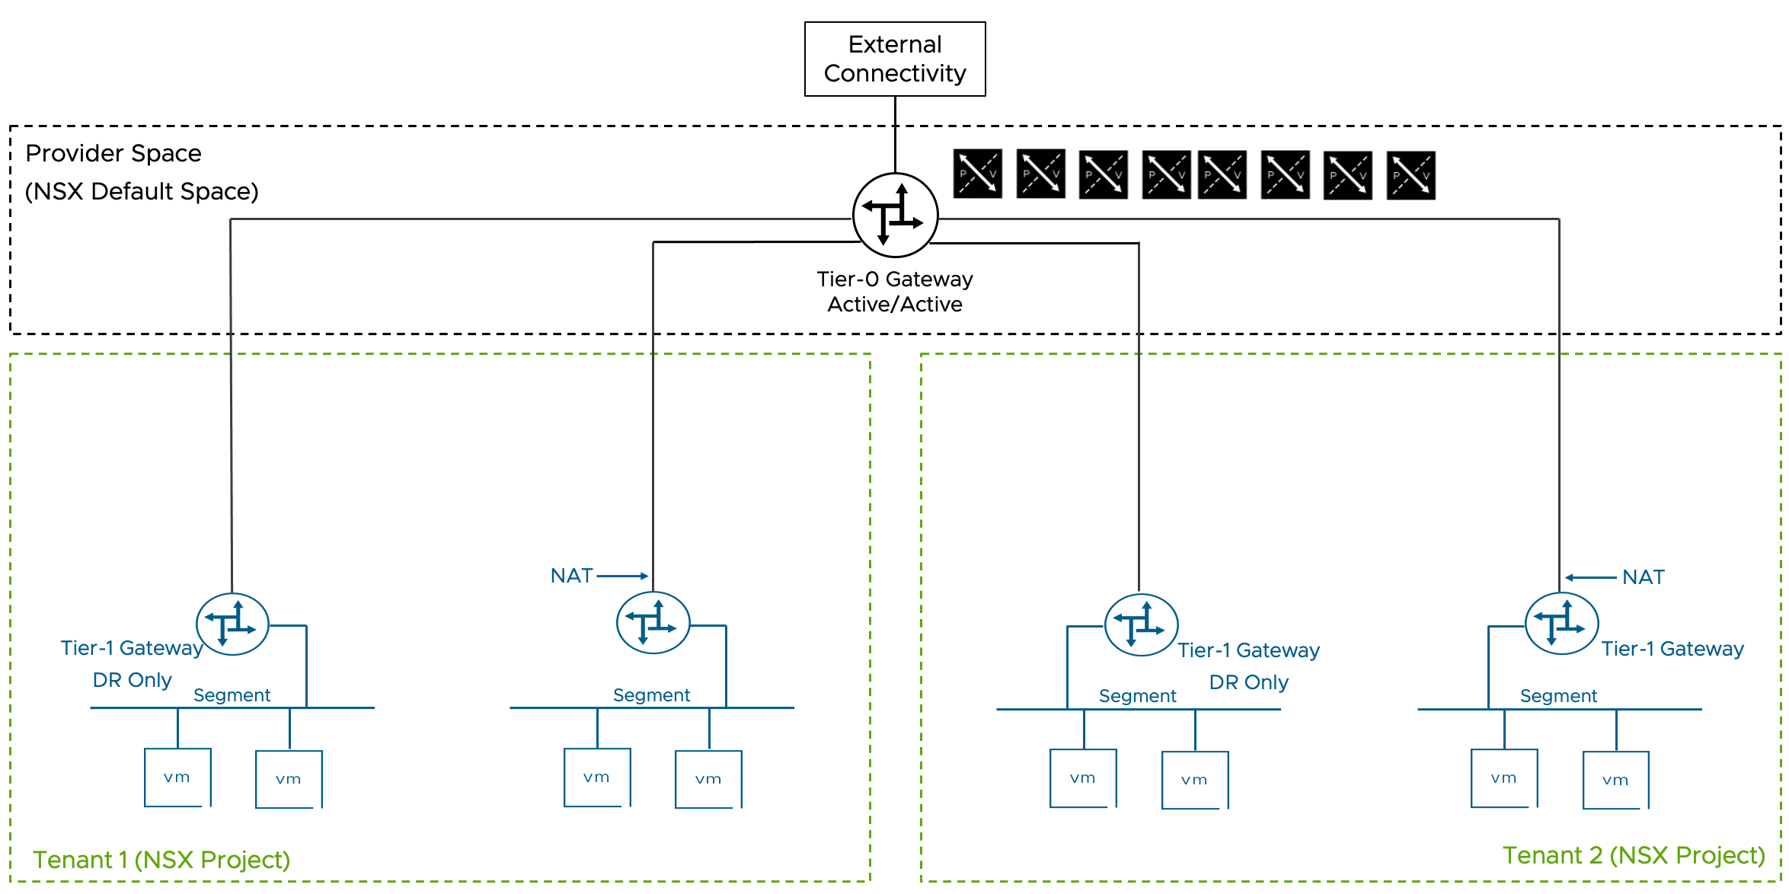

NSX Segment Network Virtualization Scalable Workload Networking Model Attributes
A NSX Segment Network Virtualization Scalable Workload Networking Model has the following attributes.
Attribute | Detail
NSX Edge nodes required | Yes
Tier-0 Gateway HA Mode | Active/Active
Network consumption model | NSX Segment
NSX Tenancy Constructs | NSX Projects only
Consumption options | NSX UI/API

Key Benefits
Superior north-south throughput scalability
Single Tier-0 gateway supports multiple workload environments mapped to individual Tier-1 Gateways
Allows environment growth before requiring additional Tier-0 Gateways
Reduces complexity in Tier-1 gateway distribution planning (When running Tier-1 Gateways in DR only mode)
VPN support on Tier-1 Gateways (Not available on Tier-1 gateways running in DR Only mode)

Limitations
Does not support certain network services required for specific use cases, for example, VCF Automation All Apps Organizations and VKS
Does not support VPNs with dynamic routing, (VPNs with dynamic routing are available on Tier-0 Gateways and VRF running in Active/Standby mode)

Performance Optimization
Best performance is achieved through:
Stateless Active/Active Tier-0 Gateway
Tier-1 gateway running in DR Only mode to maximize distributed routing benefits
Enabling centralized services for specific Tier-1 gateways, by associating them gateway to an edge cluster, is supported, but it should be limited to when those services are required.

Centralized Services Considerations
Enable centralized services on Tier-1 gateways only when necessary for:
NAT (Network Address Translation)
Centralized firewall requirements (L4 or L7)
Advanced centralized security services (i.e, Identity Firewall, URL Filtering, FQDN Analysis, IDS/IPS, Malware Detection, TLS Inspection)
Mixing Tier-1 gateways with and without centralized services enabled is supported in this topology.
Note: Enabling centralized services affects communication between workloads connected to different Tier-1 gateways by routing all traffic through the NSX edge node. It also limits the Nort-South throughput of all the workloads connected to the Tier-1 gateway to the capacity of a single Edge Node.

VRF Integration
VRF can be incorporated into the topology when tenants need dedicated external network access or when the VRF separation of the physical fabric must be extended into the virtual network.
VRF limitations in this topology:
Stateless NAT is the only network service available on the inter-SR connection to the parent Tier-0 Gateway

NSX Federation
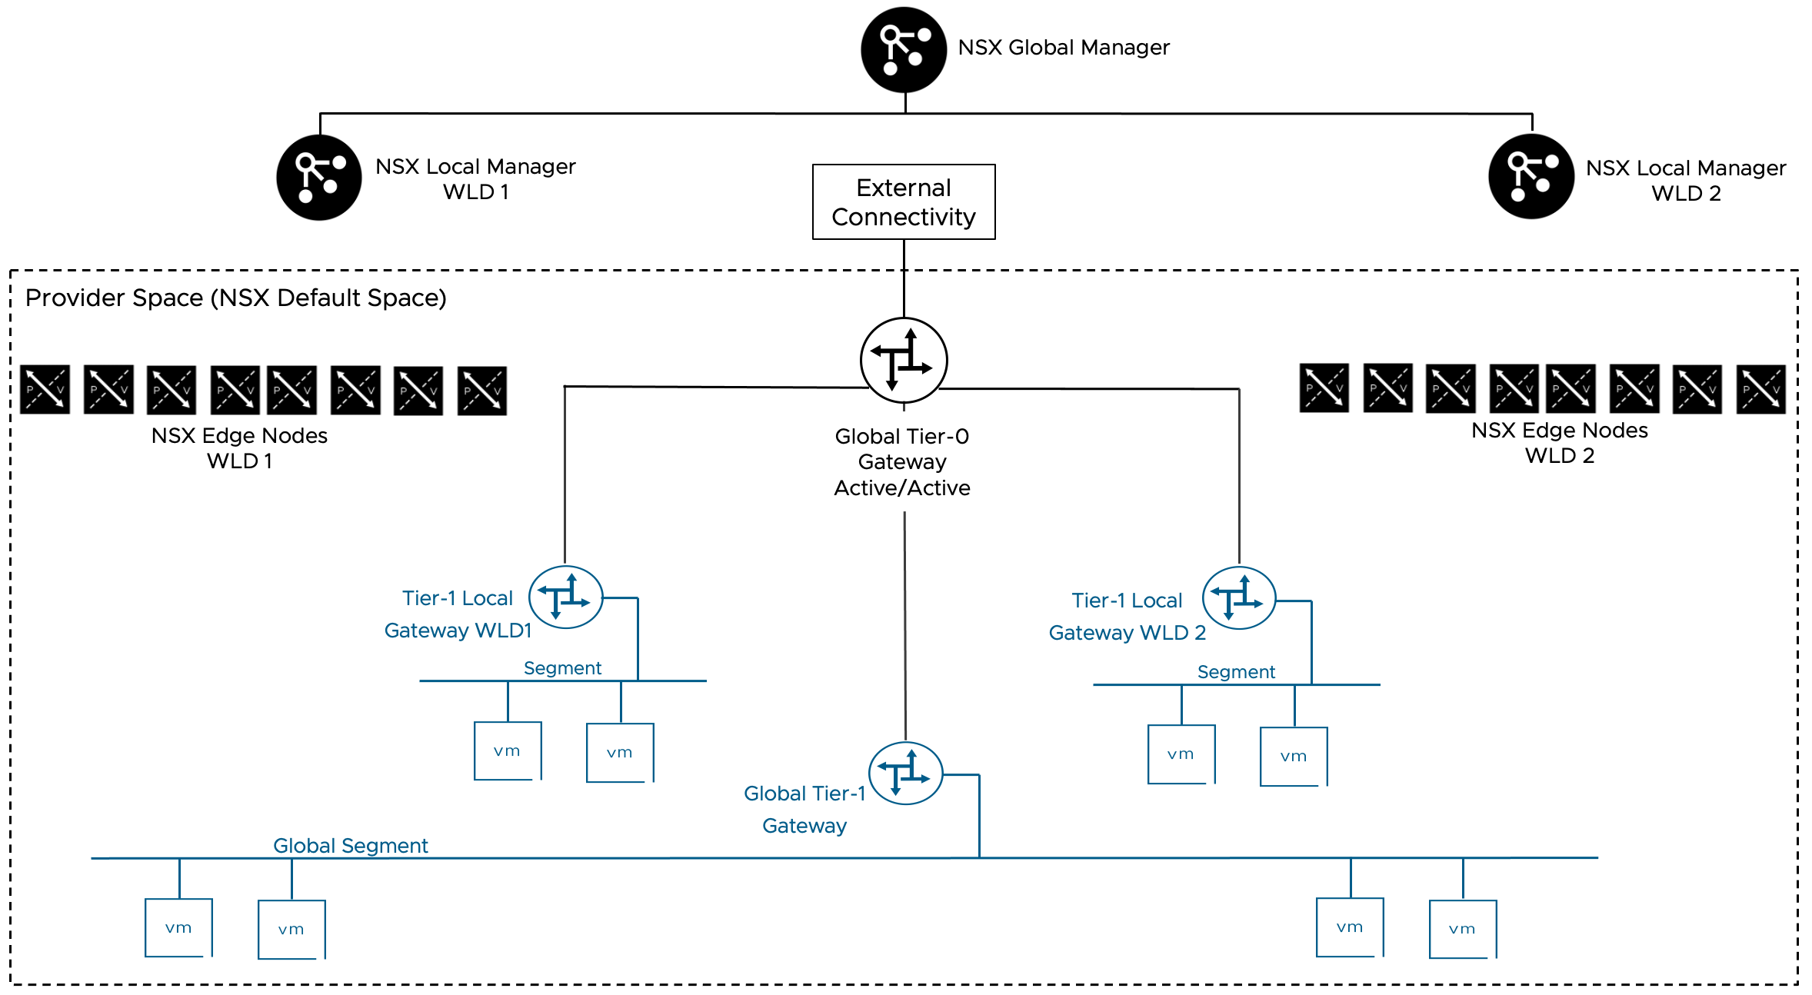
NSX Federation allows to extend the NSX Segment Scalable Model across workload domains, part of the same or different VCF Instances. When exteding the network topology accross WLD via NSX Federation, it's not possible to leverage the NSX Multi-tenancy framework, so all configurations must be performed centrally by the provider admin in the NSX Default Space.

NSX Segment Network Virtualization Scalable Workload Networking Model Design Requirements
Requirement ID | Design Requirement | Justification | Implication
VCF-WLDNET-POLICY-REQD-CFG-01 | A minimum of two (2) NSX Edge nodes must be available. | This model requires the centralized services provided by the NSX Edge nodes.  Two NSX edge nodes are the minimum to provide high availability. All edges will contribute to N-S throughput and services.  We can scale The NSX edge cluster to up to 8 edge nodes. | Resources must be available for the NSX Edge nodes.  When scaling out the edge cluster, additional ESX hosts or pNICs must be available to support the additional edge nodes. In most cases, connecting multiple edge nodes to the same pair of pNICs will not achieve the desired scalability objective.

NSX Segment Network Virtualization Scalable Workload Networking Model Design Recommendations
Recommendation ID | Design Recommendation | Justification | Implication
VCF-WLDNET-POLICY-RCMD-CFG-01 | Use EBGP as the routing protocol between the Tier-0 gateway and the physical network. | BGP is a scalable solution to interconnect the virtual network environment to the physical fabric.  New dynamically created networks in the VCF environment are automatically advertised to the physical network. BGP is a standard protocol supported by the majority of the datacenter switches.  EBGP simplifies the interconnection compared to IBGP by eliminating the need for full-mesh peering and creating a clear boundary between the administrative domains of VCF and the physical network. | Physical switches must support EBGP.
VCF-WLDNET-POLICY-RCMD-CFG-02 | Use a unique private BGP AS number for the Tier-0 gateway | It prevents advertisements from being dropped by the BGP loop detection check. If the peering devices only advertise the default route, having a unique BGP AS may not be necessary. It is assumed that the Tier-0 is peering to internal devices and it's not an Internet-facing router, in which case a public AS number is required. | A unique BGP AS must be available for the Tier-0
VCF-WLDNET-POLICY-RCMD-CFG-03 | Each of the edge nodes where the Active/Active Tier-0 Gateway runs will peer with two separate physical network devices. | It provides redundancy at the physical network layer, without requiring an edge failover. | If the NSX Edge is a appliance, the ESX host where it runs must be connected to two (2) physical switches running BGP.  If the NSX Edge is a bare-Metal NSX Edge, the server where the bare-Metal NSX Edge software is installed must be connected to two (2) physical switches running BGP.
VCF-WLDNET-POLICY-RCMD-CFG-04 | The physical network devices peering to the Tier-0 Gateway are physically connected to the ESX host where the NSX edges run, or to the NSX bare metal edge. | The Layer 3 peering is not dependent on ant L2 technology, making it easier to map a physical failure to a routing convergence.  Peering over a VLAN transported over multiple physical switches and over potentially multiple redundant paths increases the operational complexity of the design. | The physical switches connected to the ESX host where the edge VM is running or those connected to a bare metal edge must be BGP capable.
VCF-WLDNET-POLICY-RCMD-CFG-05 | If using edge VMs, use two interfaces for data plane fastpath traffic. | Two (2) data path interfaces provide redundancy for both VLAN and Overlay traffic. Using the additional two (2) data plane fastpath interfaces does not increase the performance of the NSX edge VM in the majority of situations, in particular when the additional vNics leverage the same set of pNICs. When the ESX hosts have four (4) pNICs available to the edge VMs, we recommend the use of multiple edge nodes connected to different sets of pNICs. | 2 pNIC must be available on the ESX hosts where the NSX Edge VM is running.
VCF-WLDNET-POLICY-RCMD-CFG-06 | If using bare metal edge, use four (4) pNIC interfaces for data plane fastpath traffic. | Bare metal NSX edge nodes are generally limited by the speed of their interfaces. In most cases, increasing the number of interfaces in use will linearly improve the throughput that can be achieved. | Four (4) data plane fastpath pNIC must be available on the bare metal edge server  Using 2 100G pNICs is a good option for bare metal edges when 4 pNICs are not available.
VCF-WLDNET-POLICY-RCMD-CFG-07 | Each NSX Edge Node data plane fastpath interface transports both VLAN and TEP traffic. | Two data plane fastpath interfaces are sufficient to provide redundancy for both types of traffic. | Inbound and outbound traffic from the virtual network are mixed on the same vNICs, making monitoring less intuitive.
VCF-WLDNET-POLICY-RCMD-CFG-08 | Every edge shares the same VLAN to peer to a specific physical device. With two physical devices, it means two peering VLANs are needed. | Adding or replacing additional edge nodes to the NSX edge node cluster doesn't require creating new VLANs on the physical fabric. | Peering subnet ranges should accommodate NSX edge cluster growth.
VCF-WLDNET-POLICY-RCMD-CFG-09 | Use /28 or larger uplink peering subnets are recommended. | Allow to scale the Tier-0 gateway to 8 edge nodes when in an Active/Active configuration. | For an Active/Standby Tier-0, the peering subnets can be smaller as the Tier-0 is limited to 2 NSX Edge nodes.
VCF-WLDNET-POLICY-RCMD-CFG-10 | Peering VLANs are transported on trunk port groups connected to the edge fp-eth0 and fp-eth1 interfaces. | Trunk port groups allow to transport both peering VLAN and TEP VLAN traffic on the same edge vNIC.  Trunk port groups allow seamless integration of VRFs and service interfaces for VLANs. | Peering VLANs and TEP VLAN are transported on the same peering port-groups but they have different NIC teaming requirements.Peering VLANs do not need to failover between uplinks, the TEP VLAN does. The teaming policy for port group must be active/standby to satisfy the TEP VLAN requirement. Physical switches should prune the peering VLAN from their interfaces where they are not required and should avoid transporting them on the inter-switch link, or via a physical overlay extension (e.g., VXLAN in an EVPN fabric)
VCF-WLDNET-POLICY-RCMD-CFG-11 | Set the MTU of the Tier-0 external interfaces to the MTU of the peering interface on the physical network switches (e.g., 9000). | Some network devices set the df bit to "Do not Fragment" on the BGP peering session, a mismatch in the MTU may cause peering issues. | Manual configuration is required.
VCF-WLDNET-POLICY-RCMD-CFG-12 | Set the global gateway MTU to the value of the external interfaces of the Tier-0 gateway minus 200 (i.e., 8800 = 9000 -200). | Avoid fragmentation at the NSX layer when packets larger than the default 1500 bytes are exchanged between workloads in the virtual network and workloads on the physical network. | Must be set post deployment in NSX as a global setting.
VCF-WLDNET-POLICY-RCMD-CFG-13 | Enable BFD between the Tier-0 gateway and the physical devices. | Provide fast failure detection and failover with minimal CPU overhead. It permits leaving the BGP timers to their default. | Physical switches need to support BFD.
VCF-WLDNET-POLICY-RCMD-CFG-14 | Use the default BGP timers, 60/180. | When BFD is enabled, there is no need to lower the default BGP timer settings increasing edge CPU overhead. | BFD is required for fast failure detection and failover  If BFD is not available on the physical switches, BGP timers can be lowered to allow a faster failure detection and failover.
VCF-WLDNET-POLICY-RCMD-CFG-15 | On the Tier-0 Gateway, enable redistribution of the following network types into BGP:  Tier-1 connected networks  Tier-1 NAT routes | In this model, all workloads are connected to Tier-1 segments. Those segments must be advertised for direct workload reachability.  NAT routes advertisement is required by workloads connected segments not advertised by the Tier-1 gateways. | All Tier-1 connected segments will be advertised to the physical network unless they are not advertised by the Tier-1 Gateway. If filtering is required, route filters should be configured.
VCF-WLDNET-POLICY-RCMD-CFG-16 | Create an ingress route filter allowing the advertisement of the default route only from the physical network to the Tier-0 Gateway. A corresponding summarization from the physical network is recommended. | In most cases, the virtual network is a stub network with a single exit point. The filtering reduces the Tier-0 routing table, simplifying troubleshooting and potentially reducing converge time. It also prevents RFP checks from being triggered by asymmetric routing advertisements from the physical switches. | If the virtual network has multiple exit points, for example, one to shared services and one as a private interconnection to the tenant's remote data center, this recommendation cannot be implemented. In such cases reducing the routing table size via summarization is still recommended.
VCF-WLDNET-POLICY-RCMD-CFG-17 | Leave the RPF check enabled (set to strict) on all four external interfaces of the Tier-0 Gateway. | RPF check mitigates IP Address Spoofing Attacks. | Asymmetric routing advertisements (Not asymmetric routing, which is normal in any ECMP configuration a supported by the RFP check) from the physical switches will trigger the RPF check and drop nonmalicious traffic. RPF check should be enabled only if consistent routing advertisement from all BGP peers can be guaranteed via route summarization and filtering.
VCF-WLDNET-POLICY-RCMD-CFG-18 | Set BGP Graceful restart to Helper-only. | Graceful restart may slow down the BGP convergence by waiting for the peer device control plane to recover. Helper-only ensures that routing convergence is delayed only when a peer device negotiates graceful restart. The helper-only setting will allow the Tier-0 gateway to adapt to the peer device behavior. | If the peer device doesn't support graceful restart or if graceful restart is not desirable it may be better to disable graceful restart altogether.
VCF-WLDNET-POLICY-RCMD-CFG-19 | Set the Forwarding Up timer to 5 seconds (Default). | This will delay traffic from being forwarded to the edge from the virtual network before the routing table is fully populated. | None.
VCF-WLDNET-POLICY-RCMD-CFG-20 | Configure Tier-1 Gateways in DR Only Mode. | The goal is to have all Tier-1 gateways in DR-Only mode unless required. North-South Traffic from DR-Only Tier-1 will be spread across all the edge nodes available via ECMP hashing increasing the scalability of the solution. | Centralized services will not be available for the Tier-1 gateway unless the user associates the Tier-1 gateway to an edge cluster to make it Active/Standby.
VCF-WLDNET-POLICY-RCMD-CFG-21 | Only for specifics Tier-1 gateway select the Active/Standby mode and associate them to the edge cluster where the Tier-0 gateway runs. | Provide the option to consume centralized services for specific Tier-1 gateways. | Any traffic between different Tier-1 gateways will traverse the NSX edge node if at least one of them is in Active/Standby mode.  Edge Nodes will leverage additional CPU cycles to serve Tier-0 Gateway, and Tier-1 Gateways centralized services. Monitor the CPU utilization via one of the following methods:  NSX Edge CLI  NSX API/UI  VCF Ops  Do not use the vCenter UI graphs to monitor the NSX Edge CPU utilization as it will provide unreliable results.
VCF-WLDNET-POLICY-RCMD-CFG-22 | In a multi-tenant design leveraging NSX Projects, assign a range of routable IPs to each tenant and create a corresponding project route filter. | Avoid IP conflicts between tenants. | It is not possible to share routable ranges across tenants (the VPC model allows to share the same range across tenants while avoiding individual IP conflicts).  Project route filters must be created via the NSX API.

Large Scale Topology Workload Networking Model
This model is mainly designed for service providers managing multiple tenants via VCF Automation, each using the "VPC with full services" topology". It can also be leveraged in architectures based on the NSX Segment consumption model where VCF Automation All Apps Orgs are not in use. Its key purpose is to provide centralized access to shared services, including Internet connectivity, while enabling dedicated VPN services for each tenant. The solution features a stateless Active/Active Tier-0 Gateway at the aggregation layer, providing shared services and internet access across all tenants.
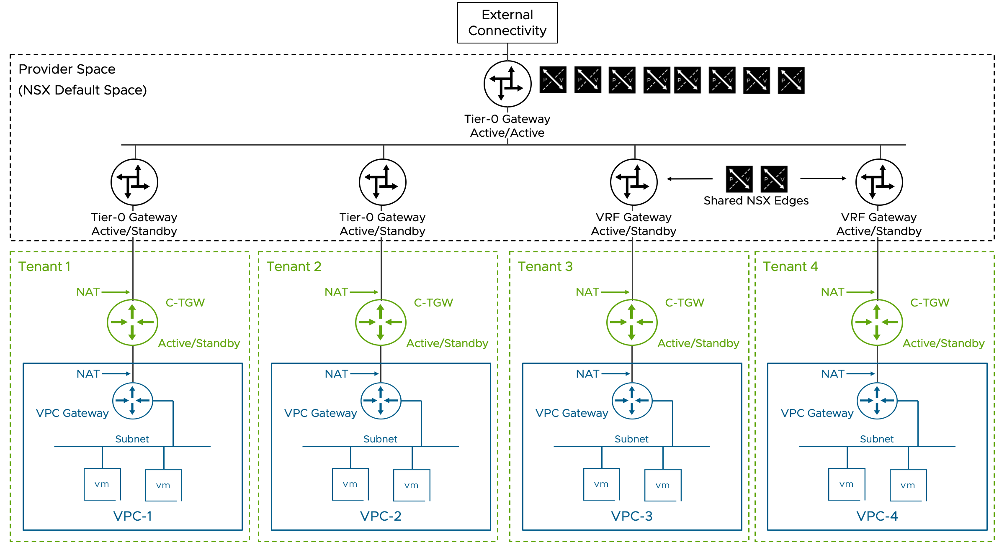

Large Scale Topology Workload Networking Model Attributes
A Large Scale Topology Workload Networking Model has the following attributes.
Attribute | Detail
Transit Gateway Type | Centralized
NSX Edge nodes required | Yes
Tier-0 Gateway HA Mode | Mix of Active/Standby and Active/Active
Network consumption model | VPC and NSX Segment Network Virtualization
NSX Tenancy Constructs | NSX Projects, VPCs
Consumption options | vCenter UI/API  VCF Automation All Apps Orgs  VMware Kubernetes Engine (VKS)  NSX UI/API

Common challenged addressed
Tenant Onboarding Complexity:
Reduces physical fabric configuration requirements for new tenant connections
Streamlines tenant integration process
Shared Resource Access:
Centralizes shared network access (e.g., Internet VLAN)
Addresses VRF connection limitations:
VRFs under the same parent Tier-0 Gateway cannot connect to the same VLAN
VRFs on different edge nodes (different parent Tier-0 gateways) can connect
Optimizes IP space utilization:
Reduces public IP consumption (traditionally 1-3 IPs per Tier-0/VRF on shared Internet VLAN)

Key Components
Aggregation Layer: Active/Active stateless Tier-0 Gateway
Tenant Layer: Individual dedicated Tier-0 Gateways or VRFs
Interconnection: Shared overlay segment between tenant and aggregation gateways
Routing: eBGP peering between aggregation Tier-0 and tenant gateways

Tenant Deployment Options
High-Throughput Tenants:
Dedicated Tier-0 Gateway
Dedicated pair of edge nodes
Full North-South services capacity (limited to single Edge Node due to Active/Standby mode)
Lower-Throughput Tenants:
Dedicated VRF
Shared edge node pairs
Provider-determined tenant-to-edge node ratio
Configurable VPN services

Large Scale Topology Workload Networking Model Design Requirements
Requirement ID | Design Requirement | Justification | Implication
VCF-WLDNET-LSCA-REQD-CFG-01 | Each aggregation Tier-0 Gateway edge node must peer with all tenant VRF/Tier-0 Gateway edge nodes | Full mesh peering between tenant and aggregation Gateways will prevent black holing of traffic in some failure scenario in which traffic is received by the tenant edge node running the standby gateway. | Additional BGP peering must be configured
VCF-WLDNET-LSCA-REQD-CFG-02 | Use EBGP between tenant and provider gateways | Avoid the IBGP requirement of peering between tenant gateways | Additional BGP ASNs must be available

Large Scale Topology Workload Networking Model Design Recommendations
Recommendation ID | Design Requirement | Justification | Implication
VCF-WLDNET-LSCA-REQD-RCMD-01 | Do not configure BGP peering between tenant VRFs or tenant Tier-0 Gateways | Simpler and more scalable BGP peering design | None.
VCF-WLDNET-LSCA-REQD-RCMD-02 | Shared overlay segment for interconnection | More robust transport layer, especially when TEP Groups are enabled | Peering over a VLAN is suported but it less reliable.  Peering over VLAN is the only option when the Gateways are managed by different NSX Managers. Peering over VLAN should only be used in such cases.

NSX Edge Cluster Detailed Design
This section outlines various NSX Edge Cluster Models for virtualized data center environments, including the physical rack placement of NSX Edge nodes. Each design is tailored to address specific requirements for high availability, scalability, capabilities, and infrastructure footprint.

NSX Edge Cluster Models for Single Availability Zone
NSX Edge cluster designs deployed in a single availability zone have their infrastructure components typically installed in close proximity to each other. For example, when using multiple racks, they are placed in the same room or adjacent rooms in the same building. Asymmetric traffic is not a concern in such single availability zone designs.
Consider the main design attributes of the available models.
Table 3-763. Host Fault Tolerant NSX Edge Cluster Model Attributes
Attribute | Detail
Compute availability model | Host level only
Storage availability model | Single shared storage
Physical network fabric supportability | Layer 2 or Layer 3 network fabric
Physical vSphere Cluster layout | Single vSphere cluster deployed within a single rack
Physical footprint | Low
Scalability | Adding more hosts to the existing vSphere cluster to deploy more NSX Edge nodes  Adding more NSX Edge nodes to existing hosts that have free CPU and memory resources requires additional physical NICs (pNICs) to maintain maximum packet forwarding rates (PPS) for each NSX Edge node. A ratio of two physical NICs for each NSX Edge node is recommended
NSX Edge mobility | Not required. Optional during host maintenance by disabling the VM/host rule.
Table 3-764. Rack Fault Tolerant NSX Edge Cluster Model Comparison
Attribute | Rack Fault Tolerant NSX Edge cluster design using two or more vertical Layer 2 vSphere clusters in separate racks | Rack Fault Tolerant NSX Edge cluster design using single Layer 3 vSphere Cluster deployed across multiple racks | Rack Fault Tolerant NSX Edge cluster design using single Layer 2 vSphere Cluster deployed across multiple racks
Compute availability model | Rack and host level
Storage availability model | Independent storage for each rack when using vSAN | Single shared storage across racks
Physical network fabric supportability | Layer 2 or Layer 3 network fabric |  | Must support Layer 2 adjacencies for VLANs spanning racks, for example with VXLAN encapsulation
Physical vSphere Cluster layout | Multiple vSphere clusters deployed vertically, each vSphere cluster in separate dedicated rack | Single vSphere cluster deployed horizontal across multiple racks
Physical footprint | Medium to high
Scalability | Adding more hosts to the existing vSphere cluster to serve more NSX Edge nodes  Adding more NSX Edge nodes to existing hosts that have free CPUs and memory resources requires additional physical NICs (pNICs) to maintain maximum packet forwarding rates (PPS) for each NSX Edge node. A ratio of two physical NICs for each NSX Edge node is recommended
NSX Edge mobility | Not required. Optional during host maintenance by disabling the VM/host rule. | Not required. Optional during host maintenance within the same rack by disabling the VM/host rule. Not supported across racks. | Not required. Optional during host maintenance by disabling VM/host rule, but not recommended in order to maintain BGP peering local to each rack.
Note A Layer 2 vSphere cluster refers to a vSphere cluster implementation where the host relevant host networks, including vMotion, ESX management and storage traffic, reside within a single Layer 2 broadcast domain.
Note A Layer 3 vSphere cluster refers to a vSphere cluster implementation where for each individual host or a sub-set of hosts from a vSphere cluster, the relevant host networks, including vMotion, ESX management and storage traffic, are assigned to individual Layer 2 broadcast domain, separated through Layer 3 boundaries.

Host Fault Tolerant NSX Edge Cluster Model
A vSphere Single-Rack Cluster Model for hosting NSX Edge nodes offers a minimalist footprint while maintaining basic host-level availability.
Figure 3-109. Host Fault Tolerant NSX Edge Cluster Model
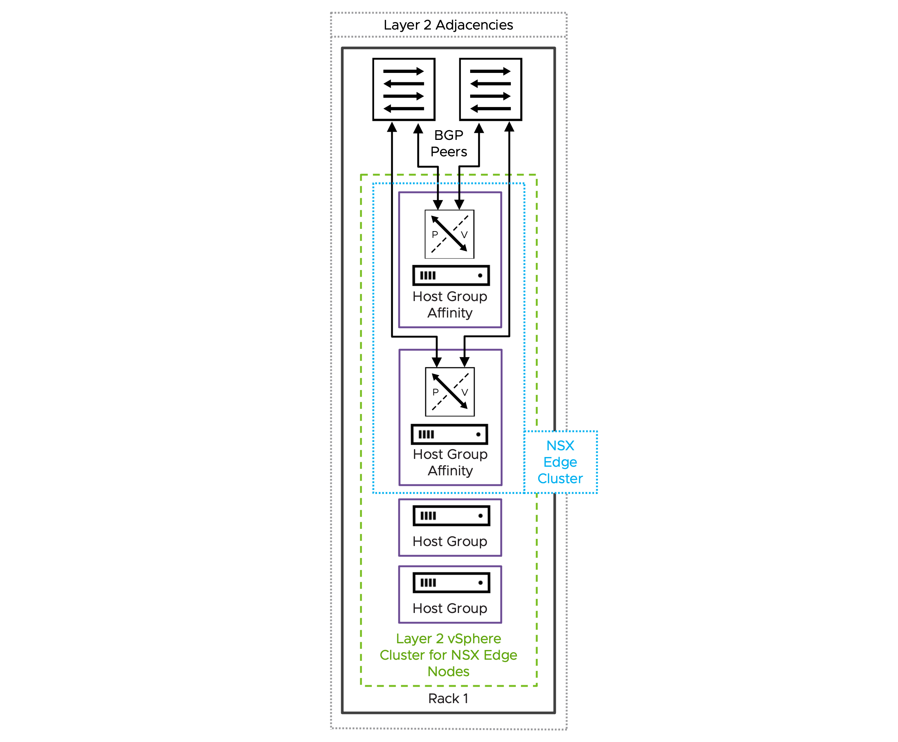

Host Fault Tolerant NSX Edge Cluster Model Attributes
The Host Fault Tolerant NSX Edge Cluster Model has the following attributes.
Attribute | Details
Availability model | Host level redundancy only.  Single shared storage.  This design cannot ensure continuous service availability for north-south communication and centralized network services during a complete rack failure.
NSX Edge node mobility across racks | N/A
BGP peering | Establish BGP peering solely with the local ToR switches located within the same rack that hosts the NSX Edge node.
NSX Edge node and link failover mechanisms | Fast NSX Edge node High-Availability detection for NSX Edge node failures.  Fast link failure detection with Bidirectional Forwarding Detection (BFD) for BGP.
North-South bandwidth growth | Add hosts to the single existing vSphere cluster or preferably transition to a rack fault tolerant design with two or more vertical Layer 2 vSphere cluster in separate rack.  When deploying more NSX Edge nodes on existing hosts, ensure each host has sufficient CPU, memory, and importantly, additional physical NICs (pNICs) to maintain maximum packet forwarding rates (PPS) for each NSX Edge node.
Table 3-765. Common NSX Edge for Single Availability Zone Design Requirements
Design Requirement ID | Design Requirement | Justification | Implication
VCF-NSX-EDGE-REQD-COMSAZ-01 | Align the Tunnel Endpoint (TEP) MTU for NSX Edge nodes to the same MTU as the VDS MTU. | Consistent MTU within the same NSX Overlay Transport Zone is required. | Requires manual configuration of the Tunnel Endpoint (TEP) MTU value in NSX Global Fabric Settings.
Table 3-766. Common NSX Edge for Single Availability Zone Design Recommendations
Design Recommendation ID | Design Recommendation | Justification | Implication
VCF-NSX-EDGE-RCMD-COMSAZ-01 | Dedicated vSphere cluster to exclusively host NSX Edge nodes. | NSX Edge nodes use dedicated and exclusively host resources (CPU, memory, pNIC) to provide best packet forwarding performance, reliability and operational simplification.  Enables the selection of an independent vSphere Distributed Switch design separate from the vSphere cluster hosting workload virtual machines.  Enable specific hardware selection for NSX Edge node hosts. | Additional servers are required.
VCF-NSX-EDGE-RCMD-COMSAZ-02 | Limit the number of NSX Edge nodes per host to the number of available physical NICs. | Each NSX Edge node should be connected to a pair of physical NICs to ensure maximum packet forwarding rates (PPS). | Additional physical NICs or hosts, or both are required to support the deployment of a higher number of NSX Edge nodes.
VCF-NSX-EDGE-RCMD-COMSAZ-03 | Use the default memory reservation with 100% for NSX Edge nodes. | The 100% memory reservation configuration is a guaranteed minimum allocation of host physical memory that is entirely dedicated to a NSX Edge node, ensuring this full memory amount remains available to the NSX Edge node even when the host system is in an over-committed state. | In a collapsed cluster where other workload VMs have memory reservation too:  Virtual machines may fail to power on when memory reservations can't be guaranteed, even if idle reserved memory exists.  vSphere HA may be unable to restart VMs after host failures if it cannot meet their memory reservations on surviving hosts.Memory reservation locks physical RAM, while CPU reservation guarantees minimum access to a shared resource.
VCF-NSX-EDGE-RCMD-COMSAZ-04 | Use the default CPU reservation priority in NSX set to high shares for NSX Edge nodes. | Setting CPU shares to "High" ensures that NSX Edge nodes receive higher relative priority during CPU contention scenarios, allowing critical network functions to maintain performance when host resources are constrained. | High CPU reservations are generally less critical than high memory reservations.
VCF-NSX-EDGE-RCMD-COMSAZ-05 | For each NSX Edge node, assign a dedicated physical NIC to the data plane fastpath interfaces fp-eth0 and fp-eth1. | Each NSX Edge node leverages only two of four data plane fastpath interfaces.  When two NSX Edge nodes are deployed per host, each NSX Edge node should use a dedicated pair of physical NICs - one active and one standby.  When deploying two NSX Edge nodes per host, each NSX Edge node requires two dedicated physical NICs configured for optimal performance. | The two remaining data plane fastpath interfaces per NSX Edge node are not used.
VCF-NSX-EDGE-RCMD-COMSAZ-06 | Map data plane fastpath interface fp-eth0 with physical NIC 1 as active and physical NIC 2 as standby; map data plane fastpath interface fp-eth1 with physical NIC 1 as standby and physical NIC 2 as active, creating complementary failover paths. | Enables redundant paths for both data plane fastpath interfaces on each NSX Edge node, preventing single points of failure. | None.
VCF-NSX-EDGE-RCMD-COMSAZ-07 | Create a new dvPortGroup for the NSX Edge node management interface, separate from the dvPortGroup used for ESX host management VMkernel. Depending on the selected NSX Edge cluster design, an NSX Edge node management dvPortGroup is required for each vSphere cluster, rack, or Availability Zone. | Traffic segregation enables organizations to implement and enforce network security policies. | Increased configuration effort.  For a management domain: a separate dvPortGroup for the NSX Edge node management interface already exists when using a single VDS design; this is the same dvPortGroup as used for the management stack.
VCF-NSX-EDGE-RCMD-COMSAZ-08 | Create for every host an individual host group. | Host groups will be required to enable compute policy type Best Effort Restart (BER). | Host groups must be configured through the administrator before initiating the NSX or vCenter Network Connectivity workflow.
VCF-NSX-EDGE-RCMD-COMSAZ-09 | Create for every NSX Edge node an individual VM group. | VM groups will be required to enable compute policy type Best Effort Restart (BER). | The NSX or vCenter Network Connectivity workflow automatically configures VM groups when the host group affinity option is selected. Do not create this VM group manually.
VCF-NSX-EDGE-RCMD-COMSAZ-10 | Assign to each individual NSX Edge node the previously configured host group. | Each NSX Edge node has a 1:1 affinity with the underlying ESX host. | If the assignment was not set through the NSX or vCenter Network Connectivity workflow , it can be added via NSX API.
VCF-NSX-EDGE-RCMD-COMSAZ-11 | Create a VM/Host "must" rule by mapping the previously created host group and VM group together, ensuring the NSX Edge node in the VM group must only run on this specific host. | VM/Host "must" rule for each NSX Edge node will be required to enable compute policy type Best Effort Restart (BER). | The NSX or vCenter Network Connectivity workflow automatically configures VM/Host rule when the host group affinity option is selected. Do not create this VM/host rule manually.
VCF-NSX-EDGE-RCMD-COMSAZ-12 | Create a vCenter tag with a category to identify the compute policy type Best Effort Restart (BER) and assign it to each NSX Edge node. | The vCenter tag with a category is required to map both the compute policy type Best Effort Restart (BER) and the NSX Edge nodes together. | The NSX or vCenter Network Connectivity workflow automatically configures the vCenter tag with a category and assign to each NSX Edge node when the host group affinity option is selected. Do not create the vCenter tag and category manually.
VCF-NSX-EDGE-RCMD-COMSAZ-13 | Create a compute policy type Best Effort Restart (BER) and assign the previously created vCenter tag and category to it. | Compute policy type Best Effort Restart (BER) enables smooth rolling host upgrades leveraging graceful NSX Edge node shutdown to minimize traffic disruption.  The compute policy type Best Effort Restart (BER) verifies peer NSX Edge node readiness during host upgrades through multiple pre-checks before initiating NSX Edge node failover and ensures the NSX Edge node shutdown process begins gracefully only after successful pre-checks. | The NSX or vCenter Network Connectivity workflow automatically configures the compute policy type Best Effort Restart (BER) when the host group affinity option is selected. Do not create this compute policy type Best Effort Restart (BER) manually.  Evacuating the NSX Edge node using vMotion during host upgrades or maintenance is not possible.  User-initiated host maintenance mode will shut down the hosted NSX Edge node regardless of whether a healthy peer NSX Edge node is available to take over, as readiness pre-checks are not executed during this process; it is the administrator's responsibility to ensure service availability is maintained.
VCF-NSX-EDGE-RCMD-COMSAZ-14 | Select the NSX Edge node size large or x-large. | The size of an NSX Edge node depends on the throughput requirements and any configured centralized network services.  For most deployments, particularly when NSX Edge nodes are used solely for north-south traffic forwarding, the large NSX Edge node size provides an optimal balance between performance and resource utilization. | You must provide sufficient compute resources to support the chosen NSX Edge node size.  In vSphere clusters with a high density of NSX Edge nodes, such as multi-tenancy environments with high oversubscription ratios or collapsed vSphere clusters where both workload virtual machines and NSX Edge nodes run on the same hosts, the resource requirements of large or extra large NSX Edge nodes occasionally create resource constraints.
VCF-NSX-EDGE-RCMD-COMSAZ-15 | Select the auto-generation password option for NSX Edge nodes. | Auto-generation password option enables centralized password management in VCF Operations. | Password needs to be looked up to gain SSH access.
VCF-NSX-EDGE-RCMD-COMSAZ-16 | Select static IP allocation for the NSX Edge node management interface. | Static IP allocation removes the dependency on external DHCP services. | None.
VCF-NSX-EDGE-RCMD-COMSAZ-17 | Configure separate Tunnel Endpoint (TEP) VLANs for NSX Edge nodes and ESX hosts.  It is possible to use a single TEP VLAN across host and NSX Edge node by enabling "NSX on dvPG". | Simplifies Tunnel Endpoint (TEP) IP management by separating IP allocation methods between ESX hosts and NSX Edge nodes, for example using static IP assignment for NSX Edge nodes while utilizing DHCP-based allocation for ESXi hosts.  No need to enable "NSX on dvPG". | NSX Edge nodes and host Tunnel Endpoint (TEP) require separate VLANs with routing configured between them to enable proper overlay network communication.  Requires the configuration of ab additional VLAN for NSX Edge node Tunnel Endpoint (TEP) traffic.
VCF-NSX-EDGE-RCMD-COMSAZ-18 | Configure IP Pool allocation for the NSX Edge node Tunnel Endpoint (TEP) interfaces. | IP Pool allocation eliminates dependency on external DHCP services while reducing configuration overhead compared to static IP assignment.  Each of the two data plane fastpath interfaces get an IP address assigned to enable NSX Edge node Tunnel Endpoint (TEP) | Requires the configuration of one or more IP Pools depending on the vSphere cluster model.
VCF-NSX-EDGE-RCMD-COMSAZ-19 | Enable TEP Groups for NSX Edge nodes. | Higher throughput achievable by a single NSX Edge node.  Granular flow base load balancing of NSX Edge node TEP traffic.  Resiliency to partial link failures (Physical link state up but not forwarding). | TEP Groups must be enabled through NSX API globally for all NSX Edge nodes.
VCF-NSX-EDGE-RCMD-COMSAZ-20 | Limit the span of NSX Edge node networks to the local racks. | VLANs including NSX Edge node Tunnel Endpoint (TEP), the NSX Edge node management and the two (2) Edge Uplink VLANs that carry BGP sessions and north-south traffic are limited to the rack.  BGP will establish peering connections exclusively with Top-of-Rack (ToR) switches located within the same rack, ensuring a deterministic alignment between physical components (ToRs and cabling) and the corresponding BGP session. | Limit the span of networks to reduce failure propagation across racks.  Avoid BGP peering across racks.
VCF-NSX-EDGE-RCMD-COMSAZ-21 | Use a single Edge Switch in the NSX Edge nodes. | Simplifies deployment of NSX Edge nodes.  Supports multiple Tunnel Endpoint (TEP) interfaces.  Carries both overlay and uplink traffic. | The NSX or vCenter Network Connectivity workflow automatically configures always a single Edge Switch.

Host Fault Tolerant NSX Edge Cluster Model Design Requirements
This design requirement is a specific requirement in addition to the common design requirements.
Table 3-767. Host Fault Tolerant NSX Edge Cluster Model Design Requirements
Design Requirement ID | Design Requirement | Justification | Implication
VCF-NSX-EDGE-REQD-HFTSR-01 | Deploy two (2) or more NSX Edge nodes in the same vSphere Cluster. | NSX Edge nodes are required to support centralized network connectivity for the virtual network.  At least two (2) NSX Edge nodes are required to support NSX Edge high-availability. | Cluster resources must be available to support the NSX Edge nodes.  Additional NSX Edge nodes may be required to satisfy increased bandwidth requirements.

Host Fault Tolerant NSX Edge Cluster Model Design Recommendations
These design recommendations are specific recommendations in addition to the common design recommendations.
Table 3-768. Host Fault Tolerant NSX Edge Cluster Model Design Recommendations
Design Recommendation ID | Design Recommendation | Justification | Implication
VCF-NSX-EDGE-RCMD-HFTSR-01 | Ensure that NSX Edge nodes belonging to the same NSX Edge cluster are evenly deployed across different hosts.. | Maintain High-Availability and prevent single points of failure | Additional servers are required.
VCF-NSX-EDGE-RCMD-HFTSR-02 | Configure an NSX failure domain for each host where the NSX Edge node can run - this is only valid when you have more than two NSX Edge nodes; map the NSX Edge nodes to the NSX failure domains appropriately. | Failure domains guarantee service availability in case of a failure affecting multiple NSX Edge nodes.  Active and standby instance of a VPC or Tier-1 gateway always run in different failure domains. | Additional manual configuration.  This applies only for designs incorporating VPC or Tier-1 gateway in A/S mode.

Rack Fault Tolerant using multiple Single-Rack Clusters NSX Edge Cluster Model
Using two or more vSphere clusters to host NSX Edge nodes provides both host-level and rack-level availability, with each rack maintaining independent storage when using vSAN. Each vSphere cluster's infrastructure is contained entirely within a single rack.
Figure 3-110. Rack Fault Tolerant using multiple Single-Rack Clusters NSX Edge Cluster Model
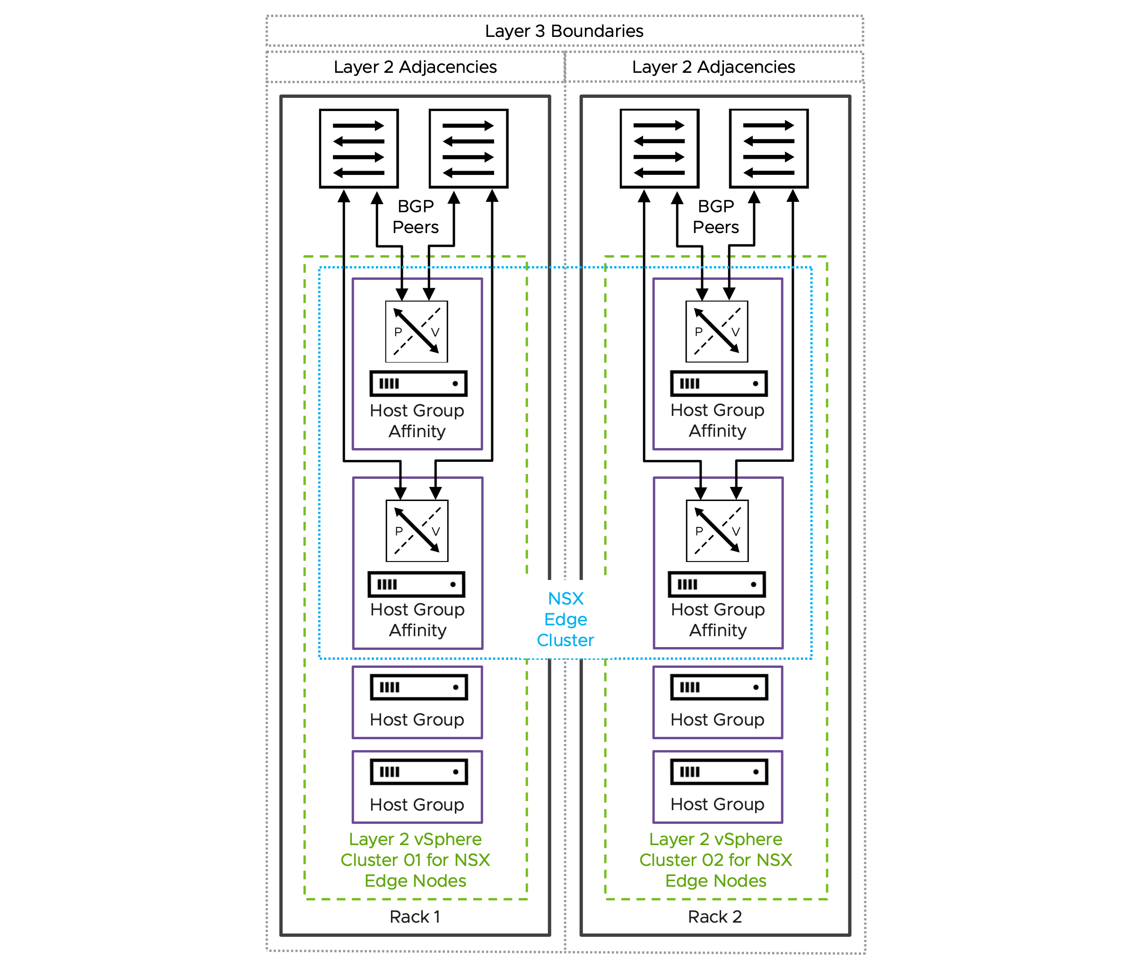

Rack Fault Tolerant using multiple Single-Rack Clusters NSX Edge Cluster Model Attributes
The Rack Fault Tolerant using multiple Single-Rack Clusters NSX Edge Cluster Model has the following attributes.
Attribute | Details
Availability model | Host and rack-level redundancy.  Independent shared storage per vSphere cluster when using vSAN.  This design ensures continuous service availability for north-south communication and centralized network services during a complete rack failure.
NSX Edge node mobility across racks | Not supported.
BGP peering | Establish BGP peering solely with the local ToR switches located within the same rack that hosts the NSX Edge node.
NSX Edge node and link failover mechanisms | Fast NSX Edge node High-Availability detection for NSX Edge node failures.  Fast link failure detection with Bidirectional Forwarding Detection (BFD) for BGP.
North-South bandwidth growth | Expand all vSphere clusters simultaneously, ensuring NSX Edge nodes remain evenly distributed across vSphere clusters. This differs from the single vSphere cluster approach where scaling could be limited to one vSphere cluster and one rack.  When deploying more NSX Edge nodes on existing hosts, ensure each host has sufficient CPU, memory, and importantly, additional physical NICs (pNICs) to maintain maximum packet forwarding rates (PPS) for each NSX Edge node.
Table 3-769. Common NSX Edge for Single Availability Zone Design Requirements
Design Requirement ID | Design Requirement | Justification | Implication
VCF-NSX-EDGE-REQD-COMSAZ-01 | Align the Tunnel Endpoint (TEP) MTU for NSX Edge nodes to the same MTU as the VDS MTU. | Consistent MTU within the same NSX Overlay Transport Zone is required. | Requires manual configuration of the Tunnel Endpoint (TEP) MTU value in NSX Global Fabric Settings.
Table 3-770. Common NSX Edge for Single Availability Zone Design Recommendations
Design Recommendation ID | Design Recommendation | Justification | Implication
VCF-NSX-EDGE-RCMD-COMSAZ-01 | Dedicated vSphere cluster to exclusively host NSX Edge nodes. | NSX Edge nodes use dedicated and exclusively host resources (CPU, memory, pNIC) to provide best packet forwarding performance, reliability and operational simplification.  Enables the selection of an independent vSphere Distributed Switch design separate from the vSphere cluster hosting workload virtual machines.  Enable specific hardware selection for NSX Edge node hosts. | Additional servers are required.
VCF-NSX-EDGE-RCMD-COMSAZ-02 | Limit the number of NSX Edge nodes per host to the number of available physical NICs. | Each NSX Edge node should be connected to a pair of physical NICs to ensure maximum packet forwarding rates (PPS). | Additional physical NICs or hosts, or both are required to support the deployment of a higher number of NSX Edge nodes.
VCF-NSX-EDGE-RCMD-COMSAZ-03 | Use the default memory reservation with 100% for NSX Edge nodes. | The 100% memory reservation configuration is a guaranteed minimum allocation of host physical memory that is entirely dedicated to a NSX Edge node, ensuring this full memory amount remains available to the NSX Edge node even when the host system is in an over-committed state. | In a collapsed cluster where other workload VMs have memory reservation too:  Virtual machines may fail to power on when memory reservations can't be guaranteed, even if idle reserved memory exists.  vSphere HA may be unable to restart VMs after host failures if it cannot meet their memory reservations on surviving hosts.Memory reservation locks physical RAM, while CPU reservation guarantees minimum access to a shared resource.
VCF-NSX-EDGE-RCMD-COMSAZ-04 | Use the default CPU reservation priority in NSX set to high shares for NSX Edge nodes. | Setting CPU shares to "High" ensures that NSX Edge nodes receive higher relative priority during CPU contention scenarios, allowing critical network functions to maintain performance when host resources are constrained. | High CPU reservations are generally less critical than high memory reservations.
VCF-NSX-EDGE-RCMD-COMSAZ-05 | For each NSX Edge node, assign a dedicated physical NIC to the data plane fastpath interfaces fp-eth0 and fp-eth1. | Each NSX Edge node leverages only two of four data plane fastpath interfaces.  When two NSX Edge nodes are deployed per host, each NSX Edge node should use a dedicated pair of physical NICs - one active and one standby.  When deploying two NSX Edge nodes per host, each NSX Edge node requires two dedicated physical NICs configured for optimal performance. | The two remaining data plane fastpath interfaces per NSX Edge node are not used.
VCF-NSX-EDGE-RCMD-COMSAZ-06 | Map data plane fastpath interface fp-eth0 with physical NIC 1 as active and physical NIC 2 as standby; map data plane fastpath interface fp-eth1 with physical NIC 1 as standby and physical NIC 2 as active, creating complementary failover paths. | Enables redundant paths for both data plane fastpath interfaces on each NSX Edge node, preventing single points of failure. | None.
VCF-NSX-EDGE-RCMD-COMSAZ-07 | Create a new dvPortGroup for the NSX Edge node management interface, separate from the dvPortGroup used for ESX host management VMkernel. Depending on the selected NSX Edge cluster design, an NSX Edge node management dvPortGroup is required for each vSphere cluster, rack, or Availability Zone. | Traffic segregation enables organizations to implement and enforce network security policies. | Increased configuration effort.  For a management domain: a separate dvPortGroup for the NSX Edge node management interface already exists when using a single VDS design; this is the same dvPortGroup as used for the management stack.
VCF-NSX-EDGE-RCMD-COMSAZ-08 | Create for every host an individual host group. | Host groups will be required to enable compute policy type Best Effort Restart (BER). | Host groups must be configured through the administrator before initiating the NSX or vCenter Network Connectivity workflow.
VCF-NSX-EDGE-RCMD-COMSAZ-09 | Create for every NSX Edge node an individual VM group. | VM groups will be required to enable compute policy type Best Effort Restart (BER). | The NSX or vCenter Network Connectivity workflow automatically configures VM groups when the host group affinity option is selected. Do not create this VM group manually.
VCF-NSX-EDGE-RCMD-COMSAZ-10 | Assign to each individual NSX Edge node the previously configured host group. | Each NSX Edge node has a 1:1 affinity with the underlying ESX host. | If the assignment was not set through the NSX or vCenter Network Connectivity workflow , it can be added via NSX API.
VCF-NSX-EDGE-RCMD-COMSAZ-11 | Create a VM/Host "must" rule by mapping the previously created host group and VM group together, ensuring the NSX Edge node in the VM group must only run on this specific host. | VM/Host "must" rule for each NSX Edge node will be required to enable compute policy type Best Effort Restart (BER). | The NSX or vCenter Network Connectivity workflow automatically configures VM/Host rule when the host group affinity option is selected. Do not create this VM/host rule manually.
VCF-NSX-EDGE-RCMD-COMSAZ-12 | Create a vCenter tag with a category to identify the compute policy type Best Effort Restart (BER) and assign it to each NSX Edge node. | The vCenter tag with a category is required to map both the compute policy type Best Effort Restart (BER) and the NSX Edge nodes together. | The NSX or vCenter Network Connectivity workflow automatically configures the vCenter tag with a category and assign to each NSX Edge node when the host group affinity option is selected. Do not create the vCenter tag and category manually.
VCF-NSX-EDGE-RCMD-COMSAZ-13 | Create a compute policy type Best Effort Restart (BER) and assign the previously created vCenter tag and category to it. | Compute policy type Best Effort Restart (BER) enables smooth rolling host upgrades leveraging graceful NSX Edge node shutdown to minimize traffic disruption.  The compute policy type Best Effort Restart (BER) verifies peer NSX Edge node readiness during host upgrades through multiple pre-checks before initiating NSX Edge node failover and ensures the NSX Edge node shutdown process begins gracefully only after successful pre-checks. | The NSX or vCenter Network Connectivity workflow automatically configures the compute policy type Best Effort Restart (BER) when the host group affinity option is selected. Do not create this compute policy type Best Effort Restart (BER) manually.  Evacuating the NSX Edge node using vMotion during host upgrades or maintenance is not possible.  User-initiated host maintenance mode will shut down the hosted NSX Edge node regardless of whether a healthy peer NSX Edge node is available to take over, as readiness pre-checks are not executed during this process; it is the administrator's responsibility to ensure service availability is maintained.
VCF-NSX-EDGE-RCMD-COMSAZ-14 | Select the NSX Edge node size large or x-large. | The size of an NSX Edge node depends on the throughput requirements and any configured centralized network services.  For most deployments, particularly when NSX Edge nodes are used solely for north-south traffic forwarding, the large NSX Edge node size provides an optimal balance between performance and resource utilization. | You must provide sufficient compute resources to support the chosen NSX Edge node size.  In vSphere clusters with a high density of NSX Edge nodes, such as multi-tenancy environments with high oversubscription ratios or collapsed vSphere clusters where both workload virtual machines and NSX Edge nodes run on the same hosts, the resource requirements of large or extra large NSX Edge nodes occasionally create resource constraints.
VCF-NSX-EDGE-RCMD-COMSAZ-15 | Select the auto-generation password option for NSX Edge nodes. | Auto-generation password option enables centralized password management in VCF Operations. | Password needs to be looked up to gain SSH access.
VCF-NSX-EDGE-RCMD-COMSAZ-16 | Select static IP allocation for the NSX Edge node management interface. | Static IP allocation removes the dependency on external DHCP services. | None.
VCF-NSX-EDGE-RCMD-COMSAZ-17 | Configure separate Tunnel Endpoint (TEP) VLANs for NSX Edge nodes and ESX hosts.  It is possible to use a single TEP VLAN across host and NSX Edge node by enabling "NSX on dvPG". | Simplifies Tunnel Endpoint (TEP) IP management by separating IP allocation methods between ESX hosts and NSX Edge nodes, for example using static IP assignment for NSX Edge nodes while utilizing DHCP-based allocation for ESXi hosts.  No need to enable "NSX on dvPG". | NSX Edge nodes and host Tunnel Endpoint (TEP) require separate VLANs with routing configured between them to enable proper overlay network communication.  Requires the configuration of ab additional VLAN for NSX Edge node Tunnel Endpoint (TEP) traffic.
VCF-NSX-EDGE-RCMD-COMSAZ-18 | Configure IP Pool allocation for the NSX Edge node Tunnel Endpoint (TEP) interfaces. | IP Pool allocation eliminates dependency on external DHCP services while reducing configuration overhead compared to static IP assignment.  Each of the two data plane fastpath interfaces get an IP address assigned to enable NSX Edge node Tunnel Endpoint (TEP) | Requires the configuration of one or more IP Pools depending on the vSphere cluster model.
VCF-NSX-EDGE-RCMD-COMSAZ-19 | Enable TEP Groups for NSX Edge nodes. | Higher throughput achievable by a single NSX Edge node.  Granular flow base load balancing of NSX Edge node TEP traffic.  Resiliency to partial link failures (Physical link state up but not forwarding). | TEP Groups must be enabled through NSX API globally for all NSX Edge nodes.
VCF-NSX-EDGE-RCMD-COMSAZ-20 | Limit the span of NSX Edge node networks to the local racks. | VLANs including NSX Edge node Tunnel Endpoint (TEP), the NSX Edge node management and the two (2) Edge Uplink VLANs that carry BGP sessions and north-south traffic are limited to the rack.  BGP will establish peering connections exclusively with Top-of-Rack (ToR) switches located within the same rack, ensuring a deterministic alignment between physical components (ToRs and cabling) and the corresponding BGP session. | Limit the span of networks to reduce failure propagation across racks.  Avoid BGP peering across racks.
VCF-NSX-EDGE-RCMD-COMSAZ-21 | Use a single Edge Switch in the NSX Edge nodes. | Simplifies deployment of NSX Edge nodes.  Supports multiple Tunnel Endpoint (TEP) interfaces.  Carries both overlay and uplink traffic. | The NSX or vCenter Network Connectivity workflow automatically configures always a single Edge Switch.

Rack Fault Tolerant using multiple Single-Rack Clusters NSX Edge Cluster Model Design Requirements
This design requirement is a specific requirement in addition to the common design requirements.
Table 3-771. Rack Fault Tolerant using multiple Single-Rack Clusters NSX Edge Cluster Model Design Requirements
Design Requirement ID | Design Requirement | Justification | Implication
VCF-NSX-EDGE-REQD-RFTMC-01 | Deploy two (2) or more NSX Edge nodes evenly across racks. | NSX Edge nodes are required to support centralized network connectivity for the virtual network.  At least two NSX Edge nodes are required to support NSX Edge high-availability. | Cluster resources must be available to support the NSX Edge nodes.  Additional NSX Edge nodes may be required to satisfy increased bandwidth requirements.

Rack Fault Tolerant using a Layer 3 Multi-Rack Cluster NSX Edge Cluster Model
A single horizontally deployed vSphere cluster for hosting NSX Edge nodes provides host-level and rack-level availability but without providing independent storage for each rack. The vSphere cluster is deployed with one or more hosts per rack across two or more racks, unlike the other designs with separated vertical vSphere clusters where each vSphere cluster was contained within a single rack. This design distributes hosts from the same vSphere cluster across multiple racks, with Layer 3 network boundaries providing separation between each rack.
Figure 3-111. Rack Fault Tolerant using a Layer 3 Multi-Rack Cluster NSX Edge Cluster Model
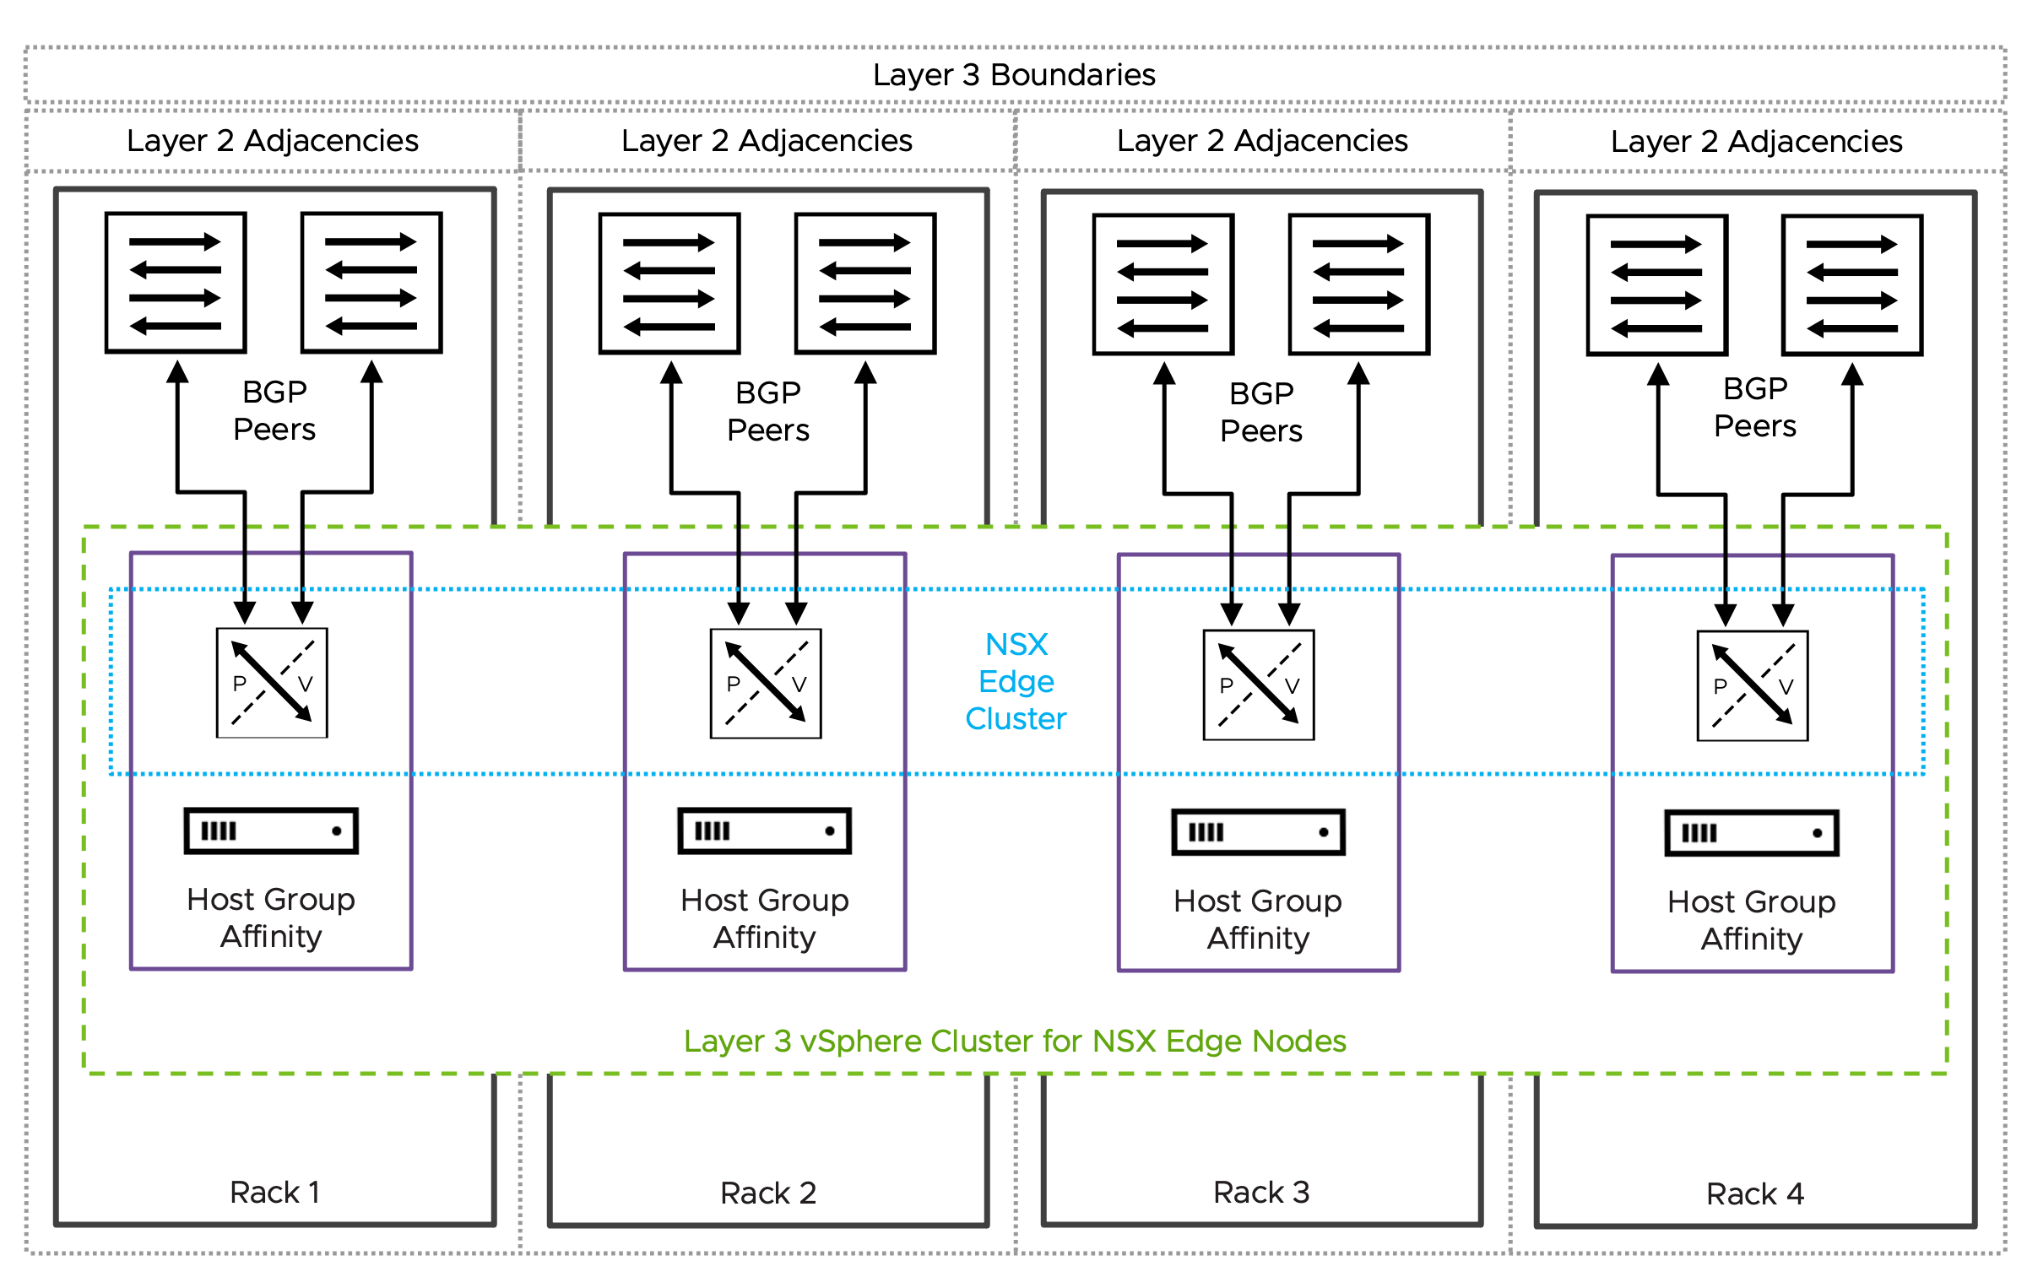

Rack Fault Tolerant using a Layer 3 Multi-Rack Cluster NSX Edge Cluster Model Attributes
The Rack Fault Tolerant using a Layer 3 Multi-Rack Cluster NSX Edge Cluster Model has the following attributes.
Attribute | Properties
Availability model | Host and rack-level redundancy.  Single shared storage.  This design ensures continuous service availability for north-south communication and centralized network services during a complete rack failure, similar to the multiple vertical vSphere cluster design.
NSX Edge node mobility across racks | Not supported
BGP peering | Establish BGP peering solely with the local ToR switches located within the same rack that hosts the NSX Edge node.
NSX Edge node and link failover mechanisms | Fast NSX Edge node High-Availability detection for NSX Edge node failures.  Fast link failure detection with Bidirectional Forwarding Detection (BFD) for BGP.
North-South bandwidth growth | Add hosts to existing racks or extend the vSphere cluster to span additional racks, with NSX Edge nodes distributed evenly across the racks.  When deploying more NSX Edge nodes on existing hosts, ensure each host has sufficient CPU, memory, and importantly, additional physical NICs (pNICs) to maintain maximum packet forwarding rates (PPS) for each NSX Edge node.
Table 3-772. Common NSX Edge for Single Availability Zone Design Requirements
Design Requirement ID | Design Requirement | Justification | Implication
VCF-NSX-EDGE-REQD-COMSAZ-01 | Align the Tunnel Endpoint (TEP) MTU for NSX Edge nodes to the same MTU as the VDS MTU. | Consistent MTU within the same NSX Overlay Transport Zone is required. | Requires manual configuration of the Tunnel Endpoint (TEP) MTU value in NSX Global Fabric Settings.
Table 3-773. Common NSX Edge for Single Availability Zone Design Recommendations
Design Recommendation ID | Design Recommendation | Justification | Implication
VCF-NSX-EDGE-RCMD-COMSAZ-01 | Dedicated vSphere cluster to exclusively host NSX Edge nodes. | NSX Edge nodes use dedicated and exclusively host resources (CPU, memory, pNIC) to provide best packet forwarding performance, reliability and operational simplification.  Enables the selection of an independent vSphere Distributed Switch design separate from the vSphere cluster hosting workload virtual machines.  Enable specific hardware selection for NSX Edge node hosts. | Additional servers are required.
VCF-NSX-EDGE-RCMD-COMSAZ-02 | Limit the number of NSX Edge nodes per host to the number of available physical NICs. | Each NSX Edge node should be connected to a pair of physical NICs to ensure maximum packet forwarding rates (PPS). | Additional physical NICs or hosts, or both are required to support the deployment of a higher number of NSX Edge nodes.
VCF-NSX-EDGE-RCMD-COMSAZ-03 | Use the default memory reservation with 100% for NSX Edge nodes. | The 100% memory reservation configuration is a guaranteed minimum allocation of host physical memory that is entirely dedicated to a NSX Edge node, ensuring this full memory amount remains available to the NSX Edge node even when the host system is in an over-committed state. | In a collapsed cluster where other workload VMs have memory reservation too:  Virtual machines may fail to power on when memory reservations can't be guaranteed, even if idle reserved memory exists.  vSphere HA may be unable to restart VMs after host failures if it cannot meet their memory reservations on surviving hosts.Memory reservation locks physical RAM, while CPU reservation guarantees minimum access to a shared resource.
VCF-NSX-EDGE-RCMD-COMSAZ-04 | Use the default CPU reservation priority in NSX set to high shares for NSX Edge nodes. | Setting CPU shares to "High" ensures that NSX Edge nodes receive higher relative priority during CPU contention scenarios, allowing critical network functions to maintain performance when host resources are constrained. | High CPU reservations are generally less critical than high memory reservations.
VCF-NSX-EDGE-RCMD-COMSAZ-05 | For each NSX Edge node, assign a dedicated physical NIC to the data plane fastpath interfaces fp-eth0 and fp-eth1. | Each NSX Edge node leverages only two of four data plane fastpath interfaces.  When two NSX Edge nodes are deployed per host, each NSX Edge node should use a dedicated pair of physical NICs - one active and one standby.  When deploying two NSX Edge nodes per host, each NSX Edge node requires two dedicated physical NICs configured for optimal performance. | The two remaining data plane fastpath interfaces per NSX Edge node are not used.
VCF-NSX-EDGE-RCMD-COMSAZ-06 | Map data plane fastpath interface fp-eth0 with physical NIC 1 as active and physical NIC 2 as standby; map data plane fastpath interface fp-eth1 with physical NIC 1 as standby and physical NIC 2 as active, creating complementary failover paths. | Enables redundant paths for both data plane fastpath interfaces on each NSX Edge node, preventing single points of failure. | None.
VCF-NSX-EDGE-RCMD-COMSAZ-07 | Create a new dvPortGroup for the NSX Edge node management interface, separate from the dvPortGroup used for ESX host management VMkernel. Depending on the selected NSX Edge cluster design, an NSX Edge node management dvPortGroup is required for each vSphere cluster, rack, or Availability Zone. | Traffic segregation enables organizations to implement and enforce network security policies. | Increased configuration effort.  For a management domain: a separate dvPortGroup for the NSX Edge node management interface already exists when using a single VDS design; this is the same dvPortGroup as used for the management stack.
VCF-NSX-EDGE-RCMD-COMSAZ-08 | Create for every host an individual host group. | Host groups will be required to enable compute policy type Best Effort Restart (BER). | Host groups must be configured through the administrator before initiating the NSX or vCenter Network Connectivity workflow.
VCF-NSX-EDGE-RCMD-COMSAZ-09 | Create for every NSX Edge node an individual VM group. | VM groups will be required to enable compute policy type Best Effort Restart (BER). | The NSX or vCenter Network Connectivity workflow automatically configures VM groups when the host group affinity option is selected. Do not create this VM group manually.
VCF-NSX-EDGE-RCMD-COMSAZ-10 | Assign to each individual NSX Edge node the previously configured host group. | Each NSX Edge node has a 1:1 affinity with the underlying ESX host. | If the assignment was not set through the NSX or vCenter Network Connectivity workflow , it can be added via NSX API.
VCF-NSX-EDGE-RCMD-COMSAZ-11 | Create a VM/Host "must" rule by mapping the previously created host group and VM group together, ensuring the NSX Edge node in the VM group must only run on this specific host. | VM/Host "must" rule for each NSX Edge node will be required to enable compute policy type Best Effort Restart (BER). | The NSX or vCenter Network Connectivity workflow automatically configures VM/Host rule when the host group affinity option is selected. Do not create this VM/host rule manually.
VCF-NSX-EDGE-RCMD-COMSAZ-12 | Create a vCenter tag with a category to identify the compute policy type Best Effort Restart (BER) and assign it to each NSX Edge node. | The vCenter tag with a category is required to map both the compute policy type Best Effort Restart (BER) and the NSX Edge nodes together. | The NSX or vCenter Network Connectivity workflow automatically configures the vCenter tag with a category and assign to each NSX Edge node when the host group affinity option is selected. Do not create the vCenter tag and category manually.
VCF-NSX-EDGE-RCMD-COMSAZ-13 | Create a compute policy type Best Effort Restart (BER) and assign the previously created vCenter tag and category to it. | Compute policy type Best Effort Restart (BER) enables smooth rolling host upgrades leveraging graceful NSX Edge node shutdown to minimize traffic disruption.  The compute policy type Best Effort Restart (BER) verifies peer NSX Edge node readiness during host upgrades through multiple pre-checks before initiating NSX Edge node failover and ensures the NSX Edge node shutdown process begins gracefully only after successful pre-checks. | The NSX or vCenter Network Connectivity workflow automatically configures the compute policy type Best Effort Restart (BER) when the host group affinity option is selected. Do not create this compute policy type Best Effort Restart (BER) manually.  Evacuating the NSX Edge node using vMotion during host upgrades or maintenance is not possible.  User-initiated host maintenance mode will shut down the hosted NSX Edge node regardless of whether a healthy peer NSX Edge node is available to take over, as readiness pre-checks are not executed during this process; it is the administrator's responsibility to ensure service availability is maintained.
VCF-NSX-EDGE-RCMD-COMSAZ-14 | Select the NSX Edge node size large or x-large. | The size of an NSX Edge node depends on the throughput requirements and any configured centralized network services.  For most deployments, particularly when NSX Edge nodes are used solely for north-south traffic forwarding, the large NSX Edge node size provides an optimal balance between performance and resource utilization. | You must provide sufficient compute resources to support the chosen NSX Edge node size.  In vSphere clusters with a high density of NSX Edge nodes, such as multi-tenancy environments with high oversubscription ratios or collapsed vSphere clusters where both workload virtual machines and NSX Edge nodes run on the same hosts, the resource requirements of large or extra large NSX Edge nodes occasionally create resource constraints.
VCF-NSX-EDGE-RCMD-COMSAZ-15 | Select the auto-generation password option for NSX Edge nodes. | Auto-generation password option enables centralized password management in VCF Operations. | Password needs to be looked up to gain SSH access.
VCF-NSX-EDGE-RCMD-COMSAZ-16 | Select static IP allocation for the NSX Edge node management interface. | Static IP allocation removes the dependency on external DHCP services. | None.
VCF-NSX-EDGE-RCMD-COMSAZ-17 | Configure separate Tunnel Endpoint (TEP) VLANs for NSX Edge nodes and ESX hosts.  It is possible to use a single TEP VLAN across host and NSX Edge node by enabling "NSX on dvPG". | Simplifies Tunnel Endpoint (TEP) IP management by separating IP allocation methods between ESX hosts and NSX Edge nodes, for example using static IP assignment for NSX Edge nodes while utilizing DHCP-based allocation for ESXi hosts.  No need to enable "NSX on dvPG". | NSX Edge nodes and host Tunnel Endpoint (TEP) require separate VLANs with routing configured between them to enable proper overlay network communication.  Requires the configuration of ab additional VLAN for NSX Edge node Tunnel Endpoint (TEP) traffic.
VCF-NSX-EDGE-RCMD-COMSAZ-18 | Configure IP Pool allocation for the NSX Edge node Tunnel Endpoint (TEP) interfaces. | IP Pool allocation eliminates dependency on external DHCP services while reducing configuration overhead compared to static IP assignment.  Each of the two data plane fastpath interfaces get an IP address assigned to enable NSX Edge node Tunnel Endpoint (TEP) | Requires the configuration of one or more IP Pools depending on the vSphere cluster model.
VCF-NSX-EDGE-RCMD-COMSAZ-19 | Enable TEP Groups for NSX Edge nodes. | Higher throughput achievable by a single NSX Edge node.  Granular flow base load balancing of NSX Edge node TEP traffic.  Resiliency to partial link failures (Physical link state up but not forwarding). | TEP Groups must be enabled through NSX API globally for all NSX Edge nodes.
VCF-NSX-EDGE-RCMD-COMSAZ-20 | Limit the span of NSX Edge node networks to the local racks. | VLANs including NSX Edge node Tunnel Endpoint (TEP), the NSX Edge node management and the two (2) Edge Uplink VLANs that carry BGP sessions and north-south traffic are limited to the rack.  BGP will establish peering connections exclusively with Top-of-Rack (ToR) switches located within the same rack, ensuring a deterministic alignment between physical components (ToRs and cabling) and the corresponding BGP session. | Limit the span of networks to reduce failure propagation across racks.  Avoid BGP peering across racks.
VCF-NSX-EDGE-RCMD-COMSAZ-21 | Use a single Edge Switch in the NSX Edge nodes. | Simplifies deployment of NSX Edge nodes.  Supports multiple Tunnel Endpoint (TEP) interfaces.  Carries both overlay and uplink traffic. | The NSX or vCenter Network Connectivity workflow automatically configures always a single Edge Switch.

Rack Fault Tolerant using a Layer 3 Multi-Rack Cluster NSX Edge Cluster Model Design Requirements
This design requirement is a specific requirement in addition to the common design requirements.
Table 3-774. Rack Fault Tolerant using a Layer 3 Multi-Rack Cluster NSX Edge Cluster Model Design Requirements
Design Requirement ID | Design Requirement | Justification | Implication
VCF-NSX-EDGE-REQD-RFTL3-01 | Deploy two (2) or more NSX Edge nodes evenly across racks. | NSX Edge nodes are required to support centralized network connectivity for the virtual network.  At least two (2) NSX Edge nodes are required to support NSX Edge high-availability. | Cluster resources must be available to support the NSX Edge nodes.  Additional NSX Edge nodes may be required to satisfy increased bandwidth requirements.

Rack Fault Tolerant using a Layer 3 Multi-Rack Cluster NSX Edge Cluster Model Design Recommendations
These design recommendations are specific recommendations in addition to the common design recommendations.
Table 3-775. Rack Fault Tolerant using a Layer 3 Multi-Rack Cluster NSX Edge Cluster Model Design Recommendations
Design Recommendation ID | Design Recommendation | Justification | Implication
VCF-NSX-EDGE-RCMD-RFTL3-01 | Ensure that NSX Edge nodes belonging to the same NSX Edge cluster are deployed evenly across different racks. | Maintain high availability and prevent single points of failure. | Additional servers are required.
VCF-NSX-EDGE-RCMD-RFTL3-02 | Configure an NSX failure domain for each rack where the NSX Edge node can run - this is only valid when you have more than two NSX Edge nodes; map the NSX Edge nodes to the NSX failure domains appropriately. | Failure domains guarantee service availability in case of a failure affecting multiple NSX Edge nodes.  Active and standby instance of a VPC or Tier-1 gateway always run in different failure domains. | Additional manual configuration.  This applies only for designs incorporating VPC or Tier-1 gateway in A/S mode.

Rack Fault Tolerant using a Layer 2 Multi-Rack Cluster NSX Edge Cluster Model
A single horizontally deployed vSphere cluster for hosting NSX Edge nodes provides host-level and rack-level availability but without providing independent storage for each rack. The vSphere cluster is deployed with one or more hosts per rack across two or more racks, unlike the other designs with separated vertical vSphere clusters where each vSphere cluster was contained within a single rack. Unlike the previous horizontal design, this design distributes hosts from the same vSphere cluster within the same Layer 2 domain between racks rather than across Layer 3 boundaries. The physical network fabric must support Layer 2 adjacencies (e.g., through VXLAN encapsulation) to enable connectivity between hosts across different racks.
Figure 3-112. Rack Fault Tolerant using a Layer 2 Multi-Rack Cluster NSX Edge Cluster Model
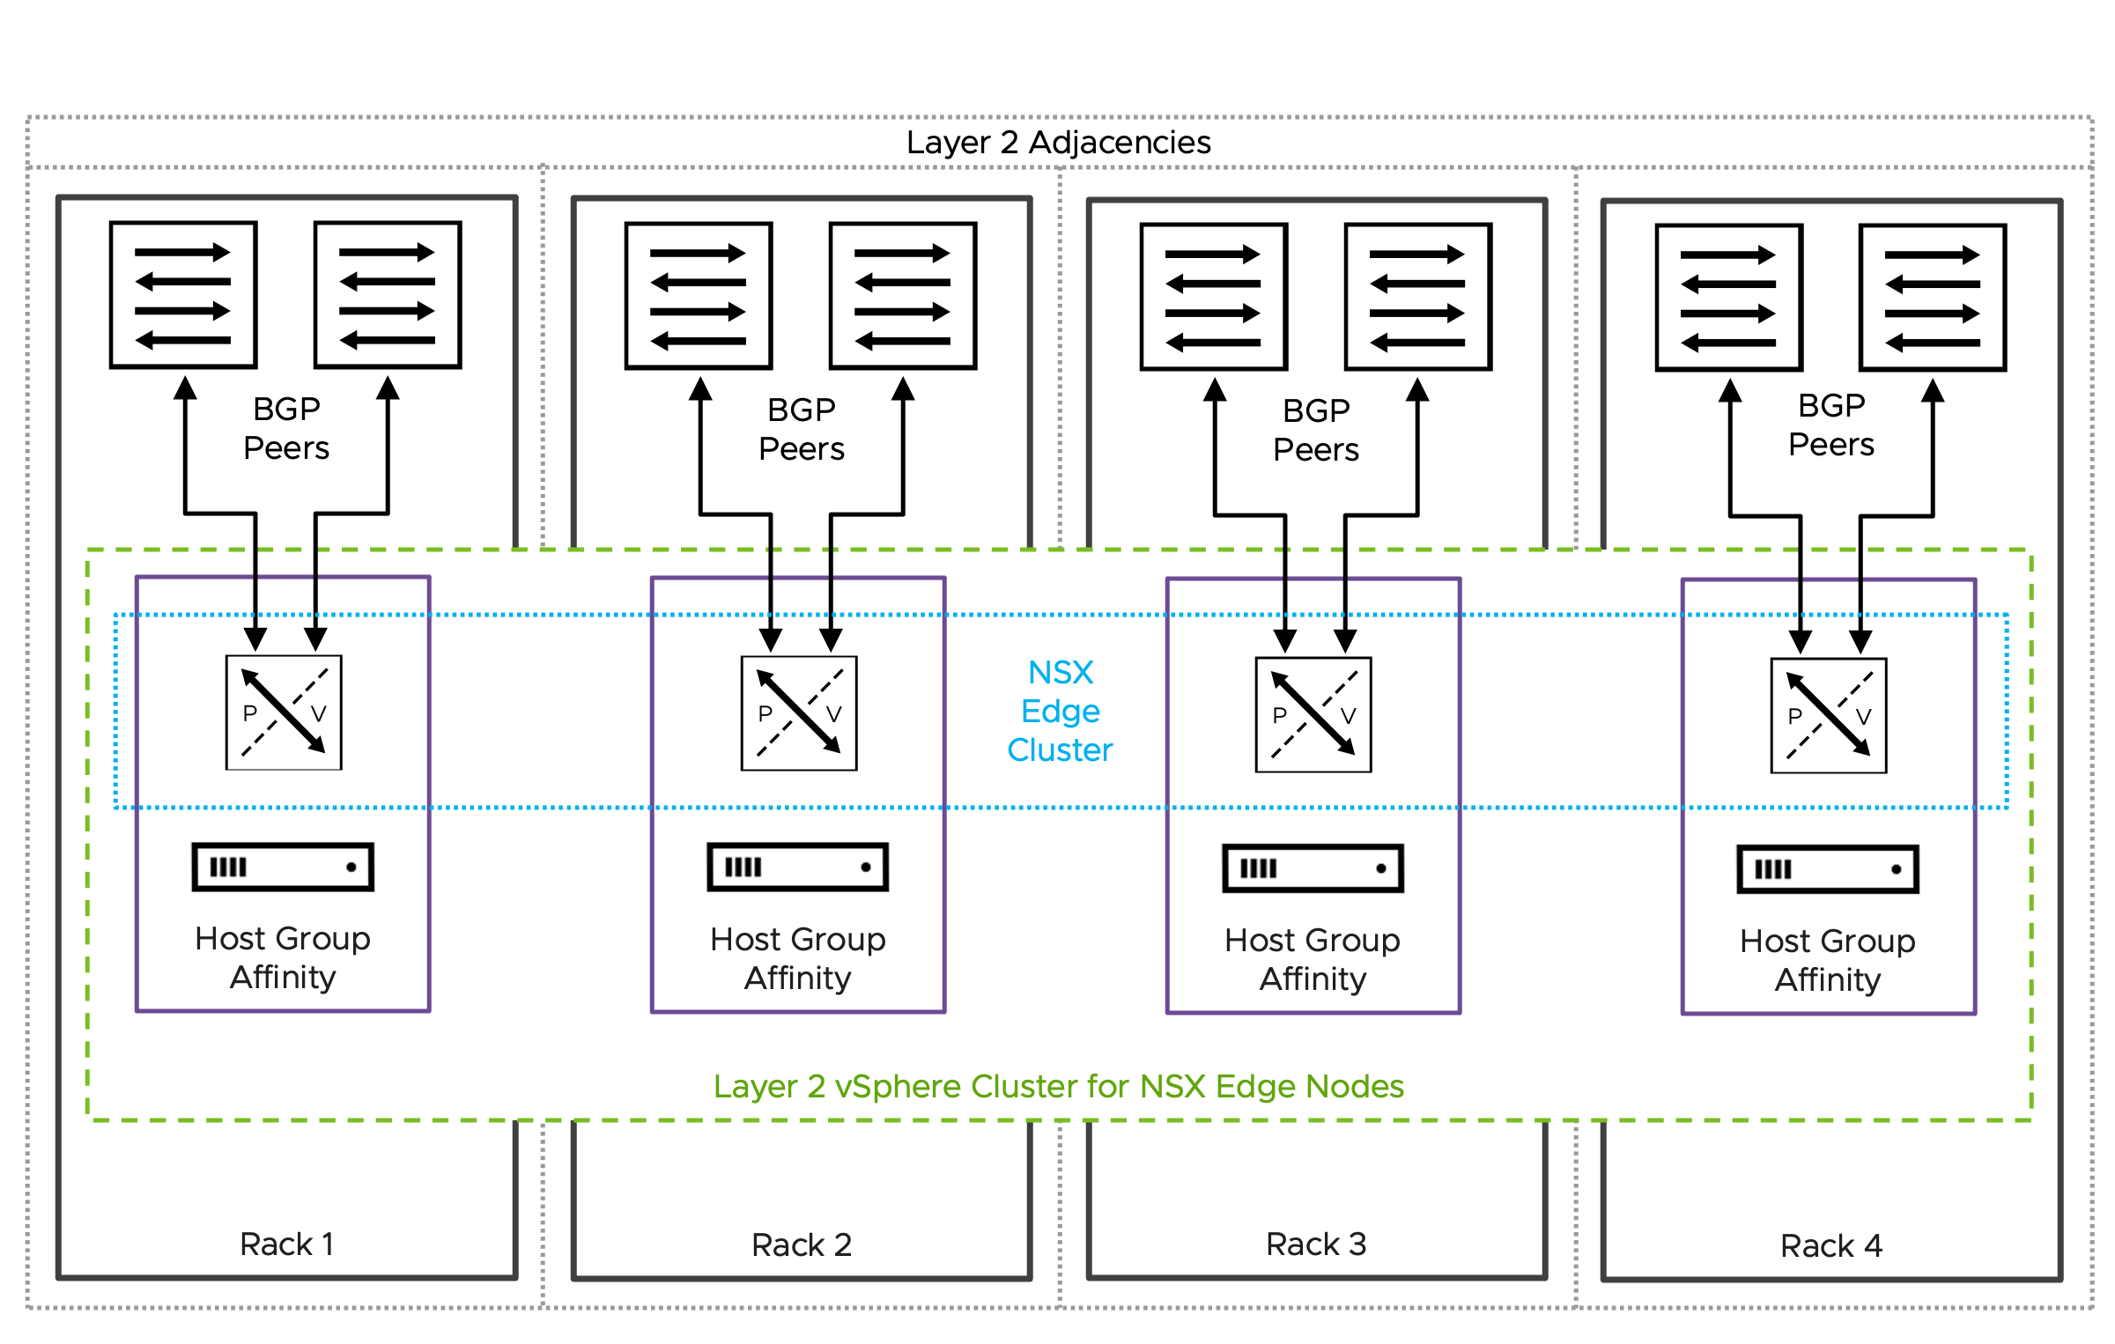

Rack Fault Tolerant using a Layer 2 Multi-Rack Cluster NSX Edge Cluster Model Attributes
The Rack Fault Tolerant using a Layer 2 Multi-Rack Cluster NSX Edge Cluster Model has the following attributes.
Attribute | Details
Availability model | Host and rack-level redundancy.  Single shared storage.  This design ensures continuous service availability for north-south communication and centralized network services during a complete rack failure, similar to the multiple vertical vSphere cluster design.
NSX Edge node mobility across racks | Supported, though implementing this capability is not required nor recommended.
BGP peering | Because BGP peering over extended networks may be problematic in some physical network fabrics, it's recommended to establish BGP peering only with local ToR switches to eliminate this dependency, even when Layer 2 adjacency is available across racks.
NSX Edge node and link failover mechanisms | Fast NSX Edge node High-Availability detection for NSX Edge node failures.  Fast link failure detection with Bidirectional Forwarding Detection (BFD) for BGP.
North-South bandwidth growth | Add hosts to existing racks or extend the vSphere cluster to span additional racks, with NSX Edge nodes distributed evenly across the racks.  When deploying more NSX Edge nodes on existing hosts, ensure each host has sufficient CPU, memory, and importantly, additional physical NICs (pNICs) to maintain maximum packet forwarding rates (PPS) for each NSX Edge node.
Table 3-776. Common NSX Edge for Single Availability Zone Design Requirements
Design Requirement ID | Design Requirement | Justification | Implication
VCF-NSX-EDGE-REQD-COMSAZ-01 | Align the Tunnel Endpoint (TEP) MTU for NSX Edge nodes to the same MTU as the VDS MTU. | Consistent MTU within the same NSX Overlay Transport Zone is required. | Requires manual configuration of the Tunnel Endpoint (TEP) MTU value in NSX Global Fabric Settings.
Table 3-777. Common NSX Edge for Single Availability Zone Design Recommendations
Design Recommendation ID | Design Recommendation | Justification | Implication
VCF-NSX-EDGE-RCMD-COMSAZ-01 | Dedicated vSphere cluster to exclusively host NSX Edge nodes. | NSX Edge nodes use dedicated and exclusively host resources (CPU, memory, pNIC) to provide best packet forwarding performance, reliability and operational simplification.  Enables the selection of an independent vSphere Distributed Switch design separate from the vSphere cluster hosting workload virtual machines.  Enable specific hardware selection for NSX Edge node hosts. | Additional servers are required.
VCF-NSX-EDGE-RCMD-COMSAZ-02 | Limit the number of NSX Edge nodes per host to the number of available physical NICs. | Each NSX Edge node should be connected to a pair of physical NICs to ensure maximum packet forwarding rates (PPS). | Additional physical NICs or hosts, or both are required to support the deployment of a higher number of NSX Edge nodes.
VCF-NSX-EDGE-RCMD-COMSAZ-03 | Use the default memory reservation with 100% for NSX Edge nodes. | The 100% memory reservation configuration is a guaranteed minimum allocation of host physical memory that is entirely dedicated to a NSX Edge node, ensuring this full memory amount remains available to the NSX Edge node even when the host system is in an over-committed state. | In a collapsed cluster where other workload VMs have memory reservation too:  Virtual machines may fail to power on when memory reservations can't be guaranteed, even if idle reserved memory exists.  vSphere HA may be unable to restart VMs after host failures if it cannot meet their memory reservations on surviving hosts.Memory reservation locks physical RAM, while CPU reservation guarantees minimum access to a shared resource.
VCF-NSX-EDGE-RCMD-COMSAZ-04 | Use the default CPU reservation priority in NSX set to high shares for NSX Edge nodes. | Setting CPU shares to "High" ensures that NSX Edge nodes receive higher relative priority during CPU contention scenarios, allowing critical network functions to maintain performance when host resources are constrained. | High CPU reservations are generally less critical than high memory reservations.
VCF-NSX-EDGE-RCMD-COMSAZ-05 | For each NSX Edge node, assign a dedicated physical NIC to the data plane fastpath interfaces fp-eth0 and fp-eth1. | Each NSX Edge node leverages only two of four data plane fastpath interfaces.  When two NSX Edge nodes are deployed per host, each NSX Edge node should use a dedicated pair of physical NICs - one active and one standby.  When deploying two NSX Edge nodes per host, each NSX Edge node requires two dedicated physical NICs configured for optimal performance. | The two remaining data plane fastpath interfaces per NSX Edge node are not used.
VCF-NSX-EDGE-RCMD-COMSAZ-06 | Map data plane fastpath interface fp-eth0 with physical NIC 1 as active and physical NIC 2 as standby; map data plane fastpath interface fp-eth1 with physical NIC 1 as standby and physical NIC 2 as active, creating complementary failover paths. | Enables redundant paths for both data plane fastpath interfaces on each NSX Edge node, preventing single points of failure. | None.
VCF-NSX-EDGE-RCMD-COMSAZ-07 | Create a new dvPortGroup for the NSX Edge node management interface, separate from the dvPortGroup used for ESX host management VMkernel. Depending on the selected NSX Edge cluster design, an NSX Edge node management dvPortGroup is required for each vSphere cluster, rack, or Availability Zone. | Traffic segregation enables organizations to implement and enforce network security policies. | Increased configuration effort.  For a management domain: a separate dvPortGroup for the NSX Edge node management interface already exists when using a single VDS design; this is the same dvPortGroup as used for the management stack.
VCF-NSX-EDGE-RCMD-COMSAZ-08 | Create for every host an individual host group. | Host groups will be required to enable compute policy type Best Effort Restart (BER). | Host groups must be configured through the administrator before initiating the NSX or vCenter Network Connectivity workflow.
VCF-NSX-EDGE-RCMD-COMSAZ-09 | Create for every NSX Edge node an individual VM group. | VM groups will be required to enable compute policy type Best Effort Restart (BER). | The NSX or vCenter Network Connectivity workflow automatically configures VM groups when the host group affinity option is selected. Do not create this VM group manually.
VCF-NSX-EDGE-RCMD-COMSAZ-10 | Assign to each individual NSX Edge node the previously configured host group. | Each NSX Edge node has a 1:1 affinity with the underlying ESX host. | If the assignment was not set through the NSX or vCenter Network Connectivity workflow , it can be added via NSX API.
VCF-NSX-EDGE-RCMD-COMSAZ-11 | Create a VM/Host "must" rule by mapping the previously created host group and VM group together, ensuring the NSX Edge node in the VM group must only run on this specific host. | VM/Host "must" rule for each NSX Edge node will be required to enable compute policy type Best Effort Restart (BER). | The NSX or vCenter Network Connectivity workflow automatically configures VM/Host rule when the host group affinity option is selected. Do not create this VM/host rule manually.
VCF-NSX-EDGE-RCMD-COMSAZ-12 | Create a vCenter tag with a category to identify the compute policy type Best Effort Restart (BER) and assign it to each NSX Edge node. | The vCenter tag with a category is required to map both the compute policy type Best Effort Restart (BER) and the NSX Edge nodes together. | The NSX or vCenter Network Connectivity workflow automatically configures the vCenter tag with a category and assign to each NSX Edge node when the host group affinity option is selected. Do not create the vCenter tag and category manually.
VCF-NSX-EDGE-RCMD-COMSAZ-13 | Create a compute policy type Best Effort Restart (BER) and assign the previously created vCenter tag and category to it. | Compute policy type Best Effort Restart (BER) enables smooth rolling host upgrades leveraging graceful NSX Edge node shutdown to minimize traffic disruption.  The compute policy type Best Effort Restart (BER) verifies peer NSX Edge node readiness during host upgrades through multiple pre-checks before initiating NSX Edge node failover and ensures the NSX Edge node shutdown process begins gracefully only after successful pre-checks. | The NSX or vCenter Network Connectivity workflow automatically configures the compute policy type Best Effort Restart (BER) when the host group affinity option is selected. Do not create this compute policy type Best Effort Restart (BER) manually.  Evacuating the NSX Edge node using vMotion during host upgrades or maintenance is not possible.  User-initiated host maintenance mode will shut down the hosted NSX Edge node regardless of whether a healthy peer NSX Edge node is available to take over, as readiness pre-checks are not executed during this process; it is the administrator's responsibility to ensure service availability is maintained.
VCF-NSX-EDGE-RCMD-COMSAZ-14 | Select the NSX Edge node size large or x-large. | The size of an NSX Edge node depends on the throughput requirements and any configured centralized network services.  For most deployments, particularly when NSX Edge nodes are used solely for north-south traffic forwarding, the large NSX Edge node size provides an optimal balance between performance and resource utilization. | You must provide sufficient compute resources to support the chosen NSX Edge node size.  In vSphere clusters with a high density of NSX Edge nodes, such as multi-tenancy environments with high oversubscription ratios or collapsed vSphere clusters where both workload virtual machines and NSX Edge nodes run on the same hosts, the resource requirements of large or extra large NSX Edge nodes occasionally create resource constraints.
VCF-NSX-EDGE-RCMD-COMSAZ-15 | Select the auto-generation password option for NSX Edge nodes. | Auto-generation password option enables centralized password management in VCF Operations. | Password needs to be looked up to gain SSH access.
VCF-NSX-EDGE-RCMD-COMSAZ-16 | Select static IP allocation for the NSX Edge node management interface. | Static IP allocation removes the dependency on external DHCP services. | None.
VCF-NSX-EDGE-RCMD-COMSAZ-17 | Configure separate Tunnel Endpoint (TEP) VLANs for NSX Edge nodes and ESX hosts.  It is possible to use a single TEP VLAN across host and NSX Edge node by enabling "NSX on dvPG". | Simplifies Tunnel Endpoint (TEP) IP management by separating IP allocation methods between ESX hosts and NSX Edge nodes, for example using static IP assignment for NSX Edge nodes while utilizing DHCP-based allocation for ESXi hosts.  No need to enable "NSX on dvPG". | NSX Edge nodes and host Tunnel Endpoint (TEP) require separate VLANs with routing configured between them to enable proper overlay network communication.  Requires the configuration of ab additional VLAN for NSX Edge node Tunnel Endpoint (TEP) traffic.
VCF-NSX-EDGE-RCMD-COMSAZ-18 | Configure IP Pool allocation for the NSX Edge node Tunnel Endpoint (TEP) interfaces. | IP Pool allocation eliminates dependency on external DHCP services while reducing configuration overhead compared to static IP assignment.  Each of the two data plane fastpath interfaces get an IP address assigned to enable NSX Edge node Tunnel Endpoint (TEP) | Requires the configuration of one or more IP Pools depending on the vSphere cluster model.
VCF-NSX-EDGE-RCMD-COMSAZ-19 | Enable TEP Groups for NSX Edge nodes. | Higher throughput achievable by a single NSX Edge node.  Granular flow base load balancing of NSX Edge node TEP traffic.  Resiliency to partial link failures (Physical link state up but not forwarding). | TEP Groups must be enabled through NSX API globally for all NSX Edge nodes.
VCF-NSX-EDGE-RCMD-COMSAZ-20 | Limit the span of NSX Edge node networks to the local racks. | VLANs including NSX Edge node Tunnel Endpoint (TEP), the NSX Edge node management and the two (2) Edge Uplink VLANs that carry BGP sessions and north-south traffic are limited to the rack.  BGP will establish peering connections exclusively with Top-of-Rack (ToR) switches located within the same rack, ensuring a deterministic alignment between physical components (ToRs and cabling) and the corresponding BGP session. | Limit the span of networks to reduce failure propagation across racks.  Avoid BGP peering across racks.
VCF-NSX-EDGE-RCMD-COMSAZ-21 | Use a single Edge Switch in the NSX Edge nodes. | Simplifies deployment of NSX Edge nodes.  Supports multiple Tunnel Endpoint (TEP) interfaces.  Carries both overlay and uplink traffic. | The NSX or vCenter Network Connectivity workflow automatically configures always a single Edge Switch.

Rack Fault Tolerant using a Layer 2 Multi-Rack Cluster NSX Edge Cluster Model Design Requirements
This design requirement is a specific requirement in addition to the common design requirements.
Table 3-778. Rack Fault Tolerant using a Layer 2 Multi-Rack Cluster NSX Edge Cluster Model Design Requirements
Design Requirement ID | Design Requirement | Justification | Implication
VCF-NSX-EDGE-REQD-RFTL2-01 | Deploy two (2) or more NSX Edge nodes evenly across racks. | NSX Edge nodes are required to support centralized network connectivity for the virtual network.  At least two NSX Edge nodes are required to support NSX Edge high availability. | Cluster resources must be available to support the NSX Edge nodes.  Additional NSX Edge nodes may be required to satisfy increased bandwidth requirements.

Rack Fault Tolerant using a Layer 2 Multi-Rack Cluster NSX Edge Cluster Model Design Recommendations
These design recommendations are specific recommendations in addition to the common design recommendations.
Table 3-779. Rack Fault Tolerant using a Layer 2 Multi-Rack Cluster NSX Edge Cluster Model Design Recommendations
Design Recommendation ID | Design Recommendation | Justification | Implication
VCF-NSX-EDGE-RCMD-RFTL2-01 | Ensure that NSX Edge nodes belonging to the same NSX Edge cluster are deployed evenly across different racks. | Maintain High-Availability and prevent single points of failure. | Additional servers are required.
VCF-NSX-EDGE-RCMD-RFTL2-02 | Configure an NSX failure domain for each rack where the NSX Edge node can run - this is only valid when you have more than two NSX Edge nodes; map the NSX Edge nodes to the NSX failure domains appropriately. | Failure domains guarantee service availability in case of a failure affecting multiple NSX Edge nodes.  Active and standby instance of a VPC or Tier-1 gateway always run in different failure domains. | Additional manual configuration.  This applies only for designs incorporating VPC or Tier-1 gateway in A/S mode.

NSX Edge Cluster Models for Dual Availability Zones
NSX Edge deployments across two availability zones require careful consideration of network characteristics, even though these zones are located in close proximity to each other. The latency (RTT) requirements vary based on the underlying vSphere cluster topology: a maximum of 5ms latency (RTT) is required when deploying on vSAN stretched clusters, while up to 10ms latency (RTT) is acceptable when running on independent vSphere clusters in each availability zone. When designing for these deployments, organizations must make a binary decision regarding asymmetric traffic flows between availability zones—they are either acceptable or not acceptable, usually based on the presence of a stateful device in the path or not. This decision, along with considerations about network failover speed and north-south throughput requirements, will determine the appropriate design model to implement.

NSX Edge Cluster for Dual Availability Zones Models Comparison
Attribute | One dedicated vSphere cluster per Availability Zone based on NSX Edge Node HA (4 routing options: A, B, C and D) | Single stretched vSAN cluster across Availability Zones based on NSX Edge Node HA (4 routing options: A, B, C and D) | NSX Edge Node design for a single stretched vSAN cluster across Availability Zones based on vSphere HA recovery
Max Latency (RTT) between Availability zones | 10 ms | 5ms
Availability zone failover | Fast and Automatic for routing option A, B and C. Availability zone failover is based on NSX Edge node High-Availability detection  Manual for routing option D; availability zone failover requires an automated script for Tier-1 gateway switchover  Note See next section below for details around the routing options A, B, C and D |  | Automatic but slower, based on vSphere HA
Compute availability model | Availability zone and host level
Storage availability model | Independent storage for each availability zone when using vSAN | Single shared storage across availability zones
Physical network fabric dependency and fault isolation | No dependency  Maintain optimal fault isolation between Availability Zones |  | Requires stretched VLAN across zvailability zone  limited error isolation/fault isolation between zvailability zones
Physical vSphere Cluster layout | Two vSphere clusters each contained within an availability zone | Single stretched vSphere cluster across the two availability zones
Physical footprint | medium to high
Scalability | Adding more hosts to the existing vSphere cluster to serve more NSX Edge nodes  Adding more NSX Edge nodes to existing hosts that have free CPU and memory resources requires additional physical NICs (pNICs) to maintain maximum packet forwarding rates (PPS) for each NSX Edge node. A ratio of 2 to 1 physical NICs for each edge node is recommended
NSX Edge mobility | Not required. Optional during host maintenance by disabling the VM/host rule within a single availability zone. |  | Required across availability zones for NSX Edge nodes to failover and restart at secondary availability zone
Routing peering failover | Fast link failure detection with Bidirectional Forwarding Detection (BFD) for BGP. |  | BGP failover without Bidirectional Forwarding Detection (BFD)

Routing Options for Dual Availability Zone Edge Cluster Models based on NSX Edge Node High Availability
When the NSX Edges nodes are pinned to specific Availability Zones, the design supports different routing design choices based on the requirement to provide symmetric traffic in and out of the virtual network. Deterministic symmetric traffic forwarding is required when external stateful services are implemented in the network path connecting the two Availability Zones.
Choice ID | Attributes | Benefits | Implications
A - Active/Active Tier-0 gateway with asymmetric routing | Single Tier-0 gateway across Availability Zones in active/active mode.  Applies to VPC Scalable Workload Networking and NSX Segment Virtualization Workload Networking Model. | Scalable throughput.  Fast and automatic failover across Availability Zones. | Asymmetric traffic, not suitable when a stateful device is in the path between Availability Zone.
B - Active/Active Tier-0 gateway with symmetric routing | Single Tier-0 gateway across Availability Zones in active/active mode.  To direct ingress traffic to a specific Availability Zone, the Tier-0 gateway must advertise BGP routes with AS-Path prepending to the physical network fabric in the secondary Availability Zones.  To direct egress traffic to a specific Availability Zone, the physical network fabric must advertise more specific routes to the NSX Edge nodes in the primery Availability Zone.  Applies to VPC Scalable Workload Networking and NSX Segment Virtualization Workload Networking Model. | Scalable throughput  Fast and automatic failover across Availability Zones.  Symmetric traffic in and out of the virtual network.  Suitable when a stateful device is in the path between Availability Zones. | Physical network fabric configuration requirement ( Advertisement of more specific routes in the primary Availability Zone).  Some outbound flows will traverse the NSX Edge nodes in the secondary Availability Zone before being redirected to the edges in the primary Availability Zone.
C - Active/Standby Tier-0 gateway with symmetric routing | Single Tier-0 gateway across Availability Zones in active/standby mode.  In the Tier-0 gateway settings, designate as preferred the NSX Edge node located in the Availability Zone that manages incoming and outgoing traffic.  Applies to VPC with Full Service Workload Networking Model | Fast, automatic failover across Availability Zones  Symmetric traffic in and out of the virtual network.  Suitable when a stateful device is in the path between Availability Zones. | Throughput limited by a single NSX Edge node capacity.  NSX Edge node failover (e.g., for an upgrade) requires Availability Zone failover.
D - Two Active/Active Tier-0 gateway with manual failover | Independent Tier-0 gateways per Availability Zone in active/active mode.  Connect the Tier-1 gateway to the Tier-0 gateway deployed in the primary availability zone that manages egress and ingress traffic flows.  Applies to VPC Scalable Workload Networking and NSX Segment Virtualization Workload Networking Model. | Scalable throughput.  Symmetric traffic in and out of the virtual network.  Suitable when a stateful device is in the path between Availability Zones.  Controlled network failover across Availability Zone via manual intervention. | Manual network failover across Availability Zone.

Dual Availability Zone Design based on NSX Edge Node HA
NSX Edge nodes can be hosted in two ways: either using rack fault-tolerant NSX Edge Clusters across multiple dedicated vSphere clusters, or using a single stretched vSAN cluster across two Availability Zones with NSX Edge nodes restricted to one specific zone. Note that NSX Edge nodes cannot move between Availability Zones in these two design options. Each Availability Zone can use separate VLANs for NSX Edge node uplink traffic (BGP sessions, north-south traffic, NSX Edge node TEP traffic, and NSX Edge node management interface), improving failure isolation. The design supports adaptable Tier-0 gateway routing configurations that prevent asymmetric traffic issues.
Figure 3-113. Dual Availability Zone Design based on NSX Edge Node HA - dedicated vSphere cluster
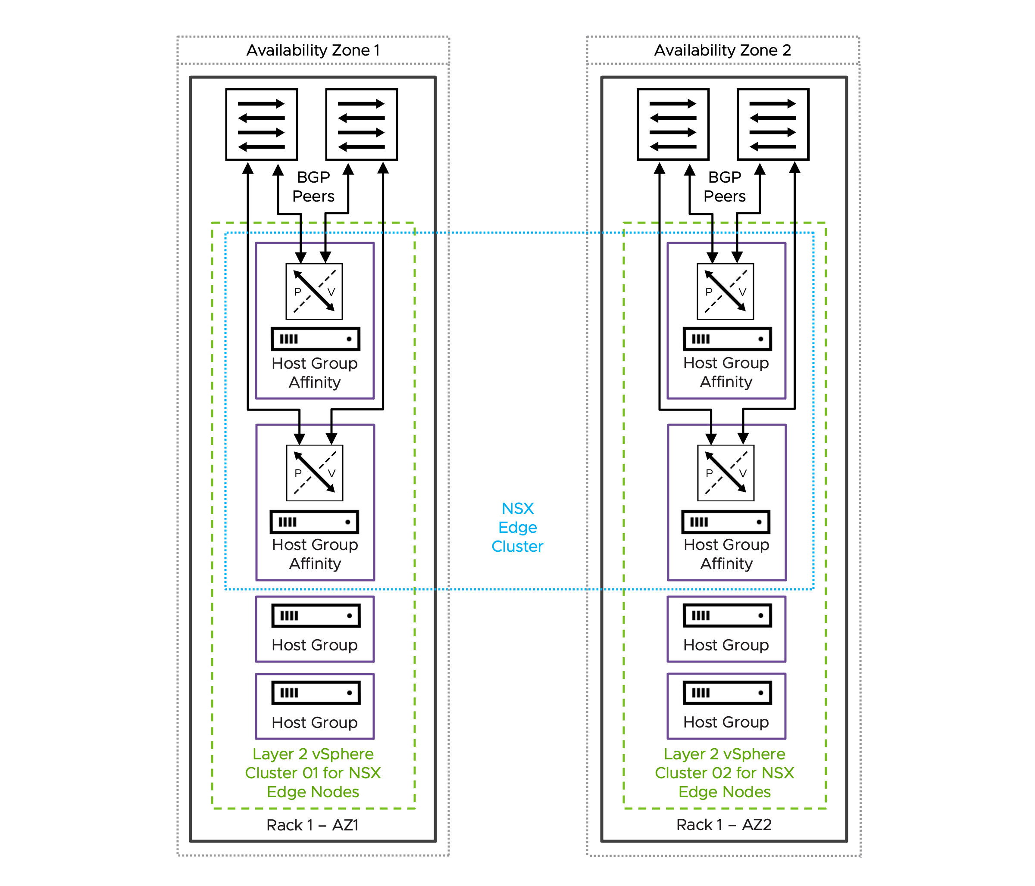
Figure 3-114. Dual Availability Zone Design based on NSX Edge Node HA - stretched vSAN cluster
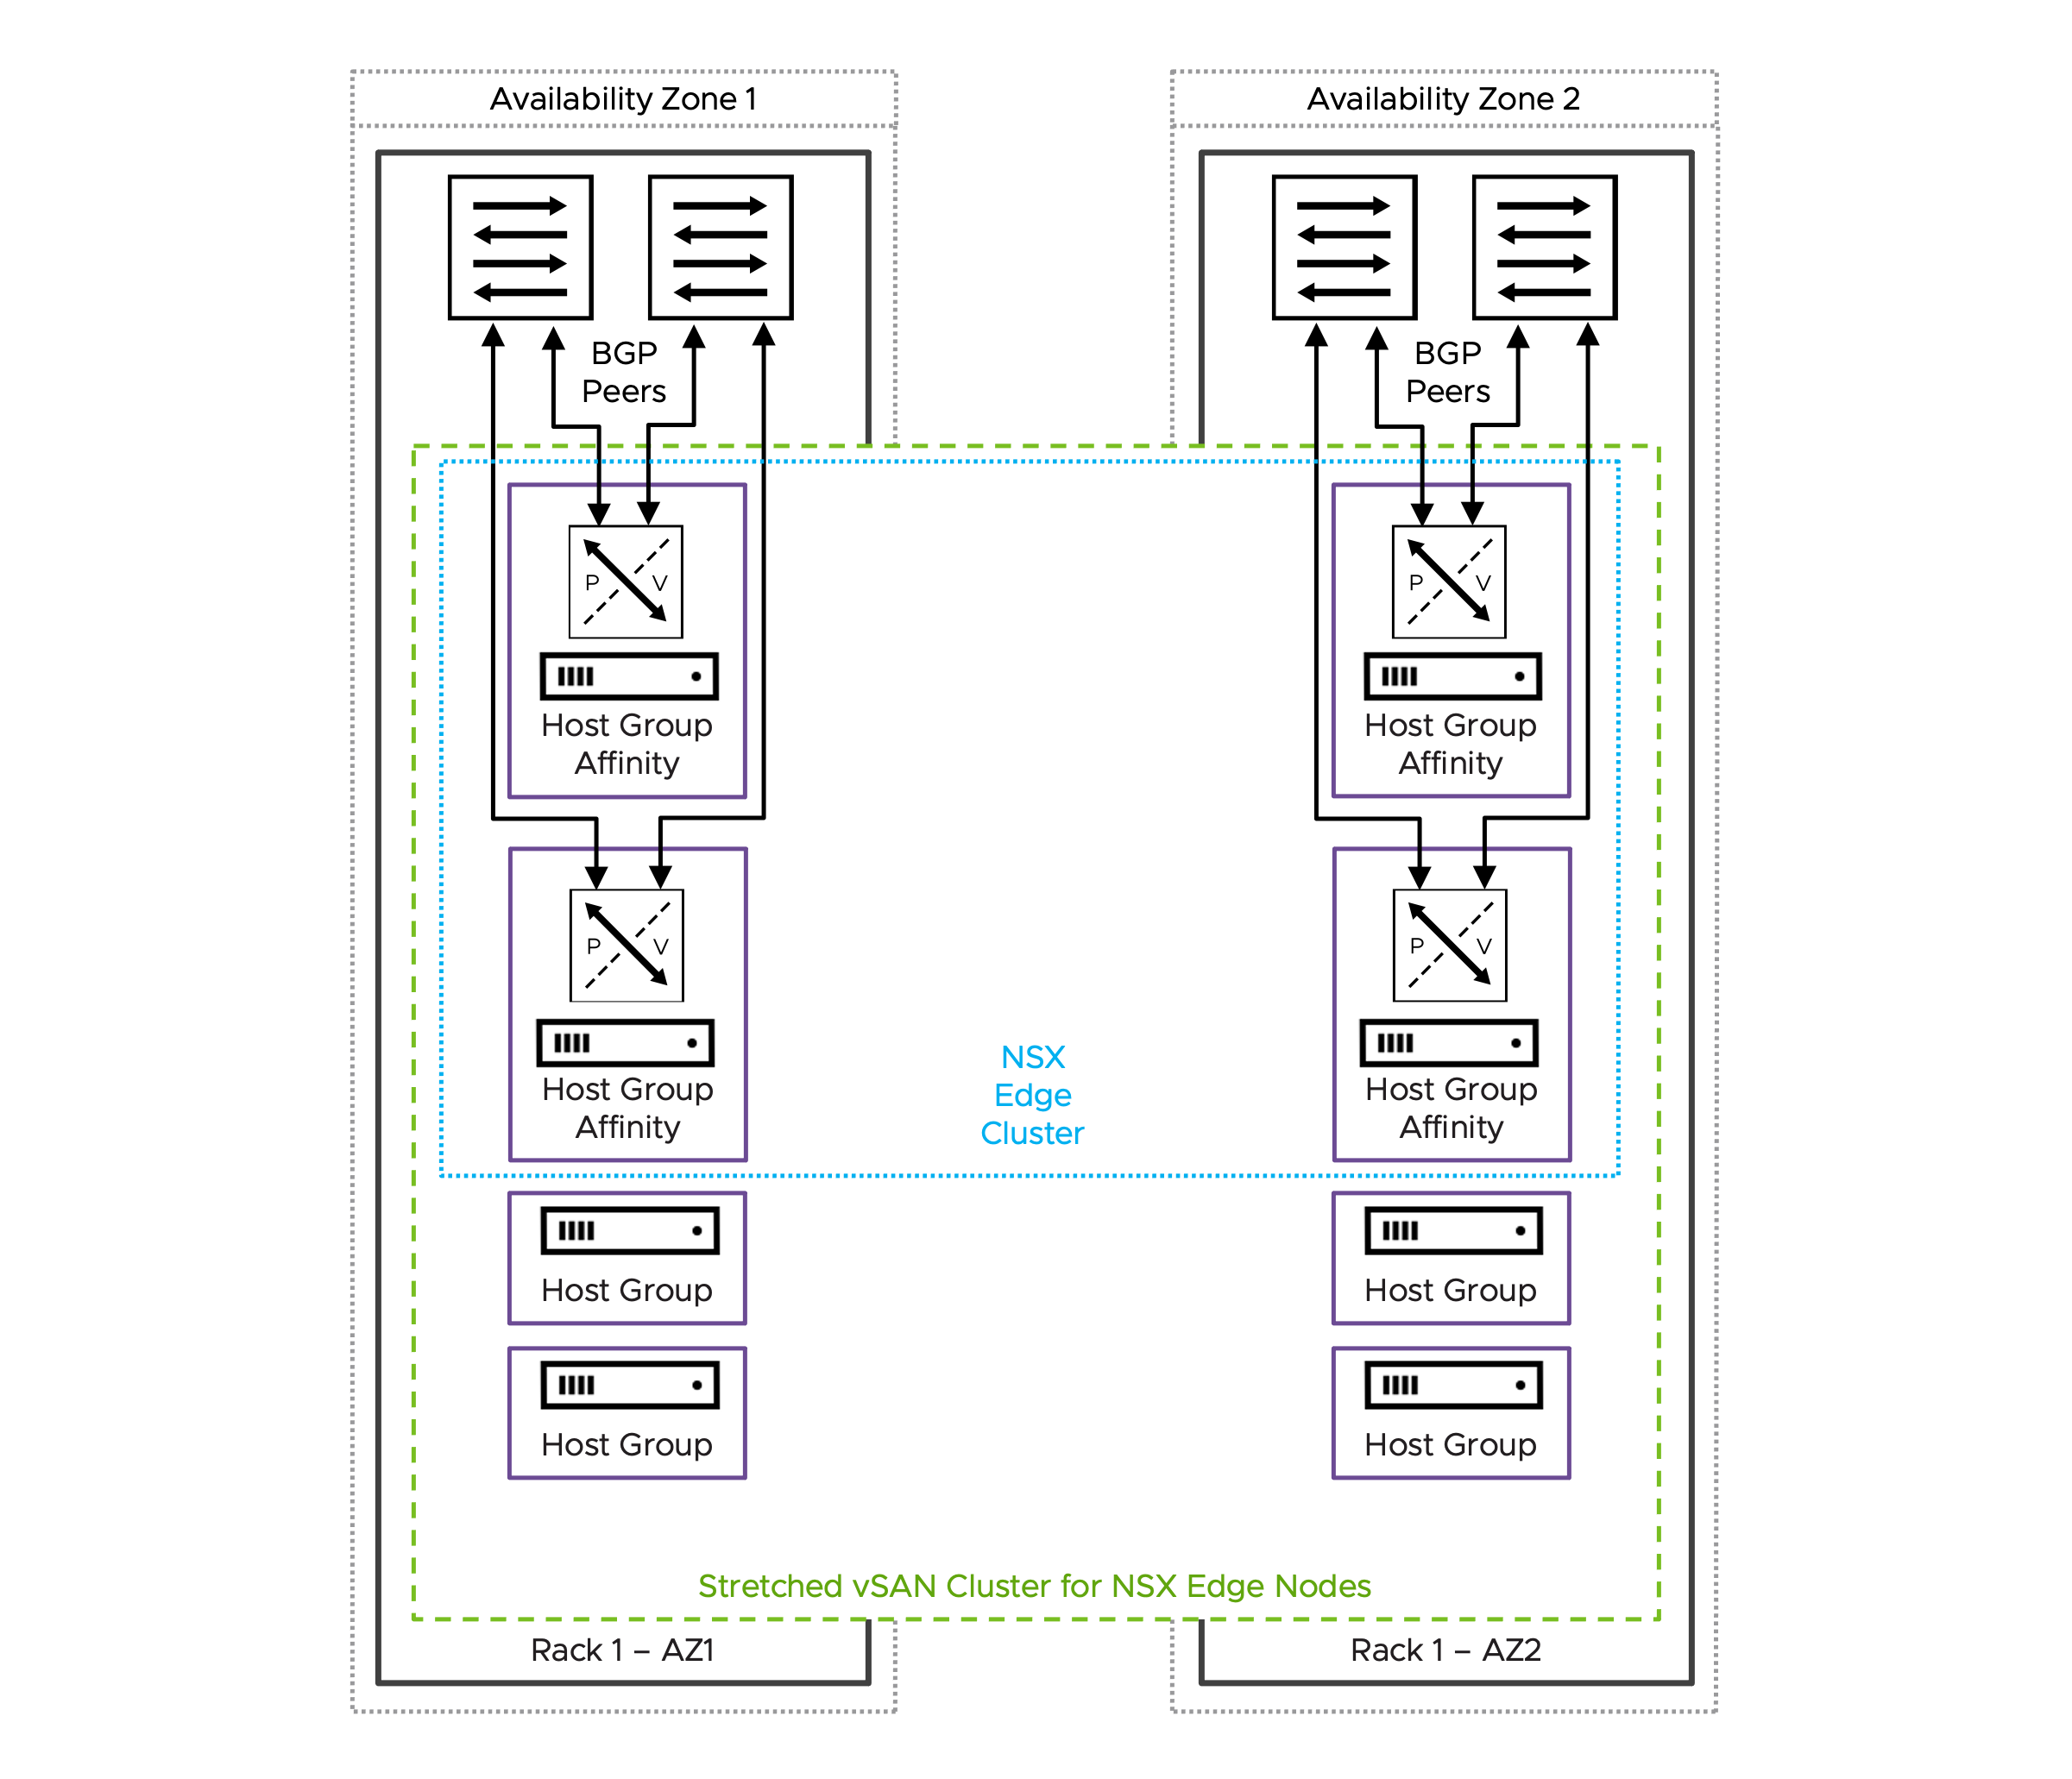

Design Attributes for Dual Availability Zone Design based on NSX Edge Node HA
The Dual Availability Zone Design based on NSX Edge Node HA has the following attributes.
Attribute | Details
Availability model | Host and Availability Zone redundancy.  Independent shared storage per vSphere cluster when using vSAN or single shared storage.  This design ensures continuous north-south communication and centralized network services even if one Availability Zone completely fails.
NSX Edge node mobility across racks | Not supported.
BGP peering | Establish BGP peering solely with the local ToR switches located within the same Availability Zones that hosts the NSX Edge node.
NSX Edge node and link failover mechanisms | Fast NSX Edge node High-Availability detection for NSX Edge node failures.  Fast link failure detection with Bidirectional Forwarding Detection (BFD) for BGP.
North-South bandwidth growth | Add more hosts to both vSphere clusters simultaneously or scale out the stretched vSAN cluster with additional hosts in each Availability Zone.  When deploying more NSX Edge nodes on existing hosts, ensure each host has sufficient CPU, memory, and importantly, additional physical NICs (pNICs) to maintain maximum packet forwarding rates (PPS) for each NSX Edge node.
Table 3-780. Common NSX Edge Cluster for Dual Availability Zones Design Requirements
Design Requirement ID | Design Requirement | Justification | Implication
VCF-NSX-EDGE-REQD-COMDAZ-01 | Align the Tunnel Endpoint (TEP) MTU for NSX Edge nodes to the same MTU as the VDS MTU. | Consistent MTU within the same NSX Overlay Transport Zone is required. | Requires manual configuration of the Tunnel Endpoint (TEP) MTU value in NSX Global Fabric settings.
Table 3-781. Common NSX Edge Cluster for Dual Availability Zones Design Recommendations
Design Recommendation ID | Design Recommendation | Justification | Implication
VCF-NSX-EDGE-RCMD-COMDAZ-01 | Dedicated vSphere cluster to exclusively host NSX Edge nodes. | NSX Edge nodes use dedicated and exclusively host resources (CPU, memory, pNIC) to provide best packet forwarding performance, reliability and operational simplification.  Enables the selection of an independent vSphere Distributed Switch design separate from the vSphere cluster hosting workload virtual machines.  Enable specific hardware selection for NSX Edge node ESX hosts. | Additional servers are required.
VCF-NSX-EDGE-RCMD-COMDAZ-02 | Limit the number of NSX Edge nodes per host to the number of available physical NICs. | Each NSX Edge node should be connected to a pair of physical NICs to ensure maximum packet forwarding rates (PPS). | Additional physical NICs or ESX hosts, or both are required to support the deployment of a higher number of NSX Edge nodes.
VCF-NSX-EDGE-RCMD-COMDAZ-03 | Use the default memory reservation with 100% for NSX Edge nodes. | The 100% memory reservation configuration is a guaranteed minimum allocation of host physical memory that is entirely dedicated to a NSX Edge node, ensuring this full memory amount remains available to the NSX Edge node even when the host system is in an over-committed state. | In a collapsed cluster where other workload virtual machines have memory reservation too:  Virtual machines may fail to power on when memory reservations can't be guaranteed, even if idle reserved memory exists.  vSphere HA may be unable to restart after ESX host failures if it cannot meet their memory reservations on surviving ESX hosts.  Memory reservation locks physical RAM, while CPU reservation guarantees minimum access to a shared resource.
VCF-NSX-EDGE-RCMD-COMDAZ-04 | Use the default CPU reservation priority in NSX set to high shares for NSX Edge nodes. | Setting CPU shares to "High" ensures that NSX Edge nodes receive higher relative priority during CPU contention scenarios, allowing critical network functions to maintain performance when host resources are constrained. | Generally None.  High CPU reservations are generally less critical than high memory reservations.
VCF-NSX-EDGE-RCMD-COMDAZ-05 | For each NSX Edge node, assign a dedicated physical NIC to the data plane fastpath interfaces fp-eth0 and fp-eth1. | Each NSX Edge node leverages only two of four data plane fastpath interfaces.  When two NSX Edge nodes are deployed per host, each NSX Edge node should use a dedicated pair of physical NICs - one active and one standby. | The two remaining data plane fastpath interfaces per NSX Edge node are not used.
VCF-NSX-EDGE-RCMD-COMDAZ-06 | Map data plane fastpath interface fp-eth0 with physical NIC 1 as active and physical NIC 2 as standby; map data plane fastpath interface fp-eth1 with physical NIC 1 as standby and physical NIC 2 as active, creating complementary failover paths. | Enables redundant paths for both data plane fastpath interfaces on each NSX Edge node, preventing single points of failure. | None.
VCF-NSX-EDGE-RCMD-COMDAZ-07 | Create a new dvPortGroup for the NSX Edge node management interface, separate from the dvPortGroup used for ESX host management VMkernel. Depending on the selected NSX Edge cluster design, an NSX Edge node management dvPortGroup is required for each vSphere cluster, rack, or Availability Zone. | Traffic segregation enables organizations to implement and enforce network security policies. | Increased configuration effort.  For a management domain: a separate distributed port group for the NSX Edge node management interface already exists when using a single vSphere Distributed Switch design; this is the same distributed port group as used for the management stack.
VCF-NSX-EDGE-RCMD-COMDAZ-08 | Ensure that NSX Edge nodes belonging to the same NSX Edge cluster are deployed evenly across both Availability Zones. | Maintain high availability and prevent single points of failure. | Additional servers are required.  This design recommendation is not applicable to the design model based on vSphere HA Recovery
VCF-NSX-EDGE-RCMD-COMDAZ-09 | Select the NSX Edge node size large or x-large. | The size of an NSX Edge node depends on the throughput requirements and any configured centralized network services.  For most deployments, particularly when NSX Edge nodes are used solely for north-south traffic forwarding, the large NSX Edge node size provides an optimal balance between performance and resource utilization. | You must provide sufficient compute resources to support the chosen NSX Edge node size.  In vSphere clusters with a high density of NSX Edge nodes, such as multi-tenancy environments with high oversubscription ratios or collapsed vSphere clusters where both workload VMs and NSX Edge nodes run on the same hosts, the resource requirements of large or extra large NSX Edge nodes occasionally create resource constraints.
VCF-NSX-EDGE-RCMD-COMDAZ-10 | Select the auto-generation password option for NSX Edge nodes. | Auto-generation password option enables centralized password management in VCF Operations. | Password needs to be looked up to gain SSH access.
VCF-NSX-EDGE-RCMD-COMDAZ-11 | Select static IP allocation for the NSX Edge node management interface. | Static IP allocation removes the dependency on external DHCP services. | None.
VCF-NSX-EDGE-RCMD-COMDAZ-12 | Configure separate Tunnel Endpoint (TEP) VLANs for NSX Edge nodes and ESX hosts.  It is possible to use a single TEP VLAN across host and NSX Edge node by enabling "NSX on dvPG". | Simplifies Tunnel Endpoint (TEP) IP management by separating IP allocation methods between ESX hosts and NSX Edge nodes, for example using static IP assignment for NSX Edge nodes while utilizing DHCP-based allocation for ESX hosts.  No need to enable "NSX on dvPG". | NSX Edge nodes and host Tunnel Endpoint (TEP) require separate VLANs with routing configured between them to enable proper overlay network communication.  Requires the configuration of an additional VLAN for NSX Edge node Tunnel Endpoint (TEP) traffic.
VCF-NSX-EDGE-RCMD-COMDAZ-13 | Configure IP Pool allocation for the NSX Edge node Tunnel Endpoint (TEP) interfaces.. | IP Pool allocation eliminates dependency on external DHCP services while reducing configuration overhead compared to static IP assignment.  Each of the two (2) data plane fastpath interfaces get an IP address assigned to enable NSX Edge node Tunnel Endpoint (TEP). | Requires the configuration of one or more IP Pools depending on the vSphere cluster model.
VCF-NSX-EDGE-RCMD-COMDAZ-14 | Enable TEP Groups for NSX Edge nodes. | Higher throughput achievable by a single NSX Edge node.  Granular flow base load balancing of NSX Edge node TEP traffic.  Resiliency to partial link failures (physical link state up but no forwarding). | TEP Groups must be enabled through NSX API globally for all NSX Edge nodes.
VCF-NSX-EDGE-RCMD-COMDAZ-15 | Use a single Edge Switch in the NSX Edge nodes. | Simplifies deployment of NSX Edge nodes.  Supports multiple Tunnel Endpoint (TEP) interfaces.  Carries both overlay and uplink traffic. | The NSX or vCenter Network Connectivity workflow automatically configures always a single Edge Switch.

Design Requirements for Dual Availability Zone Design based on NSX Edge Node HA
These design requirements are specific requirement in addition to the common design requirements.
Table 3-782. Dual Availability Zone Design based on NSX Edge Node HA Design Requirements
Design Requirement ID | Design Requirement | Justification | Implication
VCF-NSX-EDGE-REQD-DAZEHA-01 | Deploy two (2) or more NSX Edge nodes evenly across the two dedicated vSphere cluster respective across the two Availability Zones. | NSX Edge nodes are required to support centralized network connectivity for the virtual network.  At least two NSX Edge nodes are required to support NSX Edge high availability. | Cluster resources must be available to support the NSX Edge nodes.  Additional NSX Edge nodes may be required to satisfy increased bandwidth requirements.

Design Recommendations for Dual Availability Zone Design based on NSX Edge Node HA
These design recommendations are specific recommendations in addition to the common design recommendations.
Table 3-783. Dual Availability Zone Design based on NSX Edge Node HA Design Recommendations
Design Recommendation ID | Design Recommendation | Justification | Implication
VCF-NSX-EDGE-RCMD-DAZEHA-01 | Limit the span of NSX Edge node networks to the local rack. | VLANs including NSX Edge node Tunnel Endpoint (TEP), the NSX Edge node management and the two Edge Uplink VLANs that carry BGP sessions and north-south traffic are limited to the rack.  BGP will establish peering connections exclusively with Top-of-Rack (ToR) switches located within the same rack, ensuring a deterministic alignment between physical components (ToRs and cabling) and the corresponding BGP sessions. | Limit the span of networks to reduce failure propagation across racks.  Avoid BGP peering across racks.
VCF-NSX-EDGE-RCMD-DAZEHA-02 | Create for every host an individual host group. | Host groups will be required to enable compute policy type Best Effort Restart (BER). | Host groups must be configured through the administrator before initiating the NSX or vCenter Network Connectivity workflow.  This design recommendation is not applicable with routing option C - Active/Standby Tier-0 gateway with symmetric routing.
VCF-NSX-EDGE-RCMD-DAZEHA-03 | Create for every NSX Edge node an individual VM group. | VM groups will be required to enable compute policy type Best Effort Restart (BER). | The NSX or vCenter Network Connectivity workflow automatically configures VM groups when the host group affinity option is selected. Do not create this VM group manually.  This design recommendation is not applicable with routing option C - Active/Standby Tier-0 gateway with symmetric routing.
VCF-NSX-EDGE-RCMD-DAZEHA-04 | Assign to each individual NSX Edge Node the previously configured host group. | Each NSX Edge node has a 1:1 affinity with the underlying ESX host. | Increased configuration effort.  If the assignment was not set through the NSX or vCenter Network Connectivity workflow , it can be added via NSX API.  This design recommendation is not applicable with routing option C - Active/Standby Tier-0 gateway with symmetric routing.
VCF-NSX-EDGE-RCMD-DAZEHA-05 | Create a VM/Host "must" rule by mapping the previously created host group and VM group together, ensuring the NSX Edge node in the VM group must only run on this specific host. | VM/Host "must" rule for each NSX Edge node will be required to enable compute policy type Best Effort Restart (BER). | The NSX or vCenter Network Connectivity workflow automatically configures VM/Host rule when the host group affinity option is selected. Do not create this VM/host rule manually.  This design recommendation is not applicable with routing option C - Active/Standby Tier-0 gateway with symmetric routing.
VCF-NSX-EDGE-RCMD-DAZEHA-06 | Create a vCenter tag with a category to identify the compute policy type Best Effort Restart (BER) and assign it to each NSX Edge node. | The vCenter tag with a category is required to map both the compute policy type Best Effort Restart (BER) and the NSX Edge nodes together. | The NSX or vCenter Network Connectivity workflow automatically configures the vCenter tag with a category and assign to each NSX Edge node when the host group affinity option is selected.  This design recommendation is not applicable with routing option C - Active/Standby Tier-0 gateway with symmetric routing.
VCF-NSX-EDGE-RCMD-DAZEHA-07 | Create a compute policy type Best Effort Restart (BER) and assign the previously created vCenter tag and category to it. | The compute policy type Best Effort Restart (BER) enables smooth rolling host upgrades leveraging graceful NSX Edge node shutdown to minimize traffic disruption.  The compute policy type Best Effort Restart (BER) verifies peer NSX Edge node readiness during host upgrades through multiple pre-checks before initiating NSX Edge node failover and ensures the NSX Edge node shutdown process begins gracefully only after successful pre-checks. | The NSX or vCenter Network Connectivity workflow automatically configures the compute policy type Best Effort Restart (BER) when the host group affinity option is selected. Do not create this compute policy type Best Effort Restart (BER) manually.  Evacuating the NSX Edge node using vMotion during host upgrades or maintenance is not possible.  User-initiated host maintenance mode will shut down the hosted NSX Edge node regardless of whether a healthy peer NSX Edge node is available to take over, as readiness pre-checks are not executed during this process; it is the administrator's responsibility to ensure service availability is maintained.  This design recommendation is not applicable with routing option C - Active/Standby Tier-0 gateway with symmetric routing.
VCF-NSX-EDGE-RCMD-DAZEHA-08 | Configure an NSX failure domain for each Availability Zone where the NSX Edge node can run - this is only valid when you have more than two NSX Edge nodes; map the NSX Edge nodes to the NSX failure domains appropriately. | Failure domains guarantee service availability in case of a failure affecting multiple NSX Edge nodes.  Active and standby instance of a VPC or Tier-1 gateway always run in different failure domains. | Additional manual configuration.  This applies only for designs incorporating VPC or Tier-1 gateway in A/S mode.

BGP Routing Design Requirements for Dual Availability Zone Design based on NSX Edge Node HA for Routing Option B
These BGP routing design requirements are specific requirement for the Dual Availability Zone Design based on NSX Edge Node HA for Routing option B. Routing option B implements a high-availability design using a Tier-0 gateways configured in active/active mode and ensures symmetric traffic in and out of the virtual network. General BGP routing design requirements and recommendations and can be found in the Workload Networking Detailed Design section.
Table 3-784. BGP Routing Design Requirements for Dual Availability Zone Design based on NSX Edge Node HA for Routing Option B
Design requirement ID | Design Requirement | Justification | Implication
VCF-NSX-BGP-REQD-DAZEHA-001 | Create a route-map that prepends the BGP AS path using the local Tier-0 gateway ASN and matches a new configured IP prefix list set to "Any". Apply this route-map as an outbound filter to all BGP neighbors configured with the top of rack switches in the second Availability Zone. | The Tier-0 gateway will use BGP AS path prepending in BGP route advertisements to the second Availability Zone's top of rack switches, ensuring ingress traffic preferentially flows through the primary Availability Zone, as BGP selects paths with a shorted AS path. | Additional manual configuration.  The Tier-0 gateway will route north-south traffic through the second Availability Zone only if the connection to their BGP neighbors in the primary Availability Zone is lost, for example, if a failure of the top of the rack switch pair or in the availability zone occurs.
VCF-NSX-BGP-REQD-DAZEHA-002 | The top of rack switches in the primary Availability Zone must advertise 0.0.0.0/1 and 128.0.0.0/1 to the NSX Edge nodes in the primary Availability Zone and the top of rack switches in the second Availability Zone must advertise 0.0.0.0/0 to the NSX Edge nodes in the second Availability Zone. | The NSX Edge nodes in the primary Availability Zone will receive more specific routes compared to the NSX Edge nodes in the second Availability Zone, ensuring the egress traffic preferentially flows through the primary Availability Zone. | Additional manual configuration on the top of rack switches.

Dual Availability Zone Design based on vSphere HA Recovery
NSX Edge nodes are hosted using a stretched vSAN cluster across two Availability Zones and support NSX Edge node mobility between zones (unlike the previous design where mobility was not supported). The NSX Edge node uplink VLANs (carrying BGP sessions and north-south traffic) and NSX Edge node management VLAN must be stretched across both Availability Zones, which provides only limited fault isolation between zones. This approach is different from the previous dual Availability Zone design where separate VLANs improved isolation. The design supports Tier-0 gateway configuration in active/active mode with symmetric flows and Availability Zone awareness based on NSX Edge node location. This approach is different from the previous adaptable Tier-0 gateway design.
Figure 3-115. Dual Availability Zone Design based on vSphere HA Recovery - stretched vSAN cluster
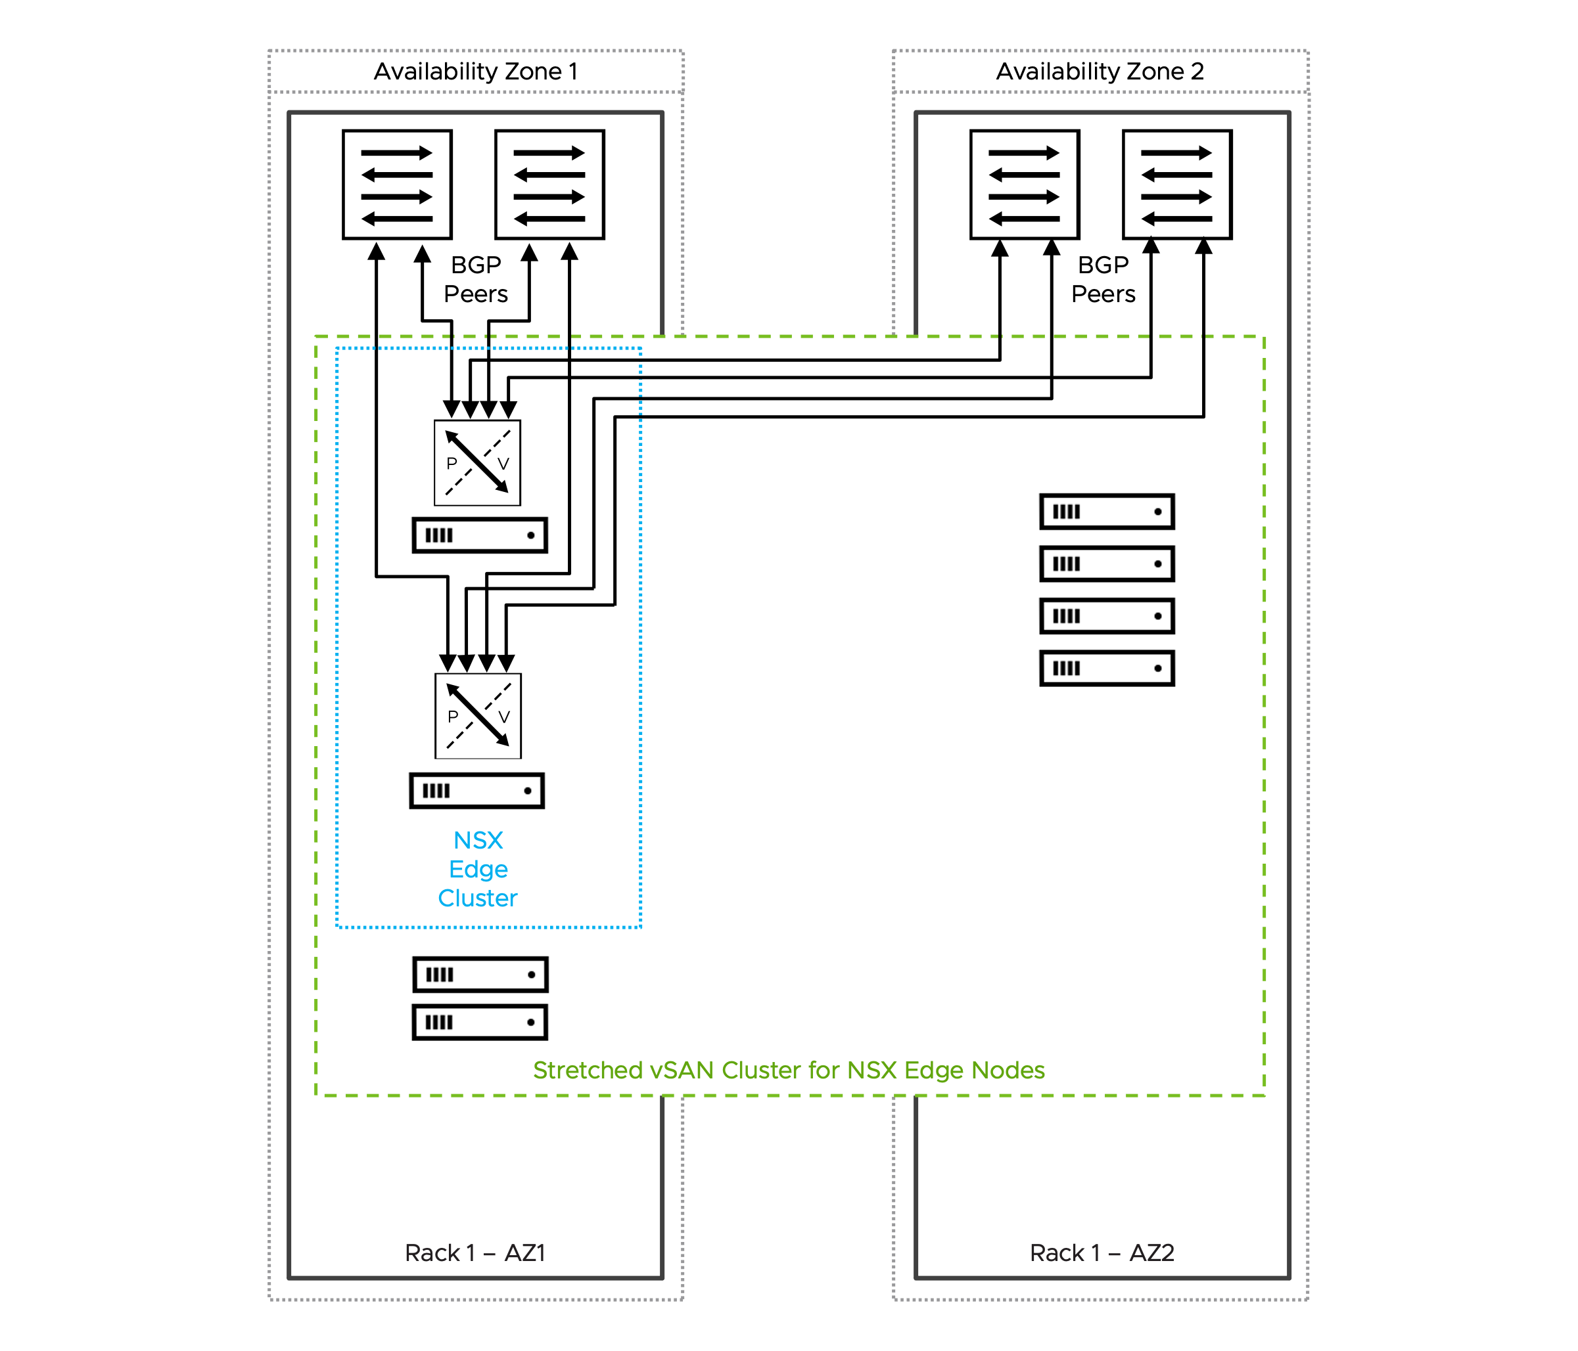

Design Attributes for Dual Availability Zone Design based on vSphere HA Recovery
The Dual Availability Zone Design based on vSphere HA recovery has the following attributes.
Attribute | Properties
Availability model | Host and Availability Zone redundancy.  Single shared storage.  This design ensures continuous north-south communication and centralized network services even if one Availability Zone completely fails.
NSX Edge node mobility across racks | Supported
BGP peering | BGP peering over stretched networks across both Availability Zone is required.
NSX Edge node and link failover mechanisms | Fast NSX Edge node High Availability detection for NSX Edge node failures with the same Availability Zone.  A complete Availability Zone outage, the recovery depends on vSphere High Availability (vSphere HA), which may take several minutes.  Fast link failure detection with Bidirectional Forwarding Detection (BFD) for BGP.
North-South bandwidth growth | Scale out the stretched vSAN cluster with additional hosts in each Availability Zone.  When deploying more NSX Edge nodes on existing hosts, ensure each host has sufficient CPU, memory, and importantly, additional physical NICs (pNICs) to maintain maximum packet forwarding rates (PPS) for each NSX Edge node.
Table 3-785. Common NSX Edge Cluster for Dual Availability Zones Design Requirements
Design Requirement ID | Design Requirement | Justification | Implication
VCF-NSX-EDGE-REQD-COMDAZ-01 | Align the Tunnel Endpoint (TEP) MTU for NSX Edge nodes to the same MTU as the VDS MTU. | Consistent MTU within the same NSX Overlay Transport Zone is required. | Requires manual configuration of the Tunnel Endpoint (TEP) MTU value in NSX Global Fabric settings.
Table 3-786. Common NSX Edge Cluster for Dual Availability Zones Design Recommendations
Design Recommendation ID | Design Recommendation | Justification | Implication
VCF-NSX-EDGE-RCMD-COMDAZ-01 | Dedicated vSphere cluster to exclusively host NSX Edge nodes. | NSX Edge nodes use dedicated and exclusively host resources (CPU, memory, pNIC) to provide best packet forwarding performance, reliability and operational simplification.  Enables the selection of an independent vSphere Distributed Switch design separate from the vSphere cluster hosting workload virtual machines.  Enable specific hardware selection for NSX Edge node ESX hosts. | Additional servers are required.
VCF-NSX-EDGE-RCMD-COMDAZ-02 | Limit the number of NSX Edge nodes per host to the number of available physical NICs. | Each NSX Edge node should be connected to a pair of physical NICs to ensure maximum packet forwarding rates (PPS). | Additional physical NICs or ESX hosts, or both are required to support the deployment of a higher number of NSX Edge nodes.
VCF-NSX-EDGE-RCMD-COMDAZ-03 | Use the default memory reservation with 100% for NSX Edge nodes. | The 100% memory reservation configuration is a guaranteed minimum allocation of host physical memory that is entirely dedicated to a NSX Edge node, ensuring this full memory amount remains available to the NSX Edge node even when the host system is in an over-committed state. | In a collapsed cluster where other workload virtual machines have memory reservation too:  Virtual machines may fail to power on when memory reservations can't be guaranteed, even if idle reserved memory exists.  vSphere HA may be unable to restart after ESX host failures if it cannot meet their memory reservations on surviving ESX hosts.  Memory reservation locks physical RAM, while CPU reservation guarantees minimum access to a shared resource.
VCF-NSX-EDGE-RCMD-COMDAZ-04 | Use the default CPU reservation priority in NSX set to high shares for NSX Edge nodes. | Setting CPU shares to "High" ensures that NSX Edge nodes receive higher relative priority during CPU contention scenarios, allowing critical network functions to maintain performance when host resources are constrained. | Generally None.  High CPU reservations are generally less critical than high memory reservations.
VCF-NSX-EDGE-RCMD-COMDAZ-05 | For each NSX Edge node, assign a dedicated physical NIC to the data plane fastpath interfaces fp-eth0 and fp-eth1. | Each NSX Edge node leverages only two of four data plane fastpath interfaces.  When two NSX Edge nodes are deployed per host, each NSX Edge node should use a dedicated pair of physical NICs - one active and one standby. | The two remaining data plane fastpath interfaces per NSX Edge node are not used.
VCF-NSX-EDGE-RCMD-COMDAZ-06 | Map data plane fastpath interface fp-eth0 with physical NIC 1 as active and physical NIC 2 as standby; map data plane fastpath interface fp-eth1 with physical NIC 1 as standby and physical NIC 2 as active, creating complementary failover paths. | Enables redundant paths for both data plane fastpath interfaces on each NSX Edge node, preventing single points of failure. | None.
VCF-NSX-EDGE-RCMD-COMDAZ-07 | Create a new dvPortGroup for the NSX Edge node management interface, separate from the dvPortGroup used for ESX host management VMkernel. Depending on the selected NSX Edge cluster design, an NSX Edge node management dvPortGroup is required for each vSphere cluster, rack, or Availability Zone. | Traffic segregation enables organizations to implement and enforce network security policies. | Increased configuration effort.  For a management domain: a separate distributed port group for the NSX Edge node management interface already exists when using a single vSphere Distributed Switch design; this is the same distributed port group as used for the management stack.
VCF-NSX-EDGE-RCMD-COMDAZ-08 | Ensure that NSX Edge nodes belonging to the same NSX Edge cluster are deployed evenly across both Availability Zones. | Maintain high availability and prevent single points of failure. | Additional servers are required.  This design recommendation is not applicable to the design model based on vSphere HA Recovery
VCF-NSX-EDGE-RCMD-COMDAZ-09 | Select the NSX Edge node size large or x-large. | The size of an NSX Edge node depends on the throughput requirements and any configured centralized network services.  For most deployments, particularly when NSX Edge nodes are used solely for north-south traffic forwarding, the large NSX Edge node size provides an optimal balance between performance and resource utilization. | You must provide sufficient compute resources to support the chosen NSX Edge node size.  In vSphere clusters with a high density of NSX Edge nodes, such as multi-tenancy environments with high oversubscription ratios or collapsed vSphere clusters where both workload VMs and NSX Edge nodes run on the same hosts, the resource requirements of large or extra large NSX Edge nodes occasionally create resource constraints.
VCF-NSX-EDGE-RCMD-COMDAZ-10 | Select the auto-generation password option for NSX Edge nodes. | Auto-generation password option enables centralized password management in VCF Operations. | Password needs to be looked up to gain SSH access.
VCF-NSX-EDGE-RCMD-COMDAZ-11 | Select static IP allocation for the NSX Edge node management interface. | Static IP allocation removes the dependency on external DHCP services. | None.
VCF-NSX-EDGE-RCMD-COMDAZ-12 | Configure separate Tunnel Endpoint (TEP) VLANs for NSX Edge nodes and ESX hosts.  It is possible to use a single TEP VLAN across host and NSX Edge node by enabling "NSX on dvPG". | Simplifies Tunnel Endpoint (TEP) IP management by separating IP allocation methods between ESX hosts and NSX Edge nodes, for example using static IP assignment for NSX Edge nodes while utilizing DHCP-based allocation for ESX hosts.  No need to enable "NSX on dvPG". | NSX Edge nodes and host Tunnel Endpoint (TEP) require separate VLANs with routing configured between them to enable proper overlay network communication.  Requires the configuration of an additional VLAN for NSX Edge node Tunnel Endpoint (TEP) traffic.
VCF-NSX-EDGE-RCMD-COMDAZ-13 | Configure IP Pool allocation for the NSX Edge node Tunnel Endpoint (TEP) interfaces.. | IP Pool allocation eliminates dependency on external DHCP services while reducing configuration overhead compared to static IP assignment.  Each of the two (2) data plane fastpath interfaces get an IP address assigned to enable NSX Edge node Tunnel Endpoint (TEP). | Requires the configuration of one or more IP Pools depending on the vSphere cluster model.
VCF-NSX-EDGE-RCMD-COMDAZ-14 | Enable TEP Groups for NSX Edge nodes. | Higher throughput achievable by a single NSX Edge node.  Granular flow base load balancing of NSX Edge node TEP traffic.  Resiliency to partial link failures (physical link state up but no forwarding). | TEP Groups must be enabled through NSX API globally for all NSX Edge nodes.
VCF-NSX-EDGE-RCMD-COMDAZ-15 | Use a single Edge Switch in the NSX Edge nodes. | Simplifies deployment of NSX Edge nodes.  Supports multiple Tunnel Endpoint (TEP) interfaces.  Carries both overlay and uplink traffic. | The NSX or vCenter Network Connectivity workflow automatically configures always a single Edge Switch.

Design Requirements for Dual Availability Zone Design based on vSphere HA Recovery
These design requirements are specific requirement in addition to the common design requirements.
Table 3-787. Dual Availability Zone Design based on vSphere HA Recovery Design Requirements
Design Requirement ID | Design Requirement | Justification | Implication
VCF-NSX-EDGE-REQD-DAZVHA-01 | Deploy two (2) or more NSX Edge nodes in the primary availability zone. | NSX Edge nodes are required to support centralized network connectivity for the virtual network.  At least two NSX Edge nodes are required to support NSX Edge high-availability. | Cluster resources must be available to support the NSX Edge nodes.  Additional NSX Edge nodes may be required to satisfy increased bandwidth requirements.
VCF-NSX-EDGE-REQD-DAZVHA-02 | Do not enable compute policy type Best Effort Restart (BER) for each NSX Edge node. | In a stretched vSAN cluster deployment supporting NSX Edge node mobility across the two Availability Zone the compute policy type Best Effort Restart (BER) cannot be used.  NSX Edge node mobility requires "should" VM-to-host groups to place the NSX Edge nodes into the primary Availability Zone to support deterministic egress and ingress traffic flows, whereas Best Effort Restart (BER) compute policy requires "must" VM/host rule. | None.
VCF-NSX-EDGE-REQD-DAZVHA-03 | Create a host group to include all hosts from the primary Availability Zone. | This host groups is required to enable the NSX Edge node affinity with the primary Availability Zone. | None.
VCF-NSX-EDGE-REQD-DAZVHA-04 | Create a VM group to include all NSX Edge nodes from a specific NSX Edge cluster. | This VM group is required to enable the NSX Edge node affinity with the primary Availability Zone. | None.
VCF-NSX-EDGE-REQD-DAZVHA-05 | Create "should" VM/host rule for the primary Availability Zones. | Deterministic ingress and egress traffic path within the primary Availability Zone is achieved by associating the VM group containing the NSX Edge nodes with the host group from the primary Availability Zone through the creation of a VM/host "should" rule. | Supports external stateful services implemented in the network path connecting two Availability Zones.
VCF-NSX-EDGE-REQD-DAZVHA-06 | Extend the NSX Edge node networks across both Availability Zones. | NSX Edge nodes can fail over between Availability Zones, ensuring continuous connectivity to the top of rack switches in both Availability Zones regardless of which zone the NSX Edge nodes are currently hosted in  NSX Edge node networks must be stretched across both Availability Zones, including the NSX Edge node Tunnel Endpoint (TEP) VLAN, the NSX Edge node management VLAN, and the two Edge Uplink VLANs that carry BGP sessions and north-south traffic. | Stretched VLANs between the Availability Zones must be configured in the physical network infrastructure.

BGP Routing Design Requirements for Dual Availability Zone Design based on vSphere HA Recovery
These BGP routing design requirements are specific requirement for the Dual Availability Zone Design based on vSphere HA Recovery across the Availability Zones. General BGP routing design requirements and recommendations and can be found in the Workload Networking Detailed Design section.
Table 3-788. BGP Routing Design Requirements for Dual Availability Zone Design based on vSphere HA Recovery
Design requirement ID | Design Requirement | Justification | Implication
VCF-NSX-BGP-REQD-DAZVHA-001 | Do not use Bidirectional Forwarding Detection (BFD) for BGP. | Bidirectional Forwarding Detection (BFD) failure detection for BGP sessions can trigger connectivity failures during vMotion migrations, use instead lower BGP timer (4/12 seconds) | Slower link failure detection.
VCF-NSX-BGP-REQD-DAZVHA-002 | Create a route-map that prepends the BGP AS path using the local Tier-0 gateway ASN and matches a new configured IP prefix list set to "Any". Apply this route-map as an outbound filter to all BGP neighbors configured with the top of rack switches in the secondary Availability Zone. | The Tier-0 gateway will use BGP AS path prepending in BGP route advertisements to the secondary Availability Zone's top of rack switches, ensuring ingress traffic preferentially flows through the primary Availability Zone, as BGP selects paths with a shorted AS path. | Additional manual configuration.  The Tier-0 gateway will route north-south traffic through the secondary Availability Zone only if the connection to their BGP neighbors in the primary Availability Zone is lost, for example, if a failure of the top of the rack switch pair or in the availability zone occurs.
VCF-NSX-BGP-REQD-DAZVHA-003 | Create a route-map that set a lower BGP local preference, for example 90, and matches a new configured IP prefix list set to "0.0.0.0/0". Apply this route-map as an inbound filter to all BGP neighbors configured with the top of rack switches in the secondary Availability Zone. | The Tier-0 gateway will set a lower BGP local preference for the 0.0.0.0/0 route (assuming the physical network advertises only the default route across both Availability Zones) received from the secondary Availability Zone's top of rack switches, ensuring egress traffic preferentially flows through the primary Availability Zone, as BGP selects paths with higher local preference values (default 100). | Additional manual configuration.  The Tier-0 gateway will route north-south traffic through the secondary Availability Zone only if the connection to their BGP neighbors in the primary Availability Zone is lost, for example, if a failure of the top of the rack switch pair or in the availability zone occurs.

vSphere Supervisor Detailed Design
A VCF Workload Domain can include one or more of the supported vSphere Supervisor Models. The following sections details the design of each deployment model types for vSphere Supervisor.
Simplified Supervisor Model
vSphere Supervisor Zone Models
vSphere Supervisor Control Plane Availability Models
vSphere Supervisor Load Balancer Models

Simplified Supervisor Model
VMware Cloud Foundation 9.0 allows you to create a simplified Supervisor deployment requiring fewer resources and configuration steps than a typical deployment. This simplified deployment allows access to a limited subset of Supervisor capabilities. You can then expand the deployment over time to build out to full Supervisor functionality.
For information on how to deploy or scale a Simplified vSphere Supervisor, refer to Deploying with a Simplified Deployment Flow.
Figure 3-116. Simplified Supervisor Model Diagram
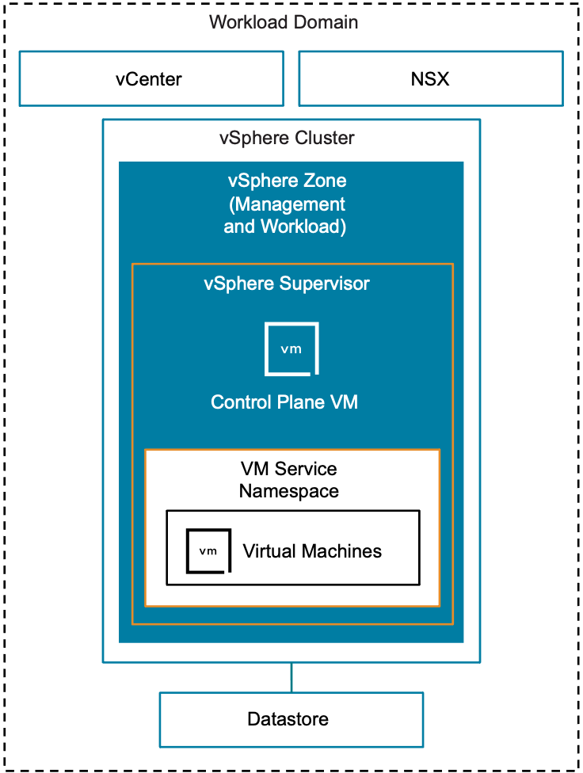

Simplified Supervisor Model Attributes
Attribute | Detail
Supervisor Management Zone | Single
Supervisor Workload Zone | Single - Combined with management
Control Plane VMs | Single
Supported Service | VM Service
Scalability | Scalable to full feature Single Management Zone with Combined Workload Zones Model or Single Management Zone with Isolated Workload Zones Model
Activation | From vCenter

vSphere Supervisor Zone Models
vSphere Supervisor management workloads can be deployed to one or three management zones. Workloads in vSphere Namespaces can be deployed to the same or separate dedicated zones to isolate them from management workloads. This section details the different deployment models to choose from.
Single Management Zone with Combined Workload Zones Model
Single Management Zone with Isolated Workload Zones Model
Three Management Zones with Combined Workload Zones Model
Three Management Zones with Isolated Workload Zones Model

Single Management Zone with Combined Workload Zones Model
A Single Management Zone with Combined Workload Zones Model utilizes resources from a single vSphere Zone for management and workloads. Availability protection is provided using vSphere HA.
Figure 3-117. Single Management Zone with Combined Workload Zones Model Diagram
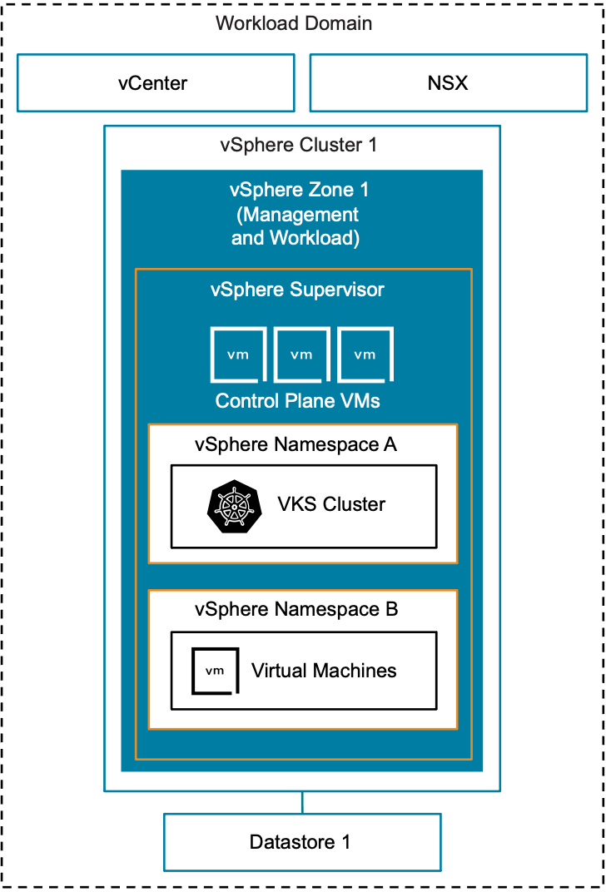

Single Management Zone with Combined Workload Zones Model Attributes
Attribute | Detail
Supervisor Management Zone | Single
Supervisor Workload Zones | Single - Combined with management
Activation | At workload domain creation OR  From vCenter.

Single Management Zone with Combined Workload Zones Model Options
Design Area | Choice
Cluster Model | vSphere Single-Rack Cluster Model  Layer 2 Multi-Rack Cluster Model  Layer 3 Multi-Rack Cluster Model  vSphere Stretched Cluster Model
Control Plane Availability Model | Simple Control Plane Model  High Availability Control Plane Model
Networking Model | VPC with Full Services Workload Networking Model  Centralized Gateway - Active/Standby  NSX Segment Network Virtualization Scalable Workload Networking Model  Centralized Gateway - Active/Active  VLAN Networking Model  Distributed Port Groups support only
Load Balancer Model | Supervisor NSX Load Balancer Model  Supervisor Avi Load Balancer Model  Supervisor Foundation Load Balancer Model
Table 3-789. vSphere Supervisor Single Management Zone Design Requirements
Design Requirement ID | Design Requirement | Justification | Implication
VCF-SUP-SMZ-REQD-CFG-001 | One available vSphere Zone of a supported vSphere Cluster model that is not in use by another Supervisor instance at activation. | vSphere Zone for Supervisor management workload use. | vSphere Zone will not be available for another vSphere Supervisor instance within the same vCenter.
Table 3-790. vSphere Supervisor Design Requirements for all Zone Models
Design Requirement ID | Design Requirement | Justification | Implication
VCF-SUP-AMZ-REQD-CFG-001 | vSphere clusters must have vSphere HA enabled. | Required feature to automatically recover from host failure. | Sufficient spare ESX host resources required for vSphere HA functionality.
VCF-SUP-AMZ-REQD-CFG-002 | vSphere clusters must have vSphere DRS enabled in Fully Automated or Partially Automated mode. | Required feature to automatically balance resource utilization within the cluster. | Sufficient host resources required for vSphere DRS functionality.
VCF-SUP-AMZ-REQD-CFG-003 | vSphere Zones must be configured. | vSphere clusters needs to be configured with vSphere Zone names before it can be utilized by vSphere Supervisor. | A vSphere Zone name will be generated for a Single Management Zone Model if not configured and cannot be changed.
Table 3-791. vSphere Supervisor Networking Design Requirements
Design Requirement ID | Design Requirement | Justification | Implication
VCF-SUP-NET-REQD-CFG-001 | NSX centralized gateway must be deployed in Active/Active configuration when deploying with NSX Segment Networking Model. | Required topology. | NSX centralized gateway must be manually configured
VCF-SUP-NET-REQD-CFG-002 | NSX centralized gateway must be deployed in Active/Standby configuration when deploying on NSX VPC Networking Model. | Required topology. | Sufficient throughput is required from the active edge node.
VCF-SUP-NET-REQD-CFG-003 | Opt-out of Supervisor activation when deploying a workload domain when activating Supervisor for any networking model other than NSX VPC with NSX Load Balancer. | Activating Supervisor as part of the workload domain deployment is only possible on NSX VPC with NSX Load balancer topology. | Supervisor activation needs to be performed from vCenter.
Table 3-792. vSphere Supervisor Design Recommendations
Design Recommendation ID | Design Recommendation | Justification | Implication
VCF-SUP-RCMD-CFG-001 | Activate vSphere Supervisor with NSX VPC Networking Model. | Benefits of NSX VPC and VCF Automation All Apps.  Out of the box configuration during workload domain creation. | NSX VPC Centralized Gateway connectivity must be manually configured.
VCF-SUP-RCMD-CFG-002 | Deploy control plane in high-availability mode. | High availability for vSphere Supervisor control plane. | Additional hosting resources are required.

Single Management Zone with Isolated Workload Zones Model
A Single Management Zone with Isolated Workload Zones Model utilizes resources from a single management zone for control plane VMs. Workloads are isolated from the Management Zone by deploying into additional vSphere Zones. Management workload availability protection is provided using vSphere HA. Workloads can be distributed across multiple zones for increased availability.
Figure 3-118. Single Management Zone with Isolated Workload Zones Model Diagram
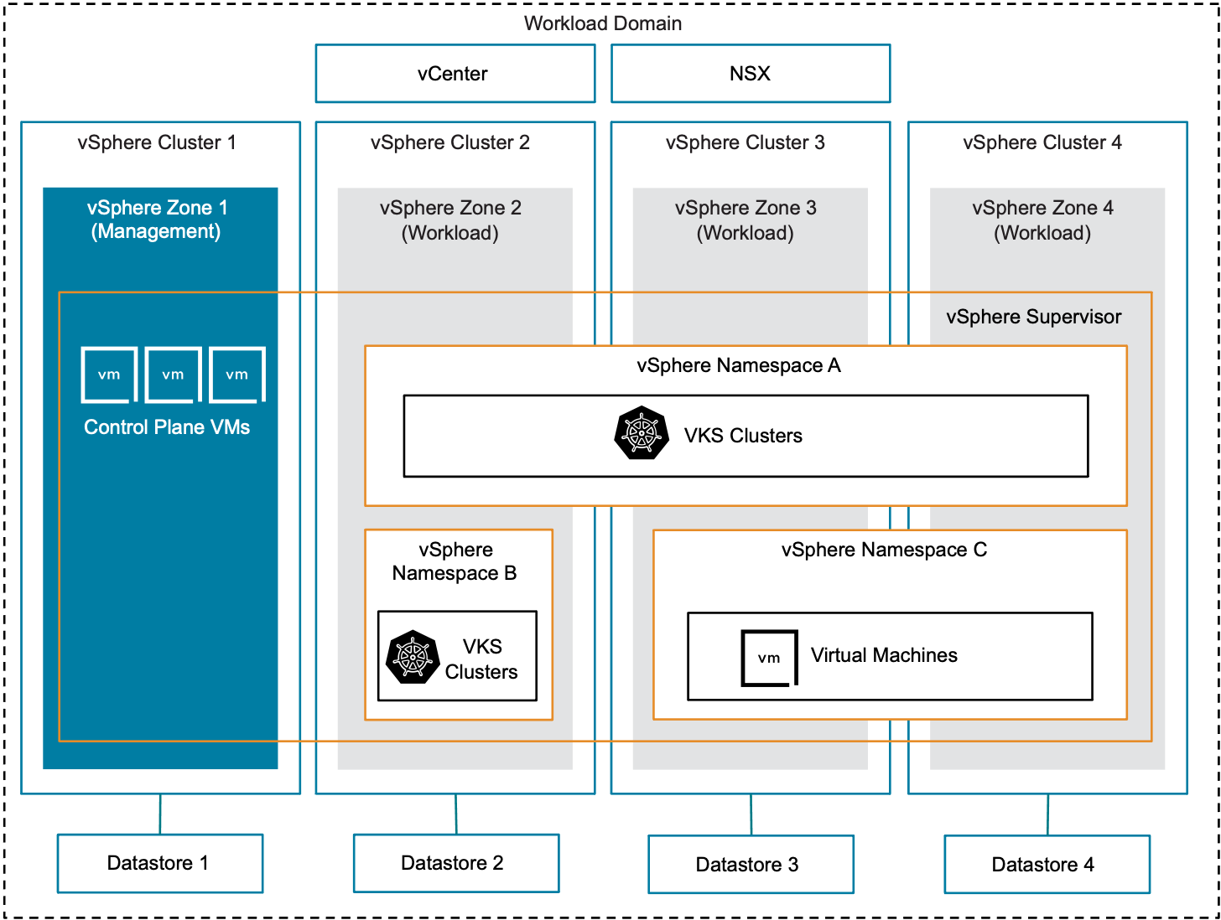

Single Management Zone with Isolated Workload Zones Model Attributes
Attribute | Detail
Supervisor Management Zone | Single
Supervisor Workload Zones | Single or multiple - Isolated from management
Activation | Default management zone option at workload domain creation or a Day 2 operation from vCenter.

Single Management Zone with Isolated Workload Zones Model Options
Design Area | Choice
Cluster Model | vSphere Single-Rack Cluster Model  Layer 2 Multi-Rack Cluster Model  Layer 3 Multi-Rack Cluster Model  vSphere Stretched Cluster Model
Control Plane Availability Model | Simple Control Plane Model  High Availability Control Plane Model
Networking Model | VPC with Full Services Workload Networking Model  Centralized Gateway - Active/Standby  NSX Segment Network Virtualization Scalable Workload Networking Model  Centralized Gateway - Active/Active  VLAN Networking Model  Distributed Port Groups support only
Load Balancer Model | Supervisor NSX Load Balancer Model  Supervisor Avi Load Balancer Model  Supervisor Foundation Load Balancer Model
Table 3-793. vSphere Supervisor Single Management Zone Design Requirements
Design Requirement ID | Design Requirement | Justification | Implication
VCF-SUP-SMZ-REQD-CFG-001 | One available vSphere Zone of a supported vSphere Cluster model that is not in use by another Supervisor instance at activation. | vSphere Zone for Supervisor management workload use. | vSphere Zone will not be available for another vSphere Supervisor instance within the same vCenter.
Table 3-794. vSphere Supervisor Design Requirements for all Zone Models
Design Requirement ID | Design Requirement | Justification | Implication
VCF-SUP-AMZ-REQD-CFG-001 | vSphere clusters must have vSphere HA enabled. | Required feature to automatically recover from host failure. | Sufficient spare ESX host resources required for vSphere HA functionality.
VCF-SUP-AMZ-REQD-CFG-002 | vSphere clusters must have vSphere DRS enabled in Fully Automated or Partially Automated mode. | Required feature to automatically balance resource utilization within the cluster. | Sufficient host resources required for vSphere DRS functionality.
VCF-SUP-AMZ-REQD-CFG-003 | vSphere Zones must be configured. | vSphere clusters needs to be configured with vSphere Zone names before it can be utilized by vSphere Supervisor. | A vSphere Zone name will be generated for a Single Management Zone Model if not configured and cannot be changed.
Table 3-795. vSphere Supervisor Networking Design Requirements
Design Requirement ID | Design Requirement | Justification | Implication
VCF-SUP-NET-REQD-CFG-001 | NSX centralized gateway must be deployed in Active/Active configuration when deploying with NSX Segment Networking Model. | Required topology. | NSX centralized gateway must be manually configured
VCF-SUP-NET-REQD-CFG-002 | NSX centralized gateway must be deployed in Active/Standby configuration when deploying on NSX VPC Networking Model. | Required topology. | Sufficient throughput is required from the active edge node.
VCF-SUP-NET-REQD-CFG-003 | Opt-out of Supervisor activation when deploying a workload domain when activating Supervisor for any networking model other than NSX VPC with NSX Load Balancer. | Activating Supervisor as part of the workload domain deployment is only possible on NSX VPC with NSX Load balancer topology. | Supervisor activation needs to be performed from vCenter.
Table 3-796. vSphere Supervisor Design Recommendations
Design Recommendation ID | Design Recommendation | Justification | Implication
VCF-SUP-RCMD-CFG-001 | Activate vSphere Supervisor with NSX VPC Networking Model. | Benefits of NSX VPC and VCF Automation All Apps.  Out of the box configuration during workload domain creation. | NSX VPC Centralized Gateway connectivity must be manually configured.
VCF-SUP-RCMD-CFG-002 | Deploy control plane in high-availability mode. | High availability for vSphere Supervisor control plane. | Additional hosting resources are required.

Three Management Zones with Combined Workload Zones Model
A Three Management Zones Supervisor Model with Combined Workload Zones Model utilizes resources from three vSphere Zones for control plane VMs. Workloads share resources from the same vSphere Zones. Management workload availability protection is provided using vSphere HA and can tolerate a single cluster failure. Workload availability protection is provided using vSphere HA and can be distributed across multiple zones for increased availability.
Figure 3-119. Three Management Zones with Combined Workload Zones Model Diagram
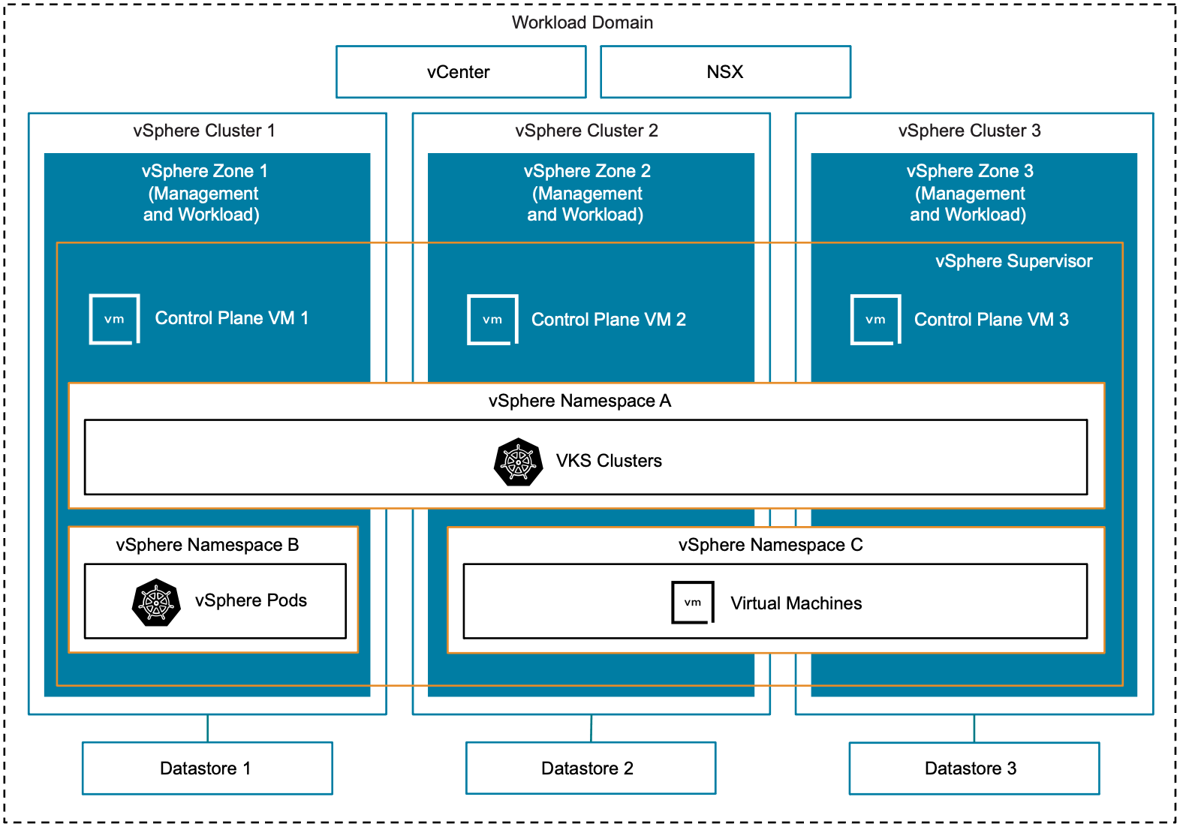

Three Management Zones with Combined Workload Zones Model Attributes
Attribute | Detail
Supervisor Management Zones | Three
Supervisor Workload Zones | Three - Combined with management
Activation | Activated from vCenter API after workload domain creation.

Three Management Zones with Combined Workload Zones Model Options
Design Area | Choice
Cluster Model | vSphere Single-Rack Cluster Model  Layer 2 Multi-Rack Cluster Model  Layer 3 Multi-Rack Cluster Model
Control Plane Availability Model | High Availability Control Plane Model
Networking Model | VPC with Full Services Workload Networking Model  Centralized Gateway - Active/Standby  NSX Segment Network Virtualization Scalable Workload Networking Model  Centralized Gateway - Active/Active  VLAN Networking Model  Distributed Port Groups support only
Load Balancer Model | Supervisor NSX Load Balancer Model  Supervisor Avi Load Balancer Model  Supervisor Foundation Load Balancer Model
Table 3-797. vSphere Supervisor Three Management Zones Design Requirements
Design Requirement ID | Design Requirement | Justification | Implication
VCF-SUP-TMZ-REQD-CFG-001 | Three available identical vSphere Zone of a supported vSphere Cluster model that is not in use by another vSphere Supervisor instance at activation. | Dedicated vSphere Zones for vSphere Supervisor management workload use.  Individual zones provide single cluster level failure scenarios. | vSphere Zones will not be available for another vSphere Supervisor instance within the same vCenter.
VCF-SUP-TMZ-REQD-CFG-002 | High-availability control plane model option selected. | Ensures even distribution and quorum is available across three management zones. | Additional resources required to host additional control plane nodes.
VCF-SUP-TMZ-REQD-CFG-003 | Opt-out of vSphere Supervisor activation when deploying a workload domain. | Activating vSphere Supervisor as part of the workload domain creation defaults to a Single Management Zone model. | vSphere Supervisor activation needs to be performed from vCenter as a Day 2 operation.
Table 3-798. vSphere Supervisor Design Requirements for all Zone Models
Design Requirement ID | Design Requirement | Justification | Implication
VCF-SUP-AMZ-REQD-CFG-001 | vSphere clusters must have vSphere HA enabled. | Required feature to automatically recover from host failure. | Sufficient spare ESX host resources required for vSphere HA functionality.
VCF-SUP-AMZ-REQD-CFG-002 | vSphere clusters must have vSphere DRS enabled in Fully Automated or Partially Automated mode. | Required feature to automatically balance resource utilization within the cluster. | Sufficient host resources required for vSphere DRS functionality.
VCF-SUP-AMZ-REQD-CFG-003 | vSphere Zones must be configured. | vSphere clusters needs to be configured with vSphere Zone names before it can be utilized by vSphere Supervisor. | A vSphere Zone name will be generated for a Single Management Zone Model if not configured and cannot be changed.
Table 3-799. vSphere Supervisor Networking Design Requirements
Design Requirement ID | Design Requirement | Justification | Implication
VCF-SUP-NET-REQD-CFG-001 | NSX centralized gateway must be deployed in Active/Active configuration when deploying with NSX Segment Networking Model. | Required topology. | NSX centralized gateway must be manually configured
VCF-SUP-NET-REQD-CFG-002 | NSX centralized gateway must be deployed in Active/Standby configuration when deploying on NSX VPC Networking Model. | Required topology. | Sufficient throughput is required from the active edge node.
VCF-SUP-NET-REQD-CFG-003 | Opt-out of Supervisor activation when deploying a workload domain when activating Supervisor for any networking model other than NSX VPC with NSX Load Balancer. | Activating Supervisor as part of the workload domain deployment is only possible on NSX VPC with NSX Load balancer topology. | Supervisor activation needs to be performed from vCenter.
Table 3-800. vSphere Supervisor Design Recommendations
Design Recommendation ID | Design Recommendation | Justification | Implication
VCF-SUP-RCMD-CFG-001 | Activate vSphere Supervisor with NSX VPC Networking Model. | Benefits of NSX VPC and VCF Automation All Apps.  Out of the box configuration during workload domain creation. | NSX VPC Centralized Gateway connectivity must be manually configured.
VCF-SUP-RCMD-CFG-002 | Deploy control plane in high-availability mode. | High availability for vSphere Supervisor control plane. | Additional hosting resources are required.

Three Management Zones with Isolated Workload Zones Model
A Three Management Zones Supervisor Model with Isolated Workload Zones Model utilizes resources from three dedicated vSphere Zones for control plane VMs. Workloads are isolated from the Management Zone by deploying into additional vSphere Zones. Management workload availability protection is provided using vSphere HA and can tolerate a single cluster failure. Workload availability protection is provided using vSphere HA and can be distributed across multiple zones for increased availability.
Figure 3-120. Three Management Zones with Isolated Workload Zones Model Diagram
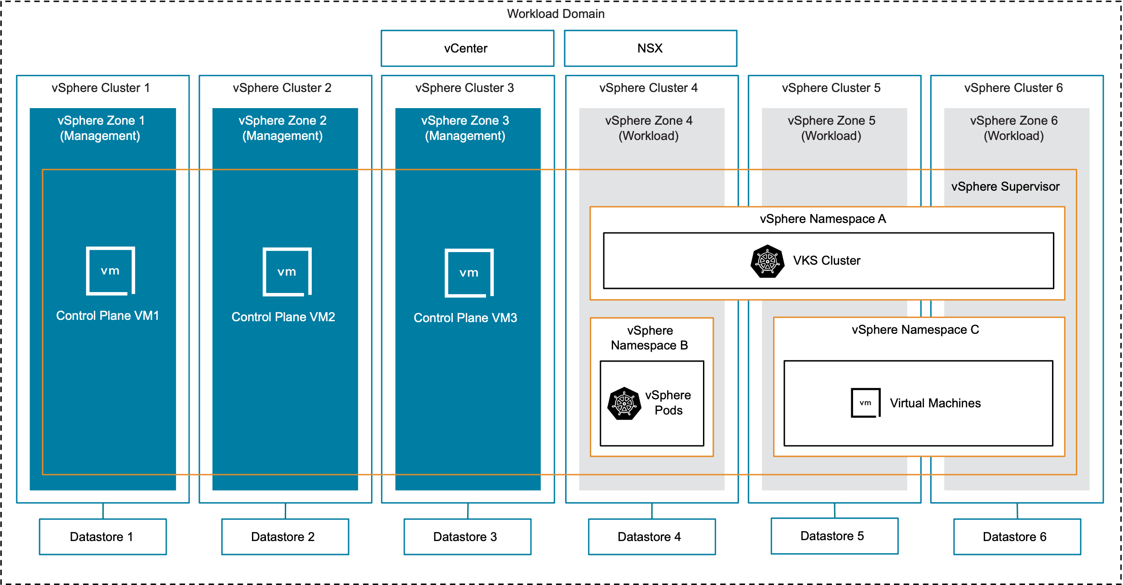

Three Management Zones with Isolated Workload Zones Model Attributes
Attribute | Detail
Supervisor Management Zones | Three
Supervisor Workload Zones | Single or multiple - Isolated from management
Activation | Activated from vCenter API after workload domain creation.

Three Management Zones with Isolated Workload Zones Model Options
Design Area | Choice
Cluster Model | vSphere Single-Rack Cluster Model  Layer 2 Multi-Rack Cluster Model  Layer 3 Multi-Rack Cluster Model
Control Plane Availability Model | High Availability Control Plane Model
Networking Model | VPC with Full Services Workload Networking Model  Centralized Gateway - Active/Standby  NSX Segment Network Virtualization Scalable Workload Networking Model  Centralized Gateway - Active/Active  VLAN Networking Model  Distributed Port Groups support only
Load Balancer Model | Supervisor NSX Load Balancer Model  Supervisor Avi Load Balancer Model  Supervisor Foundation Load Balancer Model
Table 3-801. vSphere Supervisor Three Management Zones Design Requirements
Design Requirement ID | Design Requirement | Justification | Implication
VCF-SUP-TMZ-REQD-CFG-001 | Three available identical vSphere Zone of a supported vSphere Cluster model that is not in use by another vSphere Supervisor instance at activation. | Dedicated vSphere Zones for vSphere Supervisor management workload use.  Individual zones provide single cluster level failure scenarios. | vSphere Zones will not be available for another vSphere Supervisor instance within the same vCenter.
VCF-SUP-TMZ-REQD-CFG-002 | High-availability control plane model option selected. | Ensures even distribution and quorum is available across three management zones. | Additional resources required to host additional control plane nodes.
VCF-SUP-TMZ-REQD-CFG-003 | Opt-out of vSphere Supervisor activation when deploying a workload domain. | Activating vSphere Supervisor as part of the workload domain creation defaults to a Single Management Zone model. | vSphere Supervisor activation needs to be performed from vCenter as a Day 2 operation.
Table 3-802. vSphere Supervisor Design Requirements for all Zone Models
Design Requirement ID | Design Requirement | Justification | Implication
VCF-SUP-AMZ-REQD-CFG-001 | vSphere clusters must have vSphere HA enabled. | Required feature to automatically recover from host failure. | Sufficient spare ESX host resources required for vSphere HA functionality.
VCF-SUP-AMZ-REQD-CFG-002 | vSphere clusters must have vSphere DRS enabled in Fully Automated or Partially Automated mode. | Required feature to automatically balance resource utilization within the cluster. | Sufficient host resources required for vSphere DRS functionality.
VCF-SUP-AMZ-REQD-CFG-003 | vSphere Zones must be configured. | vSphere clusters needs to be configured with vSphere Zone names before it can be utilized by vSphere Supervisor. | A vSphere Zone name will be generated for a Single Management Zone Model if not configured and cannot be changed.
Table 3-803. vSphere Supervisor Networking Design Requirements
Design Requirement ID | Design Requirement | Justification | Implication
VCF-SUP-NET-REQD-CFG-001 | NSX centralized gateway must be deployed in Active/Active configuration when deploying with NSX Segment Networking Model. | Required topology. | NSX centralized gateway must be manually configured
VCF-SUP-NET-REQD-CFG-002 | NSX centralized gateway must be deployed in Active/Standby configuration when deploying on NSX VPC Networking Model. | Required topology. | Sufficient throughput is required from the active edge node.
VCF-SUP-NET-REQD-CFG-003 | Opt-out of Supervisor activation when deploying a workload domain when activating Supervisor for any networking model other than NSX VPC with NSX Load Balancer. | Activating Supervisor as part of the workload domain deployment is only possible on NSX VPC with NSX Load balancer topology. | Supervisor activation needs to be performed from vCenter.
Table 3-804. vSphere Supervisor Design Recommendations
Design Recommendation ID | Design Recommendation | Justification | Implication
VCF-SUP-RCMD-CFG-001 | Activate vSphere Supervisor with NSX VPC Networking Model. | Benefits of NSX VPC and VCF Automation All Apps.  Out of the box configuration during workload domain creation. | NSX VPC Centralized Gateway connectivity must be manually configured.
VCF-SUP-RCMD-CFG-002 | Deploy control plane in high-availability mode. | High availability for vSphere Supervisor control plane. | Additional hosting resources are required.

vSphere Supervisor Control Plane Availability Models
vSphere Supervisor can be deployed with one or three control plane VMs. This section details the deployment models.
Simple Control Plane Model
High Availability Control Plane Model

Simple Control Plane Model
The Simple Control Plane Model deploys a single Supervisor control plane VM into the selected Supervisor management zone. This deployment model can be scaled to three control plane VMs to convert the model to the Supervisor High Availability Control Plane Model.
Note The Simple Control Plane Model is not an option when deploying a Supervisor three management zones model.
Figure 3-121. Simple Control Plane Model Diagram
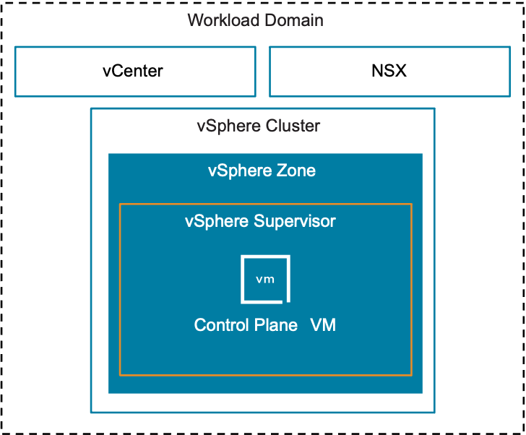
Attribute | Detail
Control Planes Nodes | One
Availability | Relies on vSphere HA
Scalability | Scale up and scale out
Placement | Hosted in a single Supervisor Management Zone
Applicable zone models | Simplified Supervisor Model  Single Management Zone with Combined Workload Zones Model  Single Management Zone with Isolated Workload Zones Model
Table 3-805. vSphere Supervisor Control Plane Model Design Requirements
Design Requirement ID | Design Requirement | Justification | Implication
VCF-SUP-CP-REQD-CFG-001 | Five consecutive management IP addresses routable to vCenter, NSX and Avi management networks. | Required for integration and management communications. | Requires precise IP address management.
VCF-SUP-CP-REQD-CFG-002 | Three vSphere Zones required for High-Availabiliy Model in a Three Management Zone Model. | Control Panel nodes are evenly placed with one per zone to protect against a single vSphere cluster failure. | Additional vSphere clusters are required.

High Availability Control Plane Model
The High Availability Control Plane Model deploys three Supervisor control plane VMs into the selected Supervisor management zones. This deployment model can be scaled from the Simple Control Plane Model.
Figure 3-122. High Availability Control Plane Model in a Single Management Zone Model Diagram
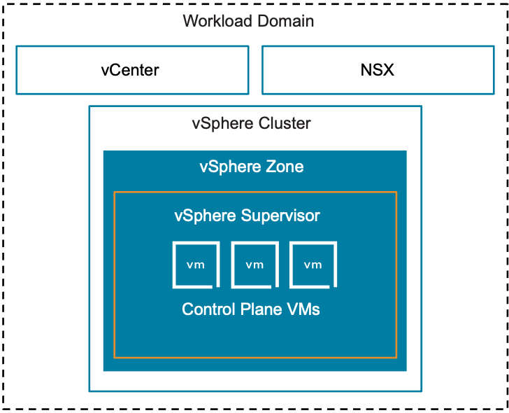
Figure 3-123. High Availability Control Plane Model in a Three Management Zones Model Diagram
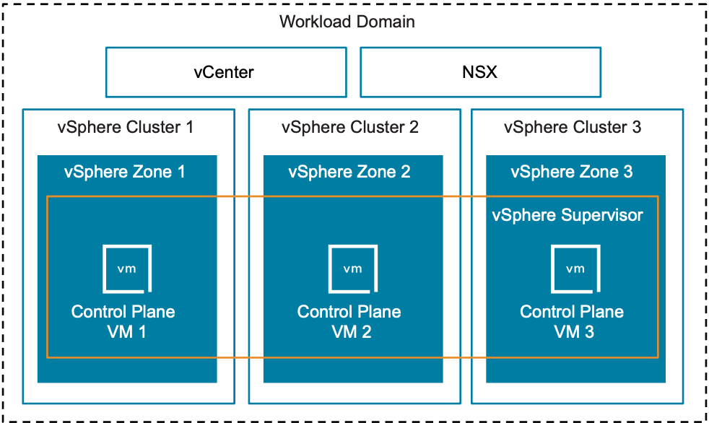
Attribute | Detail
Control Planes Nodes | Three
Availability | Relies on vSphere HA  Three management zones  Protected from single cluster failure
Scalability | Scale up only
Placement | Single management zone  All nodes in a single management zone  Three management zones  One node per management zone
Applicable zone models | Single Management Zone with Combined Workload Zones Model  Single Management Zone with Isolated Workload Zones Model  Three Management Zones with Combined Workload Zones Model  Three Management Zones with Isolated Workload Zones Model
Table 3-806. vSphere Supervisor Control Plane Model Design Requirements
Design Requirement ID | Design Requirement | Justification | Implication
VCF-SUP-CP-REQD-CFG-001 | Five consecutive management IP addresses routable to vCenter, NSX and Avi management networks. | Required for integration and management communications. | Requires precise IP address management.
VCF-SUP-CP-REQD-CFG-002 | Three vSphere Zones required for High-Availabiliy Model in a Three Management Zone Model. | Control Panel nodes are evenly placed with one per zone to protect against a single vSphere cluster failure. | Additional vSphere clusters are required.
Table 3-807. vSphere Supervisor Control Plane Design Recommendations
Design Requirement ID | Design Recommendation | Justification | Implication
VCF-SUP-CP-RCMD-CFG-001 | Deploy high availability (three) control plane VMs.  *Applicable to Non-Simplified Supervisor models only. | Three control plane VMs allow for continuous availability of the Supervisor control plane during rolling upgrades and single node outages. | Additional resources are required to support the extra control plane VMs.

vSphere Supervisor Load Balancer Models
vSphere Supervisor requires selecting an appropriate load balancer for the backing workload networking type. The choice of load balancer includes NSX Load Balancer, Avi Load Balancer and Foundation Load Balancer. This section describes the different load balancer models.
Supervisor NSX Load Balancer Model
Supervisor Avi Load Balancer Model
Supervisor Foundation Load Balancer Model

Supervisor NSX Load Balancer Model
The NSX Load Balancer can be utilized when activating Supervisor. This is the default load balancer if an Avi Load Balancer integration is not detected. The NSX Load Balancer is an included feature and entitlement of VCF for use by Supervisor and services it manages.
Table 3-808. Supervisor NSX Load Balancer Model Attributes
Attribute | Detail
Compatible Networking Model | NSX VPC Networking  NSX Segment Networking
Sharing with non-Supervisor workloads | No
Table 3-809. vSphere Supervisor NSX Load Balancer Design Requirements
Design Requirement ID | Design Requirement | Justification | Implication
VCF-SUP-NLB-REQD-CFG-001 | Workload networking model must be NSX Segment or NSX VPC. | Compatibility with NSX Virtual Networking models only. | Incompatible with VLAN Networking model.
VCF-SUP-NLB-REQD-CFG-002 | NSX Edge cluster must be deployed. | NSX Load Balancers run on NSX Edges. | NSX Edge design, deployment and configuration required.
VCF-SUP-NLB-REQD-CFG-003 | NSX Edge nodes must be deployed with a minimum of large form factor. | NSX Load Balancers have fixed resource allocations on NSX Edge nodes. Large form factor is required to accommodate basic system and workload needs. | Large form factor resources required. If additional load balancers are required, NSX Edges can be scaled up or out.

Supervisor Avi Load Balancer Model
The Avi Load Balancer can be utilized when activating Supervisor with NSX Segment Networking, NSX VPC Networking or VLAN Networking models. Avi Load Balancer is highly scalable, performing with advanced monitoring features and can be shared with other non-Supervisor managed workloads.
Table 3-810. Supervisor Avi Load Balancer Model Attributes
Attribute | Detail
Compatible Networking Model | NSX VPC Networking  NSX Segment Networking  VLAN Networking Model
Sharing with non-Supervisor workloads | Yes
Table 3-811. vSphere Supervisor Avi Load Balancer Design Requirements
Design Requirement ID | Design Requirement | Justification | Implication
VCF-SUP-ALB-REQD-CFG-001 | Avi must be deployed with a 1:1 relationship with NSX Manager. | Product requirement. | When NSX is shared across workload domains, only one Avi instance can be integrated with NSX. Subsequent workload domains deployed share the same Avi and NSX instance through a dedicated service account on vCenter.
VCF-SUP-ALB-REQD-CFG-002 | Avi Load Balancer must be integrated with NSX before Supervisor activation. | If Avi Load Balancer integration is not detected, Supervisor defaults to utilizing NSX Load Balancer. | When activating Supervisor as part of workload domain creation, Avi must be deployed after workload domain creation but before centralized gateway connectivity configuration.

Supervisor Foundation Load Balancer Model
The Foundation Load Balancer (FLB) can be utilized when activating Supervisor with VLAN Networking model. The FLB deploys and shares the same resource and storage policy of the Supervisor management zone.
Table 3-812. Supervisor Foundation Load Balancer Model Attributes
Attribute | Detail
Compatible networking models | VLAN Networking Model
Sharing with non-Supervisor workloads | No
Topology options | One-arm (One NIC)  One-arm (Two NICs)  Two-arm (Three NICs)
Availability modes | One VM  Two VMs (Active / Passive)
Table 3-813. vSphere Supervisor Foundation Load Balancer Design Requirements
Design Requirement ID | Design Requirement | Justification | Implication
VCF-SUP-FLB-REQD-CFG-001 | Two or three routable distributed port groups. One for the management network, transit network (in a two-arm configuration) and load balancer network. | Required networks. | Distributed port groups must be manually prepared ahead.

Modern Applications Consumption Models
VMware Cloud Foundation (VCF) offers a robust foundation for managing both modern and traditional workloads. It enables unified management of VMs, Kubernetes clusters, and other resources by using a single, consistent API, simplifying operations and reducing the need for separate platforms.
The modern application API of VCF provides the following benefits:
Unified management–
A single API manages VMs, Kubernetes clusters, and other resources, eliminating the need for separate platforms.
Declarative API–
Users define the desired state, and the system automatically configures and maintains it.
Extensible ecosystem–
Private cloud services offer additional functionality on demand while maintaining a consistent user experience.
Infrastructure abstraction–
It abstracts the complexities of the underlying infrastructure, allowing teams to focus on application delivery.
Self-service for catalog–
Consumers can deploy VMs and Kubernetes clusters on-demand through a self-service model with VCF Automation.
Integrated services–
Core services like vSphere Kubernetes Service (VKS) for clusters and VM Service for VMs are included.
Consistent lifecycle–
Building-block services have independent lifecycles, enabling flexible deployment and updates without affecting the entire environment.
Workload isolation–
vSphere Namespaces provide logical units for resource and network isolation.
Developers and platform engineers can use the following consumption models as examples of how to use VCF to build, run and manage modern applications with VCF native tooling or with third-party tooling:
Continuous Integration and Delivery with Harness
Continuous Integration and Delivery with Argo CD

Continuous Integration and Delivery with Harness Architecture
The high-level architecture for implementing GitOps with Harness and VKS clusters uses a CI/CD approach, integrating a suite of tools for automation, security, and observability. This architecture aims to provide a robust and efficient delivery pipeline for applications and infrastructure.
Figure 3-124. Example Harness CI/CD Architecture
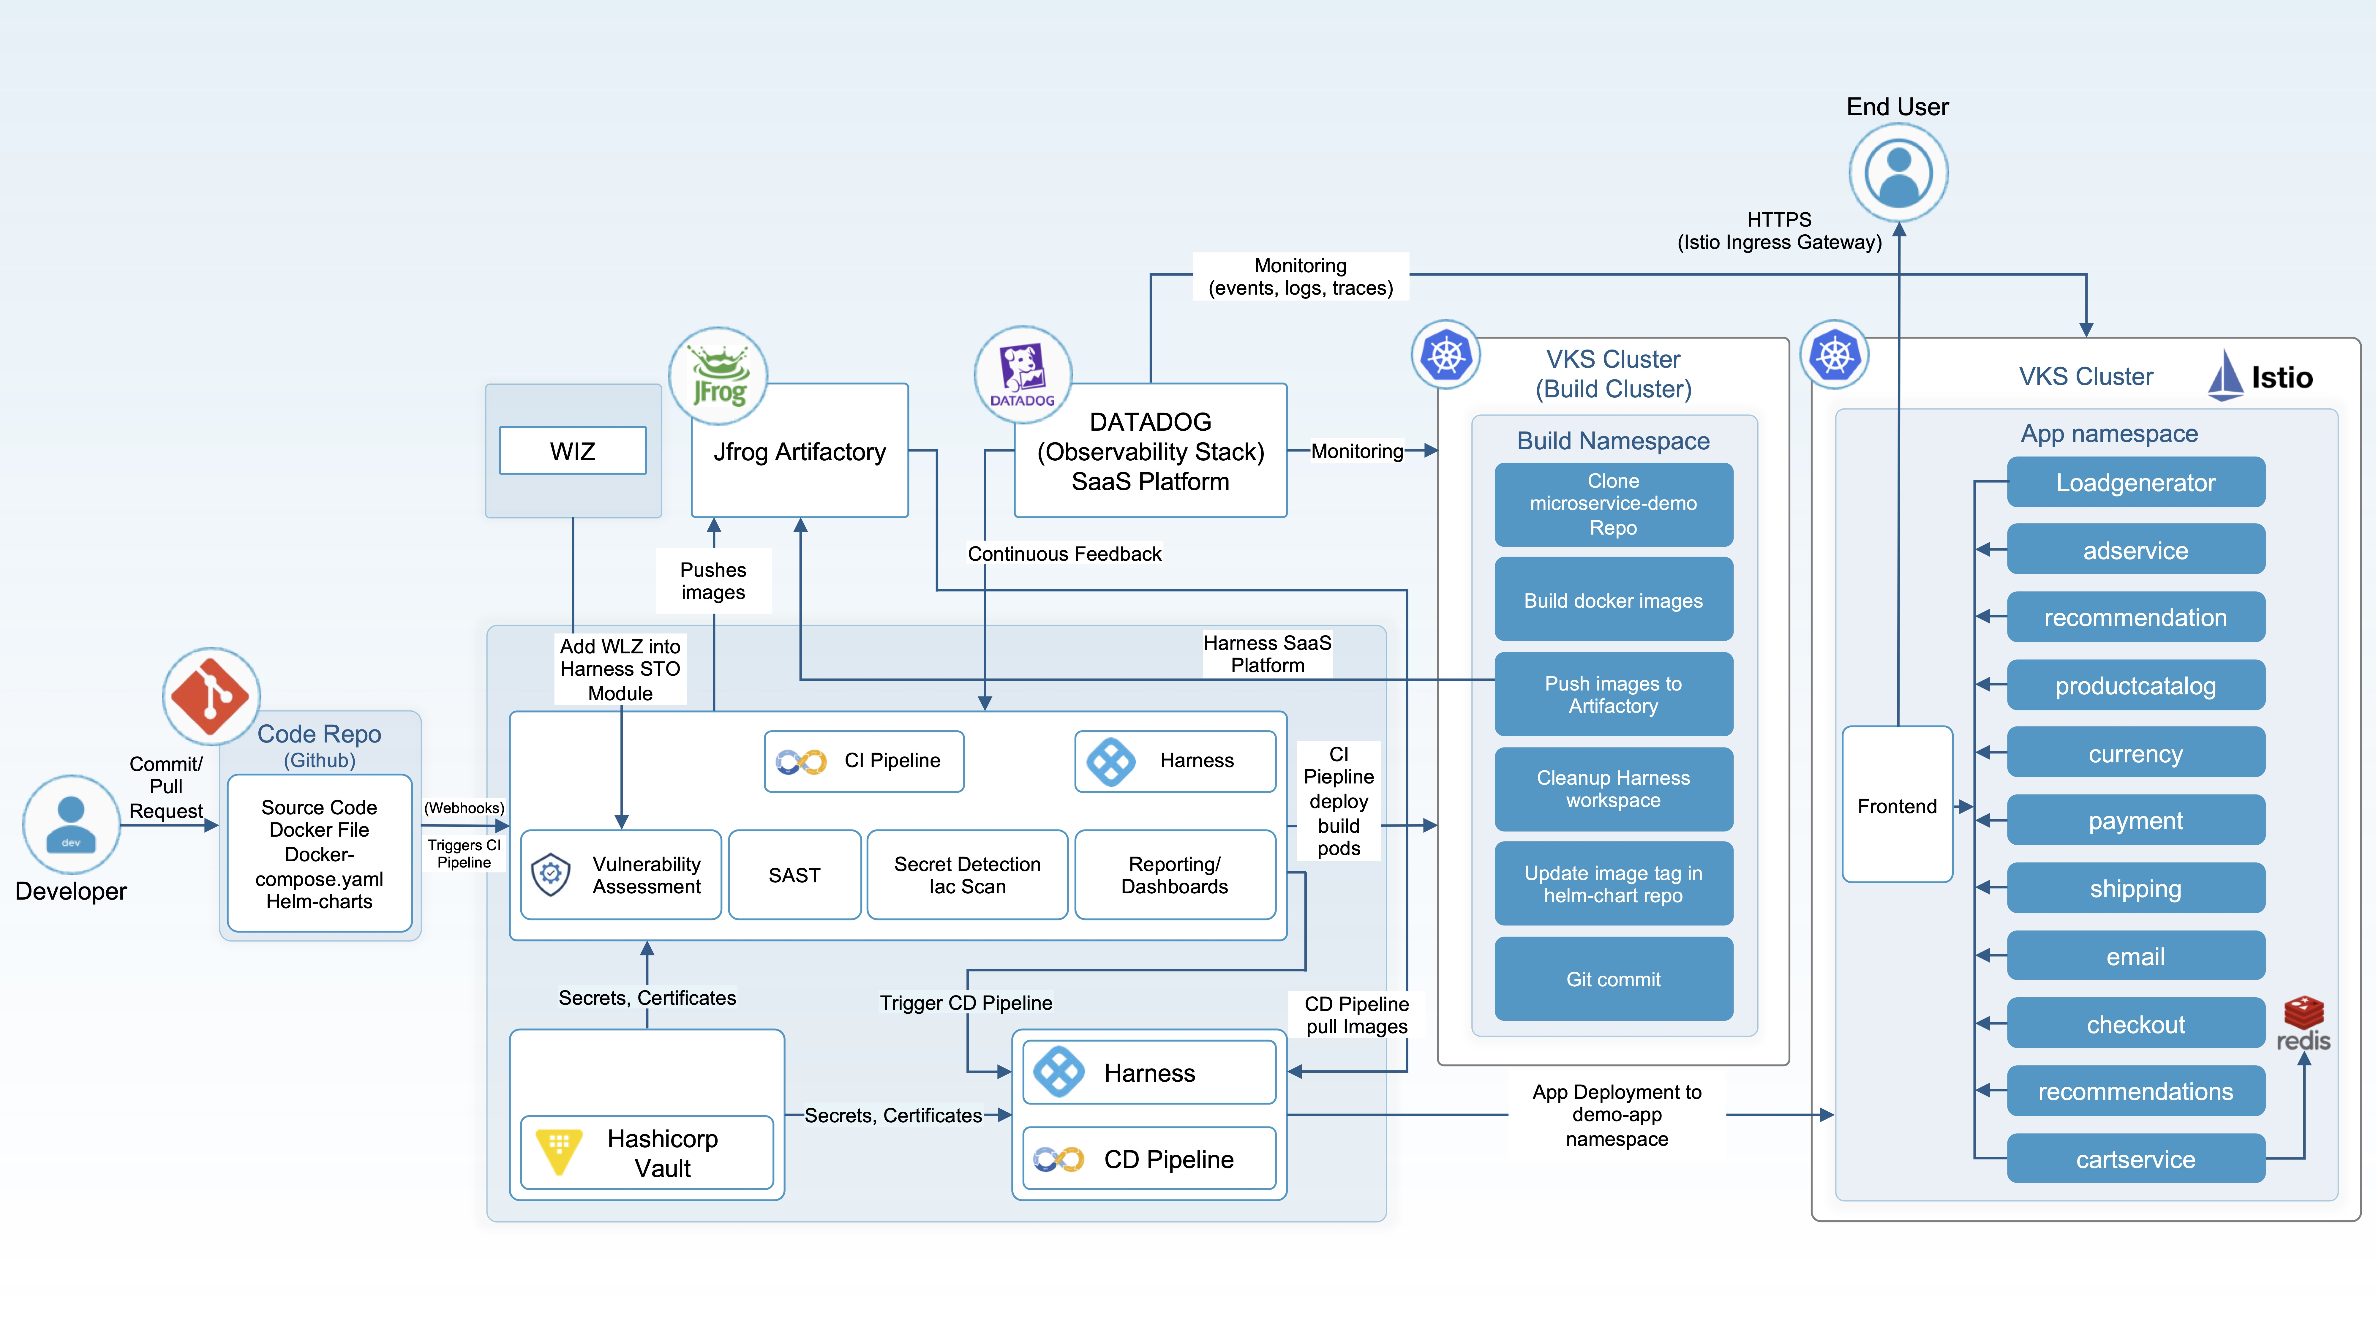

Introduction to GitOps with CI/CD
GitOps is an operational framework that takes DevOps best practices that are used for application development, like version control, collaboration, compliance, and CI/CD, and applies them to infrastructure automation. With GitOps, the desired state of the application and infrastructure is described declaratively in Git, and Git repositories are the single source of truth. CI/CD pipelines then automate the deployment and synchronization of this desired state to the deployment environments.

Architectural Overview
The architecture uses a combination of industry-leading tools to create a secure, automated, and observable GitOps workflow. The core principles guiding this architecture include:
Git as the single source of truth - All infrastructure and application configurations are stored in Git.
Automation - CI/CD pipelines automate the build, test, and deployment processes.
Observability - Comprehensive monitoring and tracing provide insights into the system's health and performance.
Security - Integrated security scanning and secrets management protect the pipeline and deployed applications.

Component Overview
The Harness CI/CD architecture incorporates the following components:
GitLab - Serves as the Git repository for source code, infrastructure as code (IaC), and configuration files. It also provides built-in CI/CD capabilities.
Harness - Acts as the primary CI/CD platform, orchestrating deployments, managing pipelines, and providing release automation.
Artifactory - Functions as a universal repository manager for all binaries, artifacts, and Docker images.
Dynatrace - Provides end-to-end observability, including application performance monitoring (APM), infrastructure monitoring, and digital experience monitoring.
HashiCorp Vault - Manages and secures sensitive data, such as API keys, passwords, and certificates.
Wiz - Offers cloud security posture management (CSPM) and cloud workload protection platform (CWPP) capabilities, providing continuous security monitoring across the cloud environment.

Detailed Workflow
In each phase in the Harness CI/CD architecture, you must include a set of operations.
CI/CD Pipeline Phase | Operations
1. Code commit and CI pipeline (GitLab and Harness) | Developer commits code.  Developers push application code or infrastructure changes (IaC) to a designated GitLab repository.  GitLab webhook.  A GitLab webhook triggers a Harness CI pipeline upon code commit to the main branch or a pull request merge.  Harness CI pipeline.  Fetches the latest code from GitLab.  Runs static code analysis and unit tests.  Builds application binaries or Docker images.  Pushes built artifacts and Docker images to Artifactory.
2. Artifact management (Artifactory) | Artifact storage.  Artifactory securely stores all built artifacts, Docker images, and other dependencies.  Version control.  Artifactory maintains version control for all stored artifacts, enabling easy rollbacks if needed.
3. Security scanning (Wiz) | Pre-deployment scanning.  Wiz integrates with the CI pipeline (using Harness) to scan Docker images and IaC templates for vulnerabilities, misconfigurations, and compliance issues before deployment.  Continuous monitoring.  Wiz continuously monitors the cloud environment and deployed workloads for security risks and compliance deviations.
4. Secrets management (HashiCorp Vault) | Centralized secret storage.  All sensitive information, such as database credentials, API keys, and certificates, is stored securely in HashiCorp Vault.  Dynamic secrets.  Vault can generate dynamic secrets for services, reducing the risk of compromised long-lived credentials.  Integration with Harness.  Harness integrates with Vault to retrieve secrets at deployment time, ensuring that sensitive information is never hardcoded or exposed in plain text.
5. CD Pipeline and deployment (Harness and GitLab) | Harness CD pipeline trigger.  Upon successful completion of the CI pipeline and security scans, a Harness CD pipeline is triggered. This can also be triggered manually for specific releases.  GitOps reconciliation.  The CD pipeline fetches the desired state (application and infrastructure configurations) from the Git repository (GitLab).  Deployment to environment.  Harness orchestrates the deployment to the target environment (for example, Kubernetes cluster, cloud infrastructure). The deployment operation involves:  Pulling the latest images from Artifactory.  Applying the IaC changes.  Updating application configurations.  Rollback strategy.  Harness provides robust rollback capabilities, providing support for quick reversions to previous stable states if deployment failures or issues occur.
6. Observability and monitoring (Dynatrace) | Automatic instrumentation.  Dynatrace automatically instruments applications and infrastructure upon deployment, collecting metrics, logs, and traces.  End-to-end monitoring.  Provides real-time insights into application performance, infrastructure health, user experience, and business impact.  Problem detection.  The AI engine of Dynatrace automatically detects anomalies, identifies root causes, and provides intelligent alerts.  Feedback loop.  Monitoring data from Dynatrace can feed back into the development process to improve application quality and performance.

Code Repository for Harness CI/CD
For an example of a Harness CI/CD pipeline, see Harness CI/CD Pipeline in the VKS Consumption Models GitHub public repository. This Harness CI/CD pipeline builds and deploys a modern microservices-based application. The pipeline automates Docker image creation, pushing to a container registry, updating Helm charts, and rolling out deployments to a VKS cluster.

